**Name # Noman Amjad**

**Class # BSCS-3B**

**Arid No # 21-Arid-654**

**Date # 29-10-2022**

**Assignment No # 01**

**Question: Propose the most appropriate generic software process model that might be used as a basis for the development of following systems. Give reasons for your answers.**

**A) A complex real-time system whose requirements can be relatively easily identified and are stable.**

**Answer:** Waterfall Model

It should be the right decision in this situation. When the requirements and predictability of the project's progress and completion are understood, this model is the ideal option.

The waterfall model is a linear process model that separates the various project phases of the development process. Unlike iterative models, each phase is only executed once. The outcomes of each step before it serve as assumptions for the phase that follows. The waterfall paradigm is particularly popular in the creation of software.

Different iterations of the waterfall model are applied in reality. There are several models that break down development processes into five parts.

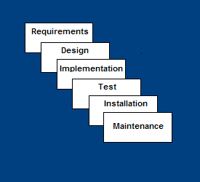

**1-**1st Analysis:Planning, requirements analysis, and specification comprise .

**2-**Design: system stipulation and design.

**3-**Implementation: includes module testing and programming.

**4-**System and integration: testing for system integration.

**5-**Operation: includes distribution, upkeep, and improvement.

**b) A web-site for a uaar library. Requirements are vague and are likely to change in the future.**

**Answer:** Incremental development Model

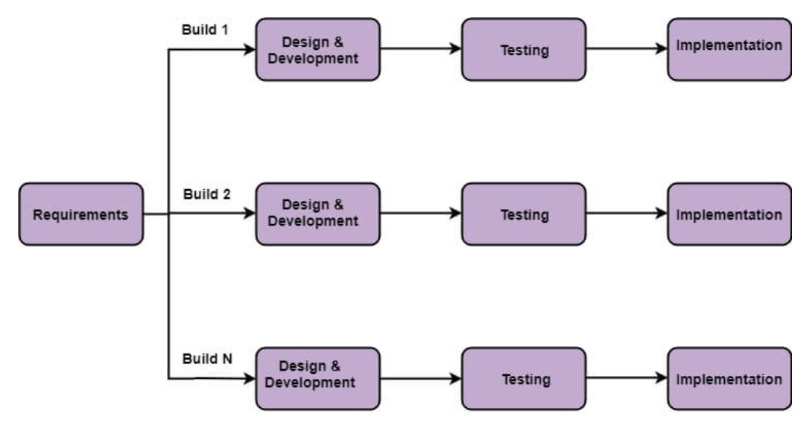

In this case, it should be the best choice. due to increased customer involvement and vague yet variable needs. hence, the need for quick prototyping.

**1-Requirement Analysis:**Complete the analysis is performed on the requirement and how to make sure that this requirement will be compatible to previously developed

**2-Design:**Once the requirement for this particular increment i understood and clear then design will be drafted on how to implement and archive this requirement.

**3-Code:**Now the coding is performed in accordance to achieve the purpose of the requirements. All the coding standards will be followed without any defaults and unnecessary hard codes

**4-Test:**This is the last in the incremental phase where aggressive testing is performed on the developed code and defects are reported and resolved

**C) An order processing system with a web-site for a local shopping business. Requirements are vague but stable (i.e. unlikely to change in the near future).**

**Answer->**

Discarding the incremental development methodology that has been "merged" with prototyping.

It should be the right decision in this situation. The requirements are ambiguous and stable, and prototyping is also necessary.

since the project is an online store. In the future, it would require new design and upgrading technologies. Therefore, as time goes on, Internet development will continue to offer upgrades and maintain a client-friendly website.