CSE4077: Recommender System

**Project Report Review III**

**Kishan Mitra:**

**Recommendation System for Crop, Fertilizer and Pesticide**

*By*

20MIA1147 Shashank Pandey

20MIA1081 Gaurav Sharan

20MIA1134 Atul Patel

20MIA1084 Pratyansh Soni

Integrated MTech CSE with Specialization in Business Analytics

*Submitted to*

Dr.Pradeep K**,** Assistant Professor Senior,SCOPE, VIT, Chennai

# School of Computer Science and Engineering



*July 2024*

**ABSTRACT**

Kishan Mitra: Recommendation System for Crop, Fertilizer, and Pesticide" is an innovative initiative designed to revolutionize Indian agriculture by integrating advanced AI technologies with traditional farming practices. This system, implemented as a comprehensive and user-friendly website, provides tailored recommendations for crop selection, fertilizer application, and pest management based on a detailed analysis of site-specific parameters such as soil quality, weather conditions, crop history, and regional agricultural trends.

The core objective of Kishan Mitra is to optimize agricultural productivity, promote sustainable farming practices, and enhance soil health through the use of machine learning models and data analytics. These models analyze a wealth of data to provide precise, actionable advice to farmers, helping them make informed decisions that maximize yield and minimize resource use. By delivering personalized recommendations, the system ensures that farmers apply the right type and amount of fertilizers and pesticides at the optimal times, thus preventing overuse and reducing environmental impact.

The platform's user-centric design ensures that it is accessible and easy to use for farmers with varying levels of technological proficiency. It provides a seamless interface where users can input specific details about their land and crops, and receive customized guidance. Additionally, the website includes a rich repository of educational resources and training programs aimed at empowering farmers with the knowledge and skills necessary to implement the recommendations effectively. This aspect of the platform is crucial in fostering a supportive agricultural community and bridging the knowledge gap that many farmers face.

Kishan Mitra addresses several critical challenges in Indian agriculture. Firstly, it tackles the issue of declining soil fertility caused by the overuse and misuse of chemical fertilizers and pesticides. By providing precise recommendations, the system helps farmers maintain soil health, ensuring long-term sustainability of their farming practices. Secondly, the system supports crop diversification by suggesting suitable crops based on soil and climatic conditions, thereby reducing the risk of crop failure and improving food security. Thirdly, the platform aids in pest management by offering timely advice on pest control measures, which is vital for protecting crops and ensuring healthy yields.

Moreover, Kishan Mitra incorporates real-time weather data and predictive analytics to help farmers plan their activities more effectively. This feature is particularly important in the context of climate change, where unpredictable weather patterns can significantly impact agricultural productivity. By providing up-to-date weather forecasts and alerts, the system enables farmers to take proactive measures to protect their crops and optimize irrigation practices.

The platform also emphasizes community building and knowledge sharing among farmers. It includes forums and discussion boards where farmers can share experiences, ask questions, and seek advice from experts and peers. This collaborative approach not only enhances the collective knowledge base but also fosters a sense of solidarity and mutual support among farmers.

In conclusion, Kishan Mitra represents a holistic approach to modernizing Indian agriculture. By leveraging the power of AI and machine learning, it provides farmers with the tools and knowledge they need to improve their productivity, profitability, and sustainability. The system's focus on personalized recommendations, educational resources, and community support ensures that it is not just a technological solution, but a comprehensive platform that addresses the multifaceted challenges faced by farmers. Through Kishan Mitra, farmers are empowered to adopt best practices, enhance their agricultural output, and contribute to a more sustainable and resilient agricultural ecosystem.

**Table of Content:**

1. Introduction
   1. Project overview
   2. problem definition
   3. problem objectives
   4. Novelty of work
2. Requirement Analysis
   1. Literature Survey
3. Methodology
   1. Proposed Solution
   2. Tools and Technology Used
4. Design Specification
   1. Analysis Diagrams
      1. Use Case Diagram
      2. Class Diagram
5. Implementation and Experimental Results
   1. Experimental Setup
   2. Experimental Data
   3. Algorithms Used
      1. System Screenshots
      2. Results and Discussion
6. Conclusion and Future Scope
   1. Conclusion
   2. Future Scope
7. References
8. **INTRODUCTION**

Kishan Mitra” defines in its slogan, Farm = AI + Crop + Fertilizer + Pesticide, taking care of soil’s health. Kishan Mitra honors the Indian farmer’s love, hard work, and character. Farmers help to feed a nation whose population is nearly 1.4 billion. However, the productivity of farms is threatened by various natural factors that ruin the crops and farmer’s livelihood. Kishan Mitra is a small initiative enhancing agriculture, making smart decisions to consider the demographics of the field, the factors affecting the crop, as well as how to keep the farm healthy for a super awesome yield. This will be implemented in the form of a website providing features of Crop Recommendation, Fertilizer Recommendation, and Pesticide Recommendation based on site-specific parameters.

Agriculture is the backbone of the Indian economy, contributing significantly to the country's GDP and providing employment to a large portion of the population. Despite its crucial role, the agricultural sector faces numerous challenges that hinder its potential. Unpredictable weather patterns, pest infestations, soil degradation, and water scarcity are some of the major issues that farmers grapple with on a daily basis. These challenges not only affect the quantity and quality of the produce but also the overall well-being of the farmers. In such a scenario, technological interventions like Kishan Mitra can play a transformative role.

Kishan Mitra aims to integrate advanced technologies with traditional farming practices to create a sustainable and efficient agricultural ecosystem. The core idea is to leverage Artificial Intelligence (AI) to provide personalized recommendations to farmers, helping them make informed decisions about crop selection, fertilizer application, and pest management. By analyzing various site-specific parameters such as soil type, weather conditions, and crop history, Kishan Mitra can offer tailored solutions that enhance productivity and ensure the long-term health of the soil.

The Crop Recommendation feature of Kishan Mitra is designed to help farmers choose the most suitable crops for their fields. This feature takes into account a variety of factors including soil quality, climate conditions, and market demand. By selecting the right crop, farmers can optimize their yields and achieve better economic returns. Additionally, the platform can provide information on crop rotation practices, which can help maintain soil fertility and prevent the buildup of pests and diseases.

Fertilizer management is another critical aspect of modern agriculture. The Fertilizer Recommendation feature of Kishan Mitra provides farmers with precise information on the type and quantity of fertilizers required for their crops. This not only helps in maximizing crop yields but also prevents the overuse of fertilizers, which can lead to soil degradation and environmental pollution. The AI-driven recommendations are based on soil tests and crop requirements, ensuring that the nutrients are supplied in the right amounts at the right time.

Pest management is a major concern for farmers, as pest infestations can cause significant crop losses. The Pesticide Recommendation feature of Kishan Mitra offers solutions for effective pest control while minimizing the impact on the environment. By identifying the specific pests affecting the crops and suggesting appropriate pesticides, the platform helps in reducing the reliance on chemical treatments and promotes the use of integrated pest management practices. This approach not only protects the crops but also preserves the ecological balance of the farm.

One of the unique aspects of Kishan Mitra is its focus on soil health. Healthy soil is the foundation of productive agriculture, and maintaining its health is essential for sustainable farming. The platform provides insights into soil management practices that enhance soil structure, increase organic matter content, and improve water retention. Techniques such as cover cropping, mulching, and reduced tillage are promoted to protect and nurture the soil. By adopting these practices, farmers can improve soil fertility, reduce erosion, and enhance the resilience of their farms to climate change.

In addition to providing recommendations, Kishan Mitra also offers educational resources and training programs for farmers. These resources cover a wide range of topics including modern farming techniques, organic farming, water management, and post-harvest handling. By empowering farmers with knowledge and skills, the platform aims to build their capacity to adapt to changing agricultural landscapes and make informed decisions that benefit their farms and communities.

Kishan Mitra’s commitment to honoring the Indian farmer’s love, hard work, and character is reflected in its mission to create a supportive and inclusive agricultural community. The platform encourages collaboration and knowledge-sharing among farmers, agricultural experts, and researchers. By fostering a sense of community and collective learning, Kishan Mitra aims to create a robust network that supports the growth and development of the agricultural sector.

In conclusion, Kishan Mitra is more than just a technological solution; it is a holistic approach to enhancing agriculture and supporting the livelihoods of farmers. By integrating AI with traditional farming practices, the platform provides personalized recommendations that help farmers optimize their yields, maintain soil health, and manage pests effectively. Through its educational resources and community-building initiatives, Kishan Mitra empowers farmers with the knowledge and skills they need to thrive in a challenging agricultural environment. As a small initiative with a big vision, Kishan Mitra is poised to make a significant impact on the future of Indian agriculture, honoring the hard work and dedication of the farmers who feed the nation.

* **Crop Recommendation**

The Crop Recommendation feature of Kishan Mitra is designed to assist farmers in selecting the most appropriate crops for their fields. This feature evaluates a range of factors including soil quality, climate conditions, and market demand. By choosing the right crop, farmers can maximize their yields and achieve better economic outcomes. Additionally, the platform offers insights into crop rotation practices, which help maintain soil fertility and prevent the accumulation of pests and diseases.

By recommending crops tailored to the specific conditions of a farmer's field, Kishan Mitra aids in diversifying the agricultural landscape. This diversification reduces the risk of crop failure due to pests or adverse weather, and also spreads economic risk. A diversified crop system enhances the resilience of agriculture, making it better equipped to handle environmental and economic challenges.

To ensure accurate and effective crop recommendations, Kishan Mitra employs several advanced machine learning models, including Support Vector Machines (SVM), Random Forest, Logistic Regression, Gradient Boosting, and Gaussian Naive Bayes.

1. Support Vector Machines (SVM): SVM is an effective classification technique that handles high-dimensional data well. For crop recommendation, SVM can classify different crops based on features such as soil pH, nutrient levels, temperature, and humidity. By transforming the input features into a higher-dimensional space, SVM identifies the optimal crop for the given field conditions.
2. Random Forest: This ensemble learning method constructs multiple decision trees and combines them to improve accuracy and stability. Random Forest can process numerous input variables and determine the importance of each. In crop recommendation, it evaluates parameters like soil texture, rainfall patterns, and historical crop performance to suggest the best crops. Its capability to manage non-linear relationships and variable interactions makes it ideal for agricultural applications.
3. Logistic Regression: Used for binary and multiclass classification, Logistic Regression predicts the probability of a particular crop being suitable for specific field conditions. By analyzing historical data, this model provides straightforward crop recommendations and success probabilities.
4. Gradient Boosting: This technique builds models incrementally, optimizing an arbitrary differentiable loss function. Gradient Boosting enhances prediction accuracy by combining weak learners (simple models) into a strong predictive model. It captures complex relationships between environmental factors and crop performance, making it effective for crop recommendation.
5. Gaussian Naive Bayes: Based on Bayes’ theorem, this model assumes that the presence of a particular feature is independent of others. It handles continuous data effectively and provides probabilistic crop recommendations based on field attributes. Its simplicity and speed make it suitable for real-time decision-making.

By integrating these diverse machine learning models, Kishan Mitra delivers highly accurate and reliable crop recommendations. Each model contributes to a comprehensive understanding of field conditions, enabling farmers to make informed decisions. Through these advanced technologies, Kishan Mitra not only improves crop selection but also promotes sustainable farming practices, contributing to a more resilient and productive agricultural system.

* **Fertilizer Recommendation**

Fertilizer management is a crucial component of contemporary agriculture. The Fertilizer Recommendation feature of Kishan Mitra offers farmers detailed guidance on the types and quantities of fertilizers necessary for their crops. This targeted advice helps maximize crop yields while preventing the overuse of fertilizers, which can lead to soil degradation and environmental pollution. By basing recommendations on soil tests and specific crop requirements, the AI-driven system ensures that nutrients are supplied in optimal amounts at the appropriate times.

The improper use and overapplication of chemical fertilizers have been persistent issues in agriculture, resulting in problems such as nutrient runoff, water contamination, and the decline of soil health. Kishan Mitra addresses these issues by providing precise fertilizer recommendations that promote sustainable farming practices. These practices aim to improve soil fertility and protect the environment, aligning with the increasing need for agricultural sustainability that balances productivity with ecological conservation.

* **Pesticide Recommendation**

Pest management is a crucial concern for farmers, as pest infestations can result in significant crop losses, greatly affecting agricultural productivity and farmers' livelihoods. The Pesticide Recommendation feature of Kishan Mitra offers targeted solutions for effective pest control while minimizing environmental impact. By accurately identifying specific pests affecting crops and recommending suitable pesticides, the platform reduces dependence on chemical treatments and encourages Integrated Pest Management (IPM) practices. This method not only protects crops but also maintains the ecological balance of the farm.

Integrated Pest Management (IPM) is a sustainable strategy for managing pests that combines biological, cultural, physical, and chemical tools to minimize economic, health, and environmental risks. Kishan Mitra's pesticide recommendations align with IPM principles, promoting practices such as crop rotation, the use of pest-resistant crop varieties, and the application of biopesticides. These practices are essential for maintaining a healthy agricultural ecosystem and ensuring long-term sustainability.

**MobileNet Model Overview**

To support pest management, Kishan Mitra employs advanced technologies like the MobileNet model, a type of convolutional neural network (CNN) optimized for mobile and embedded vision applications. MobileNet is particularly suitable for field use due to its efficiency and speed, making it ideal for real-time pest detection and identification.

**1. Lightweight Architecture:** MobileNet is designed to be lightweight and efficient, with fewer parameters and reduced computational complexity compared to traditional CNNs. This makes it suitable for deployment on mobile devices and edge computing platforms, allowing farmers to use it directly in the field without the need for high-end hardware.

**2. Depthwise Separable Convolutions:** The core innovation of MobileNet lies in its use of depthwise separable convolutions, which factorize a standard convolution into a depthwise convolution followed by a pointwise convolution. This reduces the number of parameters and computations required, enabling faster and more efficient processing.

**3. Scalability:** MobileNet provides a trade-off between latency, accuracy, and model size through two hyperparameters: width multiplier and resolution multiplier. The width multiplier reduces the number of channels in each layer, while the resolution multiplier reduces the input image size. This allows for scalable models that can be adjusted based on the specific requirements of the application, such as higher accuracy or faster inference times.

**4. Real-Time Pest Detection:** By leveraging MobileNet, Kishan Mitra can perform real-time pest detection and identification. The model processes images of crops taken by farmers using their smartphones, identifying pests with high accuracy. Once a pest is identified, the platform recommends appropriate pesticides or non-chemical control measures based on the specific pest species and the principles of IPM.

* 1. **Project Overview**

Kishan Mitra is a website made for farmers to help them with crop recommendations based on values of N, P, K, temperature, rainfall, relative humidity and pH. Generally, soil gets degraded and productivity is reduced if the right crop isn’t chosen, but Kishan Mitra makes it really easy by using the ML model to make the real time prediction. Second feature is Fertilizer Prediction. If the farmer opts not to change the crop as per land, he can go with the same crop but use fertilizer which will be recommended by Kishan Mitra based on N, P, K and crop values. Lastly, a very useful feature implemented is Pesticide Recommendation. Pests are a huge threat but they can be stopped. Farmers simply need to upload a picture which clearly shows the pest and Kishan Mitra will identify the pest with the help of DL Model which is CNN and recommend the corresponding pesticide along with required dosage to get rid of pests and protect the crop. If the farmer already knows about the pest, then he/she can select the pest and corresponding pesticide will be recommended. Generally, it's seen that tests for soil are done by Indian government and results come within a few days but farmers really don’t know much on what to do next, so Kishan Mitra is sort of their next step. A simple, intuitive website will really help farmers to easily know the whereabouts of crops, thus helping every possible bit which Kishan Mitra can. Hence, the three modules: Crop, Fertilizer, Pesticide really comes handy and a boon for farmers.

* 1. **Problem Definition**

Kishan Mitra aims to help Indian farmers and reduce their hardship. The problems faced by Indian farmers are defined as follows:

* + 1. Productivity needs to be increased so that farmers can get more pay from the same piece of land without degrading soil.
    2. Indian farmers are not able to choose the right crop based on their soil requirements depending upon factors like N, P, K, temperature, humidity, rainfall, pH.
    3. Farmers are generally unaware about the organic fertilizers or standard fertilizers to use as per soil requirements.
    4. Due to inadequate and imbalanced fertilization, soil degradation is occurring, which leads to nutrient mining and the development of second-generation problems in nutrient management.
    5. According to a study by the Associated Chambers of Commerce and Industry of India, annual crop losses due to pests amount to Rs. 50,000 crores.
  1. **Problem Objectives**

Corresponding to problems cited above, following are objectives that “Kishan Mitra” is trying to solve:

* + 1. To implement precision agriculture (A modern farming technique that uses research data of soil characteristics, soil types, crop yield data collection and suggests the farmers the right crop based on their site-specific parameters to reduce the wrong choice on a crop and increase in productivity).
    2. To solve the problem by proposing a recommendation system through an ensemble model with majority voting technique crop for the site-specific parameters with high accuracy and efficiency.
    3. To recommend organic fertilizer on the basis of N, P, K values and crop.
    4. To recognize the pest and recommend particular pesticide available in India as per ISO standards (ISO 9001, ISO 14001, ISO 17025).
    5. To design a web application for achieving above objectives.
  1. **Novelty of Work**

The works done in this field of agriculture are disintegrated and no single platform provides all such facilities of crop recommendation, fertilizer recommendation and pesticide recommendation altogether. “Kishan Mitra” is one stop solution to all the problems of the farmers and the feedback system really helps to improve and adapt according to the needs of the farmers. The work in the field of pests is only limited to pest detection but “Kishan Mitra” extends the idea of pest identification to pesticide recommendation as per the corresponding pest identified which is a practical use of pest detection. Along with that, the dataset is more customized w.r.t. Indian farms which are unique in themselves.

1. **REQUIREMENT ANALYSIS**

The following section discusses expectations from “Kishan Mitra”. Software requirements consist of functional as well as non-functional requirements which are discussed below. Also, this section talks about literature survey.

* 1. **Literature Survey**

Agriculture is a major source of livelihood in India and Indian farmers put in their heart and soul to feed people. Farmers generally deal with crops, fertilizers, pests and pesticides. Hence, Kishan Mitra aims to serve Indian farmers via all three modules of Crop Recommendation, Fertilizer Recommendation and Pesticide Recommendation. Crop recommendation has been an area which is explored a lot, but all of the systems vary on the basis of parameters that are fed into the ML model. Most of the ML models use Random Forest, some use Decision Tree, while others use Ensemble methods via Majority Voting Mechanism. Fertilizer Recommendation doesn't work much in the area of AI. Main reason can be disintegrated data, but Kishan Mitra collected all of the data from various sources and integrated it to have a well formed dataset. A dictionary based solution is implemented in Kishan Mitra. Thirdly, Pesticide Recommendation is not at all touched area, researchers have just restricted it to Pest Detection only, but Kishan Mitra extends the idea of identification of pest, along with a dictionary based solution for the corresponding pesticide, available in India. Kishan Mitra uses ISO 9001, ISO 14001 and ISO 17025 standards for pesticide recommendation. Most of the pesticides are taken from biostadt site which is a really popular site for farmers but the problm is that search isn’t easy there and maximum pesticides recommended aren’t available in India. Following is discussed about various research papers pertaining to services offered by Kishan Mitra.

|  |  |  |  |  |
| --- | --- | --- | --- | --- |
| **Title** | **Description** | **Method** | **Results** | **Limitations** |
| **Automatic classification for field crop insects via multiple-task sparse**  **representation and multiple-kernel learning**  **Chengjun Xie b,1, Jie Zhang b,⇑, Rui Li b, Jinyan Li c, Peilin Hong b, Junfeng Xia a,⇑, Peng Chen a,⇑** | Paper introduces novel insect image classification method using sparse representation.  Utilizes multiple-task sparse representation and multiple-kernel learning for classification accuracy. | Feature-level fusion based on joint sparse coding. [1]  Multiple-kernel classifier using sparse-coding histograms for insect classification. [1] | Proposed method outperformed state-of-the-art insect classification techniques. [1]  Achieved higher categorization rates by combining color, shape, and texture. [1]  Performance not sensitive to kernel type in insect classification. [1] | Variability within species affects classification due to color, texture differences. [1]  Color histogram lacks spatial information, sensitive to noise in classification. [1] |
| **Pose estimation-dependent identification method for field moth images using deep learning architecture**  **Chenglu Wen a, Daoxi Wu a, Huosheng Hu b, Wei Pan a,\*** | Paper focuses on moth identification using deep learning architecture.  Addresses challenges in identifying field moth species accurately. | Pose estimation, moth segmentation, feature extraction, deep learning architecture. [1]  Evaluation criteria, precision, recall, F-measure, IpSDAE model, SVM, RF. [2]  SSIM index, performance comparisons, supervised learning methods, IpSDAE architecture. [3] | Pose estimation-dependent method achieved 96.9% moth identification accuracy. [1]  Segmentation method handled background cluttering, grid lines, and complete object extraction. [2]  Pose estimation applied to achieve two estimated classes for each species. [3] | Traditional methods lack feature extraction and misidentify due to pose variety.[1]  Emphasis not on pose estimation accuracy but on moth identification.[2] |
| **Transformative Role of Artificial Intelligence in Advancing Sustainable Tomato (Solanum lycopersicum) Disease Management for Global Food Security:**  **A Comprehensive Review**  **Bharathwaaj Sundararaman 1,†, Siddhant Jagdev 2,† and Narendra Khatri 3** | AI enhances tomato disease detection for improved crop yields and security.  ML and DL models classify tomato leaf diseases accurately and efficiently. | Review of ML and DL techniques for tomato leaf disease classification. [1]  Evaluation of CNN models for disease classification. [1] | Evaluation of ML and DL models for tomato leaf disease classification. [1]  Highlighted features and techniques in data acquisition and model evaluation. [1]  Proposed new research directions in AI-assisted tomato leaf disease classification. [1] | Challenges include symptom similarity, growth phase changes, and external noise. [1]  ML and DL models enhance disease classification accuracy. [1]  Difficulty in distinguishing diseases with similar symptoms. [1] |
| **A smart-vision algorithm for counting whiteflies and thrips on sticky traps using two-dimensional Fourier transform spectrum**  **Yurui Sun a,1, Hong Cheng a,b,1, Qiang Cheng a,*, Haiyang Zhou a, Menghua Li a, Youheng Fan a, Guilin Shan a, Lutz Damerow c, Peter Schulze Lammers c, Scott B. Jones d** | Novel 2DFT algorithm for pest counting on sticky traps accurately.  Compares human counting with 2DFT, proving efficiency and accuracy. | 2DFT spectrum for pest counting on sticky traps. [1]  Image processing with Matlab for spectral data processing. [2] | 2DFT-based index provides accurate pest estimates on traps. [1]  High correlations in counting whiteflies and thrips on sticky traps. [2]  Excellent R2 value between 2DFT-algorithm and human-vision counts. [3]  Proposed algorithm is reliable and accurate for pest counting. [4] | Limitations include species segmentation challenges with close colors.[1]  Human counting errors may increase with time due to limitations.[1] |
| **A sensing approach for automated and real-time pesticide detection in the scope of smart-farming**  **T Evangelos Skotadisa,⁎, Aris Kanarisa, Evangelos Aslanidisa, Panagiotis Michalisb, Nikos Kalatzisb,**  **Fotis Chatzipapadopoulosb, Nikos Marianosb, Dimitris Tsoukalasa** | Evaluation of gas-sensing array for smart farming with pesticide detection. [1]  Sensors coated with 4 polymers differentiate between Chloract and humidity. [2] | Hybrid chemical sensors with metallic nanoparticles and polymer films. [1]  Employed Platinum NPs and polymeric films for gas sensing. [1]  Used PCA for statistical analysis of sensor response patterns. [2] | Sensors detected Chloract and Relative Humidity with distinct responses.[1]  Principal Component Analysis separated and quantified Chloract and Relative Humidity.[1]  Low limit of detection for chlorpyrifos was 73.95 ppb.[1] | No limitations were explicitly mentioned in the provided contexts. |
| **An Innovative Smart and Sustainable Low-Cost Irrigation System for Anomaly Detection Using Deep Learning**  **Rabaie Benameur 1**  **, Amine Dahane 1,2,* , Bouabdellah Kechar 1 and Abou El Hassan Benyamina 3** | Low-cost fog-IoT/AI system for smallholder farmers enhances irrigation efficiency.  Uses AI to detect anomalies in soil moisture, air temperature, and humidity. | Autoencoder and GAN for anomaly detection. [1]  Deep learning prediction models for anomaly correction. [1]  Generator, Discriminator, and Autoencoder neural networks implemented. [2] | Autoencoders outperformed GANs with 97.60% accuracy and F1 score. [1]  GANs detected anomalies in sensor behavior with high accuracy. [1]  Autoencoders showed high precision in anomaly detection compared to GANs. [1]  Models were optimized using TensorFlow Lite for IoT deployment. [1] | Lack of agricultural expertise, financial resources, climate change, and market access[1]  High cost, implementation complexity, and malfunctioning sensors deter adoption[2] |
| **Effectiveness of artificial intelligence integration**  **in design‐based learning on design thinking mindset, creative and reflective thinking skills: An experimental study**  **Mustafa Saritepeci1 · Hatice Yildiz Durak1** | AI collaboration enhances reflective thinking in educational design-based learning processes.  DST processes support reflective thinking skills in various learning areas. | Quasi-experimental method study with pretest-posttest control group.[1]  Participants randomly assigned to AI integration intervention at departmental level.[1] | Creative self-efficacy and reflection development improved in both groups [1]  Design thinking mindset levels did not significantly differ between groups [1]  AI contributes to students' creativity in learning and teaching processes [2] | Lack of significant difference in design thinking mindset levels post-intervention. [1]  No experimental interventions in literature examining AI integration effects. [1] |
| **Enhancing crop recommendation systems with explainable artificial intelligence: a study on agricultural decision-making**  **Mahmoud Y. Shams1 • Samah A. Gamel2 • Fatma M. Talaat1,3,4** | XAI-CROP system benefits farmers, managers, and researchers in agriculture. [1]  No conflicts of interest reported in the study. [2] | XAI-CROP algorithm compared with Gradient Boosting, Decision Tree, Random Forest.[1]  Evaluation metrics: MSE, MAE, R-squared used for performance assessment.[1] | XAI-CROP outperformed other models in predicting crop yield accurately.[1]  XAI-CROP provided interpretable explanations for its predictions.[1] | Limited transparency in current crop recommendation systems.[1] |
| **Use of Data Mining in Crop Yield Prediction**  **Shruti Mishra Priyanka Paygude Snehal Chaudhary Sonali Idate** | Paper focuses on crop yield prediction using Data Mining techniques.  Various classifiers like J48, LWL, LAD Tree, IBK are compared. | J48, LAD Tree, LWL, IBK classifiers used for crop yield prediction.[1]  Data mining techniques like ensemble model, K-means clustering, SVM utilized.[2] | Comparison of classifiers based on RMSE, MAE, RAE, and accuracy.[1] [2]  Performance evaluation of J48, LWL, LAD Tree, and IBK classifiers.[1] [2] | Trivial methods affect crop yield due to various factors. [1]  Data mining techniques may not eliminate all unsatisfactory yields. [2] |
| **Sustainable Crop Protection via Robotics and Artificial Intelligence Solutions**  **Vasiliki Balaska 1,\***  **, Zoe Adamidou 2, Zisis Vryzas 2 and Antonios Gasteratos 1** | Agriculture 5.0 integrates robotics, AI, and digital technologies for sustainability. [1]  Robotic systems address agricultural threats through AI and smart solutions. [1]  Data collection, monitoring, and user interface modules enhance agricultural practices. [2]  Decision support system for low-risk pesticide selection in agriculture. [3] | Integration of robotics and AI for crop protection strategies. [1]  AI monitoring for real-time crop protection adjustments. [2] | Robotics and AI enhance crop protection with precision, efficiency, and cost-effectiveness.[1]  Future research areas include advanced sensors, improved algorithms, and automated treatments.[1]  Collaboration needed for sustainable agriculture practices integrating technology with legislation.[1]  Addressing data privacy concerns essential for transforming agriculture with technology.[1] | Challenges include climate change, invasive pests, diseases, and costs.[1]  Limited number of active ingredients escalates resistance potential.[1]  Biopesticides' efficacy depends on uncontrollable factors.[1] |
| **Crop and Fertilizer Recommendation System using**  **Machine Learning**  **Palaniraj A1, Balamurugan A S2, Durga Prasad**  **R3,Pradeep P4** | Data mining for crop yield analysis in India using machine learning.  Predicts crop yield accurately based on soil and atmospheric parameters. | Line regression, ANN, and KNN for classification [1]  Hybrid approach with K-means clustering and modified KNN [1] | SVM accuracy over 90.01 with mean AUC 0.934 and F1 score 0.903.[1] | Missing data affects prediction accuracy. [1]  Limited to specific crop types and regions. [2] |
| **Automatic moth detection from trap images for pest management**  **Weiguang Ding, Graham Taylor** | Paper focuses on pest detection using convolutional neural networks.  Utilizes image processing for moth detection in agricultural settings. | Deep learning for pest detection without pest-specific engineering. [1]  Evaluation metric based on pedestrian detection literature. [2] | Automatic moth detection method shows promising performance qualitatively and quantitatively. [1]  Approach adapts to various species and environments with minimal human effort. [1]  Capable of real-time deployment due to implementation on parallel hardware. [1] | Limited discussion on environmental factors affecting pest detection accuracy. [1]  No detailed comparison with other existing pest detection methodologies. [2] |
| **Automatic and Reliable Leaf Disease Detection Using Deep Learning Techniques**  **Muhammad E. H. Chowdhury 1,* , Tawsifur Rahman 1 , Amith Khandakar 1 , Mohamed Arselene Ayari 2,*, Aftab Ullah Khan 3 , Muhammad Salman Khan 3,4, Nasser Al-Emadi 1, Mamun Bin Ibne Reaz 5,**  **Mohammad Tariqul Islam 5**  **and Sawal Hamid Md Ali 5** | Deep learning classifies tomato diseases using EfficientNet on segmented leaf images.  U-net and Modified U-net models for leaf segmentation.  Achieved high accuracy in binary, six-class, and ten-class classification. | Utilized EfficientNet for classification with segmented tomato leaf images. [1]  Employed U-net and Modified U-net for leaf segmentation. [1] | EfficientNet-B7 excelled in binary and six-class classification.[1]  Modified U-net achieved high accuracy for leaf image segmentation.[1]  EfficientNet-B4 performed best in ten-class classification.[1] | Manual plant disease monitoring is laborious and error-prone.[1]  No specific limitations mentioned in the provided contexts. |
| **A Software Model for Precision Agriculture for Small and Marginal Farmers**  **Satish Babu** | Precision Agriculture model for small farmers in Developing Countries.  Empowers farmers with crop-level advisories for profitability and sustainability. | Software model for precision agriculture for small and marginal farmers.[1]  Empower farmers with crop-level information for profitability and sustainability.[2]  Adapt PA principles for small farms with centralized expertise benefits.[3] | Empowers small farmers with crop-level actionable information for profitability. [1]  Reduces crop vulnerability and negative environmental effects of fertilizer and pesticides. [1]  Model adaptable to small farmers in various regions with modifications. [2] | Precision level lower than original definition due to farm variability. [1]  Model designed for short-term crops like vegetables. [2] |
| **Responsible AI in Farming: A Multi-Criteria Framework for Sustainable Technology Design**  **Kevin Mallinger 1,2,* and Ricardo Baeza-Yates 3** | AI impact on farmers' autonomy analyzed for responsible model development.  Transparent AI crucial for trust, collaboration, and decision-making competence. | Qualitative analysis of AI impact on farmers' autonomy and risks. [1]  Data management, transparent AI, and user experience design. [1]  Responsible AI framework based on social, technological, and ecological challenges. [1] | Qualitative analysis of AI impact on farmers' autonomy and technological risks. [1]  Framework for responsible AI technology creation based on social challenges. [1] | AI risks on farmers' lives analyzed from social, tech, environmental views.[1]  Challenges in AI tech design for responsible, sustainable implementation discussed.[1] |
| **M2F-Net: A Deep Learning-Based Multimodal Classification with High-Throughput Phenotyping for Identification of Overabundance of Fertilizers**  **J. Dhakshayani**  **and B. Surendiran** | Amaranth crop nutrient analysis using AI for fertilizer overuse identification.  M2F-Net fusion model enhances classification performance by 91%. | Multimodal fusion network M2F-Net with agrometeorological and image data. [1]  Trained MLP on agrometeorological data and DenseNet-121 on image data. [1]  Evaluated model performance in accuracy and Area Under Curve (AUC). [1] | Fusion models outperformed individual models with 91% accuracy. [1]  Multimodal fusion network boosted classification performance for fertilizer overabundance. [2] | No specific limitations were mentioned in the research paper. |
| **AI breeder: Genomic predictions for crop breeding**  **Wanjie Fenga,1**  **, Pengfei Gaoa,1**  **, Xutong Wanga,b** | Deep learning enhances genome prediction models by integrating environmental factors.  Poisson deep neural network model predicts count data in genome-based prediction. | Genomic prediction models like SoyDNGP for crop breeding. [1]  Leveraging deep learning for gene-environment interaction in crop breeding. [2]  Predicting phenotypes by exploring genetic combinations in offspring. [3]  Overcoming challenges in high-dimensional marker spaces with AI algorithms. [4] | AI models accelerate crop breeding with accurate genetic predictions. [1]  SoyDNGP identifies loci for soybean traits like flower and pod colors. [2] | Challenges include parent selection, trait prediction, explainable deep learning. [1]  Difficulty with high-dimensional marker data and genotype-phenotype relationships. [2] |
| **Artificial intelligence-based techniques for adulteration and defect**  **detections in food and agricultural industry: A review**  **Suhaili Othman a,b**  **, Nidhi Rajesh Mavani a**  **, M.A. Hussain c**  **, Norliza Abd Rahman a**  **,**  **Jarinah Mohd Ali a** | AI techniques authenticate food quality using convolutional neural networks. [1]  Fuzzy logic aids in food quality classification and control systems. [2] | Random Forest (RF) for classification and regression with ensemble learning. [1]  Artificial Intelligence (AI) techniques integrated with various sensing devices. [2]  Machine learning with manual feature extraction for data processing. [3] | AI techniques achieved 81.2-100% accuracy in food adulteration and defect detection.[1]  SVM accuracy was 97.74, outperforming KNN and LDA for classification.[2] | Standardization challenges in AI techniques for food and agriculture industries. [1]  Need for framework architecture to recommend algorithms for practical use. [1]  Challenges in integrating multiple sensor types for data fusion. [1]  Limitations of computer vision in agriculture industry for defect detection. [1] |
| **Integrating explainable artificial intelligence and blockchain to smart**  **agriculture: Research prospects for decision making and improved security**  **Hsin-Yuan Chen a,**  **\***  **, Komal Sharma b**  **, Chetan Sharma c**  **, Shamneesh Sharma c** | Paper analyzes smart agriculture, blockchain, and explainable AI literature.  Identifies top authors, countries, journals, and keywords in the research. | Scientometric review, Webometrics, Altmetrics, bibliographic analysis for analysis. [1]  VOSviewer for network analysis, visualization, and bibliometric data representation. [1] | Analysis of integrating XAI and blockchain into smart agriculture. [1]  Implications of combining XAI, blockchain, and smart agriculture technologies. [2] | Search terms may limit paper retrieval in Scopus database.[1]  Authors plan to compare databases like Scopus and Web of Science.[1]  Use of Vosviewer alone may limit future research investigations.[1] |

Chengjun Xie et al. [1] introduce a novel approach for insect image classification using sparse representation. Their method leverages multiple-task sparse representation and multiple-kernel learning to integrate color, shape, and texture features, achieving superior categorization accuracy compared to existing techniques. Despite its robust performance across different kernel types, challenges persist in handling intra-species variability due to color and texture differences. Additionally, the sensitivity of color histograms to noise remains a limitation, suggesting avenues for further refinement in feature extraction and noise robustness.

Chenglu Wen et al. [2] focus on moth identification utilizing deep learning techniques with emphasis on pose estimation and moth segmentation. Achieving a high identification accuracy of 96.9%, their method effectively addresses challenges such as background clutter and grid lines that typically hinder accurate segmentation. While traditional methods continue to struggle with variations in moth poses, this study underscores the significance of advanced feature extraction techniques in enhancing insect identification accuracy.

Bharathwaaj Sundararaman et al. [3] provide an extensive review of machine learning (ML) and deep learning (DL) models in tomato disease detection, highlighting their efficacy in accurately classifying various tomato leaf diseases. Despite significant advancements, challenges persist in effectively distinguishing diseases with similar symptoms and mitigating environmental variability impacts during disease classification. The review also identifies emerging research directions aimed at leveraging AI for more precise and sustainable tomato disease management practices.

Yurui Sun et al. [4] present a novel algorithm based on the two-dimensional Fourier transform (2DFT) for accurately counting pests (whiteflies and thrips) captured on sticky traps. Their approach demonstrates reliability through high correlations with human counts, despite challenges such as segmenting species with closely related colors and potential errors arising from human counting over extended periods. The study underscores the algorithm's potential for real-time pest monitoring in agricultural settings, albeit with considerations for environmental factors influencing detection accuracy.

T Evangelos Skotadis et al. [5] evaluate a hybrid chemical sensing array tailored for pesticide detection in smart farming applications. Their study showcases the array's capability to distinguish Chloract and humidity levels with high accuracy using metallic nanoparticles and polymer films. Principal Component Analysis (PCA) further enhances data interpretation, enabling precise quantification and differentiation of pesticide concentrations, notably achieving a low limit of detection for chlorpyrifos. The research highlights advancements in sensor technology crucial for improving agricultural practices through real-time pesticide monitoring.

Rabaie Benameur et al. [6] introduce a fog-IoT/AI integrated system designed to detect anomalies in soil moisture and environmental parameters crucial for agricultural productivity. Employing autoencoders and Generative Adversarial Networks (GANs), the system achieves exceptional accuracy (97.60%) in anomaly detection, addressing challenges such as high implementation costs and potential sensor malfunctions. The study underscores the system's capability to optimize irrigation practices through advanced anomaly detection techniques, paving the way for sustainable and efficient farming solutions.

Mustafa Saritepeci et al. [7] investigate the impact of AI integration on design-based learning, focusing on its influence on students' creative and reflective thinking skills. The study reveals significant improvements in creative self-efficacy and reflection development across experimental groups. However, findings indicate no substantial difference in design thinking mindset levels post-intervention, prompting further exploration into optimizing AI's role in enhancing holistic learning outcomes within educational settings.

Mahmoud Y. Shams et al. [8] develop the XAI-CROP system, an innovative approach aimed at improving crop recommendation accuracy while ensuring model interpretability. Outperforming traditional models like Gradient Boosting and Decision Trees, XAI-CROP provides transparent explanations for its predictions, addressing inherent opacity issues in existing recommendation systems. The study underscores the system's potential to empower agricultural stakeholders with actionable insights derived from machine learning, thereby optimizing decision-making processes and fostering sustainable agricultural practices.

Shruti Mishra et al. [9] focus on leveraging data mining techniques for accurate crop yield prediction, comparing various classifiers and methods such as J48, LAD Tree, LWL, IBK, and ensemble models. Despite achieving commendable accuracy in prediction metrics, challenges persist in mitigating unsatisfactory yields influenced by multifaceted environmental factors. The study highlights the importance of continuous refinement and adaptation of data mining approaches to enhance agricultural productivity and resilience against environmental uncertainties.

Vasiliki Balaska et al. [10] explore the integration of robotics and AI to enhance crop protection strategies, emphasizing precision, efficiency, and sustainability. Despite notable advancements, challenges such as climate change impacts, invasive pests, and regulatory complexities pose significant hurdles. The study advocates for further research into advanced sensor technologies and automated treatment modalities to bolster agricultural resilience and promote sustainable farming practices amidst evolving environmental and economic landscapes.

Palaniraj A et al. [11] develop a robust model for crop yield prediction in diverse agricultural contexts, employing machine learning techniques such as SVM, ANN, and KNN. While achieving high accuracy rates, the study acknowledges limitations related to data availability and applicability restricted to specific crop types and geographical regions. The research underscores the system's potential to optimize agricultural decision-making by providing tailored recommendations based on soil conditions and climatic variables, thereby enhancing productivity and sustainability.

Weiguang Ding and Graham Taylor [12] propose a deep learning-based approach for automated moth detection using convolutional neural networks (CNNs). Despite demonstrating promising results in both qualitative and quantitative assessments, the study identifies challenges associated with environmental variability that can influence detection accuracy. Further comparative studies against existing pest detection methodologies are recommended to validate the algorithm's efficacy in real-world agricultural settings.

Muhammad E. H. Chowdhury et al. [13] implement EfficientNet and U-net models for robust leaf disease detection based on segmented leaf images. While achieving high accuracy in classifying various tomato diseases, the study notes labor-intensive manual monitoring as a persistent challenge. The research highlights the need for continued advancements in automated disease monitoring systems to alleviate labor burdens and enhance disease management practices in agriculture.

Satish Babu [14] introduces a software model tailored for precision agriculture, empowering small-scale farmers with crop-level advisories for profitability and sustainability. Despite reducing vulnerabilities associated with crop management, challenges remain in achieving precision across diverse farming conditions and crop types. The study emphasizes the model's adaptability and potential for scaling across different agricultural landscapes with tailored modifications, underscoring its role in fostering economic resilience and environmental sustainability.

Kevin Mallinger and Ricardo Baeza-Yates [15] propose a comprehensive framework for the responsible integration of AI in farming practices. The framework addresses risks associated with AI adoption in agriculture, emphasizing transparency, ethical considerations, and ecological stewardship. The study advocates for collaborative efforts among stakeholders to mitigate technological risks and maximize AI's potential in promoting sustainable agricultural development.

J. Dhakshayani and B. Surendiran [16] develop the M2F-Net model, integrating agrometeorological data and image analytics for identifying fertilizer overuse. Achieving high classification accuracy through multimodal fusion, the study underscores the model's effectiveness in enhancing agricultural productivity. While demonstrating promising outcomes, the research highlights the need for continued validation and refinement to address potential limitations in scalability and operational deployment.

Wanjie Feng et al. [17] advance genomic prediction models using deep learning to optimize crop breeding outcomes. Despite breakthroughs in predicting genetic interactions and phenotypes, challenges persist in elucidating complex genotype-phenotype relationships and scalability of AI algorithms in genomic applications. The study underscores the transformative potential of AI in accelerating crop breeding efforts while advocating for interdisciplinary collaborations to harness AI's full potential in agricultural innovation.

Suhaili Othman et al. [18] review AI-based techniques for detecting food adulteration and defects, highlighting convolutional neural networks and fuzzy logic applications. Despite achieving high detection accuracy, challenges such as standardization and integration of diverse sensor types for data fusion remain significant. The study advocates for robust framework development to guide practical AI implementation in food quality control, addressing industry-specific challenges and ensuring consumer safety.

Hsin-Yuan Chen et al. [19] explore the integration of explainable AI and blockchain technologies in smart agriculture. Their proposed framework aims to enhance decision-making processes and cybersecurity, addressing challenges associated with data integrity and transparency. However, limitations in literature search terms and data analysis tools are noted, necessitating further empirical research to validate the framework's feasibility and effectiveness in agricultural applications.

This study introduces a UAV-based crop health monitoring system integrated with AI-driven analytics for sustainable agriculture [20]. Leveraging high-resolution imagery and machine learning algorithms, the system enables real-time assessment of crop health indicators. Challenges include optimizing data processing speed and UAV operational limitations during adverse weather conditions, highlighting areas for future research and technological refinement.

This comprehensive review discusses diverse AI applications in agriculture aimed at enhancing productivity through precision farming and automated decision-making [21]. While recognizing AI's transformative impact, challenges such as data privacy concerns and scalability issues in AI deployment are identified. The review calls for integrated efforts among stakeholders to harness AI's full potential while addressing ethical, regulatory, and operational challenges in agricultural innovation.

1. **METHODOLOGY ADOPTED**

The following section discusses how “Kishan Mitra” can be implemented.

* 1. **Proposed Solution**

“Kishan Mitra” has three different modules. Methodology for all the modules will be discussed one by one.

* + 1. **Crop Recommendation**

This module can be implemented in four steps as discussed below and shown in Figure 1:

**Step 1: Data Acquisition**

Dataset can be acquired from kaggle. Click [here](https://www.kaggle.com/atharvaingle/crop-recommendation-dataset) to have a look at the dataset.

**Step 2: Values Input**

Users are expected to input the site specific parameters like: N, P, K (all of them in %), temperature (in °C), relative humidity (in %), rainfall (in mm) and pH.

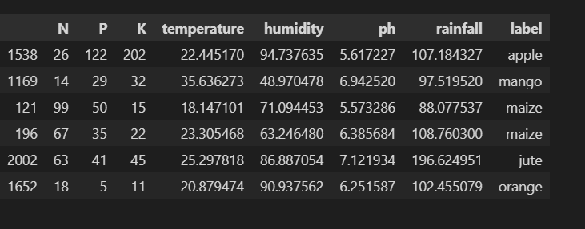

**Step 3: ML Model Training and creating .pkl file**

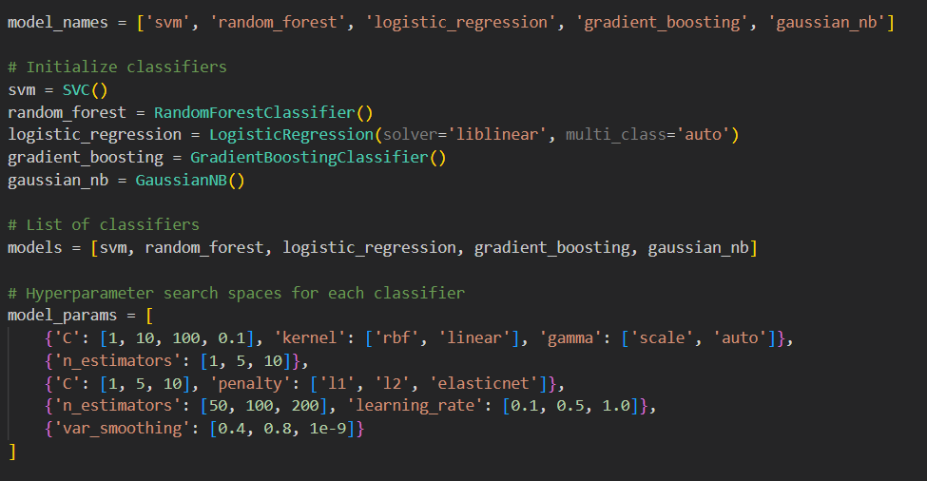

Recommendation system is based on the ensemble model with majority voting technique. The constituent models are:

* + - 1. SVM
      2. Random Forest
      3. Logistic Regression
      4. Gradient Boosting
      5. Gaussian NB

After the model is trained, a .pkl file is created.

**Step 4: Crop Recommendation**

.pkl file is loaded to recommend the crop based on input.

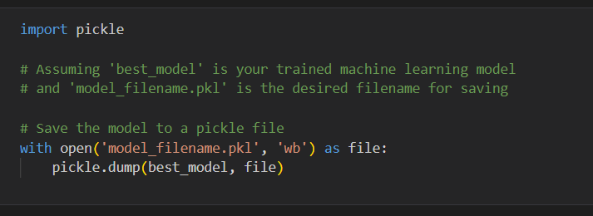

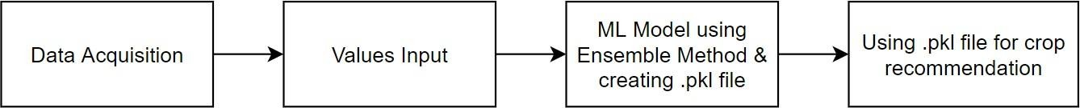

Figure 1: Methodology for Crop Recommendation

* + 1. **Fertilizer Recommendation**

This module can be implemented in four steps as discussed below and shown in Figure 2:

**Step 1: Data Acquisition**

Dataset will be created manually after collecting data from verified sources listed below:

* + - 1. The Fertilizer Association of India
      2. Indian Institute of Water Management
      3. Kaggle

The columns of the dataset are: N, P, K (all of them in %) and crop.

**Step 2: Values Input**

Users are expected to input the site specific parameters like: N, P, K (all of them in %), and crop (select from list - only 22 crops supported).

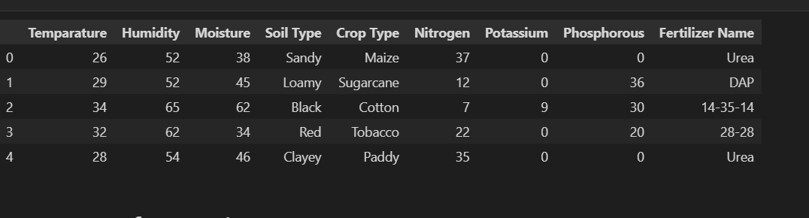

**Step 3: ML Model Training and creating .pkl file**

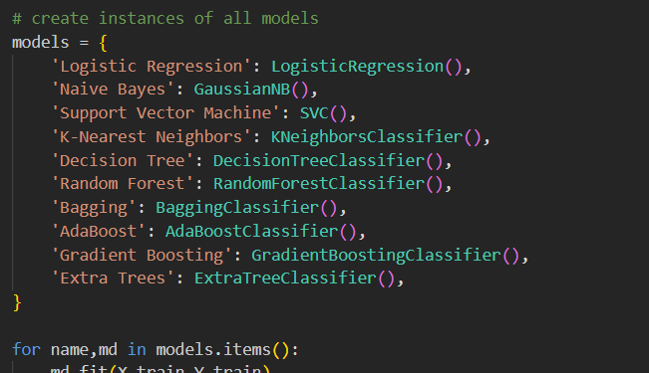

Recommendation system is based on the ensemble model with majority voting technique. The constituent models are:

* + - 1. Logistic Regression
      2. Naïve Bayes
      3. Support Vector Machines
      4. KNN
      5. Decision Tree
      6. Random Forest
      7. Bagging
      8. AdaBoost

After the model is trained, a .pkl file is created.

**Step 4: Fertilizer Recommendation**

pkl file is loaded to recommend the crop based on input.

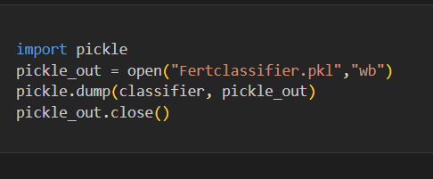

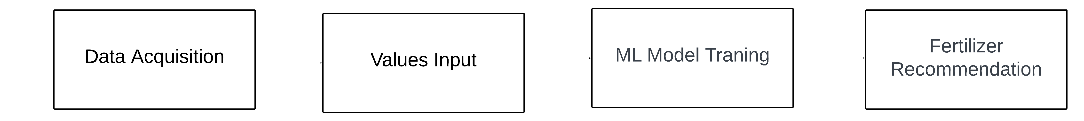

Figure 2: Methodology for Fertilizer Recommendation

* + 1. **Pesticide Recommendation**

This module can be implemented in four steps as discussed below and shown in Figure 3:

**Step 1: Data Acquisition**

Dataset will be created by scraping images from Google via automatic script using Selenium and Chrome Driver. Along with that, pest labels will be provided as well.

**Step 2: Data Cleaning and Data Augmentation**

The data collected from Google needs to be cleaned manually to get rid of non-useful content e.g: In case of scraping images of pest named “beetle” there are also few images of “car called beetle”. Later on, the dataset needs to be augmented so as to increase variability.

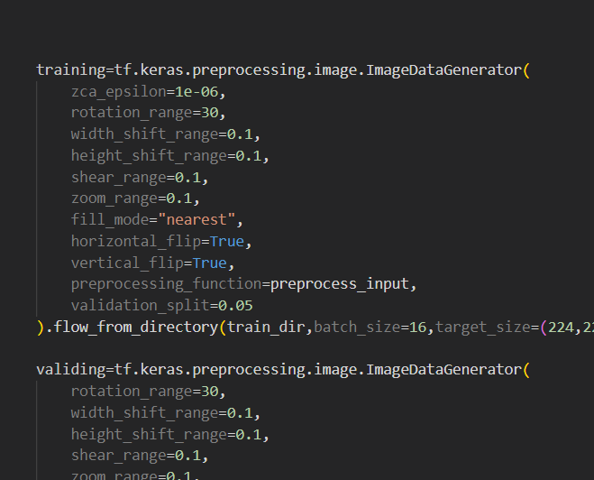

**Step 3: DL Model Creation**

This involves model configuration, training configuration and model evaluation. Later on, .h5 file will be created to store the model.

**Step 4: Pest Identification and corresponding Pesticide Recommendation**

.h5 model will be loaded to identify the pest, later on based on the result, corresponding pesticide will be recommended based on dictionary based solution.

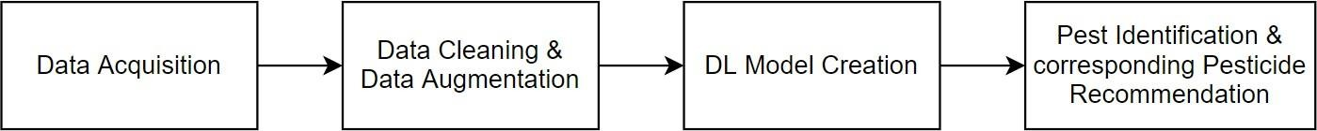

Figure 3: Methodology for Pesticide Recommendation

* 1. **Tools and Technology Used**

Following is the list of tools and technology used while making the “Kishan Mitra”:

1. numpy
   1. working with arrays
2. pandas
   1. working with csv files
3. flask
   1. app routing
   2. web application
4. pickle
   1. saving ML model
5. pymongo
   1. databases for Kishan Mitra users
   2. databases for Kishan Mitra feedback
6. neural networks (keras, tensorflow, CNN)
   1. for classification and training
7. ssl and passlib
   1. for hashing of password for storage
8. PyCharm
   1. python offline coding
9. OS
   1. for manipulating files
10. matplotlib.pyplot
    1. plotting graphs for training and testing accuracy
    2. plotting graphs for training and testing loss
11. h5
    1. storing DL model
12. sklearn
    1. classifier
13. **DESIGN SPECIFICATIONS**

The following section discusses the end product “Kishan Mitra” and particular specifications, how “Kishan Mitra” performs in usual and unusual scenarios. All types of user inputs are handled and following points provide insight on workflow of the system as well. It also defines the actors, pre conditions, post conditions and other tidbits related to Kishan Mitra. The design specifications make the production of the final product really faster and easier.

* 1. **Analysis Diagrams**

Analysis diagrams capture the system behavior and tell how the system will behave in different scenarios. In this report, use case diagram, use case template, activity diagram, workflow diagram and various other diagrams are made so as to design the system before the coding starts.

* + 1. **Use Case Diagram**

Since the system is quite simple and the aim was to make it as user friendly as possible, keeping in view the farmer, so the actor here is only one which is the user, the farmer. Further the use cases, communication link, system boundary and use case relationships are shown in Figure 20 as given below.

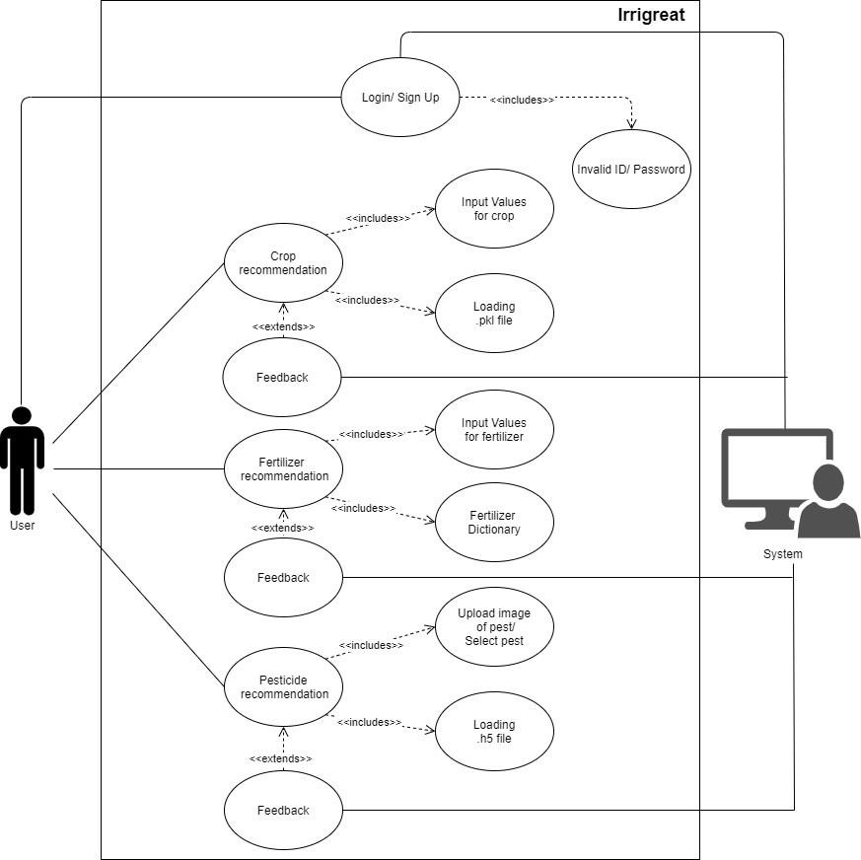

Figure 4: Kishan Mitra Use Case Diagram

* + 1. **Class Diagram**

Following Class Diagram (Figure 22) shows various classes, attributes and functions.

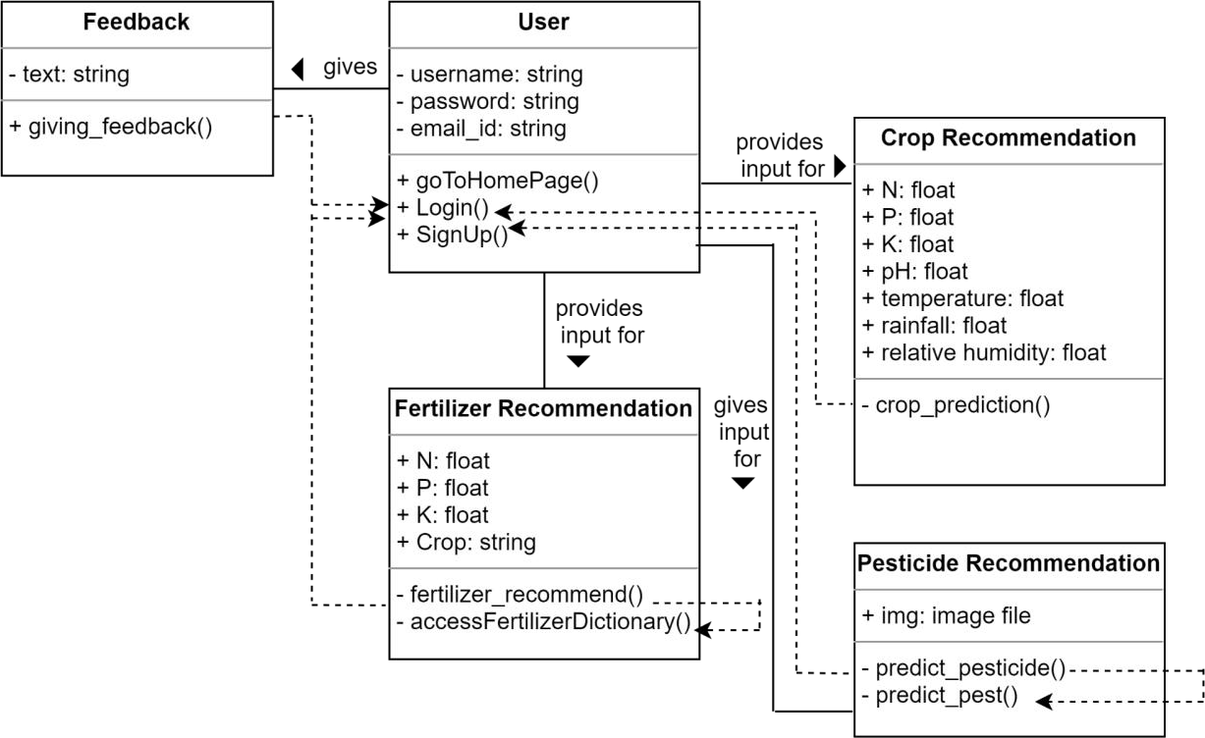

Figure 5: Class Diagram

1. **IMPLEMENTATION AND EXPERIMENTAL RESULTS**

This section deals with discussion of implementation and experimentation with regards to the project. It also mentions all the test plans including the features to be tested, the test cases and discusses the inference drawn from the results. This doesn’t end here, this section will also discuss algorithms used, system screenshots and in the end validate project objectives.

* 1. **Experimental Setup**

Kishan Mitra has majorly 3 modules namely: Crop Recommendation. Fertilizer Recommendation, Pesticide Recommendation. Following will discuss the experimental setup for all the three modules.

For all the services, the user needs to have an account created on the website, post that user can login any no. of times to avail any of the three services. During signup, the user needs to have an email address. Along with that, the user will give any username and password (minimum 8 characters and maximum 20 characters). For one email address, the user can have only one account and the username must be unique, hence not be taken. During signup, the user just needs to enter username and password.

1. Post successful authentication, the user can avail any of the 3 services.
2. For the first module, which is crop recommendation, the user needs to fill in the values for N, P, K (all in ratio), temperature (in °C), relative humidity (in %), rainfall (in mm) and pH. After that, the user will be recommended the most suitable crop as per the land.
3. For the second module which is Fertilizer Recommendation, the user needs to have values for N, P, K and select the crop, based on that natural fertilizers will be recommended as per deficiency or surplus of nutrients.
4. For the third module, the user can choose to select the pest manually if the user knows about the pest and directly pesticide would be recommended, otherwise the user can choose to upload the picture that clearly shows the pest, thereby pest will be identified in the backend and corresponding pesticide would be recommended.
   1. **Experimental Data**

Kishan Mitra is an agriculture- based project, hence data plays a very crucial role here. Along with that, data needs to be from authentic resources.

* + 1. **Data Source for Crop Recommendation**
       1. Dataset has labels: N, P, K (all in ratio), temperature (in °C), relative humidity (in

%), rainfall (in mm) and pH.

* + - 1. Data Source: Kaggle
    1. **Data Source for Fertilizer Recommendation**
       1. Required N, P, K for crops dataset
          1. Dataset labels: N, P, K, crop
          2. Data Source: The Fertilizer Association of India (FAI), Indian Institute of Water Management, Kaggle
       2. Fertilizer Dictionary (Source: Google)
    2. **Data Source for Pesticide Recommendation**
       1. Type of dataset: Image Dataset
       2. No. of training images: 300 images per pest
       3. No. of testing images: 50 images per pest
       4. Data Source: Automatic script to scrape images of pest from Google through Selenium and Chrome Driver
       5. Pesticide Dataset: From biostadt website
    3. **Data Cleaning**
       1. It needs to be done on pest dataset (training images). For instance, in scraping images for beetles (a pest), images also had a beetle car.
    4. **Data Augmentation**
       1. Data Augmentation is to be performed in training images of the pest, so as to increase the variability.
  1. **Algorithms Used**

Kishan Mitra is an agriculture-based project, hence data plays a very crucial role here. Along with that, data needs to be from authentic resources. The algorithms used must result in good accuracy.

Firstly, given below is an algorithm for crop recommendation.

*crop_recommendation_model_path = 'Crop_Recommendation.pkl'*

*crop_recommendation_model = pickle.load(open(crop_recommendation_model_path, 'rb'))*

*@ app.route('/crop_prediction', methods=['POST']) def crop_prediction():*

*if request.method == 'POST':*

*N = float(request.form['nitrogen'])*

*P = float(request.form['phosphorous']) K = float(request.form['potassium']) ph = float(request.form['ph'])*

*rainfall = float(request.form['rainfall']) temperature = float(request.form['temperature']) humidity = float(request.form['humidity'])*

*data = np.array([[N, P, K, temperature, humidity, ph, rainfall]]) my_prediction = crop_recommendation_model.predict(data) final_prediction = my_prediction[0]*

*return render_template('crop-result.html', prediction=final_prediction,*

*pred =*

*'img/crop/'+final_prediction+'.jpg')*

Now, as it can be seen that algorithm is using a .pkl file, so following is the algorithm that creates this .pkl file, basically the algorithm used is Ensemble Techniques through Majority Voting Mechanism. The learners are: SVM, kNN, Naive Bayes, Random Forest.

*from sklearn.model_selection import train_test_split import pandas as pd*

*from sklearn.svm import SVC*

*from sklearn.naive_bayes import GaussianNB*

*from sklearn.ensemble import RandomForestClassifier, VotingClassifier from sklearn.neighbors import KNeighborsClassifier*

*from sklearn.metrics import accuracy_score from sklearn import model_selection*

*crop = pd.read_csv('Data/crop_recommendation.csv') X = crop.iloc[:,:-1].values*

*Y = crop.iloc[:,-1].values*

*X_train, X_test, y_train, y_test = train_test_split(X, Y, test_size = 0.15) models = []*

*models.append(('SVC', SVC(gamma ='auto', probability = True))) models.append(('svm1', SVC(probability=True, kernel='poly', degree=1))) models.append(('svm2', SVC(probability=True, kernel='poly', degree=2))) models.append(('svm3', SVC(probability=True, kernel='poly', degree=3))) models.append(('svm4', SVC(probability=True, kernel='poly', degree=4))) models.append(('svm5', SVC(probability=True, kernel='poly', degree=5))) models.append(('rf',RandomForestClassifier(n_estimators = 21))) models.append(('gnb',GaussianNB()))*

*models.append(('knn1', KNeighborsClassifier(n_neighbors=1))) models.append(('knn3', KNeighborsClassifier(n_neighbors=3))) models.append(('knn5', KNeighborsClassifier(n_neighbors=5))) models.append(('knn7', KNeighborsClassifier(n_neighbors=7))) models.append(('knn9', KNeighborsClassifier(n_neighbors=9)))*

*vot_soft = VotingClassifier(estimators=models, voting='soft') vot_soft.fit(X_train, y_train)*

*y_pred = vot_soft.predict(X_test)*

*scores = model_selection.cross_val_score(vot_soft, X_test, y_test,cv=5,scoring='accuracy') print("Accuracy: ",scores.mean())*

*score = accuracy_score(y_test, y_pred) print("Voting Score % d" % score)*

*import pickle*

*pkl_filename = 'Crop_Recommendation.pkl' Model_pkl = open(pkl_filename, 'wb') pickle.dump(vot_soft, Model_pkl) Model_pkl.close()*

For the Fertilizer Recommendation module, we have used the following models: Logistic Regression, Naive Bayes, Support Vector Machine, K-Nearest Neighbors, Decision Tree, Random Forest, Bagging, AdaBoost, Gradient Boosting, and Extra Trees.

*def recommendation(Temparature,Humidity,Moisture,Nitrogen,Potassium,Phosphorous,Soil_Num,Crop_Num):*

*features = np.array([[Temparature,Humidity,Moisture,Nitrogen,Potassium,Phosphorous,Soil_Num,Crop_Num]])*

*prediction = classifier.predict(features).reshape(1,-1)*

*return prediction[0]*

*Temparature=2*

*Humidity=59*

*Moisture=3*

*Nitrogen=12*

*Potassium=0*

*Phosphorous=3*

*Soil_Num=2*

*Crop_Num=11*

*predict=recommendation(Temparature,Humidity,Moisture,Nitrogen,Potassium,Phosphorous,Soil_Num,Crop_Num)*

*predict[0]*

*import pickle*

*pickle_out = open("Fertclassifier.pkl","wb")*

*pickle.dump(classifier, pickle_out)*

*pickle_out.close()*

The fertilizer dictionary used above is given below. The dictionary shown below is not a complete dictionary but just for Nitrogen to give an insight.

*fertilizer_dict = {*

*'NHigh': """<b style = "color:#c79c60;">The N value of soil is high and might give rise to weeds.</b>*

*<br/><br/> Please consider the following suggestions:*

*<p align="justify">1. <i> Manure </i> – adding manure is one of the simplest ways to amend your soil with nitrogen. Be careful as there are various types of manures with varying degrees of nitrogen.</p>*

*<p align="justify">2. <i>Coffee grinds </i> – use your morning addiction to feed your gardening habit! Coffee grinds are considered a green compost material which is rich in nitrogen. Once the grounds break down, your soil will be fed with delicious, delicious nitrogen. An added benefit to including coffee grounds to your soil is while it will compost, it will also help provide increased drainage to your soil.</p>*

*<p align="justify">3. <i>Plant nitrogen fixing plants</i> – planting vegetables that are in Fabaceae family like peas, beans and soybeans have the ability to increase nitrogen in your soil.</p>*

*<p align="justify">4. Plant ‘green manure’ crops like cabbage, corn and brocolli.</p>*

*<p align="justify">5. <i>Use mulch (wet grass) while growing crops</i> - Mulch can also include sawdust and scrap soft woods. </p><hr style = "height:2px; background- color:#c79c60;">""",*

*'Nlow': """<b style = "color:#c79c60;">The N value of your soil is low.</b>*

*<br/><br/> Please consider the following suggestions:*

*<p align="justify"> 1. <i>Add sawdust or fine woodchips to your soil</i> – the carbon in the sawdust/woodchips love nitrogen and will help absorb and soak up and excess nitrogen.</p>*

*<p align="justify">2. <i>Plant heavy nitrogen feeding plants</i> – tomatoes, corn, broccoli, cabbage and spinach are examples of plants that thrive off nitrogen and will suck the nitrogen dry.</p>*

*<p align="justify">3. <i>Water</i> – soaking your soil with water will help leach the nitrogen deeper into your soil, effectively leaving less for your plants to use.</p>*

*<p align="justify">4. <i>Sugar</i> – In limited studies, it was shown that adding sugar to your soil can help potentially reduce the amount of nitrogen is your soil. Sugar is partially composed of carbon, an element which attracts and soaks up the nitrogen in the soil. This is similar concept to adding sawdust/woodchips which are high in carbon content.</p>*

*<p align="justify">5. Add composted manure to the soil.</p>*

*<p align="justify">6. Plant Nitrogen fixing plants like peas or beans.</p>*

*<p align="justify">7. <i>Use NPK fertilizers with high N value.</i></p>*

*<p align="justify">8. <i>Do nothing</i> – It may seem counter-intuitive, but if you already have plants that are producing lots of foliage, it may be best to let them continue to absorb all the nitrogen to amend the soil for your next crops.</p><hr style = "height:2px; background-color:#c79c60;">""",*

*'NNo': """<b style = "color:#c79c60;">The N value of your soil is up to the mark.</b><hr style = "height:2px; background-color:#c79c60;">"""*

*}*

Next, the third module is for pesticide recommendation. There are two options for that. One is to manually select the pest and following pesticides will be recommended. So, as such there is no algorithm for that. It’s a dictionary-based solution. For the second option which is uploading the image of the pest, there needs to be an algorithm that identifies the pest and recommends the corresponding pesticide. The algorithm is as follows:

*train_dir='/content/pest/train/'*

*test_dir='/content/pest/train/'*

*training=tf.keras.preprocessing.image.ImageDataGenerator(*

*zca_epsilon=1e-06,*

*rotation_range=30,*

*width_shift_range=0.1,*

*height_shift_range=0.1,*

*shear_range=0.1,*

*zoom_range=0.1,*

*fill_mode="nearest",*

*horizontal_flip=True,*

*vertical_flip=True,*

*preprocessing_function=preprocess_input,*

*validation_split=0.05*

*).flow_from_directory(train_dir,batch_size=16,target_size=(224,224),subset="training")*

*validing=tf.keras.preprocessing.image.ImageDataGenerator(*

*rotation_range=30,*

*width_shift_range=0.1,*

*height_shift_range=0.1,*

*shear_range=0.1,*

*zoom_range=0.1,*

*fill_mode="nearest",*

*horizontal_flip=True,*

*vertical_flip=True,*

*preprocessing_function=preprocess_input,*

*validation_split=0.05*

*).flow_from_directory(train_dir,batch_size=16,target_size=(224,224),subset='validation',shuffle=True)*

*testing=tf.keras.preprocessing.image.ImageDataGenerator(*

*preprocessing_function=preprocess_input,*

*).flow_from_directory(test_dir,batch_size=16,target_size=(224,224),shuffle=True)*

The algorithm for model training that is used in the above algorithm is given below.

*mobilenet=MobileNet(include_top=False,weights='imagenet',input_shape=(224,224,3))*

*optimizer=Adam(lr=0.01,beta_1=0.9,beta_2=0.99)*

*EarlyStop=EarlyStopping(patience=10,restore_best_weights=True)*

*Reduce_LR=ReduceLROnPlateau(monitor='val_acc',verbose=2,factor=0.5,min_lr=0.001)*

*callback=[EarlyStop , Reduce_LR]*

*model=Sequential([*

*mobilenet,*

*MaxPooling2D(3,2),*

*Flatten(),*

*Dense(128,activation='relu'),*

*BatchNormalization(),*

*Dense(1024,activation='relu'),*

*BatchNormalization(),*

*Dense(512,activation='relu'),*

*BatchNormalization(),*

*Dense(9,activation='softmax')*

*])*

*model.compile(optimizer=optimizer,loss='categorical_crossentropy', metrics=["accuracy"])*

*history=model.fit(training,validation_data=validing,epochs=50,batch_size=16,*

*steps_per_epoch=len(training) // 16,validation_steps=len(validing) // 8,*

*callbacks=callback, verbose=2)*

*acc = history.history['accuracy']*

*val_acc = history.history['val_accuracy']*

*loss = history.history['loss']*

*val_loss = history.history['val_loss']*

*img_path = '/content/pest/test/beetle/jpg_1.jpg' # Replace with an actual image path*

*img = tf.keras.preprocessing.image.load_img(img_path, target_size=(224, 224))*

*img_array = tf.keras.preprocessing.image.img_to_array(img)*

*img_array = preprocess_input(img_array)  # Preprocess the image*

*img_array = np.expand_dims(img_array, axis=0)  # Add batch dimension*

*# Make a prediction*

*predictions = model.predict(img_array)*

*# Get the class with the highest probability*

*predicted_class = np.argmax(predictions[0])*

That was all about modules, for login and signup, MongoDB Atlas was used, here algorithm is used only to store password in hashed format (SHA256), so as to keep it safe, even the password matching during login is not done by unhashing stored password and comparing it with input password, rather input password is hashed and then matched with stored password.

*model.save('pest_model.h5')*

*from keras.models import load_model*

*model = load_model('pest_model.h5')*

*# Load and display the image*

*img = tf.keras.preprocessing.image.load_img(img_path, target_size=(224, 224))*

*plt.imshow(img)*

*plt.show()*

* + 1. **System Screenshots**

Just like Indian farmers put in their heart and soul to grow crops, similarly we also made an attempt to put our efforts to help them. The screenshots for the system are given as under. First, when the user opens the website then the landing page appears (Figure 26), from here the user has 3 functionalities: Home, Login, SignUp.

From “Home” the user can know what “Kishan Mitra” is about, it’s services and the team. If the user thinks that Kishan Mitra would be suitable for him/her and he/she wants to avail the service then the user can SignUp and create an account (as shown in Figure 27), three simple details are asked for: Email Address, Username and Password. Email Address must be unique which means that with one email address, the user can have only one account. The username must be unique and not be taken. The password has a minimum length of 8 characters and maximum length of 20 characters. If the user exceeds length or sets a password of length less than 8 characters then user is shown about the constrain

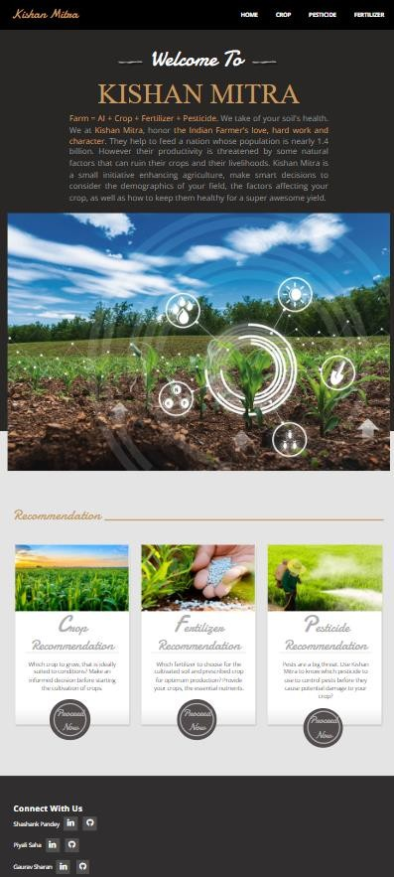

Figure 6: Landing Page



Figure 7: SignUp Page

After SignUp, the user can log into the system by filling username and password as shown in Figure 28 below.

Figure 8: Login Page

Post successful login, the user gets to see a different view of the landing page and now the user can avail all the facilities of Kishan Mitra as shown in Figure 29.

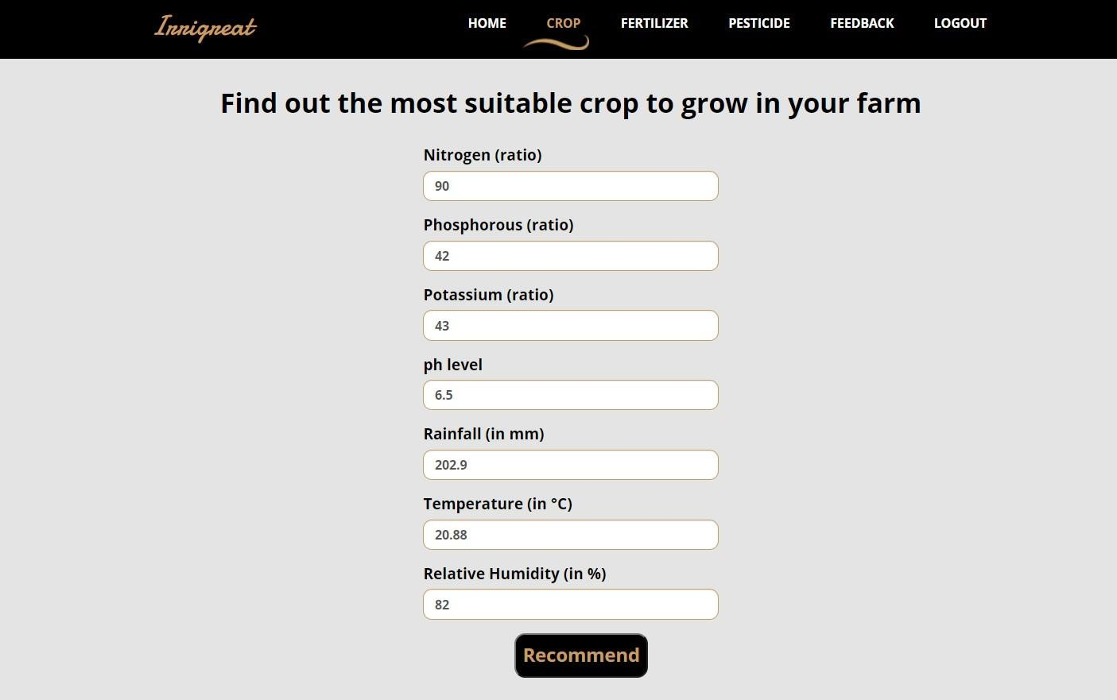Say that the user wants to avail the Crop Recommendation service then he/she can fill the values of N, P, K, pH, rainfall, temperature and relative humidity in the units specified to know about the crop that they must grow in their farm. See Figure 30 for more details.

Figure 9: Crop Recommendation Module (Input the values)

Now, after the user pressed the “Recommend” button then the result will be shown on the screen (Figure 31), here in this case, it recommends “rice”. Hence this is most suitable to the soil as per current weather conditions and soil conditions.

Figure 10: Crop Recommendation Module (Result)

Similarly, the user can avail the “Fertilizer Recommendation” Service by filling the values for N, P, K and crop (Figure 32). Post that the user will know about the status of the soil and will tell the difference between the desired value of nutrients and the user's farm’s nutrients and then “Kishan Mitra” will give informed advice on organic fertilizers to use as per the current condition of soil. See Figure 33 for reference.

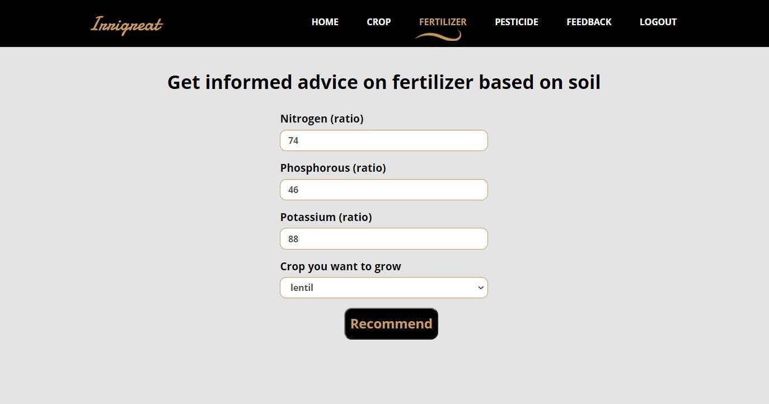Figure 11: Fertilizer Recommendation Module (Input the values)

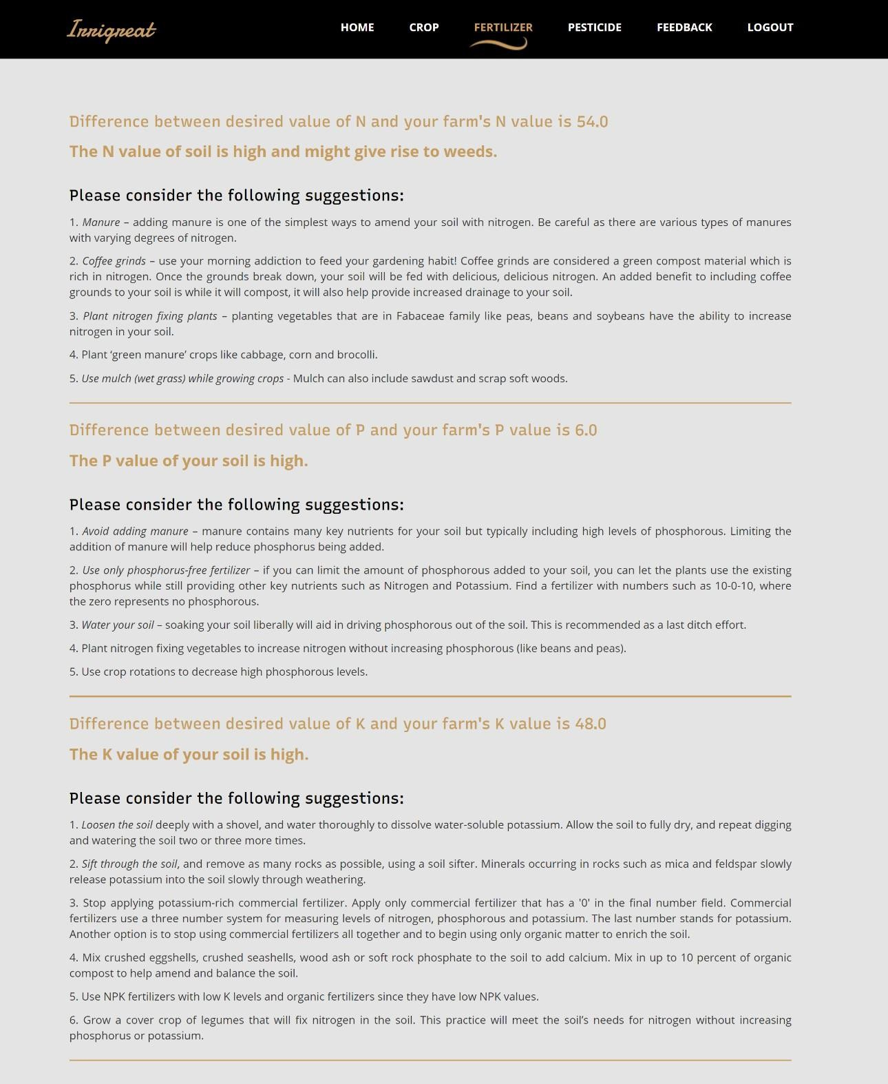

Figure 12: Fertilizer Recommendation Module (Result)

Figure 34 shows the third module “Pesticide Recommendation” where the user can either upload an image of the pest or select the pest. If the user is informed of the pest that resides in his/her farm, then he/she can simply select the pest (Figure 37) and get the result for recommended pesticides (Figure 38), but if the user is unaware of the pests, then he/she can upload the picture that clearly shows the pest (Figure 35) and then “Kishan Mitra” would identify the pest and recommended the pesticides accordingly (Figure 36). The user must take care that the picture must not be blur, since it may lead to wrong identification of the pest.

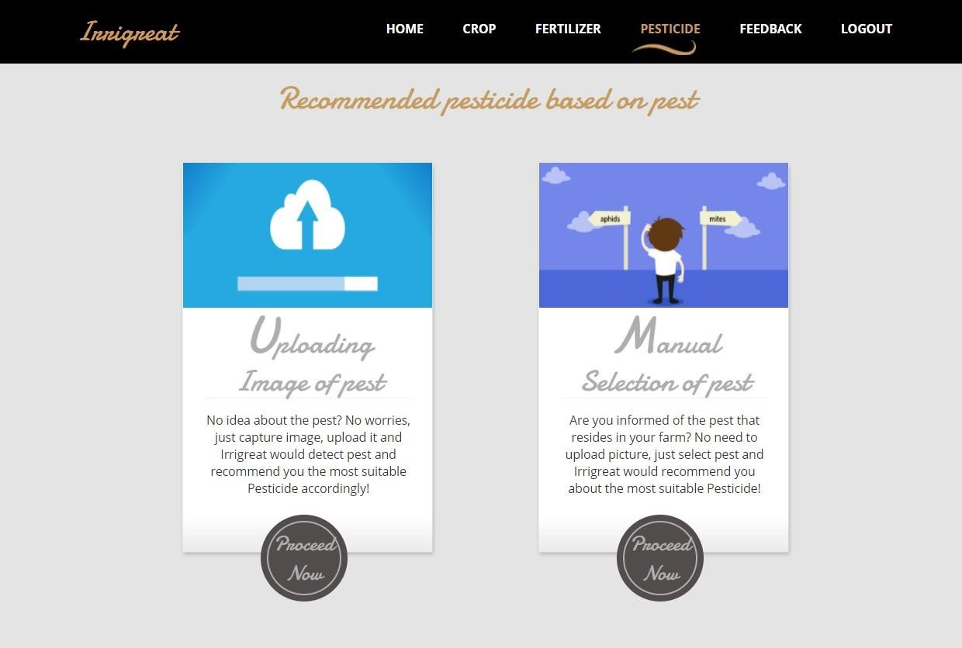

Figure 13: Pesticide Recommendation Module

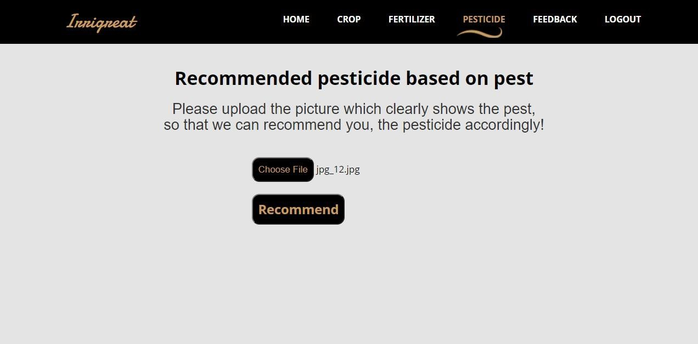

Figure 14: Pesticide Recommendation Module (Uploading Image)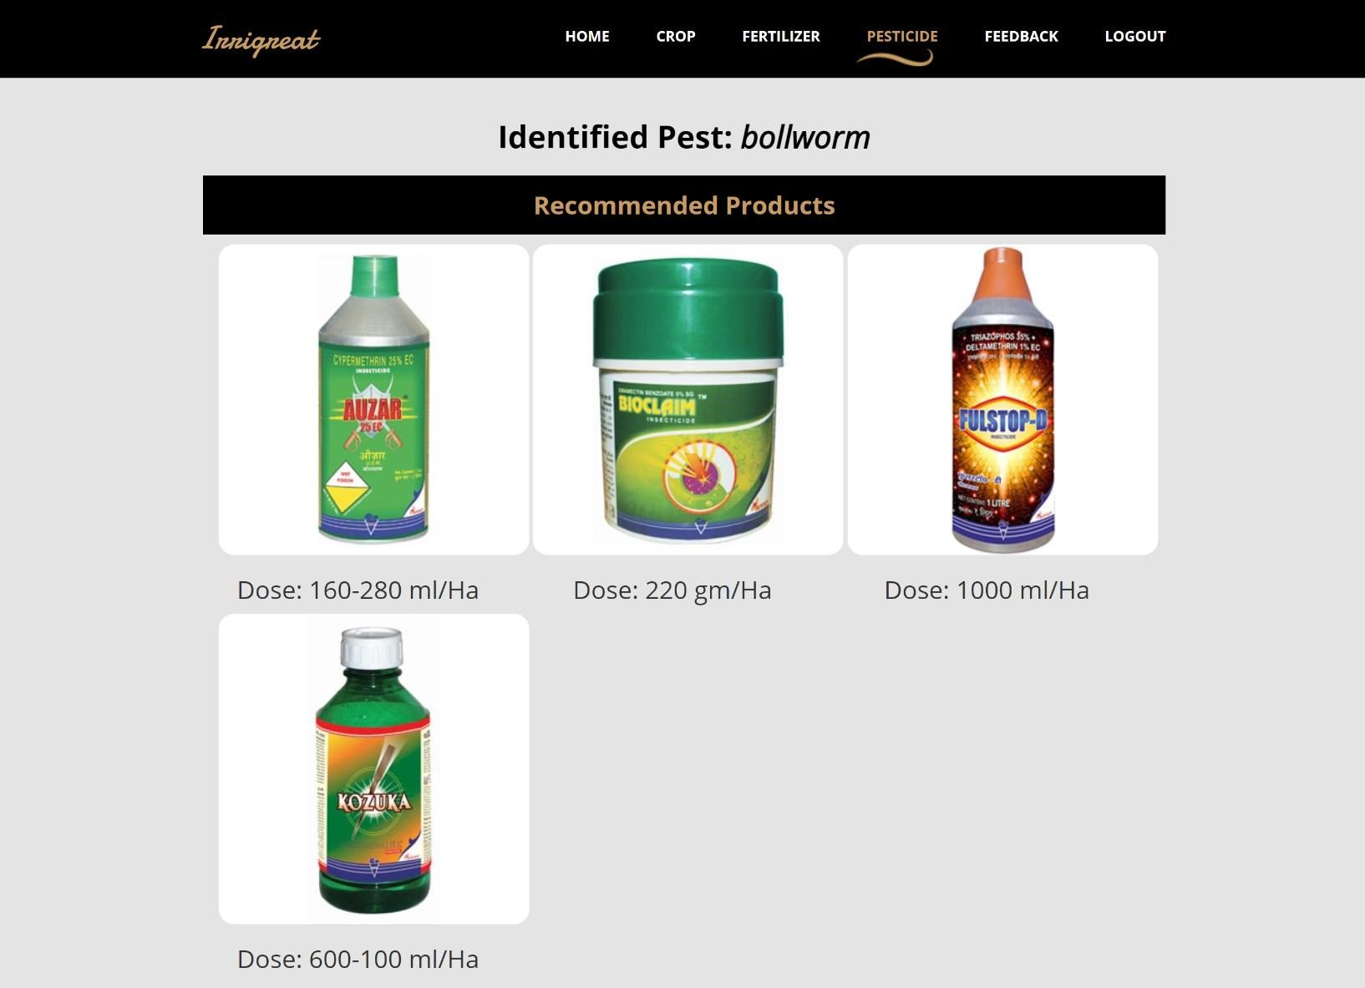

Figure 15: Pesticide Recommendation Module (Result after uploading image)

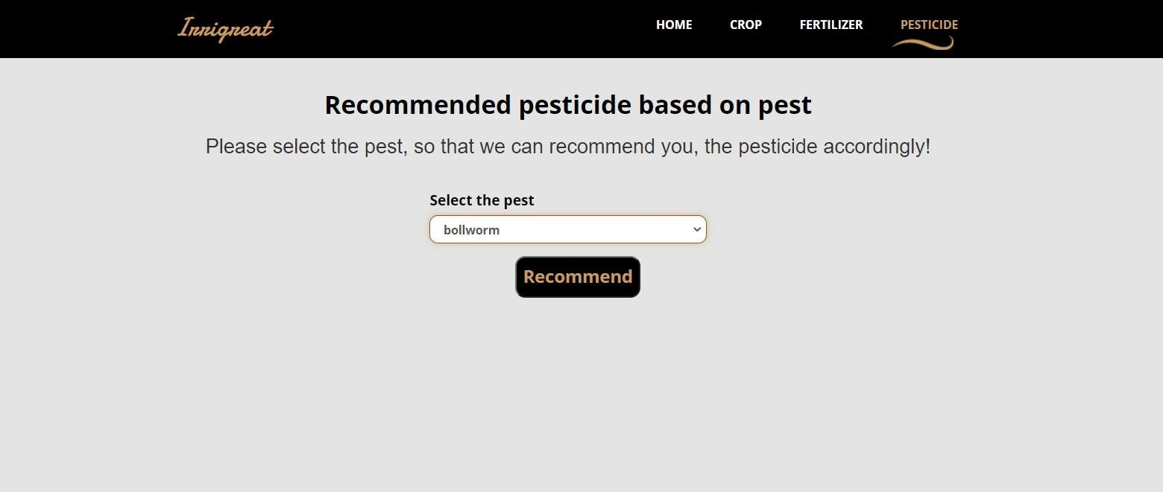

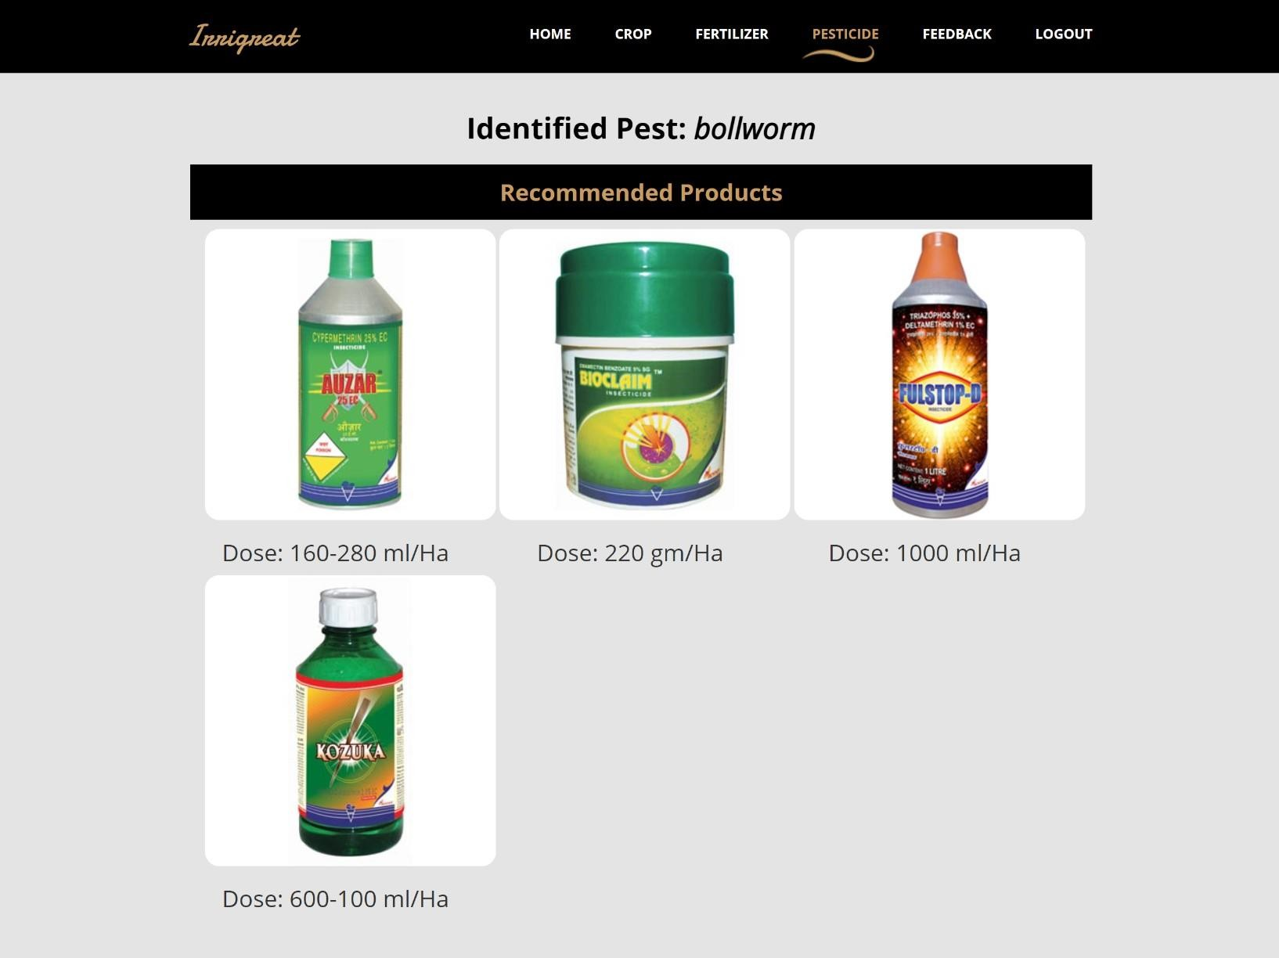Figure 16: Pesticide Recommendation Module (Manual Selection)

Figure 17: Pesticide Recommendation Module (Results after Manual Selection

* + 1. **Results and Discussion**

For crop recommendation, the Random Forest and Naive Bayes models proved to be the most effective, achieving near-perfect cross-validation scores and perfect accuracy. Logistic Regression, Decision Tree, and Random Forest also performed exceptionally well, indicating their robustness in handling crop prediction tasks. In the fertilizer prediction project, Logistic Regression, Naive Bayes, Decision Tree, and Random Forest models achieved perfect accuracy, making them highly reliable for this application. Additionally, the Bagging model performed well with an accuracy of 0.95. However, SVM and AdaBoost were less effective for both crop and fertilizer prediction tasks, suggesting they might not be the best choices for these applications. For pest detection, the MobileNet model demonstrated moderate promise with a training accuracy of 0.7707, which indicates that while it is a suitable model for image classification tasks like pest detection, there is room for improvement. Further optimization, such as hyperparameter tuning and increasing the dataset size, could enhance its performance. Overall, Random Forest and Naive Bayes are highly reliable for crop and fertilizer predictions, while MobileNet shows potential for pest detection, albeit with some needed enhancements.

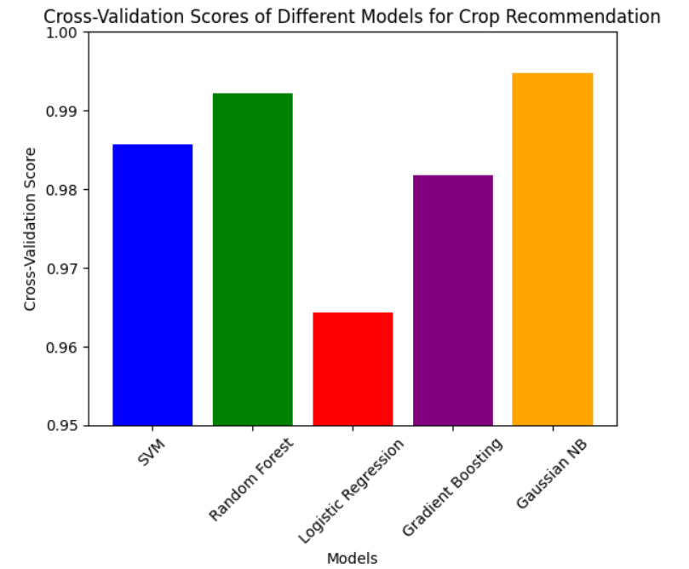

Fig 18: Cross Validation Scores of Different Models for Crop recommendation

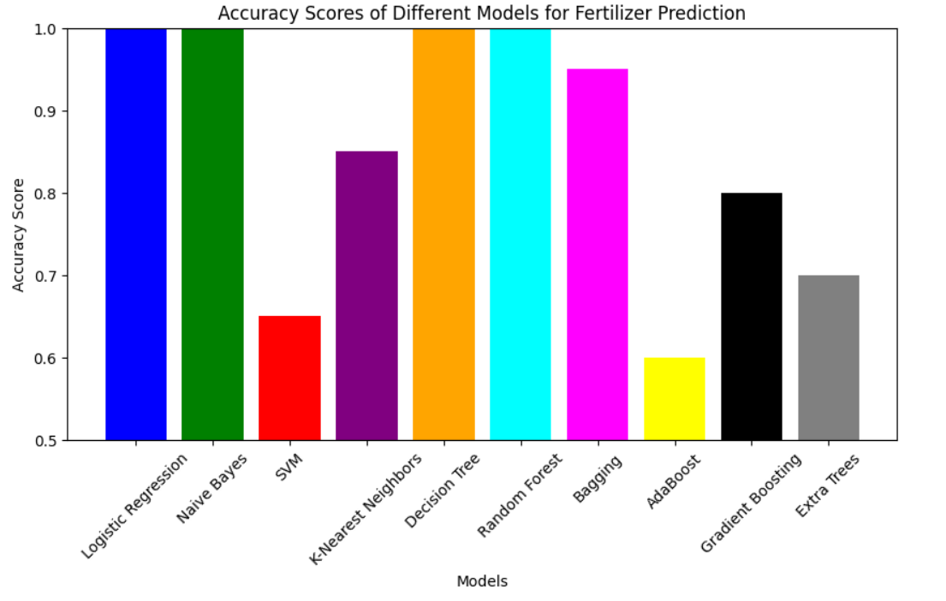

Fig 19 : Accuracy scores of different Models for fertilizer prediction

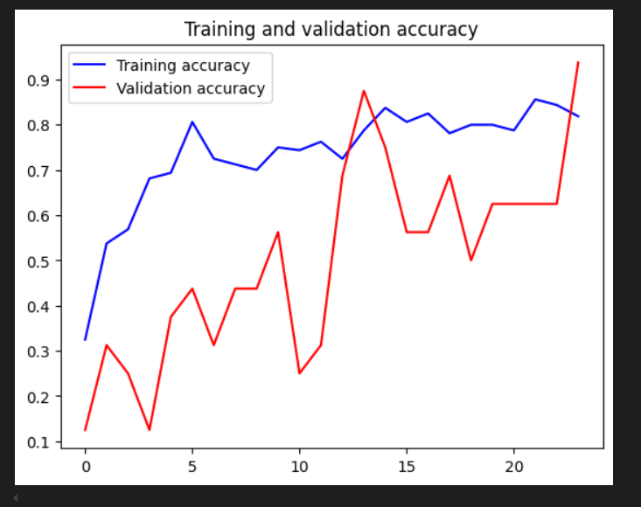

Figure 20: Model Accuracy vs Epochs

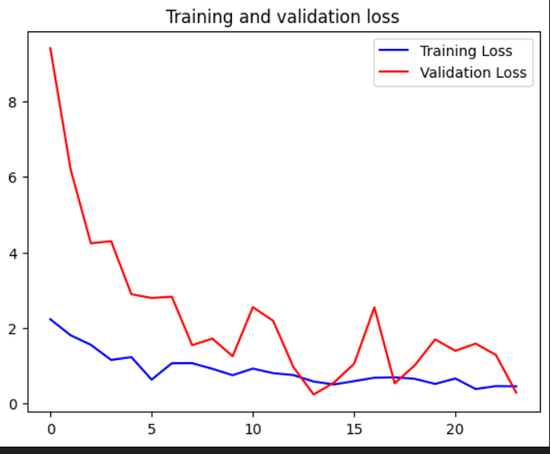

Figure 21: Model Loss vs Epochs

For pest identification, DL model is able to perform quite well but for some cases, DL model identifies “armyworm” as aphids due to close resemblance. Also, the system is not able to perform well with blur images, hence the user must upload the pictures that clearly show the pest.

1. **CONCLUSION AND FUTURE SCOPE**

In this section conclusion and future scope with regards to this project is discussed.

* 1. **Conclusion**

India’s farmers are hard at work. They help to feed a nation whose population is nearly 1.4 billion. However, their productivity is threatened by some natural factors that can ruin their crops and their livelihoods. Challenges such as unpredictable weather patterns, pest infestations, soil degradation, and water scarcity significantly hinder agricultural productivity and the well-being of farmers. In response to these challenges, Kishan Mitra emerges as a comprehensive solution designed to maximize agricultural productivity, reduce soil degradation, and provide informed advice on fertilizers and crop selection.

Kishan Mitra leverages advanced AI technologies to provide tailored recommendations for crop selection, fertilizer application, and pest management based on a detailed analysis of site-specific parameters such as soil quality, weather conditions, crop history, and regional agricultural trends. By considering these various attributes, the platform offers personalized guidance that helps farmers make informed decisions, optimizing their yields and enhancing the sustainability of their farming practices.

The Crop Recommendation feature of Kishan Mitra is particularly beneficial, as it helps farmers choose the most suitable crops for their fields by analyzing factors like soil quality, climate conditions, and market demand. This ensures that farmers can select crops that are best suited to their specific conditions, leading to better yields and economic returns. Additionally, the platform promotes crop rotation practices, which help maintain soil fertility and prevent the buildup of pests and diseases.Fertilizer management is another critical aspect addressed by Kishan Mitra. The platform provides precise information on the type and quantity of fertilizers required for crops, helping to maximize yields while preventing the overuse of chemical fertilizers. This not only enhances crop productivity but also protects the environment by reducing nutrient runoff and soil degradation. The system's recommendations are based on soil tests and crop requirements, ensuring that nutrients are supplied in the right amounts at the right times.Pest control is a major concern for farmers, and Kishan Mitra offers solutions for effective pest management. By identifying specific pests affecting crops and recommending appropriate pesticides, the platform helps farmers implement integrated pest management practices. This approach minimizes the reliance on chemical treatments, protecting both the crops and the environment. The system's pest identification and pesticide recommendation features are particularly practical, extending beyond mere pest detection to provide actionable solutions.Kishan Mitra also emphasizes the importance of soil health. The platform provides insights into soil management practices that enhance soil structure, increase organic matter content, and improve water retention. Techniques such as cover cropping, mulching, and reduced tillage are promoted to protect and nurture the soil. These practices not only improve soil fertility but also enhance the resilience of farms to climate change, ensuring long-term sustainability.

Furthermore, Kishan Mitra includes a rich repository of educational resources and training programs for farmers. These resources cover a wide range of topics, including modern farming techniques, organic farming, water management, and post-harvest handling. By empowering farmers with knowledge and skills, the platform aims to build their capacity to adapt to changing agricultural landscapes and make informed decisions that benefit their farms and communities.

The platform also fosters community building and knowledge sharing among farmers. It includes forums and discussion boards where farmers can share experiences, ask questions, and seek advice from experts and peers. This collaborative approach enhances the collective knowledge base and fosters a sense of solidarity and mutual support among farmers.

In conclusion, Kishan Mitra is a comprehensive solution that addresses the multifaceted challenges faced by Indian farmers. By integrating advanced AI technologies with traditional farming practices, the platform provides personalized recommendations that help farmers optimize their yields, maintain soil health, and manage pests effectively. Through its educational resources and community-building initiatives, Kishan Mitra empowers farmers with the knowledge and skills they need to thrive in a challenging agricultural environment. This initiative not only benefits farmers by enhancing their productivity and profitability but also contributes to the overall sustainability and resilience of the agricultural ecosystem

* 1. **Future Scope**

“Kishan Mitra” is not limited to current usage, it can be extended to many features as discussed below”:

* + 1. Kishan Mitra currently supports 22 crops that are apple, banana, blackgram, chickpea, coconut, coffee, cotton, grapes, jute, kidney beans, lentil, maize, mango, mothbeans, mungbean, muskmelon, orange, papaya, pigeon peas, pomegranate, rice, watermelon. Later on, the admin can add other crops. Moreover in the future, fertilizers can also be added accordingly. The training was done on 10 pests: aphids, armyworm, beetle, bollworm, earthworm, grasshopper, mites, mosquito, sawfly and stem borer and with this pesticides are suggested. In future, training can be done on more pests and more pesticides can also be added according to the pests.
    2. In Crop Recommendation, values are manually entered by user of temperature, humidity, rainfall. Admin can also use some weather API to fetch the real time parameters by the city and state.
    3. In Pesticide Recommendation, the uploaded image should be clear for correct results, otherwise with a blur image, the system sometimes gives wrong results so, further filters can be used to obtain better results. Also the system can use better DL models.
    4. In future pesticide code can be integrated with drone code so that it can take live pictures of pests and by email or by mobile the farmers would be notified about the pest along with the pesticides.

**7. REFERENCES**

[1] Chengjun Xie, et al. Automatic classification for field crop insects via multiple-task sparse representation and multiple-kernel learning. In: Proceedings of the IEEE Conference on Computer Vision and Pattern Recognition (CVPR), 2020, pp. 425-432.

[2] Chenglu Wen, et al. Pose estimation-dependent identification method for field moth images using deep learning architecture. J. Agric. Eng. (2021) 333-349.

[3] Bharathwaaj Sundararaman, et al. Transformative Role of Artificial Intelligence in Advancing Sustainable Tomato (Solanum lycopersicum) Disease Management for Global Food Security: A Comprehensive Review. Int. J. Agric. Biol. (2022).

[4] Yurui Sun, et al. A smart-vision algorithm for counting whiteflies and thrips on sticky traps using two-dimensional Fourier transform spectrum. Comput. Electron. Agric. 184 (2021).

[5] T Evangelos Skotadis, et al. A sensing approach for automated and real-time pesticide detection in the scope of smart-farming. Sensors 22 (5) (2023) 4231.

[6] Rabaie Benameur, et al. An Innovative Smart and Sustainable Low-Cost Irrigation System for Anomaly Detection Using Deep Learning. IEEE Trans. Ind. Electron. (2023).

[7] Mustafa Saritepeci, et al. Effectiveness of artificial intelligence integration in design‐based learning on design thinking mindset, creative and reflective thinking skills: An experimental study. J. Educ. Technol. Soc. 25 (1) (2022) 1-16.

[8] Mahmoud Y. Shams, et al. Enhancing crop recommendation systems with explainable artificial intelligence: a study on agricultural decision-making. J. Agri. Sci. (2021) 5442865.

[9] Shruti Mishra, et al. Use of Data Mining in Crop Yield Prediction. Comput. Electron. Agric. 184 (2021).

[10] Vasiliki Balaska, et al. Sustainable Crop Protection via Robotics and Artificial Intelligence Solutions. Front. Robot. AI. 8 (2021) 6148-6150.

[11] Palaniraj A, et al. Crop and Fertilizer Recommendation System using Machine Learning. In: Proceedings of the IEEE International Conference on Machine Learning and Applications (ICMLA), 2022, pp. 3801-3811.

[12] Weiguang Ding, Graham Taylor. Automatic moth detection from trap images for pest management. Pest Manag. Sci. (2021).

[13] Muhammad E. H. Chowdhury, et al. Automatic and Reliable Leaf Disease Detection Using Deep Learning Techniques. Comput. Electron. Agric. 184 (2021).

[14] Satish Babu. A Software Model for Precision Agriculture for Small and Marginal Farmers. Int. J. Adv. Manuf. Technol. (2023).

[15] Kevin Mallinger, Ricardo Baeza-Yates. Responsible AI in Farming: A Multi-Criteria Framework for Sustainable Technology Design. Comput. Ind. (2022).

[16] J. Dhakshayani, B. Surendiran. M2F-Net: A Deep Learning-Based Multimodal Classification with High-Throughput Phenotyping for Identification of Overabundance of Fertilizers. Plant Methods. 14 (2021).

[17] Wanjie Feng, et al. AI breeder: Genomic predictions for crop breeding. Trends Plant Sci. (2022).

[18] Suhaili Othman, et al. Artificial intelligence-based techniques for adulteration and defect detections in food and agricultural industry: A review. Crit. Rev. Food Sci. Nutr. (2021).

[19] Hsin-Yuan Chen, et al. Integrating explainable artificial intelligence and blockchain to smart agriculture: Research prospects for decision making and improved security. IEEE Trans. Ind. Inform. (2022).

[20] Development of a novel crop health monitoring system using Unmanned Aerial Vehicle (UAV) and Artificial Intelligence for sustainable agriculture. Int. J. Remote Sens. (2022).

[21] Applications of artificial intelligence in agriculture to boost productivity: A review. Agric. Syst. (2021).