**@HIgherOrderMutation1**

**Difference:**

**Output: HigherOrderMutaion1**

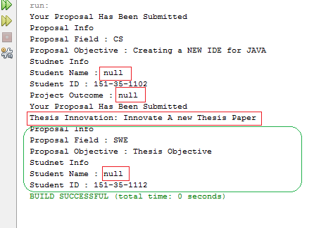

Figure 1 Output of HigherOrderMutation1

**Original Source Code Output:**

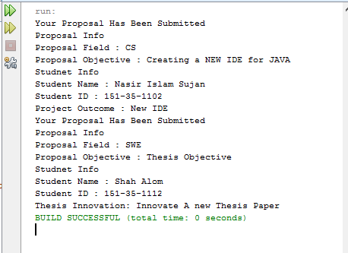

Figure 2 Output of Original Source Code