**@MutationTesting2**

According to my opinion,

This **@MutationTesting2** code shows approximately 95% **equivalent** to the Original Source Code.

**Difference between Original and MutationTesting2 codes output are showing below:**

Output of **MutationTesting2** Source Code:

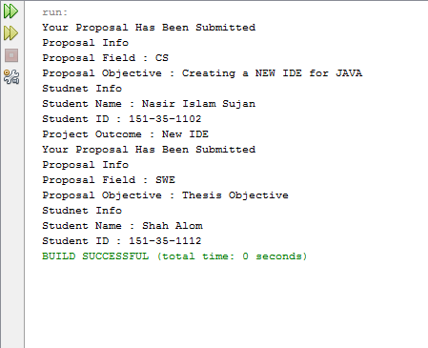

Figure 1 Output of Mutation Testing2

**Output of Original Source Code:**

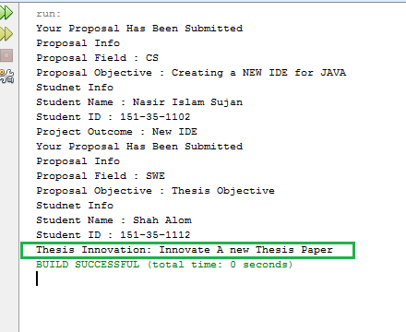

Figure 2 Output of Original Source Code