# Deep Sea Habitat

## System Architecture Block Diagram (Original)

This is the original system architecture block diagram for the deep sea habitat project. The diagram shows all major subsystems, their relationships, and data/power flows.

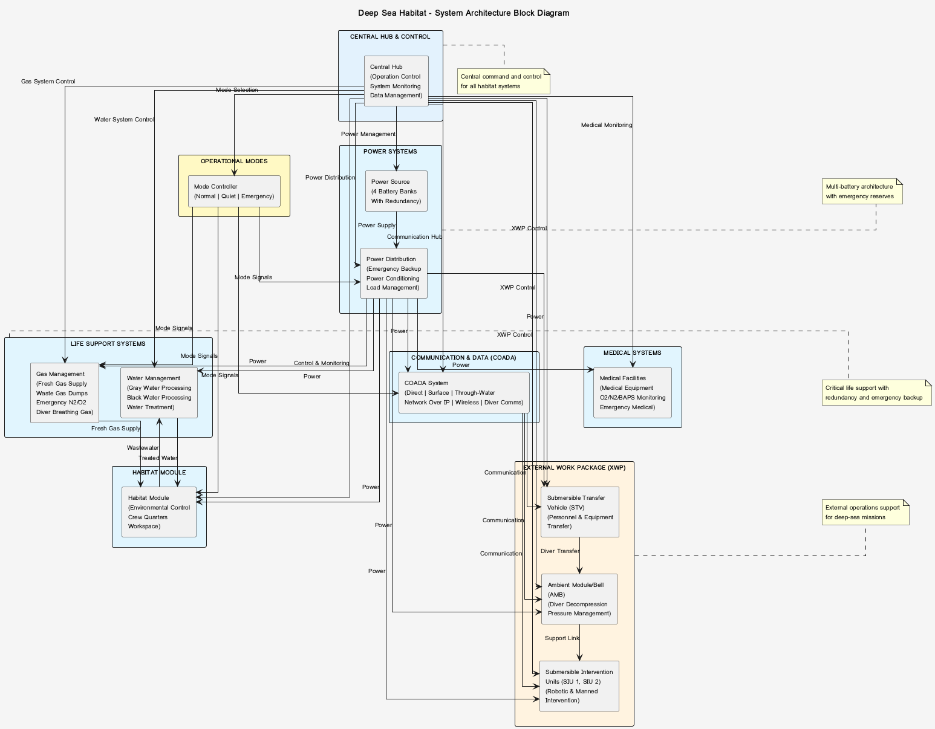

### System Components

* Central Hub & Control - Operation control, system monitoring, data management
* Life Support Systems - Gas management, water management, environmental control
* Power Systems - 4-battery architecture with redundancy and emergency backup
* Medical Systems - Medical facilities, health monitoring, emergency response
* Communication & Data (COADA) - Multi-channel communication system
* External Work Package (XWP) - STV, AMB, SIU for external operations