Criterion E: Product development

Product directory structure highlights:
extension/
src/
common.js – miscellaneous utility functions
content.js – content script (runs on the EHR page itself)
ezyvet.js – Utilities for extracting information from the ezyvet site
input.js – Object-oriented forms
menu.js – Controls the drop-down menu
units.js – Unit conversion
html/menu.html – Drop-down menu
ezymock/
ezymock.py – Mock server
static/ – Static files for the mock server
templates/ – Jinja2 templates for dynamic portions of the mock server
har/
harcapture.py – Script for capturing HAR files
hardiff.py – Assorted utilities that I accumulated for analyzing HAR files

This file structure clearly separates the project into 3 components. JavaScript files are separated into individual modules of related code.

Examples of techniques from Criterion D
Technique: Arrays and Iterators
A few examples of array usage:
* An array of pdf urls is collected in content.js and sent as a response to brower.tabs.sendMessage calls from menu.js.
* menu.js stores an array of tools which are exchanged as the displayed element when drop-down menu items are moused over
In several places where arrays would typically be used, I opted to use iterators instead. In common.js, I define an imap generator function which acts like the Array.map builtin in JavaScript, returning a generator iterator. imap is nice when dealing with non-array iterables like Map objects (hash tables). I could have converted the Map object into an array as an intermediary step to mapping, but this seemed inelegant. By using ES6 generator functions, I can concisely abstract the concept of mapping on arbitrary iterable streams.
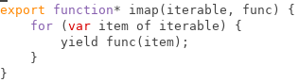

Babel.js then uses the regenerator library to convert the generator function into a function compatible with older versions of JavaScript.
Technique: String Handling
In ezyvet.js, I use some regular expressions to extract information from EzyVet. For example, I use /^Weight\s*\(([^\)]*)\)$/ to get the weight units. This regular expression matches “Weight” followed by any number of space characters, a parenthesis, an arbitrary number of non-close-parenthesis characters, and finally, a close paren. The inner non-escaped parentheses create a match group which selects everything within the surrounding parens, which I use to decide which units the associated value is in.
I believe that EzyVet always uses pounds, but if this is not correct, my client could end up using an incorrect weight value in the automatic calculations and giving an improper dosage to an animal. I made this regular expression very specific to how EzyVet presents records so that if something changes, the weight value becomes null rather than improperly doing something else.
Technique: Object-oriented design
In input.js, I abstracted the concept of “Inputs” – which are essentially form components – using classes. Inputs are abstractly said to have a name and value, as well as the ability to be listened to in the event of changes to their value and a method for adding them to the DOM.
The base Input class is extended by subclasses to create various input types, and are combined together into even more abstract Input types, like a Form which combines many Inputs and uses their values as parameters to a function to compute a value.
Below is an example of an Input type (MeasurementInput) which combines the functionality of two different inputs (NumberInput and SelectInput). The value of the class is computed dynamically with a descriptor property. This shows the flexibility of the Input class hierarchy and its usefulness in easily creating abstract input types which greatly reduce the complexity of building forms. With a MeasurementInput, the caller need not worry about the value of either of its components or any of the DOM structure that makes it up.
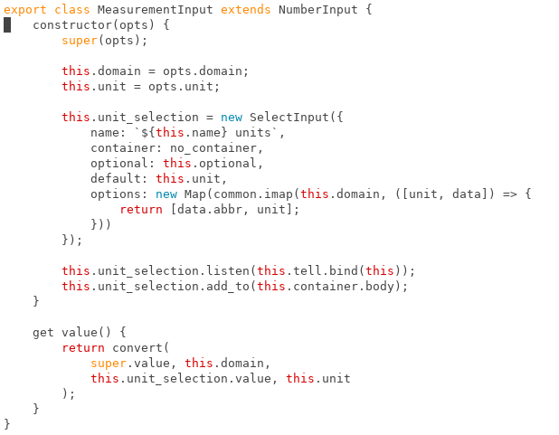
Asynchronous programming
I used several asynchronous APIs, such as the sending of XMLHttpRequests and passing of messages between menu.js and content.js. I made use of promises and async-await functions for dealing with these APIs. In some cases in order to do this, I needed to convert callback-based APIs to promise-based APIs and vice-versa.
To give an interesting example: MDN documents that browser.runtime.onMessage event listener functions may return a promise to indicate an asynchronous response. However, this did not work for me, possibly due to the polyfilled promises I was using. Instead, I used the callback API for onMessage events to send an object that indicated whether the promise that I wanted to send was resolved or rejected and converted that back into a promise on the menu.js side. The advantage to this over simply using the callback API to send results is that errors can be sent along to the receiver as well, and can be awaited in async functions.
Use of CSS
I pretty much just used bootstrap classes for styling, although I did use CSS directly to fix the width of the drop-down menu popup because otherwise it constantly resized which was poor for usability. Below: Without CSS vs with CSS.
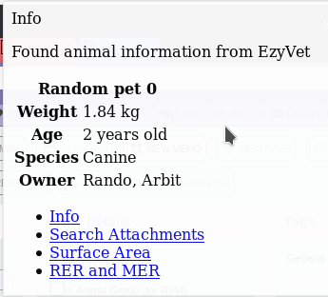
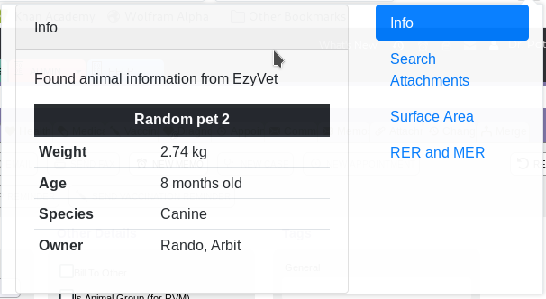

Analysis of HTTP requests sent by the browser
Firefox and Chromium both have a feature in their dev tools to save HTTP logs as HAR. This works fine for most sites, but for some inexplicable reason, both browsers failed to save a HAR file properly for EzyVet. Firefox silently failed, not saving anything at all, while Chromium truncated the file at seemingly arbitrary points every time I tried it, destroying the JSON structure of the data. I switched to browsermobproxy for capturing http requests, creating a simple script (harcapture.py) that attached the browsermobproxy proxy to the browser and provided an interface for saving HAR files. I had to use Chromium as the browser because I couldn’t get Firefox to accept the phony https certificates which browsermobproxy generates. Below is a screenshot of a session with harcapture.py on https://google.com:
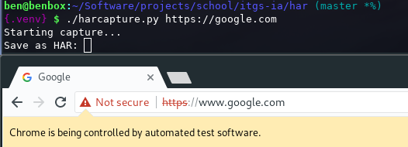

After capturing the HAR files, I had to analyze them. Because I needed to perform arbitrary tasks such as filtering by when query parameters on URLs matched something of interest, I couldn’t create a single script for dealing with them. Instead I manipulated the HAR structure in the Python REPL. For convenience, I created hardiff.py, where I put a few tools which I used frequently. Notably, it has an install function which writes the responses to all requests that match a certain path to the filesystem with names that include the HTTP method like ./General/SideList-GET.html. I could then easily write routes for such files in Flask and edit them to replace content with dynamic data from the mock server using the Jinja2 templating language.

Use of external resources
As I have already mentioned, I used a few software libraries:
* pdf.js (for extracting text from pdfs)
* moment.js (for parsing and manipulating time)
* webextension-polyfill (for chrome compatibility)
* bootstrap (for styling)
* Flask (for the mock server)
* browsermobproxy-python (for capturing HAR)
* selenium-python (for opening web browsers with the desired proxy configuration)
I used the documentation at https://developer.mozilla.org/en-US/ (MDN) extensively for reference on JavaScript, the DOM, and the WebExtension standard. However, I did not copy any of the example code. To a lesser extent I also used the Python docs, the Flask docs, the bootstrap docs, and the moment.js docs similarly. Pdf.js didn’t have much in the way of docs, so I learned how to use it from the answers to https://stackoverflow.com/q/1554280, but I did not copy the code, preferring to do things a little differently with ES7 async functions.
I copied the configuration for babeljs and bootstrap in my webpack.config.js from https://babeljs.io/docs/setup and https://getbootstrap.com/docs/4.0/getting-started/webpack/ respectively.
I used the answer to https://stackoverflow.com/q/11450158/3154567 to make the Chrome WebDriver accept the browsermobproxy proxy.
/extension/src/package.json (and of course package-lock.json) were generated automatically as I performed npm installs of the dependencies I used.

