Unit Test Manual Document

**Senario-1**

When fuel d is equal to true

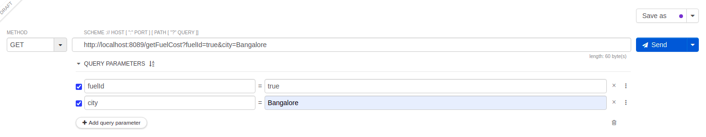

It should calculate the amount of fuel got into the tank and calculate the price and return that values.

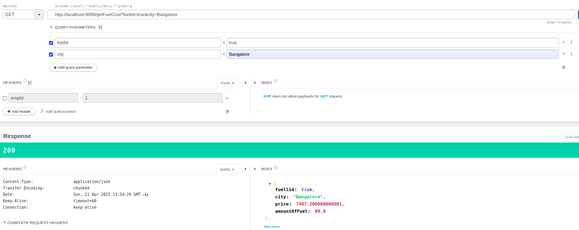

**Senario-2**

When Fuel Id is false

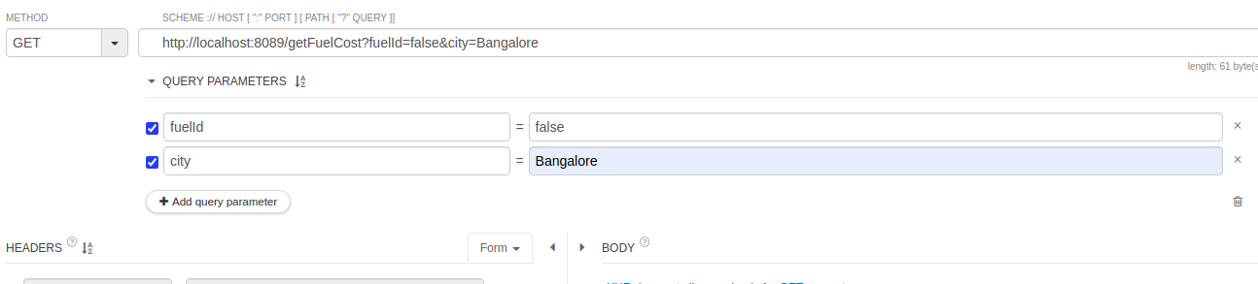

It should return 400 with the Error message Fuel id of the car is Not opened

