**Description Documentation**

**Rashid Yaseen**

**Please See below Directories format if getting any Errors:**

**Make a folder of ‘Lab 8’ in htdocs then paste the extracted files in it then Run it.**

**Pictures also in WhatIsDone file.**

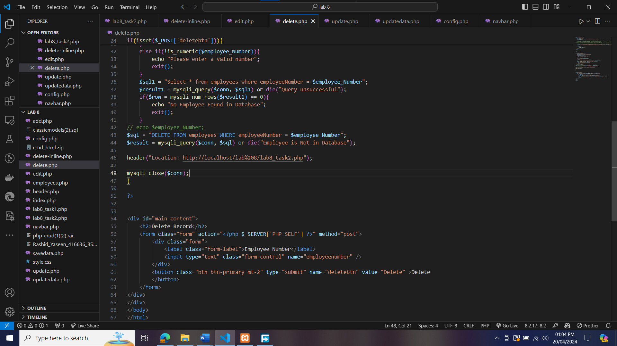

**Displaying Employee Information in Tabular Form**

* I have successfully written a PHP script to display the employee information in a tabular format.
* I have used the appropriate database join to retrieve the necessary data, including the details of the employee's manager (ReportTo) and the office address.
* The displayed information follows the specified format, showing the employee's first name, last name, job title, manager's name and job title, and the complete office address.
* The output is presented in a clear and well-organized tabular layout, making it easy for the user to read and understand the employee data.

**Implementing CRUD Operations on the Employee Table**

* I have developed a comprehensive PHP-based solution to perform CRUD (Create, Read, Update, Delete) operations on the employee table.
* The user interface includes well-designed forms that allow users to add new employees, update existing employee records, and delete employees from the database.
* The data submitted through the forms is correctly saved in the database, and the changes are reflected in the system.
* The application demonstrates a strong understanding of database manipulation and user interface design principles.

**Thank you**