**Description:**

Using ‘classicmodels.sql’ and running it on phpMyAdmin to create a local database on your machine.

Download ‘php-crud.rar which contains working examples of CRUD operations in PHP. For the examples to run correctly, you have to execute the ‘test-database.sql’ file under ‘sql’ folder in phpMyAdmin so that relevant databases and tables are created first.

**A PHP script to display the information of the employees in tabular form. The employees data can be retrieved from the ‘employees’ table. For each employee you have to display the data as shown in the below figure.**

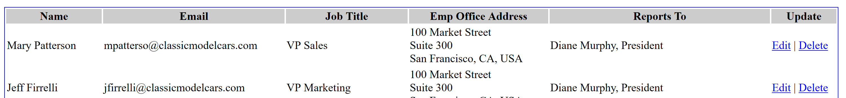

Important Hints:

1. You have to use a join to retrieve data of the reportsTo employee and the office address. Both of these are given in the employees table as foreign keys.
2. The office address should display following: addressline1, addressline2, city, state, and country.
3. ReportTo should display: employee first and last name, employee job title

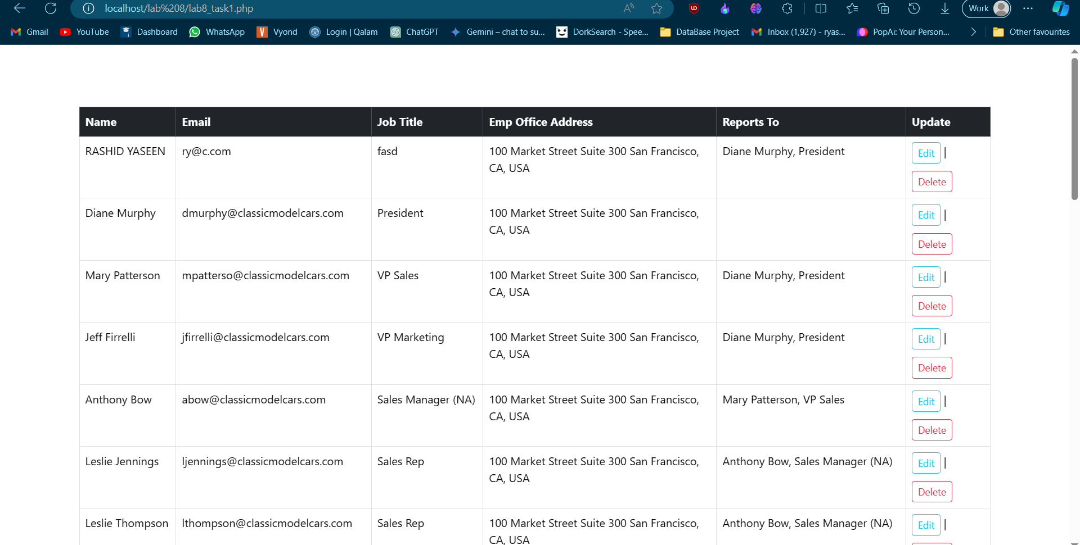

### Task 2

Using PHP, perform the CRUD operations on the *employee* table. This includes: create employee, update employee, and delete employee. You should design forms where a user can add/edit employee data and the data must be saved in the database upon submission.



