**iBudget**

**Software Design**

**Document**

|  |  |  |  |  |
| --- | --- | --- | --- | --- |
| Approvals: | L. Assayah | _____________ | date: | _____________ |
|  | C. Leung | _____________ | date: | _____________ |
|  | Q. Pham | _____________ | date: | _____________ |
|  | V. Velev | _____________ | date: | _____________ |
|  | J. Reimels | _____________ | date: | _____________ |

**Revision History**

|  |  |  |  |
| --- | --- | --- | --- |
| **Date** | **Author** | **Version** | **Reason** |
| 3/13/12 | V.Velev | 1.0 | First Draft |
|  |  |  |  |

# Introduction

## Purpose

This document describes the design of the *iBudget* personal finance software. It shows how the software system will be structured to satisfy the requirements identiﬁed in the software requirements speciﬁcation.

## Scope

This design is intended for the initial version of *iBudget*. It is intended as the basis for other versions of the software in the future.

## Definitions, acronyms and abbreviations

API: Application Programming Interface – a way for the programmer to interact with the system hardware

DBMS: Database Management System

GUI: Graphical User Interface

etc.

## References

[1] Role-playing video game SDD

[2] *Encounter* video game SDD

[3] IEEE Std 1016-1998 IEEE Recommended Practice for Software Design Descriptions

# System Architecture

## Architecture design

Top-level decomposition: the application consists of the client side, server side and back-end modules – a typical three tier client-server architecture where one server serves many clients. The top tier is the graphical user interface developed with HTML. The bottom tier is the database layer, developed through the use of MySQL that will hold all transaction, account and category information. The middle layer, or middleware, is developed using PHP, and issues functionality between the user interface and the database such as adding, removing, and editing transactions, accounts and categories.

The code structure is to use the MVC architecture pattern. Use of the MVC pattern results in separating the different aspects of the application (input logic, business logic, and GUI logic), while providing a loose coupling between these elements. The MVC was chosen as it simplifies the architecture by decoupling models and views, and to makes source code more flexible and maintainable and it maps nicely to the three-tier architecture as well.

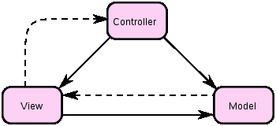

Figure 1 Model–view–controller concept.

The solid line represents a direct association, the dashed an indirect association

(via an observer for example)

The model manages the behavior and data of the application domain, responds to requests for information about its state (usually from the view), and responds to instructions to change state (usually from the controller). The model is not necessarily merely a database; the 'model' in MVC is both the data and the business/domain logic needed to manipulate the data.

The view renders the model into a form suitable for interaction, typically a user interface element. Multiple views can exist for a single model for different purposes.

The controller receives user input and initiates a response by making calls on model objects. A controller accepts input from the user and instructs the model and a view port to perform actions based on that input.

## Design pattern

## Factory

The factory pattern creates objects without exposing the instantiation logic to the client and refers to the newly created object through a common interface. The factory pattern is being used... *(please provide examples where and how it is being used)*

## Singleton

The singleton pattern ensures that there is exactly one instance of a given class and that it is accessible from anywhere in the application. The singleton pattern is being used in the *iBudget* application to restrict the number of database connections to only one.

Indeed it is used with all the source objects that are in the source folder. For all these files, the constructor is made private and only called once to create the object the one time. All other attempts to create another instance of the same object will result with getting the instance created before. A static attribute called $instance is created when calling for the first time the getSource() method. Then every time the method is called again, the same instance is returned. Below is an example of how it is implemented in categorysource.inc :

Attribute:

**private static** $instance = **null**;

Method:

**public static function** *getSource* () {

**if** (**self**::*$instance* == **null**) {

**self**::*$instance* = **new CategorySource();**

}

}

Constructor:

**private function** __construct () {

**/*content */**

}

And an example of how it is used in category.inc by calling the getSource() method:

**protected function** delete () {

$source = CategorySource::getSource();

$source->delete(**array**('ID' => **$this**->id));

}

# Data diagram

## Data description

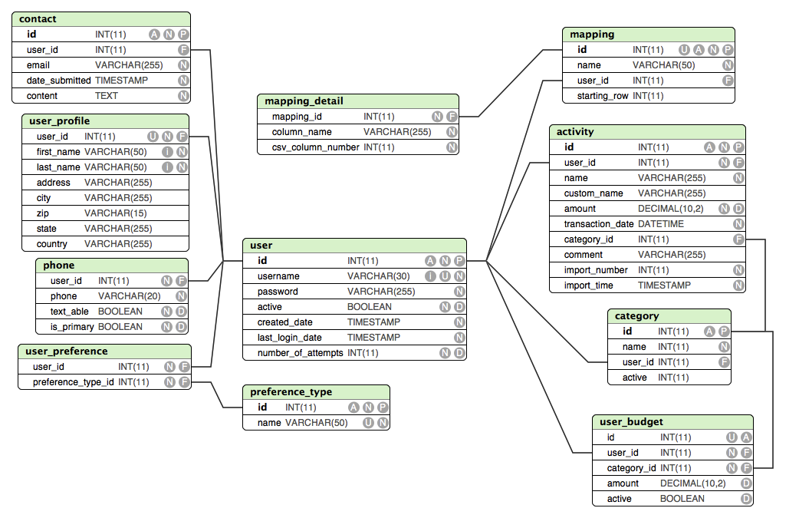

Where the following keys are being used:

A = Auto Incremement

N = NOT NULL

P = Primary Key

U = Unique

i = Indexed

D = Has default value assigned

F = Foreign Key

## Data dictionary

(functions and parameters)

(source obj.)

## 3.2.1 Source objects

The Source objects are used to access the database and execute SQL statements to modify or get information from the database. Here are the description of the different source objects used in the project:

* **activitySource**: can access the activity table
* **budgetSource**: can access the user_budget table
* **categorySource**: can access the category table
* **commonSource**: is the class inherited by all the other source classes. It contains methods that can be used by all source objects: deleteFromTableById($table, $id, $id_column) that enables to delete a row based on the id and getLastInsertedId() that returns the id of the last row inserted in the table.
* **ContactSource**: can access the contact table
* **mappingDetailSource**: can access the mapping_detail table
* **mappingSource**: can access the mapping table
* **phoneSource**: can access the phone table
* **preferenceTypeSource**: can access the preference_type table
* **userPreferenceSource**: can access the user_preference table
* **userSource**: can access the user table.

## 3.2.2 General methods of the source objects

Since all source objects implement the Source interface, they can all define and use the following four methods:

**- read()**: select elements in the database tables. The fields and tables are different depending on the purpose of the class. Ex: get the user information, the budget information, the category information etc…

The SQL statement is an SELECT statement.

**- insert():** insert rows in the database. Each field that can be inserted in the corresponding table is checked to see if it is given a value or not with the following statement:

array_key_exists('NAME', $params)with NAME the name of a field in the Category table and $params the entered parameters.

All parameters are put in an array that is then used to complete the INSERT statement.

**- update():** updates rows in the database. The original values of the rows are stocked in an array to check if the value will be changed. Each field that can be updated in the corresponding table is checked to see if it is given value or not. Those two steps are illustrated with the following:

array_key_exists('NAME', $params) && $original['name'] != $params['NAME'] with NAME the name of a field in the Category table, $params the entered parameters, $original the previous values of the row.

The SQL statement is an UPDATE statement.

**- delete()**: deletes rows in the database. Deleting rows is done by using the id field in most of the tables. If an id is given, then the following function is used to delete the corresponding row:

**$this**->deleteFromTableById('category', $params['ID']); with category the name of the table and $params the entered parameters.

The SQL statement is a DELETE statement.

# Human interface design

## Registration

## Overview

## Screenshot

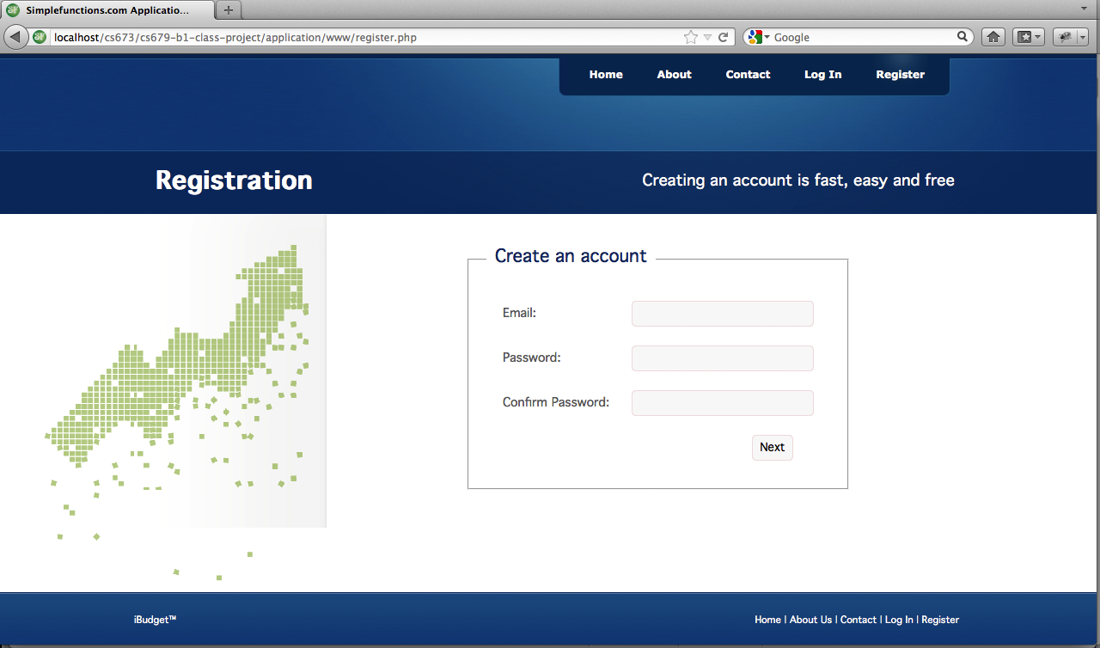

## State diagram

## Login

## Overview

## A description...Screenshot

## Process CSV

## Overview

Process CSV is one of the core components of iBudget. Turning provided CSV files into data that we can understand, store, and transform. The process first load the mapping settings which directs how the translate the CSV files. The mapping will be discussed at a later section. Which the mapping understood, the process reads the file line by line, and applies the mapping settings, The result will create an Activity object and the entire process will create a list of activity objects. If the process complete successfully, a database transaction is created to submit all these data. A randomize number between 10000000000 and 99999999999 is generated and is assigned to the list of activities in conjunction to a date time, this will help identify an import transaction, so when use needed to revert the import, this can be done easily.

## Screenshot

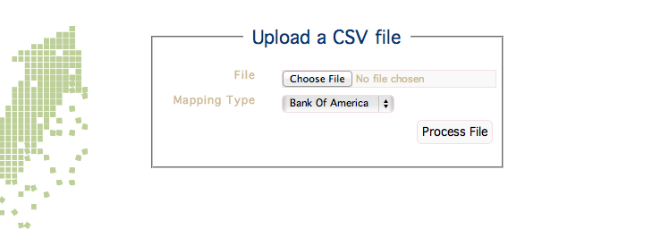

## State diagram

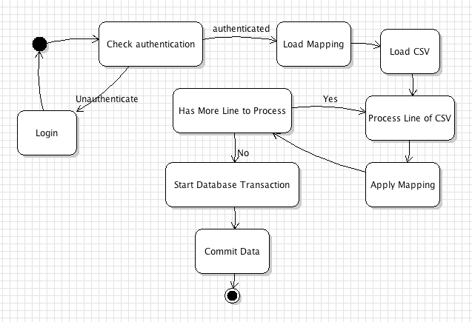

## Contact

## Overview

## Screenshot

## State diagram

## Forgot password

## Overview

If the user forgets his/her password they can reset it by clicking on the 'Forgot password' link in the login page. They are taken to the reset password page (see screenshot below). They enter the email with which they've registered at the site. In case no account with this email exists, the system displays an error message 'User with this username was not found'. An email is sent out to the user with a link they have to follow and they are taken to the reset password screen where they can enter a new password that is being checked to meet the following condition: a password must be at least 8 characters long, and have one lowercase, one uppercase, one number, and one special character. In addition, the 'password' and 'repeat password' fields must match. Once they hit the submit button, the password field in the database is updated, they are logged into the site and being taken to the dashboard page.

## A description...Screenshot

## State diagram

## Dashboard

## Overview

## Screenshot

## State diagram

## Custom mapping

## Overview

## Screenshot

## State diagram

# 5. Requirements Matrix???