**Q1 - Write a program which takes the values of length and breadth from user and check if it is**

**a square or not.**

import java.util.*;  
class Assignment{  
 public static void main(String[] args) {  
 Scanner sc = new Scanner(System.*in*);  
 int a = sc.nextInt();  
 int b = sc.nextInt();  
 if(a==b){  
 System.*out*.println("it is square");  
 }  
 else {  
 System.*out*.println("it is rectangle");  
 }  
 }  
}

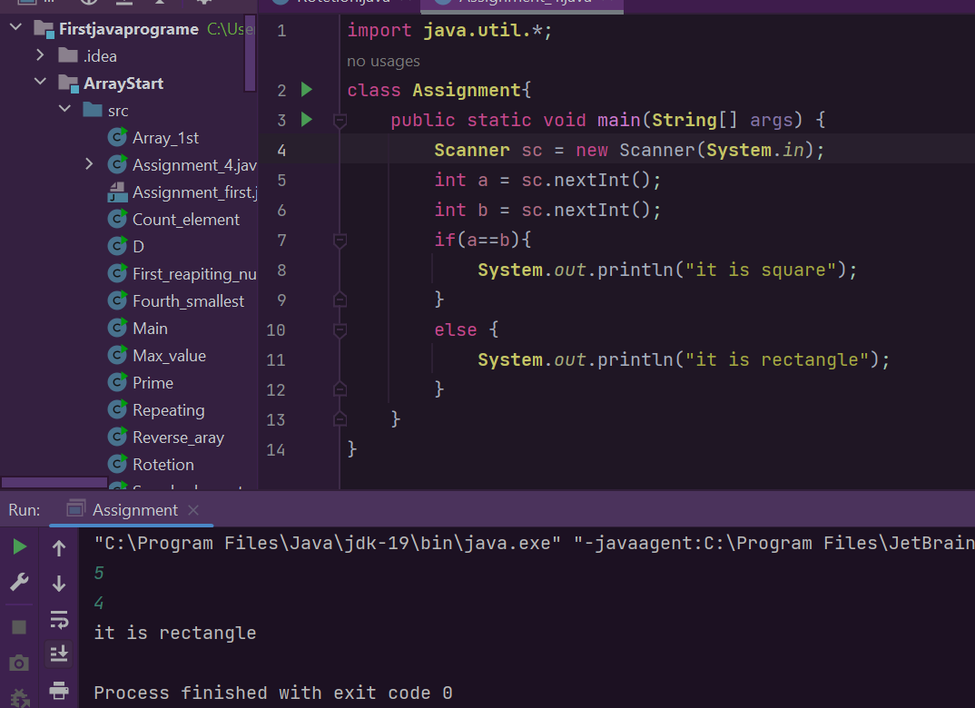

**Q2 - Write a program to print absolute value of a number entered by the user.**

import java.util.*;  
class Assignment{  
 public static void main(String[] args) {  
 Scanner sc=new Scanner(System.*in*);  
 int a;  
 System.*out*.print("Enter the number : ");  
 a=sc.nextInt();  
 if(a<0)  
 {  
 a=a*-1;  
 }  
 System.*out*.print("The absolute value is : " + a);  
 }  
}

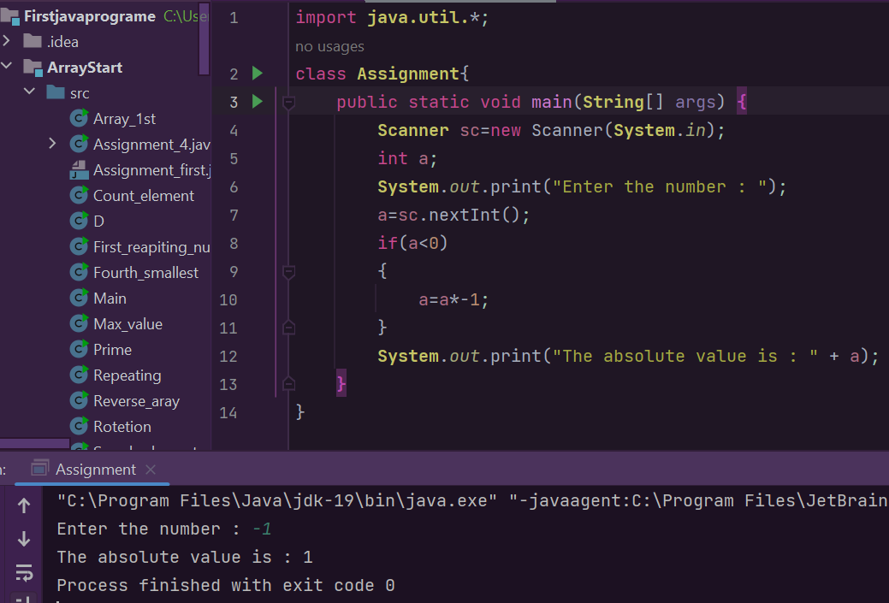

**Q3 - Write a program to take input from user for Cost Price (C.P.) and Selling Price(S.P.) and calculate Profit or Loss.**

import **java.util.**\*;  
class **Assignment**{  
 public static void main(**String**[] args) {  
 **Scanner** sc=new Scanner(**System**.*in*);  
 int cp,sp;  
 **System**.*out*.print("Enter the Cost Price : ");  
 cp=sc.nextInt();  
 **System**.*out*.print("Enter the Selling Price : ");  
 sp=sc.nextInt();  
 int amt;  
 if(cp>sp)  
 {amt=cp-sp;  
 **System**.*out*.print("The loss is : "+amt);  
 }else if(cp<sp)  
 {  
 amt=sp-cp;  
 **System**.*out*.print("The profit is : "+amt);  
 }else{  
 **System**.*out*.print("No Profit No Loss");  
 }  
 }  
}

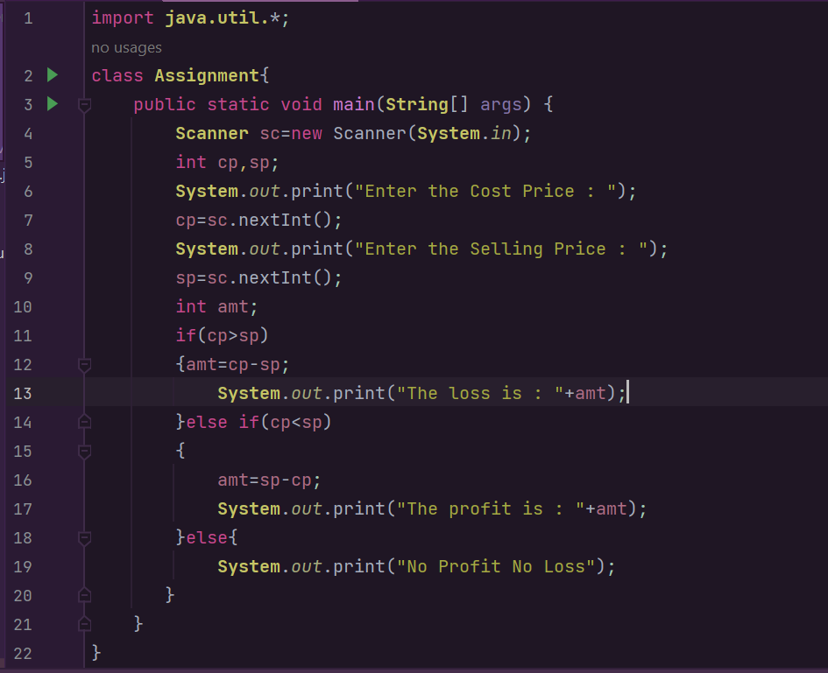

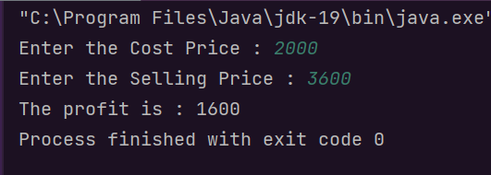

**Q4 - Write a program to print positive number entered by the user, if user enters a negative number, it is skipped**.

import **java.util.**\*;  
class **Assignment**{  
 public static void main(**String**[] args) {  
 **Scanner** sc=new Scanner(**System**.*in*);  
 int x;  
 **System**.*out*.print("Enter the Number : ");  
 x=sc.nextInt();  
 if(x>=0)  
 {  
 **System**.*out*.print("You entered a positive number");  
 }else{  
 **System**.*out*.print("You number is negative and is skipped");  
 }  
 }  
}

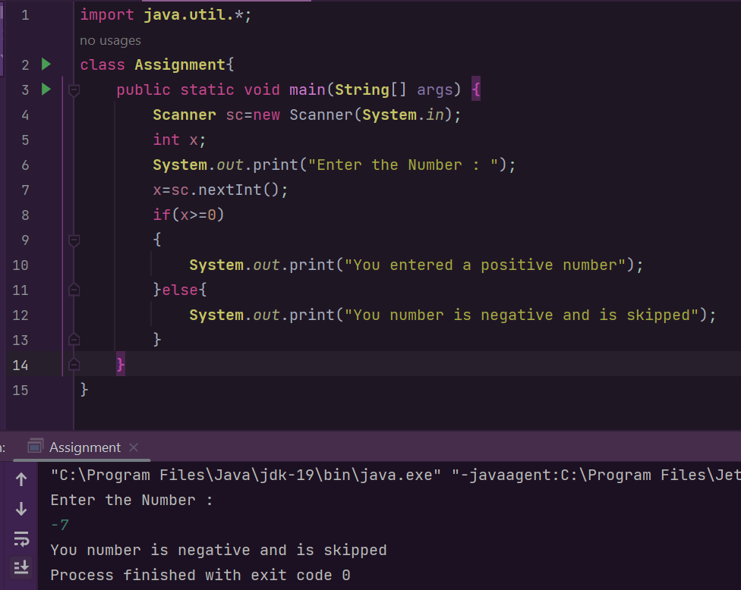

**Q5 - Create a calculator using switch statement to perform addition, subtraction, multiplication and division.**

**import java.util.*;  
class Assignment{  
 public static void main(String[] args) {  
 char op;  
 Double num1,num2,answer;  
 Scanner sc = new Scanner(System.*in*);  
 System.*out*.print("Enter an operator: (+, -, *, or /)");  
 op = sc.next().charAt(0);  
 System.*out*.print("Enter first number : ");  
 num1 = sc.nextDouble();  
 System.*out*.print("Enter second number : ");  
 num2 = sc.nextDouble();  
 switch (op) {  
 case '+':  
 answer = num1 + num2;  
 System.*out*.println(num1 + " + " + num2 + " = " + ans);  
 break;  
 case '-':  
 answer = num1 - num2;  
 System.*out*.println(num1 + " - " + num2 + " = " + ans);  
 break;  
 case '*':  
 answer = num1 * num2;  
 System.*out*.println(num1 + " * " + num2 + " = " + ans);  
 break;  
 case '/':  
 answer = num1 / num2;  
 System.*out*.println(num1 + " / " + num2 + " = " + ans);  
 break;  
 default:  
 System.*out*.println("Error! The operator is not correct");  
 break;  
 }  
 }  
}**

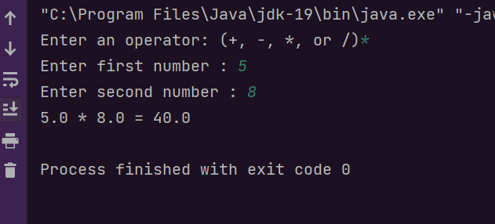

**Q6 - Write a program to calculate marks to grades . Follow the conversion rule as given below :**

import java.util.*;  
class Assignment{  
 public static void main(String[] args) {  
 char op;  
 Scanner sc=new Scanner(System.*in*);  
 int marks;  
 System.*out*.print("Enter the marks : ");  
 marks=sc.nextInt();  
 if(marks>=90)  
 {  
 System.*out*.print("Your Grade is A+");  
 }else if(marks>=80)  
 {  
 System.*out*.print("Your Grade is A");  
 }else if(marks>=70)  
 {  
 System.*out*.print("Your Grade is B+");  
 }else if(marks>=60)  
 {  
 System.*out*.print("Your Grade is B");  
 }else if(marks>=50)  
 {  
 System.*out*.print("Your Grade is C");  
 }else if(marks>=40)  
 {  
 System.*out*.print("Your Grade is D");  
 }else if(marks>=30)  
 {  
 System.*out*.print("Your Grade is E");  
 }else if(marks<30){  
 System.*out*.print("Your Grade is f");  
 }else{  
 System.*out*.print("Enter valid marks");  
 }  
 }  
}

