**Q1 - Take 2 integer values in two variables x and y and print their product.**

public class Assignment_first {  
 public static void main(String[] args) {  
 int a = 2;  
 int b = 4;  
 System.*out*.println(a*b);  
 }  
}

***output***

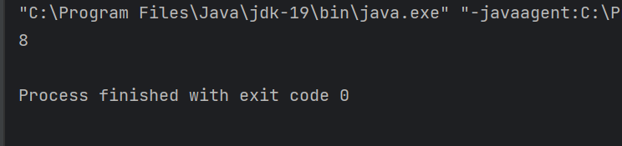

**Q2 - Print the ASCII value of character ‘U’.**

public class Assignment_first {  
 public static void main(String[] args) {  
 int a = 'U';  
 System.*out*.println("The ascll value of the character U is "+a);  
 }  
}

***output***

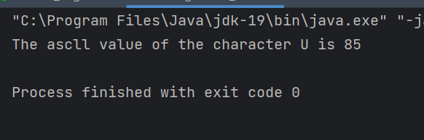

**Q3 - Write a Java program to take the length and breadth of a rectangle and print its area.**

**public class Assignment_first {  
 public static void main(String[] args) {  
 int length=6;  
 int breadth=5;  
 System.*out*.println("The length is : "+ length);  
 System.*out*.println("The breadth is : "+ breadth);  
 int area=length*breadth;  
 System.*out*.println("The area is : "+area);  
 }  
}**

***output***

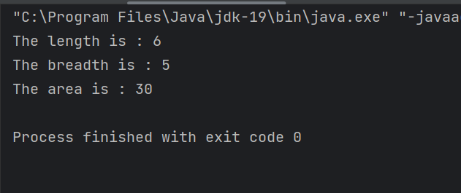

**Q4 - Write a Java program to calculate the cube of a number.**

public class Assignment_first {  
 public static void main(String[] args) {  
 int x = 2;  
 int cube=x*x*x;  
 System.*out*.println("The side is : "+x);  
 System.*out*.println("The cube is : "+cube);  
 }  
}

***output***

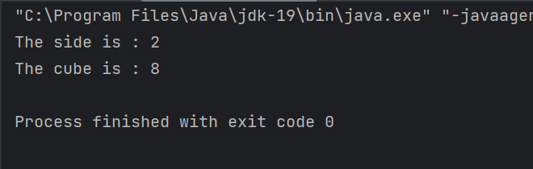

**Q5 - Write a Java program to swap two numbers with the help of a third variable.**

public class Assignment_first {  
 public static void main(String[] args) {  
 int num1=2;  
 int num2=3;  
 System.*out*.println("The first number before swap is :" + num1);  
 System.*out*.println("The second number before swap is : " + num2);  
 int temp;   
 temp=num1;  
 num1=num2;  
 num2=temp;  
 System.*out*.println("The first number after swap is :" + num1);  
 System.*out*.println("The second number after swap is : " + num2);  
 }  
}

***output***

