**Q1 - Input name, roll number and field of interest from user and print in the format below :**

**Name: xyz, Roll number: xyz, Field of interest: xyz**

**Input : Single line format**

**Aman Gupta 4053 Physics**

**Output :**

**Name: Aman Gupta**

**Roll Number: 4053**

**Field of interest: Physics**

import java.util.Scanner;  
public class second {  
 public static void main(String[] args) {  
 Scanner scn = new Scanner(System.*in*);  
 String first_name = scn.next();  
 String last_name = scn.next();  
 int roll_number = scn.nextInt();  
 String field_of_interest = scn.next();  
 System.*out*.println("Name: " + first_name + " " + last_name);  
 System.*out*.println("Roll Number: " + roll_number);  
 System.*out*.println("Field of interest: " + field_of_interest);  
 }  
}

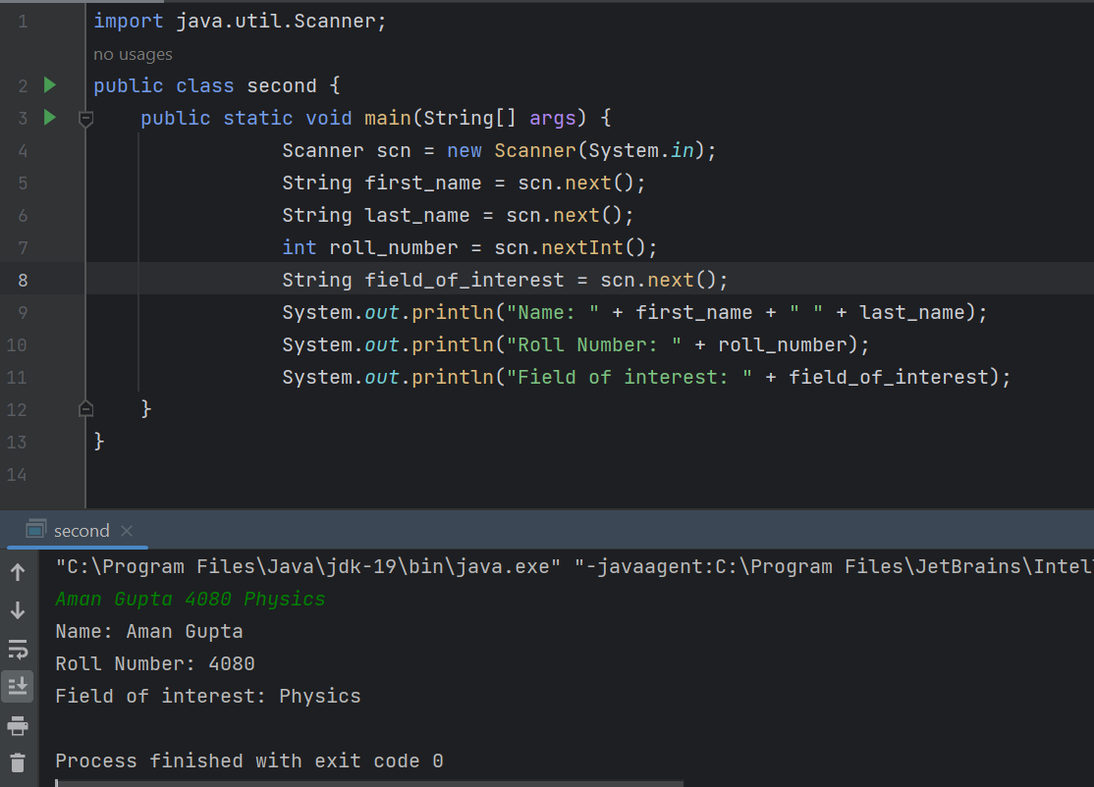

**Q2 - Input two different string and print them in same line.**

***Input :***

**Level**

**Up**

***Output* :**

**LevelUp**

import java.util.Scanner;  
public class second {  
 public static void main(String[] args) {  
  
 Scanner scn = new Scanner(System.*in*);  
 String first = scn.nextLine();  
 String last = scn.nextLine();  
 System.*out*.println(first + last);  
 }  
}

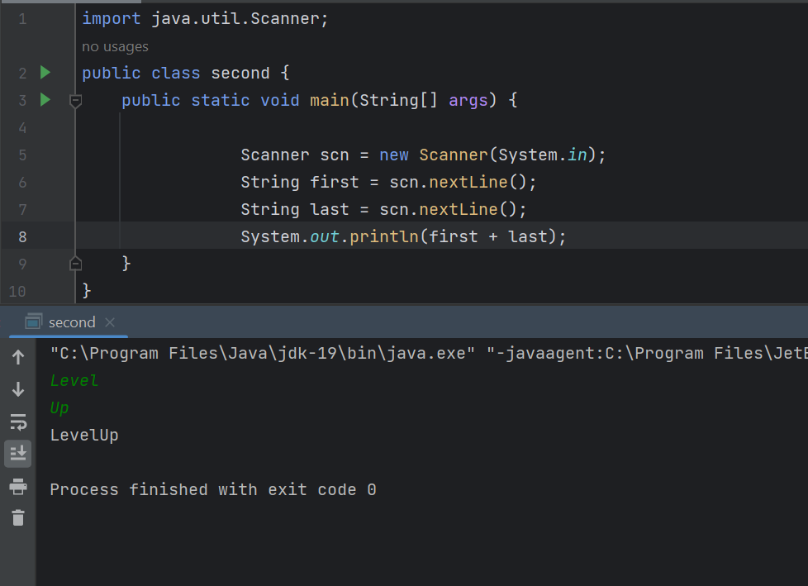

**Q3 - If the marks of Robert in three subjects are entered through keyboard (each out of 100), write a program**

**to calculate his total marks and percentage marks.**

***Input :***

**78**

**89**

**95**

***Output* : Total marks: 262**

**percentage marks: 87%**

import java.util.Scanner;  
public class second {  
 public static void main(String[] args) {  
 Scanner scn = new Scanner(System.*in*);  
 int mark1 = scn.nextInt();  
 int mark2 = scn.nextInt();  
 int mark3 = scn.nextInt();  
 int total_marks = mark1 + mark2 + mark3;  
 int percentage = (total_marks / 3);  
 System.*out*.println(total_marks);  
 System.*out*.println(percentage + "%");  
 }  
}

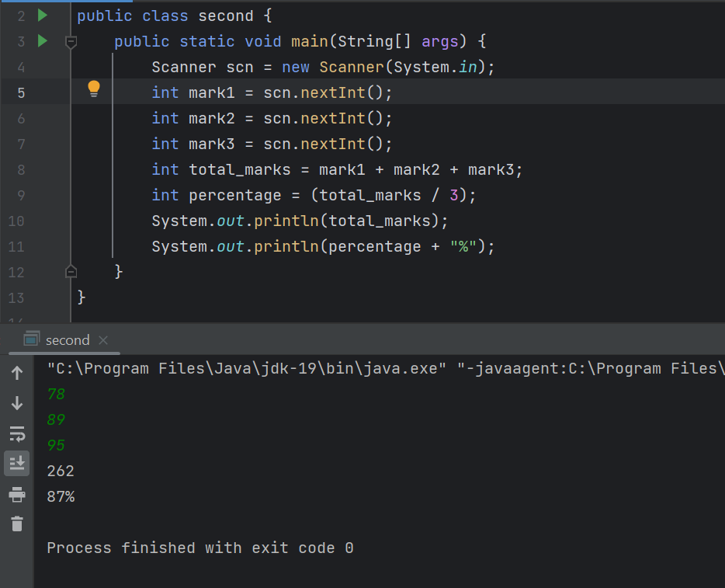

**Q4 - Given two numbers, return their sum in the following format:**

**Int t representing number of test cases**

**T lines of Two integers representing the numbers to be added**

**Input :**

**3**

**4 5**

**18 20**

**49 27**

**Output :**

**9**

**38**

**76**

import java.util.Scanner;  
public class second {  
 public static void main(String[] args) {  
 Scanner scn = new Scanner(System.*in*);  
 int t = scn.nextInt();  
 for(int i = 1; i <= t; i++){  
 int a = scn.nextInt();  
 int b = scn.nextInt();  
 System.*out*.println(a+b);  
 }  
 }  
}

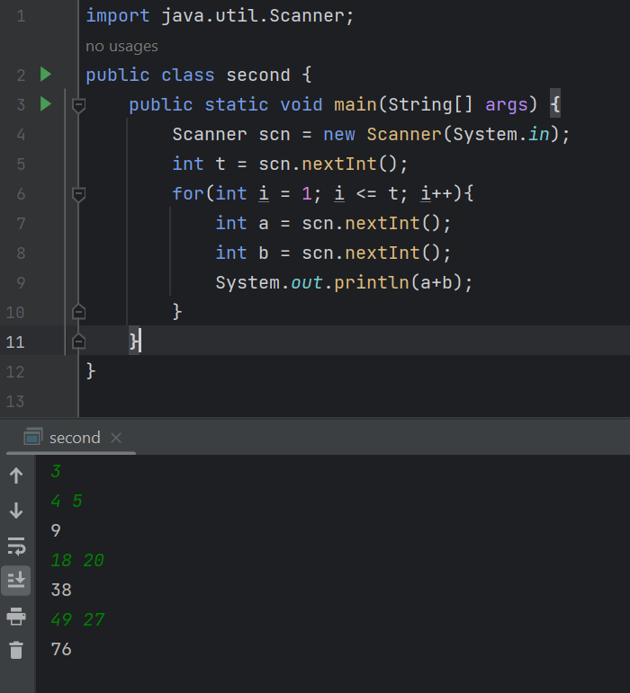

**Q5 - Given few lines of input(number of lines unknown) where each line has two**

**strings, concatenate the strings.**

***Input* :**

**Hello World**

**Happy Faces**

**Sunny Day**

**Good Morning**

***Output* :**

**HelloWorld**

**HappyFaces**

**SunnyDay**

**GoodMorning**

**import java.util.Scanner;  
public class second {  
 public static void main(String[] args) {  
 Scanner scn = new Scanner(System.*in*);  
 while(scn.hasNextLine()){  
 String a = scn.next();  
 String b = scn.next();  
 System.*out*.println(a+b);  
 }  
 }  
}**

