**Q1 - Write a program to add 8 to the number x and then divide it by 3. Now, the modulus of the quotient**

**is taken with 5 and then multiply the resultant value by 5. Display the final result.**

**Input: 2345**

**Output: 20**

import java.util.*;  
public class Assignment_3 {  
 public static void main(String[] args) {  
 Scanner scn = new Scanner(System.*in*);  
 int x = scn.nextInt();  
 System.*out*.print((((x + 8) / 3) % 5) * 5);  
 }  
}

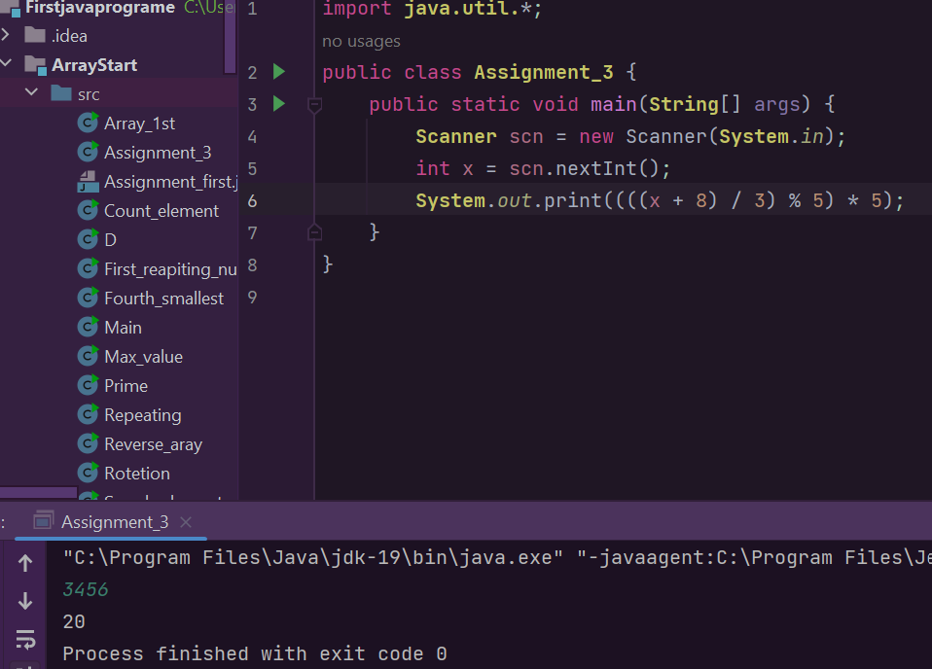

**Q2 - Swap two numbers without the use of third variable.**

import java.util.*;  
public class Assignment_3 {  
 public static void main(String[] args) {  
 Scanner sc = new Scanner(System.*in*);  
 int a = sc.nextInt();  
 int b = sc.nextInt();  
 System.*out*.println("before swapping");  
 System.*out*.println("a="+a);  
 System.*out*.println("b="+b);  
 a = a+b;  
 b = a-b;  
 a = a-b;  
 System.*out*.println("after swappingSS");  
 System.*out*.println("a="+a);  
 System.*out*.println("b="+b);  
 }  
}

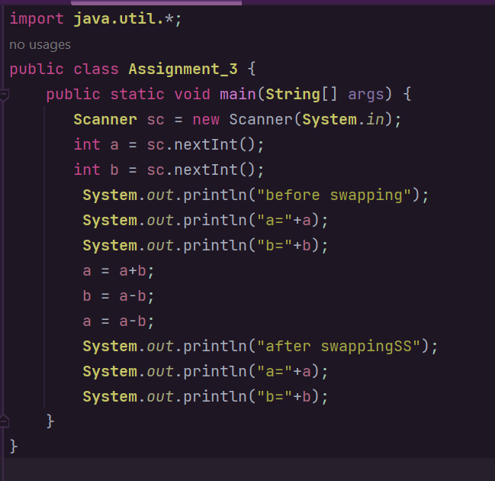

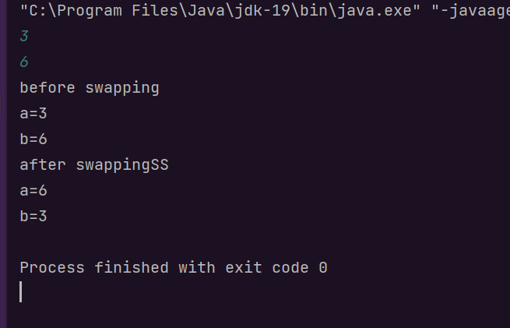

**Q3 - Write a program to calculate the sum of the digits of a 3-digit number.**

**Input: 132**

**Output: 6**

import java.util.*;  
public class Assignment_3 {  
 public static void main(String[] args) {  
 Scanner sc = new Scanner(System.*in*);  
 Scanner scn = new Scanner(System.*in*);  
 int x = scn.nextInt();  
 int sum = 0;  
 while(x > 0){  
 sum += x % 10;  
 x /= 10;  
 }  
 System.*out*.println(sum);  
 }  
}

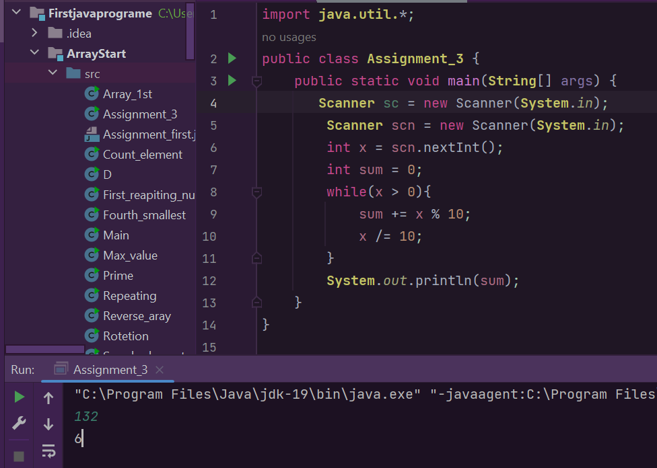

**Q4 - Assign values of variables 'a' and 'b' as 55 and 70 respectively and then check if:**

i) both the conditions 'a < 50' and 'a < b' are true.

ii) at least one of the conditions 'a < 50' or 'a < b' is true.

import **java.util.**\*;  
public class **Assignment_3** {  
 public static void main(**String**[] args) {  
 int a = 40;  
 int b = 80;  
 **System**.*out*.print(a < 50 && a < b);  
 }  
}

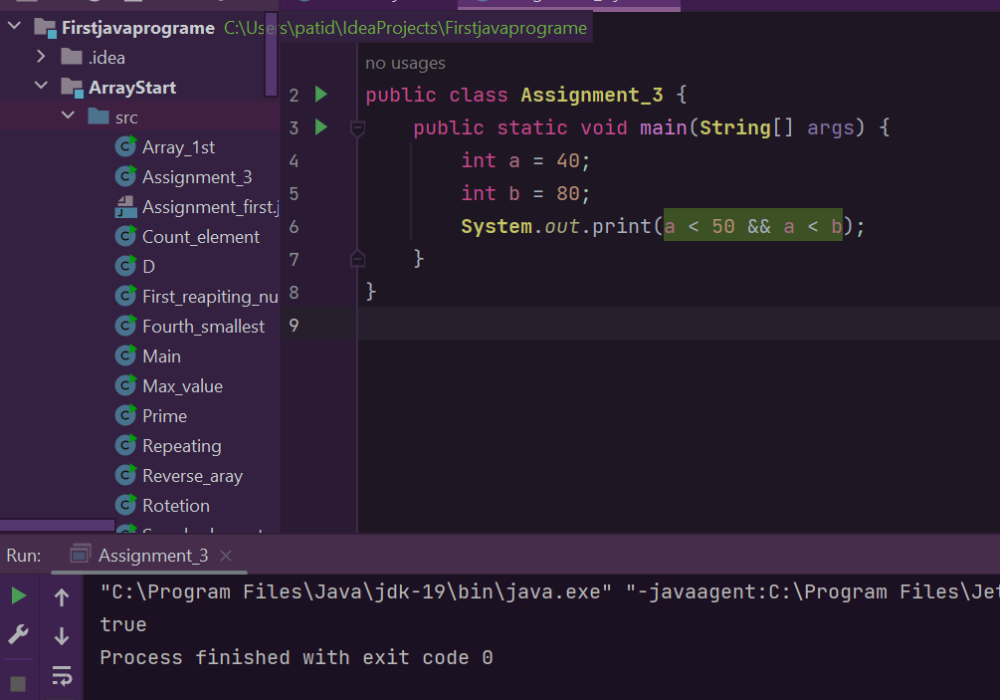

**Q5 - Find the total number of bits needed to be flipped to convert x to y.**

**Input: 65 80**

**Output: 2**

import java.util.*;  
public class Assignment_3 {  
 public static void main(String[] args) {  
 Scanner scn = new Scanner(System.*in*);  
 int x = scn.nextInt();  
 int y = scn.nextInt();  
 int n = x ^ y;  
 int count = 0;  
 while (n != 0){  
 n = n & (n - 1);  
 count++;  
 }  
 System.*out*.print(count);  
 }  
}

