HOW TO RETRIEVE A VIDEO FROM FLUTTER APP WHEN PHP IS MY BACKEND AND MYSQL IS DATABASE THEN AM USING LINUX “and that video is been retreieved through localnetwork between my phone and computer as I have switched on the hotspot of my phone and then my pc has connect to that hotspot so we are in the same network ”

first video been stored in that folder in my pc you should open terminal of that folder and write like these

sudo chmod -R 777 ./

then after there go to the flutter project in these directory android/app/src/main/res/ and the view will be like these

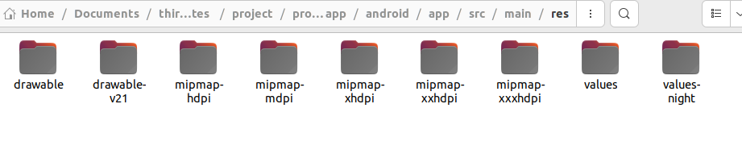

whereby the reality there is no xml folder so we will have top create folder named xml then create a file within it known as network_security_config.xml then in that file you will have to write like these

**<?xml version="1.0" encoding="utf-8"?>**

**<network-security-config>**

**<base-config cleartextTrafficPermitted="true">**

**<trust-anchors>**

**<certificates src="system" />**

**</trust-anchors>**

**</base-config>**

**</network-security-config>**

then after there you will navigate into these directory android/app/src/main/AndroidManifest.xml

the view will be like these

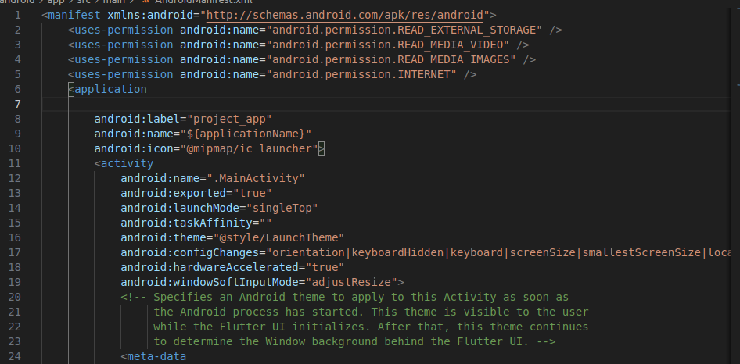

so beneath <application tag you will write like these

android:networkSecurityConfig="@xml/network_security_config"  
and the view will be like these

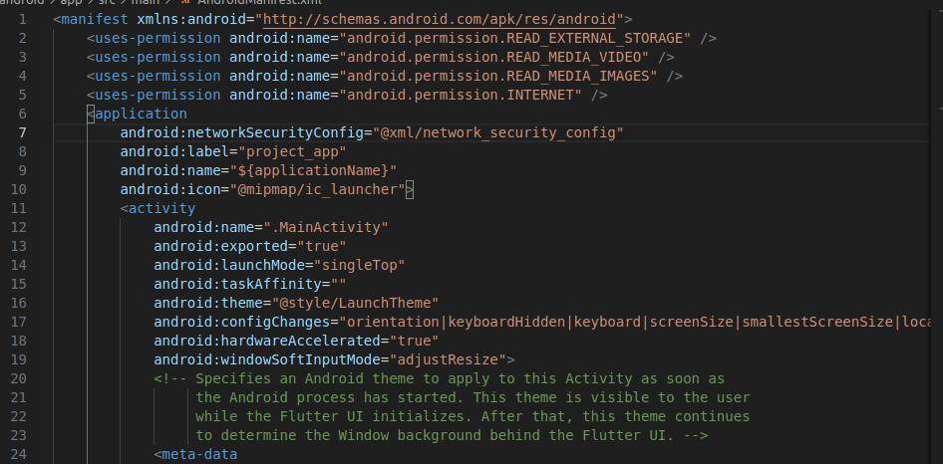

what is the purpose of all of these and what was the actual problem

The error you're encountering is related to Android's network security policy that was introduced in Android 9 (API level 28) and above.

## The Actual Problem

Your app is trying to load video content from an HTTP URL (not HTTPS) at 192.168.249.102. Modern Android versions block plain HTTP ("cleartext") traffic by default as a security measure. This is why you're seeing the error:

Caused by: java.io.IOException: Cleartext HTTP traffic to 192.168.249.102 not permitted

## The Purpose of the Files in Your res Directory

The directories in your res folder have specific purposes in Android development:

* drawable & drawable-v21: For storing image resources and drawable XML files. The v21 suffix indicates resources specific to Android 5.0 (API 21) and above.
* mipmap-hdpi, mdpi, xhdpi, etc.: For app icons at different screen densities - these directories contain the same images at different resolutions for various device screen densities.
* values: Contains XML files that define resources like strings, colors, dimensions, styles, etc.
* values-night: Similar to values but specifically for dark mode/night theme.

## The Solution (XML Directory)

The solution involves creating a new XML directory that doesn't exist yet in your resources. This directory is meant for general XML configuration files that aren't covered by the other resource directories.

The network security configuration file allows you to specify security settings for network communications, including whether to allow cleartext (HTTP) traffic. By implementing this configuration, you're telling Android that your app needs to communicate with servers over HTTP, which would otherwise be blocked.

It's worth noting that while this solution works, using HTTPS instead of HTTP would be more secure for production applications. The configuration is mainly useful for development environments or when connecting to local servers that don't have SSL certificates.

Additional tips to change navigate to android/app/build.gradle and change

android {

namespace = "com.example.project_app"

// compileSdk = flutter.compileSdkVersion

compileSdk = 35

whereby I have commented about compileSdk and write it again to 35 but also in that directory I have changed also

defaultConfig {

// TODO: Specify your own unique Application ID (https://developer.android.com/studio/build/application-id.html).

applicationId = "com.example.project_app"

// You can update the following values to match your application needs.

// For more information, see: https://flutter.dev/to/review-gradle-config.

minSdk = flutter.minSdkVersion

// targetSdk = flutter.targetSdkVersion

targetSdk = 35