攀枝花学院本科毕业设计（论文）

外文译文

院 （系）： 数学与计算机学院
专 业： 软件工程
姓 名： 程淼
学 号： 201410804009

指导教师评语：

签名：
年 月 日

说 明

一、本科毕业设计（论文）外文译文原则上应与学生课题技术相关或者是功能相关，可以选用相关的书籍或文献等。
二、指导老师应认真按《数学与计算机学院毕业设计（论文）考核方法与成绩评定细则》对学生的外文译文进行评审并写出评语和等级。
三、外文译文评定等级为优秀、良好、中等、及格和不及格，具体标准如下：
- 优秀：外文资料与选题密切相关，译文准确、质量好、格式规范，字数达到要求；
- 良好：外文资料与选题密切相关，译文准确、质量较好，字数达到要求；
- 中等：外文资料与选题相关，译文质量一般，字数达到要求。
- 及格：外文资料与选题有一定关联，译文质量尚可，字数达到要求。
- 不及格：外文资料与选题无关，译文质量差，字数未达到要求。
四、本文档要求双面打印。

译文：

Java Web服务的性能评估：开发人员的角度
Sanjay Ahuja, Je-Loon Yang
School of Computing, University of North Florida, Jacksonville, Florida, USA
E-mail: {sahuja, n00168553}@unf.edu
Received March 7, 2010; revised July 2, 2010; accepted July 3, 2010

摘要
随着互联网人口的迅速增长，网络技术的发展变得非常重要。对于Web 2.0的发展，Web服务至关重要。Web服务是一种程序，它允许Web上不同平台的计算机以交互方式进行通信，而无需为人类阅读界面和诸如网页结构等格式提供额外数据。由于Web服务是互联网发展的未来趋势，因此用于开发的工具也很重要。虽然Web服务框架有多种选择可供选择，但开发人员应根据框架的性能，时间和精力选择最适合其应用的框架。在这个项目中，我们选择了四个通用框架来比较定性和定量指标。运行测试后，结果由SAS进行统计分析。

关键词：Web服务，框架，性能，Java，开发人员。

1．介绍
对于前往其他国家或国家的旅行，该人通常需要购买机票，租车，并预订酒店留下。在处理飞机票时，大多数时候人们甚至不得不为一些站点购买几张票，而不是将票直接带到最终目的地的票。查看飞机的到达和离开时间以连接每个航班可能需要数小时的搜索和计划。如果有一个虚拟代理可以在几秒钟内完成这件事情会怎么样？所以通常人们会寻找代理人为他们做这件事。但是如果这个代理实际上是在线虚拟代理呢？如果该人员刚刚输入他想从哪里开始的位置，目的地，期望的出发或到达时间以及计算机所需的所有信息，则计算机将显示所有结果供人选择，并且购买门票。更好的是，这些虚拟代理商还可以显示目的地的汽车租赁和酒店信息，并为您预留它们。通过使用这种类型的虚拟代理，可以节省许多精力和时间，并且也可以比人工代理更准确。这种技术依赖于Web服务的发展和普及。
没有从头开始开发Web服务应用程序，有许多开源框架可以使开发更容易。哪个框架将成为Web服务应用程序开发的更好选择？这项研究通过做几次测试和分析比较了四种流行的开源框架的定性和定量。这四个框架是Apache Axis，JBossWS，XFire和Hessian。第2部分介绍了更多Web服务的介绍。第3部分介绍了本研究中使用的四个框架。在第4节中，将更详细地解释用于度量框架的度量标准。第5节介绍用于分析测量结果的统计分析方法。在第6节中，显示和分析了测试结果。结论在第7节。

2．Web服务框架
由于Web服务旨在以常用方式传输数据，因此为了方便Web服务开发人员，一些公司和团队开发了Web服务框架，以便他们无需从头开始编写完整的Web服务。一些流行的框架是Apache Axis，JBossWS，Codehaus XFire和Caucho Hessian。在本节中，将介绍这些框架。
2.1 Apache Axis
Apache Axis（Apache可扩展交互系统）是Apache Software Foundation（ASF）创建的基于Java和XML的开源Web服务框架。该基金会是一家非营利性公司，主要生产网络使用软件，例如服务器和服务器框架。他们的项目众所周知是协作性的，基于共识的开发流程和免费或开源软件。 Apache Axis包具有用于生成和部署Web服务应用程序的SOAP服务器和API的实现。 SOAP引擎构造SOAP处理器，如客户端，服务器和网关。这允许服务器和客户端通过SOAP消息进行通信。该API支持多种语言。除了Java版本之外，C ++实现也是可用的。它允许开发人员以各种方式构建他们的应用程序。最简单的方法只需要将文件扩展名从“.java”更改为“.jws”。这种方法的缺点是缺乏进一步配置的灵活性。
2.2 JBossWS
JBossWS是JBoss的J2EE兼容Web服务的实现。该框架旨在更好地适应整体JBoss体系结构，并且通常更适合Web服务的特定J2EE要求。JBoss没有为这个框架使用传统的Apache服务器，而是拥有自己的服务器，并建议在该服务器上使用该框架以获得最佳性能。与ASF类似，JBoss社区是一群专注于开源项目的人。他们的项目强调Java Enterprise Middleware的开发，这些软件在应用程序，操作系统或两者之间起着桥梁作用。
2.3 Codehaus XFire
Codehaus XFire是下一代Java SOAP框架。它是一个免费且开源的SOAP框架，可以让您轻松简单地实现Web服务。它还提供了许多Web服务规范中标识的功能，这些功能在大多数商业或开源工具中尚不可用。据称它具有更高的性能，因为它基于低内存StAX（基于XML的Streaming API）模型，但没有数据可以证明这一事实。
2.4 Hessian
Hessian二进制Web服务协议使得开发Web服务变得简单而且可用，无需大型框架，因此开发人员不需要花费更多的时间和精力来学习一系列的协议。由于它是一种二进制协议，因此它在发送二进制数据时运行良好，无需使用附件扩展协议。像手机PDA这样的J2ME设备可以使用Hessian以更好的性能连接到Web服务，因为它是一个小型协议。黑森州是以黑森州布料命名的，这是英国的布尔拉普术语。它是这样命名的，因为粗麻布很简单，实用，而且非常有用，但却是非常普通的材料，就像Hessian协议的特点。

3．评估指标
在比较这个项目中的四个框架时考虑了不同的因素。一些指标用于确定性能和效率;有些是为了展示透明度和抽象。本节介绍这些指标。
3.1 Latency
就网络而言，等待时间表示将数据发送回请求需要多少时间。这包括请求发送到服务器的时间，服务器处理任务的时间以及结果发回的时间。网络延迟由许多因素造成，如传播，传输，调制解调器和路由器处理以及存储延迟。传播是一个物体（如数据）以光速从一个位置转移到另一个位置所需的时间。传输是光纤或无线网络等媒介的延迟。调制解调器和路由器需要一些时间来检查数据包的标题。存储延迟是实际硬件存储（例如硬盘驱动器）存储接收到的数据所花费的时间。在这个项目中，测试延迟是在不同的场景下进行的，例如请求1,2,3,4和5 MB数据以及1,5,10,15,20个客户端同时请求数据。从这些测试的结果中，可以找到并比较每个框架的趋势。
3.2 吞吐量
吞吐量是在一定时间内处理的客户端或数据的数量，如秒数。它与延迟高度相关，因为具有高延迟的情况会导致低吞吐量，而低延迟情况会导致高吞吐量。但是，通过查看延迟图，我们只能说出响应时间的趋势，而我们可以通过查看吞吐量图来确定框架的最有效方案。
3.3 内存使用情况
在计算中，内存是数据存储器，用于临时存储用于计算计算机的数据。有各种各样的内存，如高速缓存，闪存，随机存取内存（RAM），虚拟内存等。无论是内存，由于成本和空间的原因，它们在服务器上都是有限的。使用更少内存的框架将具有允许服务器具有更高容量的优势。
3.4 CPU使用率
中央处理单元（CPU），也称为处理器，是计算机中用于解释程序指令和处理数据的组件。虽然它一次只能处理一个任务，但当有多个任务需要完成时，而不是完成一个任务，然后转到另一个任务，CPU设计为在必要时完成一个任务之前切换到其他任务，以便它会像是在同一时间执行多个任务一样行事。但是，大型任务可能占用大量CPU时间，这会减少计划用于其他任务的时间。使用较少CPU的框架将允许服务器有更多时间来执行其他任务。
3.5 Source Lines of Code
框架中使用的源代码行（SLOC）可以指示框架的透明度和抽象度。框架的主要目标是通过不必从头编写整个代码来节省开发人员的时间和精力。因此，框架所需的代码量越少，这个框架就可以节省更多的时间和精力。但是，由于某些行可能很长，而某些行很短，因此代码行不能完全精确。所以文件的数量和文件的大小也是一个考虑因素。

4．统计分析方法
检索测试数据以比较性能后，我们需要一种方法来分析结果。通过简单地计算平均响应时间并将它们绘制成图形是不足以进行分析的。查看平均响应时间1.5秒和1.6秒，我们不能确定这是否有很大的差异。因此，需要统计分析方法来判断差异是否显着。在这个项目中，一般线性模型（GLM）[9]和双向方差分析（双向ANOVA）用于统计分析。此外，统计分析系统（SAS）[10]被用作帮助计算所需统计分析的工具。
4.1 SAS系统
SAS系统是具有各种统计模块和程序的统计分析软件。他们使用第四代编程语言（4GL）代码，程序由三个主要组件组成 - 数据步骤，过程步骤和宏语言。数据步骤用于输入数据，如将数据插入代码或从数据文件读取数据。程序步骤是使用统计方法和模型来分析在数据步骤中读取的数据。宏语言是为了减少整个程序中反复使用的函数的冗余。
4.2 GLM模型
GLM模型是一般情况下使用的统计线性模型。它是许多统计分析的基础，如t检验，方差分析，协方差分析（ANCOVA）等。理解GLM模型如何工作的最简单情况是双变量情况。此分析的目标是使用一种方法来准确描述此图中的信息。使用GLM模型，我们试图找出最接近图中所有点的直线。这条线可以写成：y = b0 + b1x + e，其中y是y轴变量，x是x轴变量，b0是截距（当x等于0时y的值），b1是直线的斜率，e是误差。通过求解b0和b1，我们可以得到关于描述图中点的这条直线的信息。在其他情况下，如果有两个以上变量，公式可以扩展为：y = b0 + b1x1 + b2x2 + b3x3 + ... + bnxn + e，其中n是情境变量的数量。但解决这些问题的机制是一样的。

- 结果和分析
为了从SAS分析中获得最好的结果，每个案例都进行了20次测试。 由于四个框架和五个不同数量的客户端进行了测试，有二十种不同的情况。 为20个不同情况添加20个测试时间将导致SAS计算400个数据集。 除了客户数量之外，还考虑数据的大小。 在发送五种不同大小的数据的情况下，将有二十种情况下总共400个数据集。 通过记录调用Web服务之前的时间并在接收到请求的数据后立即记录时间，然后减去时间差来测量响应时间。
5.1 结果
5.1.1 客户场景
为了测试不同场景下的四种不同框架，创建了发送数据的Web服务应用程序。 基于四个框架测试性能的客户端数量的五个方案是1个客户端，5个客户端，10个客户端，15个客户端和20个客户端，每个客户端检索1MB数据。 记录每个场景和每个框架的平均响应时间以供分析。 结果如图1所示。通过计算吞吐量结果，图2显示了每个场景和框架的每秒平均客户端数量。

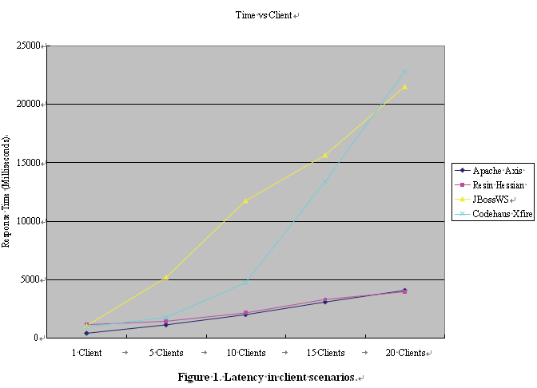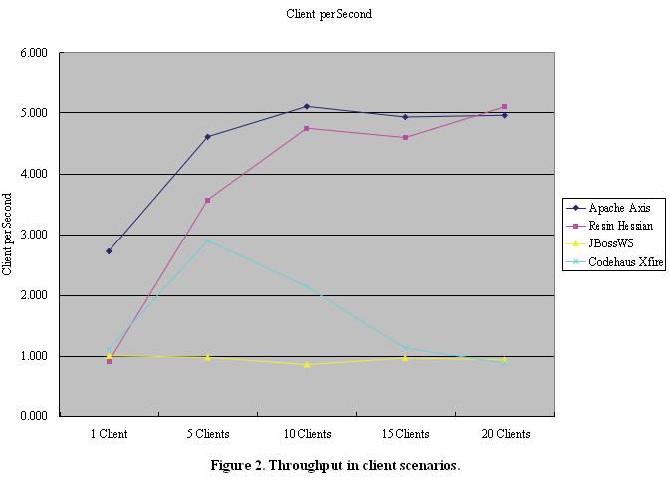

6．References

- A. Ching and A. Wagner, “Understanding Performance Testing,” Technical Report, Microsoft Developer Net- work, February 2001.
- F. Curbera, M. Duftler, R. Khalaf, W. Nagy, N. Mukhi, and S. Weerawarana, “Unraveling the Web Services Web: An Introduction to SOAP, WSDL, and UDDI,” IEEE In- ternet Computing, New York, March 2002, pp. 86-93.
- F. Curbera, R. Khalaf, N. Mukhi, S. Tai, and S. Weer- awarana, “The Next Step in Web Services,” Communica- tions of the ACM, New York, October 2003, pp. 29-34.
- S. Decker, S. Melnik, F. van Harmelen, D. Fensel, M. Klein, J. Broekstra, M. Erdmann, and I. Horrocks, “The Semantic Web: The Roles of XML and RDF,” IEEE In- ternet Computing, New York, September-October 2000, pp. 63-73.
- J. Hendler, “Agents and the Semantic Web,” IEEE Intel- ligent Systems, Maryland, March-April 2001, pp. 30-37.
- A. McIlraith Sheila, T. C. Son and H. Zeng, “Semantic Web Services,” IEEE Intelligent Systems, New York, March-April 2001, pp. 46-53.
- S. Narayanan and S. A. McIlraith, “Simulation, Verifica- tion and Automated Composition of Web Services,” In- ternational World Wide Web Conference, Honolulu, May 2002, pp. 77-88.
- J. Yang and M. P. Papazoglou, “Web Component: A Substrate for Web Service Reuse and Composition,” Lecture Notes in Computer Science, Vol. 2348, 2002, pp. 21-36.
- General Linear Model (GLM), http://www.statsoft.com/textbook/general-linear-models/
- Statistical Analysis with SAS/STAT Software, http://www.sas.com/technologies/analytics/statistics/stat/i ndex.html

Performance Evaluation of Java Web Services: A Developer’s Perspective
Sanjay Ahuja, Je-Loon Yang
School of Computing, University of North Florida, Jacksonville, Florida, USA E-mail: {sahuja, n00168553}@unf.edu
Received March 7, 2010; revised July 2, 2010; accepted July 3, 2010

Abstract

As the population of the Internet grows rapidly the development of web technologies becomes extremely important. For the evolvement of Web 2.0, web services are essential. Web services are programs that allow computers of different platforms on the web to interactively communicate without the need of extra data for human reading interfaces and formats such as web page structures. Since web service is a future trend for the growth of internet, the tools that are used for development is also important. Although there are many choices of web service frameworks to choose from, developers should choose the framework that fits best to their application based on performance, time and effort for the framework. In this project, we chose four common frameworks to compare them in both qualitative and quantitative metrics. After running the tests, the results are statistically analyzed by SAS.

Keywords: Web Service, Framework, Performance, Java, Developer

1.Introduction
For going on trips to other states or countries, the person usually requires to buy airplane tickets, rent a car, and make reservations for hotels to stay at. When dealing with airplane tickets, most of the time the person even has to buy several tickets for some stops instead of a ticket that takes the person directly to the final destina- tion. Looking up the airplane arrival and departure times to connect each flight might take hours of searching and planning. What if there was a virtual agent that could do this all in just a few seconds? So usually people would look for agents to do this for them. But what if this agent was actually is actually a virtual agent online. If the per- son just enters the location he wants to start from, the destination, the desired time for departure or arrival, and all the information required into the computer, in a snap, the computer shows all the results for the person to choose from and purchase the tickets. Even better, such virtual agents could have possibilities to also show information of the car rentals and hotels at the destination and reserve them for you. By using this type of virtual agent, could save much effort and time and can also be more accurate than human agents. Such technology relies on the development and widespread of web services.
Instead of developing a web service application from scratch, there are many open source frameworks that make development much easier. Which of these frame- works would be a better choice for web service application development? This study compares four popular open source frameworks both qualitatively and quantitatively by doing several tests and analysis. The four frameworks are Apache Axis, JBossWS, XFire, and Hessian. More introductions of web services are done in Section 2. Section 3 describes the four frameworks that are used in this study. In Section 4, the metrics that are used to measure the frameworks are explained in more detail. Section 5 introduces the statistical analysis methods that are use to analyze the measured results. In Section 6, the test results are shown and analyzed. The conclusions are in Section 7.

2.Web Service Frameworks
Since web services are designed to transfer data in com- mon ways, several companies and groups developed web service frameworks for the convenience of web service developers so that they do not need to write a complete web service from scratch. Some of the popular frame- works are Apache Axis, JBossWS, Codehaus XFire, and Caucho Hessian. In this section, these frameworks are going to be introduced.
2.1.Apache Axis
Apache Axis (Apache Extensible Interaction System) is an open source, Java and XML based Web service framework created by the Apache Software Foundation (ASF). The foundation is a non-profit corporation that mainly produces software for network use, such as serv- ers and frameworks for servers. Their projects are well known to be collaborative, consensus based development process and free or open source software. The Apache Axis package has an implementation of a SOAP server and API’s for generating and deploying web service applications. The SOAP engine constructs SOAP processors like clients, servers, and gateways. This allows the servers and clients to communicate through SOAP messages. The API supports a variety of lan- guages. Besides the Java version, a C++ implementation is also available. It allows developers to construct their application in a variety of ways. The easiest method only requires changing the file name extension from “.java” to “.jws”. The downside of such a method is lacks flexibility for further configuration.
2.2.JBossWS
JBossWS is JBoss' implementation of J2EE compatible web services. The framework is designed to fit better in the overall JBoss architecture and is generally more suitable for the specific J2EE requirements for web ser- vices. Instead of using the traditional Apache server for this framework, JBoss has a server of its own, and is suggested that the framework is used on this server to get best performance. Similar to ASF, the JBoss community is a group of people that focus on open source projects. Their projects emphasize on the development of Java Enterprise Middleware, which are software that act like bridge between applications, operating systems or both.
2.3.Codehaus XFire
Codehaus XFire is a next-generation java SOAP frame- work. It is a free and open source SOAP framework that allows you to implement web services with great ease and simplicity. It also provides many features identified in web service specifications, which are not yet available in most commercial or open source tools. It is claimed to have higher performance since it is built on a low memory StAX (Streaming API for XML) based model but there is no data to document this fact.
2.4.Hessian
The Hessian binary web service protocol makes developing web services simple and usable without requiring a large framework so that developers would not need to spend more time and effort to learn an alphabet soup of protocols.

3.Evaluation Metrics
Different factors are considered when comparing the four frameworks in this project. Some metrics are to deter- mine the performance and efficiency; some are to show the transparency and abstraction. This section explains these metrics.

3.1.Latency
In terms of network, latency is an expression of how much time it takes for data to be sent back to a request. This includes the time for the request to be sent to the server, the time the server spends on processing the task, and the time for the results to be sent back. The network latency is contributed by many factors, such as propagation, transmission, modem and router processing, and storage delays. The propagation is the time it takes for an object, such as data, to transfer from a location to another in the speed of light. Transmission is the delay from the medium like optical fiber or wireless networks. Modems and routers take time to check the headers of a packet. The storage delay is the time it takes for the actual hardware storage, such as hard drives, to store the received data. In this project, the latency is tested with different scenarios such as requesting 1, 2, 3, 4, and 5 MB of data, and 1, 5,10, 15, 20 clients simultaneous requesting data. From the results of such testing, trends can be found and compared for each framework.

3.2.Throughput
Throughput is the amount of clients or data processed within a certain unit of time, like a second. It is highly related to latency, since scenarios with high latency would result in low throughput, and scenarios with low latency would result in high throughput. However, by viewing the latency graph, we can only tell the trends of response time, while we can determine the most efficient scenario for a framework through viewing a throughput graph.

3.3.Memory Usage
In computing, memory is data storage to temporarily store data for calculations of the computer. There is a wide variety of memory, such as cache memory, flash memory, random access memory (RAM), virtual memory, etc. Either memory, they are all limited in server due to the cost and space. A framework that uses less memory would have an advantage of allowing higher capacity for the server.

3.4.CPU Usage
Central Processing Unit (CPU), also known as processor, is a component in a computer used to interpret program instructions and process data. Although it is only able to process one task at a time, when there are multiple tasks to be done, instead of finishing a task then going to an- other, the CPU is designed to switch to other tasks before finishing one if necessary, so that it would act like if it is executing multiple tasks at the same time. However, large tasks might occupy a lot of CPU time, which de- creases the time scheduled for other tasks. A framework that uses less CPU would allow the server to have more time to execute other tasks.

3.5.Source Lines of Code
The source lines of code (SLOC) used in a framework can indicate the transparency and abstraction of the framework. The main goal of a framework is to save the developer’s time and effort by not having to write the entire code from scratch. Thus the less lines of code that is required for a framework, the more time and effort is saved by this framework. However, lines of code cannot be exactly accurate since some lines might be long while some lines are short. So the number of files and size of files also is a consideration.

- Statistical Analysis Methods

After retrieving the test data to compare the performances, we need a method to analyze the results. By simply calculating the average response times and making them into a graphs is not sufficient for the analysis. Looking at the average response times 1.5 seconds and 1.6 seconds, we can not be sure if that is a great difference or not. Therefore, statistical analysis methods are required to tell if the difference is significant or not. In this project, the general linear model (GLM) [9] and two-way analysis of variance (two-way ANOVA) is used for statistical analysis. Furthermore, the Statistical Analysis System (SAS) [10] is used as a tool for aiding the calculations of the statistical analyses required.

4.1.The SAS System
The SAS system is statistical analysis software that has a wide variety of statistical modules and procedures. They use a fourth-generation programming language (4GL) for their code and the programs are composed by three main components – the data step, the procedure step, and the macro language. The data step is for entering data, like inserting the data in the code or read from data files. The procedure step is the use of the statistical methods and models to analysis the data that was read in the data step. The macro language is for decreasing the redundancy of functions that are used again and again throughout the program.

4.2.The GLM Model
The GLM model is a statistical linear model that is used in general cases. It is the foundation of many statistical analyses, such as t-test, ANOVA, Analysis of Covariance (ANCOVA), etc. The easiest case to understand how the GLM model works is the two-variable case. The goal of this analysis is to use a way to accurately describe the information in this plot. Using the GLM model, we try to find a straight line that is closest to all the dots in the plot. This line would be written as: y = b0 + b1x + e, where y is the y-axis variable, x is the x-axis variable, b0 is the intercept (the value of y when x equals 0), b1 is the slope of the straight line, and e is the error. By solving b0 and b1, we can get information about this linear line that describes the dots in the plot. In other cases with more than two variables, the formula can be extended as: y = b0 + b1x1 + b2x2 + b3x3 + ... + bnxn + e, where n is the number of variables of the situation. But the mechanism for solving such problems is the same.

5.Results and Analyses

In order to get best results from SAS analysis, each case is tested twenty times. Since four frameworks with five different amounts of clients are tested, there are twenty different cases. Adding the twenty test times for the twenty different cases would result 400 data sets to be calculated by SAS. Besides the amount of clients, the size of data is also considered. With also five different sizes of data sent, there would be twenty cases with a total of 400 data sets. The response time is measured by recording the time right before invoking the web service and recording the time right after the data requested is received then subtracting the time difference.

5.1.Results
5.1.1.Client Scenarios
For testing the four different frameworks in different scenarios, web service applications to send out data are created. The five scenarios based on amount of clients for testing performance of the four frameworks are 1 client, 5 clients, 10 clients, 15 clients, and 20 clients each retrieving 1 MB of data. The average response time for each scenario and each framework is recorded for analysis. The results are as shown in Figure 1. By calculating the results to throughput, Figure 2 shows the average clients per second for each scenario and framework.
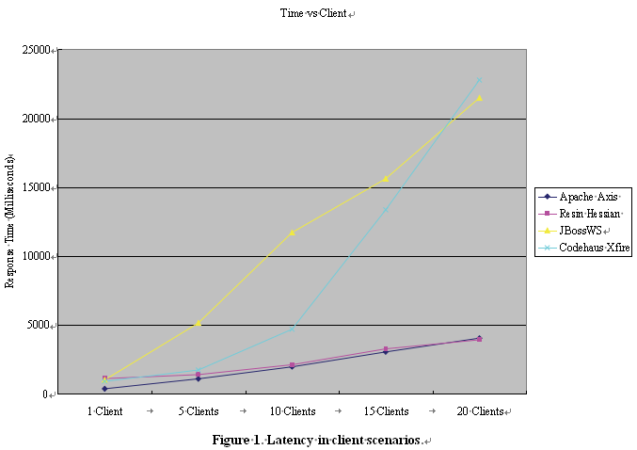
- A. Ching and A. Wagner, “Understanding Performance Testing,” Technical Report, Microsoft Developer Net- work, February 2001.
- F. Curbera, M. Duftler, R. Khalaf, W. Nagy, N. Mukhi, and S. Weerawarana, “Unraveling the Web Services Web: An Introduction to SOAP, WSDL, and UDDI,” IEEE In- ternet Computing, New York, March 2002, pp. 86-93.
- F. Curbera, R. Khalaf, N. Mukhi, S. Tai, and S. Weer- awarana, “The Next Step in Web Services,” Communica- tions of the ACM, New York, October 2003, pp. 29-34.
- S. Decker, S. Melnik, F. van Harmelen, D. Fensel, M. Klein, J. Broekstra, M. Erdmann, and I. Horrocks, “The Semantic Web: The Roles of XML and RDF,” IEEE In- ternet Computing, New York, September-October 2000, pp. 63-73.
- J. Hendler, “Agents and the Semantic Web,” IEEE Intel- ligent Systems, Maryland, March-April 2001, pp. 30-37.
- A. McIlraith Sheila, T. C. Son and H. Zeng, “Semantic Web Services,” IEEE Intelligent Systems, New York, March-April 2001, pp. 46-53.
- S. Narayanan and S. A. McIlraith, “Simulation, Verifica- tion and Automated Composition of Web Services,” In- ternational World Wide Web Conference, Honolulu, May 2002, pp. 77-88.
- J. Yang and M. P. Papazoglou, “Web Component: A Substrate for Web Service Reuse and Composition,” Lecture Notes in Computer Science, Vol. 2348, 2002, pp. 21-36.
- General Linear Model (GLM), http://www.statsoft.com/textbook/general-linear-models/
- Statistical Analysis with SAS/STAT Software, http://www.sas.com/technologies/analytics/statistics/stat/i ndex.html

