Software Engineering Specification
for
Multimodal Video Understanding Engine
Version 0.2 Draft
Prepared by Thamer
Date: 2026-05-28

Revision History
Table 1. Revision History
Name | Date | Reason For Changes | Version
Thamer | 2026-05-28 | Initial requirements draft based on the IEEE template and MVP discussion | 0.1
Thamer | 2026-05-28 | Consolidated requirements, design, architecture, and analysis diagrams into one software engineering specification | 0.2

Table of Contents
Revision History 1
List of Tables 1
List of Figures 1
Part I. Introduction and Requirements 1
1. Introduction 1
1.1 Purpose 1
1.2 Document Conventions 1
1.3 Intended Audience and Reading Suggestions 1
1.4 Product Scope 1
1.5 References 1
2. Overall Description 1
2.1 Product Perspective 1
2.2 Product Functions 1
2.3 User Classes and Characteristics 1
2.4 Operating Environment 1
2.5 Design and Implementation Constraints 1
2.6 User Documentation 1
2.7 Assumptions and Dependencies 1
3. External Interface Requirements 1
3.1 User Interfaces 1
3.2 Hardware Interfaces 1
3.3 Software Interfaces 1
3.4 Communications Interfaces 1
4. System Features 1
4.1 Video Upload 1
4.2 Video Preprocessing 1
4.3 Visual Analysis and Timeline Generation 1
4.4 Video Question Answering 1
4.5 Storage and Retrieval 1
5. Other Nonfunctional Requirements 1
5.1 Performance Requirements 1
5.2 Safety Requirements 1
5.3 Security Requirements 1
5.4 Software Quality Attributes 1
5.5 Business Rules 1
6. Other Requirements 1
Part II. Software Architecture 1
7. Software Architecture 1
7.1 Architecture Goals 1
7.2 Architectural Style: Modular Monolith 1
7.3 Layered Module Boundaries 1
7.4 API Boundaries 1
7.5 Pipeline Orchestration 1
7.6 Data and Storage Architecture 1
7.7 Async Readiness 1
7.8 Error and Status Handling 1
7.9 Testability 1
7.10 Architecture Decisions 1
Part III. Software Design 1
8. Software Design 1
8.1 Proposed Project Structure 1
8.2 API Layer Design 1
8.3 Application Service Design 1
8.4 Infrastructure Adapter Design 1
8.5 Repository Design 1
8.6 Domain Model Design 1
8.7 Error Handling Design 1
8.8 Configuration Design 1
9. Data Design 1
9.1 File Storage Design 1
9.2 Database Entities 1
9.3 Indexing Strategy 1
9.4 Status Model 1
9.5 Implementation Schema Summary 1
9.6 Persistence Technology Decision 1
10. API and Integration Design 1
10.1 Upload Video 1
10.2 Analyze Video 1
10.3 Get Video Status 1
10.4 Get Timeline 1
10.5 Ask Video 1
10.6 External Integration Contracts 1
10.7 API Error Envelope 1
10.8 Pipeline Stage Contracts 1
10.9 Request Limits and Identifier Rules 1
Part IV. Verification, Release, and Supporting Models 1
11. Testing Strategy 1
11.1 Unit Tests 1
11.2 Integration Tests 1
11.3 Manual Acceptance Test 1
12. Implementation and Release Plan 1
12.1 Implementation Milestones 1
12.2 Release Scope 1
12.3 GitHub Release Readiness 1
13. Traceability Matrix 1
Appendix A: Glossary 1
Appendix B: Analysis Models and Diagrams 1
B.1 Diagram Index 1
B.2 Use Case Diagram 1
B.3 Use Case Summary 1
B.4 System Context Diagram 1
B.5 Level-1 Data Flow Diagram 1
B.6 Processing Pipeline Diagram 1
B.7 Activity Diagram 1
B.8 Upload and Analysis Sequence Diagram 1
B.9 Ask Video Sequence Diagram 1
B.10 Domain Class Diagram 1
B.11 Entity Relationship Diagram 1
B.12 Video Status State Diagram 1
B.13 Component Diagram 1
B.14 Deployment Diagram 1
B.15 API and Integration Swimlane Diagram 1
B.16 Proposed Initial API Endpoints 1
B.17 Diagram-to-Requirement Traceability 1
Appendix C: To Be Determined List 1

List of Tables
Table 1. Revision History 1
Table 2. 1.5 References 1
Table 3. 2.3 User Classes and Characteristics 1
Table 4. 3.3 Software Interfaces 1
Table 5. 7.3 Layered Module Boundaries 1
Table 6. 7.4 API Boundaries 1
Table 7. 7.10 Architecture Decisions 1
Table 8. 8.1 Proposed Project Structure 1
Table 9. 8.3 Application Service Design 1
Table 10. 8.4 Infrastructure Adapter Design 1
Table 11. 8.7 Error Handling Design 1
Table 12. 8.8 Configuration Design 1
Table 13. 9.1 File Storage Design 1
Table 14. 9.2 Database Entities 1
Table 15. 9.3 Indexing Strategy 1
Table 16. 9.4 Status Model 1
Table 17. 9.5 Implementation Schema Summary 1
Table 18. 10.6 External Integration Contracts 1
Table 19. 10.8 Pipeline Stage Contracts 1
Table 20. 12.1 Implementation Milestones 1
Table 21. 13. Traceability Matrix 1
Table 22. Appendix A: Glossary 1
Table 23. B.1 Diagram Index 1
Table 24. B.3 Use Case Summary 1
Table 25. B.16 Proposed Initial API Endpoints 1
Table 26. B.17 Diagram-to-Requirement Traceability 1
Table 27. Appendix C: To Be Determined List 1

List of Figures
Figure 1. Use Case Diagram 1
Figure 2. System Context Diagram 1
Figure 3. Level-1 Data Flow Diagram 1
Figure 4. Processing Pipeline Diagram 1
Figure 5. Activity Diagram 1
Figure 6. Upload and Analysis Sequence Diagram 1
Figure 7. Ask Video Sequence Diagram 1
Figure 8. Domain Class Diagram 1
Figure 9. Entity Relationship Diagram 1
Figure 10. Video Status State Diagram 1
Figure 11. Component Diagram 1
Figure 12. Deployment Diagram 1
Figure 13. API and Integration Swimlane Diagram 1

Part I. Introduction and Requirements
This part presents the SRS content for the project. It defines the product scope, external interfaces, system features, nonfunctional requirements, constraints, assumptions, and remaining TBD items that must be understood before implementation starts.

1. Introduction

1.1 Purpose
This Software Engineering Specification defines the requirements, architecture, software design, data design, testing strategy, and release plan for the first MVP release of the Multimodal Video Understanding Engine. The system allows a user to upload a video, preprocess it into audio transcript segments and key visual frames, build a timestamped timeline, and ask natural-language questions about the uploaded video.
The scope of this document is the backend-centered MVP. It covers video upload, preprocessing, transcription, frame extraction, scene detection, visual analysis, timeline generation, basic video question answering, local metadata storage, software architecture, module boundaries, API contracts, database design, and testing expectations. It does not cover custom model training, production authentication, real-time video streaming, or large-scale distributed processing.

1.2 Document Conventions
The requirements portion of this document follows the IEEE requirements template structure, while later sections define the software design and architecture needed for implementation. Requirement identifiers use the following prefixes:
- FR: Functional Requirement
- NFR: Nonfunctional Requirement
- BR: Business Rule
- TBD: To Be Determined item
Priority is marked as High, Medium, or Low. High priority requirements are required for the MVP unless explicitly moved out of scope.

1.3 Intended Audience and Reading Suggestions
This document is intended for the project owner, academic supervisor, developers, testers, and future maintainers. Readers should start with the Product Scope and Overall Description to understand the product vision, then review System Features for functional behavior, Software Architecture and Software Design for implementation structure, and Testing Strategy for verification expectations.

1.4 Product Scope
The Multimodal Video Understanding Engine is a web API system that turns uploaded videos into a searchable and question-answerable video memory. Instead of sending every frame to an AI model, the system extracts the important parts of the video: audio transcript with timestamps, keyframes, scene boundaries, visual summaries, and a chronological timeline.
The main objective is to let a user ask questions such as:
- What happened at second 15?
- Summarize the video.
- Did anything unusual happen?
- Identify interface errors shown in the video.
The MVP goal is to prove the software pipeline, not to train a new model.

1.5 References
This reference list is treated as a living section. It should be checked during implementation and before release so external tool behavior, API names, and version notes stay current.
Table 2. 1.5 References
Reference | Purpose | Link
IEEE SRS Template | Source template provided by the user for the requirements structure. | Local file: srs_template-ieee (3).doc
Project MVP Notes | Project discussion and scope notes for the video understanding engine. | Internal project notes
FastAPI Documentation | REST API framework, request validation, OpenAPI documentation, and testing support. | FastAPI
FFmpeg Documentation | Audio extraction and video processing command behavior. | FFmpeg
OpenCV Documentation | Frame extraction and video decoding reference. | OpenCV
PySceneDetect Documentation | Scene boundary detection reference. | PySceneDetect
OpenAI Speech to Text Documentation | Transcription API behavior and timestamp planning. | OpenAI Speech to Text
OpenAI Images and Vision Documentation | Vision-language analysis behavior for selected frames. | OpenAI Images and Vision
SQLAlchemy Documentation | Database access and repository implementation reference. | SQLAlchemy
Alembic Documentation | Migration planning once schema changes | Alembic

2. Overall Description

2.1 Product Perspective
The product is a new standalone software system. It acts as an orchestration layer around video processing tools, speech-to-text services, vision-language analysis, and language model reasoning. The first version will expose REST API endpoints and use local file storage plus a lightweight database for metadata.
At a high level, the system flow is:
- User uploads a video.
- System stores the video file.
- System extracts audio from the video.
- System transcribes the audio with timestamps.
- System samples keyframes and detects scenes.
- System analyzes selected visual frames.
- System builds a chronological timeline.
- User asks questions about the video.
- System answers using stored transcript, timeline, frame summaries, and relevant timestamps.

2.2 Product Functions
The product must provide the following major functions:
- Upload video files through an API endpoint.
- Validate video type and size.
- Extract audio from uploaded video files.
- Generate transcript text with timestamps.
- Extract keyframes at fixed intervals and, later, by scene changes.
- Detect scene boundaries.
- Analyze selected frames with a vision-language model.
- Generate a structured timeline of events.
- Store video metadata, transcript, keyframes, scene data, and timeline records.
- Answer user questions about a processed video with timestamped evidence.

2.3 User Classes and Characteristics
Table 3. 2.3 User Classes and Characteristics
User Class | Description | Main Needs
Primary User | A student, evaluator, or end user who uploads a video and asks questions about it. | Simple upload, clear timeline, accurate answers with timestamps.
Developer | The engineer implementing and maintaining the backend pipeline. | Modular code, clear API contracts, testable processing steps.
Tester or Evaluator | A reviewer verifying the system behavior for project grading or QA. | Repeatable test videos, visible outputs, clear success criteria.
Future Admin | A future role that may manage uploaded videos, storage, and system settings. | Access control, cleanup tools, monitoring. Not required for MVP.

2.4 Operating Environment
The MVP will run in a local development environment with:
- macOS or Linux development machine.
- Python 3.11 or newer.
- FastAPI backend.
- Uvicorn development server.
- FFmpeg installed on the host machine.
- OpenCV for frame extraction.
- PySceneDetect for scene detection.
- OpenAI API access for transcription and vision-language reasoning.
- SQLite for initial metadata storage, with PostgreSQL as a future upgrade.
- Local folders for uploaded videos, extracted audio, and keyframes.

2.5 Design and Implementation Constraints
- The MVP must not require training a custom AI model.
- The first release must prioritize a working pipeline over dashboard, login, or microservices.
- Video processing depends on FFmpeg being installed.
- Transcription and vision analysis depend on external model APIs and valid API credentials.
- Uploaded files must be stored safely and must not overwrite unrelated files.
- Processing large videos may be slow or expensive, so the MVP should target short videos first.
- The system must preserve timestamps across transcript, frames, scenes, timeline events, and answers.

2.6 User Documentation
The MVP should include:
- README with setup instructions.
- Environment variable guide, including API key configuration.
- API endpoint documentation through FastAPI Swagger UI.
- Sample workflow for uploading and analyzing a short video.
- Testing instructions.

2.7 Assumptions and Dependencies
- Users will initially upload short videos suitable for local development testing.
- Supported formats for the MVP are mp4 and mov. Other formats are TBD.
- The user has permission to process the uploaded video.
- The development machine has enough disk space for uploads, audio files, and extracted frames.
- External AI APIs are available during analysis.
- The first release does not require real-time processing or live camera input.

3. External Interface Requirements

3.1 User Interfaces
The MVP user interface will be FastAPI Swagger UI. A later web interface may be built with React or Vite.
The expected screens or views for a future UI are:
- Video upload view.
- Analysis status view.
- Timeline view with timestamped events.
- Video question-answering chat view.
- Evidence view showing relevant timestamps and keyframes.

3.2 Hardware Interfaces
No special hardware interface is required for the MVP. The system should run on a standard development laptop. GPU acceleration is not required for the first release because model inference will be handled through external APIs.

3.3 Software Interfaces
Table 4. 3.3 Software Interfaces
Component | Purpose
FastAPI | REST API backend framework.
FFmpeg | Extract audio from video and support video processing operations.
OpenCV | Read videos and extract frames.
PySceneDetect | Detect scene boundaries.
OpenAI Transcription API | Convert extracted audio into transcript text with timestamps.
OpenAI Vision-capable model | Analyze keyframes and visual context.
SQLite | Store metadata and analysis records for the MVP.
SQLAlchemy | Provide database access through repository classes.
Alembic | Manage database migrations once the schema stabilizes for release.

3.4 Communications Interfaces
The system will expose HTTP REST endpoints. File upload must use multipart/form-data. Structured responses must use JSON. Future deployment should use HTTPS to protect uploaded media, transcripts, and analysis results.

4. System Features

4.1 Video Upload

4.1.1 Description and Priority
Priority: High.
The system shall allow the user to upload a video file for processing.

4.1.2 Stimulus/Response Sequences
- User sends a video file to the upload endpoint.
- System validates the file type and stores the file.
- System creates a video record with a unique identifier.
- System returns the video identifier and initial status.

4.1.3 Functional Requirements
- FR-1: The system shall provide an endpoint to upload a video file.
- FR-2: The system shall accept mp4 and mov files for the MVP.
- FR-3: The system shall reject unsupported file types with a clear error response.
- FR-4: The system shall store uploaded videos in a dedicated uploads directory.
- FR-5: The system shall generate a unique video identifier for each upload.
- FR-6: The system shall prevent uploaded files from overwriting existing files.

4.2 Video Preprocessing

4.2.1 Description and Priority
Priority: High.
The system shall preprocess uploaded videos by extracting audio, transcript segments, keyframes, and scene boundaries.

4.2.2 Stimulus/Response Sequences
- User requests analysis for an uploaded video.
- System extracts audio from the video.
- System transcribes the audio.
- System extracts keyframes at configured intervals.
- System detects scene boundaries.
- System stores preprocessing outputs.

4.2.3 Functional Requirements
- FR-7: The system shall extract audio from an uploaded video using FFmpeg.
- FR-8: The system shall store extracted audio in a dedicated audio directory.
- FR-9: The system shall transcribe extracted audio using a transcription service.
- FR-10: The system shall preserve transcript timestamps when available.
- FR-11: The system shall extract keyframes at a configurable interval.
- FR-12: The system shall store keyframes with their source video identifier and timestamp.
- FR-13: The system shall detect scene changes when scene detection is enabled.
- FR-14: The system shall store scene start and end timestamps.
- FR-15: The system shall mark analysis status as failed if a preprocessing step fails.

4.3 Visual Analysis and Timeline Generation

4.3.1 Description and Priority
Priority: High.
The system shall analyze selected keyframes and combine visual information with transcript segments to produce a chronological timeline.

4.3.2 Stimulus/Response Sequences
- System selects frames and transcript segments for each scene or time interval.
- System sends selected visual and textual context to a vision-language model.
- System stores visual summaries.
- System builds timeline events.
- User requests the timeline.
- System returns ordered events with timestamps.

4.3.3 Functional Requirements
- FR-16: The system shall create a visual summary for selected keyframes.
- FR-17: The system shall connect visual summaries to timestamps.
- FR-18: The system shall combine transcript segments and visual summaries into timeline events.
- FR-19: The system shall return timeline events sorted by start time.
- FR-20: Each timeline event shall include start time, end time when available, summary, and evidence references.
- FR-21: The system shall avoid sending every video frame to the model by default.

4.4 Video Question Answering

4.4.1 Description and Priority
Priority: High.
The system shall allow the user to ask natural-language questions about a processed video.

4.4.2 Stimulus/Response Sequences
- User submits a question for a specific video.
- System retrieves relevant transcript segments, timeline events, and frame summaries.
- System generates an answer using the retrieved evidence.
- System returns the answer with timestamped evidence.

4.4.3 Functional Requirements
- FR-22: The system shall provide an endpoint for asking questions about a video.
- FR-23: The system shall reject questions for videos that have not been analyzed.
- FR-24: The system shall retrieve relevant timeline and transcript context before answering.
- FR-25: The system shall include timestamped evidence in the answer when possible.
- FR-26: The system shall support questions about a specific timestamp.
- FR-27: The system shall support summary questions about the full video.
- FR-28: The system shall return a clear response when the evidence is insufficient.

4.5 Storage and Retrieval

4.5.1 Description and Priority
Priority: Medium.
The system shall store metadata and analysis results so the same video does not need to be fully reprocessed for every user question.

4.5.2 Stimulus/Response Sequences
- System completes an analysis step.
- System writes resulting metadata to storage.
- User requests timeline or asks a question.
- System reads existing records instead of repeating the full pipeline.

4.5.3 Functional Requirements
- FR-29: The system shall store video metadata, including filename, storage path, upload time, and analysis status.
- FR-30: The system shall store transcript segments.
- FR-31: The system shall store keyframe metadata.
- FR-32: The system shall store scene metadata.
- FR-33: The system shall store timeline events.
- FR-34: The system shall support retrieving a video timeline by video identifier.
- FR-35: The system shall support retrieving video processing status by video identifier.

5. Other Nonfunctional Requirements

5.1 Performance Requirements
- NFR-1: The system should avoid analyzing every frame of a video unless explicitly configured to do so.
- NFR-2: The system should support configurable frame sampling intervals.
- NFR-3: For MVP testing, the system should target short videos up to 2 minutes. Larger limits are TBD.
- NFR-4: The system should reuse stored analysis results for repeated questions.
- NFR-5: Long-running analysis should be designed so it can later move to a background queue.

5.2 Safety Requirements
- NFR-6: The system shall validate uploaded file extensions and content type before processing.
- NFR-7: The system shall isolate uploaded media files in project-controlled directories.
- NFR-8: The system shall handle corrupted or unreadable video files without crashing the API process.
- NFR-9: The system shall not execute uploaded files as programs or scripts.

5.3 Security Requirements
- NFR-10: API keys shall be loaded from environment variables and shall not be committed to source control.
- NFR-11: Uploaded videos and extracted assets shall not be publicly exposed in the MVP unless explicitly served through controlled endpoints.
- NFR-12: The system shall avoid logging sensitive API keys or full external service credentials.
- NFR-13: A maximum upload size shall be defined before deployment. See TBD-2.
- NFR-14: Production deployment shall use HTTPS.

5.4 Software Quality Attributes
- NFR-15: The backend shall be organized into separate modules for upload handling, video processing, transcription, frame extraction, timeline building, and question answering.
- NFR-16: Core processing functions shall be testable without requiring the FastAPI server to run.
- NFR-17: The system shall produce traceable outputs so answers can be linked back to timestamps and evidence.
- NFR-18: The API shall return clear error messages for invalid video IDs, unsupported files, failed analysis, and missing configuration.
- NFR-19: The codebase shall support replacing SQLite with PostgreSQL in a future release.

5.5 Business Rules
- BR-1: The MVP shall focus on a working pipeline and shall not include custom model training.
- BR-2: A user cannot ask questions about a video until analysis has completed successfully.
- BR-3: Answers should cite timestamps or frame references whenever evidence exists.
- BR-4: The system should not reprocess a video from scratch for every question.
- BR-5: Authentication and user accounts are out of scope for the first MVP unless required by the course evaluator.

6. Other Requirements
- OR-1: The project shall include a README with installation and usage instructions.
- OR-2: The project shall include a .env.example file documenting required environment variables.
- OR-3: The project shall include a simple test strategy before implementation is considered complete.
- OR-4: The project should be prepared for GitHub release with a clear repository structure.
- OR-5: Docker support is optional for the first release and may be added after the local MVP works.

Part II. Software Architecture
This part defines the high-level architecture before the detailed design. In standard software engineering practice, architecture comes before detailed module design because it decides the system style, boundaries, deployment assumptions, data ownership, integration direction, and major technical constraints. The later design section then translates these decisions into files, classes, APIs, schemas, and tests.

7. Software Architecture
This section defines the architectural foundation for the MVP. The purpose is to make implementation easier, safer, and more professional by clarifying module boundaries, data ownership, processing flow, status handling, and future extension points before coding begins.

7.1 Architecture Goals
- Build a local-first MVP that proves the video understanding pipeline.
- Use a modular monolith to keep development simple while preserving clean internal boundaries.
- Make transcription, frame analysis, storage, and question answering replaceable.
- Preserve timestamp traceability from raw video to final answer.
- Keep the design ready for background workers without requiring them in the first MVP.
- Avoid custom model training in the MVP and rely on proven external AI services.

7.2 Architectural Style: Modular Monolith
The backend will run as one FastAPI application. Internally, the application will be divided into modules by responsibility. This avoids the complexity of early microservices while still preventing the codebase from becoming one large script.
Architectural rules:
- API routes shall not call FFmpeg, OpenCV, PySceneDetect, or OpenAI directly.
- Application services shall orchestrate workflows.
- Infrastructure adapters shall isolate external tools and APIs.
- Repositories shall isolate database access.
- Domain objects shall represent video memory concepts such as videos, transcript segments, keyframes, scenes, timeline events, and evidence links.

7.3 Layered Module Boundaries
Table 5. 7.3 Layered Module Boundaries
Layer | Responsibility | Examples
API Layer | HTTP endpoints, request validation, response schemas, HTTP errors | app/api/videos.py, app/schemas.py
Application Layer | Main workflows and business orchestration | video_storage.py, video_processor.py, timeline_builder.py, question_answerer.py
Domain Layer | Core entities and status concepts | Video, TranscriptSegment, Keyframe, Scene, TimelineEvent, EvidenceLink
Persistence Layer | Database models and repositories | video_repository.py, SQLite models
Infrastructure Layer | External tools, file storage, and AI API clients | FFmpeg, OpenCV, PySceneDetect, OpenAI clients

7.4 API Boundaries
The MVP API should remain small and explicit:
Table 6. 7.4 API Boundaries
Endpoint | Purpose
POST /videos/upload | Upload a video and create a video record.
POST /videos/{video_id}/analyze | Run the analysis pipeline for an uploaded video.
GET /videos/{video_id}/status | Return the current processing status and failure reason when available.
GET /videos/{video_id}/timeline | Return stored timeline events.
POST /videos/{video_id}/ask | Answer a question using stored video memory.

The API should return clear error responses for invalid input, unsupported files, missing video records, ask-before-analysis conflicts, failed processing, and missing configuration.

7.5 Pipeline Orchestration
The VideoProcessor service coordinates the pipeline but does not implement every processing detail directly. Each step should be its own service with a structured input and output.
Pipeline steps:
- Validate and store the uploaded video.
- Extract audio from the video.
- Transcribe audio and preserve timestamps when available.
- Extract keyframes at a configurable interval.
- Detect scene boundaries.
- Analyze selected frames.
- Build timeline events from transcript, scenes, and visual summaries.
- Store analysis results for reuse.
- Answer questions using stored evidence.
The system shall not reprocess a full video for every user question.

7.6 Data and Storage Architecture
Large media files should be stored as local files in the MVP. Metadata and analysis outputs should be stored in SQLite.
Storage rules:
- Store uploaded videos under `data/uploads`.
- Store extracted audio under `data/audio`.
- Store keyframes under `data/frames/{video_id}`.
- Store paths, timestamps, summaries, status values, and evidence links in the database.
- Keep database schema compatible with future PostgreSQL migration.
- Add indexes for `video_id`, `(video_id, start_time)`, and timeline lookup fields during implementation.

7.7 Async Readiness
The MVP may execute analysis synchronously, but the architecture should treat analysis as a job-like workflow. This makes it easier to move analysis to Redis and Celery later.
Async-ready rules:
- Store video status explicitly.
- Expose status through an API endpoint.
- Keep pipeline steps idempotent where practical.
- Make retry from `failed` to `processing` explicit.
- Avoid keeping processing state only in memory.

7.8 Error and Status Handling
Valid video states:
- `uploaded`
- `processing`
- `analyzed`
- `failed`
The system should use controlled exceptions for validation errors, not found errors, conflict errors, processing errors, and configuration errors. It must not expose stack traces, API keys, or internal secrets through API responses. When processing fails, the failure reason should be saved safely on the video record.

7.9 Testability
The architecture must support testing without requiring real external AI calls for every test.
Testing rules:
- Use fake transcription and vision clients in unit and integration tests.
- Unit test each processing service without starting FastAPI.
- Integration test endpoints with mocked AI calls.
- Use temporary directories and a temporary SQLite database.
- Test unsupported file type, missing video ID, corrupted video, ask-before-analysis, successful timeline retrieval, and successful question answering.

7.10 Architecture Decisions
Table 7. 7.10 Architecture Decisions
Decision | Rationale | Consequence
Modular monolith | Fast MVP with clean internal boundaries | Easier development now, still extensible later
SQLite first | Simple local setup and demo | PostgreSQL migration can be added later
SQLAlchemy repository access | Keeps database code isolated and migration-friendly | Slight setup overhead, better maintainability
Alembic before release | Makes schema changes traceable | Can be introduced after the first tables are stable
Local files for media | Avoid storing large blobs in the database | Requires cleanup policy later
External AI APIs | Avoid custom model training in MVP | Requires API key, cost control, and mocking in tests
Timestamped evidence | Makes answers trustworthy and verifiable | Requires careful timestamp and evidence modeling
Explicit status model | Supports retries and future background workers | Requires status endpoint and consistent transitions

Part III. Software Design
This part turns the architecture into implementable design decisions. It explains the repository structure, API layer, application services, infrastructure adapters, domain model, database schema, integration contracts, and data movement rules that the coding phase should follow.

8. Software Design
This section translates the requirements and architecture into practical implementation boundaries. The goal is to make the first coding phase predictable: each module should have a clear reason to exist, a narrow responsibility, and a testable contract.

8.1 Proposed Project Structure
The repository should be organized by responsibility instead of by technical accident. The structure below keeps API code, workflow orchestration, domain concepts, external adapters, persistence, tests, and documentation separated while still remaining simple enough for an MVP.
Table 8. 8.1 Proposed Project Structure
Area | Location | Design Responsibility
Application entry point | app/main.py | Creates the FastAPI application, registers routers, and exposes the local development server entry point.
Configuration | app/config.py | Loads environment variables, paths, upload limits, model settings, and feature flags from one controlled place.
Database setup | app/database.py | Creates the database engine, sessions, and initialization helpers used by repositories.
API package | app/api/videos.py | Defines upload, analyze, status, timeline, and ask endpoints without owning processing logic.
Schema package | app/schemas.py | Defines Pydantic request and response models so API contracts stay explicit.
Domain package | app/domain | Defines entities, statuses, and controlled errors that represent the video memory model.
Service package | app/services | Coordinates upload storage, analysis, timeline generation, and question answering workflows.
Adapter package | app/adapters | Wraps FFmpeg, OpenCV, PySceneDetect, transcription APIs, and vision-language APIs.
Repository package | app/repositories | Persists and retrieves videos, transcript segments, keyframes, scenes, timeline events, and evidence links.
Database models | app/db/models.py | Defines ORM models that map the domain data to SQLite tables.
Runtime data | data/uploads, data/audio, data/frames | Stores large local media artifacts outside the database.
SQLite database | data/video_ai.sqlite3 | Stores metadata and analysis records for the MVP.
Automated tests | tests | Verifies upload behavior, frame extraction, timeline building, API contracts, and error cases.
Project documentation | docs | Stores this software engineering specification and supporting diagrams.
Setup files | requirements.txt, .env.example, README.md | Defines dependencies, environment variables, and user setup workflow.

Application entry point. The main file should stay thin. It should create the app, include routers, and configure startup behavior only.
API package. Route handlers should validate HTTP requests and map application errors to HTTP responses. They should not run FFmpeg commands, call AI APIs, or write database records directly.
Domain package. Domain files define the shared vocabulary of the system: video statuses, entity fields, evidence types, and safe application errors.
Service package. Services own the workflow. For example, the video processor coordinates audio extraction, transcription, keyframe sampling, scene detection, frame analysis, timeline building, status changes, and persistence.
Adapter package. Adapters protect the core system from tool-specific details. If FFmpeg, OpenCV, PySceneDetect, or the AI provider changes later, the change should mostly stay inside this layer.
Repository package. Repositories keep SQLAlchemy and SQL details away from API handlers and services. This makes tests easier and keeps the future PostgreSQL migration cleaner.
Runtime data folders. The MVP stores large files on disk and stores only metadata in SQLite. This avoids putting video blobs inside the database and keeps local development simple.
Automated tests. Tests should use temporary folders, a temporary SQLite database, and fake AI clients so most verification can run without external API cost.

8.2 API Layer Design
Primary file: app/api/videos.py.
Responsibilities:
- Define the video upload, analysis, status, timeline, and question-answering endpoints.
- Validate HTTP requests and return structured JSON responses.
- Convert application errors into appropriate HTTP status codes.
- Use Pydantic request and response schemas.
- Avoid direct calls to FFmpeg, OpenCV, PySceneDetect, OpenAI APIs, or database internals.

8.3 Application Service Design
Application services coordinate the system workflows. They are allowed to call repositories and infrastructure adapters, but they should not contain low-level processing details.
Table 9. 8.3 Application Service Design
Service | Primary Responsibility
video_storage.py | Validate file metadata, generate safe names, store uploaded videos, and create video records.
video_processor.py | Orchestrate the full analysis workflow and status transitions.
timeline_builder.py | Merge transcript segments, scenes, and visual summaries into ordered timeline events.
question_answerer.py | Retrieve relevant evidence and generate answers with timestamp references.

8.4 Infrastructure Adapter Design
Infrastructure adapters isolate external tools and APIs behind small local interfaces. This keeps the core application testable and makes later replacement easier.
Table 10. 8.4 Infrastructure Adapter Design
Adapter | Tool or API | Output
adapters/audio_extractor.py | FFmpeg | Audio file path and extraction metadata.
adapters/transcriber.py | OpenAI transcription service | Transcript segments with timestamps when available.
adapters/frame_extractor.py | OpenCV | Keyframe records with timestamps and file paths.
adapters/scene_detector.py | PySceneDetect | Scene start and end timestamps.
adapters/frame_analyzer.py | Vision-language model | Visual summaries linked to frames and timestamps.

8.5 Repository Design
Primary file: app/repositories/video_repository.py.
Responsibilities:
- Create and update video records.
- Persist transcript segments, keyframes, scenes, timeline events, and evidence links.
- Retrieve timeline data by video identifier.
- Retrieve video status and failure reason.
- Keep database operations away from API route handlers and processing services.

8.6 Domain Model Design
The domain model should represent the video memory created by the pipeline:
- `Video`: upload metadata, storage path, status, timestamps, and safe failure reason.
- `TranscriptSegment`: timestamped audio text.
- `Keyframe`: selected frame path, timestamp, and optional visual summary.
- `Scene`: detected start and end timestamps with optional summary.
- `TimelineEvent`: ordered description of what happened during a time interval.
- `EvidenceLink`: link from an answer or timeline event back to transcript, frame, scene, or timeline evidence.

8.7 Error Handling Design
The implementation should use controlled application exceptions instead of leaking raw tool or API failures into route handlers.
Table 11. 8.7 Error Handling Design
Error Type | Example | API Response
Validation error | Unsupported file extension | 400
Not found | Unknown video ID | 404
Conflict | Ask before analysis completes | 409
Processing error | FFmpeg fails or video is corrupted | 500 with safe message
Configuration error | Missing API key | 500 with safe message

Internal logs may contain diagnostic details, but API responses must not expose API keys, local secrets, full stack traces, or sensitive file paths.

8.8 Configuration Design
Configuration should be loaded from environment variables through one central settings module.
Table 12. 8.8 Configuration Design
Variable | Purpose | Default
OPENAI_API_KEY | API key for transcription and vision-language analysis. | Required
DATABASE_URL | SQLite database path or future PostgreSQL URL. | sqlite:///data/video_ai.sqlite3
UPLOAD_DIR | Uploaded video directory. | data/uploads
AUDIO_DIR | Extracted audio directory. | data/audio
FRAME_DIR | Extracted frame directory. | data/frames
FRAME_SAMPLE_SECONDS | Frame sampling interval. | 2
MAX_UPLOAD_MB | Maximum upload size. | TBD

9. Data Design
The MVP uses local files for large media assets and SQLite for metadata. This split keeps the database small, makes local development simple, and keeps the schema migration-friendly for PostgreSQL later.

9.1 File Storage Design
Table 13. 9.1 File Storage Design
Asset | Storage Location | Notes
Uploaded videos | data/uploads/{video_id}/original.ext | Preserve original extension, avoid unsafe filenames.
Extracted audio | data/audio/{video_id}.mp3 | Generated by FFmpeg.
Keyframes | data/frames/{video_id}/frame_000001.jpg | Store frame timestamp in the database.
SQLite database | data/video_ai.sqlite3 | Metadata and analysis records only.

9.2 Database Entities
Table 14. 9.2 Database Entities
Entity | Purpose
videos | Stores video metadata, status, paths, and failure reason.
transcript_segments | Stores timestamped audio transcript segments.
keyframes | Stores selected frame metadata and visual summaries.
scenes | Stores scene boundaries and optional scene summaries.
timeline_events | Stores chronological events built from multimodal evidence.
evidence_links | Stores references from timeline events or answers to supporting evidence.

9.3 Indexing Strategy
Indexes should be driven by the way the API reads video memory. The MVP will repeatedly look up one video, retrieve ordered time-based evidence, and load timeline relationships.
Table 15. 9.3 Indexing Strategy
Read Pattern | Recommended Index | Why It Matters
Load one video by ID | videos.id | Supports upload, status, analyze, timeline, and ask endpoints.
Load all transcript for one video | transcript_segments.video_id | Speeds transcript retrieval for summaries and timeline building.
Find transcript near a timestamp | transcript_segments(video_id, start_time) | Supports questions such as what happened at second 15.
Find frames near a timestamp | keyframes(video_id, time) | Supports timestamp evidence and targeted visual context.
Load scenes in order | scenes(video_id, start_time) | Supports scene-based timeline generation.
Load timeline in order | timeline_events(video_id, start_time) | Supports the timeline endpoint and evidence retrieval.
Load evidence for one event | evidence_links.timeline_event_id | Supports answer explanations and traceability.
Index rule. The implementation should add indexes only after the table fields are stable enough to avoid migration churn. For the first local prototype, primary keys and the timeline lookup indexes are the highest priority.

9.4 Status Model
Table 16. 9.4 Status Model
Status | Meaning | Allowed Next Status
uploaded | Video file was stored but not analyzed. | processing
processing | Analysis pipeline is currently running. | analyzed, failed
analyzed | Analysis completed successfully. | processing for explicit reanalysis, future archived
failed | Analysis failed and safe error details are available. | processing for retry

9.5 Implementation Schema Summary
The exact migration file will be created during implementation, but the MVP schema should follow this table-level contract. The table below keeps each entity compact and moves longer rules into the notes after the table.
Table 17. 9.5 Implementation Schema Summary
Table | Primary Role | Required Fields
videos | Owns upload metadata and analysis status. | id, original_filename, stored_path, status, created_at, updated_at, error_message
transcript_segments | Stores speech-to-text output with time boundaries. | id, video_id, start_time, end_time, text
keyframes | Stores selected visual evidence from the video. | id, video_id, time, path, visual_summary
scenes | Stores detected scene boundaries and optional summaries. | id, video_id, start_time, end_time, summary
timeline_events | Stores chronological multimodal events. | id, video_id, start_time, end_time, summary
evidence_links | Connects timeline events to transcript, frame, scene, or timeline evidence. | id, timeline_event_id, evidence_type, evidence_id

Primary keys. Each table should use a backend-generated string identifier. UUID strings are acceptable for the MVP.
Foreign keys. Transcript segments, keyframes, scenes, and timeline events must reference videos.id. Evidence links must reference timeline_events.id.
Status constraint. The videos.status value must stay inside the lifecycle defined in Section 9.4.
Time constraints. When both start and end time exist, start_time must be less than or equal to end_time.
Path uniqueness. Stored video paths and keyframe paths should be unique to prevent accidental overwrite or ambiguous evidence.
Delete behavior. The first release does not need a public delete endpoint. If a video is manually deleted during development, dependent database records and local files should be cleaned together.

9.6 Persistence Technology Decision
The MVP should use SQLAlchemy for database access and SQLite as the database engine. Repository methods should hide ORM details from the API and application services. Alembic migrations should be added before the first GitHub release if the schema changes more than once during implementation; otherwise, a simple initialization script is acceptable for the earliest local prototype.

10. API and Integration Design
The API should remain intentionally small for the MVP. It should expose the core product behavior without forcing a frontend to exist before the backend is proven.
The end-to-end API and integration flow is visualized in Appendix B.15. That swimlane diagram shows which layer owns each interaction and how REST calls, processing services, external tools, AI APIs, SQLite, and local files work together.

10.1 Upload Video
Endpoint: POST /videos/upload.
Request:
Request format example
multipart/form-data
field: file

Response:
Structured response example
{
"video_id": "uuid",
"filename": "demo.mp4",
"status": "uploaded"
}

Error cases:
- 400 for unsupported file type.
- 413 for file size above configured limit.
- 500 for safe storage failure.

10.2 Analyze Video
Endpoint: POST /videos/{video_id}/analyze.
Response:
Structured response example
{
"video_id": "uuid",
"status": "analyzed",
"transcript_segments": 12,
"keyframes": 30,
"scenes": 6,
"timeline_events": 8
}

Error cases:
- 404 if the video does not exist.
- 409 if the video is already processing.
- 500 if analysis fails.

10.3 Get Video Status
Endpoint: GET /videos/{video_id}/status.
Response:
Structured response example
{
"video_id": "uuid",
"status": "processing",
"error_message": null
}

Error cases:
- 404 if the video does not exist.

10.4 Get Timeline
Endpoint: GET /videos/{video_id}/timeline.
Response:
Structured response example
{
"video_id": "uuid",
"events": [
{
"start_time": 0.0,
"end_time": 5.0,
"summary": "The video opens on a dashboard screen.",
"evidence": [
{
"type": "frame",
"time": 2.0,
"path": "data/frames/{video_id}/frame_000001.jpg"
}
]
}
]
}

Error cases:
- 404 if the video does not exist.
- 409 if analysis has not completed.

10.5 Ask Video
Endpoint: POST /videos/{video_id}/ask.
Request:
Structured response example
{
"question": "What happened at second 15?"
}

Response:
Structured response example
{
"answer": "At around second 15, the user clicks the save button and an error message appears.",
"evidence": [
{
"start_time": 14.2,
"end_time": 17.8,
"type": "timeline_event"
},
{
"time": 15.0,
"type": "frame",
"path": "data/frames/{video_id}/frame_000008.jpg"
}
]
}

Error cases:
- 400 if the question is empty.
- 404 if the video does not exist.
- 409 if the video has not been analyzed.

10.6 External Integration Contracts
Table 18. 10.6 External Integration Contracts
Integration | Contract
FFmpeg | Called through a subprocess wrapper; failures become controlled processing errors.
OpenCV | Used by the frame extractor; frame paths and timestamps are returned as structured records.
PySceneDetect | Used by the scene detector; scene boundaries are optional but stored when available.
Transcription model | Returns transcript text and timestamp segments when available.
Vision-language model | Receives selected frames only and returns concise visual summaries.
Language model | Receives compact evidence context and returns answers with traceable references.

10.7 API Error Envelope
All API errors should use one consistent response shape.
Structured response example
{
"error": {
"code": "video_not_found",
"message": "Video was not found.",
"details": {
"video_id": "uuid"
}
}
}

The code field should be stable enough for a future frontend to handle. The message field should be safe for users. The details object should never include API keys, stack traces, or private local paths.

10.8 Pipeline Stage Contracts
Table 19. 10.8 Pipeline Stage Contracts
Stage | Input | Output | Failure Behavior
Validate upload | Uploaded file metadata and bytes | Safe filename, extension decision, size decision | Reject request with validation error.
Store video | Validated upload | Video record and local path | Return storage error and do not create partial analysis records.
Extract audio | Stored video path | Audio path | Mark video failed if FFmpeg cannot read the file.
Transcribe audio | Audio path | Transcript segments | Mark video failed if transcription is required and unavailable.
Extract keyframes | Video path and sample interval | Keyframe paths and timestamps | Mark video failed if the video cannot be decoded.
Detect scenes | Video path | Scene records | Continue with interval-based pseudo-scenes if scene detection fails safely.
Analyze frames | Selected keyframes | Visual summaries | Mark video failed if visual analysis is required; allow future partial mode as a later enhancement.
Build timeline | Transcript, keyframes, scenes, visual summaries | Timeline events and evidence links | Mark video failed if no usable evidence exists.
Answer question | Question and stored video memory | Answer with evidence | Return conflict if video is not analyzed; return insufficient-evidence answer when evidence is weak.

10.9 Request Limits and Identifier Rules
- `video_id` should be a UUID string generated by the backend.
- Uploaded filenames should never be trusted as storage paths.
- MVP file types are `mp4` and `mov`.
- Maximum upload size remains TBD until the demonstration target is confirmed.
- The first MVP should target short videos up to 2 minutes for predictable cost and processing time.

Part IV. Verification, Release, and Supporting Models
This part defines how the project will be verified, released, traced back to requirements, and supported with diagrams. It keeps testing, release readiness, glossary terms, and appendix models connected to the requirements and design decisions above.

11. Testing Strategy
The project should be testable before real AI integrations are fully connected. The MVP should use fake transcription and vision clients in automated tests, then reserve a small number of manual tests for real end-to-end verification.

11.1 Unit Tests
Unit tests should cover:
- File extension validation.
- Safe filename and path generation.
- Frame interval calculation.
- Scene fallback behavior.
- Timeline event ordering.
- Timestamp-based evidence retrieval.
- Error handling for missing video IDs and invalid states.

11.2 Integration Tests
Integration tests should cover:
- Uploading a small sample video.
- Running analysis with mocked AI services.
- Retrieving status during and after analysis.
- Retrieving a timeline after analysis.
- Asking a question after analysis.
- Rejecting ask requests before analysis.

11.3 Manual Acceptance Test
The MVP is acceptable when a reviewer can:
- Start the API server.
- Open Swagger UI.
- Upload a short mp4 video.
- Run analysis.
- View timestamped timeline events.
- Ask a question and receive an answer with evidence timestamps.
- Repeat a question without forcing full video reprocessing.

12. Implementation and Release Plan

12.1 Implementation Milestones
Table 20. 12.1 Implementation Milestones
Milestone | Outcome
M1: Project scaffold | FastAPI app, config, folders, README, .env.example, base tests.
M2: Upload and metadata | Upload endpoint, safe file storage, video repository, status endpoint.
M3: Media preprocessing | FFmpeg audio extraction, OpenCV frame extraction, PySceneDetect scene detection.
M4: Transcription and visual summaries | Transcription adapter, frame analyzer adapter, fake clients for tests.
M5: Timeline builder | Stored transcript, frames, scenes, timeline events, evidence links.
M6: Ask video | Question endpoint, evidence retrieval, answer generation, timestamped evidence.
M7: Verification and release | Tests, README workflow, GitHub-ready repository state.

12.2 Release Scope
Included in the first MVP:
- FastAPI backend.
- Swagger UI workflow.
- Local file storage.
- SQLite metadata.
- Video upload and analysis.
- Timeline retrieval.
- Question answering with timestamped evidence.
- Automated tests with mocked AI clients.
Deferred from the first MVP:
- User accounts and authentication.
- React dashboard.
- Redis and Celery background jobs.
- PostgreSQL production migration.
- Cloud object storage.
- Embedding-based semantic search.
- Custom model training.

12.3 GitHub Release Readiness
Before the first GitHub release, the repository should include:
- Clear README setup steps.
- `requirements.txt`.
- `.env.example`.
- Test command.
- Documented API workflow.
- Project structure matching this specification.
- A short note explaining that the project is a pipeline-based video understanding engine, not a custom-trained model.

13. Traceability Matrix
This matrix connects requirements to implementation modules and planned verification. It helps keep coding focused and prevents features from becoming detached from the original requirements.
Table 21. 13. Traceability Matrix
Requirement Area | Main Requirements | Implementation Modules | Verification
Video upload | FR-1 to FR-6 | api/videos.py, video_storage.py, video_repository.py | Upload tests, unsupported file test, safe path test.
Audio extraction | FR-7 to FR-8 | video_processor.py, adapters/audio_extractor.py | Unit test with fake FFmpeg result, integration test with small video.
Transcription | FR-9 to FR-10 | adapters/transcriber.py, repository transcript methods | Mocked transcription integration test.
Keyframe extraction | FR-11 to FR-12 | adapters/frame_extractor.py | Frame interval unit test and temporary output directory test.
Scene detection | FR-13 to FR-14 | adapters/scene_detector.py | Scene fallback test and mocked detection test.
Failure handling | FR-15, NFR-8, NFR-18 | domain/errors.py, video_processor.py, API exception handlers | Corrupted video test, missing config test, safe error response test.
Visual analysis | FR-16 to FR-17, FR-21 | adapters/frame_analyzer.py | Mock vision client test and frame selection test.
Timeline generation | FR-18 to FR-20 | timeline_builder.py, timeline repository methods | Timeline ordering test and evidence link test.
Video question answering | FR-22 to FR-28 | question_answerer.py, evidence retrieval methods | Ask-before-analysis test, timestamp question test, summary question test.
Storage and retrieval | FR-29 to FR-35, NFR-19 | db/models.py, video_repository.py | Repository tests with temporary SQLite database.
Security and configuration | NFR-6 to NFR-14 | config.py, upload validation, API error handling | Env var test, rejected extension test, no-secret-response check.
Release readiness | OR-1 to OR-5 | README, .env.example, test suite | Manual acceptance checklist and GitHub readiness review.

Appendix A: Glossary
Table 22. Appendix A: Glossary
Term | Definition
Keyframe | A selected video frame used to represent a time interval or scene.
Scene Detection | The process of identifying boundaries between visually distinct video shots or scenes.
Transcript Segment | A piece of transcribed audio with a start and end timestamp.
Timeline Event | A structured event describing what happened during a time interval in the video.
Vision-Language Model | An AI model that can reason about images and text together.
MVP | Minimum Viable Product, the smallest useful version of the system.
DFD | Data Flow Diagram, a diagram that shows how data moves through the system.
ERD | Entity Relationship Diagram, a diagram that shows database entities and relationships.
API | Application Programming Interface, the HTTP endpoints used by clients.
Evidence | Timestamped transcript, frame, scene, or timeline data used to support an answer.

Appendix B: Analysis Models and Diagrams
This appendix contains the analysis models used to connect requirements, architecture, design, and implementation. These diagrams are intentionally included in the main software engineering specification because they clarify system boundaries, actors, data movement, user workflows, object relationships, database structure, and runtime behavior before coding begins.

B.1 Diagram Index
Table 23. B.1 Diagram Index
Diagram | Purpose
Use Case Diagram | Shows actors and major user-visible functions.
System Context Diagram | Shows the system boundary and external dependencies.
Level-1 Data Flow Diagram | Shows how video, audio, frames, transcripts, and analysis data move through the system.
Activity Diagram | Shows the end-to-end analysis workflow and decision points.
Upload and Analysis Sequence Diagram | Shows runtime messages for upload and preprocessing.
Ask Video Sequence Diagram | Shows runtime messages for question answering.
Domain Class Diagram | Shows key software objects and their relationships.
Entity Relationship Diagram | Shows the MVP database structure.
Video Status State Diagram | Shows valid video lifecycle states.
Component Diagram | Shows backend modules and dependencies.
Deployment Diagram | Shows the local MVP deployment environment.
API and Integration Swimlane Diagram | Shows API calls, backend responsibilities, processing services, external integrations, and storage interactions in one swimlane flow.
Processing Pipeline Diagram | Shows the ordered multimodal processing stages.

B.2 Use Case Diagram
The use case diagram identifies the main system functions visible to the primary user and evaluator.
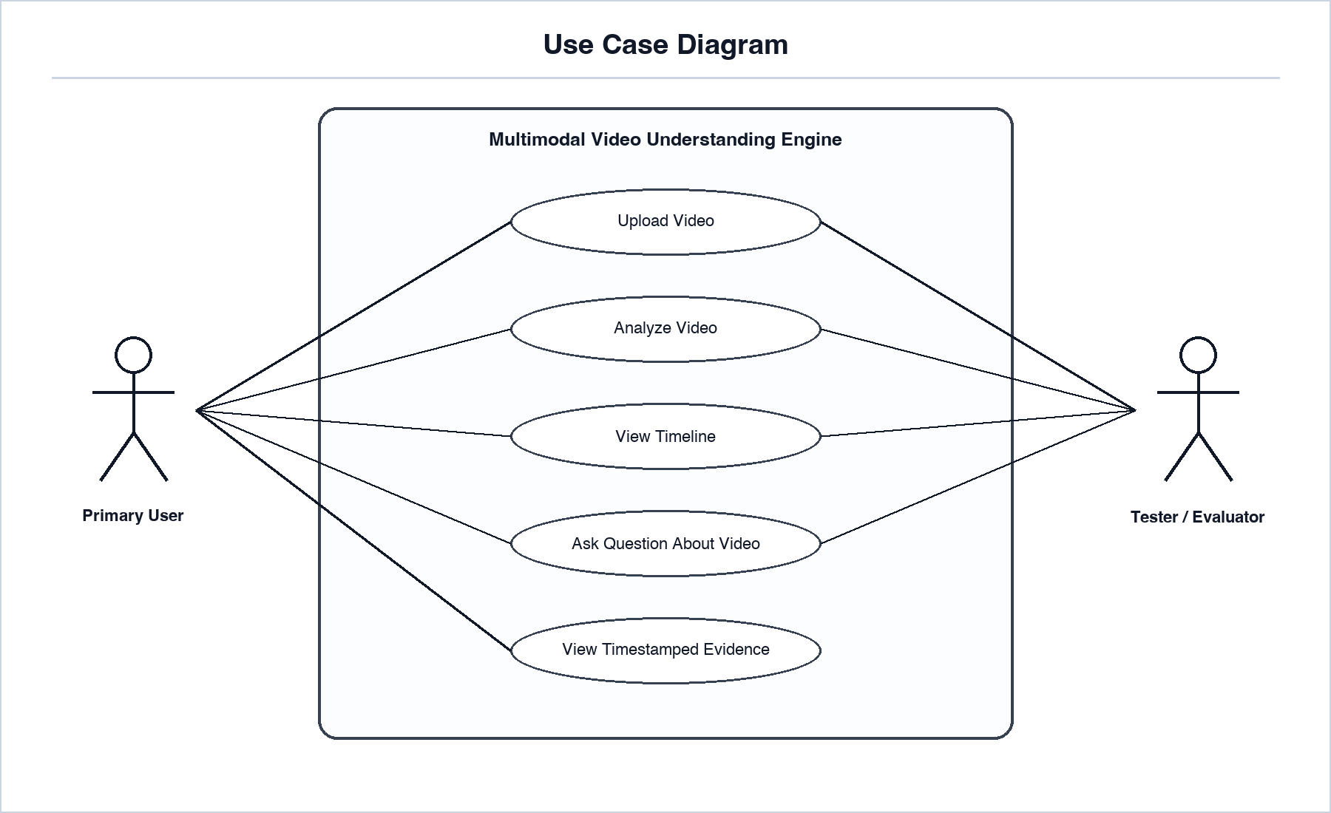
Figure 1. Use Case Diagram

B.3 Use Case Summary
Table 24. B.3 Use Case Summary
Use Case | Actor | Description | Related Requirements
Upload Video | Primary User, Evaluator | User uploads an mp4 or mov video file. | FR-1 to FR-6
Analyze Video | Primary User, Evaluator | System extracts audio, transcript, keyframes, scenes, frame summaries, and timeline. | FR-7 to FR-21
View Timeline | Primary User, Evaluator | User retrieves timestamped timeline events. | FR-18 to FR-20, FR-34
Ask Question About Video | Primary User, Evaluator | User asks natural-language questions about a processed video. | FR-22 to FR-28
View Timestamped Evidence | Primary User, Evaluator | System returns timestamps, frames, and timeline evidence with answers. | FR-20, FR-25

B.4 System Context Diagram
The context diagram defines what is inside the system boundary and what remains external. Each external connection is shown with both direction and meaning: user inputs enter the system as uploaded videos and questions, while system outputs return as status, timeline, answers, and timestamped evidence.
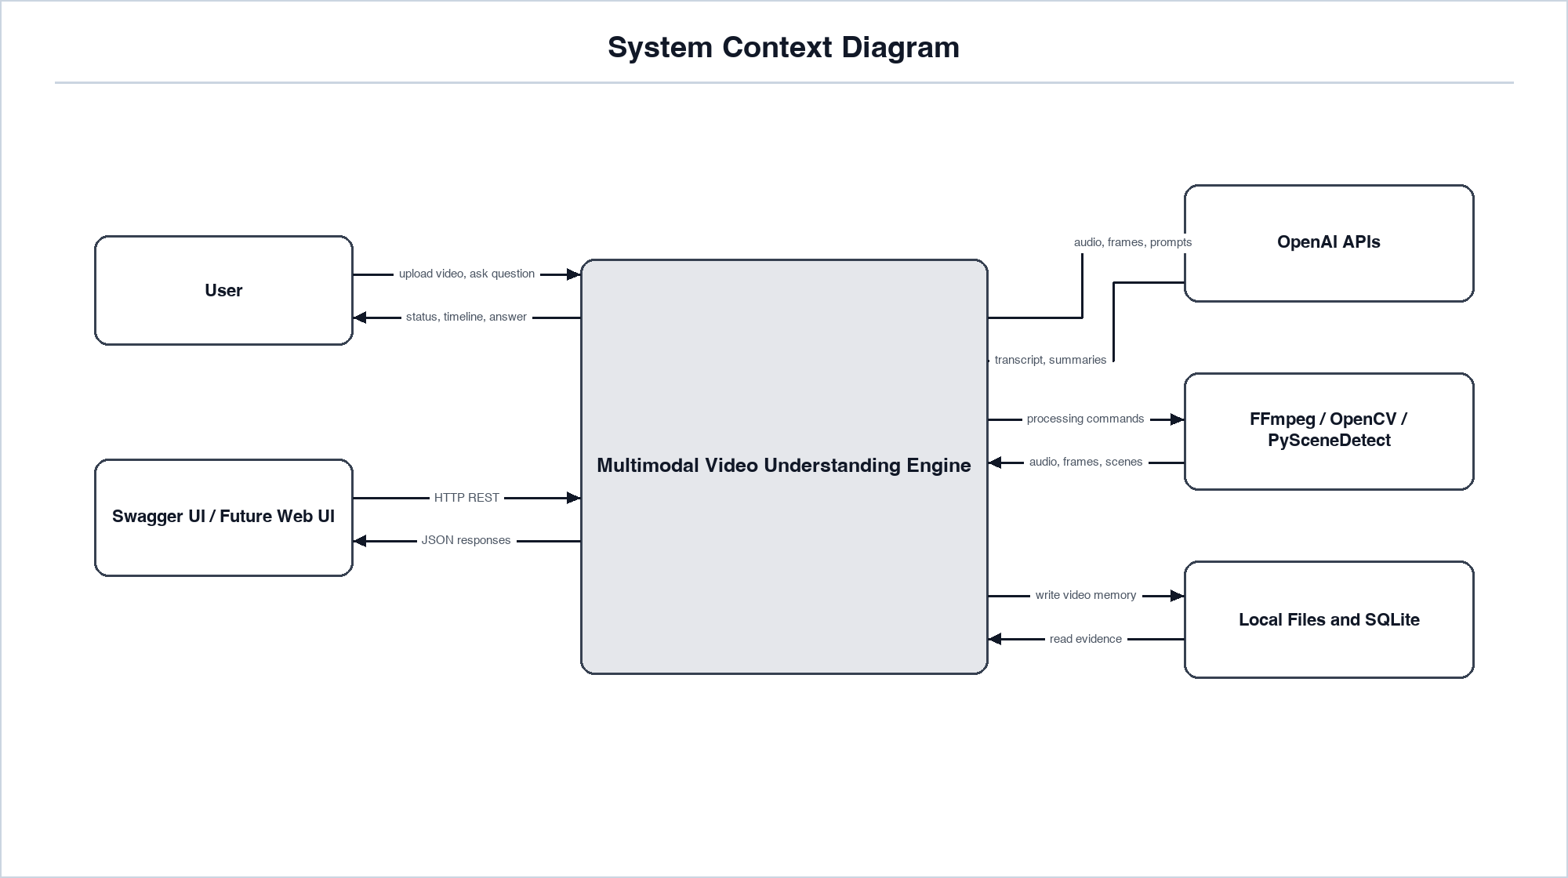
Figure 2. System Context Diagram

B.5 Level-1 Data Flow Diagram
The data flow diagram shows how raw video becomes structured video memory.
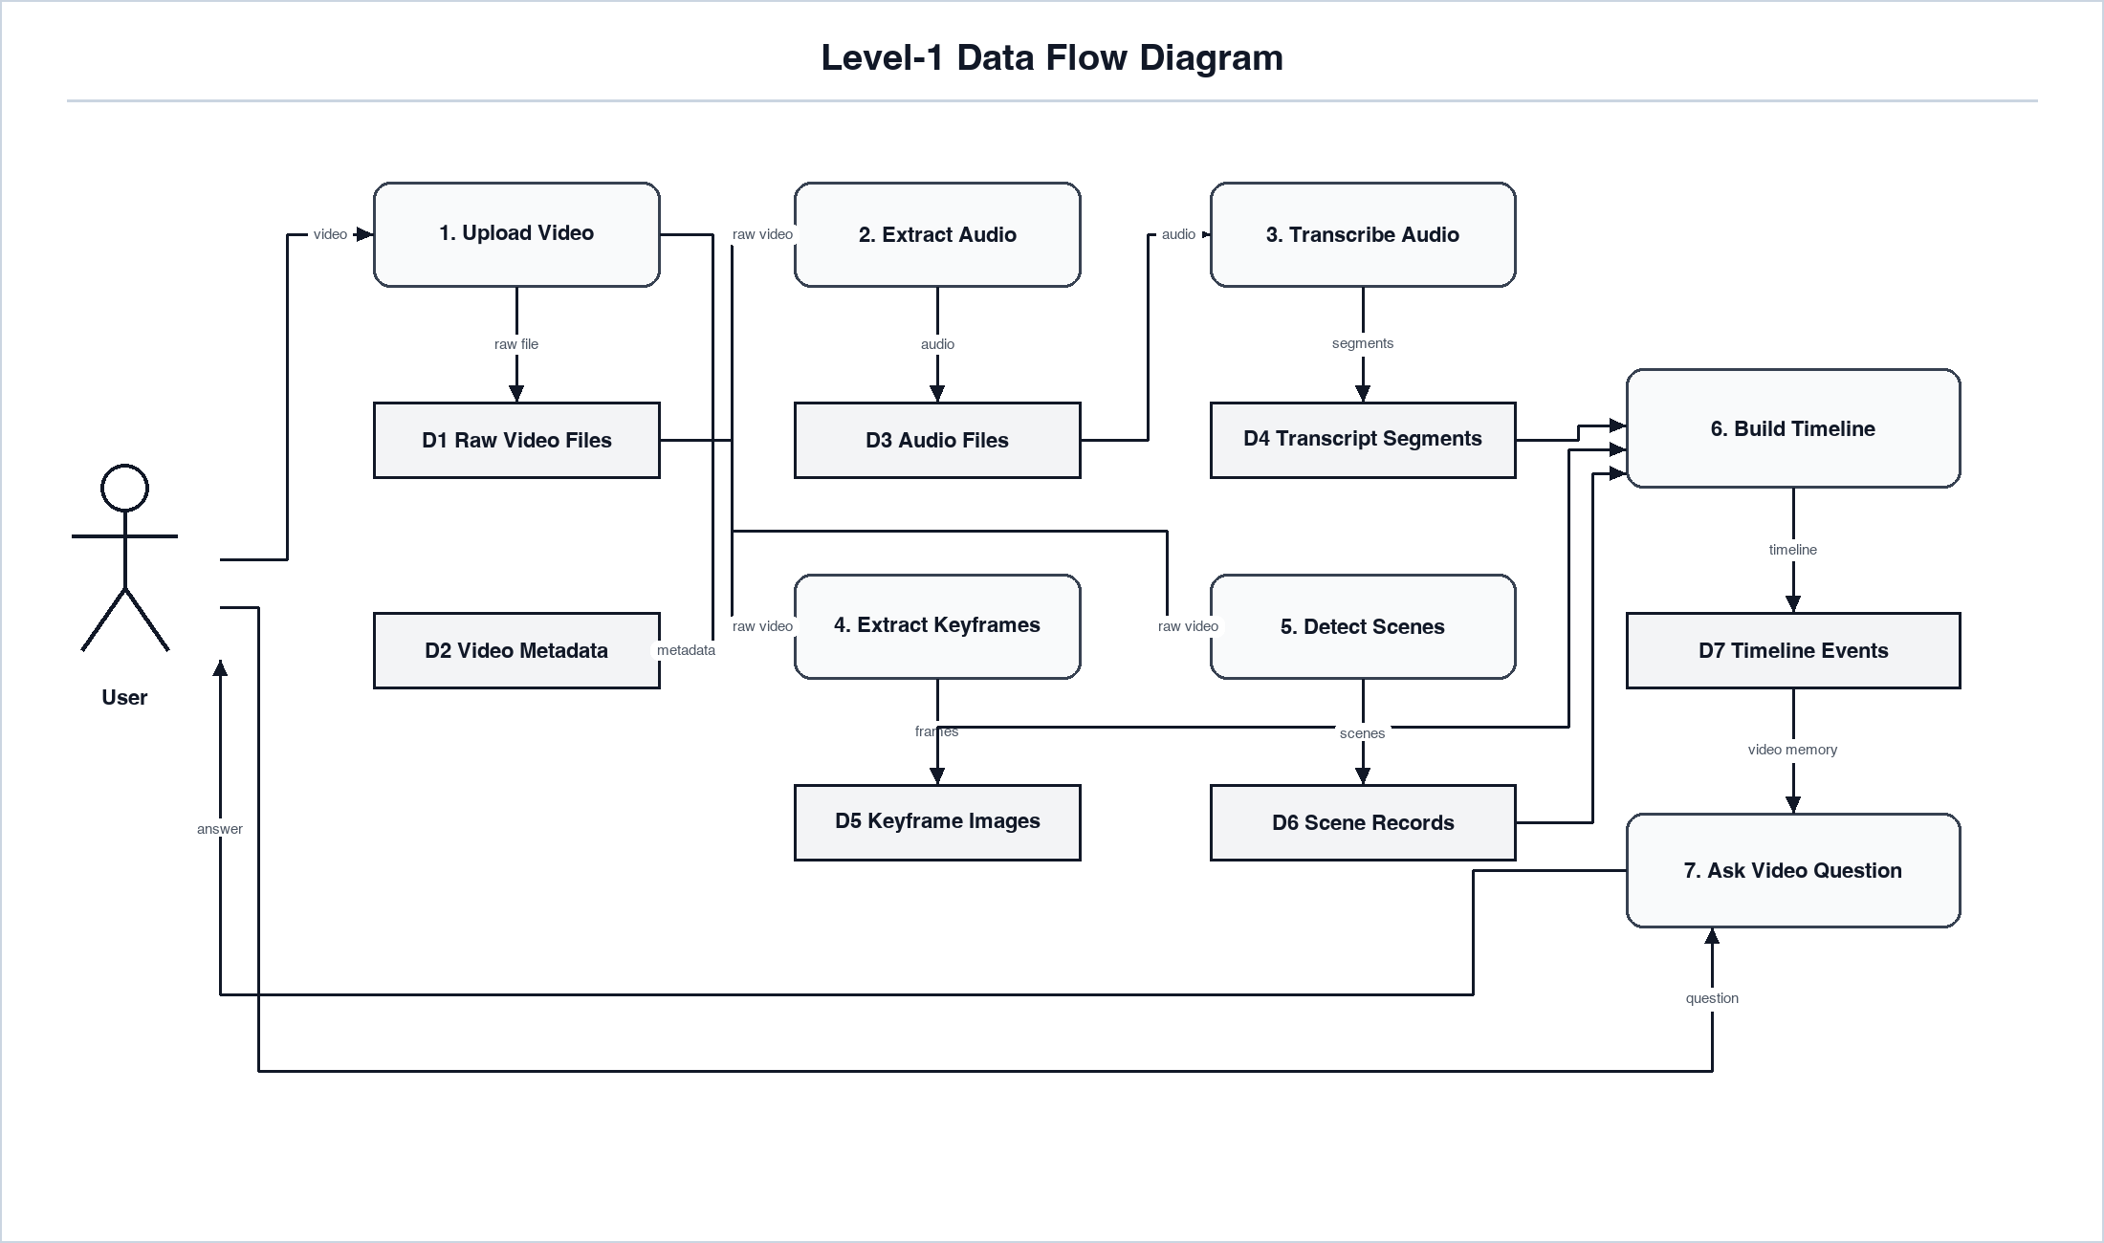
Figure 3. Level-1 Data Flow Diagram

B.6 Processing Pipeline Diagram
This diagram represents the technical pipeline that replaces the naive idea of watching every frame.
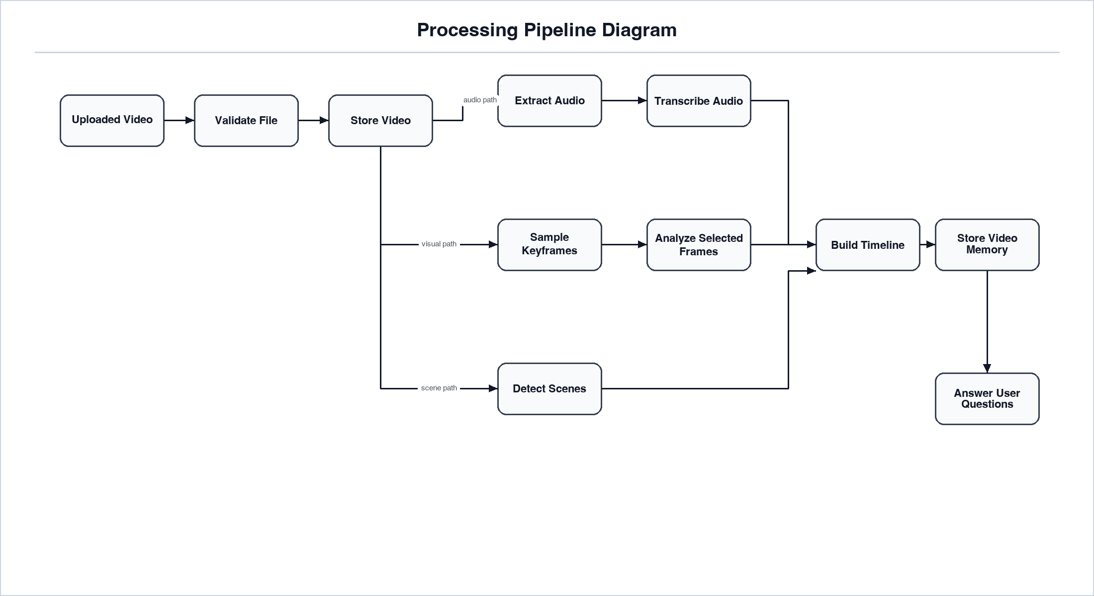
Figure 4. Processing Pipeline Diagram

B.7 Activity Diagram
The activity diagram describes the main user workflow and the important decision points.
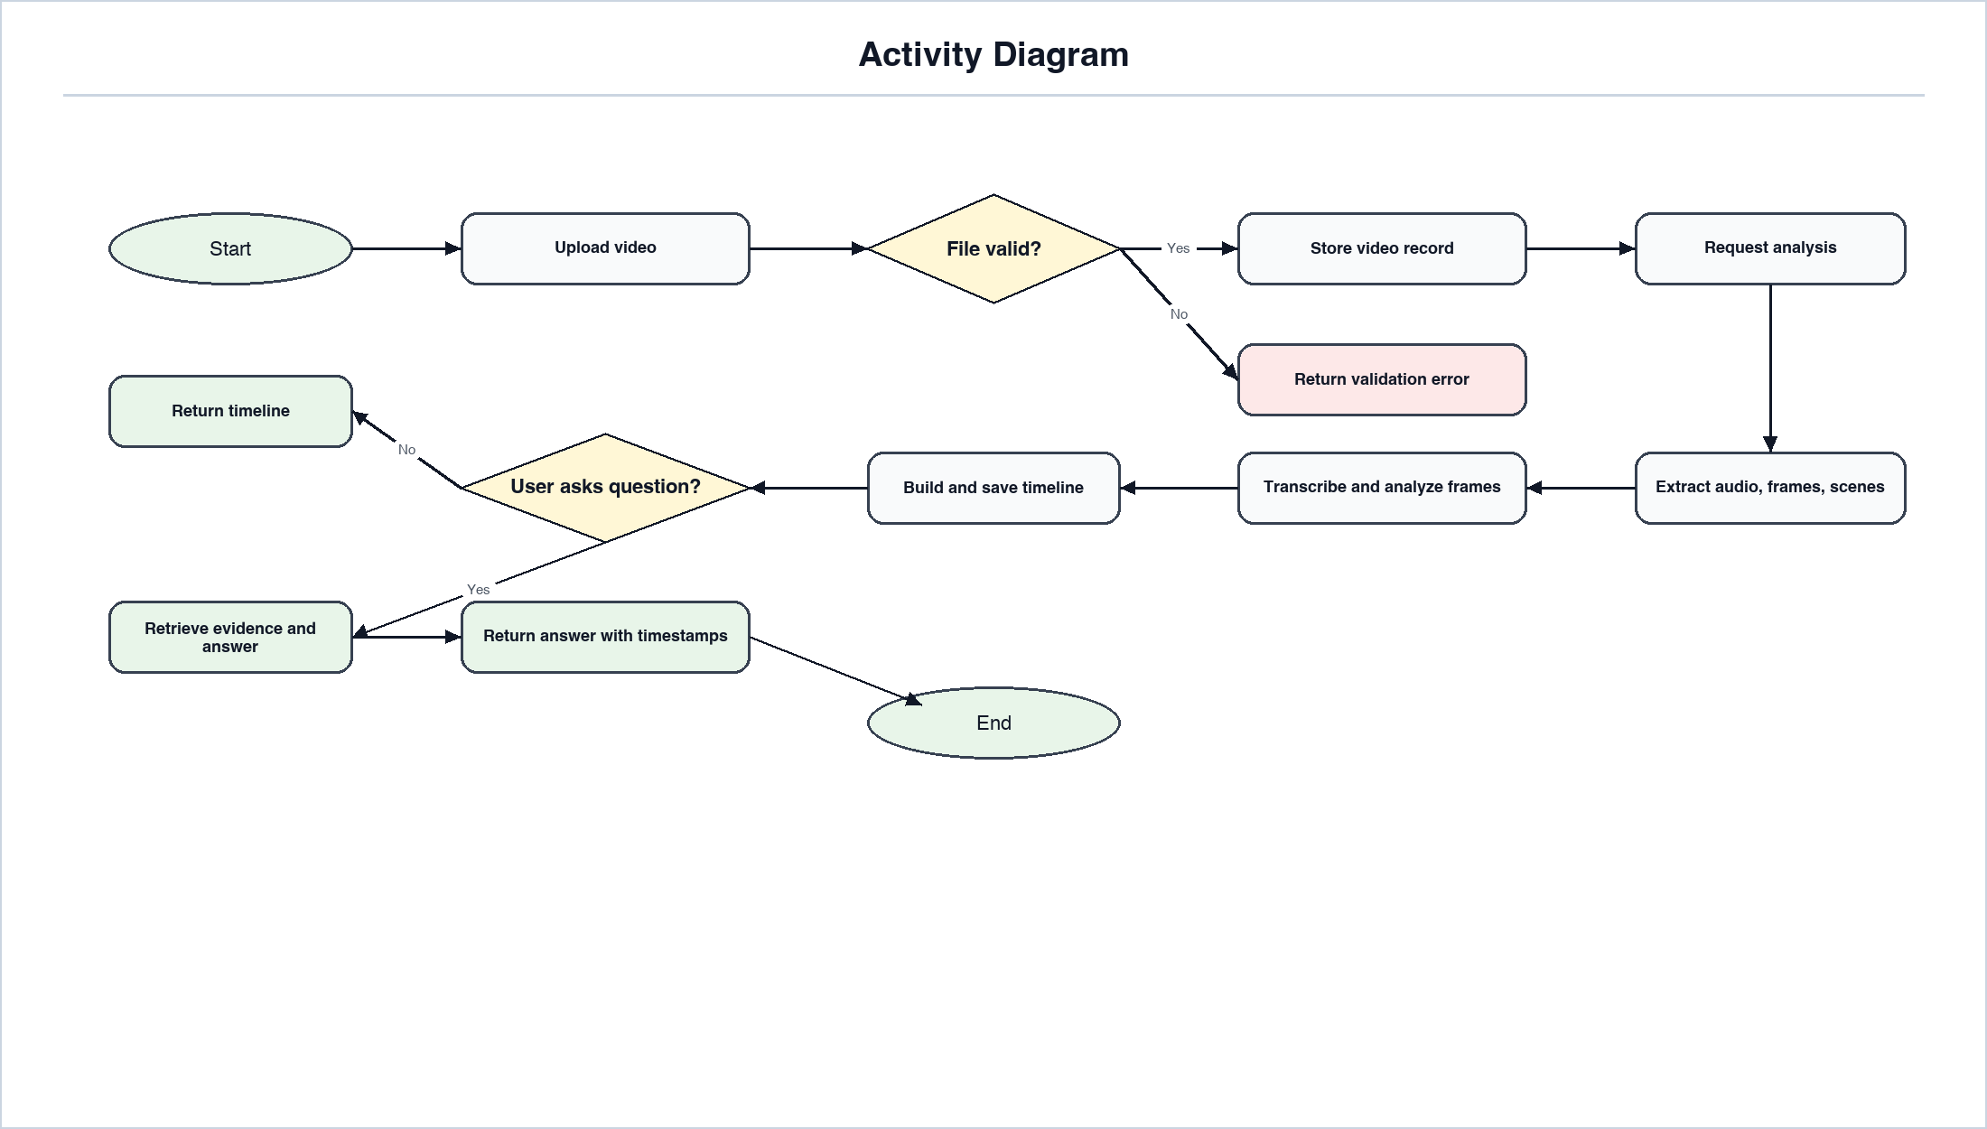
Figure 5. Activity Diagram

B.8 Upload and Analysis Sequence Diagram
This sequence diagram shows the runtime behavior for uploading and analyzing a video.
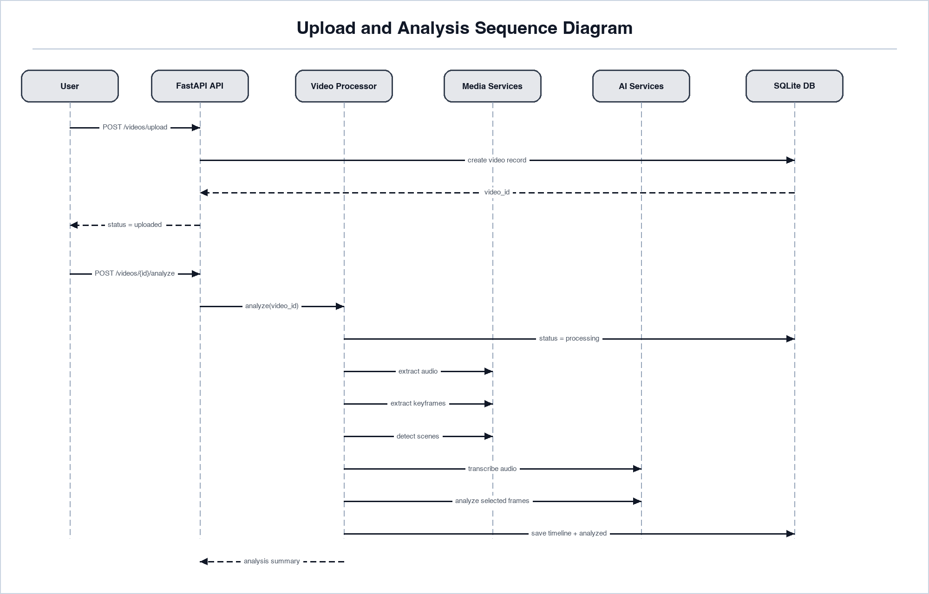
Figure 6. Upload and Analysis Sequence Diagram

B.9 Ask Video Sequence Diagram
This sequence diagram shows how the system answers a question without reprocessing the whole video.
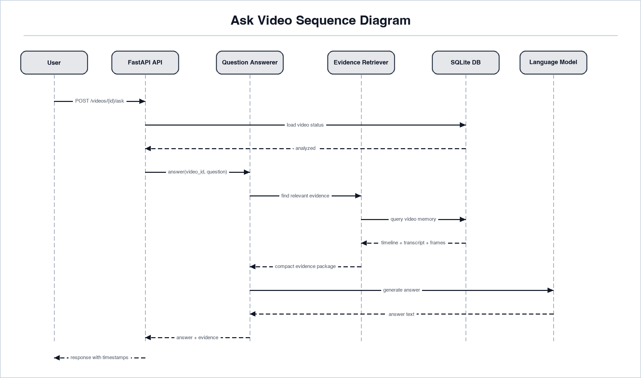
Figure 7. Ask Video Sequence Diagram

B.10 Domain Class Diagram
The domain class diagram shows the main software objects the backend should model.
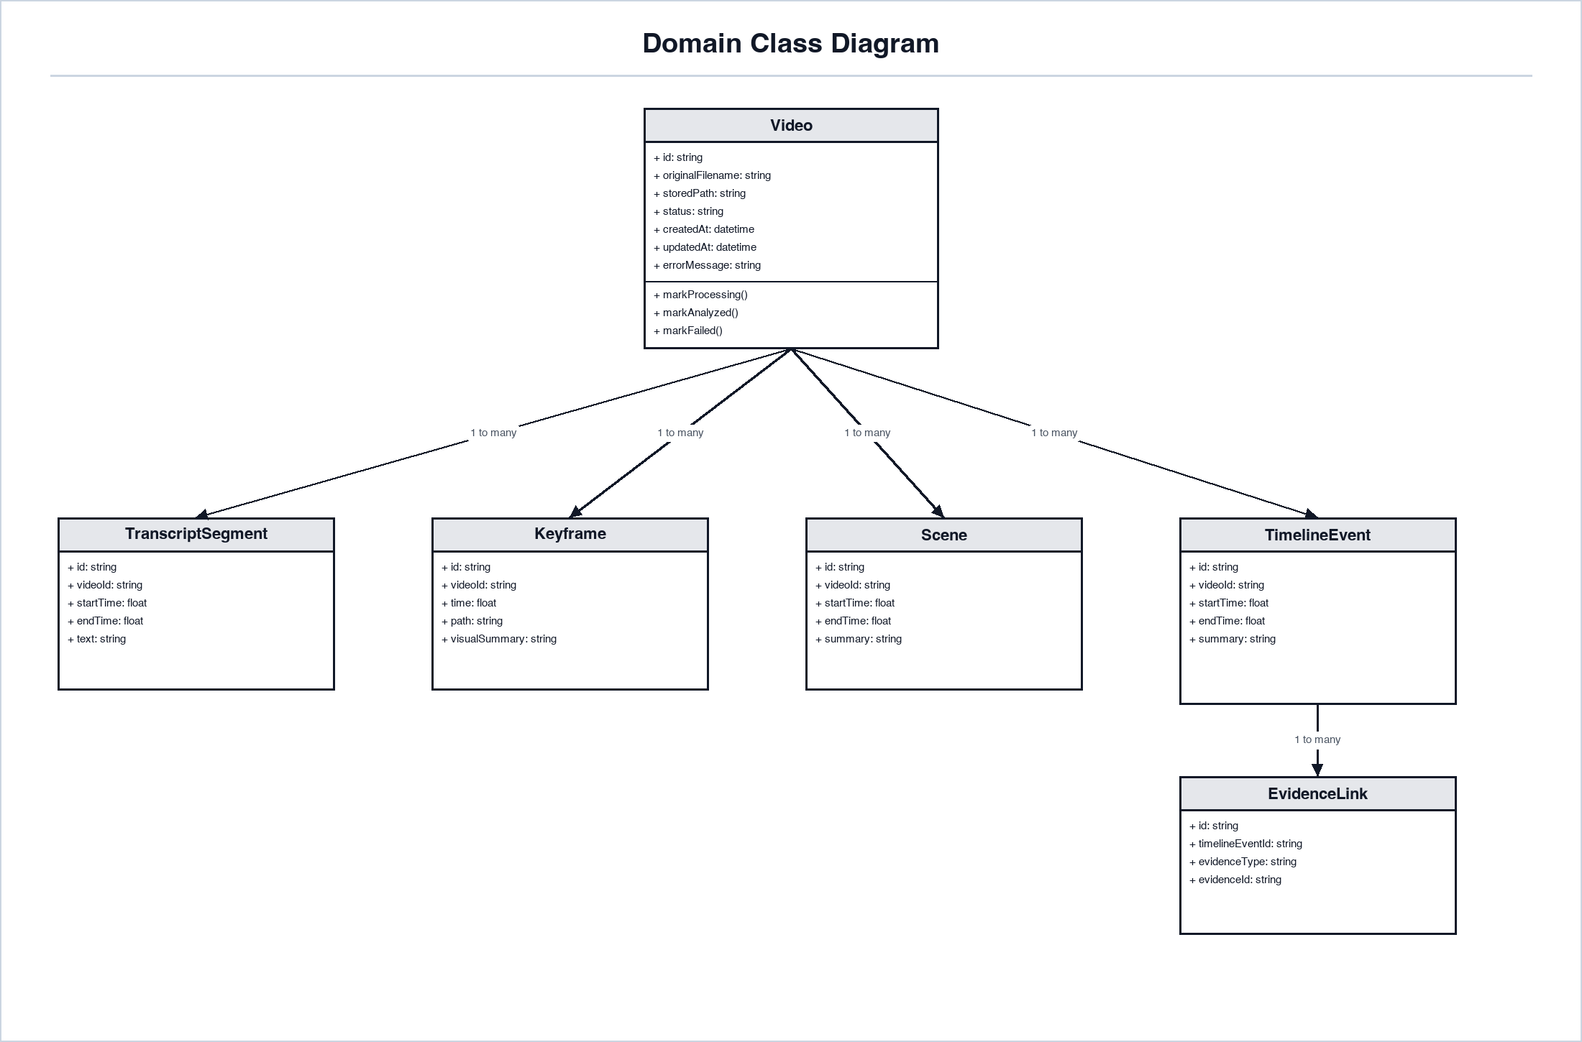
Figure 8. Domain Class Diagram

B.11 Entity Relationship Diagram
The ERD defines the MVP storage model. SQLite is the first database target, but this model should remain compatible with PostgreSQL later.
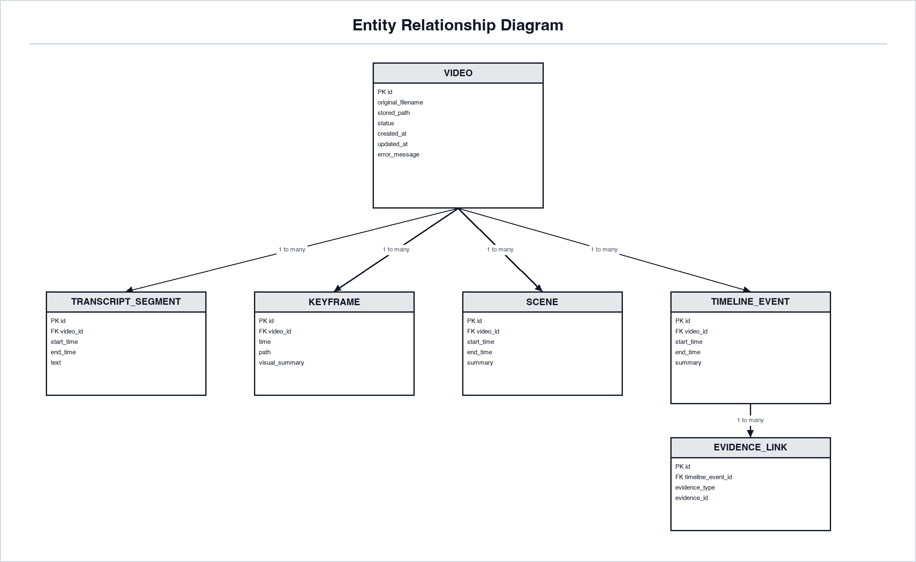
Figure 9. Entity Relationship Diagram

B.12 Video Status State Diagram
The state diagram defines valid analysis states and prevents ambiguous behavior.
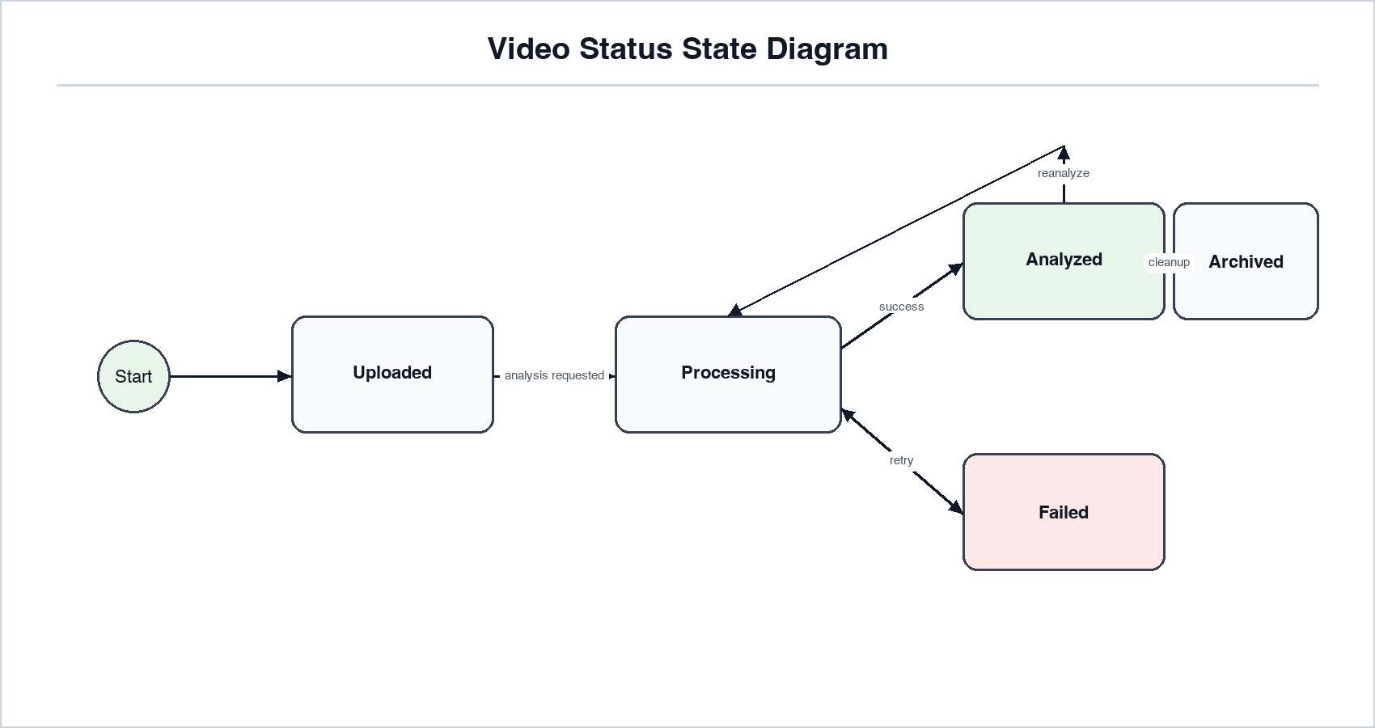
Figure 10. Video Status State Diagram

B.13 Component Diagram
The component diagram shows the MVP backend modules as large owning components with their subcomponents inside them. It separates API ownership, application services, domain objects, infrastructure adapters, persistence, and external tools.
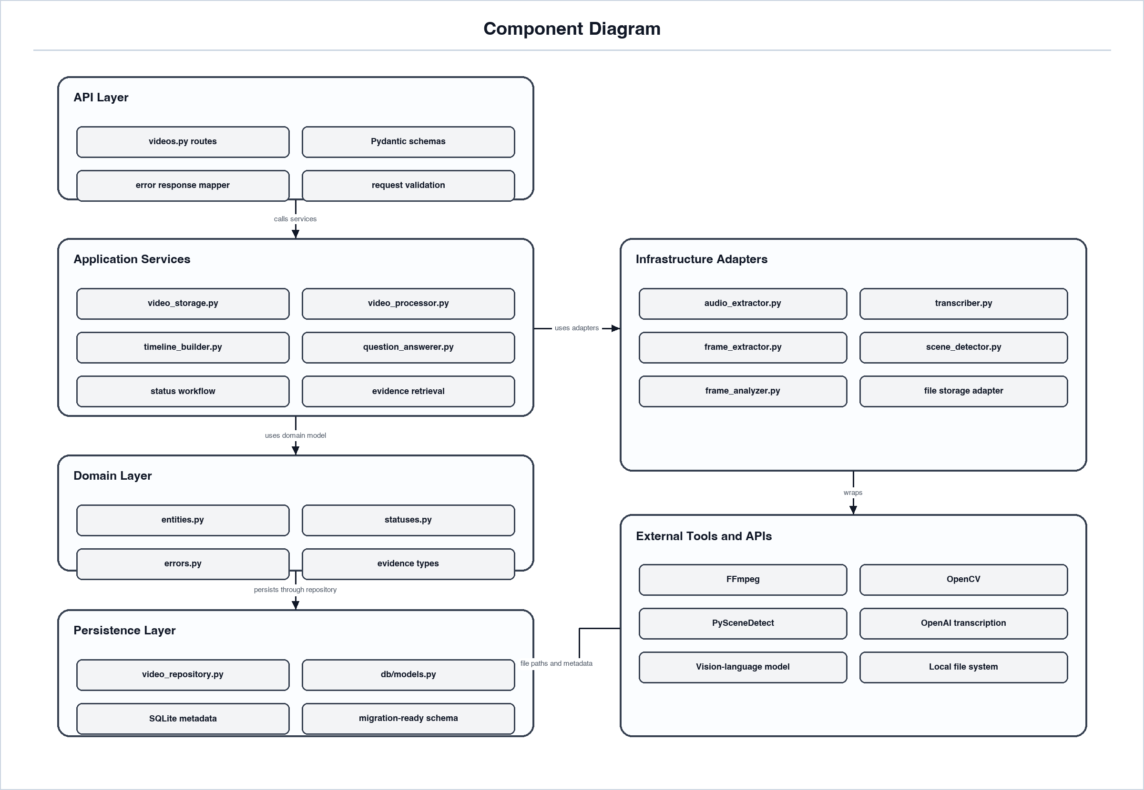
Figure 11. Component Diagram

B.14 Deployment Diagram
The deployment diagram shows the first local MVP environment. It separates the application runtime from local processing/storage and the external AI provider so deployment responsibilities remain clear.
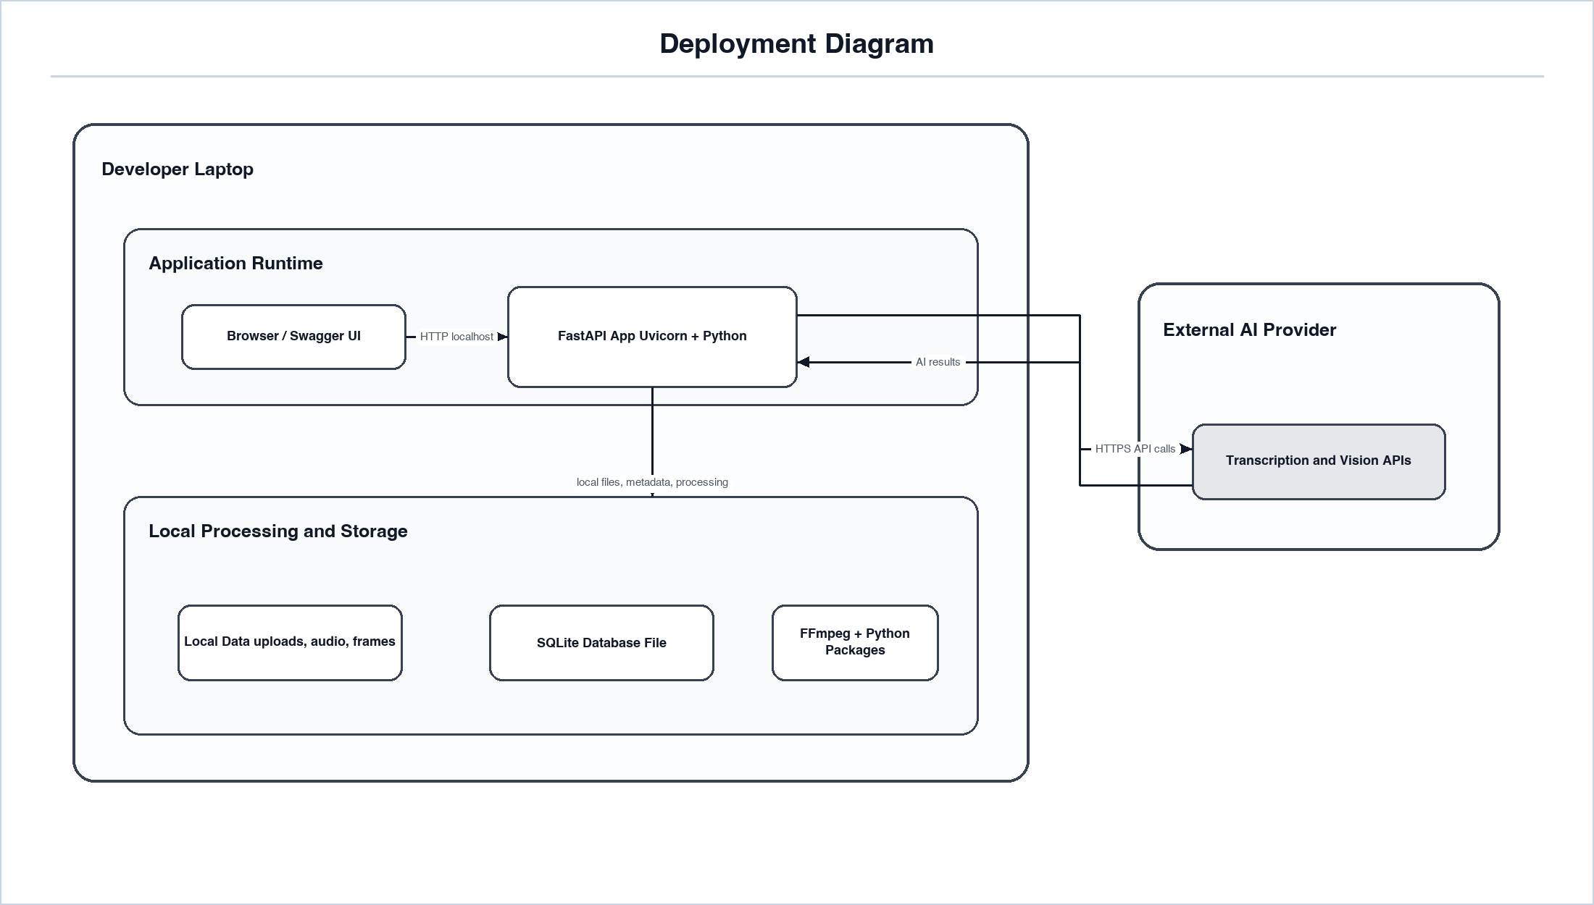
Figure 12. Deployment Diagram

B.15 API and Integration Swimlane Diagram
This swimlane diagram shows the API and integration flow across the user/client, FastAPI backend, processing services, external tools and AI APIs, and local storage. The diagram is arranged by vertical request columns so upload, analysis, timeline retrieval, and question answering can be followed without crossing arrows.
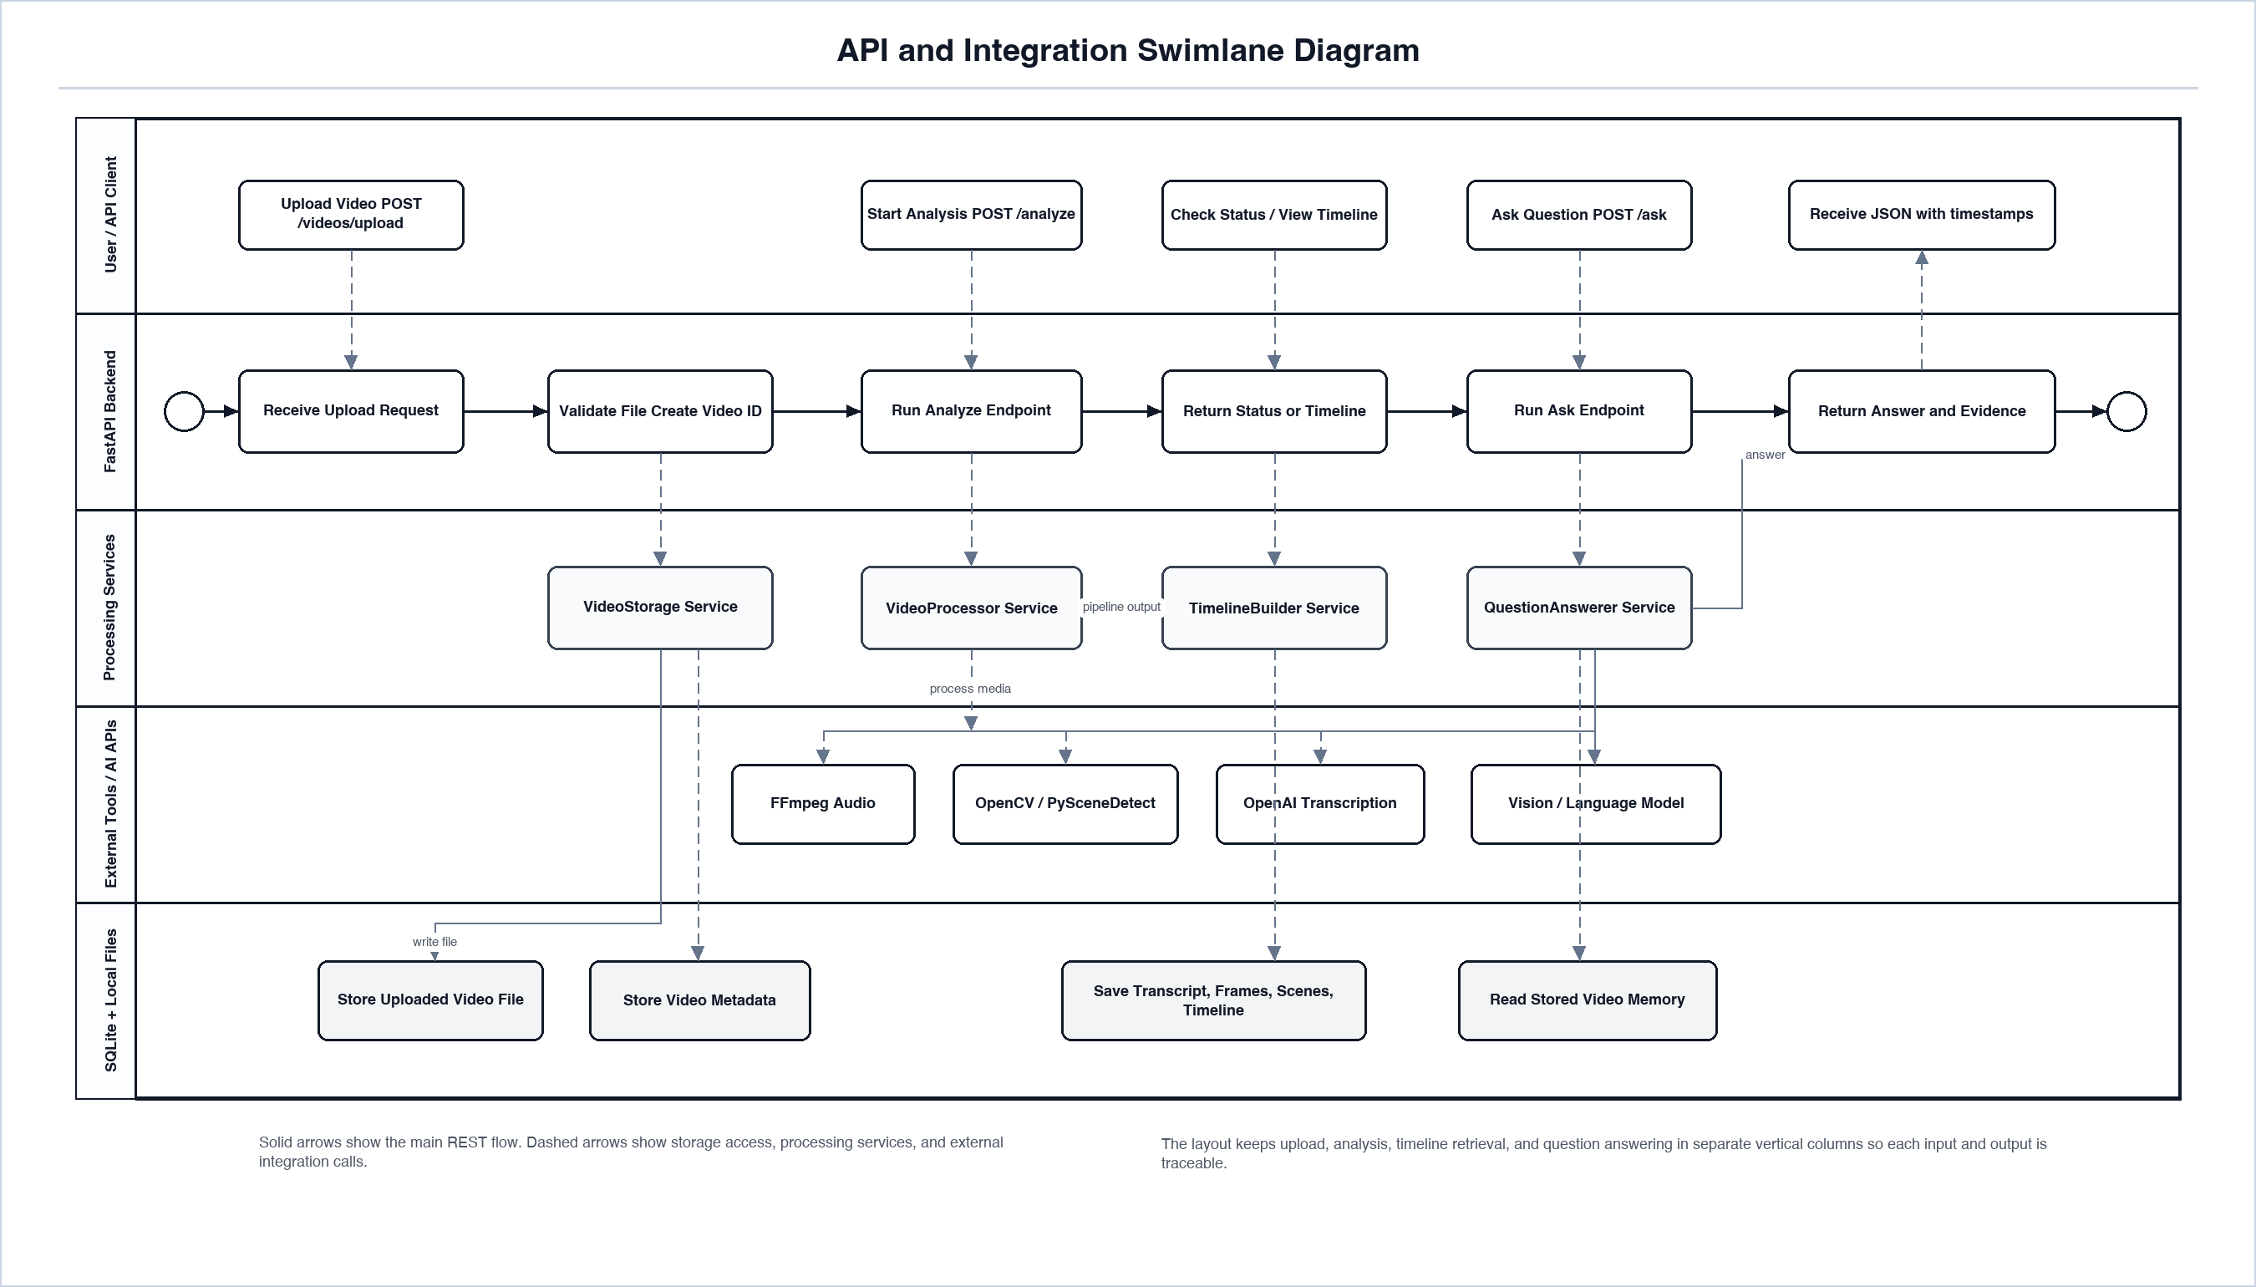
Figure 13. API and Integration Swimlane Diagram

B.16 Proposed Initial API Endpoints
Table 25. B.16 Proposed Initial API Endpoints
Endpoint | Method | Purpose
/videos/upload | POST | Upload a video and create a video record.
/videos/{video_id}/analyze | POST | Run preprocessing and timeline generation.
/videos/{video_id}/status | GET | Return current video processing status.
/videos/{video_id}/timeline | GET | Return the generated timeline.
/videos/{video_id}/ask | POST | Ask a question about the processed video.

B.17 Diagram-to-Requirement Traceability
Table 26. B.17 Diagram-to-Requirement Traceability
Requirement Area | Supporting Diagrams
Video upload | Use Case, Activity, Upload and Analysis Sequence, Component
Audio extraction | Data Flow, Processing Pipeline, Component
Transcription | Data Flow, Processing Pipeline, Upload and Analysis Sequence
Keyframe extraction | Data Flow, Processing Pipeline, Component
Scene detection | Data Flow, Processing Pipeline, Component
Visual analysis | Processing Pipeline, Component, Upload and Analysis Sequence
Timeline generation | Data Flow, Domain Class, ERD
Video question answering | Use Case, Ask Video Sequence, API and Integration Swimlane, Component
Storage and retrieval | ERD, Domain Class, Data Flow
Status and error behavior | Activity, Video Status State Diagram

Appendix C: To Be Determined List
Table 27. Appendix C: To Be Determined List
ID | Item
TBD-1 | Confirm exact external API models, versions, and documentation references before implementation.
TBD-2 | Define maximum upload size for the MVP and future deployment.
TBD-3 | Confirm whether the course requires a web frontend in addition to Swagger UI.
TBD-4 | Confirm final database choice for the MVP: SQLite or PostgreSQL.
TBD-5 | Confirm expected video duration and resolution limits for demonstration.
TBD-6 | Confirm final project team/member details for the specification cover page if required by the course.

