1、

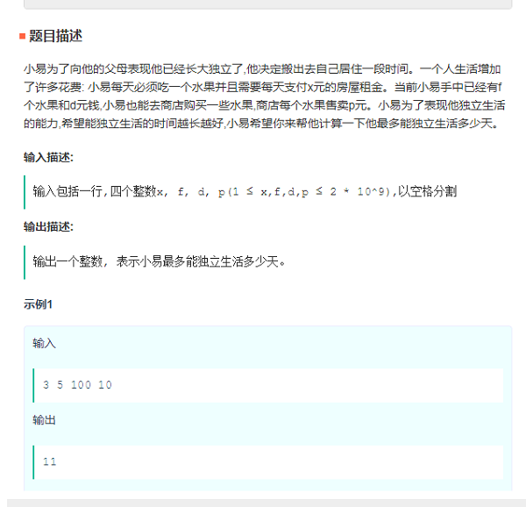

/**

* [网易笔试1: 水果题]

* @type {[type]}

*/

var readline = require('readline');

const rl = readline.createInterface({

input: process.stdin,

output: process.stdout

});

rl.on('line', function(line){

var tokens = line.split(' ');

//接收进来的输入是字符串，首先将其转换处理为数字类型，否则在"+"时，导致拼接成为字符串

var x = parseInt(tokens[0]), //房租

f = parseInt(tokens[1]), //初始水果

d = parseInt(tokens[2]), //初始钱

p = parseInt(tokens[3]); //水果单价

var day = 0;

if(d <= f * x){

//f个水果，应该可以存活f天，看房租是否满足

//钱不够支撑f个水果，看钱能过几天

day = parseInt(d / x);

}else{

//钱够支撑f个水果,花费f*x元

d = d - (x * f);

day = f + parseInt(d / (x + p));

}

console.log(day);

});

2.

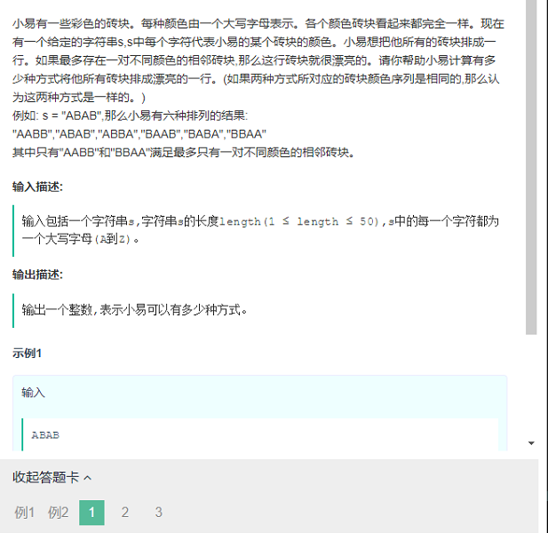

process.stdin.resume();

process.stdin.setEncoding('ascii');

var input = "";

var input_array = "";

process.stdin.on('data', function (data) {

input += data;

});

function removeSame(arr){

var newArr=[],strArr;

var len=arr.length;

for(var i=0;i<len;i++){

strArr=newArr.join('');

if(strArr.indexOf(arr[i])==-1){

newArr.push(arr[i]);

}

}

return newArr;

}

process.stdin.on('end', function () {

input_array = input.split("\n");

var nLine = 0;

while(nLine < input_array.length){

var line = input_array[nLine++].trim();

if(line === ''){

continue;

}

var lineArr=line.split('');

var arr=removeSame(lineArr);

var len=arr.length;

if(arr.length==2){

console.log(2);

}else if(arr.length==1){

console.log(1);

}else{

console.log(0);

}

}

});

3.

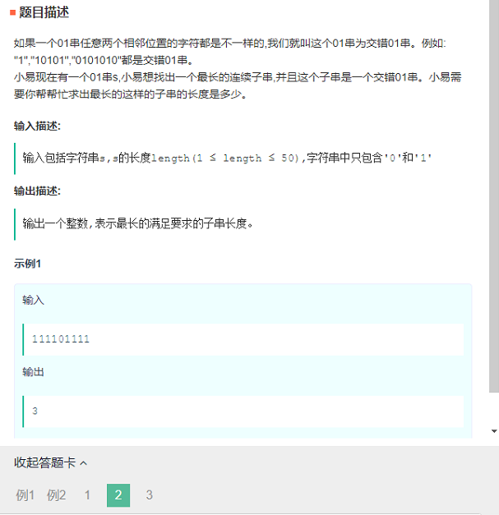

process.stdin.resume();

process.stdin.setEncoding('ascii');

var input = "";

var input_array = "";

process.stdin.on('data', function (data) {

input += data;

});

function maxStr(arr){

var len=0;

var flag=true;

var max=0;

for(var i=0;i<arr.length-1;i++){

if(arr[i]!=arr[i+1]){

len+=1;

if(i==arr.length-2){

max=Math.max(max,len);

}

}else{

max=Math.max(max,len);

len=0

}

}

return max+1;

}

process.stdin.on('end', function () {

input_array = input.split("\n");

var nLine = 0;

while(nLine < input_array.length){

var line = input_array[nLine++].trim();

if(line === ''){

continue;

}

var lineArr=line.split('');

var arr=[];

for(var i=0;i<lineArr.length;i++){

arr.push(+lineArr[i]);

}

if(arr.length<1 || arr.length>50){

continue;

}

var len=maxStr(arr);

console.log(len);

}

});

Java解法：

