WEEK -7 LAB ASSIGNMENT-1

BASIC LINUX COMMANDS

System and hardware information

File and directory commands

file editing and navigation inside files

Copying and moving files

Pipeline

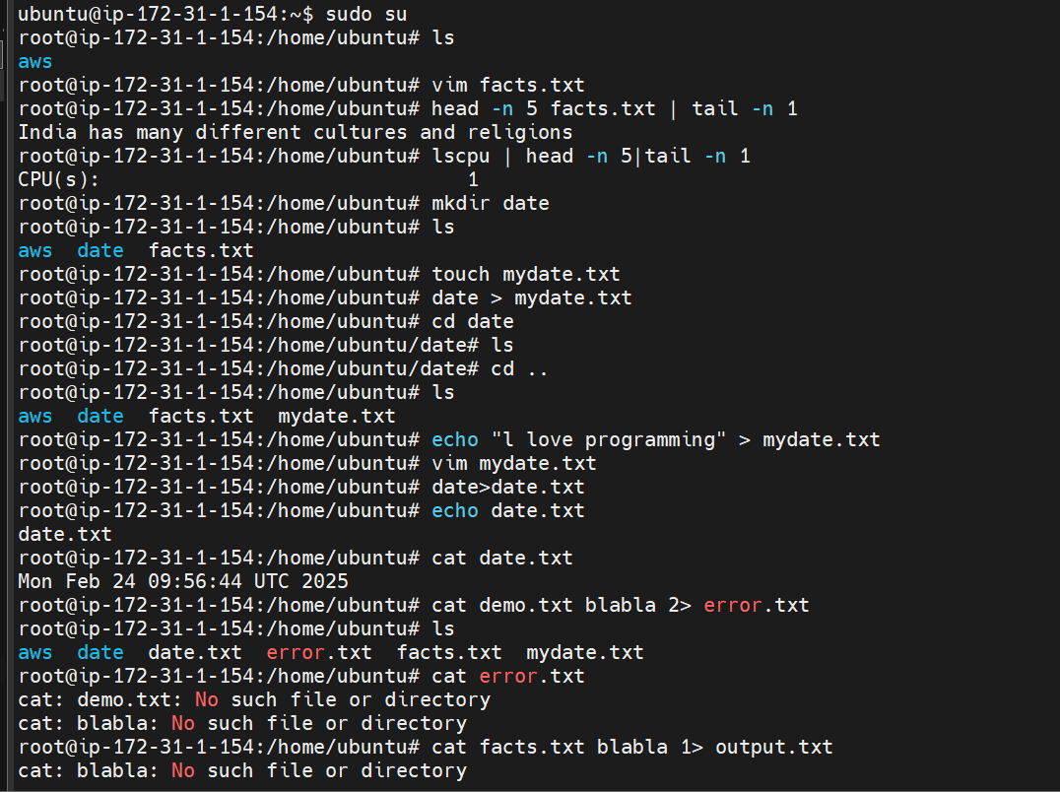

Analysis and file manipulation

Wildcard chars



User management and password

User , user group and file permission



