**UDEMY FOR BUSINESS USERS/ Regular Users :**

**How to Rate the Courses in Udemy**

To Rate the Course, From your Course Dashboard, check if you can see an option “**Leave a rating”** as shown in below screenshot to rate the course, Select the link if it is visible for you, If not please scroll down for second screenshot

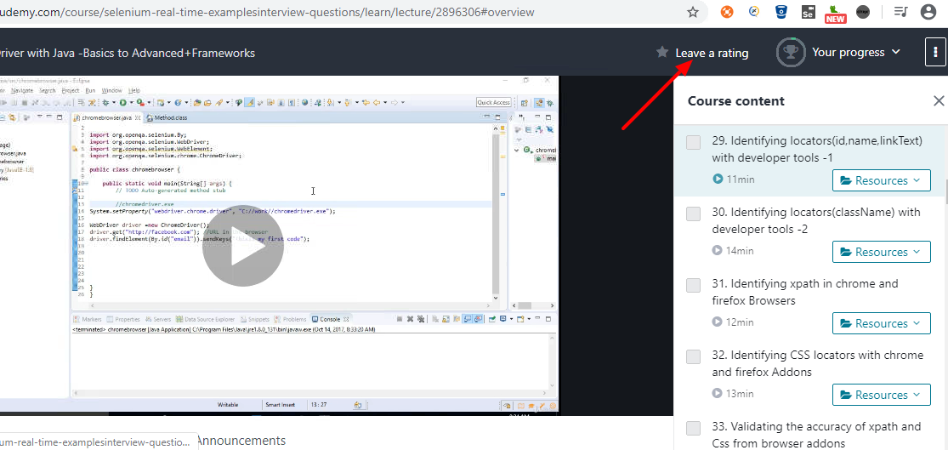

If you don’t see that option please click on the (vertical dots) icon as shown in the screenshot below which opens Menu and you will see the option to **Edit your Rating.** Please select it

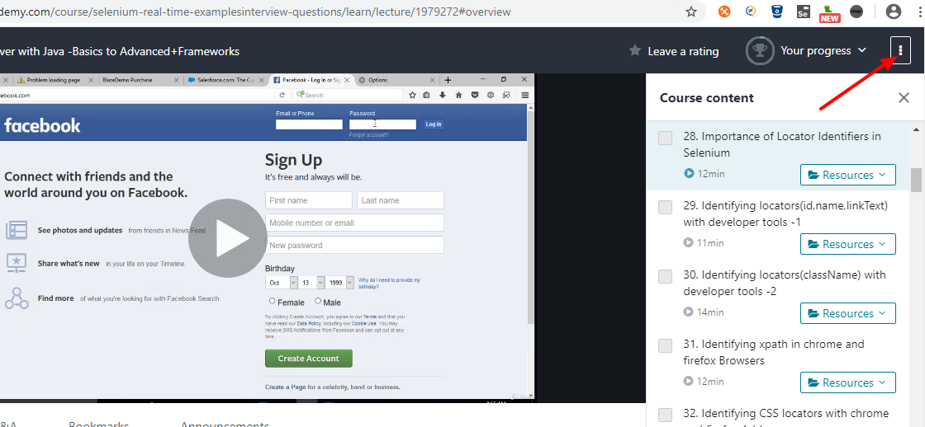

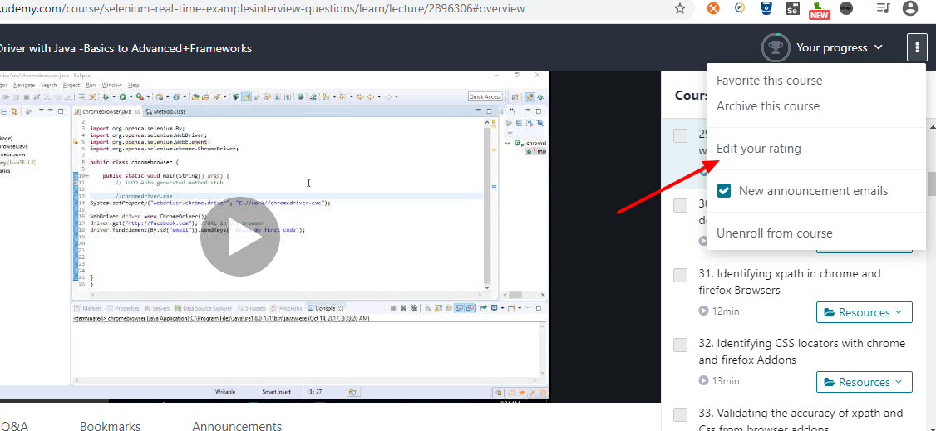

Once you select the rating link, you will see the stars as below. Please select the Stars and rate us if you are satisfied with my teaching Good LUCK!!

