**Note**

This script is exclusively designed for Windows 11! Please check your system version before use, as it is currently incompatible with Windows 10.

**Enable the 1000Hz Polling Rate Script**

1. Right-click on *Enable.bat* and select “Run as administrator”.

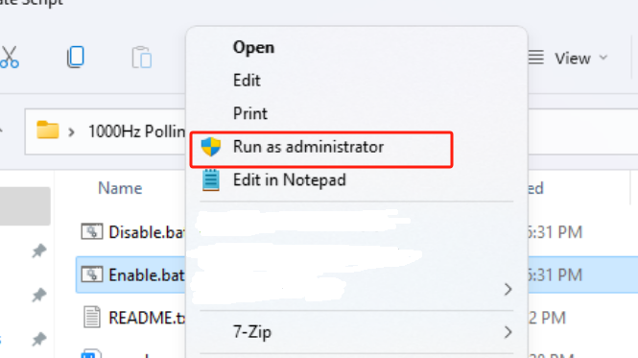

2. After receiving the successful operation prompt, a computer restart is required for the changes to take effect. (Subsequent usage does not require restarting every time; enabling the 1000Hz setting in the GameSir Nexus software will make the script take effect directly.)

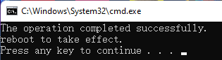

**Disable the 1000Hz Polling Rate Script**

1. Right-click on *Disable.bat* and select “Run as administrator”.

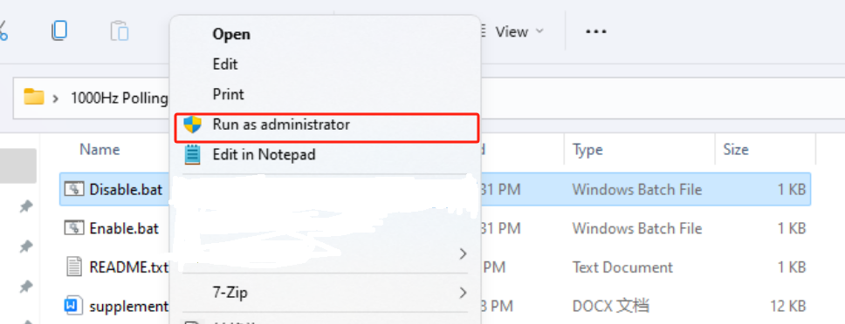

2. After receiving the successful operation prompt, a computer restart is required for the changes to take effect.

