 Capstone Project - Team 20
Early detection of Pulmonary fibrosis

Project Title : Early detection of Pulmonary fibrosis with Machine Learning
Project ID : Capstone24; EC20
Project Guide : Prof. Lakshmeesha Sir

Table of Contents

Abstract

Literature Survey
Symptoms
The Global Impact of IPF
Symptoms
Survival Insights
Datasets

Conclusion
References

Abstract

Pulmonary fibrosis is a progressive and often fatal lung disease marked by excessive scarring of lung tissues, leading to compromised respiratory function. The condition, particularly idiopathic pulmonary fibrosis (IPF), is characterized by irreversible damage to the bronchioles and alveoli, the tiny structures responsible for efficient gas exchange. In normal lungs, alveoli are surrounded by a fine capillary network and supported by elastic connective tissue that facilitates optimal oxygen-carbon dioxide exchange. However, in IPF, these structures are replaced or thickened by fibrotic tissue, drastically reducing lung elasticity and gas diffusion capacity.

On a histological level, fibrosis is a pathological process involving the accumulation of extracellular matrix (ECM) components such as collagen. In normal tissue, fibroblasts and stromal structures are balanced, ensuring tissue integrity and repair. In fibrotic tissue, this balance is disrupted, resulting in the presence of enlarged fibroblasts and dense, pink-staining collagen within a fibrotic stroma.
Note: Scarring results in the thickening and stiffening of the affected tissue, leading to the disruption of normal structure and function.

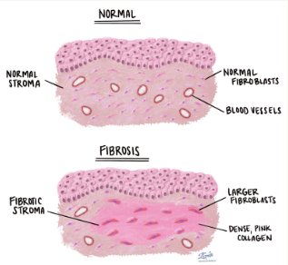
Idiopathic pulmonary fibrosis (IPF) is a serious chronic (long term) disease that affects the tissue surrounding the air sacs, or alveoli, in the lungs
|--> It worsens over time.

Our project introduces a novel, multimodal diagnostic approach for detecting pulmonary fibrosis by combining:
- Lung Auscultation Sounds: Subtle fibrotic crackles are often difficult to distinguish even for trained clinicians. By analysing lung sounds using machine learning models, we aim to detect fibrosis-specific acoustic patterns.
- Chest X-ray Imaging: We complement sound-based analysis with image-based diagnostics to identify structural changes such as reticulonodular opacities, honeycombing, and ground-glass opacities.
This dual-modality system enhances diagnostic accuracy and provides a non-invasive, early-stage fibrosis detection tool, offering significant support in clinical decision-making.
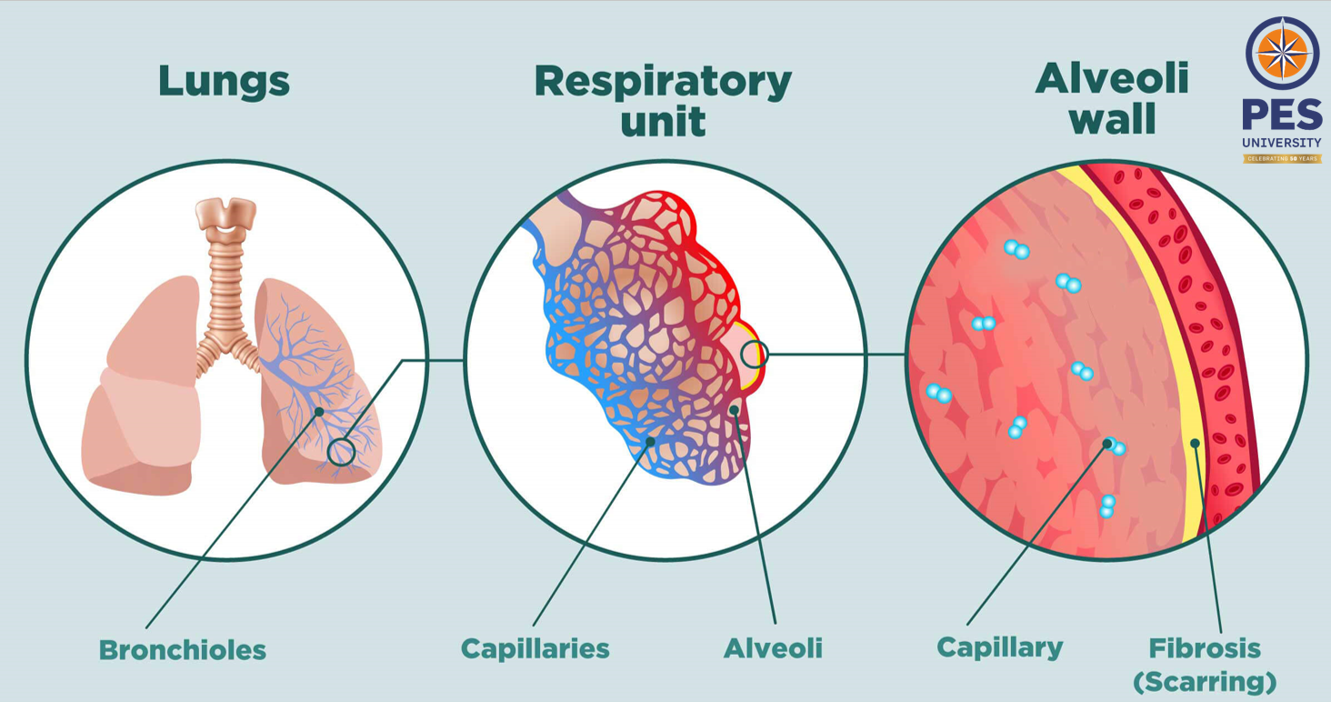

Literature Survey
Paper Details | Objective of paper, Techniques/Methods | Advantages | Limitations
Computer-Aided Diagnosis System for Lung Fibrosis: From the Effect of Radiomic Features and Multi-Layer-Perceptron Mixers to Pre-Clinical Evaluation | - High resolution CT  - 2D,3D x-ray  - Computer vision(to compare with human readings) | - Comparative study btw humans and computer vision(clinical validation is performed)  - Highly accurate  - Multi-feature integration | - Presence of misclassification
Lung Sound Classification With Multi-Feature Integration Utilizing Lightweight CNN Model  By T. Wanasinghe; S. Bandara; S. Madusanka; D. Meedeniya; M. Bandara; I. D. L. T. DÃez | Lightweight CNN model for lung sound classification using multiple audio-specific features & Mel spectrograms, MFCCs, and Chromagram features from lung sounds. | - High Accuracy  - Multi-Feature Integration  - Explainability | - Data Imbalance  - Lack of Clinical Validation  - Limited Generalization
Link for Excel Spread Sheet:

The Global Impact of IPF
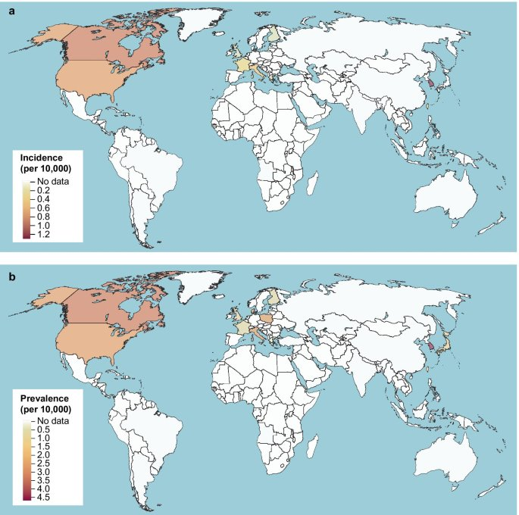
Pulmonary Fibrosis, particularly Idiopathic Pulmonary Fibrosis (IPF), is a growing global health concern, especially in developed countries like those in North America, Europe, and Japan, where both incidence and prevalence rates are highest.
As shown in the global maps, the number of new cases per 10,000 people is significantly higher in these regions, indicating not only better diagnostic capabilities but also higher exposure to risk factors such as pollution, aging populations, and occupational hazards.
The increasing burden of IPF in these countries highlights the urgent need for early detection tools and cost-effective diagnostic solutions—such as the dual-modality approach we propose—to reduce disease progression and improve patient outcomes globally.

Symptoms
Early diagnosis and treatment of IPF may increase lifespan and preserve quality of life.

Clinical Presentation
Patients with pulmonary fibrosis may present with a variety of symptoms that develop slowly and persist over time:
- Shortness of Breath: Initially noticed after walking short distances and progressively worsening.
- Dry Cough: Non-productive and persistent for several months to years.
- Chest Discomfort: A vague sense of tightness or pain in the chest.
- Systemic Symptoms:
  - Aching muscles and joints
  - Loss of appetite
  - Fatigue
- Auscultation Findings
Crepitations (Crackles): Fine crackling or popping sounds, typically heard during inspiration, most prominent at the lung bases.

Radiological and Diagnostic Imaging Features
- Reticulonodular Opacities: Appear as fine, web-like (reticular) patterns interspersed with small nodules across both lungs, reflecting interstitial thickening and fibrosis.
- Honeycombing Pattern: A hallmark of advanced fibrosis, seen as clustered cystic air spaces with well-defined walls, indicating permanent architectural distortion.
- Ground-Glass Opacities (GGO): Hazy, cloud-like areas on imaging where the lung parenchyma is partially filled with fluid, inflammatory cells, or thickened interstitial, indicating active inflammation or early fibrosis.
- Lung Texture Changes: Progressive thickening and stiffness of lung tissue reduce elasticity and impair gas exchange

Survival Insights

The survival curve shows decreasing survival over time:
- Patients with <1 year since diagnosis have the best outcomes.
- Those with >4 years show the lowest survival rates.
- p = 0.03 indicates a significant downward trend with disease duration.
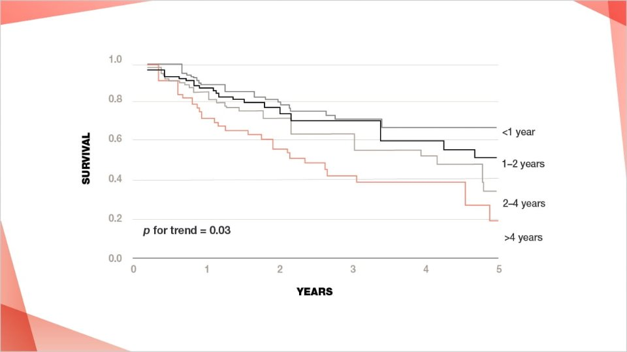

Datasets
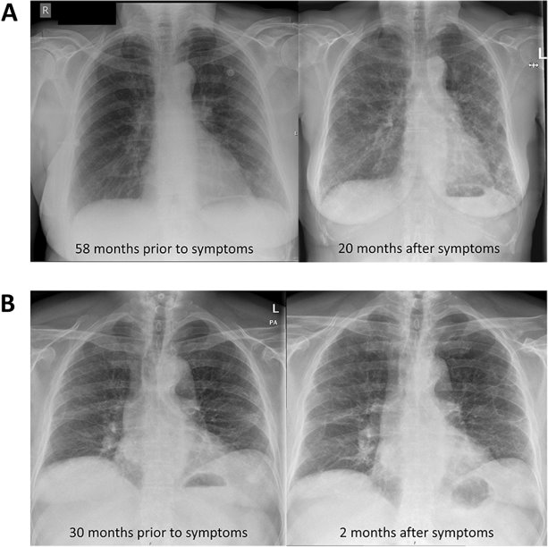
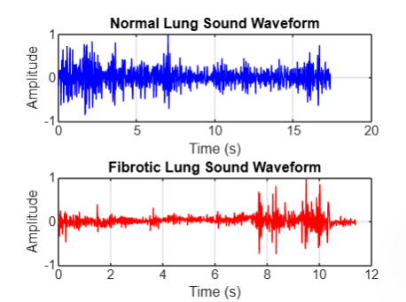

The Audio Datasets were downloaded & used from the following open-source websites:
- https://data.mendeley.com/datasets/fr7zvy8j5s/1
- https://www.kaggle.com/datasets/vbookshelf/respiratory-sound-database?utm_source=chatgpt.com
- https://data.mendeley.com/datasets/jwyy9np4gv/3
Normal Sound:

Fibrotic Sound:

The CT-Scan Datasets were downloaded & used from the following open-source websites:
- Kaggle : https://www.kaggle.com/competitions/osic-pulmonary-fibrosis-progression/data

The X-Ray image Datasets were downloaded & used from the following open-source websites:

Data Pre-Processing – Audio Dataset
he Lung sounds after segregation and post filtering out files manually & renamed the files with folder labels are as follows :
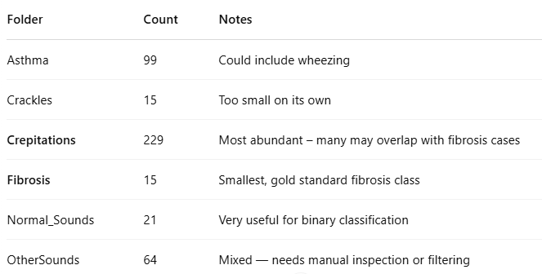
To improve model performance in binary classification between normal lung sounds and fibrotic (abnormal) sounds, a structured preprocessing and data labelling approach was adopted:
- Binary Labelling Strategy:
Since lung sounds associated with fibrosis are difficult to interpret and not always distinctly labelled in available datasets, we curated a custom dataset by selecting approximately 60 random samples of lung crepitations.
These crepitations, often indicative of fibrosis, were used as pseudo-fibrotic samples and placed under the “fibrosis” category. This enabled the model to perform binary classification between “normal” and “fibrosis.”
- Audio-to-Image Conversion:
All audio samples were converted into Mel-spectrograms, which serve as the input to convolutional neural networks (CNNs).
A Mel-spectrogram represents the power spectrum of sound and provides a visual fingerprint of audio signals, capturing frequency and time-based features effectively for deep learning applications.
This preprocessing pipeline enhances the model’s ability to learn discriminative features between healthy and fibrotic lung conditions from acoustic data.

The Mel-Spectrogram difference between fibrotic & healthy lung can be viewed as follows:
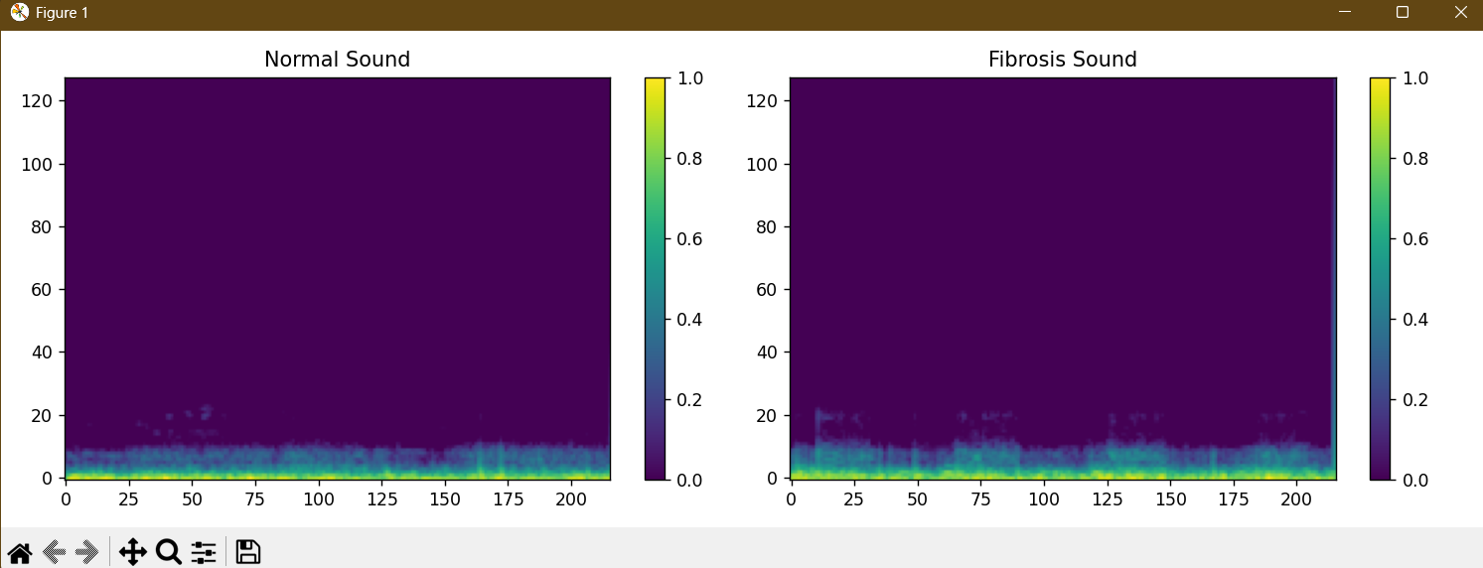
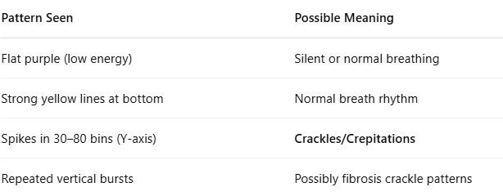
Crackles are a key acoustic marker in pulmonary fibrosis.
These are characterized by:
  - Short, burst-like sounds, typically lasting less than 20 milliseconds
  - Found in mid-to-high frequency ranges (approximately 400–1000 Hz)
  - Repetitive and sharp in fibrotic lungs, often compared to the sound of Velcro ripping
A bandpass filter (400 Hz to 1200 Hz) was applied to isolate the frequency zone where crackles commonly occur. The signal was divided into overlapping frames, and energy was computed for each frame to generate a smooth energy envelope.
SciPy’s find_peaks() function was used to detect sharp energy transients, identifying candidate crackles in the signal.
To reduce false positives, only sharp transients were retained by analysing the rise and fall slopes around each detected peak.
This ensured that only highly distinct crackles were included, filtering out soft or broad sounds.
A structured .csv file named crackle_features.csv was generated containing:
  - Filename
  - Class label (Normal / Fibrosis)
  - Detected crackle count
This feature file serves as input for training classical machine learning models such as logistic regression or random forests, enabling a lightweight yet effective fibrosis classification system based on acoustic features.
This preprocessing and analysis pipeline enables us to extract meaningful acoustic biomarkers from lung sound recordings, directly supporting the ML model’s ability to detect early-stage fibrosis. Our work ensures both accuracy and explainability, crucial for medical applications.

CNN Architecture Plan
Since Mel-spectrograms are 2D visual representations of audio signals, they can be effectively processed using convolutional neural networks (CNNs), similar to image classification tasks. The model architecture used is as follows:
- Input Layer: Mel-spectrogram images of shape (128 × 128 × 3)
- Input → Conv2D → MaxPool → Dropout
- Repeat a few times
- Flatten → Dense → Output (sigmoid for binary)

Metric | Normal (Class 0) | Fibrosis (Class 1)
Precision | 0.00 | 0.80
Recall | 0.00 | 1.00
F1-Score | 0.00 | 0.89
Support | 4 | 16
- Overall Accuracy: 80%
- Macro Average F1-Score: 0.44
- Weighted Average F1-Score: 0.71
The model perfectly classified all fibrosis samples (class 1). However, none of the normal samples were correctly identified. All 4 were misclassified as fibrosis. This indicates a strong model bias towards the majority class ("Fibrosis"), likely due to data imbalance.

Model using CT-Scan for detection of Pulmonary Fibrosis

1. Objective
Develop a deep learning model to predict Forced Vital Capacity (FVC) trends from chest CT scans of pulmonary fibrosis patients. Accurate FVC prediction supports clinical decision-making, disease progression tracking, and optimized patient care.

2. Methodology

2.1 Data Preparation
Input Format: Grayscale CT scan images resized to 224×224, normalized.
Labels: Matched with corresponding FVC measurements.
Data Augmentation: Applied random horizontal flips, brightness variations to increase robustness and reduce overfitting.

2.2 Model Architecture (CNN Regression)
Layer Type | Configuration
Conv2D Layer 1 | 32 filters, 7×7 kernel, ReLU activation
MaxPooling2D | 2×2 pooling
Conv2D Layer 2 | 64 filters, 5×5 kernel, ReLU activation
MaxPooling2D | 2×2 pooling
Conv2D Layer 3 | 128 filters, 3×3 kernel, ReLU activation
GlobalAveragePooling2D
Dense Layer | 64 units, ReLU
Output Layer | 1 unit (FVC prediction), linear activation

2.3 Training Strategy
Loss Function: Mean Squared Error (MSE)
Optimization Techniques: Early stopping and learning rate scheduling
Evaluation Metrics:
MAE (Mean Absolute Error)
RMSE (Root Mean Squared Error)
R² (Coefficient of Determination)

3. Model Refinement Plan (Ongoing Work)
OSIC Pulmonary Fibrosis Progression
Data Handling Improvements:
Balanced representation of patients with varying disease stages.
Inclusion of patient demographics for context-aware predictions.
Architectural Enhancements:
Batch Normalization and Dropout to improve generalization.
Experimenting with LeakyReLU, different kernel sizes, and filter depths.
L2 Regularization in dense layers to prevent overfitting.
Custom Loss Exploration:
Weighted error functions to prioritize clinically significant FVC deviations.

4. Literature Survey: Deep Learning for Pulmonary Fibrosis Prediction

4.1 Automated Pulmonary Fibrosis Progression Prediction using 3D CNNs (IEEE TMI, 2023)
Model: 3D ResNet-50 + LSTM
Dataset: 1,284 patients with longitudinal CT data (NSIP/UIP patterns)
Approach: Combined 3D spatial information with temporal patterns and clinical metadata.
Performance:
MAE: 189 mL ± 23
RMSE: 247 mL
R² Score: 0.79
Key Insight: Leveraging multiple CT timepoints and clinical fusion led to significantly higher prediction accuracy. Source

4.2 Deep Transfer Learning Techniques-Based Detection (MDPI, 2023)
Model: ResNet50v2 with transfer learning
Task: Binary classification of pulmonary fibrosis from chest CT
Performance:
Accuracy, Precision, Recall, F1-Score, AUC: All 100%
Key Insight: Achieved perfect classification through transfer learning and Grad-CAM for explainability. While not directly predicting FVC, it sets a benchmark in disease detection accuracy. Source

4.3 Fibrosis-Net: Predicting FVC Progression (Frontiers in AI, 2021)
Model: Fibrosis-Net (custom lightweight CNN)
Dataset: OSIC Pulmonary Fibrosis Progression Challenge
Train: 172 patients Test: ~28 patients
Evaluation Metric: Modified Laplace Log Likelihood Score
Key Insight: Integrated CT scans, initial spirometry readings, and clinical metadata for personalized prediction. Outperformed OSIC challenge leaders, with high explainability via Grad-CAM. Source

Summary of Literature Benchmarks
Study | Model | Task Type | MAE (mL) | R² | Key Techniques
IEEE TMI (2023) | 3D ResNet-50 + LSTM | FVC Regression | 189 | 0.79 | Temporal CT, clinical fusion
MDPI (2023) | ResNet50v2 | Disease Classification | — | — | Transfer learning, Grad-CAM
Frontiers in AI (2021) | Fibrosis-Net | FVC Progression | — | — | Metadata fusion, explainable CNN design

5. Conclusion & Next Steps
A CNN-based model is under active development to predict FVC directly from CT scans.
While the current model establishes a functional baseline, further tuning is underway to meet and potentially surpass published benchmarks.
Next Steps:
Incorporate 3D spatial features using 3D CNNs.
Fuse clinical and demographic metadata for multimodal learning.
Integrate Grad-CAM for explainability and clinician trust.

Final Deliverables:
Trained model weights
Codebase with inference pipeline
Performance dashboard
Model documentation and literature references

Conclusion

References

https://www.pulmonaryfibrosis360.com/pcp/suspecting-pulmonary-fibrosis/act-when-you-hear-dry-inspiratory-crackles
https://pubmed.ncbi.nlm.nih.gov/29914454/
https://www.mayoclinic.org/diseases-conditions/pulmonary-fibrosis/symptoms-causes/syc-20353690
https://drkalpeshpanchal.com/facts-about-pulmonary-fibrosis/
https://www.news-medical.net/health/What-is-Fibrosis.aspx
https://pmc.ncbi.nlm.nih.gov/articles/PMC9963026/
https://www.mypathologyreport.ca/pathology-dictionary/fibrosis/
Computer-Aided Diagnosis System for Lung Fibrosis: From the Effect of Radiomic Features and Multi-Layer-Perceptron Mixers to Pre-Clinical Evaluation
CT-Scan Model References:
https://ieeexplore.ieee.org/document/9725730
https://www.mdpi.com/2227-9717/11/2/443
https://pmc.ncbi.nlm.nih.gov/articles/PMC8596329/

