# INTRODUCTION

* 1. Overview
* Creating dashboard, story using tableau for top YouTube channels.
* The overview tab in YouTube Analytics gives you a high-level summary of how your channel and videos are performing on YouTube.
* YouTube subscribers refer t o the people or accounts that are subscribed to your channel. So whenever you upload a new video, your subscribers will be able to see it in their feeds. This makes your subscribers more likely to watch the videos.
  1. Purpose
* A problem is generally considered to be a task, a situation, or person which is difficult to deal with or control due to complexity and in Transparency.
* A YouTube is a type of a social media influencer who uploads or creates videos on the online video-sharing website YouTube, typically posting to their personal YouTube channel.
* You can use YouTube for learning. YouTube is a platform for learners. You can learn almost anything like English, Coding, Business management, and so much more.

1. **Problem Definition & Design Thinking**
   1. Empathy Map

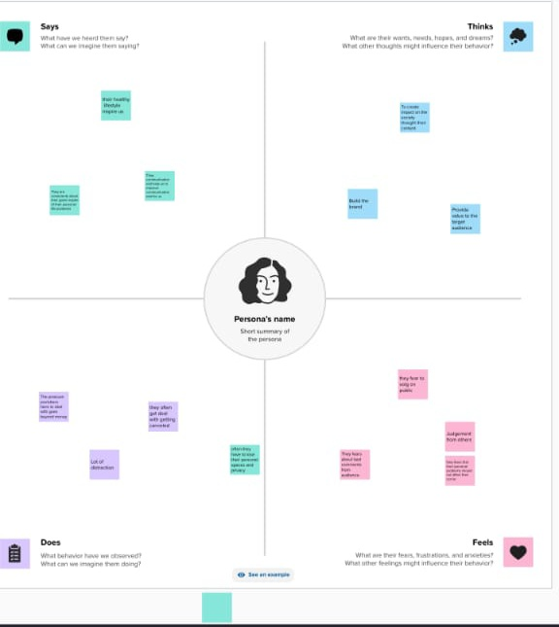

* 1. Ideation & Brainstorming Map

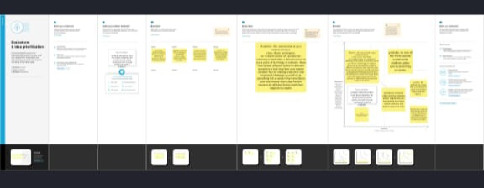

# RESULT

Finding’s (Output) of the project along with screenshots.

# ADVANTAGES & DISADVANTAGES

* Encourages creativities.
* To give everyone a voice and show them the world.
* Choosing to be a YouTube as a career is a great business idea.
* YouTube in India is good as a full time career with endless amount of possibilities.
* There are no specific qualifications required to be a YouTube.
* Ads-a drawback of YouTube for the audience. There are some distinct disadvantages of watching YouTube videos, which include a lot of commercials.
* Making money isn’t that easy.
* Defamation and bullying.
* Security and privacy issues, Technological issues, Maintenance cost, Facing negative feedback and reviews.

# APPLICATIONS

* Publish your videos and your channel on the radio, TV, websites, forums, newsletter, other social networking platforms.
* Link your YouTube channel in as many places as you can: websites, blocks, magazines.
* India is country with the most YouTube uses.
* YouTube is a video sharing service where uses can watch, like, share, commend and upload their own videos.
* Music videos are always the most popular content on YouTube.
* It’s probably the only platform where all new music videos are released and available at your fingertips.

# CONCLUSION

YouTube has an important part in education because it allows students to learn more about a particular topic or subject just by watching a short video. YouTube is full of different types of videos that can easily be in corporation and used in classrooms that will give students a better insight’s a particular subject.

# FUTURE SCOPE

* YouTube will likely become a destination for viewers and not just a place to people to find videos.
* YouTube will distribute its content directly to television, personal computer, and phones. it will also sell advertising based on this traffic.
* AI will also play a major in the future of YouTube. Through AI’s generative abilities, creators will be able to add to their stories improve the quality of their work.

# APPENDIX

A. Source Code

Attach the code for the solution built.