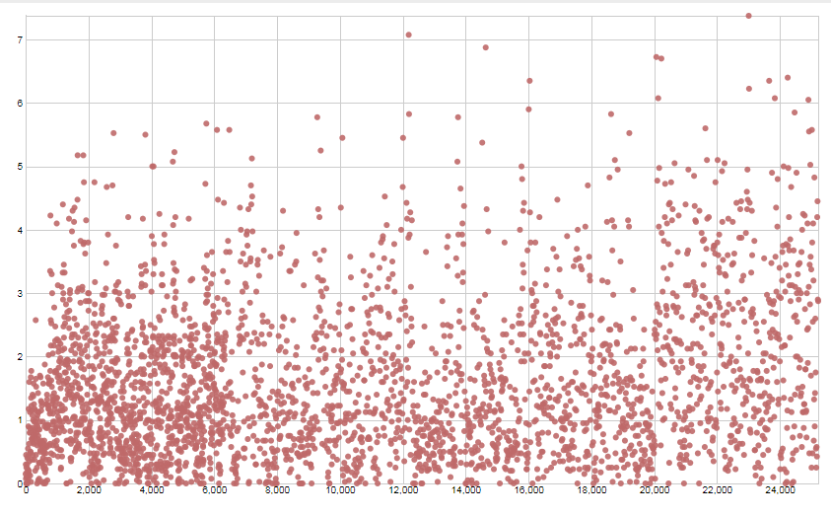

6k: changed something… cannot remember

20k: change newseedfreq to 2, lowered mutations to 5

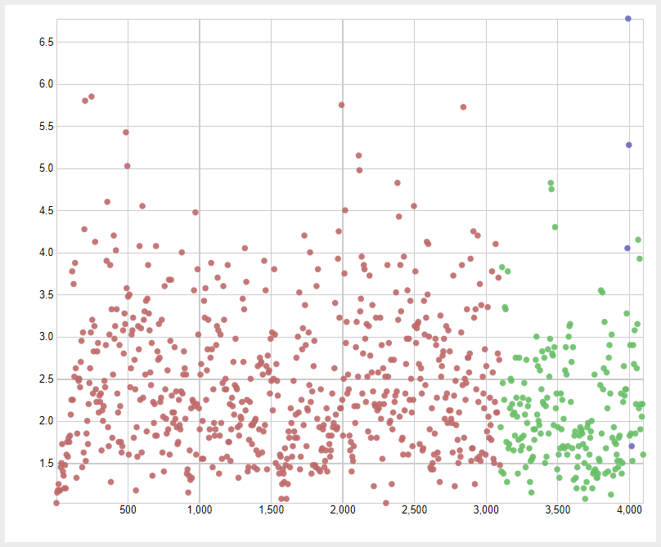

Green: 40 mutations, Red: 30 Mutations