**MongoDB Day 1 Task**

**Created a Database**: use product_info

**Collection name is items**

1. **Find all the information about each products**

db.items.find();

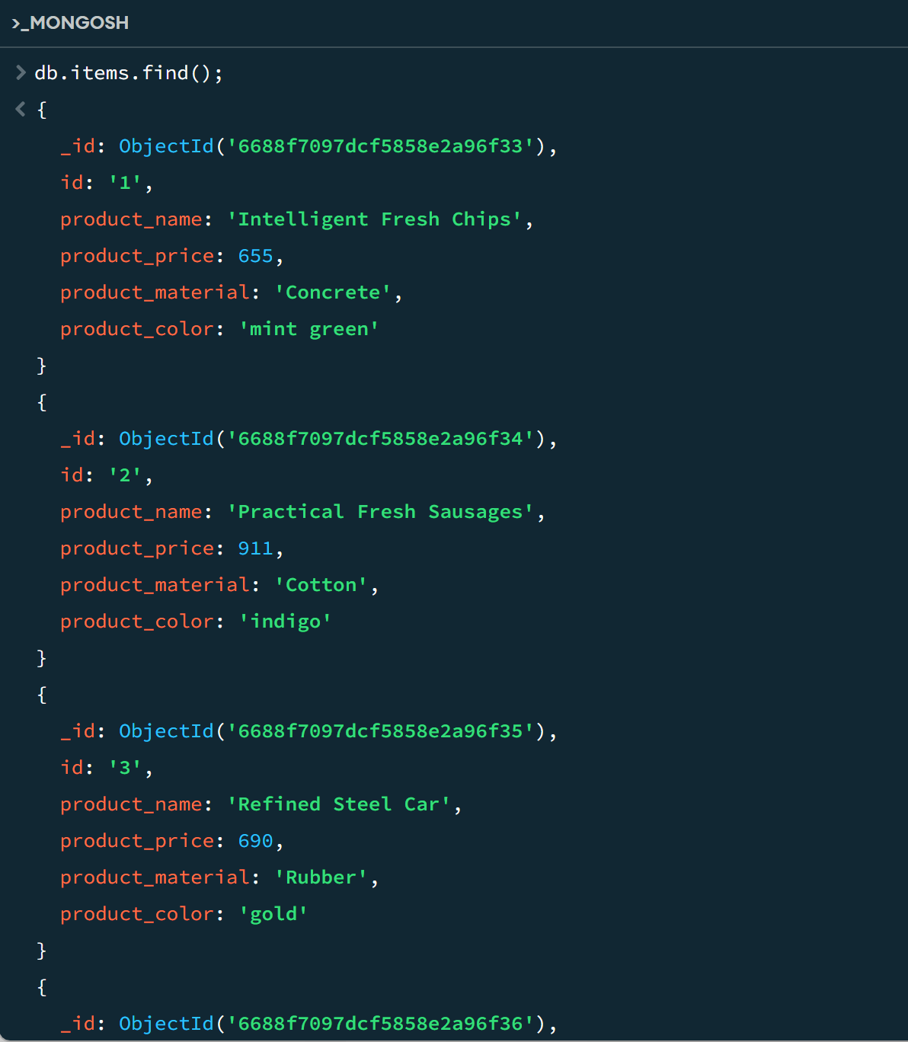

1. **Find the product price which are between 400 to 800**

db.items.find({$and:[{product_price:{$gt:400}},{product_price:{$lt:800}}]})

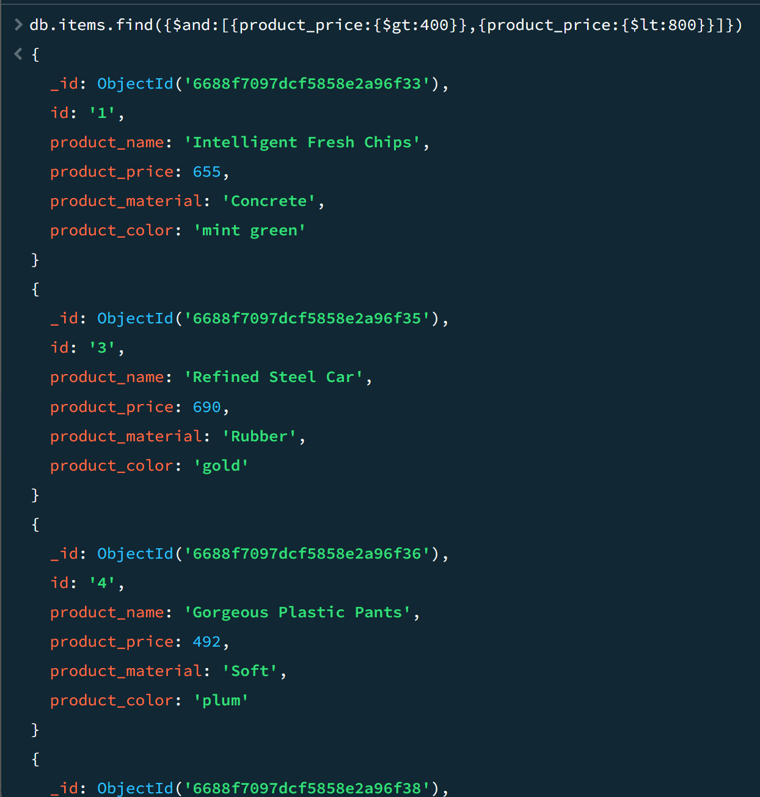

1. **Find the product price which are not between 400 to 600**

db.items.find({$or:[{product_price:{$lt:400}},{product_price:{$gt:600}}]})

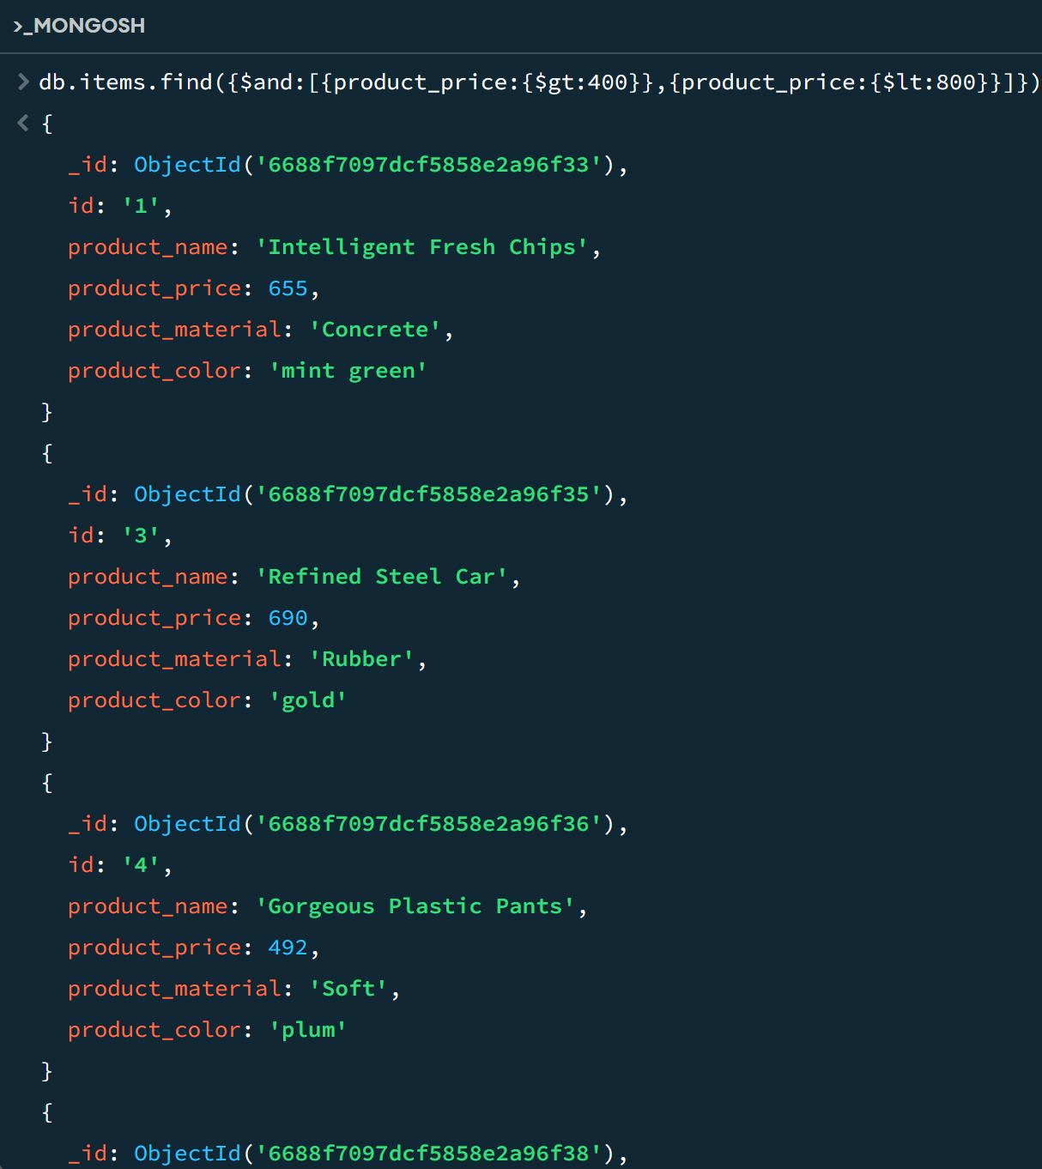

1. **List the four product which are greater than 500 in price**

db.items.find({product_price:{$gt:500}}).limit(4)

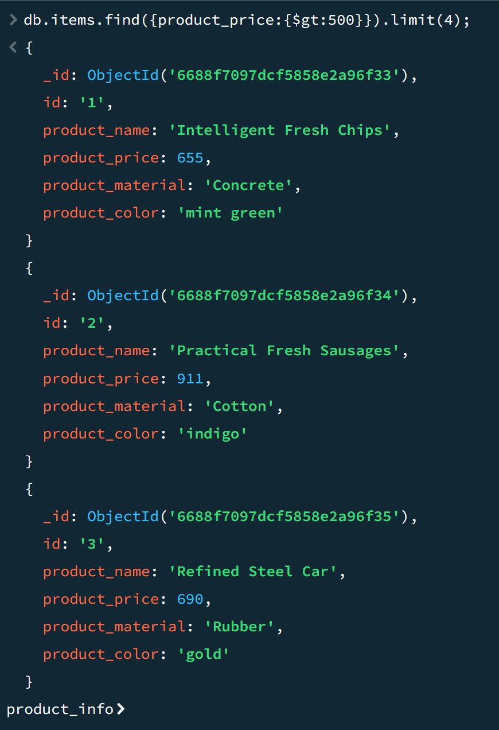

1. **Find the product name and product material of each products**

db.items.find({},{_id:0, product_name:1, product_material:1})

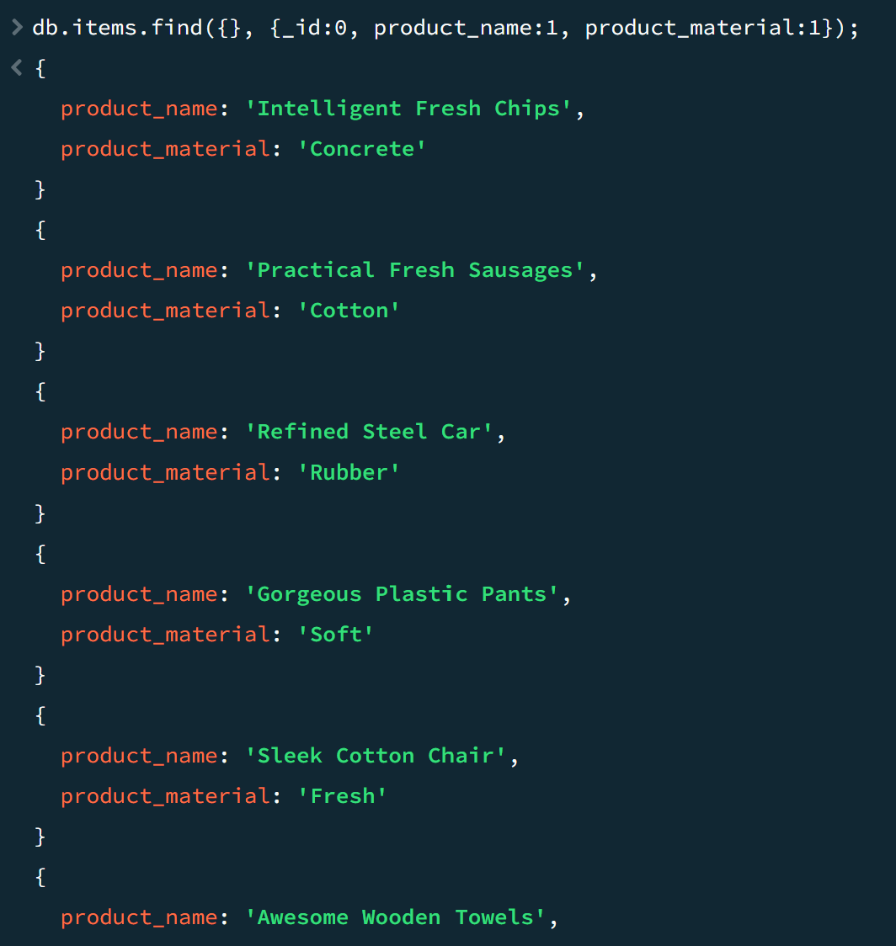

1. **Find the product with a row id of 10**

db.items.find({id:”10”})

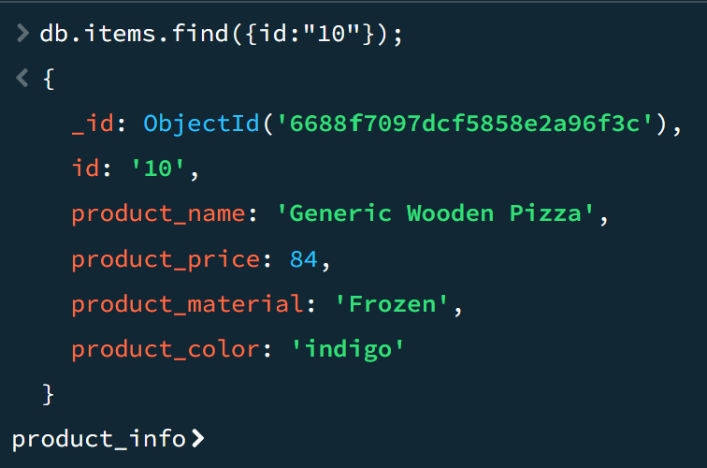

1. **Find only the product name and product material**

db.items.find({}, {_id:0, product_name: 1, product_material: 1})

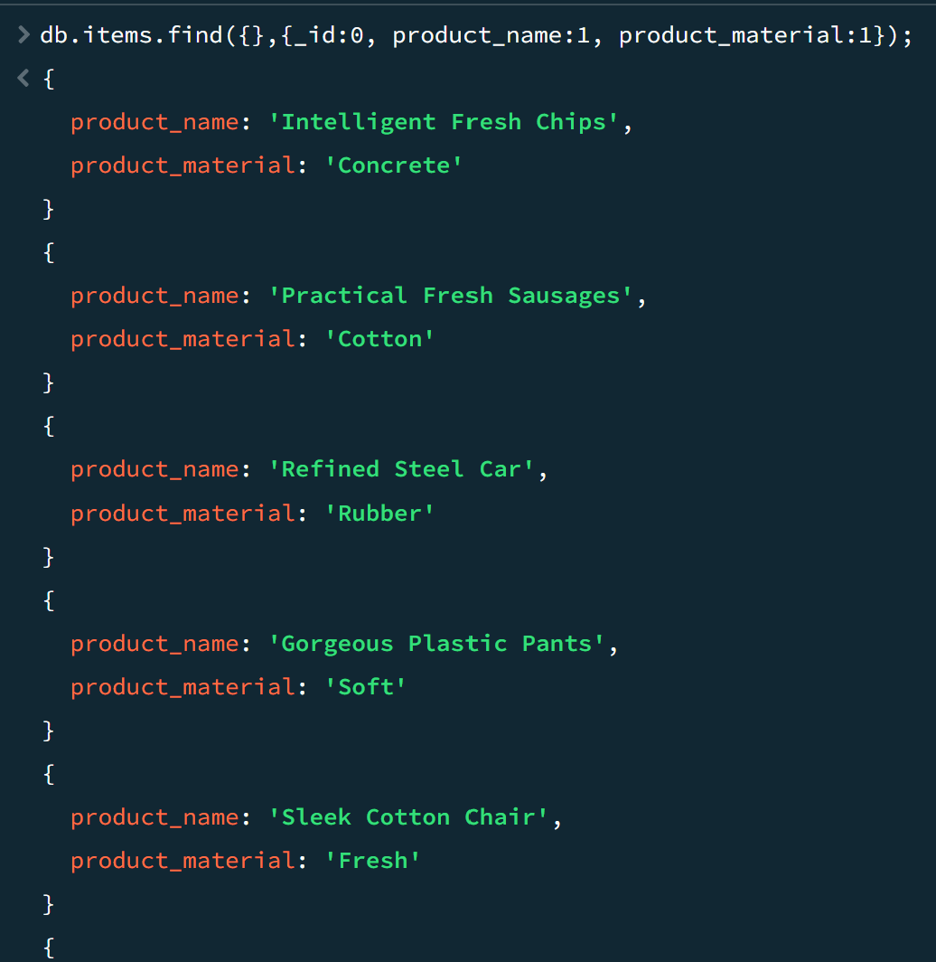

1. **Find all products which contain the value of soft in product material**

db.items.find({product_material: “Soft”})

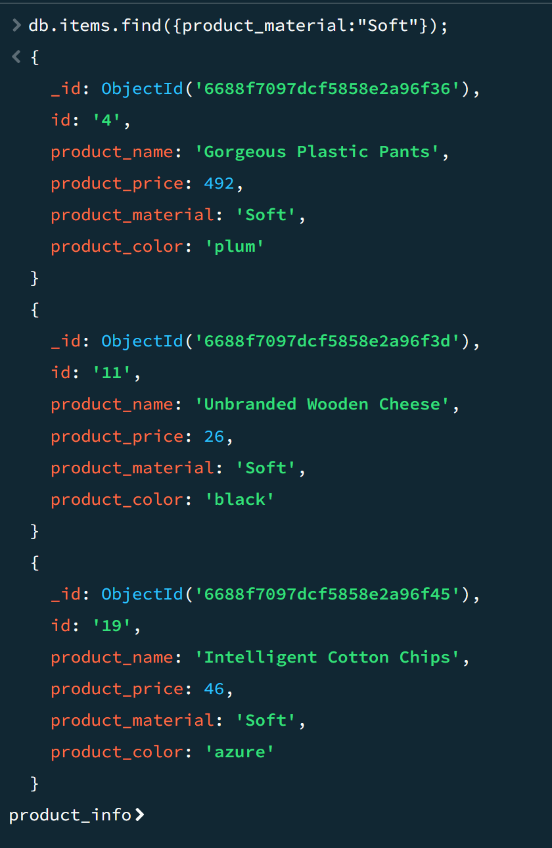

1. **Find products which contain product color indigo and product price 492.00**

db.items.find({$and:[{product_color: “indigo”}, {product_price:492.00}]})

No products with product_color: “indigo and product_price:492.00

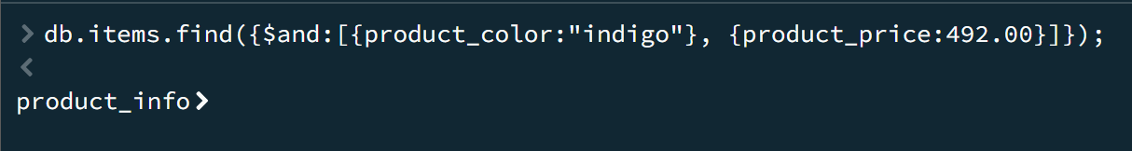

1. **Delete the products which product price value are 28**

db.items.deleteMany({product_price: 28});