Wireframe Documentation

**Back Order Prediction**

|  |  |
| --- | --- |
| Attributes | Values |
| Written By | Thomas Antony |
| Document Version 0.3 | 0.1 |
| Last Revised Date |  |

# Home Page

## Welcome page

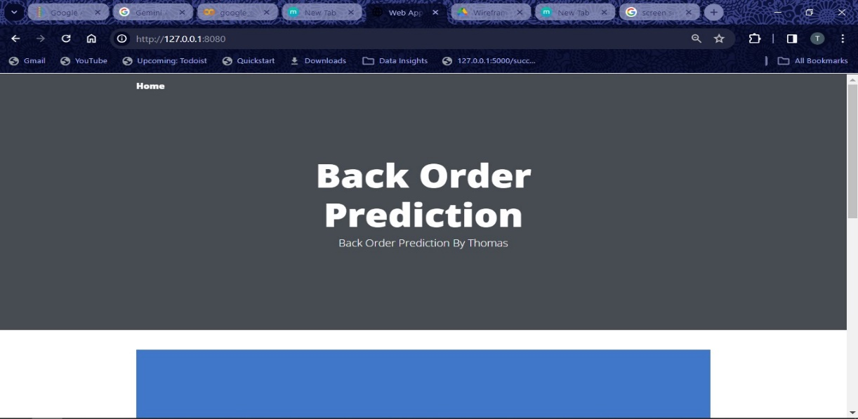

We have provided in the welcome page itself the form to enter the necessary details that was used in training the mode

## Form(home page)

This Form takes in the input fields and in the backend transformation has been done to the data for the model to predict and by clicking on the predict button you will be directed to results page

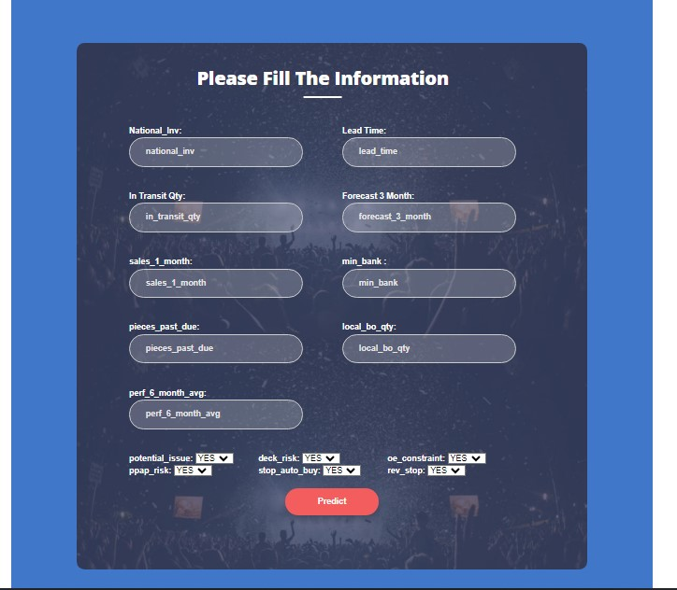

## Results page

Here You can see the prediction made by the model

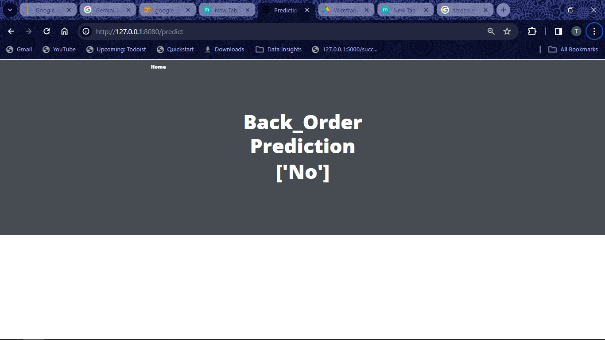

## Data Ingestion Preprocessing and Training Pipeline activation

By selecting the train page automatic data ingestion, data preprocessing, data transformation and Training will be triggered if the model has been successfully training you will get the Training Successful! message in the page

