Wireframe Documentation

**Back Order Prediction**

|  |  |
| --- | --- |
| Attributes | Values |
| Written By | Thomas Antony |
| Document Version 0.3 | 0.1 |
| Last Revised Date |  |

# Home Page

## Welcome page

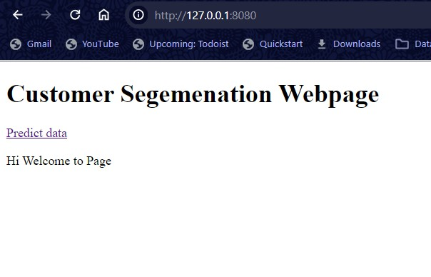

We have provided in the welcome page were you can find link to prediction page by clicking on predict data you will be directed to prediction page

## Form(home page)

This Form takes in the input fields and in the backend transformation has been done to the data for the model to predict and by clicking on the submit button you will be directed to results page

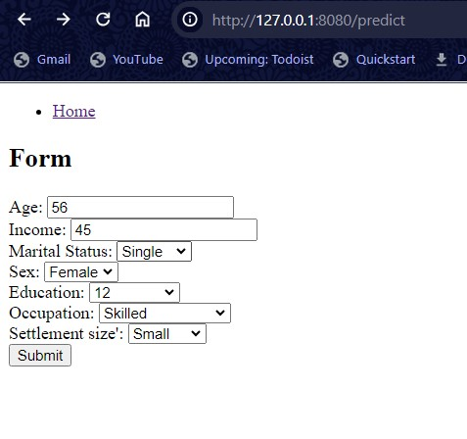

## Results page

Here You can see the prediction made by the model

