SKILL 23: PATH VARIABLE AND COMMAND RESOLUTION
Name: Anthony Nissy
Roll No: 2520030064
Sec: 8

PART 1: RETRIEVING PATH VARIABLE AND LOCATING EXECUTABLES

Aim
To write a C program to retrieve the PATH environment variable, search its directories, locate executable files, verify permissions, and handle commands that are not found.

Theory
The PATH environment variable contains a list of directories where the operating system searches for executable programs.
The directories are separated by a colon : in Linux.
For example:
/usr/local/bin:/usr/bin:/bin
When a command such as ls is entered, the system searches these directories to find the executable file.
The getenv() function is used to retrieve the value of the PATH variable.
The strtok() function can be used to split the PATH into individual directories.
The access() function checks whether a file exists and whether it has execute permission.

Objectives
- Retrieve the PATH environment variable.
- Read the command from the user.
- Separate PATH into individual directories.
- Search each directory.
- Construct the complete executable path.
- Check whether the executable exists.
- Verify execute permission.
- Display the location of the command.
- Handle commands that are not found.

Functions Used
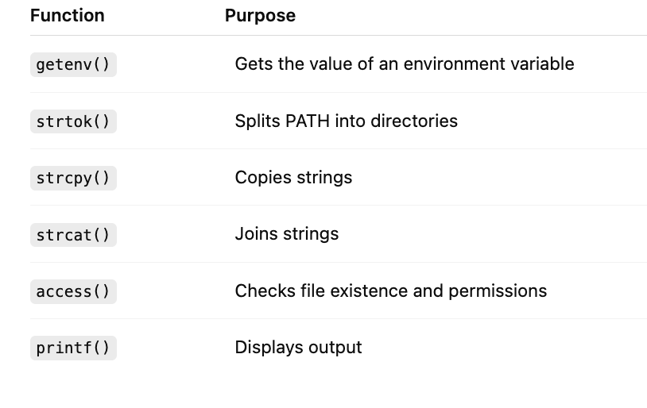

C Code
#include <stdio.h>
#include <stdlib.h>
#include <string.h>
#include <unistd.h>
int main()
{
char *path = getenv("PATH");
char *dir;
char file[500];
char cmd[100];
printf("Enter command: ");
scanf("%s", cmd);
dir = strtok(path, ":");
while (dir != NULL)
{
strcpy(file, dir);
strcat(file, "/");
strcat(file, cmd);
if (access(file, X_OK) == 0)
{
printf("Executable found: %s\n", file);
return 0;
}
dir = strtok(NULL, ":");
}
printf("Command not found\n");
return 0;
}

Explanation of Code

1. Retrieve PATH
getenv("PATH")
Gets the PATH environment variable from the operating system.

2. Read Command
scanf("%s", cmd);
Reads the command entered by the user.

3. Split PATH
strtok(path, ":")
Separates PATH into individual directories.

4. Create File Path
strcpy(file, dir);
strcat(file, "/");
strcat(file, cmd);
Combines the directory and command name.
Example:
/usr/bin + / + ls
becomes:
/usr/bin/ls

5. Check Permission
access(file, X_OK)
Checks whether the file exists and has execute permission.

6. Handle Missing Command
If no executable is found in any PATH directory:
Command not found
is displayed.

Compile
gcc path.c -o path

Run
./path

Flow Chart
START
↓
Retrieve PATH Variable
↓
Read Command
↓
Split PATH Directories
↓
Select a Directory
↓
Build Complete Path
↓
Check Execute Permission
↓
Is File Found?
↙ ↘
YES NO
↓ ↓
Display Path Check Next Directory
↓ ↓
STOP More Directories?
↙ ↘
YES NO
↓ ↓
Search Again Display
"Command
not found"
↓
STOP

Sample Output – Command Found
Enter command: ls
Executable found: /usr/bin/ls

Sample Output – Command Not Found
Enter command: abcxyz
Command not found

Observation
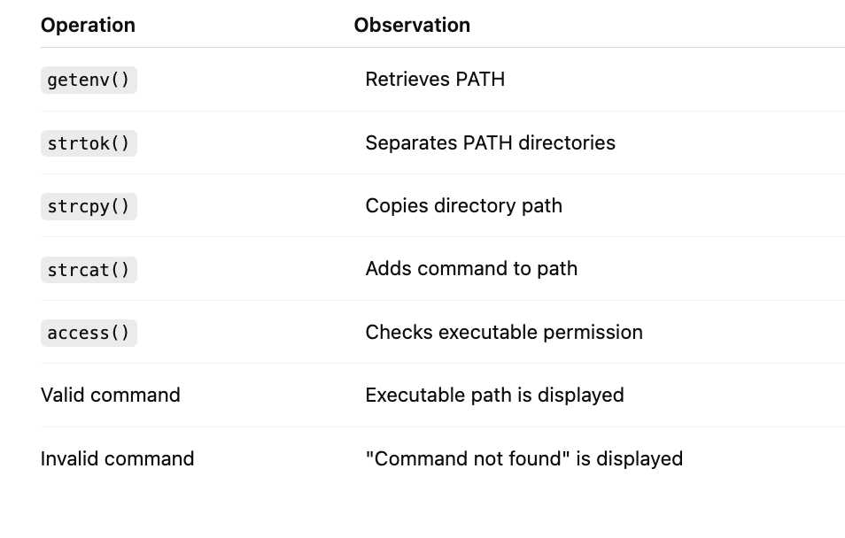

Test Cases
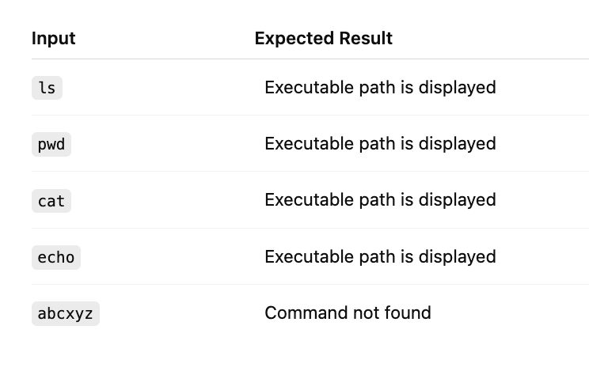

Output
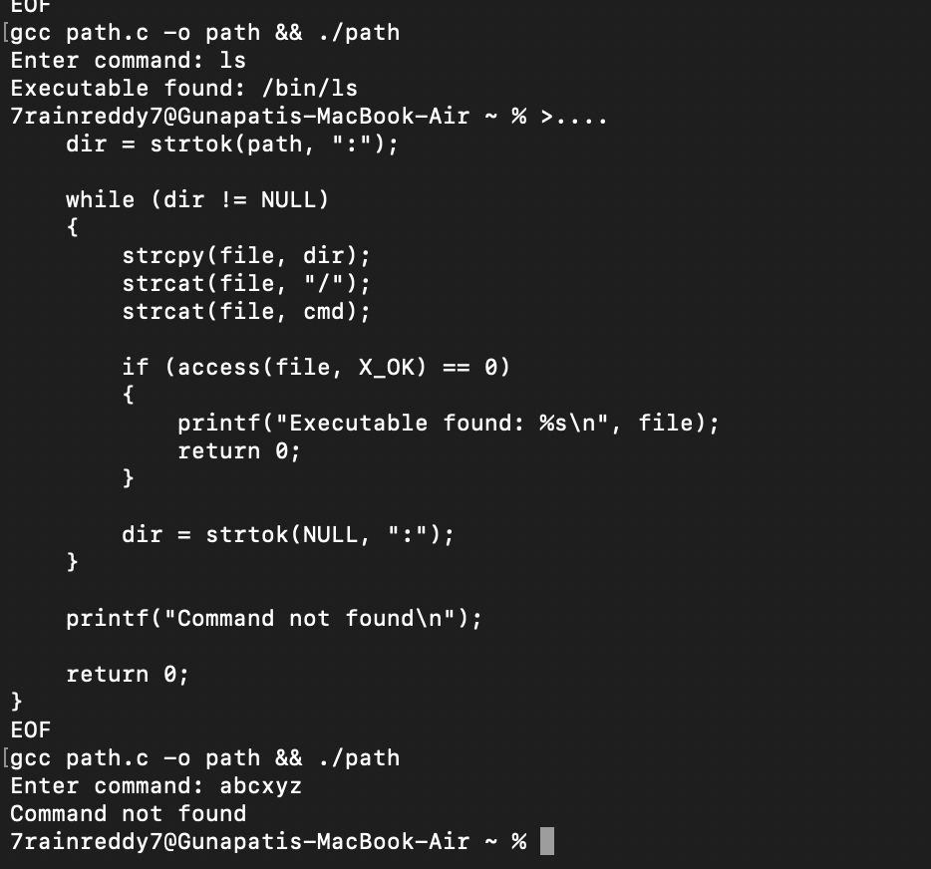
Enter command: pwd
Executable found: /usr/bin/pwd

Result:

The C program successfully retrieved the PATH environment variable, parsed its directories, searched for the requested command, verified executable permission, and handled missing commands. Thus, command resolution using the PATH variable was successfully demonstrated.

