SKILL 24: VARIABLE REFERENCE DETECTION AND EXPANSION
Name: Anthony Nissy
Roll No: 252003064
Sec: 8

PART 1: ENVIRONMENT VARIABLE EXPANSION

Aim
To write a C program to detect variable references, expand their values from the environment, handle undefined variables, and display the expanded result.

Theory
Environment variables are variables maintained by the operating system and shell.
For example:
HOME=/home/user
PATH=/usr/bin:/bin
USER=student
A variable can be referenced using the $ symbol.
For example:
$HOME
The getenv() function retrieves the value of an environment variable.
Variable expansion replaces a variable reference with its actual value.
Example:
Input: Home is $HOME
Output: Home is /home/user
If the variable does not exist, it is treated as an undefined variable.

Objectives
- Read a string from the user.
- Detect $ variable references.
- Extract the variable name.
- Retrieve its value.
- Replace the variable reference with its value.
- Handle undefined variables.
- Display the expanded string.
- Test different environment variables.

Functions Used
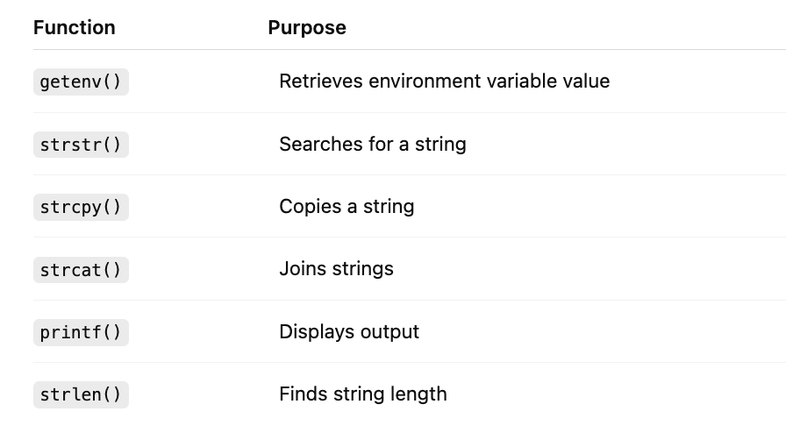

C Code
#include <stdio.h>
#include <stdlib.h>
#include <string.h>
#include <ctype.h>
int main()
{
char input[200], name[100], result[500] = "";
int i = 0, j;
char *value;
printf("Enter text: ");
fgets(input, sizeof(input), stdin);
while (input[i] != '\0')
{
if (input[i] == '$')
{
i++;
j = 0;
while (isalnum(input[i]) || input[i] == '_')
name[j++] = input[i++];
name[j] = '\0';
value = getenv(name);
if (value != NULL)
strcat(result, value);
else
strcat(result, "[undefined]");
}
else
{
char temp[2] = {input[i], '\0'};
strcat(result, temp);
i++;
}
}
printf("Expanded: %s", result);
return 0;
}

Explanation of Code

1. Read Input
fgets(input, sizeof(input), stdin);
Reads the text entered by the user.

2. Detect $
if (input[i] == '$')
Checks whether the current character represents the beginning of a variable reference.

3. Extract Variable Name
while (isalnum(input[i]) || input[i] == '_')
Reads the characters forming the variable name.
For:
$HOME
the variable name extracted is:
HOME

4. Get Variable Value
value = getenv(name);
Retrieves the value of the environment variable.

5. Handle Defined Variable
If the variable exists, its value is added to the output.

6. Handle Undefined Variable
If the variable does not exist:
[undefined]
is added to the output.

Compile
gcc variable.c -o variable

Run
./variable

Flow Chart
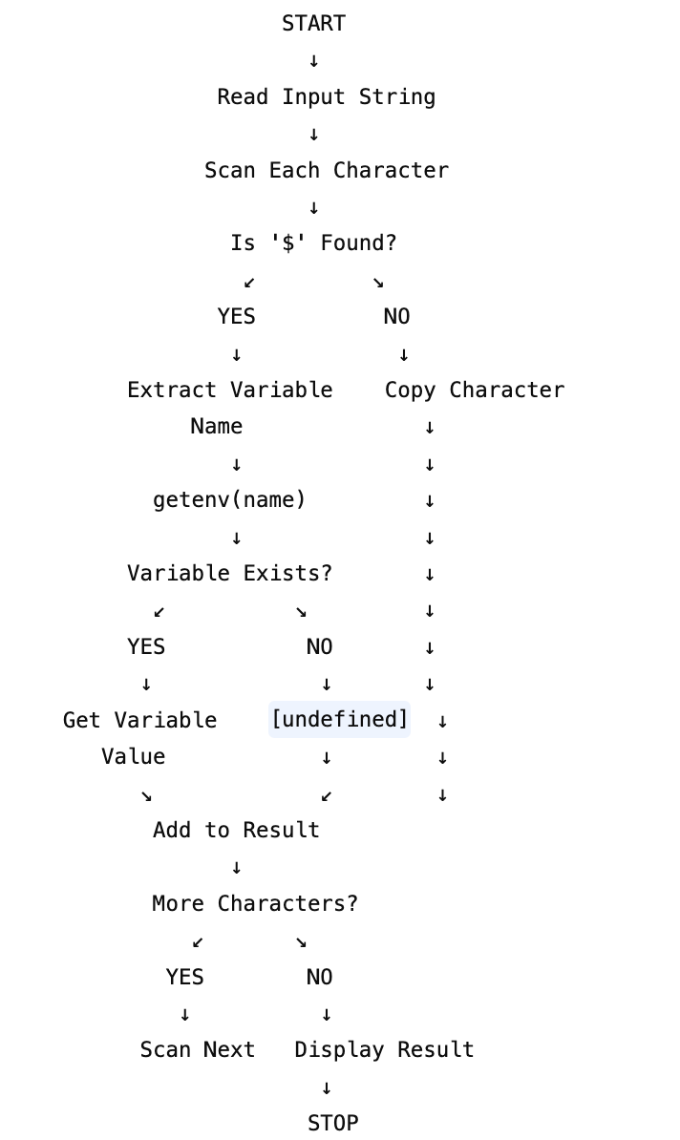

Sample Output – Defined Variable
Enter text: My home is $HOME
Expanded: My home is /home/student

Sample Output – Multiple Variables
Enter text: User is $USER and home is $HOME
Expanded: User is student and home is /home/student

Sample Output – Undefined Variable
Enter text: Value is $ABCXYZ
Expanded: Value is [undefined]

Observation
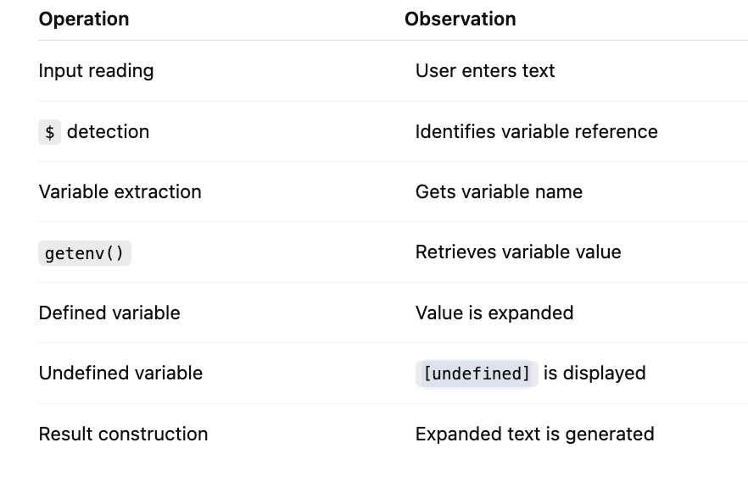

Test Cases
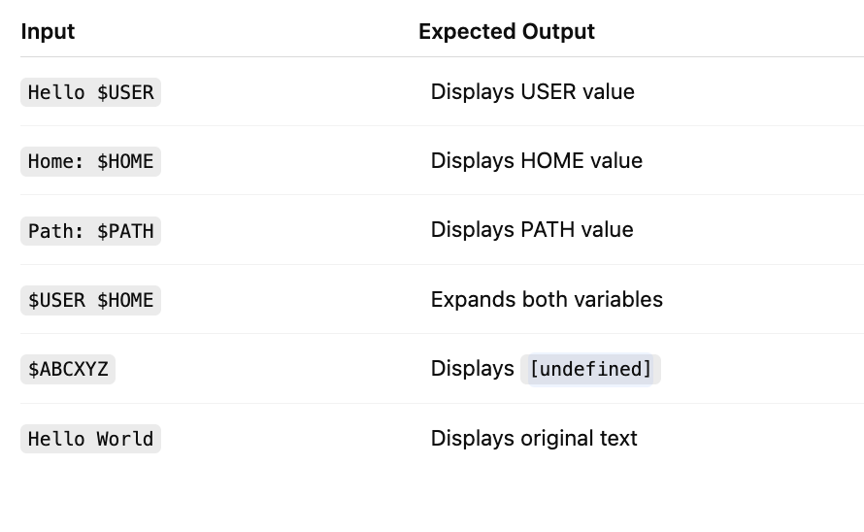

Important Points
- $ indicates a variable reference.
- getenv() is used to retrieve environment variables.
- The variable name is extracted after $.
- Defined variables are replaced by their values.
- Undefined variables are handled separately.
- Multiple variables can be expanded in one input.
- The program constructs the final expanded string.

OUTPUT
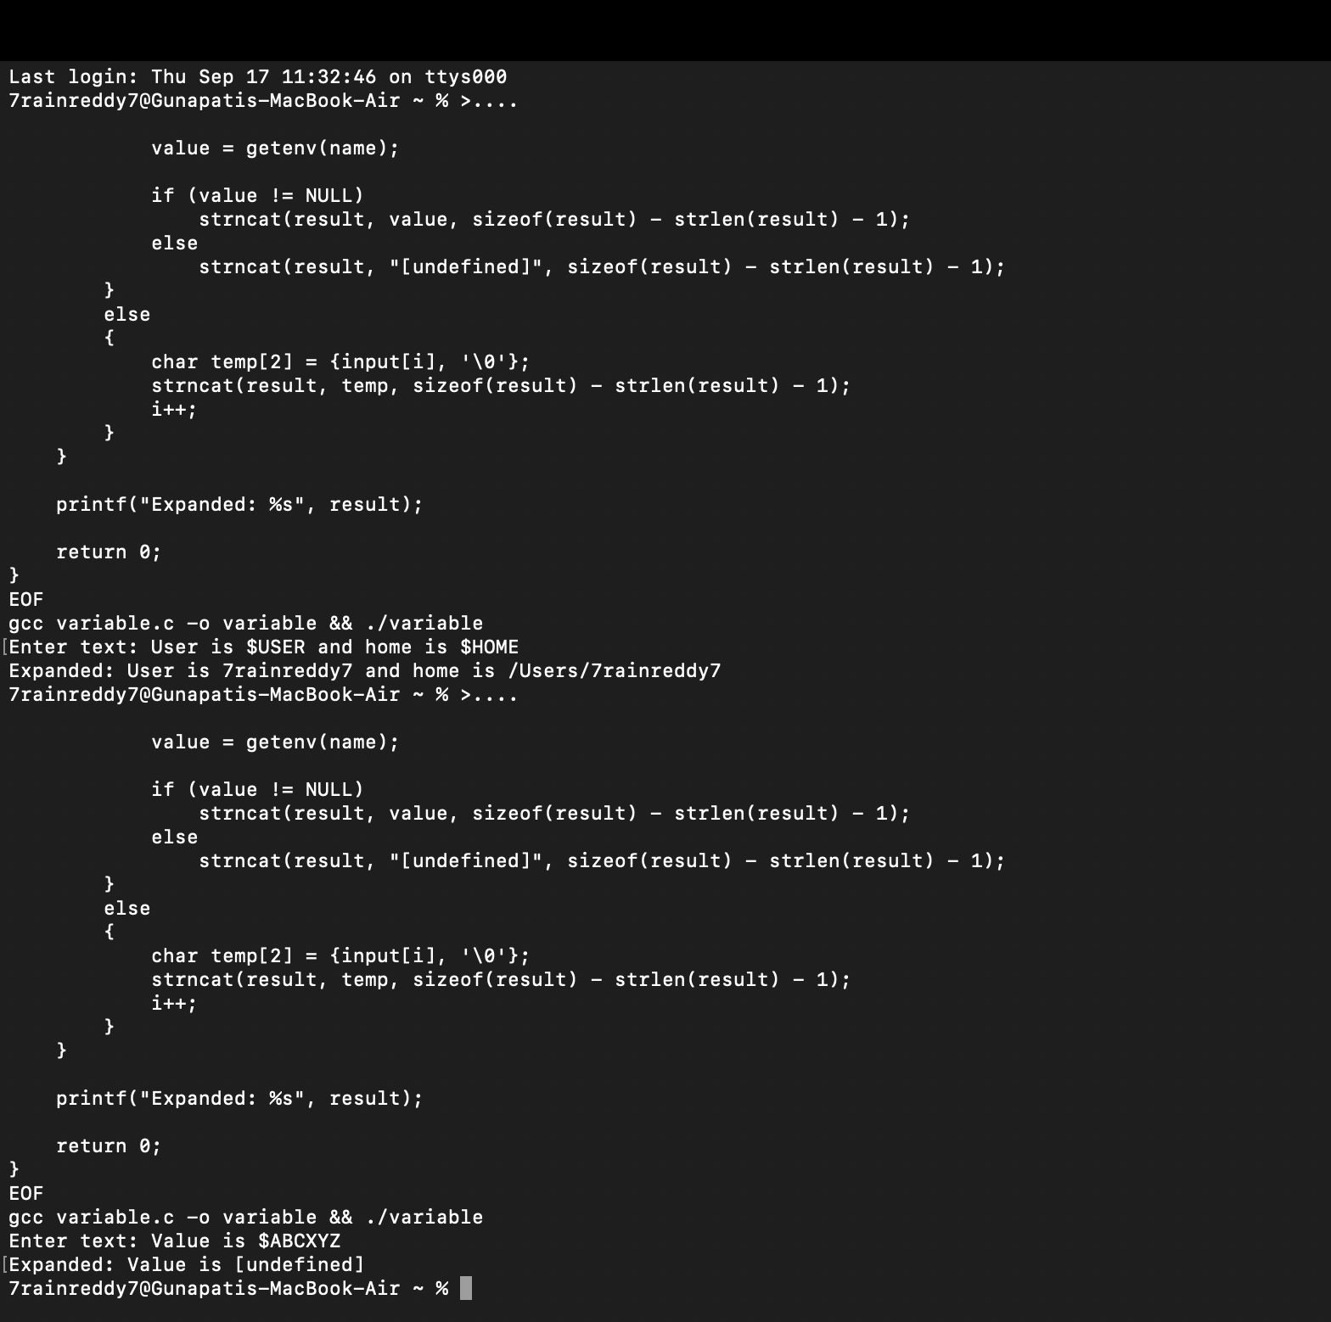

Enter text: User is $USER
Expanded: User is student

Result
The C program successfully detected environment variable references, extracted variable names, retrieved their values using getenv(), expanded defined variables, and handled undefined variables. Thus, variable reference detection and expansion were successfully demonstrated.

