SKILL-22: PROCESS SYNCHRONIZATION AND CHILD PROCESS MONITORING USING waitpid()
Name: Anthony Nissy
Roll No: 2520030064
Sec: 8

PART 1: PROCESS SYNCHRONIZATION AND CHILD PROCESS MONITORING USING waitpid()

Aim
To write a C program that creates multiple child processes using fork(), monitors their execution using waitpid(), synchronizes their completion, and collects their exit status.

Theory
The fork() system call creates a new child process from the parent process.
The waitpid() system call is used by the parent process to wait for a specific child process to terminate.
When a child process completes its execution, the parent can use waitpid() to collect its termination status. This provides proper synchronization between the parent and child processes.
waitpid() is more flexible than wait() because it allows the parent to specify which child process it wants to wait for.

Syntax
waitpid(pid, &status, options);

Parameters
- pid – Specifies the child process to wait for.
- &status – Stores the termination status of the child.
- options – Specifies the waiting behavior.
For normal blocking execution:
waitpid(pid, &status, 0);

Objectives
- Create multiple child processes.
- Obtain the PID of each child.
- Execute different tasks in child processes.
- Monitor child completion using waitpid().
- Wait for a specific child process.
- Collect the exit status of each child.
- Synchronize parent and child processes.
- Prevent child processes from remaining as zombies.

System Calls / Functions Used
Function | Purpose
fork() | Creates a new child process
waitpid() | Waits for a specific child process
getpid() | Returns the current process ID
sleep() | Delays process execution
printf() | Displays information
WEXITSTATUS() | Retrieves the exit status of a terminated child

C Code
#include <stdio.h>
#include <unistd.h>
#include <sys/wait.h>
int main()
{
pid_t p1, p2;
int status;
p1 = fork();
if (p1 == 0)
{
printf("Child 1: PID = %d\n", getpid());
sleep(2);
printf("Child 1 completed\n");
return 10;
}
p2 = fork();
if (p2 == 0)
{
printf("Child 2: PID = %d\n", getpid());
sleep(1);
printf("Child 2 completed\n");
return 20;
}
printf("Parent: PID = %d\n", getpid());
waitpid(p1, &status, 0);
printf("waitpid(): Child 1 status = %d\n",
WEXITSTATUS(status));
waitpid(p2, &status, 0);
printf("waitpid(): Child 2 status = %d\n",
WEXITSTATUS(status));
printf("Parent process completed\n");
return 0;
}

Explanation of Code

1. Header Files
#include <stdio.h>
#include <unistd.h>
#include <sys/wait.h>
These provide functions required for input/output, process creation, and process synchronization.

2. Creating Child 1
p1 = fork();
This creates the first child process.
If p1 == 0, the program is executing inside Child 1.

3. Child 1 Execution
sleep(2);
return 10;
Child 1 waits for 2 seconds and terminates with exit status 10.

4. Creating Child 2
p2 = fork();
The parent creates the second child process.
Child 2 waits for 1 second and terminates with exit status 20.

5. Parent Process
The parent displays its PID and waits for its children.

6. waitpid() for Child 1
waitpid(p1, &status, 0);
The parent waits specifically for Child 1.

7. Collecting Status
WEXITSTATUS(status)
This extracts the exit status returned by the child.

8. waitpid() for Child 2
waitpid(p2, &status, 0);
The parent then waits for Child 2.

Compile
gcc monitor.c -o monitor

Run
./monitor

Flow Chart
START
↓
Create Parent Process
↓
fork() Child 1
↓
Child 1 Executes Task
↓
fork() Child 2
↓
Child 2 Executes Task
↓
Parent Monitors Children
↓
waitpid(Child 1)
↓
Child 1 Terminates
↓
Collect Child 1 Status
↓
waitpid(Child 2)
↓
Child 2 Terminates
↓
Collect Child 2 Status
↓
Parent Completes
↓
STOP

Sample Output
Parent: PID = 4500
Child 1: PID = 4501
Child 2: PID = 4502
Child 2 completed
Child 1 completed
waitpid(): Child 1 status = 10
waitpid(): Child 2 status = 20
Parent process completed
Note: PID values and the exact order of child output may vary during execution.

Observation
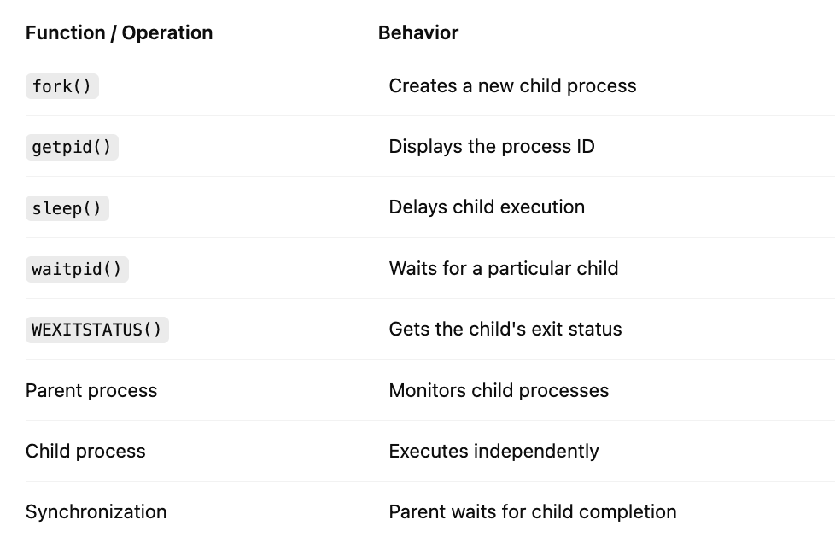

Comparison of wait() and waitpid()
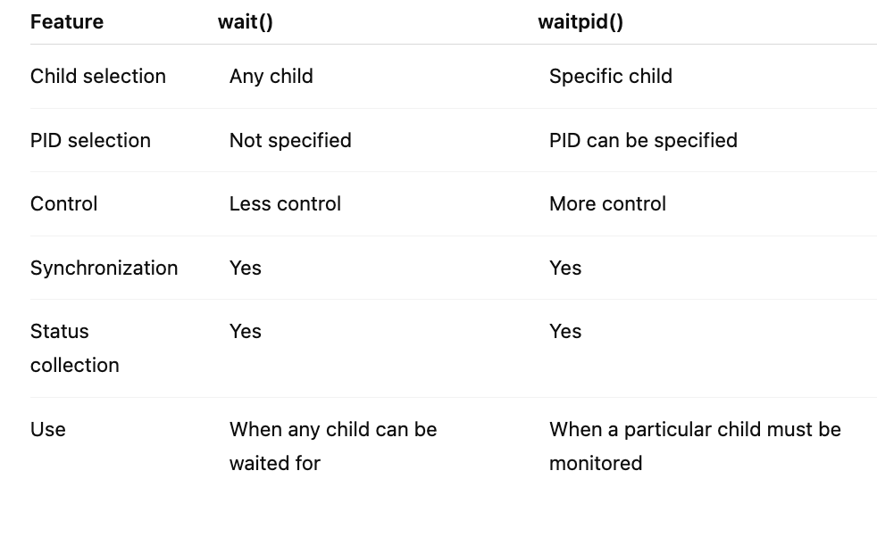

Expected Behavior
- The parent creates two child processes.
- Child 1 and Child 2 execute independently.
- Child 2 completes earlier because it sleeps for only 1 second.
- The parent specifically waits for Child 1 using waitpid().
- After Child 1 completes, its exit status is collected.
- The parent then waits for Child 2.
- After both children are handled, the parent process terminates.

Important Points
- fork() creates a new process.
- Each child has a unique PID.
- waitpid() allows specific child monitoring.
- The parent can collect the child's exit status.
- WEXITSTATUS() gives the value returned by the child.
- waitpid() provides process synchronization.
- Proper use of waitpid() helps prevent zombie processes.
- The parent continues after the required child process terminates.

OUTPUT
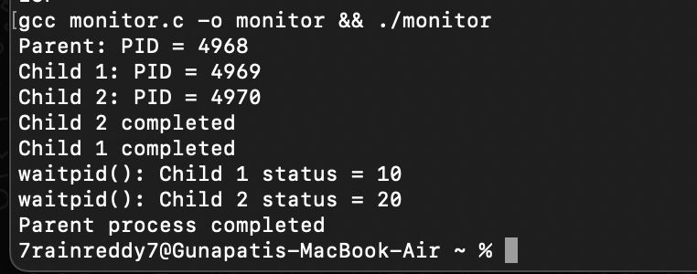
Parent: PID = 4500
Child 1: PID = 4501
Child 2: PID = 4502
Child 2 completed
Child 1 completed
waitpid(): Child 1 status = 10
waitpid(): Child 2 status = 20
Parent process completed

Result
The C program successfully created multiple child processes using fork() and monitored them using waitpid(). The parent process synchronized with the child processes, waited for specific child PIDs, and successfully collected their termination statuses. Thus, process synchronization and child process monitoring using waitpid() were successfully demonstrated.

