Practical-07
Name: Teja Hasini Reddy
Rollno: 2520030048
Section: 8
EXPERIMENT – Memory Address Space and /proc/<PID>/maps
Aim:
To write a C program that prints the addresses of code, global, static, heap, and stack variables, and analyse the Linux process address-space layout using /proc/<PID>/maps.
Objective:
- To understand the memory layout of a Linux process.
- To identify code, global, static, heap, and stack regions.
- To observe virtual memory mappings using /proc/<PID>/maps.
- To understand how Linux organizes memory for a running process.
Problem Statement:
Write a C program to display the addresses of different types of variables and use /proc/<PID>/maps to study the virtual memory organization of the running process.
Theory:
A Linux process has its own virtual address space. Important regions include:
Memory Segment | Purpose
Code/Text | Contains program instructions
Global/Data | Contains initialized global variables
BSS | Contains uninitialized global/static variables
Heap | Used for dynamically allocated memory
Stack | Stores local variables and function information
Shared Libraries | Libraries mapped into the process address space
The /proc/<PID>/maps file shows the virtual memory regions currently mapped into a process.
Example:
55a1...-55a1... r-xp ... /program
55a1...-55a1... rw-p ... /program
7f2...-7f2... r-xp ... /libc.so.6
7ffd...-7ffd... rw-p ... [stack]
Here:
- r = Read
- w = Write
- x = Execute
- p = Private mapping
Algorithm:
- Declare a global variable.
- Declare a static variable.
- Create a local stack variable.
- Create a function to represent the code segment.
- Allocate memory dynamically using malloc().
- Print the addresses of all variables.
- Print the process PID.
- Keep the program running.
- Open /proc/<PID>/maps from another terminal.
10. Analyse the virtual memory mappings.
11. identify the stack, heap, program, and shared-library regions.
C Program:
#include <stdio.h>
#include <stdlib.h>
#include <unistd.h>
int global_var = 10;
static int static_var = 20;
void code_function()
{
printf("Code address : %p\n", (void *)code_function);
}int main()
{
int stack_var = 30;
int *heap_var;
heap_var = (int *)malloc(sizeof(int));
if (heap_var == NULL)
{
printf("Memory allocation failed\n");
return 1;
}
*heap_var = 40;
printf("Linux Process Memory Layout\n");
printf("----------------------------\n");
printf("PID : %d\n", getpid());
printf("Code address : %p\n", (void *)code_function);
printf("Global address : %p\n", (void *)&global_var);
printf("Static address : %p\n", (void *)&static_var);
printf("Heap address : %p\n", (void *)heap_var);
printf("Stack address : %p\n", (void *)&stack_var);
printf("\nProcess is running...\n");
printf("Use another terminal to check /proc/%d/maps\n", getpid());
while (1)
{
sleep(10);
} free(heap_var);
return 0;
}
OUTPUT:
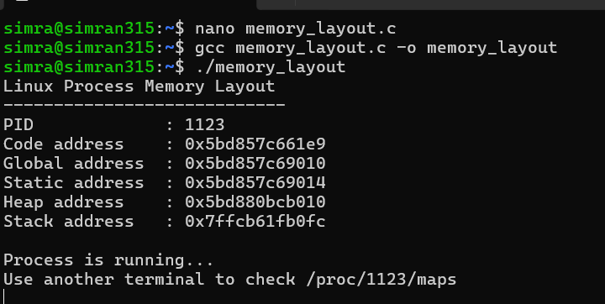
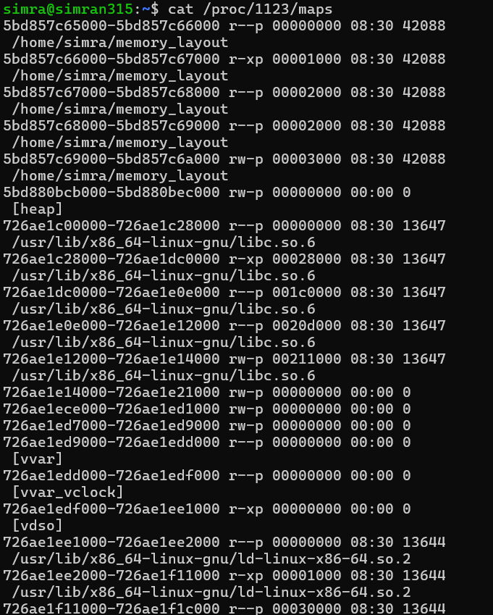
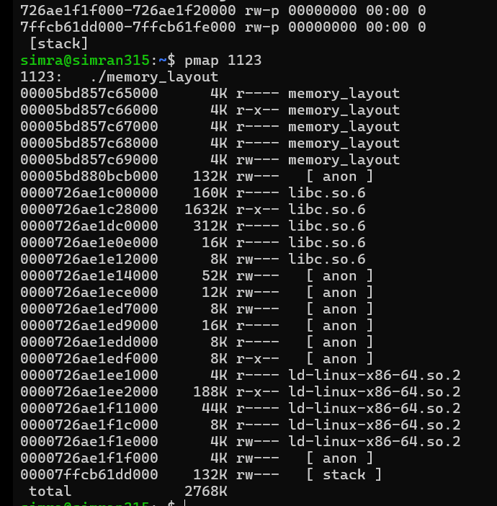
Program Explanation:
Code Segment
(void *)code_function
This displays the address of a function. Since program instructions are stored in the code/text segment, this represents the code region.
Global Segment
int global_var = 10;
The global variable is stored in the process's global data area.
Static Segment
static int static_var = 20;
The static variable has static storage duration and is stored in the program's data area.
Heap
heap_var = (int *)malloc(sizeof(int));
malloc() dynamically allocates memory from the heap.
Stack
int stack_var = 30;
A local variable inside main() is stored on the stack.
Analysis:
- The r-xp mapping of the executable corresponds to the code/text region.
- The writable executable mapping contains data/global/static areas.
- [heap] represents dynamically allocated memory.
- [stack] represents the process stack.
- libc.so.6 represents a shared library mapped into the process.
- Each process sees these as virtual addresses, which Linux manages through virtual memory.
Test Cases:
Test Case | Command/Action | Expected Result
1 | Run program | PID and memory addresses displayed
2 | Check code address | Address of function displayed
3 | Check global/static address | Data-area addresses displayed
4 | Check heap address | Dynamically allocated address displayed
5 | Check stack address | Local-variable address displayed
6 | cat /proc/PID/maps | Virtual memory mappings displayed
7 | pmap PID | Process memory map displayed
Observation:
- The program displayed different virtual addresses for code, global, static, heap, and stack variables.
- The heap and stack appeared as separate regions in /proc/PID/maps.
- The executable and shared libraries were also mapped into the process address space.
- /proc/PID/maps provided information about the permissions and ranges of each virtual memory mapping.
Result:
The C program was successfully implemented to display addresses of the code, global, static, heap, and stack regions. The /proc/<PID>/maps file was used to analyse the virtual memory organization of the running process.
Conclusion:
The experiment demonstrated how Linux organizes a process into different virtual memory regions. The memory addresses printed by the program, together with /proc/<PID>/maps, helped identify the code, data, heap, stack, and shared-library mappings.

