**QR - GENERATOR**

**Current Progress**

QR RENDERER

ALIGNMENT MARKERS

ORIENTATION MARKERS  
TIMING PATTERNS   
DATA TO BINARY CONVERTER

**THINGS TO ADD/FIX**

Data Writer is fixed but there is a issue with the converter

Reed Solomon error correction

Masking Patterns

Format , Version and mask info

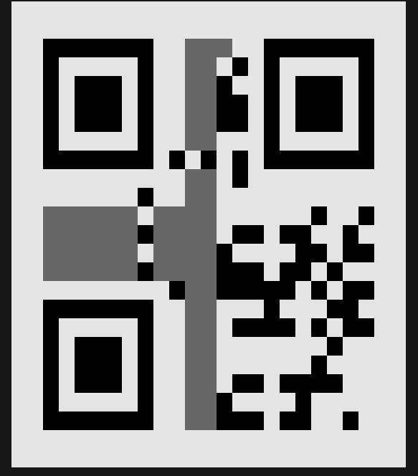

**GITHUB LINK:**[7IRE/QR-Generator](https://github.com/7IRE/QR-Generator)