|  |  |  |  |
| --- | --- | --- | --- |
| Time-Bin | Theta | Phi | Switch |
| 1 |  |  |  |
| 2 |  |  |  |
| 3 |  |  |  |
|  |  |  |  |
|  |  |  |  |
|  |  |  |  |
|  |  |  |  |

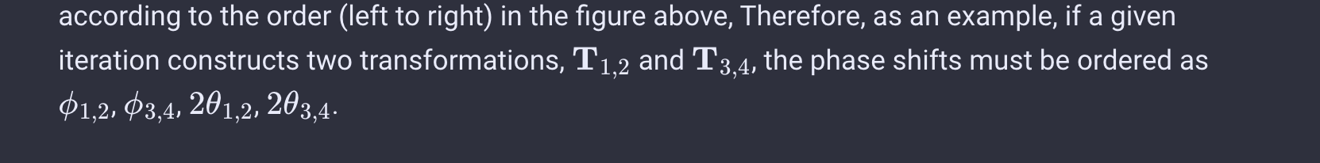

[ 3.14159265 3.75014049 3.14159265 3.14159265 3.14159265 2.21429744

3.14159265 5.8195377 3.14159265 0.84106867 3.14159265 4.06072787

4.29185465 3.14159265 1.77215425 1.77215425 5.90905349 1.15026199

3.14159265 0.84106867 5.90905349 6.28318531 5.39489081 1.23095942

2.21429744 3.14159265 1.63404334 2.22113762 3.14159265 3.14159265

1.32944844 -0.3045949 -0.37931624 -2.60045386 0.04533064 -1.99322584]

Step Time-Bin Theta Phi

0 | bin | theta | phi

0 | 0 | 0 | 0

1 | 1 | 0 | 0

2 | 2 | 0 | 0

3 | 3 | 0 | 0

4 | 4 | 0 | 0

5 | 5 | 0 | 0

6 | 6 | 1 | 2

7 | 7 | 3 | 4

8 | 8 | 5 | 6

10 | 10 | 0 | 0

11 | 11 | 7 | 8

12 | 12 | 0 | 0

13 | 13 | 9 | 10

14 | 14 | 11 | 12

15 | 15 | 13 | 14

16 | 16 | 15 | 16

17 | 17 | 0 | 0

18 | 18 | 17 | 18

19 | 19 | 19 | 20

20 | 20 | 0 | 0

21 | 21 | 21 | 22

22 | 22 | 23 | 24

23 | 23 | 25 | 26

24 | 24 | 27 | 28

25 | 25 | 0 | 0

26 | 26 | 29 | 30

27 | 27 | 31 | 32

outnow

28 | 28 | 0 | 0

saved_numbers: [1]

29 | 29 | 0 | 0

saved_numbers: [1, 3]

30 | 30 | 0 | 0

saved_numbers: [1, 3, 5]

31 | 31 | 0 | 0

saved_numbers: [1, 3, 5, 0]

32 | 32 | 0 | 0

saved_numbers: [1, 3, 5, 0, 2]

33 | 33 | 0 | 0

saved_numbers: [1, 3, 5, 0, 2, 4]

34 | 34 | 0 | 0

saved_numbers: [1, 3, 5, 0, 2, 4, 6]