**SW2 – Project Evaluation Form**

* **Each team must submit the following Documentation that contains:**

**- Project Description in detail.**

**- Class Diagram. And Database Schema.**

* **Each team must submit the project via GitHub:**
* **Source Code.**
* **Video Demo for running ( 2 – 5 Minutes ).**
* **Documentation and Evaluation Form.**
* **The Evaluation will start with giving all teams 30 marks then check the following criteria:**

|  |  |  |  |  |
| --- | --- | --- | --- | --- |
| **Violation Level** | **Full** | **Medium** | **Small** | **Grade** |
| **Documentation** | **-5** | **-2** | **-1** |  |
| **Not Apply MVC (it does not Separate Business logic from GUI).**  **Example of violation: write the implantation for a method such as an inset item into the database inside the Button Action method)** | **-6** | **- 3** | **-1** |  |
| **Violate clean code – Variables** | **-2** | **-1** | **-.05** |  |
| **Violate clean code – Functions** | **-2** | **-1** | **-.05** |  |
| **Violate Single-responsibility Principle** | **-2** | **-1** | **-.05** |  |
| **Violate Open-closed Principle** | **-2** | **-1** | **-.05** |  |
| **Violate the Liskov Substitution Principle** | **-2** | **-1** | **-.05** |  |
| **Violate Interface Segregation Principle** | **-2** | **-1** | **-.05** |  |
| **Violate Dependency Inversion Principle** | **-2** | **-1** | **-.05** |  |
| **Not Upload code to GitHub** | **-1** | | |  |
| **Only One Branch Without Merge (GitHub)** | **-2** | | |  |
| **Only One Contribution (GitHub)** | **-2** | | |  |
| **Total Minus from Grade** |  |  |  |  |

|  |  |  |
| --- | --- | --- |
| **Design Pattern Bounce** | **+4** |  |
| **Bounce on Overall Work** | **+2** |  |
| **Total Team Grade / 30** |  | |

|  |  |  |  |
| --- | --- | --- | --- |
| **Name (Arabic)** | **ID** | **Individual Bounce +2** | **Grade** |
| **طارق مصطفي اسماعيل محمد** | **201900387** |  |  |
| **سهيله محسن سعد احمد** | **201900357** |  |  |
| **عبدالرحمن عماد عبدالله السيد** | **201900425** |  |  |
| **أميمة كمال مصطفى السيد تمراز** | **201900183** |  |  |
| **رضوي منصور ابراهيم اسماعيل** | **201900302** |  |  |
|  |  |  |  |
|  |  |  |  |

|  |
| --- |
| **JAVA PROJECT**  ELECTRICITY BILLING SYSTEM |
|  |

|  |  |  |
| --- | --- | --- |
| **ELECTRICITY BILLING SYSTEM**  JAVA PROJECT Project Description in detailThis project about electricity billing system to make everything related to electricity billing online. customer can pay bill, know everything about bill without making a lot of processes, it is just press on button to know everything about bill.Modules System has 4 modules (new customer, old customer, operator, admin). each one of them has many system controls to use system well.  **Modules of system are:** **1-Old Customer Module**a. Enables customer to pay a bill with meter codeb. Enables customer to enter monthly reading of meter.c. Enables customer to complain about bill with meter code.d. System will stop meter code automatically if customer didn’t pay within 3 months.   **2 - New Customer Module**  a. Enables customer to fill all information |  | System has four modules: 1- New customer  2- Old customer  3- Operator  4- Admin |

**3-Operator Module**

a. Enables operator to collect payments from customer

b. Enables operator to print bill with meter code

c. Enables operator to view bills of specific region.

d. Enables operator to validate reading with real consumption.

e. Enables operator to define tariff for customer.

f. Enables operator to stop meter and cancel subscription for customer.

**4- Admin Module**

1. a. Enables admin to view all bills of specific regions.
2. b. Enables admin to view total collected.
3. c. Enables admin to make consumption statistics for specific region.
4. d. Enables admin to add / update / delete users with different roles.

**Functional Requirements:**

**1)Admin module:**

**1)View all bills**

|  |  |  |
| --- | --- | --- |
| **User Requirement** | Overview | Admin will choose to view all bills for the region and enter the name of this region. |
| **System Requirement** | Description | The system will take the region’s name and select all bills under this region from the database and return all information to the program to view it. |
| Pre-condition | 1)Admin successfully logs in to the system.  2)Region exists. |
| Post-condition | 1)Bills viewed successfully. |

**2)View the total collected**

|  |  |  |
| --- | --- | --- |
| **User Requirement** | Overview | Admin will choose to view all collected money. |
| **System Requirement** | Description | The system will select the sum of all collected money from the database and return it to the program to view. |
| Pre-condition | 1)Admin successfully logs in to the system. |
| Post-condition | 1)total collected money viewed successfully. |

**3)Make consumption statistics**

|  |  |  |
| --- | --- | --- |
| **User Requirement** | Overview | Admin will choose to make a consumption statistic for the region. |
| **System Requirement** | Description | The system gets the total consumption and average for the region from the database and returns it to the program to view it. |
| Pre-condition | 1)Admin successfully logs in to the system.  2)Region exists. |
| Post-condition | 1)total and average consumption for region viewed successfully. |

**4)Add user**

|  |  |  |
| --- | --- | --- |
| **User Requirement** | Overview | Admin will receive the information from a new user and put all information in the database |
| **System Requirement** | Description | The system will take all information and generate a meter code(if user is customer)/id(if user is admin or operator) and then put all information in the database and then send an email to the user to receive the meter code / id and notify him also |
| Pre-condition | 1)Admin successfully logs in to the system.  2)New users sign up for the system. |
| Post-condition | 1)user-added successfully.  2)send an email and notification to the user to receive the meter code. |

**5)Manual add**

|  |  |  |
| --- | --- | --- |
| **User Requirement** | Overview | Admin will choose to add the user manually by himself and fill the user’s information to the database. |
| **System Requirement** | Description | The system will take information and generate a meter code (if user is customer)/id(if user is admin or operator) and fill all information in the database and then view the meter code / id to the admin and notify the user . |
| Pre-condition | 1)Admin successfully logs in to the system.  2)Admin fill in user information. |
| Post-condition | 1)user-added successfully.  2)admin receives the meter code.  3)user was notified by his mail. |

**6)Update:**

**1)Update name**

|  |  |  |
| --- | --- | --- |
| **User Requirement** | Overview | Admin will update the user’s name with his meter code/id. |
| **System Requirement** | Description | The system will take the meter code/id and search in the database if this user exists or not and if yes will update his name with a new name. |
| Pre-condition | 1)Admin successfully logs in to the system.  2)User exists. |
| Post-condition | 1)User’s name updated successfully. |

**2)Update email**

|  |  |  |
| --- | --- | --- |
| **User Requirement** | Overview | Admin will update the customer’s email with his meter code. |
| **System Requirement** | Description | The system will take the meter code and search in the database if this customer exists or not and if yes will update his email with a new email. |
| Pre-condition | 1)Admin successfully logs in to the system.  2)Customer exists. |
| Post-condition | 1)Customer’s email updated successfully. |

**3)Update address**

|  |  |  |
| --- | --- | --- |
| **User Requirement** | Overview | Admin will update the customer’s address with his meter code. |
| **System Requirement** | Description | The system will take the meter code and search in the database if this Customer exists or not and if yes will update his address with a new address. |
| Pre-condition | 1)Admin successfully logs in to the system.  2)Customer exists. |
| Post-condition | 1)Customer’s address updated successfully. |

**7)Delete user**

|  |  |  |
| --- | --- | --- |
| **User Requirement** | Overview | Admin will choose to delete the user from the system. |
| **System Requirement** | Description | The system will take the meter code(if user is customer) or id (if user is admin or operator) and search in the database and if the user exists, then will delete all his information from the database. |
| Pre-condition | 1)Admin successfully logs in to the system.  2)User exists |
| Post-condition | 1)user-deleted successfully. |

**2)Operator Module**

**1)Collect payment**

|  |  |  |
| --- | --- | --- |
| **User Requirement** | Overview | The operator will choose to collect payment from customers |
| **System Requirement** | Description | The system will take the meter code from the customer and then search if the customer exists or not and if true operator will collect payment from the customer. |
| Pre-condition | 1) Operator successfully logs in to the system.  2)Customer exists. |
| Post-condition | 1)payments collected successfully. |

**2)Print bill with meter code**

|  |  |  |
| --- | --- | --- |
| **User Requirement** | Overview | The operator will choose to view a bill with a meter code |
| **System Requirement** | Description | The system will take meter code and then search if the customer exists or not if true operator will view the bill by its date |
| Pre-condition | 1) Operator successfully logs in to the system.  2)Customer exists. |
| Post-condition | 1)bill viewed successfully. |

**3)Print bills of the region**

|  |  |  |
| --- | --- | --- |
| **User Requirement** | Overview | The operator will choose to view a bill under specific region |
| **System Requirement** | Description | The system will take the name of region and then search if exists then print all bills under this region |
| Pre-condition | 1) Operator successfully logs in to the system.  2)region exists. |
| Post-condition | 1)bills viewed successfully. |

**4)Validate Reading with real consumption**

|  |  |  |
| --- | --- | --- |
| **User Requirement** | Overview | The operator will validate reading with real consumption |
| **System Requirement** | Description | The system will take the current reading and compare it with the last reading if the current reading is greater than the last one then this will be ok if less than then will be an error. |
| Pre-condition | 1) Operator successfully logs in to the system. |
| Post-condition | 1)return true or false. |

**5)Define the tariff for customer**

|  |  |  |
| --- | --- | --- |
| **User Requirement** | Overview | The operator will define the tariff to the customer according to his consumption. |
| **System Requirement** | Description | The system will take the consumption and then define the tariff to know the value of each bill. |
| Pre-condition | 1) Operator successfully logs in to the system. |
| Post-condition | 1)tariff defined successfully. |

**6)Stop meter code or cancel a subscription**

|  |  |  |
| --- | --- | --- |
| **User Requirement** | Overview | The operator will choose to stop meter code and cancel subscription |
| **System Requirement** | Description | The system will freeze any transaction for selected meter code or delete it completely from system. |
| Pre-condition | 1)Operator successfully logs in to the system.  2)Meter code exists. |
| Post-condition | 1)meter code stopped or canceled successfully. |

**3)Old customer module**

**1)pay bill with meter code**

|  |  |  |
| --- | --- | --- |
| **User Requirement** | Overview | Old customer will be able to pay bill with his meter code |
| **System Requirement** | Description | The system will take the meter code and then search if the customer exists or not if true then the customer will pay it. |
| Pre-condition | 1)Customer exists. |
| Post-condition | 1)bill paid successfully. |

**1)Enter monthly reading**

|  |  |  |
| --- | --- | --- |
| **User Requirement** | Overview | Old customer will be able to enter monthly readings into the system. |
| **System Requirement** | Description | The system will take the meter code and then search if the customer exists or not if true then the customer will enter a reading. |
| Pre-condition | 1)Customer exists. |
| Post-condition | 1)Reading entered successfully. |

**2)Complain about bill with meter code**

|  |  |  |
| --- | --- | --- |
| **User Requirement** | Overview | Old customer will be able to complain about bills with his meter code |
| **System Requirement** | Description | The system will take the meter code and bill date and then search if the customer and bill exist or not if true then the customer will complain. |
| Pre-condition | 1)Customer exists.  2)Bill exists. |
| Post-condition | 1)User complained successfully. |

**4)New customer module**

**1)fill in information**

|  |  |  |
| --- | --- | --- |
| **User Requirement** | Overview | New customer will be able to fill in his information. |
| **System Requirement** | Description | New customer will fill his all information in system and system will be saving this information into it. |
| Pre-condition |  |
| Post-condition | 1)User added to system successfully.  2)System sends an email to user to notify him the meter code |

**Non-functional Requirements:**

**1)Performance and reliability:**

1-The system can be maintained easily because using OOP modules.

2--UX is very fast due to the architecture of the system (Data Centre Architecture).

**2)Security:**

1-All personal information must be hidden

EX: password, Operator’s/Admin’s ID.

2-No meter code duplicated for different customers.

3-No same id for operators or admins.

5-Only admin as a human and system as a boot allowed to access database.

**3)Usability:**

1-UI is designed in a very way, so the user can use the system smoothly after spending an hour on it.

**4)Reliability:**

1- The system servers and services should be available when it is requested by the user.

2- user can easily connect with the admin or system if any problem happens.

3- has a very high-quality maintenance system to avoid any crashes.

**USE-CASE DIAGRAM**:

**USE-CASE DESCRIPTIONS**

|  |  |
| --- | --- |
| **Identifier and name** | UC1 Login |
| **Initiator** | Old Customer |
| **Goal** | The Old Customer has logged in. |
| **Pre-condition(s)** | None |
| **Post-condition(s)** | The Old Customer logged in to the app successfully. |
| **Assumptions** | The Old Customer controls the application, so he/she is already registered to the application. |

**Main success scenario:**

1. The Old Customer chooses to login.
2. The Old Customer enters the email and the password.
3. The Old Customer logged in to the application.

**Extensions:**

2.a An error occurs during logging in.

2.a.1 Restart the page.

|  |  |
| --- | --- |
| **Identifier and name** | UC2 PayBill |
| **Initiator** | Old Customer |
| **Goal** | The Customer has paid the bill |
| **Pre-condition(s)** | Enter Meter Code |
| **Post-condition(s)** | The customer has paid the bill successfully. |
| **Assumptions** | The Customer is known to the application’s software system, and he /she has logged in |

**Main success scenario:**

1. The customer chooses to pay a bill.
2. The customer enters the meter code.
3. The customer paid the bill successfully.

**Extensions:**

The customer cannot pay the bill due to technical issues in the form or an error may occur in the system or entering incorrect meter code.

|  |  |
| --- | --- |
| **Identifier and name** | UC3 ReadingMonthly |
| **Initiator** | Old Customer |
| **Goal** | The customer has entered the reading successfully |
| **Pre-condition(s)** | The customer has logged in |
| **Post-condition(s)** | The customer has entered the monthly reading of meter. |

**Main success scenario:**

1. The customer chooses to enter the monthly reading of meter.
2. The customer enters the meter code and the reading of meter.

**Extensions:**

2.a An error occurs during enter the monthly reading of meter.

2.a.1 Restart the page.

|  |  |
| --- | --- |
| **Identifier and name** | UC4 Complain |
| **Initiator** | Old Customer |
| **Goal** | The Customer complained about the bill with meter code. |
| **Pre-condition(s)** | The customer entered meter code |
| **Post-condition(s)** | The customer has complained about bill successfully. |
| **Assumptions** | The Customer has found bug while working on a project. |

**Main success scenario:**

1. The customer chooses to complain.
2. The customer enters the meter code.
3. The customer enters the complaint.
4. The customer sends the complaint.

**Extensions:**

The customer cannot send the complaint due to technical issues in the form or an error that occurred in the system.

|  |  |
| --- | --- |
| **Identifier and name** | UC5 Register |
| **Initiator** | New Customer |
| **Goal** | The Customer has registered |
| **Pre-condition(s)** | None |
| **Post-condition(s)** | The customer has registered successfully, and he /she can login to the application. |
| **Assumptions** | The Customer is not known to the application’s software system. |

**Main success scenario:**

1. The customer chooses to register.
2. The customer fills the form.
3. The customer registered successfully.
4. The customer can login to the application.

**Extensions:**

The customer cannot register due to technical issues in the form, or an error may occur in the system.

|  |  |
| --- | --- |
| **Identifier and name** | UC6 Attach |
| **Initiator** | New Customer |
| **Goal** | The Customer has registered |
| **Pre-condition(s)** | The Customer entered his/her information |
| **Post-condition(s)** | The customer has a copy of contract successfully. |
| **Assumptions** | The Customer entered his information. |

**Main success scenario:**

1. The customer chooses to attach a copy of contract.
2. The customer has a copy of contract successfully.

|  |  |
| --- | --- |
| **Identifier and name** | UC7 Login |
| **Initiator** | Operator |
| **Goal** | The Operator has logged in. |
| **Pre-condition(s)** | None |
| **Post-condition(s)** | The Operator logged in to the app successfully. |
| **Assumptions** | The Operator controls the application, so he/she is already registered to the application. |

**Main success scenario:**

1. The operator chooses to login.
2. The operator enters the username and the password.
3. The operator logged in to the application.

**Extensions:**

2.a An error occurs during logging in.

2.a.1 Restart the page.

|  |  |
| --- | --- |
| **Identifier and name** | UC8 PayBill |
| **Initiator** | Operator |
| **Goal** | The Operator has paid the bill |
| **Pre-condition(s)** | Enter Meter Code |
| **Post-condition(s)** | The Operator has paid the bill successfully. |
| **Assumptions** | The Operator is known to the application’s software system, and he /she has logged in |

**Main success scenario:**

1. The operator chooses to pay a bill.
2. The operator enters the meter code.

3- The operator paid the bill successfully**.**

**Extensions:**

The operator cannot pay the bill due to technical issues in the form or an error may occur in the system or entering incorrect meter code.

|  |  |
| --- | --- |
| **Identifier and name** | UC9 PrintBill |
| **Initiator** | Operator |
| **Goal** | The operator printed the bill with meter code. |
| **Pre-condition(s)** | The operator has logged in and entered meter code. |
| **Post-condition(s)** | The operator can print the bill. |

**Main success scenario:**

1. The operator chooses to print bill.
2. The operator enters meter code.
3. The operator can print the bill.

|  |  |
| --- | --- |
| **Identifier and name** | UC10 ViewBills |
| **Initiator** | Operator |
| **Goal** | The Operator viewed bills of specific region. |
| **Pre-condition(s)** | The Operator has logged in |
| **Post-condition(s)** | The Operator can view bills of specific region successfully. |

**Main success scenario:**

1. The Operator chooses to view bills of specific region.
2. The system creates a confirmation and sends it to the Operator.
3. The Operator can see the bills details of specific region.

**Extensions:**

The operator cannot view the bill due to technical issues in the form or an error may occur in the system or other than his specific region.

|  |  |
| --- | --- |
| **Identifier and name** | UC11 ReadingMonthly |
| **Initiator** | Operator |
| **Goal** | The Operator validate reading with real consumption. |
| **Pre-condition(s)** | The Operator has logged in |
| **Post-condition(s)** | The Operator can validate reading with real consumption successfully. |
| **Assumptions** | The Operator knows all the project details |

**Main success scenario:**

1. The Operator chooses to validate reading with real consumption.
2. The system creates a confirmation and sends it to the Operator.

**Extensions:**

2.a An error occurs during enter validate reading of meter.

2.a.1 Restart the page.

|  |  |
| --- | --- |
| **Identifier and name** | UC12 DefineTariff |
| **Initiator** | Operator |
| **Goal** | The Operator define tariff for customer. |
| **Pre-condition(s)** | The Operator has logged in and entered the customer details. |
| **Post-condition(s)** | The Operator can define tariff for customer successfully. |
| **Assumptions** | The Operator knows all the customer and tariff details. |

**Main success scenario:**

1. The Operator chooses to define tariff for customer(s).
2. The Operator chooses the customer(s).
3. The Operator define tariff for customer.
4. The system creates a confirmation and sends it to the Operator.

|  |  |
| --- | --- |
| **Identifier and name** | UC13 StopMeter |
| **Initiator** | Operator |
| **Goal** | The Operator stops meter and cancel subscription for customer. |
| **Pre-condition(s)** | The Operator has logged in |
| **Post-condition(s)** | The Operator can stop meter and cancel subscription for customer successfully. |

**Main success scenario:**

1. The Operator chooses to stop meter and cancel subscription for customer.
2. The Operator enters meter code.
3. The system creates a confirmation and sends it to the Operator.

|  |  |
| --- | --- |
| **Identifier and name** | UC14 Login |
| **Initiator** | Administrator |
| **Goal** | The administrator has logged in. |
| **Pre-condition(s)** | None |
| **Post-condition(s)** | The Administrator logged in to the app successfully. |
| **Assumptions** | The administrator controls the application, so he/she is already registered to the application. |

**Main success scenario:**

1. The admin chooses to login.
2. The admin enters the username and the password.
3. The admin logged in to the application.

**Extensions:**

2.a An error occurs during logging in.

2.a.1 Restart the page.

|  |  |
| --- | --- |
| **Identifier and name** | UC15 ViewAllBills |
| **Initiator** | Administrator |
| **Goal** | The Administrator viewed all bills of specific regions. |
| **Pre-condition(s)** | The Administrator has logged in |
| **Post-condition(s)** | The Administrator can view all bills of specific regions successfully. |

**Main success scenario:**

1. The Administrator chooses to view all bills of specific regions.
2. The system creates a confirmation and sends it to the Administrator.
3. The Administrator can see all the bills details of specific regions.

|  |  |
| --- | --- |
| **Identifier and name** | UC16 Total Collected |
| **Initiator** | Administrator |
| **Goal** | The admin view total collected. |
| **Pre-condition(s)** | The admin has logged in |
| **Post-condition(s)** | The admin can view total collected successfully. |

**Main success scenario:**

1. The admin chooses to view total collected.
2. The admin chooses to view general total collected or view total collected based on specific date or specific region.
3. The system creates a confirmation and sends it to the admin.
4. The system shows the bills number to the admin.

**Extensions:**

The admin cannot view total collected due to an error that occurred in the system.

|  |  |
| --- | --- |
| **Identifier and name** | UC17 Consumption Statistics |
| **Initiator** | Administrator |
| **Goal** | The admin made consumption statistics for specific region. |
| **Pre-condition(s)** | The admin has logged in |
| **Post-condition(s)** | The admin can make consumption statistics for specific region successfully. |

**Main success scenario:**

1. The admin chooses to make consumption statistics for specific region.
2. The admin enters the region name.
3. The system creates a confirmation and sends it to the admin.

**Unsuccessful scenario:**

The admin cannot view total collected due to an error that occurred in the system.

|  |  |
| --- | --- |
| **Identifier and name** | UC18 Add |
| **Initiator** | Administrator |
| **Goal** | The admin entered the information of Customer |
| **Pre-condition(s)** | The admin has logged in |
| **Post-condition(s)** | The admin can add new customer successfully. |
| **Assumptions** | The admin knows all the customer information. |

**Main success scenario:**

1. The admin chooses to enter a new customer from function CheckUser.
2. The admin enters the customer information.
3. The system creates a new customer member record.
4. The system creates a confirmation and sends it to the admin.

**Unsuccessful scenario:**

The admin cannot enter new customer due to an error that occurred in the system.

|  |  |
| --- | --- |
| **Identifier and name** | UC19 Add |
| **Initiator** | Administrator |
| **Goal** | The admin entered the information of Operator. |
| **Pre-condition(s)** | The admin has logged in |
| **Post-condition(s)** | The admin can add new operator successfully. |
| **Assumptions** | The admin knows all the operator information. |

**Main success scenario:**

1. The admin chooses to enter a new operator from function CheckUser.
2. The admin enters the operator information.
3. The system creates a new operator member record.
4. The system creates a confirmation and sends it to the admin.

**Unsuccessful scenario:**

The admin cannot enter new operator due to an error that occurred in the system.

|  |  |
| --- | --- |
| **Identifier and name** | UC20 Add |
| **Initiator** | Administrator |
| **Goal** | The admin entered the information of administrator. |
| **Pre-condition(s)** | The admin has logged in |
| **Post-condition(s)** | The admin can add new administrator successfully. |
| **Assumptions** | The admin knows all the administrator information. |

**Main success scenario:**

1. The admin chooses to enter a new admin from function CheckUser.
2. The admin enters the admin information.
3. The system creates a new admin member record.
4. The system creates a confirmation and sends it to the admin.

**Unsuccessful scenario:**

The admin cannot enter new operator due to an error that occurred in the system.

|  |  |
| --- | --- |
| **Identifier and name** | UC21 Update |
| **Initiator** | Administrator |
| **Goal** | The admin updated the information of Customer |
| **Pre-condition(s)** | The admin has logged in |
| **Post-condition(s)** | The admin can update customer information successfully. |
| **Assumptions** | The admin knows all the customer information. |

**Main success scenario:**

1. The admin chooses to update an old customer from function CheckUser.
2. The admin search for the old customer by meter code.
3. The admin changes the customer information.
4. The system creates a confirmation and sends it to the admin.

**Unsuccessful scenario:**

The admin cannot alter old customer information due to an error that occurred in the system.

|  |  |
| --- | --- |
| **Identifier and name** | UC22 Update |
| **Initiator** | Administrator |
| **Goal** | The admin updated the information of operator |
| **Pre-condition(s)** | The admin has logged in |
| **Post-condition(s)** | The admin can update operator information successfully. |
| **Assumptions** | The admin knows all the operator information. |

**Main success scenario:**

1. The admin chooses to update an old operator from function CheckUser.
2. The admin search for the operator by ID.
3. The admin changes the operator information.
4. The system creates a confirmation and sends it to the admin.

**Unsuccessful scenario:**

The admin cannot alter old operator information due to an error that occurred in the system.

|  |  |
| --- | --- |
| **Identifier and name** | UC23 Update |
| **Initiator** | Administrator |
| **Goal** | The admin updated the information of administrator |
| **Pre-condition(s)** | The admin has logged in |
| **Post-condition(s)** | The admin can update administrator information successfully. |
| **Assumptions** | The admin knows all the administrator information. |

**Main success scenario:**

1. The admin chooses to update an administrator from function CheckUser.
2. The admin search for the administrator by ID.
3. The admin changes the admin information.
4. The system creates a confirmation and sends it to the admin.

**Unsuccessful scenario:**

The admin cannot alter old admin information due to an error that occurred in the system.

|  |  |
| --- | --- |
| **Identifier and name** | UC24 Delete |
| **Initiator** | Administrator |
| **Goal** | The admin deleted the information of Customer. |
| **Pre-condition(s)** | The admin has logged in. |
| **Post-condition(s)** | The admin can delete old customer successfully. |
| **Assumptions** | The admin knows all the customer information. |

**Main success scenario:**

1. The admin chooses to delete an old customer from function CheckUser.
2. The admin search for the old customer by meter code.
3. The admin deletes the old customer.
4. The system creates a confirmation and sends it to the admin.

**Unsuccessful scenario:**

The admin cannot delete old customer due to an error that occurred in the system.

|  |  |
| --- | --- |
| **Identifier and name** | UC25 Delete |
| **Initiator** | Administrator |
| **Goal** | The admin deleted the information of operator. |
| **Pre-condition(s)** | The admin has logged in. |
| **Post-condition(s)** | The admin can delete operator successfully. |
| **Assumptions** | The admin knows all the operator information. |

**Main success scenario:**

1. The admin chooses to delete an operator from function CheckUser.
2. The admin search for the operator by ID.
3. The admin deletes the operator.
4. The system creates a confirmation and sends it to the admin.

**Unsuccessful scenario:**

The admin cannot delete operator due to an error that occurred in the system.

|  |  |
| --- | --- |
| **Identifier and name** | UC26 Delete |
| **Initiator** | Administrator |
| **Goal** | The admin deleted the information of operator. |
| **Pre-condition(s)** | The admin has logged in. |
| **Post-condition(s)** | The admin can delete admin successfully. |
| **Assumptions** | The admin knows all the admin information. |

**Main success scenario:**

1. The admin chooses to delete an admin from function CheckUser.
2. The admin search for the admin by ID.
3. The admin deletes the admin.
4. The system creates a confirmation and sends it to the admin.

**Unsuccessful scenario:**

The admin cannot delete admin due to an error that occurred in the system.

**Activity diagrams:**

Admin:

Old customer:

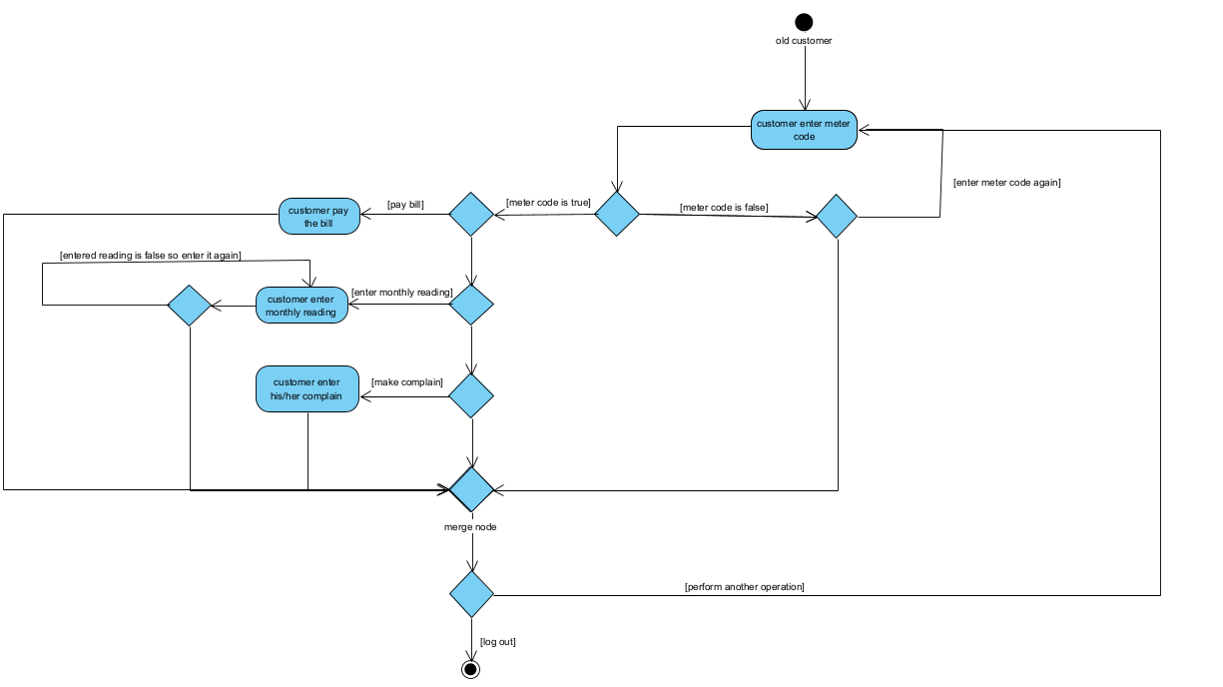

New customer:

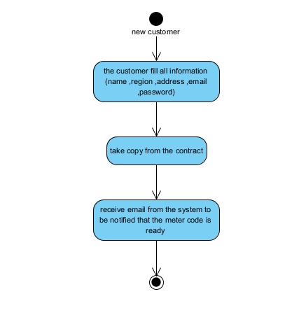

Operator:

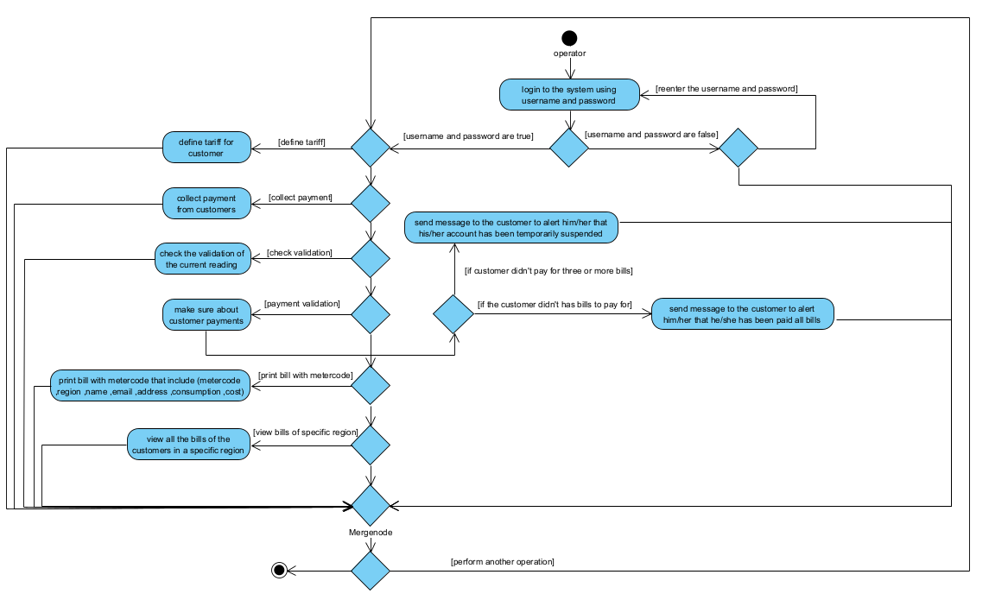

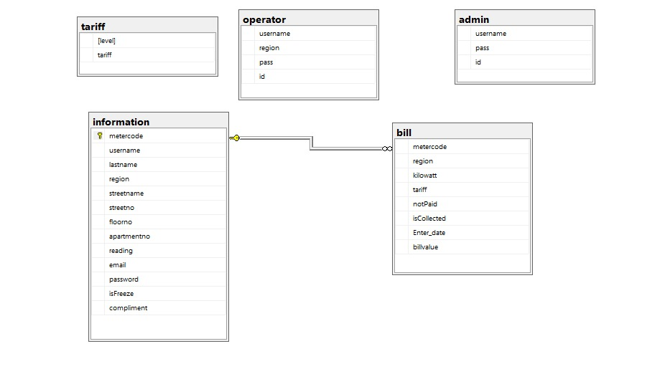**Database Schema:**

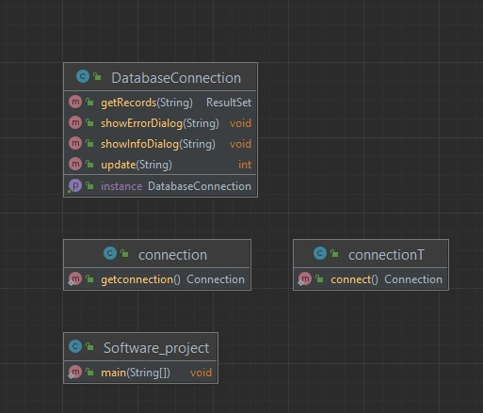**CLASS DIAGRAM:**

software project

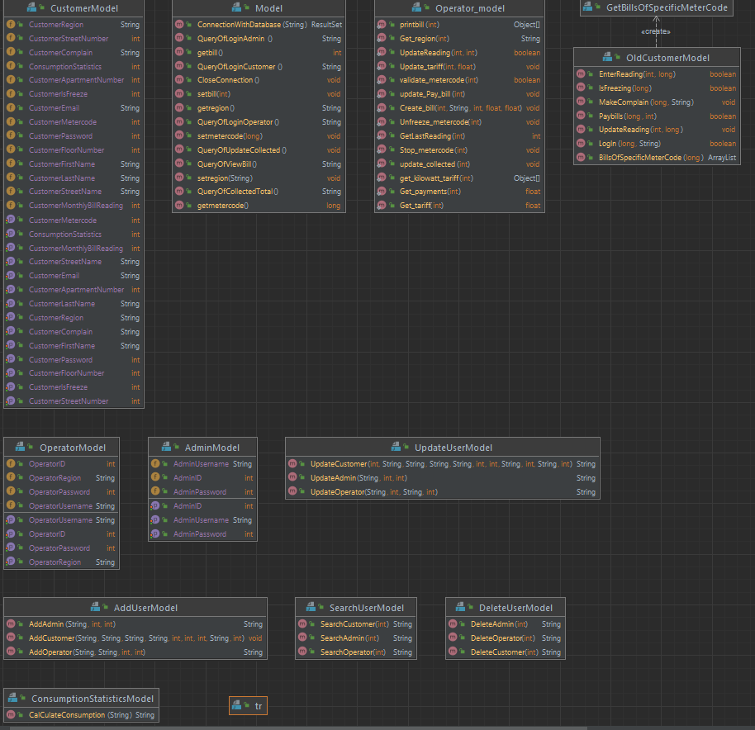**software project model**

software project controller

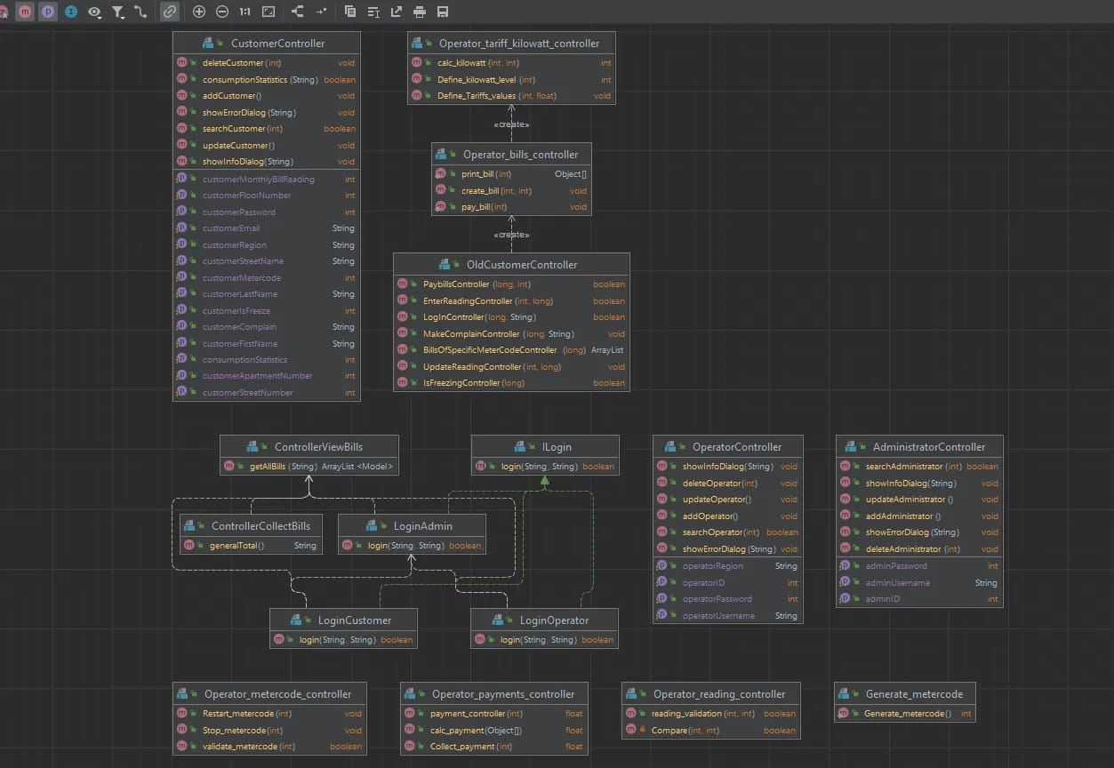

software project 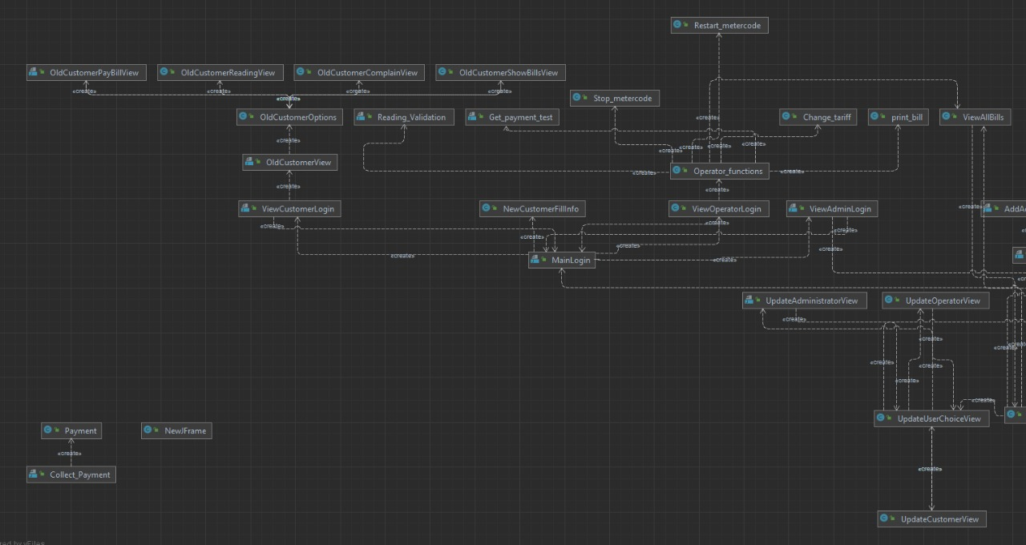GUI

**Sequence diagram:**



