|  |  |
| --- | --- |
| **Name** | Adit Verma |
| **Roll Number** | K062 |

1.Kali Linux VM Setup Using GCP

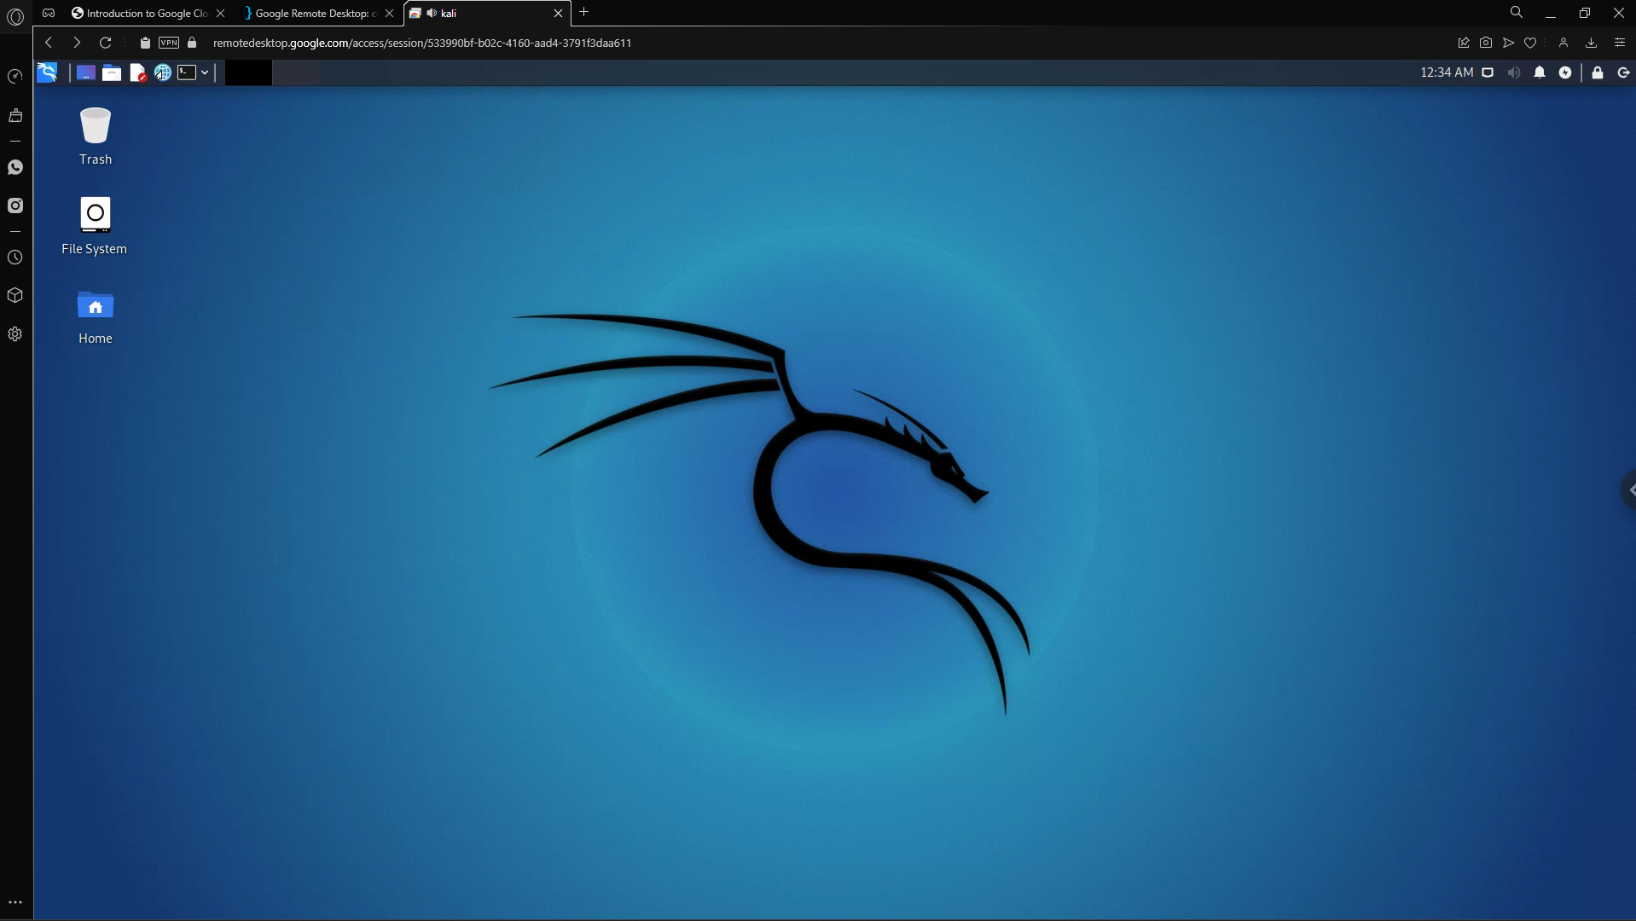

2.Screenshot showing the creation of a text file and date , name

