Company lockers PVT. LTD

Product : LockedMe.com

Subject : Documentation of Prototype Application

Developed by : Priyanshi Sharma

GitHub : https://github.com/7Priyanshi/JaVa_FSD

**About :**

Lockedme.com is a type of CRUD application performing File Handling Operations like Create new File, Delete a File, Search a File from Directory and Exit if user do not want any operation to perform. It is an easy-to-use software tool designed using Java. It helps users to maintain their personal files in a systematic way. It has been embedded by some special features which helps an individual to go through different modification options on a particular file or multiple files, thus giving a better User Experience.

Technologies Used : Java (Frontend & Backend)

Software : IntelliJ idea

Data Structures : Array List, HashMap, Binary Search, Bubble Sort, Strings.

**Features :**

Initially when user opens it, a “Welcome Screen” contains Main Menu with three options from which user have to select one of them.

1. Display All the Files - It will show all the files present in the Directory.
2. Display File Operations – It provides 4 options for user user can either Create a new File, Delete an existing File or Search a File or return to Main Menu if no option needed.
3. Exit/Quit option.

The prototype of the application is operated as a CLI (Command Line Program) without GUI. Its usage is to do file operations such as create new files along with content, delete a file or search a file from a specified directory and list them afterward in sorting order.

**User Interactions (Output):**

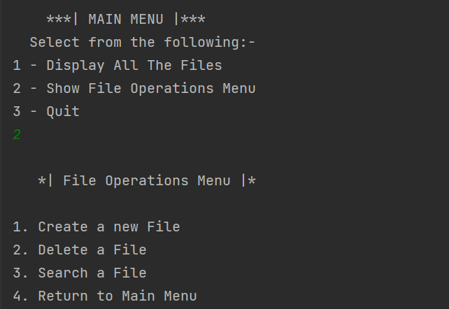

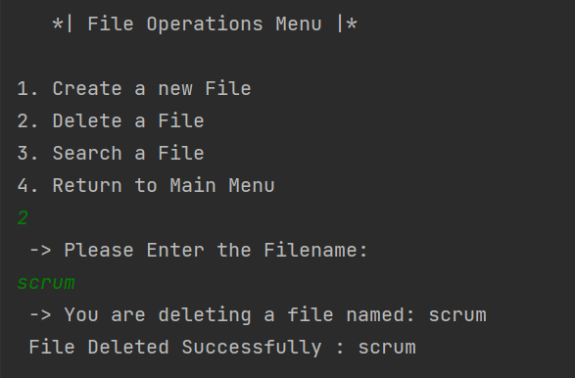

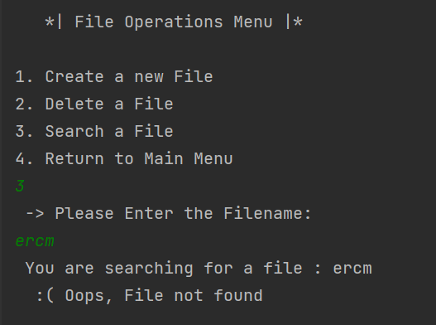

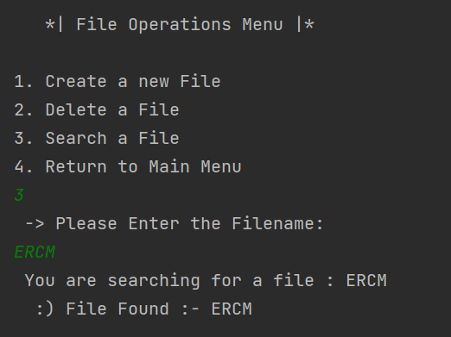

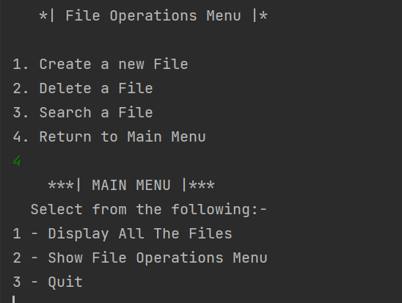

**Sprint Planning**

The Implementation is done in two sprints which are mentioned below:

Sprint 1 :

* Clarify the specification and requirements.
* Implement view content mechanism.
* Implement list of all files in sorted order.
* Implement functionality to close the program safely.

Sprint 2 :

* Implement functionality to add create files along the content.
* Implement functionality to delete a file if it is present in that user specified directory.
* Implement functionality to search a file in the same directory.
* Documentation

**Source Code/ Directories :**

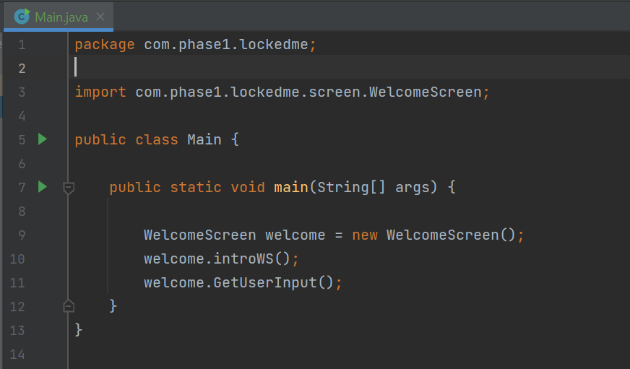

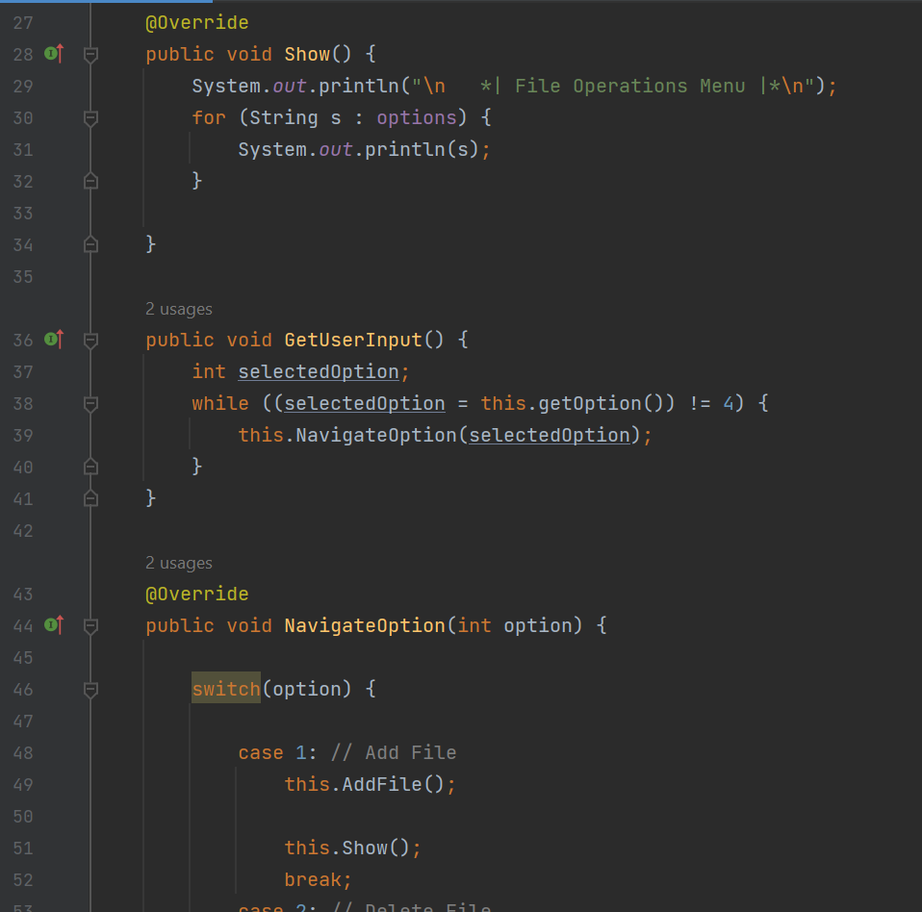

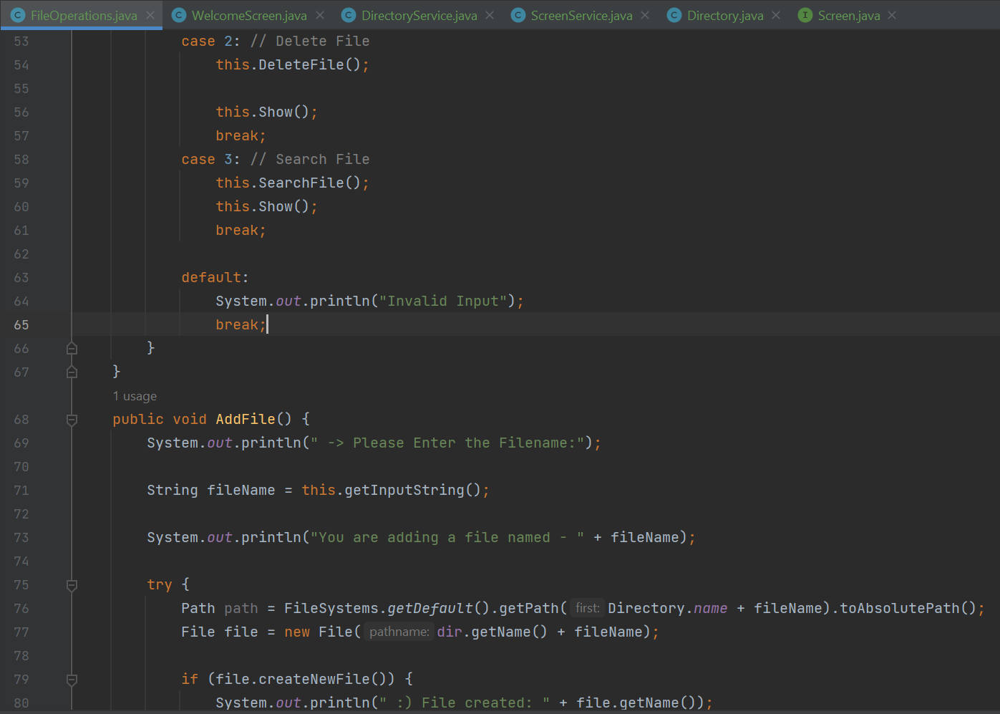

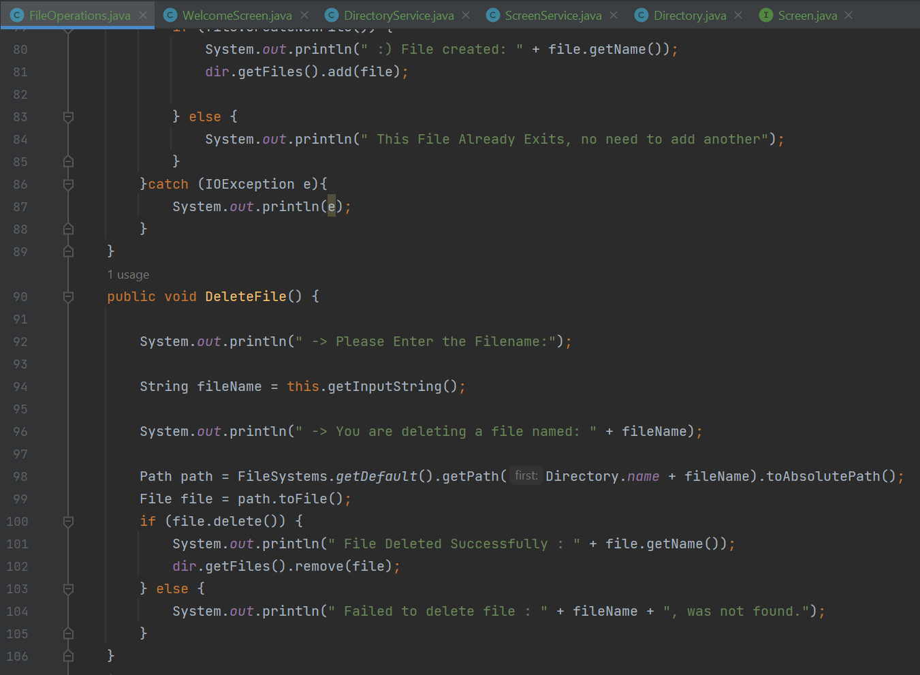

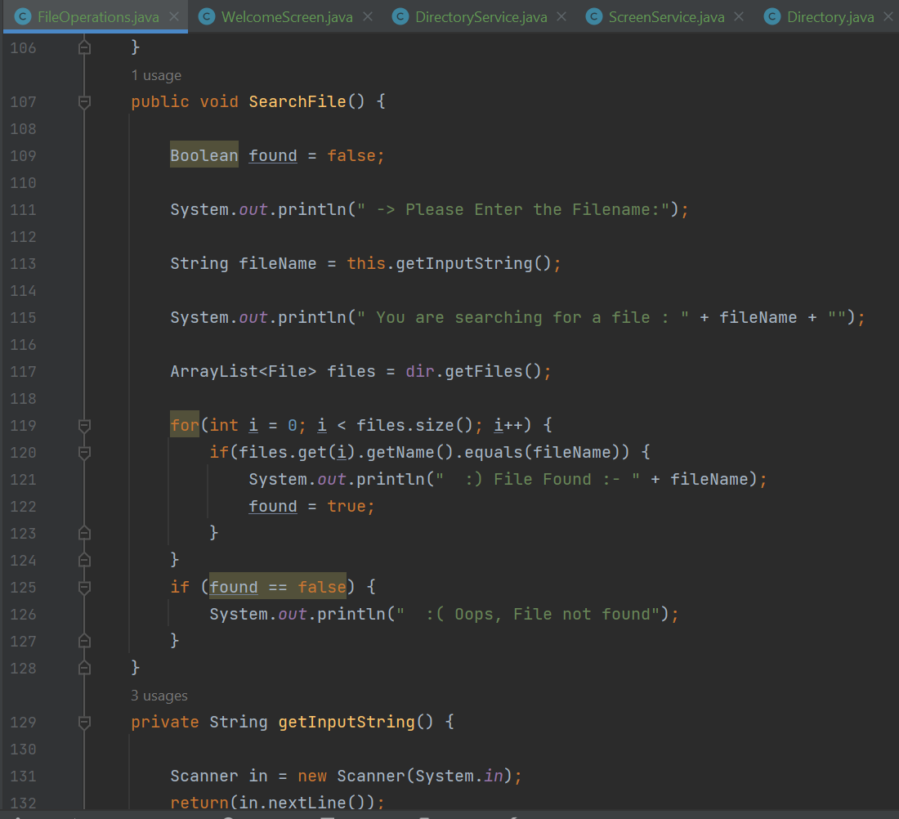

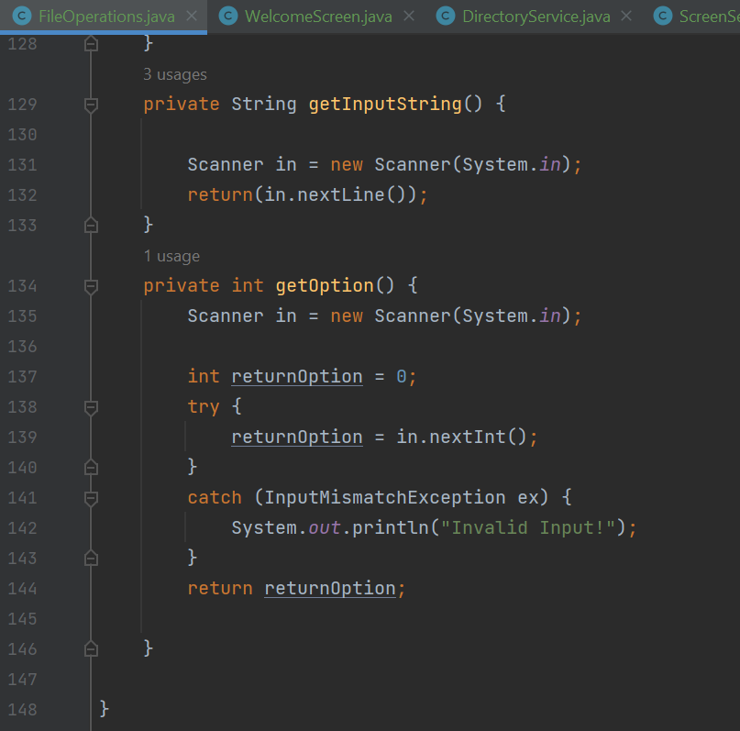

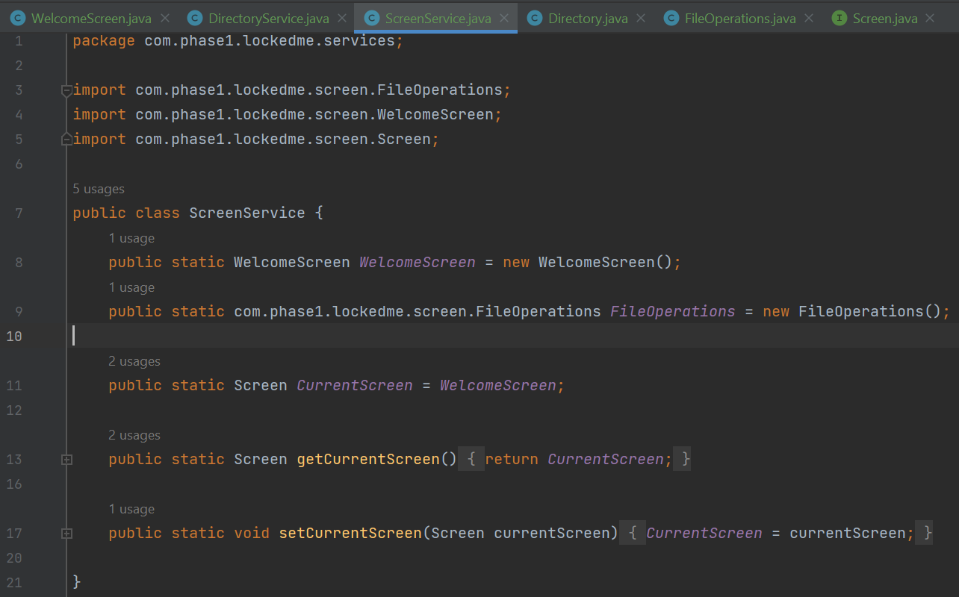

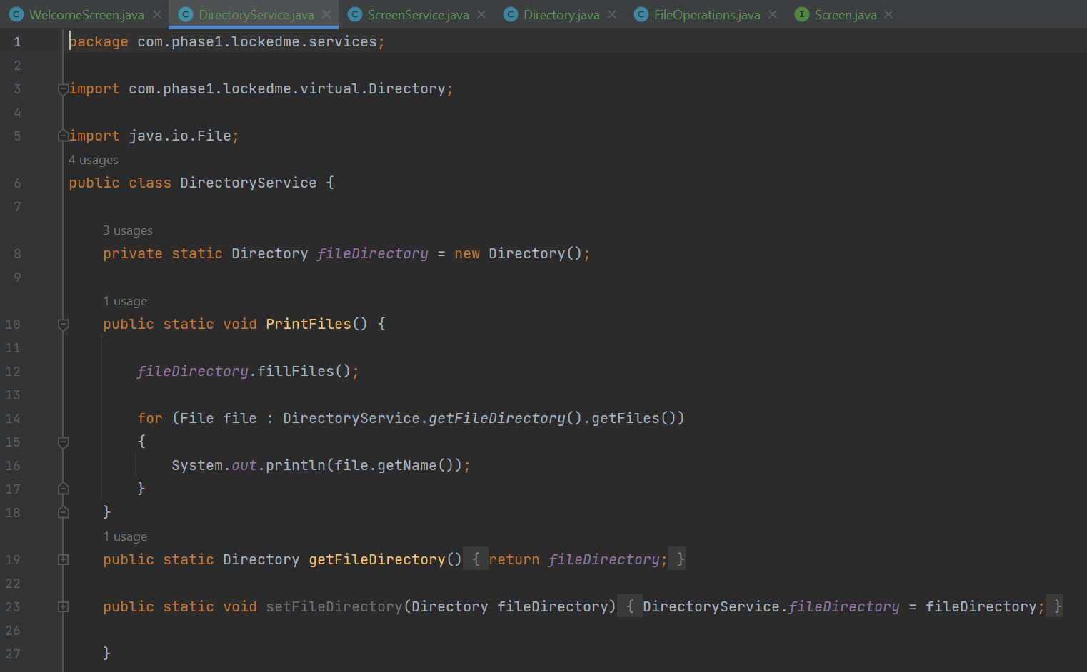

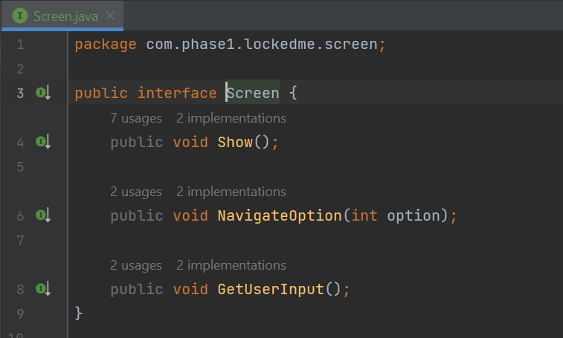

**Conclusion :**

1. The prototype of Application is robust and platform independent.
2. User can easily use the prototype and safely exit out of it.
3. The prototype has a good interface based on CLI (Command Line Interface).
4. As a developer, we can enhance it by introducing several new features such as appending in a file or overwriting a file and the file details for which user selected.
5. This prototype though is robust but user can only interact it with terminal or CLI so we can develop a good GUI interface for more better user-friendly as well as safe & secure also convenient to use.