

SEO strategy 2026
Commercial plan for ProSoccer.com

Prepared for Tony Tatikian, COO, ProSoccer
Prepared by 7 Rock Marketing LLC
Date April 2026
Executive summary
ProSoccer.com already earns most of its online store revenue from Google search. That's an asset and a risk. The commercial objective for the next twelve months is to compound the asset and cover the risk: grow organic revenue fast enough to absorb the World Cup demand spike, offset the click erosion Google's AI Overviews are starting to create, and reduce the share of online store revenue that depends on monthly Google Ads spend.
At a glance
Current: about 54 orders per day, roughly $950K/year in organic revenue, $30K/month on Google Ads.
12-month target: 75 to 85 orders per day, $1.2M+ in organic revenue, $5K to $8K/month in ads savings.

Four goals get us there: grow non-branded organic revenue, capture World Cup 2026 traffic through an 8-week focused sprint, defend organic revenue against AI Overview click erosion through Merchant Center feed work, and establish an AI search visibility baseline while Shopify's new Agentic Storefronts feature is still young. The Month 1 diagnostic confirms whether the immediate priority is traffic, conversion, or both.

Why this matters now
Roughly 51% of ProSoccer's online store revenue already comes from Google search. That's the single largest channel on the site, and it's the one with the most pull on the commercial mix. When it moves, the P&L moves with it.
Two outside forces are about to hit that channel at the same time. Google's AI Overviews now appear on about 14% of shopping queries (up from near zero six months ago) and the top organic result on those queries loses 18 to 39% of its clicks. That's the compression. Working the other direction, the FIFA World Cup opens at LA Stadium on June 12, 2026, with 78 of the 104 matches on US soil. That's the inflation. One pulls down, one pushes up, and both need a response.
One honest note on the baseline. Q1 2026 tracks slightly behind the pace ProSoccer held through full-year 2024. We're not relitigating that gap in this document. We're naming it so the forward plan is built on real ground, and so the targets below reflect what's actually in front of us.
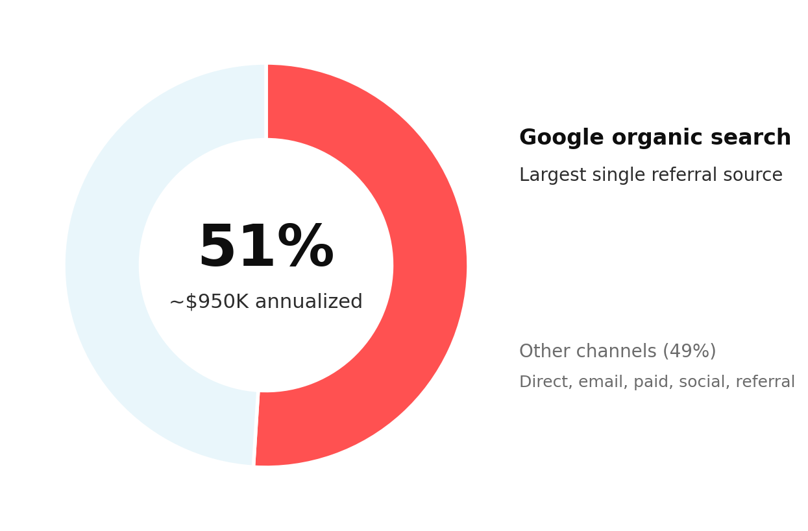
Organic search revenue share, online store channel, trailing 6 months.

The four primary goals
1. Grow non-branded organic revenue
Push the queries ProSoccer already ranks for (positions 11 to 30) onto page one.
About 3.7M non-branded impressions are currently sitting at positions 11 through 30 in Google. These are queries ProSoccer already ranks for; they just don't click yet because they're on page two or three. Moving a meaningful share of them into the top ten is the single largest organic lift available, and it's the lift that most directly reduces Google Ads dependency (new customers, not people searching for our brand).
Target categories to validate in Month 1: club team jerseys (Real Madrid, Barcelona, Manchester City, Liverpool, Juventus, Bayern, PSG, plus LA-relevant MLS clubs), goalkeeper gloves and keeper cleats, futsal and indoor shoes, youth cleats and sizing content, national team jerseys with LA-area diaspora demand, and position-specific cleat content. Final priority order comes out of a Category Priority Matrix built from Shopify sales data, GSC queries, and seasonality.
Why lead with this: branded queries already rank 1 to 3 and are stable. Growth has to come from non-branded, and non-branded is where ads dependency actually breaks.

2. Capture World Cup 2026 traffic
An 8-week sprint tied to the tournament, narrow scope, close to the catalog.
The FIFA World Cup runs June 11 through July 19, 2026. The opener is at LA Stadium on June 12, inside ProSoccer's home market. Standard SEO lead time for an event like this is 6 to 12 months. We have 8 weeks. That constraint shapes scope: we refresh the national team collection pages that already rank between positions 9 and 14 (Mexico, El Salvador, Guatemala, South Korea, Italy, USMNT), add one local LA watch guide tied to the Pasadena store, and add one authenticity guide that converts casual fans into buyers.
What we won't chase: generic "World Cup 2026" queries. FIFA.com, Fox Sports, and ESPN take that traffic; we'd lose. Narrow and close to the catalog wins.
Urgency: 8 weeks to opening match. Any approval slippage compresses the window further, so we'd like a weekly batch approval model for this sprint.

3. Defend organic revenue against AI Overview click erosion
Get more of the catalog into Google's Merchant Listings surface, cleanly.
Not all Google search surfaces are equally affected by AI Overviews. In ProSoccer's own data, Google's Merchant Listings surface pulls a 6.33% click-through rate at an average position of 4.69. Google's Product Snippets surface pulls 0.53% at position 21.4. Merchant Listings are roughly 12 times more click-efficient per impression, and they sit in a spot that AI Overviews haven't cannibalized.
The named workstream: Merchant Center feed optimization via DataFeedWatch. Every product title, attribute, image, GTIN, availability signal, and review integration in that feed is a lever on Merchant Listings performance. 7 Rock already manages the DataFeedWatch instance, which means the audit and fixes start immediately. This is likely the fastest-moving lever on the whole engagement: feed improvements show up in Merchant Listings within weeks, not quarters.
Why defensive, not offensive: Goal 1 grows new traffic. Goal 3 protects the traffic we already have. Letting a Q3 report read "impressions surged, revenue flat" isn't an acceptable outcome.

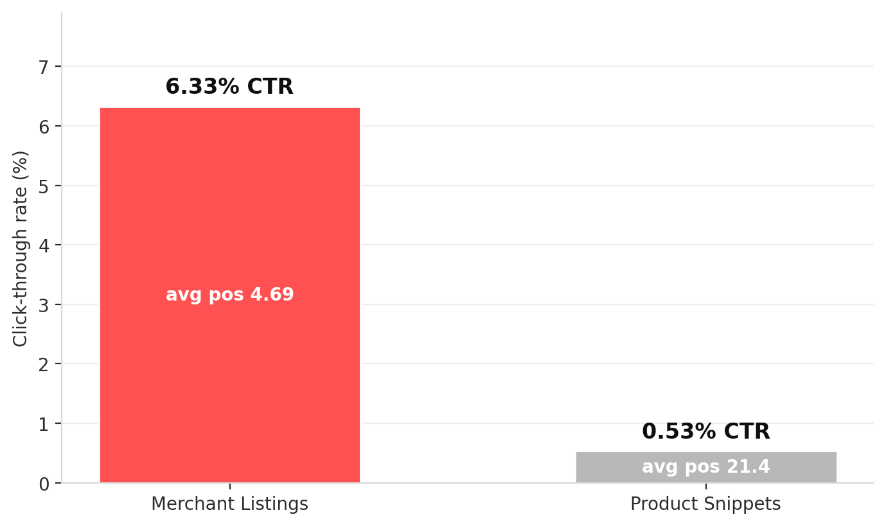
Google surface performance: where ProSoccer products actually click. Merchant Listings convert 12x more efficiently than organic product pages.
4. Establish AI search visibility baseline
Measure what's already happening and position the catalog for the shift that's coming.
AI search engines (ChatGPT, Perplexity, Gemini, Copilot) now handle an estimated 12 to 18% of English informational queries. Shopify reported a 15x increase in AI-originated orders across its merchant base over the past 12 months. ChatGPT is already sending real orders to ProSoccer.com: 9 orders for about $1,006 in Q1 2026, 10 orders for $1,367 in Q4 2025. Small numbers, still real, still trending with the broader shift.
In late March 2026, Shopify activated Agentic Storefronts for all stores as part of the Winter '26 Edition. ProSoccer's products are auto-syndicated to Google AI Mode, ChatGPT, Microsoft Copilot, and Perplexity through the Shopify Catalog by default. Month 1 work: audit the ProSoccer Shopify admin to confirm which AI channels are enabled, verify store policies and product attributes are clean (AI platforms match on structured data, not images), and build a manual citation tracking sheet against ~20 target prompts across ChatGPT, Perplexity, and Gemini.
No AI-visibility tool purchase recommended yet. 90 days of manual tracking establishes which prompts and categories actually matter. Tool decision revisits at end of Q3 2026.

Month 1 diagnostic: traffic problem or conversion problem?
Before we commit twelve months to a plan that assumes "more traffic equals more orders," we confirm whether the traffic ProSoccer already has is converting at expected rates. The baseline gives us good reasons to check. Organic clicks grew about 58% over the past twelve months, but order volume didn't grow proportionally. Q1 2026 online store orders dropped roughly 22% versus Q4 2025. Desktop average position sits 5.5 spots worse than mobile. The Shopify theme migrated late in 2025 and PageSpeed scores are weak.
What the diagnostic delivers
- Traffic-to-cart-to-checkout-to-purchase funnel analysis, segmented by device (GA4 plus Shopify).
- Product detail page load-time analysis on the top 10 revenue SKUs.
- Mobile versus desktop conversion rate comparison at category level.
- Checkout abandonment analysis, device-segmented.
- Cross-reference against the existing prosoccer-theme CRO audit already in progress.
Scope guardrail: the diagnostic is diagnosis, not scope expansion. Any CRO fixes identified flow into the separate prosoccer-theme project already in motion, or become a separate scope conversation. This engagement stays SEO.

The outcomes we'll measure
Every monthly report leads with these four metrics. Secondary metrics follow for program-health context.
Metric | Current baseline | 12-month target | Source
Online orders per day (in-scope channels) | ~54 | 75 to 85 | Shopify (excl. POS, Channable, Draft Orders)
Google organic revenue (rolling 12 months) | ~$950K | $1.2M+ | Shopify search/google referrer
Google Ads monthly spend reduction | $30K/month baseline | $5K to $8K/month saved (17-27%) | Tony's Ads account
High-order days per year (90+ orders) | ~8 | 50+ | Shopify, in-scope channels

About the 75 to 85 per day range: 75 is the defensible floor we expect to hit, a 39% lift on the current pace delivered by the 3.7M non-branded impression pool, the World Cup sprint, and Merchant Listings defense. 85 is the stretch target; it annualizes to roughly 31,000 in-scope orders, which would clear ProSoccer's 2024 full-year total. Compounding organic channels scale non-linearly once the foundation is right, so 85 is credible as ambition, not as commitment. Any conversion-rate fixes surfaced by the Month 1 diagnostic add upside on top of that range.
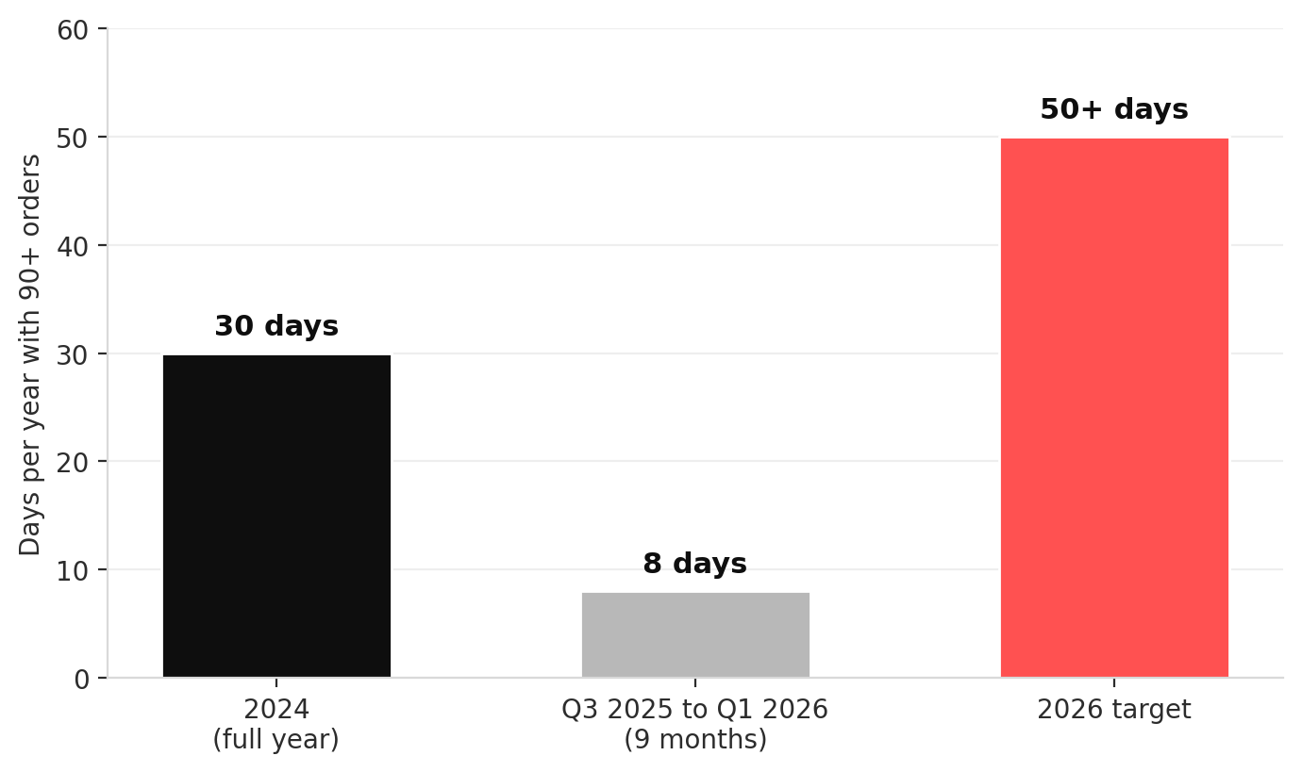
High-order days per year, the pattern we're restoring and exceeding.
Secondary metrics tracked monthly
- Keyword rankings, priority set of 50 to 100 commercial keywords, tracked weekly.
- Organic sessions and organic conversion rate, GA4, month over month.
- Indexed pages and technical health, Screaming Frog crawl, quarterly.
- Core Web Vitals, mobile and desktop, tracked monthly via PageSpeed Insights.
- Backlink profile changes via Ahrefs (pending tool approval).
- Merchant Listings click share versus organic click share, Search Console, monthly.
- AI search citation count from the manual tracking sheet in Goal 4.

12-month roadmap
Three phases. Recover what's leaking, stabilize the machine, then compound.
Recover  Months 1 to 3  Month 1 diagnostic runs. Category Priority Matrix is built. DataFeedWatch feed audit ships. Shopify Agentic Storefronts audit confirms AI-channel status. First monthly report sets the true baseline across all four commercial metrics. | Stabilize  Months 4 to 8  Core goal execution. Content cadence kicks in for priority categories. Merchant Center feed fixes land and start showing up in Merchant Listings click share. World Cup sprint executes through June and July. AI visibility tracking sheet runs weekly, building 90 days of real data. | Grow  Months 9 to 12  Compounding gains start showing. Category expansion into matrix-validated tiers. AI search integration moves from monitoring into active optimization wherever citations and orders are growing. Tool decision revisits with 90+ days of data.

What we've agreed on
Google Ads monthly spend baseline. $30,000 per month, all campaigns.
Order volume scope. All sales channels except Point of Sale, Channable (Amazon/eBay), and Draft Orders. Online Store, Shop, Tapcart, BSS B2B, Redo, and other web channels are all counted.
High-order day threshold. 90+ orders per day, using the scope above.
Paid tool approval. Always requires Tony's knowledge and sign-off, regardless of dollar amount.
These anchor the plan. The following need your input before we lock the quarter.
Open questions for your review
1. Attribution model. Our baselines use Shopify's "search/google" referrer as the organic signal. Do you track organic revenue under a specific attribution model (last-click, assisted, post-view) we should align with, or should we additionally pull GA4 Organic Search to triangulate?
2. World Cup sprint approval model. We'll propose 5 to 8 new or refreshed pages inside the 8-week sprint. Given the timeline, we'd like to run weekly batch approvals rather than page-by-page sign-off. Does that model work for you?
3. Goal sign-off. Do the four primary goals and four outcome metrics match what you want? Anything to add, remove, or re-prioritize before we lock the quarter's plan?
4. Cadence confirmation. Monthly reports starting May 2026. Format and medium preferences? PDF, Google Doc, live walkthrough?

Next steps
1. Review this document and note any changes.
2. 30-minute alignment call to answer the four open questions.
3. We begin the Month 1 diagnostic and DataFeedWatch audit immediately upon approval.
4. First monthly report delivered end of May 2026.

Prepared to move on your signal.

