## Extension screens

To implement this extension we are using dataset called ‘Extension_dataset.csv’ and this dataset saved inside ‘dataset’ folder

In this project as extension we are predicting student performance and suggesting future course. To run extension work double click ‘Run_Extension.bat’ to get below screen

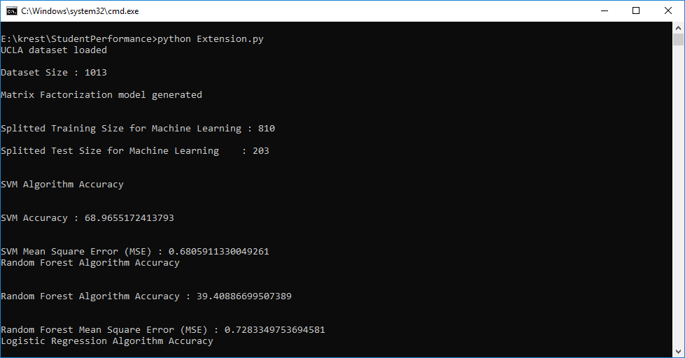

Scroll down black console to get other algorithms details

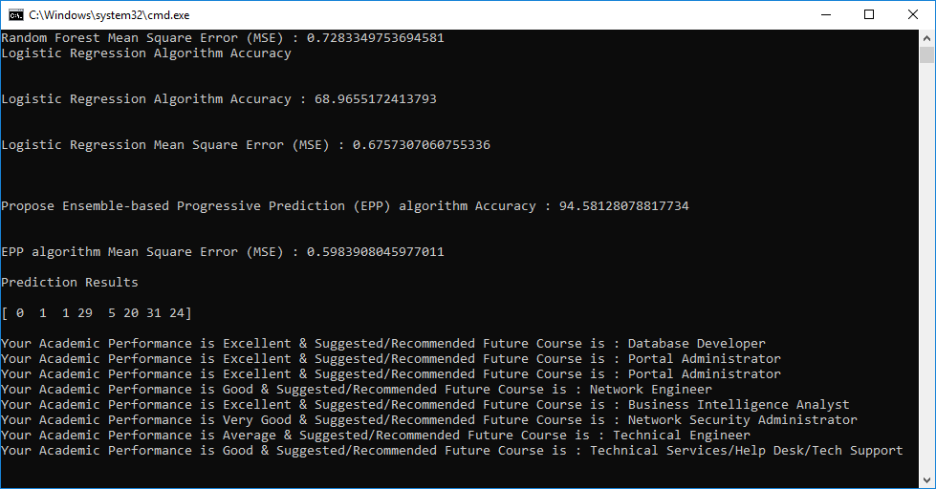

In above screen we are predicting student performance with future recommended course. Below graph showing algorithm performance

