CATFLOW
A Physically Based and
Distributed Hydrological Model for
Continuous Simulation
of
Catchment Water- and Solute Dynamics

by Thomas Maurer, Erwin Zehe

User Guide
and
Program Documentation
(VERSION CATSTAT)

Institute for Water Resources Planning, Hydraulics and Rural Engineering (IWK)
University of Karlsruhe (TH)
Copyright (C) Thomas Maurer & Erwin Zehe
October 2007
- modified September 2010 by Jan Wienhöfer

This program is free software; you can redistribute it and/or
modify it under the terms of the GNU General Public License
as published by the Free Software Foundation; either version 2
of the License, or (at your option) any later version.

This program is distributed in the hope that it will be useful,
but WITHOUT ANY WARRANTY; without even the implied warranty of
MERCHANTABILITY or FITNESS FOR A PARTICULAR PURPOSE. See the
GNU General Public License for more details.

You should have received a copy of the GNU General Public License
along with this program; if not, write to the Free Software
Foundation, Inc., 51 Franklin Street, Fifth Floor, Boston, MA 02110-1301, USA.

Institute for Hydrology and Water Resources Planning (IHW)
University of Karlsruhe, Kaiserstr. 12, 76128 Karlsruhe, Germany
Tel.: +49.721.608.43814 Fax: +49.721.608.45651
e-mail: erwin.zehe@kit.edu

1 Introduction 6
2 Overview 9
2.1 State variables 9
2.2 Geometry 9
2.3 Processes 9
2.4 Boundary conditions 10
3 Input structure 14
3.1 General 14
3.2 Main input file 14
3.3 Project control file 14
3.4 Global files 18
3.4.1 Specification of soil types 18
3.4.2 Specification of time series 21
3.4.2.1 Time series of boundary conditions 22
3.4.2.2 Time series of sink/source data 23
3.4.2.3 Time series of precipitation 24
3.4.2.4 Time series of climatic data 25
3.4.2.4.1 Type 1 25
3.4.2.4.2 Type 2 26
3.4.2.5 Time series of land-use patterns 26
3.4.2.5.1 Land-use patterns: Assigning land-use units to land-use ID 27
3.4.2.6 Solute input mass 27
3.4.2.7 Boundary conditions of the drainage network 27
3.4.3 Assigning land-use IDs to land-use parameter files 28
3.4.3.1 Specification of land use parameters 28
3.4.4 Assigning sectors to a wind direction identifier 30
3.4.5 Drainage network geometry and -discretisation 30
3.4.5.1 No interaction between subsurface and channel water 32
3.4.5.2 Interaction between subsurface and channel water 32
3.4.5.2.1 Initial state of the drainage network 33
3.4.5.2.2 Assigning time series of input fluxes to boundary nodes of the drainage channel 33
3.5 Hillslope specific files 33
3.5.1 Hillslope geometry and -discretisation 33
3.5.2 Assigning soil types 36
3.5.3 Assigning factors to the K_{sat} field of the hillslope 37
3.5.4 Assigning factors to the theta field of the hillslope 37
3.5.5 Assigning macropore parameters 37
3.5.6 Specification of control volumes 38
3.5.7 Assigning initial conditions 38
3.5.7.1 Initial state for soil water dynamics 38
3.5.7.1.1 Blockwise assignment of either absolute suction head or degree of saturation 38
3.5.7.1.2 Assigning individual absolute values at each point 39
3.5.7.1.3 Uniform potential in entire domain 40
3.5.7.2 Initial solute concentration 40
3.5.7.2.1 Blockwise assignment of residual total concentrations 40
3.5.7.2.2 Assigning individual concentration values at each point 40
3.5.8 Specification of printout times 41
3.5.9 Assigning surface attributes 41
3.5.10 Assigning boundary conditions and sinks/sources 42
4 Preparing input files 45
4.1 Prolog 45
4.2 General 47
4.3 Data organisation 47
4.4 Required information 48
4.4.1 Spatial information 48
4.4.2 Temporal information 49
4.4.3 Constant information 49
4.4.4 Domain decomposition in hillslopes and drainage network 49
4.4.4.1 T_4HIM 50
4.4.4.2 ARC/INFO 51
4.4.4.3 MATLAB 52
4.4.5 Ordered graph of drainage network 52
4.4.6 Discretisation of hillslopes 53
4.5 Assigning attributs/indices 54
4.5.1 Surface (2D) 54
4.5.2 Depth (3D) 55
4.6 Soil types 55
4.7 Wind directions 55
4.8 Land use parameters 55
4.9 Time series 55
4.10 Initial conditions 56
4.11 Control files 56
5 Simulation output 57
5.1 Log-file 57
5.2 Tables of soil-hydraulic functions 57
5.3 Water balance 58
5.4 State variables 59
5.5 Overland flow 59
5.6 Evapo-Transpiration 60
5.7 Channel flow 61
5.8 Co-ordinate files 61
6 Visualisation 62
6.1 General 62
6.2 Longitudinal sections using Matlab 62
6.2.1 2-d cross sections of state variables without water fluxes 62
6.2.2 2-d cross sections of state variables and water fluxes 63
6.3 Areal maps using ARC/VIEW 64
6.4 Time series 64
6.4.1 Hydrographs for specified channel nodes 64
6.4.2 Surface runoff for individual hillslopes 65
7 Program structure 67
8 INCLUDE-files and COMMON-blocks 71
8.1 Dim.inc 71
8.2 Zeit.inc 74
8.3 Soil.inc 75
8.4 Hgfest.inc 76
8.5 Hgvari.inc 79
8.6 Hgbdry.inc 83
8.7 Pfest.inc 86
8.8 Pvari.inc 87
8.9 pbdry.inc 89
8.10 Bach.inc 89
8.11 Erosion.inc 92
9 Alphabetical list of all variables in COMMON-blocks 93
10 Moving to other platforms 110
11 References 111

Introduction
CATFLOW is a physically based, distributed model for simulating the dynamics of water and solutes in small rural catchments on the event and season time scale. The considered control volume consists of the upper soil layer including the vegetation canopy, with the atmosphere and possibly groundwater imposing boundary conditions onto the system. Keeping in mind the aim of modelling the transport processes of dissolved and suspended substances including contaminants, both at the surface (erosion and wash-off) and underground (transport towards groundwater and channel), a process-oriented approach is chosen to model the inner structure of catchments as thoroughly as possible. This permits the examination of the interaction between subsystems, and finally enables the derivation of simplifications.
The model is based on the idea of subdividing the 3D-landscape in patches of 2D-hillslopes of variable width (assuming water flowing normal to the topographical contours) connected to a detailed (partly ephemeral) drainage network. Fig. 2.1 gives an idea of the approach for the Weiherbach cachtment. Though there have been developments based on this or similar ideas in the past (Jayawardena & White, 1977; Jayawardena & White, 1979; Beven et al., 1987; Calver & Wood, 1995; Vertessy et al., 1993) a new effort has been undertaken to improve concept and structure of this type of model.
As has been shown (Mesa & Mifflin, 1986) and is well understood today (Singh, 1995a), with increasing size of a catchment the shape of a hydrograph is more and more influenced by the properties of the drainage network rather then by overland flow; the latter then mainly has to provide realistic estimates of event based runoff coefficients. However, increasing size is a relative measure. If we trace down the drainage network into every single swale of the landscape (which of course requires a detailed spatial resolution of elevation) above considerations are valid for even very small catchments. What we get is a partial decoupling of runoff production and runoff propagation allowing us to put to work all the well-established methods developed in open channel flow and flood routing. CATFLOW implements schemes based on the simplified St. Venant equations. Thus we have achieved somewhat a reduction of the dimension of the problem.
As has been pointed out e.g. by (Kuehnel et al., 1990a; Kuehnel et al., 1990b; Wang & Dooge, 1993) runoff coefficients are determined by proper evaluation of infiltration and evapo-transpiration, both at times controlled by either soil or atmospheric conditions. CATFLOW spends considerable efforts in a more precise description of these processes.
Special features of the system include:
Problem-oriented domain decomposition and time-step control: The subdivision of the catchment area is carried out based on the topography. Beginning with the detailed drainage network and delineated subcatchments, hillslope areas are identified and then idealised as vertical longitudinal sections of variable width along the steepest gradient of the topography. This decomposition supports a far-reaching decoupling of runoff production at the hillslope and runoff propagation in the drainage network, where flow can be described in a more hydrodynamicly substantiated sense. Then, the longitudinal cross-sections as well as the drainage network are discretised taking into account the zones expected to be hydrologically most active.
Based on geomorphologically motivated considerations an efficient and simple parameterisation scheme has been developed in order to describe the complex geometry of the detailed drainage network.
Process-based modelling: The modelling scale is close to the process scale. This property of physically based models permits the consideration of the interaction between all relevant processes based on field observations. These are: evapo-transpiration, interception, infiltration and two-dimensional water movement in the soil matrix and preferential pathways, transport, ad- and desorption and degradation of non conservative solutes in the saturated/unsaturated zone as well as surface runoff, subsurface flow and channel flow (including runoff from sealed surfaces) under the influence of temporally and spatially variable climatic boundary conditions and land use. Last not least the possible interaction between channel flow and the saturated zone, i.e. groundwater influence or effluence has to be taken into account.
Flexible spatial/temporal resolution of boundary conditions and parameters: A prerequisite for the examination of interactions between those various processes and properties is the possibility of handling all data at an arbitrary spatial/temporal resolution. This requirement is also important with respect to a problem-oriented time-step control and has been met by implementing a suitable data structure.
Relational data management: To ensure the user-friendliness of the modelling system, the large amounts of temporally and spatially variable input and output data of state variables and both system and environment parameters are organised in a relational data structure, i.e. as an indicated system of tables and flexible input formats.
Furthermore, special emphasis has been put on the following features:
- Hillslope geometry is described by use of orthogonal, curvilinear coordinates as described e.g. by Kiefer et al. (1990)to (a) flexible model the irregular boundaries and (b) to more easily conduct numerical solution of Richards equation for matrix flow on a mathematical rectangular grid.
- Potential based solution of Richards equation using Picard iteration and Taylorseries expansion of the moisture content with respect to the Potential as described by (Hornung & Messing, 1984; Celia et al., 1990) thus allowing for modelling of saturated conditions. Solute transport is described by means of a two dimensional transport equation of the Convection-Dispersion-type (Briggar & Nielsen, 1967; Roth et al., 1996), including first order decay and linear, instantaneous sorption. The transport equation is numerically solved by means of the particle tracking method (Zehe, 1999; Thompson, 1987; Kinzelbach & Uffink, 1991).
- A simplified method for transport of water and solutes in preferential pathways. If the relative saturation S at the soil surface of a macroporous soil layer exceeds a threshold value, the saturated hydraulic conductivity is increased by a macroporousity factor. An effective pore water velocity is computed by averaging the corresponding values in the soil matrix and in the macropores in a grid cell. The required model parameters, i.e. the macroporousity factor f_{mac} and the macroporous cross section in a grid cell a_{mac} may easily be derived from field and laboratory data (Zehe, 1999).
- Soil properties i.e. their hydraulic functions and transport parameter are provided in tables, thus allowing for easy inclusion of different descriptions. Currently the Van Genuchten (1980) and Mualem (1976) model is used mostly.
- Channel flow within the drainage network is calculated based on the kinematic wave or the diffusion wave simplifications of the St. Venant equation. Moreover interaction between channel flow and shallow groundwater, i.e. ground water influence or effluence may be accounted for. In this case, the water table in the channel determines a time dependent Dirichlet (pressure) boundary condition at the boundary of the corresponding hill slopes.
Each hillslope has its individual time step control, thus reducing overall CPU time consumption.
Thus, CATFLOW is a flexible tool for detailed modelling of catchments water- and solute dynamics at the resolution desired by the user.
A thorough description of CATFLOWs' theory and applications is given in detail by (Maurer, 1997a; Zehe, 1999). In these studies, the modelling system and extensively collected data have been used to parameterise, calibrate, and verify a model of the research catchment “Weiherbach” near Karlsruhe. In that context, an important aim was the synthesis and integration of numerous experimental results and the detailed research of individual processes performed by other authors.

Overview
CATFLOW is a physically based, distributed model for the dynamics of water and transport of solutes in the upper soil layer of small rural catchments (including channel network and vegetation cover) on the event and season time scale. The model is based on the idea of subdividing the 3D-landscape in patches of 2D-hillslopes of variable width (assuming water flowing normal to the topographical contours) connected to a detailed (partly ephemeral) drainage network. Fig. 2.1 shows an example. The approach relies on the assumption of deterministic behaviour, i.e. starting from some initial condition the change of state variables under changing boundary conditions can be calculated.

State variables
The physically based, distributed model of high spatio-temporal resolution calculates the following state variables:
- soil water potential,
- surface water depth,
- interception storage
- residual concentration of various solutes in the soil .

Geometry
The geometry of the system under consideration (upper soil layer) is described by the following data:
- digital elevation model,
- channel profiles and elevations,
- soil hydraulic functions,
- macroporosity,
- surface roughness,
- channel roughness,
- parameters determining interaction between channel flow and the saturated zone,
- plant parameters.

Processes
The model simulates various processes of water transport, as
- fluxes in saturated/unsaturated soil matrix,
- return flow,
- surface runoff,
- subsurface storm flow
- water movement and solute transport in the soil matrix
- water movement and solute transport in preferential pathways,
- linear, instantaneous equilibrium adsorption
- first order decay of non conservative solutes
- ground water influence or effluence
- transpiration,
- evaporation,
- interception,
- channel flow,
- interactions near stream,
- runoff from sealed surfaces.

Boundary conditions
Systems state is changed by these processes under the impact of (mostly climatic) boundary conditions, as
- precipitation,
- net radiation,
- temperature,
- humidity,
- wind speed and wind direction,
- ground water levels.

Due to its high spatio-temporal resolution and thus data needs, CATFLOW requires a considerable number of files to be prepared and specified in project control files. Files are organized in a hierarchical way (Fig. 2.2), reflecting the relational data structure used throughout the program.
All geometric data are geo-referenced to a global coordinate system as well as all time series data are time-referenced to the actual date which can be input in a format dd.mm.yyyy hh:mm:ss.hs (CHAR*22). Care is taken to synchronise all temporal data with reference to the date.
The program and its input are based on SI-units (meters, seconds, kilo grams and ampere) if not stated otherwise. However, often conversion factors to SI-units can be assigned to input files, thus allowing the use of more familiar units.

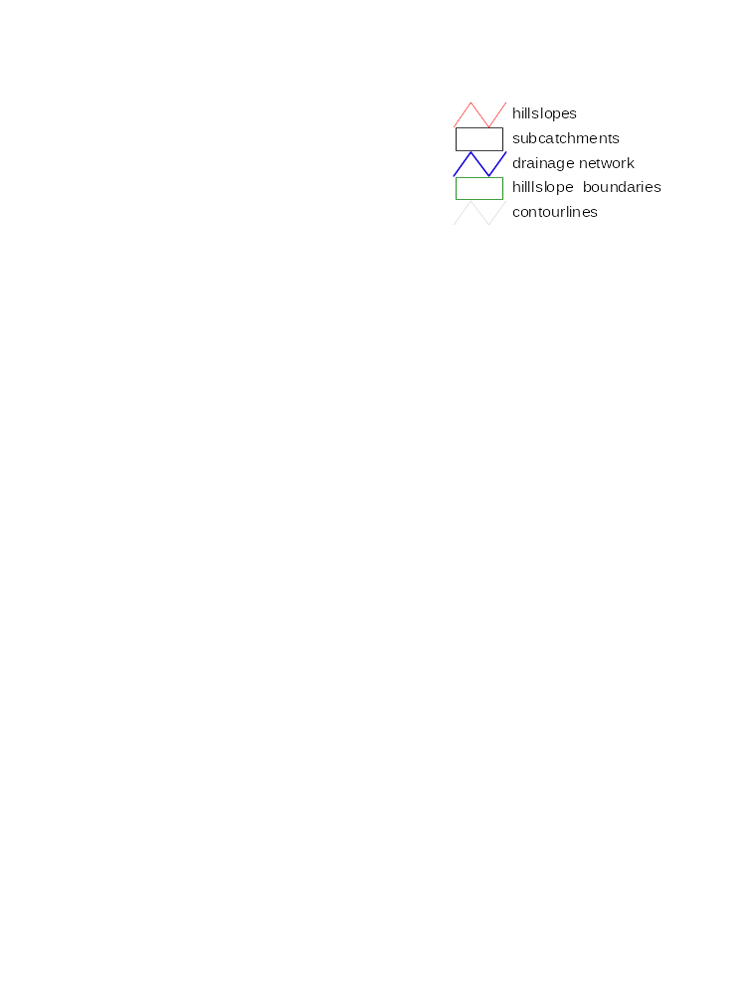
Figure 2.1: Topographic analysis of the “Weiherbach-catchment” up to the gauge Menzingen (3.5 km²)
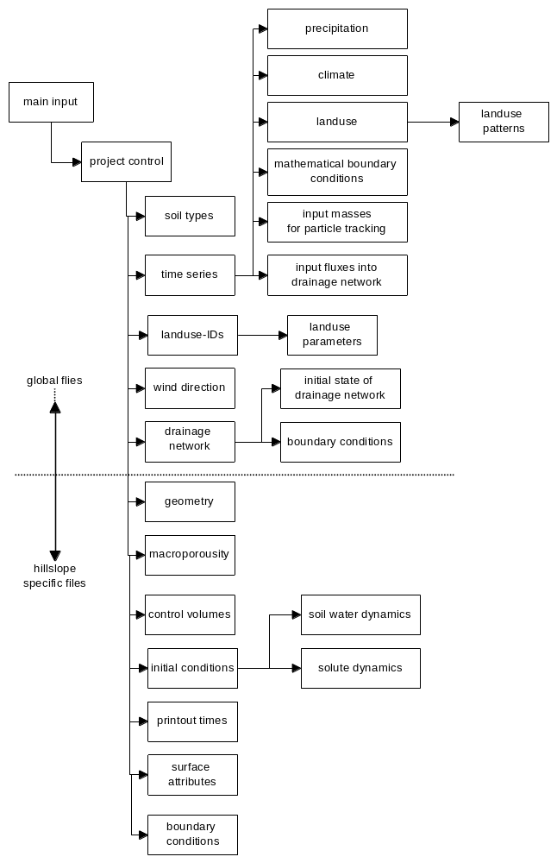
Figure 2.2: Input files hierarchy in program CATFLOW

Part I
USER GUIDE

Input structure

General
All filenames in project control files are specified relative to the location within the path, where the main input file (CATFLOW.IN) resides (and from where the program has to be executed). However, filename length is restricted to CHAR*30 (including path).

Main input file
The main input file (CATFLOW.IN) holds nothing but a list of control filenames (format a30) of individual projects, which for simulation are successively executed until a blank line is encountered. Starting from column 30, a global surface roughness has to be specified which is used as a default value for computation of overland flow. This value may be overwritten in the files characterising crop properties (section “Assigning land-use IDs to land-use parameter files”). An example:
|----.----|----.----|----.----|----.----|----.----|----.----|----.----|----.----|----.----|
|demo/catfl.in 5. % ifile0(1), kstall(1) (Strickler coefficient)
|demo/catfl_w.in 10. % ifile0(2), kstall(1) (Strickler coefficient)
| .

Project control file
The project control file holds top level information of an individual project, such as simulation times and timestep control parameters. File names of input and output data files as well as lower level control files are specified. An example:
|----.----|----.----|----.----|----.----|----.----|----.----|----.----|----.----|----.----|
|27.06.1994 18:00:00.00 % dstrs begin of simulation (a22)
|27.06.1994 24:00:00.00 % dstre end of simulation (a22)
| 0.0 % t_off time offset in [s]
|pic % meth method (always 'pic') (a3)
| 360. % dtbach max. timestep for drainage network [s]
| 1.e-7 % qtol threshold for initiating of drainage network computation [cbm/s]
| 86400. % dt_max max. timestep in [s]
| 0.01 % dt_min min. timestep in [s]
| 10.00 % dt initial timestep in [s]
| 0.020 % d_Th_opt timestep control parameter [-]
| 0.020 % d_Phi_opt timestep control parameter [-]
| 4 % n_gr treshold number of Picard iteration step
| 10 % it_max max. number of Picard iteration steps
| 1.e-3 % piceps desired convergence tolerance Picard [-]
| 5.e-6 % cgeps desired convergence tolerance CG [m]
| 15. % rlongi longitude of time zone (i.e. CET)
| 8.75 % longi longitude of catchment
| 49.13 % lati latitude of catchment
| 2 1 % istact number of solute types; i_sorp switch for adsorption isotherm (see section 3.4.1.1; needed when istact > 0)
| -80 % iseed seed for portable random number generator
|simact % q_meth switch (simact or noiact)
| 17 % io_act number of specified output files (should be fixed)
| 011 100 000 111 000 00 % io_log(i) switches that control amount of output to output files
|demo/out/log.out % ofile(1) log-file
|demo/out/vg_tab.out % ofile(2) tables of soil-hydraulic functions
|demo/out/bilanz.out % ofile(3) water balance
|demo/out/theta.out % ofile(4) soil moisture
|demo/out/psi.out % ofile(5) suction head
|demo/out/psi.fin % ofile(6) final state
|demo/out/fl_xsi.out % ofile(7) xsi-flux
|demo/out/fl_eta.out % ofile(8) eta-flux
|demo/out/senken.out % ofile(9) sinks
|demo/out/qoben.out % ofile(10) overland flow
|demo/out/etinz.out % ofile(11) Evapo-Transpiration
|demo/out/gang.out % ofile(12) drainage network hydrographs
|demo/out/v_eta.out % ofile(13) generalised pore water velocity (for particle tracking)
|demo/out/v_xsi.out % ofile(14) generalised pore water velocity (for particle tracking)
|demo/out/c.out % ofile(15) residual solute concentration in the soil
|demo/out/hko.out % ofile(16) z – coordinate of the computational grid
|demo/out/sko.out % ofile(17) x-coordinate of the computational grid
| 7 % iin_act number of specified global input files
|demo/in/vgsoil.art % ifile(1) specification of soil types
|demo/in/rbsenk.def % ifile(2) specification of time series
|demo/in/lusenam.def % ifile(3) assigning land-use ID to land-use parameter file
|demo/in/windrich.def % ifile(4) sectors of wind direction
|demo/in/vorflut.def % ifile(5) drainage network and sealed surface geometry
|demo/in/vorflut.ini % ifile(6) initial state of the drainage network
|demo/in/vorflut.rb % ifile(7) assigning boundary conditions to channel nodes
| 10 % iacnh number of hillslopes, each hillslope requires 8 – 9 input files
|demo/in/hang.geo % hgfile hillslope geometry and -discretisation
|demo/in/hang.bod % stfile assigning soil types
|demo/in/ks_feld.dat % ifile assigning factors to Ksat-fields of the hillslope (pref.flow)
|demo/in/th_feld.dat % ifile assigning factors to theta-fields of the hillslope (leave as all 1’s)
|demo/in/hang.mak % mafile assigning macropore parameters
|demo/in/hang.cv % cvfile specification of control volumes
|demo/in/hang.ini % inifil assigning initial conditions for soil water dynamics
|demo/in/conc.ini % infile assigning initial concentration for solutes optional
|demo/in/hang.prt % prtfil specification of printout times
|demo/in/hang.pob % pobfil assigning surface attributes
|demo/in/hang.rb % rbsfil assigning boundary conditions

Please note that the sequence of variables and filenames in the project control files is fixed and that the specified pathnames are read as character strings (CH*30).
The switch for model output files 011 100 000 111 000 00 consists of 17 numbers (0 or 1) for up to 17 outputfiles. If a one (switch on) is specified step, each time step will be written to the corresponding output files, if zero (switch of) is specified, output is only dumped at the printout times specified (section “Specification of printout times”). Hydrographs for certain channel nodes will only be dumped into output file # 12, if the switch is on 1.
Time step is controlled by several partly competing conditions involving a desired optimal maximum change in water content respectively potential within the entire domain and an iteration threshold.
Control parameters are:
dtbach | Δ t_{bach} | maximum time step for drainage network computations in [s]
dt_max | Δt_{max} | maximum time step for hillslope computations in [s]
dt_min | Δt _{min} | minimum time step for hillslope in [s]
d_Th_opt | Δθ_{opt} | optimal change in water content among all computational nodes within the entire domain [-]
d_Phi_opt | Δφ_{opt} | optimal change in hydraulic head among all computational nodes within the entire domain [-]
it_max | n_{it,max} | the maximum allowed number of iterations of the Picard-Iteration (Celia et al. 1990)
n_gr | n _{it,treshold} | a treshold number of iterations of the Picard-Iteration (desired)

After each simulation time step the actual changes within the entire domain are determined and a relative measure is calculated:
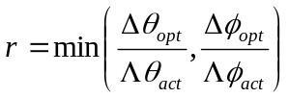 | Δφ_{act} | max. actual change in hydraulic head among all computational nodes
 | Δθ_{act} | max. actual change in water content among all computational nodes

Further, considering n_{it,akt} , the actual number of iterations of the Picard-Iteration, the following rules apply to determine a new time step:
If r < 0.5 or n_{it,akt} >n_{it,max}, repeat calculation step
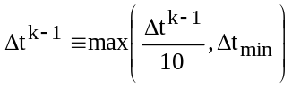
If r ≥ 0.5, calculation is continued.

1. For 0.5 ≤ r < 1 the time step is decreased:
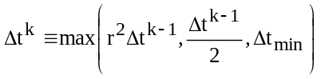
In addition, if n_{it,akt} > n_{it,threshold}, a further reduction by a factor
(1-n_{it,akt} - n_{it,grenz} )/n_{it,max} applies.

2. If r ≥ 1 the time step will be reduced for n_{it,act} > n_{it,threshold}
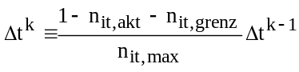
and increased otherwise:
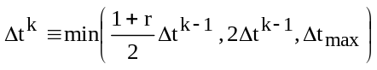

Finding optimal values for the parameters d_Th_opt and d_Phi_opt is a trial and error process, values of 0.02 to 0.03 have been found to be suitable.
The parameter piceps is a convergence criterion to stop the Picard iteration. Small values lead to a highly accurate mass balance but increase computational effort. Finding optimal values for an individual problem is also a question of trial and error. The above specified value of 10⁻³, i.e. 0.001 yielded a good compromise for simulations carried out for the Weiherbach catchment.
The parameter istact (INT) specifies for how many different types of solutes are accounted for during the simulation. If istact = 0, only catchment water dynamics is calculated and the module for solute dynamics is switched of. If istact > 0 it is necessary to specify a seed value (REAL*8) for the generation of random numbers (with a implemented random number generator) for the particle tracking.

Global files

Specification of soil types
Here all parameters to describe the hydraulic and transport properties of all soils are specified. At initialisation, CATFLOW produces look-up-tables from this data. An example:
|----.----|----.----|----.----|----.----|----.----|----.----|----.----|----.----|----.----|
| 3 %anisotrop. So albedo soil resistance erosion
|loess (VanGenuchten:1980)
| 1 800 1. 1. 5.e-5 0.5 0.34 0.11 20. 0.70 0.050 eross1 eross2 eross3
|2.1e-6 0.44 0.06 0.40 2.06 -3. 5. 1300 0.8
| 0. 0.
| 0. 0.
| 2.5 E-6 1.5 E-6
|fine river sand (Vauclin et al., 1979)
| 2 401 1. 1. 1.e-5 0.5 0.24 0.14 30. 0.60 0.030 eross1 eross2 eross3
|9.7222e-5 0.3 40000. 2.9 2.99e6 5. -2.1 1. 1300 0.8
| 0. 0.
| 0. 0.
| 2.5 E-6 1.5 E-6
|tabulated data
|99 200 1. 1. 1.e-4 0.5 0.24 0.14 30. 0.60 0.030 eross1 eross2 eross3
|soil.tab
| 0. 0.
| 0. 0.
| 2.5 1.5 E-6

Line 1 holds the number of soils. Subsequently, each soil is counted beginning from ityp=1 and requires a block of 5 lines of data (lines 2-6, 7-11, 12-16 above):
a |boden(ityp)
b |imod(ityp) iactab(ityp) anisot(1,ityp) anisot(2,ityp) snull(ityp)
+ satkni(ityp) balmax(ityp) balmin(ityp)
+ f_rs(ityp) wp_rs(ityp) zd_max(ityp)
+ eross(1,ityp) eross(2,ityp) eross(3,ityp)
c |(bodpar(ipbm,ityp), ipbm=1,npbm), sattgr
e |(abbau(ipbm,ityp), ist=1,istact)
f |(k_sorp(ipbm,ityp), ist=1,istact)
g |(d:koef(ipbm,ityp), ist=1,istact)

boden(ityp) | CHAR*30 | descriptive string
imod(ityp) | INT | soil model identifier
iactab(ityp) | INT | length of table to be generated
anisot(1,ityp) | REAL | factor on conductivity for the larger main direction of anisotropy
anisot(2,ityp) | REAL | factor on conductivity for the smaller main direction of anisotropy
snull(ityp) | REAL | specific storage coefficient
satkni(ityp) | REAL | albedo-soil moisture relation parameter
balmax(ityp) | REAL | albedo-soil moisture relation parameter
balmin(ityp) | REAL | albedo-soil moisture relation parameter
f_rs(ityp) | REAL | factor for soil moisture weighting of soil resistance
wp_rs(ityp) | REAL | inflexion point of soil moisture weighting of soil resistance
zd_max(ityp) | REAL | maximum thickness of top dry layer (soil resistance, experimentally determined)
eross(i,ityp) | REAL | 3 soil dependent erosion parameters (dummy values)
bodpar(ipbm,ityp) | REAL | parameters of soil model, number npbm+ depends on imod(ityp)
abbau(ist, ityp) | REAL | life times characterising first order decay of the specified solutes in the soil
k_sorp(ist, ityp) | REAL | adsorption coefficients of the specified solutes in the soil
d_koef(ist, ityp) | REAL | dispersion coefficients of specified solutes in the soil

Solute transport parameters
Three different parameters (decay, adsorption, dispersion) have to be specified for each solute. On runtime the solutes will be referred by an integer number according to their position in the parameter list. Hence, the sequence of the parameters has to be consistent with the sequence of the solute input masses specified in the corresponding file (section: solute input masses). For example, for three solutes, three decay parameters abbau(ist, ityp) have to specified in the line below the soil parameters (line “e” in the example above), of which the first one is for the solute 1, etc.
Adsorption coefficients are specified in relation to the type of adsorption isotherme given by i_sorp in the project control file. Possible values for i_sorp are 1 (linear adsorption), 2 (Freundlich isotherm), and 3 (Langmuir isotherm). In case of linear adsorption, one coefficient per solute type has to be given (up to 3 values in total); otherwise, two values per solute type have to be specified (up to 6 in total, first two values are for first solute, etc).

Soil hydraulic Models
Currently, three models are implemented:
imod=1: Van Genuchten-Mualem model:
This model (VanGenuchten 1980, Mualem 1976, Carsel & Parrish 1988, Rawls & Brakensiek 1989) requires 5 parameters plus 2 parameters specifying the range of the table (example: line 4 above).
bodpar(1,ityp) | k_{s} | saturated hydraulic conductivity [m/s]
bodpar(2,ityp) | θ_{s} | saturated soil moisture [-]
bodpar(3,ityp) | θ_{r} | residual soil moisture [-]
bodpar(4,ityp) | α | reciprocal air entry point [1/m]
bodpar(5,ityp) | n | quantity characterising the pore size distribution [-]
bodpar(6,ityp) | log₁₀ (ψ_{min}) | logarithm of minimum suction head (ψ_{min} in [m])
bodpar(7,ityp) | log₁₀ (ψ_{max}) | logarithm of maximum suction head (ψ_{max} in [m])
bodpar(8,ityp) | ρ | bulk density [kg^{m-3}]
sattgr |  | Threshold: relative saturation for initiating macropore flow

imod=2: Tang & Skaggs model:
This model (Tang & Skaggs 1977, Vauclin et al. 1979) requires 6 parameters plus 2 parameters specifying the range of the table (example: line 7 above).
bodpar(1,ityp) | k_{s} | saturated hydraulic conductivity [m/s]
bodpar(2,ityp) | θ_{s} | saturated soil moisture [-]
bodpar(3,ityp) | α | parameter [-]
bodpar(4,ityp) | β | parameter [-]
bodpar(5,ityp) | A | parameter [-]
bodpar(6,ityp) | B | parameter [-]
bodpar(7,ityp) | log₁₀ (ψ_{min}) | logarithm of minimum suction head (ψ_{min} in [m])
bodpar(8,ityp) | log₁₀ (ψ_{max}) | logarithm of maximum suction head (ψ_{max} in [m])
bodpar(9,ityp) | ρ | bulk density [kgm⁻³]
sattgr |  | Threshold: relative saturation for initiating macropore flow

imod=99: tabulated data:
In this case only a filename (CHAR*30) of a file holding tabulated data of soil hydraulic functions has to be specified (example: line 10 above). Also, the only considered input from the preceding line (example: line 9 above) is imod(ityp)+ (though the following 4 inputs of that line have to be specified as dummy values). Data needed are read from file tabfil(ityp)+ which looks as follows (example):
|----.----|----.----|----.----|----.----|----.----|----.----|----.----|----.----|----.----|
|tabulated soil 1.000 1.000 0.1000E-03
| 0.656065E-01 0.100000E+06 0.513940E-21 -0.156982E-07
| 0.656867E-01 0.950508E+05 0.589429E-21 -0.167519E-07
| 0.657681E-01 0.903466E+05 0.676006E-21 -0.178765E-07
| 0.658507E-01 0.858752E+05 0.775299E-21 -0.190765E-07
| 0.659344E-01 0.816251E+05 0.889178E-21 -0.203570E-07
| 0.660194E-01 0.775853E+05 0.101978E-20 -0.217236E-07
| 0.661056E-01 0.737455E+05 0.116957E-20 -0.231818E-07

The header line holds the following four entries:
boden(ityp) | CHAR*30 | descriptive string
anisot(1,ityp) | REAL | factor on conductivity for the larger main direction of anisotropy
anisot(2,ityp) | REAL | factor on conductivity for the smaller main direction of anisotropy
snull(ityp) | REAL | specific storage coefficient

and subsequent lines specify four columns holding
θ | soil moisture [-]
ψ | suction head [m]
k | hydraulic conductivity [m/s]
C | water capacity (negative) [1/m]

starting from dry conditions (θ₁=θ_{r}).

Specification of time series
In this file the filenames of files holding time series data are specified. An example:
|----.----|----.----|----.----|----.----|----.----|----.----|----.----|----.----|----.----|
|BOUNDARY CONDITIONS %mathematical boundary conditions
|2 % number of files to be read
|demo/in/bc1.dat
|demo/in/bc2.dat
|
|SINK/SOURCE
|0 % number of files to be read
|
|PRECIPITATION
|2 % number of files to be read
|demo/in/rain1.dat
|demo/in/rain2.dat
|
|CLIMATE
|1 % number of files to be read
|demo/in/ climate.dat
|
|LANDUSE
|demo/in/luse.dat
|
|MASSES
|1 % number of files to be read
|demo/in/massin.dat
|
|V Drainage network input fluxes
|1 % number of files to be read
|demo/in/gang1.dat

There are up to 7 input-blocks, which are identified by key-letters in the first column:
B | boundary conditions
S | sink/source
P | precipitation
C | climate
L | land use
M | input Masses for particle tracking in case of Neumann boundary conditions
V | input into the drainage system e.g. via a spring

Usually, either B and S is specified (imposing mathematical boundary conditions directly) or P, C and L is specified (called atmospheric boundary condition); however, each combination is correct, too. If P and/or C are/is used, specification of L is mandatory. If the number of solutes accounted for is nonzero (istact > 0) and in case of a Neumann (flux) boundary condition for solute input, M specifies files holding the input masses of the solutes. In this case also B has to be specified, because a flux of solute into a control volume is always related to a water flux. If interaction of channel flow and subsurface water is of interest, V specifies input times series of discharge, which has to be related to boundary nodes of the drainage network.
If B, M and S, P or C or V is specified, the line following a key-letter holds the number of lines to read for the block (ianz (INT)). The following lines contain a list of filenames (CHAR*30) of time series files. On runtime this files will be referred by an integer number according to their position in the list. This integer number is used in the assignment file for boundary conditions and/or surface attributes. The line following key-letter L holds the name of a file specifying time series of land-use patterns. How do the time series files look like?

Time series of boundary conditions
|----.----|----.----|----.----|----.----|----.----|----.----|----.----|----.----|----.----|
|31.12.1990 18:30:00.00 18000.
|# reference time [5h] -> [s]
|# time irbtyp [rbpar1 [rbpar2]] c_inj (for i=1, istact)
| 0. 0
| 2. 1 9.3e-6 0.165 0.165
| 10. 1 2.1e-5 0.165 0.165
| 22. 11 0.5 2.1e-5 0.165 0.165
| . . . .

The first line holds two variables, namely a string (CHAR*22) which has to start from the first column in a format dd.mm.yyyy hh:mm:ss.hs and a conversion factor for the time unit used subsequently into seconds. There might be comment lines indicated by #.
After this header information, it follows a list of lines, where each line represents one point in time. Each line starts with a time offset from the reference date (in time units e.g. h) and is followed by a boundary type specification (irbtyp) which again determines the number and type of required parameters (rbpar = 0, 1 or 2) and will be applied from the specified time onwards. If solute transport is accounted for and a Neumann boundary condition has to be specified the solute input concentrations have to be given additionally. E.g. if istact = 2, i.e. transport of two different solute is simulated (for irbtyp =1flux or irbtyp = 11 unequality) two input concentration values have two be specified. On runtime the solutes will be referred by an integer number according to their position in the list. Hence, the sequence of the input concentrations has to be consistent with the sequence of the solute parameters specified in the soil specification file (section: specification of soil types) and the specification of input masses (section: solute input mass). Please note that the total solute input mass resulting from the specified input concentrations c_inj, the water fluxes q or q_{pot} and the duration of the input, has to be equal to the values listed in the M files. Here is a complete list of all possible boundary conditions:

irbtyp | rbpar1 | rbpar2 | c_inj for number of specified solutes (optional) | description
0 | - | - | - | zero flux
1 | q [m/s] | - | c [kgm⁻³] | flux per unit boundary
3 | - | - | - | free drainage (mixed)
5 | k/d [1/s] | φ_{ref} [m] | - | leakage (mixed)
-1 | Ψ [m] | - | - | suction head
-2 | φ [m] | - | - | potential (refers to input geometry)
-4 | - | - | - | keep potential fixed
+/-10 | - | - | - | seepage
+/-11 | Ψ_{pot} [m] | q_ pot [m/s] | c [kgm⁻³] | unequality (e.g. rainfall)

If possible, boundary conditions are interpolated between discrete times. This only is possible if either irbtyp=0 or 1 is followed by irbtyp=0 or 1 or if irbtyp=-1 or -2 is followed by irbtyp=-1 or -2.

Time series of sink/source data
This file format is very similar to that used for boundary conditions. An example:
|----.----|----.----|----.----|----.----|----.----|----.----|----.----|----.----|----.----|
|31.12.1990 18:30:00.00 18000.
|# reference time [5h] -> [s]
|# time isktyp [skpar1 [skpar2]]
| 0. 0
| 2. 1 9.3e-6
| 10. 1 2.1e-5
| 22. 11 0.5 2.1e-5
| . . . .
The first line holds two variables, namely a string (CHAR*22) which has to start from the first column in a format dd.mm.yyyy hh:mm:ss.hs and a conversion factor for the time unit used subsequently (to seconds).There might be comment lines indicated by #.
After this header information, it follows a list of lines, where each line represents one point in time. Each line starts with a time offset from the reference date(in [time units]) and is followed by a sink/source type specification (isktyp) which again determines the number and type of required parameters (0, 1 or 2) and will be applied from the specified time onwards. Here is a complete list of all possible sink/source types:
isktyp | skpar1 | skpar2 | description
0 | - | - | zero flux
1 | Q [1/s] | - | flux per unit area
2 | Q [sqm/s] | - | flux
-1 | ψ [m] | - | suction head
-2 | φ [m] | - | potential (refers to input geometry)
-4 | - | - | keep potential fixed
+/-10 | - | - | seepage
+/-11 | ψ_{pot} [m] | q_{pot} [m/s] | unequality

If q_{pot} > 0 (sink) ψ cannot become greater than ψ_{pot}
If q_{pot} < 0 (source) ψ cannot become smaller than ψ_{pot}
If possible, sink/source data are interpolated between discrete times. This only is possible if either
irbtyp = 0, 1 or 2 is followed by irbtyp = 0, 1 or 2, or if irbtyp = -1 or -2 is followed by irbtyp = -1 or -2.

Time series of precipitation
The first line holds three variables, namely a string (CHAR*22) which has to start from the first column in a format dd.mm.yyyy hh:mm:ss.hs, a conversion factor for the time unit used subsequently (to seconds) and a conversion factor for the flux unit used subsequently (to [m/s]). There might be comment lines indicated by #.

|----.----|----.----|----.----|----.----|----.----|----.----|----.----|----.----|----.----|
|31.12.1990 18:30:00.00 360. 2.7778e-6
|# reference time conversion factors [6min] -> [s] [mm/6min] -> [m/s]
|# time nied
| 0. 0.
| 10. 3.1
| 11. 0.5
| . .

After this header information, a list of lines follows, where each line represents one point in time. Each line starts with a time offset from the reference date (in [time units]) and is followed by a rainfall intensity. The intensities are interpolated between discrete times.

Time series of climatic data
There are two possible different file types.

Type 1
Type 1 specifies climatic data for use with the evapo-transpiration model.
|----.----|----.----|----.----|----.----|----.----|----.----|----.----|----.----|----.----|
|1 1 #ktyp (file type); rBilart (specifies wheter measured values of net radiation rBilm (2) are used or rBil is computed (1) )
|31.12.1990 18:30:00.00 86400. 8. -6. 0.7 0.28e-3 1.5 0.1
|# 1 reference date and time
|# 2 time conversion factor, e.g. [d] -> [s]
|# 3 reference height of wind speed measurement [m]
|# 4-6 sw0 sw1 sw2: factors for rBil= sw0 + sw1*swrBil + sw2*swrBil^2,
|# relation of short wave radiation balance and net radiation, to be calibrated
|# 7-8 trueb truebf: factors to account for atmospheric dimming under consideration of water vapour
|# pressure, to be calibrated using clear sky radiation data
|#
|# meaning of -999: no data
|#
|# time glob.rad. net rad. temp rel. hum. v_wind d_wind*
|# [W/m*m] [W/m*m] [degree] [%] (0..100) [m/s] [degree]
|# rGlo rBil temp relhum uref udir
| . . . . . . . clockwise from North

The first line holds the file type (1) and a switch (1/2) for the computation of net radiation. The second line holds eight variables, namely a string (CHAR*22) which has to start from the first column in a format dd.mm.yyyy hh:mm:ss.hs, a conversion factor for the time unit used subsequently (to seconds), the reference height of wind speed measurements (in [m]), three calibration factors for radiation balance, and two calibration factors for atmospheric dimming. There might be comment lines indicated by #.
Following this header information, a list of lines, where each line represents one point in time has to be specified. Each line starts with a time offset from the reference date (in [time units]) and is followed by global radiation, net radiation, temperature, relative humidity, reference windspeed and wind direction. All these values are interpolated between discrete times, except wind direction which requires an additional file assigning sectors to a wind direction.

Type 2
Type 2 specifies evapo-transpiration data directly (measured or calculated externally).
|----.----|----.----|----.----|----.----|----.----|----.----|----.----|----.----|----.----|
|2 1
|31.12.1990 18:30:00.00 86400. 1.157407408e-8
|# reference time [d] -> [sec] [mm/d] -> [m/s]
|# time evapo transp z_root [m]
| 0. 0.124 0.008 0.180
| 1. 0.066 0.004 0.189
| 2. 0.031 0.003 0.198
| 3. 0.027 0.003 0.207
| 4. 0.055 0.007 0.216
| 5. 0.092 0.013 0.225
| 6. 0.138 0.022 0.234
| . . . .
| . . . .

The first line holds the file type (2). The second line holds three variables, namely a string (CHAR*22) which has to start from the first column in a format dd.mm.yyyy hh:mm:ss.hs, a conversion factor for the time unit used subsequently (to seconds) and a conversion factor for the flux unit used subsequently (to [m/s]). There might be comment lines indicated by #.
After this header information, it follows a list of lines, where each line represents one point in time. Each line starts with a time offset from the reference date (in [time units]) and is followed by evaporation, transpiration and root zone depth in [m]. All these values are interpolated between discrete times.

Time series of land-use patterns
|----.----|----.----|----.----|----.----|----.----|----.----|----.----|----.----|----.----|
|01.03.1993 00:00:00.00
|demo/in/luse93h.dat
|01.10.1993 00:00:00.00
|demo/in/luse93z.dat
|01.03.1994 00:00:00.00
|demo/in/luse94h.dat
|01.10.1994 00:00:00.00

This time series describes the temporal change of land-use patterns. It is a sequence of date strings (format dd.mm.yyyy hh:mm:ss.hs) and filenames (CHAR*30) (files specifying the relation between land-use units and land-use ID, as shown below). Each pattern is valid in the interval of the enclosing date strings.

Land-use patterns: Assigning land-use units to land-use ID

|----.----|----.----|----.----|----.----|----.----|----.----|----.----|----.----|----.----|
| 1 % indicates that the first column, holding land use unit IDs, is related to the first
| 1 5 1 % column of land use IDs, a land use ID points on table, specifying the properties
| 2 7 1 % of a crop such as corn or wheat
| 3 14 2
| . .
| . .

This file just holds the assignment land-use unit to several land-use Ids as e.g. exported from a GIS. The number in the first line indicates the land-use-ID column to be related to the first land-use-unit column. These land use units point on a table, that specify time dependent properties of a crop such as corn or wheat (see section “ Assigning land-use ID to land-use parameter file ”).

Solute input mass
If solute transport is accounted for, i.e. istact > 0, the first step for specifying a Neumann (flux) boundary condition for solute input is to give the total input mass of each solute respectively. The file holds a number of lines equal to the number of specified soil types. In each line the total input mass of a solute and a temporal increment for the injection of solute particles is given. On runtime the solutes will be referred by an integer number according to their position in the list. Hence, the sequence of the input masses has to be consistent with the sequence of the solute parameters specified in the soil specification file (section: “Specification of soil types”) and the sequence of input concentrations c_inj in the time series of boundary conditions. There might be comment lines indicated by #. The particle mass is calculated by dividing the input mass by the default number of particles specified in the include file dim.inc.
|----.----|----.----|----.----|----.----|----.----|----.----|----.----|
|# m_inj [kg] t_inj [s]
|4.195e-3 120. % Bromide (solute number one)
|1.e-03 120. % Isoproturon (solute number two)
|…

Boundary conditions of the drainage network
If interaction between subsurface water and channel water is simulated, i.e. q_meth = simact, it is possible to specify a time series of input flux into the drainage network for special nodes, marked as boundary nodes in the file describing the geometry of the drainage network. The first line holds two variables, namely a string (CHAR*22) which has to start from the first column in a format dd.mm.yyyy hh:mm:ss.hs and a conversion factor for the time unit used subsequently into seconds. There might be comment lines indicated by #. After this header information, it follows a list of lines, where each line represents one point in time. Each line starts with a time offset from the reference date (in time units e.g. h) and is followed by the input water flux [m³s⁻¹].
|----.----|----.----|----.----|----.----|----.----|----.----|----.----|----.----|----.----|
|01.01.2000 00:00:00.00 3600.
|# reference date conversion factor[h] → [s]
|0. 0.
|0.1 0.01
|0.2 0.05
|5.9 0.08
|12. 0.1
|12.5 1.
|13. 1.
|14. 1.
|15. 0.5
|16. 0.01
|17. 0.
|18 0.
|96. 0.

Assigning land-use IDs to land-use parameter files
|----.----|----.----|----.----|----.----|----.----|----.----|----.----|----.----|----.----|
|5 rye in/luse/variety/rye.par % land use ID 5 points of the given parameter file
|7 corn in/luse/variety/corn.par
|14 vegetables in/luse/variety/veg.par
|. . .

This file relates land use IDs, that are assigned to land use unites (section “Land-use patterns: Assigning land-use units to land-use ID”) to files that specify the time dependent properties of these crops (one line each). The first 9 columns hold the land-use identifier (INT). Columns 10-39 hold a descriptive string (CHAR*30). Columns 40-69 hold the filenames (CHAR*30) specifying land use parameters.

Specification of land use parameters
For each land use, a file with its parameters has to be specified, which covers all days of a year. From the first line only the number of parameters is read. The second line holds an offset at position 1 and as many factors as parameters specified. This numbers apply to the data read from subsequent lines, namely day number (of a year), surface roughness, macroporousity factor, leaf area index, coverage coefficient, rooting depth, plant height and several parameters characterising the evapo-transpiration model, as plant albedo, minimal stomata resistance, a factor and an inflexion point parameter of the soil moisture weighting function for stomata resistance computation. The last 3 columns hold land-use dependent erosion parameters not yet specified in more detail.
The offset allows shifting the time axis, which then is automatically extended to cover the range from 1 to 366. The factors are used to scale the associated land-use parameters by multiplication. The tables generated this way represent time series of the (changing) parameters, which are evaluated at runtime by linear interpolation.
13 | K_{ST} | f_{mac} | BFI | BBG | TWU | PFH | PALB | RST_{MIN} | WP_{BFW} | F_{BFW} | EROS1 | EROS2 | EROS3
0. | 4. | 1. | 1. | 1.1 | 1. | 1. | 1. | 1. | 1. | 1. | 1. | 1. | 1.
1. | 4. | 1. | 0.738 | 0.080 | 0.390 | 0.096 | 0.2 | 150. | 0.03 | 40. | ? | ? | ?
25. | 4. | 1. | 0.574 | 0.080 | 0.390 | 0.096 | 0.2 | 150. | 0.03 | 40. | ? | ? | ?
55. | 4. | 1. | 0.451 | 0.200 | 0.495 | 0.096 | 0.2 | 150. | 0.03 | 40. | ? | ? | ?
85. | 3. | 1. | 1.599 | 0.448 | 0.600 | 0.204 | 0.2 | 150. | 0.03 | 40. | . | . | .
115. | 2. | 1. | 3.649 | 0.800 | 0.795 | 0.504 | 0.2 | 150. | 0.03 | 40. | . | . | .
145. | 2. | 1. | 4.100 | 0.800 | 1.005 | 1.104 | 0.2 | 150. | 0.03 | 40. | . | . | .
175. | 2. | 1. | 3.321 | 0.800 | 1.500 | 1.200 | 0.2 | 150. | 0.03 | 40. | . | . | .
195. | 3. | 1. | 2.050 | 0.720 | 1.500 | 1.200 | 0.2 | 150. | 0.03 | 40. | . | . | .
196. | 4. | 1. | 0.000 | 0.000 | 0.000 | 0.000 | 0.2 | 150. | 0.03 | 40. | ? | ? | ?
271. | 4. | 1. | 0.000 | 0.000 | 0.000 | 0.000 | 0.2 | 150. | 0.03 | 40. | ? | ? | ?
300. | 4. | 1. | 0.123 | 0.080 | 0.195 | 0.096 | 0.2 | 150. | 0.03 | 40. | ? | ? | ?
330. | 3. | 1. | 0.902 | 0.080 | 0.390 | 0.096 | 0.2 | 150. | 0.03 | 40. | ? | ? | ?
360. | 4. | 1. | 0.779 | 0.080 | 0.390 | 0.096 | 0.2 | 150. | 0.03 | 40. | ? | ? | ?
366. | 4. | 1. | 0.745 | 0.080 | 0.390 | 0.096 | 0.2 | 150. | 0.03 | 40. | ? | ? | ?

with:
Kst | Strickler coefficient
f_{mac} | macroporousity factor - currently not used in calculations
BFI | Leaf area Index
BBG | plant coverage
TWU | root depth
PFH | plant height
PALB | plant albedo
RST_{MIN} | minimum stomatata resistance
WP_{BFW} | factor for soil moisture weigthing function for stomata resistance, typically around 0.05
F_{BFW} | inflexion point of soil moisture weigthing function for stomata resistance, typically value around 30
Eros1 -3 | dummy

Assigning sectors to a wind direction identifier
Computation of evapo-transpiration relies on wind velocity which is dependent from location and wind direction. Here, sectors are defined for which individual reduction factors are specified in the surface attributes file (section “Assigning surface attributes”). Angles are input in degrees clockwise from north. Furthermore, reduction factors for the location of the climate stations are specified. An example file that defines the first sector between 240 and 50 degrees, and the reduction factor of the second climate station for this sector as 0.70 would read:
|----.----|----.----|----.----|----.----|----.----|----.----|----.----|----.----|----.----|
| 240 0.81 0.70 . .
| 50 0.78 0.67 . .
| 80 0.97 0.88 . .
| 220 0.94 0.83 . .

Drainage network geometry and -discretisation
The drainage network is represented by a graph made up from interconnected nodes derived by topographical analysis. Fig. 4.2 in section “4.4.4 Domain decomposition in hillslopes and drainage network” gives an idea of this discretisation. Several attributes and parameters are assigned to each node as shown in the example below:
|----.----|----.----|----.----|----.----|----.----|----.----|----.----|----.----|----.----|
| 3480100. 5442500. % reference coordinates (x,y)
|: Comment 1
|: Comment 2
|: Comment 3
|: Comment 4
| | 1 | 2 | 1 | 13 | 0 | 993.750 | 3706.250 | 222.584 | 21.9888 | 2.5846 | 0.117540 | 13172.7 | (continued below)
| | 2 | 3 | 1 | 0 | 0 | 978.202 | 3690.702 | 219.999 | 20.3959 | 3.0324 | 0.148678 | 0.0 | (continued below)
| | 3 | 4 | 1 | 0 | 0 | 960.128 | 3681.250 | 216.967 | 21.0325 | 3.3692 | 0.160188 | 0.0 | (continued below)
| | 4 | 5 | 1 | 0 | 0 | 943.444 | 3668.444 | 213.598 | 21.9888 | 4.0124 | 0.182475 | 0.0 | (continued below)
| | 5 | 6 | 1 | 0 | 0 | 927.895 | 3652.895 | 209.585 | 21.9888 | 2.8795 | 0.130955 | 0.0 | (continued below)
| | 6 | 7 | 1 | 0 | 0 | 912.347 | 3637.347 | 206.706 | 21.9888 | 2.0083 | 0.091333 | 0.0 | (continued below)
| | 7 | 543 | 1 | 0 | 0 | 896.798 | 3621.798 | 204.697 | 21.9888 | 1.5420 | 0.070125 | 0.0 | (continued below)
| | 8 | 9 | 1 | 135 | 0 | 1443.750 | 2793.750 | 184.244 | 21.9860 | 2.8529 | 0.129761 | 14143.8 | (continued below)
| | 9 | 10 | 1 | 0 | 0 | 1428.204 | 2778.204 | 181.391 | 21.9860 | 1.4896 | 0.067753 | 0.0 | (continued below)
| | 10 | 11 | 1 | 0 | 0 | 1412.657 | 2762.657 | 179.902 | 21.9860 | 1.1476 | 0.052195 | 0.0 | (continued below)
| | 11 | 12 | 1 | 0 | 0 | 1397.111 | 2747.111 | 178.754 | 21.9860 | 1.2672 | 0.057636 | 0.0 | (continued below)
| | 12 | 13 | 1 | 0 | 0 | 1381.564 | 2731.564 | 177.487 | 21.8582 | 1.0547 | 0.048251 | 0.0 | (continued below)
| | 13 | 14 | 1 | 0 | 0 | 1381.250 | 2709.708 | 176.432 | 21.9860 | 0.7882 | 0.035850 | 0.0 | (continued below)
| | 14 | 15 | 1 | 0 | 0 | 1381.250 | 2687.722 | 175.644 | 21.9860 | 0.6028 | 0.027417 | 0.0 | (continued below)
| | 15 | 648 | 1 | 0 | 0 | 1381.250 | 2665.736 | 175.041 | 21.9860 | 0.5236 | 0.023814 | 0.0 | (continued below)
| | -16 | 17 | 1 | 40 | 0 | 493.750 | 3081.250 | 202.063 | 20.2176 | 0.3782 | 0.018708 | 15038.5 | (continued below)
| . . . . . . . . . . . .
|---.---------|----.----|----.--|----.------|-----.-----|----.----|----.----|-----.-------|-----|-----|-----|----|
(continued from above) | 13172.7 | 3 | 8.0 | 222.44 | 0.147 | 0.015 | 8.00 | 0.13853 | 0. | 0. | 1. | 1
(continued from above) | 13172.7 | 3 | 8.0 | 219.85 | 0.149 | 0.015 | 8.00 | 0.12876 | 0. | 0. | 1. | 0
(continued from above) | 13172.7 | 3 | 8.0 | 216.82 | 0.149 | 0.015 | 8.00 | 0.12888 | 0. | 0. | 1. | 0
(continued from above) | 13172.7 | 3 | 8.0 | 213.45 | 0.151 | 0.015 | 8.00 | 0.12209 | 0. | 0. | 1. | 0
(continued from above) | 13172.7 | 3 | 8.0 | 209.43 | 0.152 | 0.015 | 8.00 | 0.11510 | 0. | 0. | 1. | 0
(continued from above) | 13172.7 | 3 | 8.0 | 206.55 | 0.154 | 0.015 | 8.00 | 0.10988 | 0. | 0. | 1. | 0
(continued from above) | 13172.7 | 3 | 8.0 | 204.54 | 0.155 | 0.016 | 8.00 | 0.10358 | 0. | 0. | 1. | 0
(continued from above) | 14143.8 | 2 | 8.0 | 184.08 | 0.163 | 0.016 | 8.00 | 0.09332 | 0. | 0. | 1. | 0
(continued from above) | 14143.8 | 2 | 8.0 | 181.22 | 0.167 | 0.017 | 8.00 | 0.08125 | 0. | 0. | 1. | 0
(continued from above) | 14143.8 | 2 | 8.0 | 179.73 | 0.173 | 0.017 | 8.00 | 0.06683 | 0. | 0. | 1. | 0
(continued from above) | 14143.8 | 2 | 8.0 | 178.58 | 0.179 | 0.018 | 8.00 | 0.05662 | 0. | 0. | 1. | 0
(continued from above) | 14143.8 | 2 | 8.0 | 177.30 | 0.183 | 0.018 | 8.00 | 0.04929 | 0. | 0. | 1. | 0
(continued from above) | 14143.8 | 2 | 8.0 | 176.25 | 0.187 | 0.019 | 8.00 | 0.04460 | 0. | 0. | 1. | 0
(continued from above) | 14143.8 | 2 | 8.0 | 175.45 | 0.193 | 0.019 | 8.00 | 0.03757 | 0. | 0. | 1. | 0
(continued from above) | 14143.8 | 2 | 8.0 | 174.85 | 0.195 | 0.020 | 8.00 | 0.03553 | 0. | 0. | 1. | 0
(continued from above) | 15038.5 | 3 | 8.0 | 201.87 | 0.196 | 0.020 | 8.00 | 0.03893 | 0. | 0. | 1. | 0
| . . . . . . . . . . . .
The first line holds reference coordinates, followed by exactly 4 lines of comments. The entries of each subsequent line hold the following data:
ib | INT | number of node, negative values mark nodes for which a hydrograph is dumped to the output file
ibnext | INT | next downstream node number
ib_ord | INT | Strahler order
inhang | INT | number of hillslope connected to node
inarea | INT | sealed surface connected (1) / not connected (0)
xba | REAL | relative x-coordinate [m]
yba | REAL | relative y-coordinate [m]
b_vorl | REAL | DEM-elevation at node [m+NN]
b_dx | REAL | distance to next downstream node [m]
dz | REAL | difference in elevation to next downstream node [m]
slope | INT | DEM-slope to next downstream node [-]
aahang | REAL | hillslope surface [sqm]
b_ezg | REAL | local catchment area [sqm]
ib_reg | INT | number of rainfall station associated to node
b_rauh | REAL | Strickler-roughness
b_yso | REAL | elevation of channel bottom [m+NN]
y_vorl | REAL | channel depth [m]
brso | REAL | bottom width of trapezoidial channel bottom [m]
b_m | INT | slope of channel banks [-]
b_gef | REAL | bottom slope to next downstream node [-]
weg_br | REAL | width of sealed surface parallel to channel [m]
qbas | REAL | lateral baseflow per unit channel length [cbm/s/m]

In principle channel flow may be simulated in two different ways, with or without interaction between subsurface and channel water.

No interaction between subsurface and channel water
If no interaction between subsurface and channel water is simulated, i.e. q_meth = noicat, No initial state of the drainage network has to be specified. The lateral baseflow qbas servers as a constant lateral inflow from the hill slope into the drainage system. Moreover, surface runoff from hillslopes feeds the water flow in the channel network. Subsurface inflow from the hill slopes into the drainage network may be accounted for, if the right hill slope boundary condition is set to irbtyp = 10 (leakage boundary, see section “Assigning boundary conditions and sinks/sources). In case of saturation, subsurface water may exfiltrate via the channel walls into the drainage network. However, this way no infiltration of channel water via the channel walls into the hillslope may be accounted for.

Interaction between subsurface and channel water
If interaction between subsurface and channel water is accounted for, i.e. q_meth = simact, it is obligatory to specify an initial state of the drainage network as well as an input rime series of water flux (section “Boundary conditions of the drainage network”) for those nodes marked as boundary nodes (iqsour=1). On runtime this nodes will be referred by an integer number according to their position in the list.
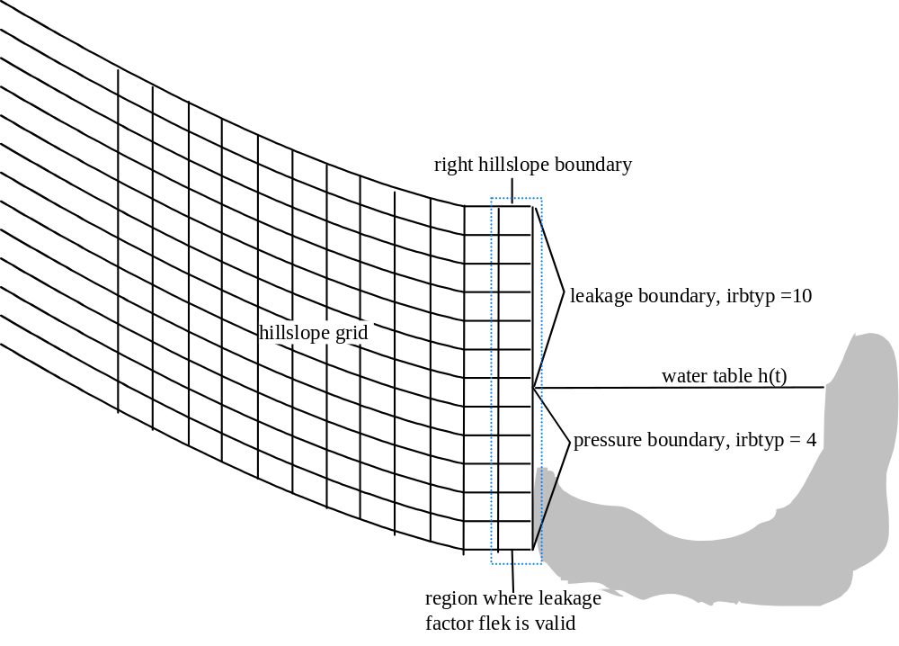
Figure 3.1: When interaction between subsurface and channel water is simulated, the height of the channel water table causes a time dependent pressure boundary condition at the right hill slope boundary.

Initial state of the drainage network
If interaction between subsurface and channel water is simulated (q_meth =simact), the initial height of the water table has to be specified for each node of the drainage network as shown in the example below.
|----.----|----.----|----.----|----.----|----.----|----.----|----.----|----.----|----.----|
| 1 0.1 : node number, height of the water table in m
| 2 0.1
| 3 0.1
| 4 0.1
| 5 0.1
|…

Assigning time series of input fluxes to boundary nodes of the drainage channel
The time series of input water fluxes into the drainage network listed in the specification of times series (see section “Specification of time series” and “Boundary conditions of the drainage network”) have to be related to the boundary nodes of the drainage network specified in the drainage network geometry. The first line holds an integer which determines the number of the following lines to be read. Please note that this number has to equal to the number of boundary nodes specified in the drainage network geometry. An example is given below:
|----.----|----.----|----.----|----.----|----.----|----.----|----.----|----.----|----.----|
| 2: two lines to be read
| 2: assigns time series number two to the first boundary node
| 1: assigns time series number one to the second boundary node 0.1
|

Hillslope specific files

Hillslope geometry and -discretisation
The hillslope is represented by a longitudinal vertical cross section along a line of steepest decent (streamline). The upper soil layer beneath this line has to be discretised in curvilinear coordinates prior to calculation by an external program. Fig. 3.2 shows an example of the discretisation of a hypothetical hillslope.

Figure 3.2: Discretisation in orthogonal curvilinear coordinates, the lateral direction is named as ξ, the vertical is named as η-direction.

Below, the file format is described by means of FORTRAN read statements; comments start with #.
Indices declaration:
# iihg: unit number | # iv: counter in vertical (eta) direction
# ih: counter for hillslopes | # il: counter in lateral (xsi) direction
read(iihg,*) iacnv(ih), iacnl(ih), w_fix, hangnr(ih) | # iacnv(ih): vertical number of points
 | # iacnl(ih): lateral number of points
 | # w_fix: additive global angle of anisotropy against horizontal
 | # hangnr(ih): hillslope number (serves as label)
read(iihg,*) xkobez(ih), ykobez(ih), hkobez(ih) | # xkobez(ih): x-reference in global coordinates
 | # ykobez(ih): y-reference in global coordinates
 | # hkobez(ih): z-reference in global coordinates
read(iihg,*) hgobfl(ih), hgbreit(ih), hglang(ih) | # hgobfl(ih): area covered by hillslope
 | # hgbreit(ih): average width of hillslope
 | # hglang(ih): length of hillslope
read(iihg,*) (eta(iv,ih),iv = 1,iacnv(ih)) | # i.e. iacnv(ih) lines containing 1 value each:
 | # eta(iv,ih): discrete curvilinear coordinates in vertical direction
do 10 il = 1,iacnl(ih) | # i.e. iacnl(ih) lines containing 4 values each:
read(iihg,*) xsi(il,ih), | # xsi(il,ih): discrete curvilinear coordinates in vertical direction
& xko(iacnv(ih),il,ih), yko(iacnv(ih),il,ih), | # local real world x,y-coordinates (relative to reference)
& varbr(il,ih) | # varbr(il,ih): relative width of hillslope
10 continue
do 30 il = 1,iacnl(ih) | # i.e. iacnv(ih)*iacnl(ih) lines containing 7 values each:
do 20 iv = 1,iacnv(ih) | # hko(iv,il,ih): local real world z-coordinate
read(iihg,*) hko(iv,il,ih), sko(iv,il,ih), | # sko(iv,il,ih): local real world s-coordinate (horizontal along hillslope)
& f_eta(iv,il,ih), f_xsi(iv,il,ih), | # f_eta, f_xsi: metric coefficients of curvilinear coordinates in vertical and lateral direction, respectively
& w_xsho(iv,il), w_hohr(iv,il), | # w_xsho(iv,il): angle between lateral coordinate and horizontal (positive counterclockwise)
& iboden(iv,il,ih) | # w_hohr(iv,il): angle between horizontal and main direction of anisotropy (positive counterclockwise)
20 continue | # iboden(iv,il,ih): associated soil number of point
30 continue

This is an example file describing the discretisation (truncated):
|----.----|----.----|----.----|----.----|----.----|----.----|----.----|----.----|----.----|
| 11 17 0.0 1 % (vertical nodes; lateral nodes; additive global angle of anisotropy against horizontal; hillslope number)
| 3480100. 5445400. 202.0 % (x,y,z coordinates)
| 4. 10. 40. % (area, width, length)
| 0.00 % (discrete curvilinear coordinates in vertical direction; relative)
| 0.10 %…
| .
| 0.90 %…
| 1.00 % (discrete curvilinear coordinates in vertical direction; relative)
| 0.00 10.00000000 10.00000000 1. % (xsi (curvilin. coord), xko (real world), yko (real world), width of hillslope)
| 0.25 10.17677670 10.17677670 1. % (4 columns)
| . . . .
| 3.75 12.65165043 12.65165043 1.
| 4.00 12.82842712 12.82842712 1. % (4 columns)
| 0.0000 0.0000 2.0000 1.0000 0.0000 0.0000 1 % (7 columns:
| 0.2000 0.0000 2.0000 1.0000 0.0000 0.0000 1 % hko, sko (real world vertical and horizontal),
| 0.4000 0.0000 2.0000 1.0000 0.0000 0.0000 1 % f_eta, f_xsi (metric coefficients for curvilin. coordinates),
| 0.6000 0.0000 2.0000 1.0000 0.0000 0.0000 1 % w_xsho (angle of lateral coord. and horizontal)
| 0.8000 0.0000 2.0000 1.0000 0.0000 0.0000 1 % w_hohr (angle of horizontal and main dir. of anisotropy),
| 1.0000 0.0000 2.0000 1.0000 0.0000 0.0000 1 % iboden (asscociated soil number of point).)
| . . . . . .

Assigning soil types
The following sketch gives an example of a discrete representation of a hillslope, where nodes are assigned soil type numbers:
1.0 | 5 | 2-------  |  | | 2-------  |  | | 2-------  |  | | 2-------  |  | | 2-------  |  | | 2-------  |  | | 2  |  |
rev=0.7 | 4 | 1-------  |  | | 1-------  |  | | 1-------  |  | | 1-------  |  | | 2-------  |  | | 2-------  |  | | 2  |  |
rav=0.4 | 3 | 2-------  |  | | 1-------  |  | | 1-------  |  | | 1-------  |  | | 2-------  |  | | 2-------  |  | | 2  |  |
0.2 | 2 | 2-------  |  | | 2-------  |  | | 2-------  |  | | 2-------  |  | | 2-------  |  | | 2-------  |  | | 2  |  |
0. | 1 | 2------- | 2------- | 2------- | 2------- | 2------- | 2------- | 2
 |  | 1 | 2=al | 3 | 4 | 5 | 6 | 7
 |  | 0.0 | 0.2 | 0.3 | 0.5 | 0.7 | 0.9 | 1.0
Figure 3.3: Assigning soil types to grid nodes

Soil type data can be assigned to the discretisation in Fig. 3.3, either by absolute node numbers and/or by relative values (example 1 below), or node wise by soil declaration in matrix form (example 2 below). These specifications overwrite the specifications given in the hillslope geometry file.
Example 1: input file for soil declaration by absolute node numbers and relative values
|----.----|----.----|----.----|----.----|----.----|----.----|----.----|----.----|----.----|
| 2 0.: number of lines to be read
| 1. 5. 1. 7 2 : soil type 2 for nodes 1 to 5 in the vertical and 1 to 7 in the horizontal
| 3. 4. 0.2 0.5 1 : soil type 1 for nodes 1 to 4 in the vertical and between 20 and 50% in the horizontal
|
Below is a general description by means of FORTRAN read statements.
read(iist,*) ianz, iart
# iist: unit number
# ianz: number of lines to read. Each line defines a window, and isoil is assigned to all nodes within.
# Each subsequent dataset may overlap and overwrite previous inputs!!!
# iart: always 0, kept for compatibility reasons
read(iist,*) rav, rev, ral, rel, isoil
# if ra? and re? are in the range (0.0...1.0) they are interpreted as relative eta,xsi values and transformed
# to absolute numbers av, ev, al, el,
# otherwise, if in the range of (1...iacnv,1...iacnl), they are regarded as absolute node numbers directly
Example 2: node wise soil declaration as matrix
|BODEN 46 48 1 % BODEN (indicates that soils are assigned nodewise), nv, nl, hillslope no.
|14 14 14 14 14 14 14 14 14 14 14 14 14
|14 14 14 14 14 14 14 14 14 14 14 14 14
|14 14 14 14 14 14 14 14 14 14 14 14 14
|…
|17 17 15 18 18 17 18 15 17 15 15 15 17
|
The hillslope number is only a description and not used in the program.

Assigning factors to the K_{sat} field of the hillslope
This file allows for a simple implementation of areas of preferential flow by assigning factors to be multiplied with the Ksat values of each node. These factors are assigned nodewise in matrix form. If you do not wish to implement preferential flow this way, assign the value “1” to each node of the hillslope.
Example file:
|-1001 22 27 % -(1000+ihg) (hillslope no.) nv, nl (no. of vertical and lateral nodes)
|1 1 1 1 1 1 1 1 100 1 1 1 … 1
|1 1 1 1 1 1 1 1 100 1 1 1 … 1
|1 1 1 1 1 1 1 1 100 1 1 1 … 1
|…
|1 1 1 1 1 1 1 1 1 1 1 1 … 1|

Assigning factors to the theta field of the hillslope
Assign the value “1” to each node of the hillslope. So far not stable for values other than 1.
Example file:
|-1001 22 27 % -(1000+ihg) (hillslope no.) nv, nl (no. of vertical and lateral nodes)
|1 1 1 1 1 1 1 1 100 1 1 1 … 1
|1 1 1 1 1 1 1 1 100 1 1 1 … 1
|1 1 1 1 1 1 1 1 100 1 1 1 … 1
|…
|1 1 1 1 1 1 1 1 1 1 1 1 … 1|

Specification of control volumes
This is done by files of the same structure then those for assigning soil types, except the fact, that instead of a soil type no value has to be specified.
|----.----|----.----|----.----|----.----|----.----|----.----|----.----|----.----|----.----|
| 2 0.: number of lines to be read
| 1 5 1 7 control volume 1 from nodes 1 to 5 in the vertical and 1 to 7 in the horizontal
| 1 4 0.2 0.5 control volume 2 from nodes 1 to 4 in the vertical and between 20 and 50% in the horizontal

Assigning macropore parameters
This is done by files of the same structure then those for assigning soil types. The first line holds 3 integers, the first indicates the number of subsequent lines to be read, the second specifies whether the assignment is done in relative coordinates (0) or node wise. The third variable indicates whether the saturated conductivity is increased only in the vertical direction (m_aniso = 1), only in lateral direction (m_aniso = 2), or in both directions (m_aniso ≠ 1 or 2). Instead of a soil type the macroporosity factor f_{mac} (for an increasing hydraulic conductivity in case of preferential flow) and the macroporous cross section a_{mac} has to be specified as a REAL number. The macroporous cross section a_{mac} is used for determination of effective transport velocities v for solute transport, with v being either the arithmetic (ari) or geometric (geo) mean of matrix velocity v_{S} = q / θ and macropore velocity v_{M} = q / (θ a_{mac}).
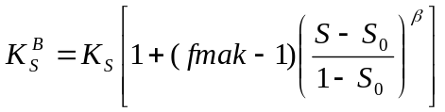 for S₀ ≤ S ≤ 1, otherwise K_{S}^{B} = K_{S}
K_{S}^{B} = conductivity of both macropore system and matrix
K_{S} = conductivity of matrix
S₀ = threshold of relative saturation for macropore flow (defined in soil type specification file)
S = relative saturation
β = exponent to steepen the gradient of K_{S}^{B} increase with saturation

|----.----|----.----|----.----|----.----|----.----|----.----|----.----|----.----|----.----|
| 2 1 2: number of lines to be read; type of assignment 0 relative coordinates or 1 node wise; m_aniso
|ari: mean calculation for transport velocities (ari= arithmetic, geo= geometric)
| 1 5 1 7 2. 1.E-3 0.1 : fmac = 2 and amac= 1. E-3, β=0.1 for nodes 1 to 5 in the vertical and 1 to 7 in the horizontal,
| 1 4 0.2 0.5 1. 0. 1: fmac = 1 and amac= 0, β=1 for nodes 1 to 4 in the vertical and between 20 and 50% in the horizontal

Or node wise assignement of macropores.
|----.----|----.----|----.----|----.----|----.----|----.----|----.----|----.----|----.----|
DIRECT amac, β, m_aniso
ari

DIRECT 1.000000 1.000000 1
ari
1.000000 1.000000 65.312296 1.000000 65.285366 …
65.312296 1.000000 65.319032 1.000000 1.000000…
….

Assigning initial conditions

Initial state for soil water dynamics
There are three different basic input formats.

Blockwise assignment of either absolute suction head or degree of saturation
This is done by files of a similar structure then those for assigning soil types. Here is a general description by means of FORTRAN read statements.

read(iist,*) ianz, ischal, iart
# iist: unit number
# ianz: number of lines to read. Each line defines a window,
# and isoil is assigned to all nodes within this window.
# Each subsequent dataset may overlap and overwrite previous inputs!!!
# ischal: controls the interpretation of rval
# ischal=0 degree of saturation (fraction of theta_sat)
# ischal=1 suction head [m]
# iart: always 0, kept for compatibility reasons
read(iist,*) rav,rev,ral,rel,rval
# if ra? and re? are in the range (0.0...1.0) they
# are interpreted as relative eta,xsi values and transformed
# to absolute numbers av, ev, al, el,
# otherwise, if in the range of (1...iacnv,1...iacnl)
# regarded as absolute node numbers directly

Two example files show, how initial condition data can be assigned to the discretisation, either by absolute node numbers and/or by relative values, please note that suction head in the model ist defined as follows ψ = 0 saturation, ψ > 0 normal case, i.e. soil moisture is less than the saturation value, ψ < 0 is reserved to saturated states, when the water pressure in the soil is higher than the atmospheric pressure:
|----.----|----.----|----.----|----.----|----.----|----.----|----.----|----.----|----.----|
| 2 0 0 % 2 lines to be read, degree of saturation (0)
| 1. 5. 1. 7. 0.6 % from node 1 to 5 in the vertical and from node 1 to 7 in the horizontal S=0.6
| 3. 4. 0.2 0.5 0.9 % from node 3 to 4 in the vertical and between 20 to 50% in the horizontal S=0.9
|
or
|----.----|----.----|----.----|----.----|----.----|----.----|----.----|----.----|----.----|
| 2 1 0 % two lines to be read, suction head/matric potential (1)
| 1. 5. 1. 7. 1.40 % from node 1 to 5 in the vertical and from node 1 to 7 in the horizontal ψ = -1.4m
| 3. 4. 0.2 0.5 0.09 % from node 3 to 4 in the vertical and between 20 to 50% in the horizontal ψ = -0.09m
|

Assigning individual absolute values at each point
This file type specifies each value separately. In fact it is the dump format of the final state file.
The header line holds 6 variables: kenn, tzeit, ihg, nv, nl and the integer 1.
kenn | CHAR*5 | either PSI or THETA
tzeit | REAL | time offset [s] from a reference time
ihg | INT | Hillslope number
nv | INT | Vertical number of nodes
nl | INT | lateral number of nodes
1 | INT | always one

Depending on the keyword (kenn) either suction head (PSI) or water content (THETA) may be specified. The header is followed by iv = 1 … nv lines of either ψ- or θ-values, each line with il = 1 … nl columns. Thus, the first line represents the upper boundary.

Uniform potential in entire domain
The header line is exactly the same as above. The keyword for potential initial condition is PHI. Only a second line follows, holding two values, phi_s and iart.
Phi_s | REAL | potential in the entire domain
iart | INT | switch which controls reference potential
 |  | iart=0: relative to heights specified in the geometry input file
 |  | iart=1: relative to lowest point of discrete geometry

Initial solute concentration
There are two different basic input formats.

Blockwise assignment of residual total concentrations
This is done by files of a similar structure then those for assigning the initial state for soil water dynamics.
|----.----|----.----|----.----|----.----|----.----|----.----|----.----|----.----|----.----|
| 2 1 2 % two lines to be read for each solute type, relative values or nodes, istac number of solute types
|1 % first solute
| 1. 5. 1. 7. 1. E-3 % from node 1 to 5 in the vertical and from node 1 to 7 in the horizontal C=1. E-3 g/kg
| 3. 4. 0.2 0.5 0.09 % from node 3 to 4 in the vertical and between 20 to 50% in the horizontal C=0.09 g/kg
|2 %second solute
| 1. 5. 1. 7. 5. E-2 % from node 1 to 5 in the vertical and from node 1 to 7 in the horizontal C=5. E-2 g/kg
| 3. 4. 0.2 0.5 0.5 % from node 3 to 4 in the vertical and between 20 to 50% in the horizontal C=0.5 g/kg

Assigning individual concentration values at each point
This file type specifies each value separately. In fact it is the dump format of the final state file. The header line holds 6 variables: kenn, tzeit, ihg, nv, nl and istact.
kenn | CHAR*5 | Konz
tzeit | REAL | time offset [s] from a reference time
ihg | INT | hillslope number
nv | INT | vertical number of nodes
nl | INT | lateral number of nodes
istact | INT | number of different solutes

The header is followed by iv=1 … nv lines of C values [g/kg], each line for il=1 … nl. Thus, the first line represents the upper boundary.

Specification of printout times
This file format is almost the same as for boundary conditions. An example:
|----.----|----.----|----.----|----.----|----.----|----.----|----.----|----.----|----.----|
|31.12.1990 18:30:00.00 18000.
|# reference time [5h] -> [s]
| 0. 0
| 2. 0
| 10. 1
| 22. 0
| …

The first line holds two variables, namely a string (CHAR*22) which has to start from the first column in a format dd.mm.yyyy hh:mm:ss.hs+ and a conversion factor for the time unit used subsequently (to seconds). There might be comment lines indicated by.
After this header information, a list of time offsets from the reference date follows in the first column, the print times. The second column holds either 0 or 1. In case of 1, values from the entire hillslope domain are dumped, in case of 0 only those of surface points are dumped.

Assigning surface attributes
For each discrete point of a hillslopes' surface this file assigns some identifiers and factors, in order to connect surface points to their correct time series of boundary conditions and land use. Line 1 holds the number of attributes to consider for 3 classes of attributes (polygon-IDs, wind direction identifiers, horizon elevations). Line 2 is merely descriptive. Subsequent lines hold attributes of land-use-unit numbers, precipitation file ID, climate file ID and as many factors as there are wind direction identifiers and horizon elevations.

|----.----|----.----|----.----|----.----|----.----|----.----|----.----|----.----|----.----|
|3 4 36
|1. node | land-use ID | precip.ID | Climat ID | wdirfac D1 | .... | wdirfacID4 | hor1 | hor2 | .... | hor36
|2. node | 5 | 2 | 1 | 0.81 | .... | 0.93 | 12 | 16 | .... | 9
|3. node | 5 | 2 | 1 | 0.76 | .... | 0.93 | 13 | 17 | .... | 10
|4. node | 5 | 4 | 1 | 0.73 | .... | 0.92 | 13 | 17 | .... | 10
|5. node | 12 | 4 | 1 | 0.72 | .... | 0.91 | 13 | 17 | .... | 11
|6. node | 12 | 4 | 1 | 0.70 | .... | 0.89 | 14 | 19 | .... | 12
|
|
|last node | 12 | 4 | 1 | 0.70 | .... | 0.89 | 14 | 19 | .... | 12

Assigning boundary conditions and sinks/sources
Each boundary node has to be assigned a boundary condition for all times of a simulation (mandatory). Optionally, each element can be assigned a sink/source term. Either constant or time varying conditions can be assigned. Again assignment is done by key-letters. There are up to 5 input-blocks, which are identified by key-letters in the first column:
R | right boundary (mandatory)
L | left boundary (mandatory)
T | top boundary (mandatory)
B | bottom boundary (mandatory)
S | source/sink (optional)
M | mass input (in case of solute transport)

Please note that if input mass file number n is related to a hill slope under M, the corresponding boundary condition file has also to be related to that hill slope. After the key letter has been identified, input is read in the following manner (analogous the assignment of soil type numbers):
read(iirb,*) ianz, iart
# iirb: unit number
# ianz: number of lines to read. Each line defines an interval
# and isoil is assigned to all nodes within this interval
# each subsequent dataset may overlap and overwrite previous inputs!!!
# iart: always 0, kept for compatibility reasons
#
# Depending on the key-letter, one of the following statements is executed:
# key-letter T or B:
read(iirb,*) ral, rel, irb_?
# key-letter R or L:
read(iirb,*) rav,rev, irb_?
# key-letter S:
read(iirb,*) rav,rev,ral,rel,irb_?
# if ra? and re? are in the range (0.0...1.0) they are interpreted as relative eta,xsi values and transformed to
# absolute numbers av, ev, al, el,
# otherwise, if in the range of (1...iacnv,1...iacnl), they are regarded as absolute node numbers directly

# irb_? specifies the boundary condition at each single node:
# irb_? > 0 indicates a time-series file-number to be assigned to specified nodes.
# The filename associated with the number is read from the boundary time series file.

# irb_? = 0 zero flux boundary condition
# irb_? = -3 gravitation flux boundary condition
# irb_? = -4 fixed constant potential
# irb_? = -5 flux divergence = zero: free flow across boundary (implemented for right and lower boundary)
# irb_? = -10 seepage boundary condition IN NEWEST VERSION: WATER LEAVES THE SYSTEM ABOVE FIELD CAPACITY (NOT ONLY WHEN SATURATED)
# irb_? = -99 atmospheric boundary condition NEEDS TO BE IMPLEMENTED IN SINK/SOURCE FOR TRANSPIRATION TO BECOME EFFECTIVE

# Interpretation of atmospheric boundary condition (-99):
# In this case boundary conditions are determined from climate, # rainfall and land-use data. Internally the following # BC apply:
## irbtyp rbpar1 rbpar2 description
# -------------------------------------------------------------------------------------------------------------------------
# | top: | +/-11 | -y_w | [m] | -i_net | [m/s] | rainfall
# | bottom: | 3 | - | - | free | drainage
# | left: | 0 | - | - | zero | flux
# | right: | +/-10 | - | - | seepage
# | or | 2 | k/d | [1/s] | Phi_a | [m] | leakage | (mixed)
# | sink/source: | according | to | evapotranspiration

This is a simple example file describing assignment:
|----.----|----.----|----.----|----.----|----.----|----.----|----.----|----.----|----.----|
|LEFT
|1 0
| 0. 1. 0 % should almost always be 0, unless input time series is defined.
|
|RIGHT %right boundary
|1 0 % 1 line to be read and dummy (always zero)
| 0. 1. 0 % zero flux is valid from 0 to 100% of the length of the right boundary
|
|TOP % upper boundary
|2 0 % 2 lines to be read and dummy (always zero)
|0. 1. –99 % atmospheric boundary conditions valid from 0 to 100% of the length of the upper boundary
|7 16 1 % boundary conditions specified in file number 1 valid from node 7 to node 16 at the upper boundary
|
|BOTTOM % lower boundary
|1 0 % 1 line to be read and dummy
| 0. 1. –3 % free drainage valid from 0 to 100% of the length of the lower boundary
|
|SINK/SOURCE
|1 0 % 1 line to be read and dummy
| 0. 1. 0. 1. –99 % atmospheric sinks and sources valid for whole domain (TRANSPIRATION!)
|
|MASS % either 0 (then no massinput is associated) or n > 1 (integer) relating the mass input file
| 1 % number n to the hillslope

Preparing input files

Prolog
As can be seen from the input description given in the previous chapter, the model's data requirements are enormous. Furthermore, the 4-dimensional nature of the problem at hand, together with the interaction of processes on different scales, and the high interdependence of model variables and parameters, is reflected in a model and data structure of considerable complexity. A range of questions has to be answered:
- At which scale (support, resolution, extend) data are available?
- At which scale data are required?
- How to bridge gaps due to differences between 1. and 2.?
- How to homogenise data of different sources?
- How to store data?
- How to retrieve data?
- How to visualise data?
- How to organise data for use in a model?
- How to flexibly incorporate new modules (and thus data) in a model?
- How to handle the even bigger amounts of data that are produced during simulation?

An attentive reading of recent publications on these issues reveals a growing awareness of open problems related to this questions and, on the other hand, the enormous development times spent to achieve thorough environmental software systems at state of the art, which easily sum up to dozens of man-years.
Exemplary, a quotation from a product information of PCRaster, a dynamic modelling language for two-dimensional map objects (http://www.frw.ruu.nl/pcraster/pcraster.html), developed in the Netherlands is given here:
Developing a computer model is not an easy task. The first difficulty is that environmental models are relatively complex because they must be both temporal and spatial due to the spatio-temporality of natural phenomena. Related to this is the problem that they are fed by huge amounts of environmental data, often coming from different kinds of sources such as manual field measurements, automated data loggers or remotely sensed images.
Further on it is pointed out that their software product is the result of eight years of research by a team of scientists with diverse backgrounds such as geographers, hydrologists, mathematicians and software engineers. Only recently, in recognition of the non-triviality of this issues, conferences and workshops on environmental software systems have been organized, e.g. the. “International Symposium on Environmental Software Systems (ISESS), 1995” at Penn State University, Malvern, PA, USA and 1997 at Whistler, British Columbia, Canada or the “Third International Conference/Workshop on Integrating GIS and Environmental Modelling”, January 1996 in Santa Fe, New Mexico, USA and also the HydroGIS conferences “Application of Geographic Information Systems in Hydrology and Water Resources Management” in Vienna, Austria, April 1993 and April 1996.
The announcement paper of a workshop called “Tools for Environmental Informatics” (Whistler, British Columbia, Canada, http://cfc.crle.uoguelph.ca/isess97/courfin.htm) points out gaps in knowledge and lack of awareness of problems associated with this issues: The concept of environmental informatics has not yet satisfactorily penetrated North America. There is an assumption that environmental science is orchestrated by planners and conciliators on one hand, and civil and environmental engineers/scientists on the other. The experiences of several groups in Canada, the U.S., Australia and Europe (most notably Germany and Austria) would suggest otherwise. Simultaneously the “stakeholders” in the academic structure and the existing environmental regulation and policy management structure are only recently wakening to the need for sophisticated information systems. The data are incomplete, the concepts of data management are slow to adapt and the money at all levels (including education and training) is shrinking.
As a consequence of this insights a workshop is proposed which theme is summarise as follows:
Environmental data management and environmental information systems have to bridge gaps in time and space in data, information and knowledge. Elements of modelling, statistical computing, scientific database, visualisation, environmental statistics (including risk assessment), uncertainty estimation and management, integration of heterogeneous and legacy systems and knowledge engineering all contribute to a better understanding of environmental problems.
It is the authors’ conviction that for a more effective use of resources much work has to be done in order to facilitate data handling and visualisation. Probably a more generalised method for administrating data has to be developed to ensure an open and easily extendable software architecture of long term continuance. This task encloses the integration of software tools such as databases and GIS as well as models for the various types of interpolation and extrapolation in the space-time domain (including physically-based, distributed models like CATFLOW). This challenge seems to be critical to prevent modellers from reinventing the wheel again and again, thus marking time and wasting resources urgently needed to advance science.

General
CATFLOW works on a specified discretisation in space and time. This has implications on how variability is treated. The smallest variability which (at least theoretically) can be taken into account explicitly is of the order of the discretisation. A possible variability below discretisation scale has to be treated in an implicit, lumped way (Bloeschl, 1996c). Several approaches exist to quantify this so-called subgrid-variability and roughly can be grouped into two classes:
- effective parameters: the parameters of a process describing equation are modified, e.g. parameters are distributed with some distribution function.
- effective models: the process equation itself is changed, e.g. the process equation is rewritten using perturbated state variables which yield additional terms, so-called closure terms, which then have to be parameterised.
Not all information is available at the scale of CATFLOW's discretisation. Therefore, scaling laws have to be applied (or are applied implicitly) when assigning data to the discrete representation of the domain under consideration. It is important to keep in mind the possible effect of the underlying scaling assumptions when judging about the quality of a simulation and the confidence which can be set into a result.
The following sections give a brief overview of CATFLOW's concepts of data management and how the preparation of data for the model CATFLOW currently is conducted, using tools provided by different software environments and exchanging data mostly in ASCII-file formats. This procedure, together with data structure already embedded in the existing code, can be regarded as the minimum effort to be invested to enable model handling.
However, it is the authors conviction, that the methodology has to be developed further towards more generality and flexibility to facilitate model handling and to more easily allow for model extensions, thus improving performance and widen the range of applicability.

Data organisation
The key to all data are their location in space and time. All data are attributed to this key. However, this location is not a point in a mathematical sense, i.e. associated with this key is an understanding of properties characterising the quality and validity of the data (method, volume/support, spacing, extend etc.). This demands for a universal definition of a data-descriptor and -qualifier. Physically based process descriptions are time marching, i.e. they describe the transition of some spatially distributed state variables with time, taking into account their interactions. In theory, there are two straightforward possibilities to provide required input data and parameters (and to store output data of computed state variables):
- For each point in space time series of every input data are given, i.e. one spatial distribution of time series (SDTS)
- For each point in time spatial distributions of every required input data (one value at each computational node) are given, i.e. one time series of spatial distributions (TSSD).
Both approaches keep the same information, but are structured in different ways. Practically there are two limitations to prevent this approach:
- For larger models (number of nodes) both methods lead to non-operational amounts of data and to a high degree of inflexibility when it comes to variation of inputs, especially due to high portions of redundant data.
- The scale of available data usually differs significantly from the scale of modelling, i.e. scaling assumptions need to be made (and, if need be, external models have to be used) in order to distribute possibly sparse data into the entire space-time domain under consideration. Often, this involves the assignment of one value to several computational nodes.
In this context, the term ``validity-volume'' is introduced, i.e. the volume in time and space for which some given data are regarded to be representative. The validity-volume is referenced as a combination of
- a polygon in the horizontal x,y-plane
- an interval in the vertical z-direction
- an interval in the time domain t
Any data are an attribute to some validity-volume.
Analogously to point values, validity-volumes can be assigned either by SDTS or TSSD. A single data value has to be assigned to all computational nodes within the validity-volume.
Which assignment approach is suited best, i.e. requires minimum data management efforts? The answer to this question depends on whether temporal or spatial variations prevail for some given data or parameter.
- If temporal variations prevail, the SDTS approach is suited better; e.g. few time series of rainfall are assigned to few Thiessen polygons of the associated rainfall stations.
- If spatial variations prevail, the TSSD approach is suited better; e.g. few spatial distributions of land-use IDs are assigned to land-use units at only few times within a year.

Required information

Spatial information
Prior to the preparation of input files spatial data have to be provided, possibly in a geographic information system (GIS) environment, as far as areal (2D) data are concerned. This can be either
- raster data or
- vector data, including the following data types
- points
- lines (series of connected points)
- polygons (closed lines)
Data included are:
- topography (raster and polygons); in order to be able to treat raster data in a similar methodology as data attributed to polygons each raster element is stored as a polygon)
- land-use units (polygons)
- soil type polygons and vertical subdivision for each polygon
- precipitation stations polygons (e.g. Thiessen-polygons)
- climate station polygons (e.g. Thiessen-polygons)

Temporal information
Prior to the preparation of input files temporal data (time series) has to be provided, possibly in a relational database management system (RDBMS):
- precipitation
- climatic data, such as net radiation, temperature, humidity, windspeed, wind direction
- changes in land use patterns
- groundwater levels
- vegetation related transient parameters, such as surface roughness, macroporousity, leaf area index, degree of soil coverage, rooting depth, plant height, diverse parameters of the evaporation model

Constant information
By this term, time and space independent data are addressed, such as:
- soil hydraulic functions, respectively parameters of a functional model
- land use parameters (not really time independent, but periodic)

Domain decomposition in hillslopes and drainage network
Prior to all computation, the control volume under consideration (i.e. the upper soil layer of a catchment) has to be decomposed in hillslopes. This task is done in a semi-automated process making use of digital elevation model (DEM) analysis software such as DEDNM (Martz & Garbrecht, 1992; Martz& Garbrecht, 1993; Garbrecht & Martz ,1993) or T_4HIM (Wiesmann et al., 1994; Streit & Wiesmann, 1996; Streit & Kleeberg, 1996).

T_4HIM
Here, T_4HIM (Tools for Hydrological Information Management'') an ARC/INFO based interactive shell-program is used.
Given the digital elevation model in a raster format the application yields subcatchments at user-defined outlets and a detailed drainage network as raster information which subsequently is transformed to vector data, depicted in Fig. 4.1 b .
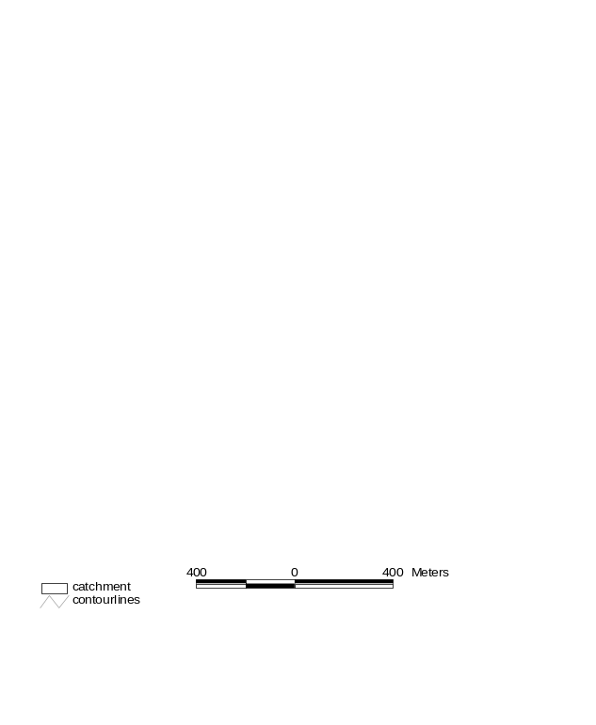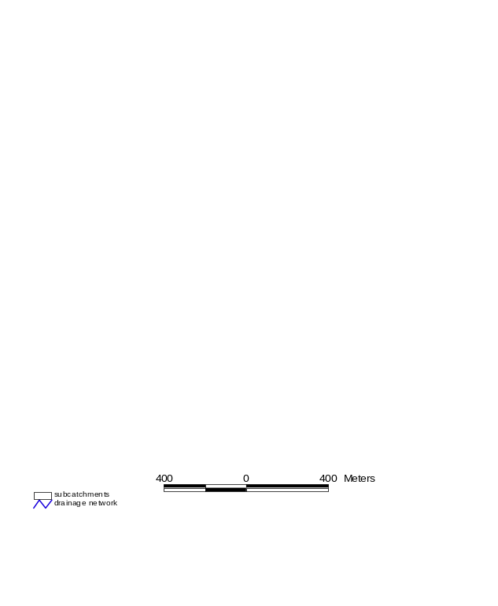 a) contourlines b) subcatchments and drainage network
Figure 4.1: Topographic analysis of the 3.5 km² Weiherbach catchment

After this, hillslopes are determined manually under consideration of geometries of the drainage network, subcatchment boundaries, land-use units and lines of steepest descend (normal to topographic contours). This task again is supported by T_4HIM allowing on-screen digitalisation on arbitrary zooms of the map while before-mentioned secondary information is underlayed. Hillslopes (Fig. 4.2a) are abstracted by their longitudinal section along mean slopelines, assumed to be of variable width. The result (as shown in Fig. 4.2b) is a graph of lateral flow paths made up from slopelines and drainage network. It is up to the modeller to choose the degree of abstraction by selecting the number of hillslopes.
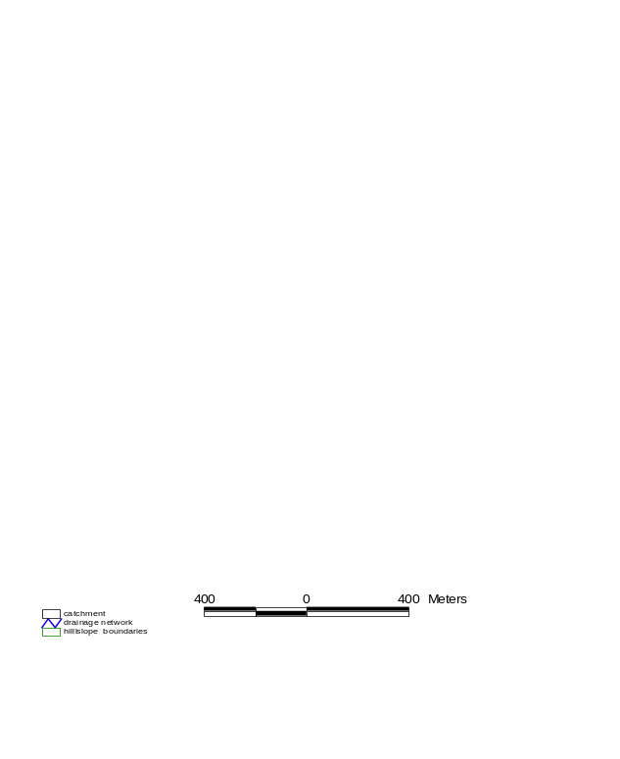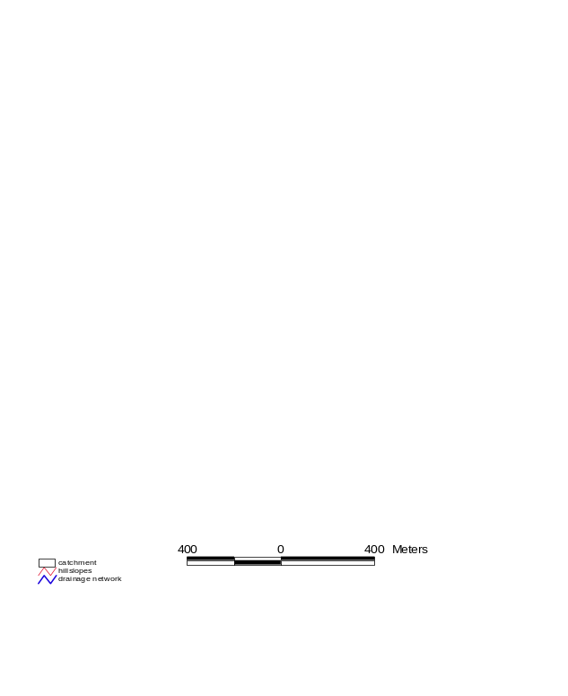 a) hillslopes b) slope- and drainage lines
Figure 4.2.: Domain decomposition of the 3.5 km² research catchment “Weiherbach” up to gauge “Menzingen”.

At this point of the analysis we have coverages of the following objects:
- hillslopes (type: polygons)
- slopelines (type: lines)
- drainage network (type: lines)

ARC/INFO
The coordinates of points making up the slopelines are dumped to an ASCII file keeping the associated hillslope number as an attribute, as well as the coordinates of the drainage network marked by a distinguished identifier (File A, hangfall.out). Unfortunately this pieces of line information are not oriented (direction of flow is unknown). In addition a list of the hillslope numbers and associated hillslope areas is dumped (File B hngpol_a.out).
In order to derive the variable width of the hillslopes, an area associated to each individual point of a slopeline has to be extracted by the following procedure implemented in an AML-script (ARC Macro Language): Each hillslope is isolated as well as its associated slopeline (Fig.4.3a). The slopeline is converted in a coverage of type “points” (Fig. 4.3b). These points keep the number of their associated slopeline as an attribute. Unfortunately the connectivity (i.e. order) of points is lost in this step. Within the boundaries of the hillslope Thiessen polygons (Voronoi diagrams) are derived for each point (Fig. 4.3c). The coordinates of the points together with the slopeline number and the area of the Thiessen polygons are dumped to two ASCII-files (File C xyzpkthg.out and File D pkthgfl.out).
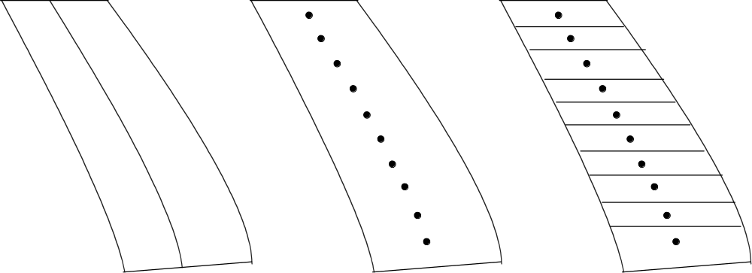
a) slopeline b) points c) Thiessen polygons
Figure 4.3: Steps towards the determination of hillslope's variable width

MATLAB
Within a MATLAB environment files A to D are read together with the DEM in order to combine and synthesize all information and derive a graph of the flow network. First, data from file C and D is read and combined by program BREIT2 to yield File E. Then data from file A and B is read and for each point's coordinate the elevation is extracted from the DEM by interpolation. Comparing the coordinates from file A and E allows to recover the alignment of points read from E. Then, the variable hillslope width can be calculated by division of polygon areas from file E and distances between slopeline points. By comparison of the endpoint elevations of line objects slopelines as well as drainage network line objects are sorted in a descending order (assuming flow to travel from higher to lower elevations). The combined data are dumped to a MAT-file (in MATLAB format, fully geo-referenced). This program is called PREPARE1.
Occasionally, the upstream point's elevation of a short line object might be lower than the downstream elevation. In such cases, subsequent analysis will fail and the flow network's connectivity has to be corrected. Here the program KORREKT is used.

Ordered graph of drainage network
By comparison of the endpoint coordinates of line objects an ordered graph of the drainage network is derived by a MATLAB program called PREPARE2. Each single point is numbered in a way, that upstream point numbers always are lower then downstream point numbers. Point numbers of confluences with slopelines are associated to slopeline numbers. Finally the Strahler order (Strahler, 1956) is determined and stored.
The graph of the drainage network is made up from reaches, each of which is assigned a trapezoidial cross-section. Optionally, the properties of the drainage network are determined by aid of geomorphological reasoning. Geometric properties derived from these profiles are passed to the flood routing schemes.

Discretisation of hillslopes
The irregularly shaped domain of a hillslope's longitudinal section is discretised using curvilinear orthogonal coordinates to (a) flexibly model the irregular boundaries and (b) more easily conduct numerical solutions of Richards equation for matrix flow on a mathematical rectangular grid. An algorithm described by Kiefer et al. (1990) is used to generate the curvilinear orthogonal coordinates from a mathematical description of the four bounding curves.
This algorithm is implemented in the MATLAB file h_spl.m making use of boundary descriptions by cubic splines. It allows passing nothing than an arbitrary number of boundary points (in cartesian coordinates) to the algorithm instead of a mathematical description. Fig. 4.5 shows the result for two exemplary hillslopes. The density of discretisation is highest in areas expected to be hydrologically most active. Fig. 4.6 shows the resulting surface discretisation of a catchment.
The program is called H_SPL.M and reads the output file from PREPARE1 (respectively KORREKT). It only relies on the slopelines geometry. The user has to specify a desired soil depth; then, the boundary curves are generated automatically. Additional input is the desired resolution of the discretisation. Final the program dumps all geometry files for use with CATFLOW.


Figure 4.5: Longitudinal-vertical section of two exemplary hillslopes and curvilinear orthogonal discretisation (computational nodes)

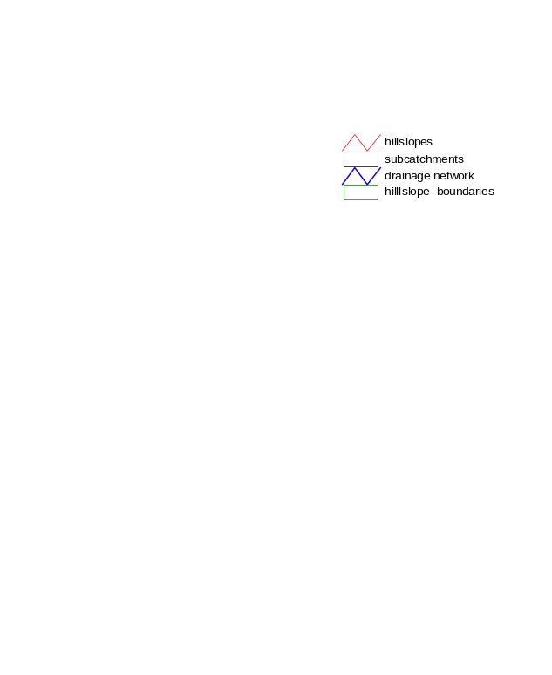
Figure 4.6: Hillslope discretisation: Plane view of the 3.5 km² research catchment “Weiherbach”

Assigning attributs/indices

Surface (2D)
The generation of several input files requires the assignment of surface attributes to the surface nodes of the computational grid. This is performed by routines which read the discretisation file as well as various polygon files (exported from GIS) and apply a “find-point-in-polygon”' algorithm. Results are dumped to an assignment file which relates computational nodes to indicators and factors like:
- land-use units
- soil column type
- precipitation stations
- climate stations
- wind reduction factors for various directions

Depth (3D)
The generation of several input files requires the assignment of attributes to all nodes of the computational grid. This is performed by routines which read the discretisation file as well as surface attributes assignment files which assign attributes to some depth intervals for different surface attributes.
A “find-point-in-interval” algorithm is applied to assign:
- soil type numbers
- initial conditions
- factors for macroporosity
- to all computational nodes

Soil types
The file assigning hydraulic functions to soil type numbers is generated manually, (section “Specification of soil types”).

Wind directions
The file assigning sectors to wind direction identifies is generated manually (section “Assigning sectors .to a wind direction identifier”).

Land use parameters
The three file types specifying land-use parameters are generated manually (a favourable approach would be retrieving data from an experts database), (section ”Land use IDs and subsections”).

Time series
Time series hold data of arbitrary spacing (breakpoint-format), thus reducing storage size. Furthermore, this storing scheme ensures the choice of a maximum possible time step at simulation time, because each breakpoint might restrict a possible time step. At one moment of simulation only the two values which directly enclose the actual simulation time are kept in memory. Currently, these files are created by custom-made programs, suited to reformat data formats of various origins.
- precipitation
- climate
- land use
- groundwater levels (pressure heads)

Initial conditions
Initial conditions can be assigned by various methods (section “Initial conditions”). Ideally, each computational node is assigned a measured and/or scaled value, as can be obtained e.g. by specialised kriging-routines (Lehmann, 1995). The requires various drift- or indicator-variables at all computational nodes and measurement point to be provided, in order to use them with e.g. external drift kriging. Finally, 3d-assignment routines have to be applied.

Control files
Various control files have to be prepared manually.
- main input file
- project control file
- global time series file name specification
- file specifying printout times
- file specifying control volumes

Simulation output
After preparation of all input files CATFLOW can be started. Information is read from the main input file CATFLOW.IN and subsequent files. Summarising information about each calculated time step is reported to the screen and the log-file. State variables are dumped to output files at specified times (section “Specification of printout times”). For each hillslope a time series of spatial distributions is stored (TSSD). A detailed time series of rainfall and overland flow at the lower end of all hillslopes is recorded.

Log-file
This file logs program inputs and lists the following information of each calculated time step:
no | hillslope number
izaehl | timestep counter
t_act [h] | actual time since start in [h]
dt [s] | actual time step in [s]
cumbil [vol] | hillslope integrated and standardised cumulative balance
stpbil [rfl] | hillslope step balance, standardised with boundary fluxes
opt/max | actual time step control variable
n_it cg | actual number of conjugate-gradient-iterations
n_it pic | actual number of Picard –iterations
dPhi max | L∞ norm of the residuum

Tables of soil-hydraulic functions
All soil type parameters are transferred to a table of the soil hydraulic functions by their associated model. These tables are dumped to a file of similar format then the file explained in section “Specification of soil types”; the header line holds a title string, two anisotropy factors, the soil model identifier (e.g. Van Genuchten = 1), the number of tabulated values and the specific storage coefficient.
|----.----|----.----|----.----|----.----|----.----|----.----|----.----|----.----|----.----|
|title string (CHAR*30) 1.000 1.000 1 500 0.1000E-03
|% θ ψ k C
|0.656065E-01 0.100000E+06 0.513940E-21 -0.156982E-07
|0.656867E-01 0.950508E+05 0.589429E-21 -0.167519E-07
|0.657681E-01 0.903466E+05 0.676006E-21 -0.178765E-07
|0.658507E-01 0.858752E+05 0.775299E-21 -0.190765E-07
|0.659344E-01 0.816251E+05 0.889178E-21 -0.203570E-07
|0.660194E-01 0.775853E+05 0.101978E-20 -0.217236E-07
|0.661056E-01 0.737455E+05 0.116957E-20 -0.231818E-07
| . . . .

Water balance
This file reports cumulative hillslope water balances for each specified output time.
ih | hillslope number
izaehl | time step number
t_act | computation time [s]
biltot | cumulative total water balance (absolute error of water balance)  bilin –bilrd- bsenk [m³]
bilin | cumulative total increase of soil water content [m³]
bsenk | cumulative sink/source input
bilrd | cumulative balance of boundary fluxes
-brfl_o | cumulative flux across upper boundary (perpendicular in the eta xsi coord.system)
-bflr_r | cumulative flux across right boundary
brfl_u | cumulative flux across lower boundary
brfl_l | cumulative flux across left boundary
qosum | cumulative amount of surface runoff
rcoeff | runoff coefficient
bnied | cumulative amount of precipitation perpendicular in eta xsi coordinates
bnied2 | Cumulative amount of precipitation perpendicular in Cartesian coordinates
bintz | cumulative amount of interception perpendicular in eta xsi coordinates
bevapo | cumulative amount of evaporation perpendicular in eta xsi coordinates
btrans | cumulative amount of transpiration
bm_l, bm_u, bm_r (istp,ih) | Cumulative loss of solute 1 at left/ lower/ right boundary of hillslope ih,  cumulative loss of solute 2 at left/ lower/ right boundary,  cumulative loss of solute 3 at left/ lower/ right boundary

At the end of simulation a more detailed cumulative hillslope water balance is reported for subregions as specified in the control volume file. Fluxes that point inward are counted positive, fluxes that point outward are counted negative.

State variables
The state variables dumped to files are soil moisture, suction head, flux and sink/source terms. All this files hold time series of spatial distributions within vertical-longitudinal hillslope sections. For each hillslope and printout time a block of the following structure is written:
A header line holds 5 variables: tzeit, -(1000+ihg), nv, nl.
tzeit | REAL | time offset [s] from reference time
-(1000+ihg) | INT | hillslope number
nv | INT | vertical number of nodes
nl | INT | lateral number of nodes

The header is followed by iv=1 … nv lines of state variables, each line for il=1 … nl. Thus, the first line represents the upper boundary. The state variables are
soil moisture
suction head
water fluxes in vertical and lateral direction
final water state
sink/source terms
solute concentrations

Overland flow
A time series of precipitation and overland flow at the lower end of a hillslope is dumped to a file, which first line keeps the reference date. The second line holds conversion factors to SI-units for columns 2-5. Subsequent lines hold hillslope number ihg, time t since reference date, overland flow (volume per time), and cumulative runoff volume. An example:

|----.----|----.----|----.----|----.----|----.----|----.----|----.----|----.----|----.----|
|28.07.1996 16:15:00.00
| 1.157407407e-05 3600000.0000 0.4006172928779019E+02 0.1112825813549728E-01
| ihg time neff [m/s] q [m³/s] cumulative q [m³]
| 1 0.00 0.0000E+00 0.0000E+00 0.0000E+00
| 1 1.50 0.8240E-08 0.0000E+00 0.0000E+00
| 1 3.75 0.8240E-08 0.0000E+00 0.0000E+00
| 1 7.13 0.8240E-08 0.0000E+00 0.0000E+00
| 1 12.19 0.8240E-08 0.0000E+00 0.0000E+00
| . . . . .

Evapo-Transpiration
The evapo-transpiration file holds for a specified node at each hill slope time series of variables important for the SVAT-module:
ich | hillslope number
il | number of surface node
time | computation time [d]
LAI | leaf area index
BBG | plant coverage
twu | root depth [m]
pfh | plant height [m]
rGlo | global radiation [W/m²]
rBil | radiation budget [W/m²]
rBilm | observed radiation budget [W/m²]
shf | soil heat flux [W/m²]
temp | air temperature [°C]
Rhum | relative humidity [-]
Uref | wind speed in reference height [m/s]
Al | albedo [-]
Ustar | friction velocity [m/s]
u100 | wind speed in reference 10m above surface[m/s]
Thpfvw | permanent wilting point
Intz | interception [mm]
Nied | precipitation [mm/d]
Neff | effective precipitation [mm/d]
Catmp | turbulent conductivity for water vapour of the atmosphere [m/s]
Ccanop | turbulent conductivity for water vapour of the canopy layer [m/s]
Catms | turbulent conductivity for water vapour of the atmosphere [m/s]
Csoil | turbulent conductivity for water vapour of the soil [m/s]
Ecanop | plant transpiration [mm/d]
Eintz | evaporation of intercepted water [mm/d]
Esoil | evaporation from the soil [mm/d]

Channel flow
For each of the specified nodes of the drainage network, i.e. the nodes with a negative node number (see section “Drainage network geometry”) a hydrograph is stored:
increasing node numbers
time [s] | icour | qpegel | totvol | regen | qb | yb | vb | qb | yb | vb
360. | 16 | 0.0 | 2.5 | 0.00 | 0.000 | 0.00 | 0.00 | 0.004 | 0.05 | 0.34
720. | 16 | 0.8 | 3.8 | 0.00 | 0.002 | 0.04 | 0.31 | 0.008 | 0.05 | 0.35
3600. | 256 | 126.8 | 15.3 | 0.00 | 0.044 | 0.10 | 0.53 | 0.048 | 0.10 | 0.54
7200. | 320 | 303.2 | 15.4 | 0.00 | 0.049 | 0.10 | 0.54 | 0.050 | 0.10 | 0.54
10800. | 320 | 481.5 | 15.5 | 0.00 | 0.050 | 0.10 | 0.54 | 0.050 | 0.11 | 0.54
14400. | 320 | 661.1 | 15.5 | 0.00 | 0.050 | 0.11 | 0.54 | 0.050 | 0.11 | 0.54
18000. | 320 | 841.8 | 15.6 | 0.00 | 0.050 | 0.11 | 0.54 | 0.050 | 0.11 | 0.54

with
icour | Part of Courant criteria
qpegel | cumulative outflow from the catchment [m³]
totvol | cumulative wetted channel volume [m³]
regen | precipitation [mm/h]
qb | channel flow [m³/s]
yb | height of water level [m]
vb | wetted channel volume [m³]

Co-ordinate files
The z- and x-coordinates of the grid of each hillslope are stored into two output files. The first line of each file contains the hillslope number -(ih+1000) followed by iv=1 … nv lines of coordinate values [m], each line for il=1 … nl. Thus, the first line represents the upper boundary of the hillslope.

Visualisation

General
Visualisation is most important to judge about input and output data. Furthermore, in case of large amounts of data comfortable data handling is an unevitable prerequisite to effectively use a model. However, developing nice post-processors is a task of high manpower consumption, requiring considerable knowledge of modern software capabilities in order to be efficient. Recently emerging interests in environmental software systems honour these findings. For the time being, an “ad hoc” solution based on Matlab-macros is presented here.

Longitudinal sections using Matlab
For individual hillslopes the distribution of soil moisture, suction head as well as solute concentrations may be plotted in as 2-d vertical cross sections in the z-x- plane.

2-d cross sections of state variables without water fluxes
In this case the MATLAB-macro pstate.m (plot state variables) and the macro calnp (calculate number of print out times) are used. As an example the following lines explain the visualisation of the soil moisture field stored in a file named theta.out for hillslope 2 at the 3. printout time (This output may be produced by running the demo project, Fig. 6.1):
- copy the macros into your output directory e.g. into demo/out
- run calnp.m with calnp(‘theta.out’) to find out the number of printout times
Running the macro pstate.m produces the plot in Fig.6.1 and requires the control files pstate.in, which looks as follows:
|----.----|----.----|----.----|----.----|----.----|----.----|----.----|----.----|----.----|
|theta.out; hko.out; sko.out; soil moisture; [-]; hillslope; 3; 2; 3600.

with:
theta.out file holding state variable moisture
hko.out; sko.out files holding coordinates of hillslope geometry (elevation and lateral position),
soil moisture; [-] name and measurement unit of variable to be plotted
hillslope headline comment
3 number of printout time to be plotted
2 number of hill slope to be plotted
3600. conversion factor for computation time (optionally into sec, hours or days)
Please note that ; has to be used as delimiter!

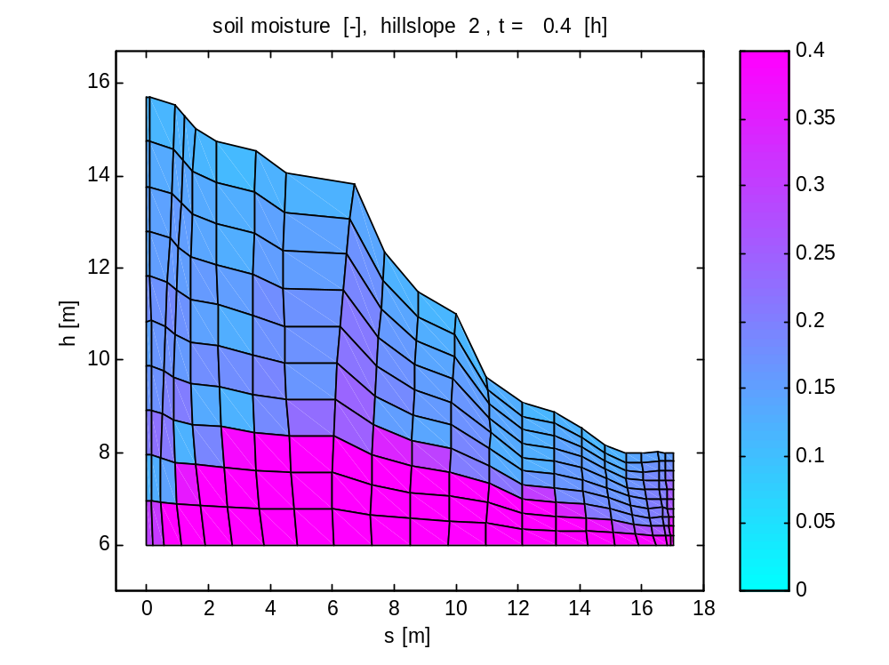
Fig.6.1: Plot of the soil moisture distribution in hillslope 2 at the third printout time, produce with the macro pstate.m

2-d cross sections of state variables and water fluxes
In this case the MATLAB-macro pstate_fl.m (plot state variables & fluxes) and the macro calnp (calculate number of print out times) are used. As an example the following lines explain the visualisation of the soil moisture field stored in a file named theta.out for hillslope 2 at the 1. printout time (This output may be produced by running the demo project, Fig. 6.2):
- copy the macros into your output directory e.g. into demo/out
- run calnp.m with calnp(‘theta.out’) to find out the number of printout times (if not done yet)
Running the macro pstate_fl.m produces the plot in Fig.6.2 and requires the control files pstatefl.in, which looks as follows:
|----.----|----.----|----.----|----.----|----.----|----.----|----.----|----.----|----.----|----.----|----.----|----.----|
| theta.out;fl_xsi.out;fl_eta.out;hko.out;sko.out; soil moisture; [-]; hillslope; 1; 2; 3600.

with: theta.out file holding state variable moisture
fl_xsi.out file holding water flux densities in xsi direction
fl_eta.out file holding water flux densities in eta direction
…. (same as above, Section 6.2.1)

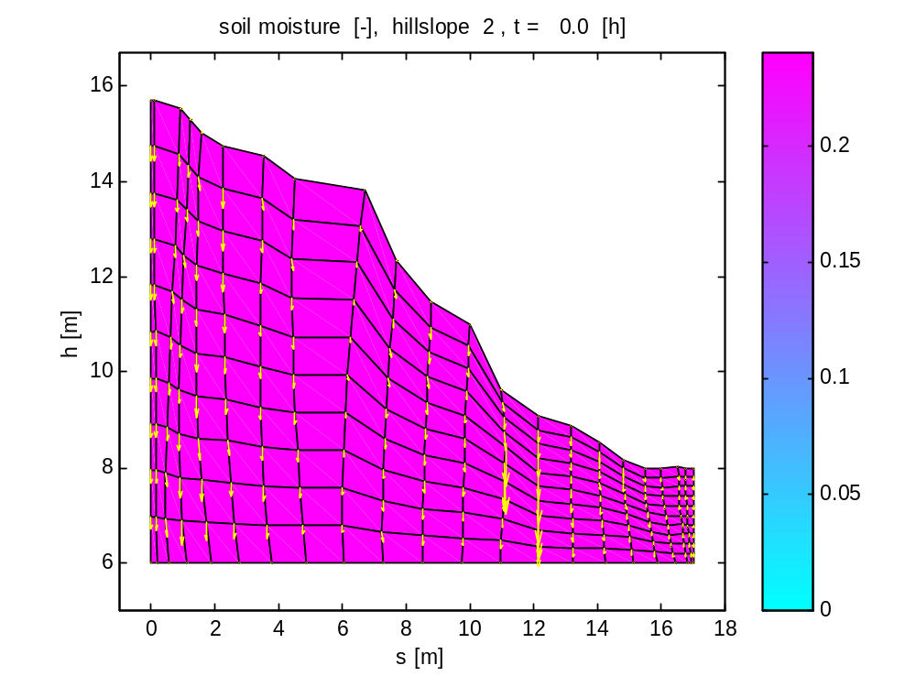
Fig.6.2: Plot of the soil moisture distribution and water fluxes in hillslope 2 at the first printout time, produce with the macro pstate.m

Areal maps using ARC/VIEW
2D areal plots can be produced using ARC/VIEW. First, a polygon coverage has to be produced, one polygon associated to each computational node. From the state variables' dump file, a table has to be produced which relates each state variable to one polygon. These files can be readily input by ARC/VIEWs interface to different database formats and be displayed.

Time series

Hydrographs for specified channel nodes
For the nodes specified in the drainage network geometry files, i.e. those with a negative channel node number, the hydrographs may be plotted using the MATLAB macro plotq_ch.m. The plotted hydrographs, which may be produced with the demo project, are shown in Fig. 6.3. The macro plotq_ch.m requires the control files plotq_ch.in, which looks as follows:
|----.----|----.----|----.----|----.----|----.----|----.----|----.----|----.----|----.----|----.----|----.----|----.----
| gang.out;gauge;3600.
with: gang.out file holding channel output
gauge headline comment
3600. conversion factor for computation time (optionally into sec, hours or days)
Please note that ; has to be used as delimiter!

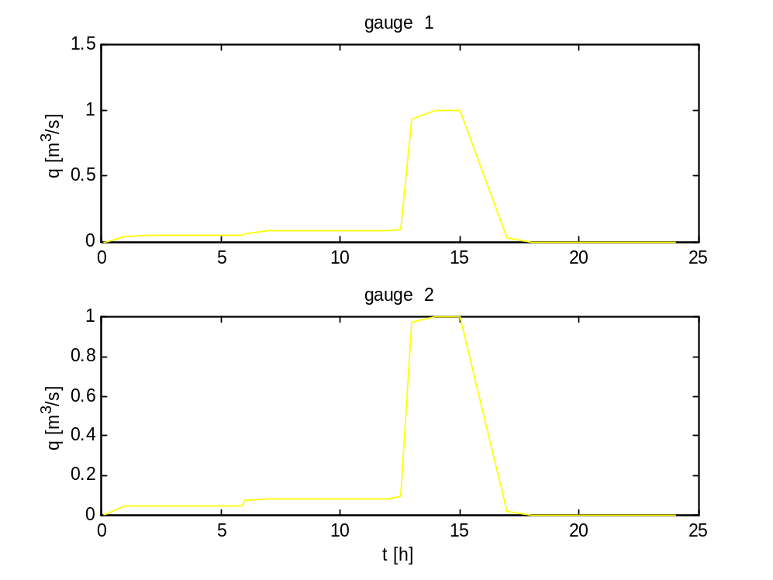
Fig.6.3: Hydrographs for specified channel nodes

Surface runoff for individual hillslopes
Surface runoff may be visualised using the MATLAB macro plotq_s.m. The macro plotq_s.m requires the control files plotq_s.in, which looks as follows:

|----.----|----.----|----.----|----.----|----.----|----.----|----.----|----.----|----.----|----.----|----.----|----.----
| qoben.out;hillslope;q_s;2;3600.

with: qoben.out file holding channel output
hillslope headline comment
q_s headline comment
2 number of hillslope to be plotted
3600. conversion factor for computation time (optionally into sec, hours or days)

Part II
Program Documentation

Program structure
The sequence of operations carried out in the process modules implemented in CATFLOW is illustrated in the diagram below:
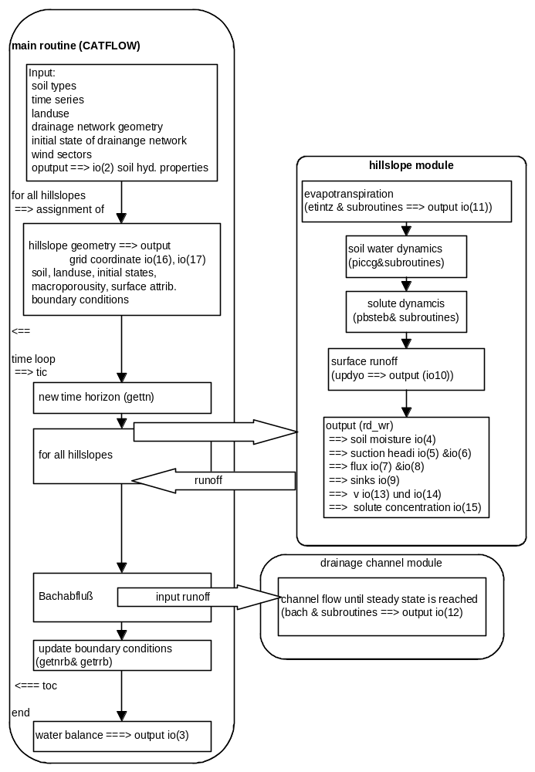
The program structure and the job which is done by individual subroutines are listed below:
-----------------------------------------------------------------------
>----, >===== denotes computation loops,
<----, <===== ih: indicates loop over all hillslopes
time: indicates time loop
-----------------------------------------------------------------------

catflow
relsec seconds from reference date
openi open input file
openo open output file
maxtst test parameter of dimensioning
rdsoil read parameters of soil-hydraulic-function-model
bodtab compute tables of soil-hydraulic functions
vg_tab van Genuchten (1980) model
ts_tab Tang & Skaggs (1977) model
filtab direct table input
rdrbf read filenames of boundary conditions, open them and wind up to start time
rdzrbf read subsequent point in time from boundary condition time series i
rdzsnk read subsequent point in time from source/sink time series i
rdzkli read subsequent point in time from climate time series i
rdznie read subsequent point in time from rainfall time series i
rdnutz read subsequent point in time from land use time series

gettn determine new time horizon (nearest time in any boundary condition file)
rdlpar read assignment of land use and related parameters from table
rdwind read wind-direction sectors
>------------ih start of input loop over all hillslopes
rdhang read geometry of hillslopes
rdstyp read soil types
rdmak read macropore data
rdcv read assignment of control volumes for watwer balance
calbna compute hillslope geometry and dump in BNA-format
calgeo compute diverse geometrical quantities of a hillslope
inicon read initial conditions for soil water dynamics
inipart read initial conditions for solute transport
rdprt read printout times
rdpob read assignment of surface-indices (land-use unit, rainfall gauge, climatic data gauge)
rdrbs read assignment of boundary condition files to individual computational nodes; initialize boundary-condition type (B-C type: positive: Neumann, negative: Dirichlet)
getln assigning land-use units to land-use IDs
<------------ih end of input loop over all hillslopes
rdbach read drainage-network parameter
getbpt assigns nodes of the drainage network to hillslopes, optional if q_meth= simact
getrrb update of right boundary condition, optional if q_meth= simact
rdbini read initial state of drainage network, optional if q_meth= simact
calflek weight hydraulic conductivity of nodes a the right hillslope boundary with leakage factor, optional if q_meth= simact
rdrbb reads assignment of time series input fluxes to boundary nodes of the drainage network
rdbrbf reads next value from time series of input fluxes
upvorz update B-C type (sign) after reading new record
upvors update sink type (sign) after reading new record
>============Zeit start of time loop
gettn determine new time horizon (smallest of all B-C time series)
>------------ih start of computation loop over all hillslopes
hg (meth=pic) simulation of one hillslope up to the time horizon
etintz evapotranspiration
etidir climate data typ 2 (Penman-Monteith)
kolle climate data typ 1 (direct input of fluxes)
lookup table lookup of land-use parameters
strahl interpolation of climate data
sunpos computation of solar position
wicht1 subdivision of net energy between soil and canopy
druck computation of air pressure
uschub friction velocity
nstab class of atmospheric stability
ratmos atmospheric resistance
rblp atmospheric boundary layer resistance above plants
penmon vaporation of interception
s_e_sat gradient of saturation vapor pressure
rho_a specific mass of air
e_sat saturation vapor pressure
e_sat saturation vapor pressure
lam_v latent heat of vaporization of water
psychro psychrometric constant
lam_v latent heat of vaporization of water
rcanop Pflanzenwiderstand
wicht1 empirical function
wicht2 empirical function
e_sat saturation vapor pressure
penmon transpiration
rbls atmospheric boundary layer resistance above soil
rsoil soil resistance
wicht1 empirical function
penmon evaporation
updyo surface runoff computation

piccg single time step by Picard-Iterat. and CG-method
koeff computation of coefficients of numerical scheme
calfak computation of coefficients of numerical scheme
kinnen -at inner nodes
koeffrb -considering boundary conditions
ksenken -considering sinks/sources
pic_it preparation of itertation scheme
cg_solv conjungated-gradient (CG)-method
linbcg according to Numerical Recipes, 2.edn
asolve approximate solution
atimes multiplication...
sprsax ...of a matrix by a vector
sprstx ...of a transposed matrix by a vector
rand_fl computation of boundary fluxes at Dirichlet boundaries
chko_rb check of switching of boundary conditions (sign) and sinks
kc_phi updating of K and C
cal_q computation of fluxes inside the domain
stpdif change within time step
stpbil water balance after time step
mtheta mean soil moisture
hgcopy saving phineu->phialt, theta->th_alt
obcopy saving yoben->yo_alt, interz->iz_alt
ptkinj2 injection of solute particles in case of a flux Boundary condition for solute transport
v_strb computation of generalised pore water velocities
p_stepb computation of a particle tracking step
v_intb interpolation of pore water velocities
ran2 generation of random numbers for particle step
ran1 generation of random numbers for particle step
pmass computation of actual particle mass due to degradation of solutes
c_ipob computation of residual solute concentration
savevz saving of BC-type (sign)
totbil total balance
wrres output of results of current time step
<------------ih start of computation loop over all hillslopes
koeffbr update of computation of input flux into boundary nodes of the drainage network
bach comutation of drainage network until a steady discharge is reached
getnrb update of boundary conditions from time series
rdzrbf read next value from B-C time series i
upvorz update B-C type (sign) after reading new record
rdzsnk read next value from sink time series i
upvors update sink type (sign) after reading new record
rdzkli read next value from climate time series i
rdznie read next value from rainfall time series i
rdnutz read next value from land-use time series
getln assigning land-use units to land-use IDs
rdbrbf read next value form time series of input fluxes into the drainage network
getrrb update right hill slope boundary as a function of the height of the water table in the channels
<============time end of time loop
wrres output of results of current time step

INCLUDE-files and COMMON-blocks

Dim.inc
c-----------------------------------------------------------------------
c DIM.INC Dimensions of arrays
c-----------------------------------------------------------------------
integer*4 maxprt, maxin, maxout
integer*4 maxnv,maxnl,maxnh
integer*4 maxtyp, maxeig, maxpbm, maxtab
integer*4 maxfix, maxwrf, maxuse, maxpft, maxpfp
integer*4 maxnie, maxkli
integer*4 maxrbf, maxsnk
integer*4 maxrbp, maxskp, maxkld
integer*4 maxgr, maxfil
integer*4 maxcv
integer*4 maxnb, maxit, maxgng, maxhor, maxnum, maxero
integer*4 maxpkt
c----- neue Parameter fuers pt
integer*4 maxstt, maxmif
integer*4 npmax
integer*4 maxbrf
c-----------------------------------------------------------------------
c control files
parameter (maxfil = 220)
c input files
parameter (maxin = 8)
c output files geaendert
parameter (maxout = 17)
c max. number of print-out times
parameter (maxprt = 3500)
c-----------------------------------------------------------------------
c max. number of soil layers (eta)
parameter (maxnv = 25)
c parameter (maxnv = 11)
c parameter (maxnv = 8)
c parameter (maxnv = 13)
c max. number of soil columns (xsi)
c parameter (maxnl = 100)
parameter (maxnl = 34)
c parameter (maxnl = 14)
c parameter (maxnl = 60)
c max. number of hillslopes
parameter (maxnh = 20)
c parameter (maxnh = 169)
c highest hillslope number (used as a name)
parameter (maxnum = 200)
c-----------------------------------------------------------------------
c max. number of soil types (as assigned in soil-parameter file)
parameter (maxtyp = 35)
c max. number of soil properties (columns in soil table)
parameter (maxeig = 5)
c max. number of soil specific erosion parameters
parameter (maxero = 3)
c max. number of soil parameters of a model of soil hydraulic behaviour
parameter (maxpbm = 8)
c max. length of soil table (rows in soil table)
parameter (maxtab = 1200)
c-----------------------------------------------------------------------
c max. number of fixed integers to be assigned to a surface node
parameter (maxfix = 3)
c max. number of wind direction dependent factors
parameter (maxwrf = 4)
c max. number of angle to horizon for a surface node
parameter (maxhor = 36)
c max. number of land uses
parameter (maxuse = 20)
c max. length of land-use time series (rows in land-use table)
parameter (maxpft = 25)
c max. number of land-use parameters (columns in land-use table)
parameter (maxpfp = 15)
c max. number of rainfall time series
parameter (maxnie = 6)
c max. number of climate time series
parameter (maxkli = 4)
c-----------------------------------------------------------------------
c max. number of boundary condition time series
parameter (maxrbf = 5)
c max. number of sink/source time series
parameter (maxsnk = 2)
c-----------------------------------------------------------------------
c max. number of boundary condition parameters geaendert 13.7.
parameter (maxrbp = 5)
c max. number of sink/source parameters
parameter (maxskp = 2)
c max. number of climatic data in climate time series (min. number = 6)
parameter (maxkld = 6)
c-----------------------------------------------------------------------
c max. number of classes for time step statistics
parameter (maxgr = 15)
c-----------------------------------------------------------------------
c max. number of control volumes for hillslope water balance
parameter (maxcv = 10)
c-----------------------------------------------------------------------
c max. number of discrete drainage network reaches
parameter (maxnb = 1000)
c max. number of inflows from upstream (confluences)
parameter (maxit = 3)
c max. number of output hydrographs for output
parameter (maxgng= 10)
c max. number of soil moisture time series for output
parameter (maxpkt= 70)
c max. number of particles for particle tracking, global
parameter (npmax= 10000)
c max. number of different solute types,
c must match the maximal number of boundary parameters minus one
parameter (maxstt =3)
c max number of mass inputs, must match the max. number of
c parameter files maxrbf
parameter (maxmif =5)
c max number of boundary files for the drainage network
parameter(maxbrf =3)

c counter
integer*4 icf
c global hillslope surface roughness for one project (can be overriden susequently)
real*8 kstall
dimension kstall(maxfil)
common /ckst/ kstall, icf
c iteration criteria
real*8 piceps, cgeps
c max. number of Picard iterations
c number of Picard iterations, from which subsequent time step is reduced
integer*4 it_max, n_gr
common /cepsi/ it_max, n_gr
common /cepsr/ piceps, cgeps

c switch is true, when surface attributes are read
c switch is true, when land use is considered
logical lpob, lland
dimension lpob(maxnh)
common /catm/ lpob, lland

c several input/output units
integer*4 ilok, ipar
integer*4 io, iin, io_log
dimension io(maxout), io_log(maxout)
dimension iin(maxin)
integer*4 io_act, iin_act
integer*4 iikli, iinie, iisnk, iirbf, inutz
dimension iikli(maxkli)
dimension iinie(maxnie)
dimension iisnk(maxsnk)
dimension iirbf(maxrbf)
common /cio/ io, iin, iikli, iinie, iisnk, iirbf,
& ilok, ipar, inutz,
& io_act, iin_act, io_log
c max. and min. soil moisture within a hillslope
real*8 th_max, th_min
c max. and min. suction head within a hillslope
real*8 psi_max, psi_min
c max. and min. total potential within a hillslope
real*8 phi_max, phi_min
c max. flux within a hillslope
c max. sink/source flux within a hillslope
real*8 fl_max, sk_max
dimension th_max(maxnh), th_min(maxnh)
dimension psi_max(maxnh), psi_min(maxnh)
dimension phi_max(maxnh), phi_min(maxnh)
dimension fl_max(maxnh), sk_max(maxnh)

common /cmima/ th_max, th_min, phi_max, phi_min,
& psi_max, psi_min, fl_max, sk_max

Zeit.inc
c-----------------------------------------------------------------------
c ZEIT.INC times
c-----------------------------------------------------------------------

c... t_start global starting point in time [s]
c... t_end global end point in time [s]
c... t_alt local starting point in time [s]
c... t_neu local end point in time [s]
c... t_act actual simulation point in time [s]
c... dt_exp max. explicit time step [s]
c... dt_min global min. time step [s]
c... dt_max global max. time step [s]
c... dtbach max. timestep for active drainage network [s]
c... itag number of day in year [s]
c... stunde hour of day [s]
c.....dt_mak max. timestep for active macropore flow

real*8 t_start, t_end, t_alt, t_neu, t_act
real*8 dt_exp, dt_min, dt_max, dtbach
real*8 itag, stunde, dt_mak

c... counter for time steps
integer*4 izaehl
dimension izaehl(maxnh)

c... date strings: start time, end time
character*22 dstrs, dstre, dstrs2

c... print times
real*8 t_p
c... counter
integer*4 ip
c... switch for output control
integer*4 it_p
dimension t_p(maxprt,maxnh), ip(maxnh)
dimension it_p(maxprt,maxnh)

c...statistics and histogram of time steps
c... boundary between classes of time step length
real*8 clgr
c... cumulative time within one time step class
real*8 cltim
c... cumulative number of timesteps within one time step class
integer*4 class
c... actual number of time step class boundaries
integer*4 iacgr
dimension clgr(maxgr), cltim(maxgr+1), class(maxgr+1)

common /czeitr/ t_start, t_end, t_alt, t_neu, t_act,
& dt_exp, dt_min, dt_max, dtbach, itag, stunde,
& t_p, clgr, cltim, dt_mak
common /czeiti/ class, iacgr,it_p, ip, izaehl
common /czeitl/ dstrs, dstre, dstrs2

Soil.inc
c-----------------------------------------------------------------------
c SOIL.INC soil properties etc.
c-----------------------------------------------------------------------
c boundary between arithmetric and geometric averaging for
c Van Genuchtens n (after Zurmuehl)
real*8 vg_ngr
parameter (vg_ngr = 2.)
c storage coefficient for saturated soil
real*8 snull
c soil-albedo-parameter: dry conditions: balmax
c from satkni * saturation: balmin
real*8 satkni,balmax,balmin
c soil resistance parameter (Kolle-model)
real*8 f_rs,wp_rs,zd_max
c soil erosion parameter (Schramm-Model, Scherer-Model ?)
real*8 eross

c soil hydraulic table
real*8 s_tab
c soil parameters
real*8 bodpar
c soil anisotropy
real*8 anisot
c permanent wilting point [Vol.-%]
real*8 th_pwp
c integer*4 for method to convert soil parameters to soil table
integer*4 imod
c soil describing string
character*30 boden
c name of a input file holding a table of soil hydraulic properties
character*30 tabfil
c actual dimensions of soil table: soiltypes, rows, columns
integer*4 iactyp, iactab, iaceig
dimension s_tab(maxtab,maxeig,maxtyp)
dimension bodpar(maxpbm,maxtyp)
dimension anisot(2,maxtyp)
dimension imod(maxtyp)
dimension boden(maxtyp)
dimension th_pwp(maxtyp)
dimension snull(maxtyp)
dimension satkni(maxtyp), balmax(maxtyp), balmin(maxtyp)
dimension f_rs(maxtyp), wp_rs(maxtyp), zd_max(maxtyp)
dimension eross(maxero,maxtyp)
dimension iactab(maxtyp)
dimension tabfil(maxtyp)

common /soilr/ s_tab, bodpar, snull, anisot, th_pwp,
& satkni,balmax,balmin,eross,f_rs,wp_rs,zd_max

common /soili/ iactyp, iactab,iaceig,imod
common /soill/ boden, tabfil

Hgfest.inc
c-----------------------------------------------------------------------
c HGFEST.INC time independent variables hillslope
c-----------------------------------------------------------------------
c rlongi reference longitude of time zone (CET: 15 degree east of Greenwich)
c longi longitude of catchment
c lati latitude of catchment
real*8 rlongi, longi, lati
real*8 varbr, fbrup, fbrlow
real*8 f_xsi, f_eta, fmf, fdf
real*8 xsi, eta, x_p1m0, x_p1m1, e_p1m0, e_p1m1
real*8 xko, yko, hko, sko, xkobez, ykobez, hkobez
real*8 hgobfl, hgbreit, hglang, lambda
real*8 macro, depth, area, xyxpy, alla, vola, hkomin, amak
real*8 slopeo, slopeu, sloper, slopel, gefall, azimut
real*8 av_fak, al_fak
real*8 dr_u, dr_o, dr_l, dr_r, drxsi, dreta
real*8 lrd_u, lrd_o, lrd_l, lrd_r
real*8 kxx, kee, kxe, w_hohr, w_xshr, w_xsho, w_xshol
real*8 d_Th_opt, d_Phi_opt
real*8 kxxf, kxef, keef
real*8 fcabf(maxnh), fabf(maxnh), flaeche

integer*4 iboden, mm_xsi, mm_eta
integer*4 ivm, igewkn
integer*4 icvo, icvu, icvl, icvr
integer*4 hangnr, hgih
integer*4 ihgr
integer*4 iacnh, m_aniso
integer*4 iacnv(maxnh), iacnl(maxnh)
integer*4 iaccv(maxnh)

logical lmak

c metric coefficients (conversion to curvelinear coordinates) xsi-direction
dimension f_xsi(maxnv,maxnl,maxnh)
c metric coefficients (conversion to curvelinear coordinates) eta-direction
dimension f_eta(maxnv,maxnl,maxnh)
c tensor of anisotropy (normed with saturated conductivity k_s)
dimension kxx(maxnv,maxnl,maxnh)
dimension kee(maxnv,maxnl,maxnh)
dimension kxe(maxnv,maxnl,maxnh)
dimension kxxf(maxnv,maxnl,maxnh)
dimension keef(maxnv,maxnl,maxnh)
dimension kxef(maxnv,maxnl,maxnh)
c angle between xsi-direction and main direction of anisotropy, positiv counterclockwise
dimension w_xshr(maxnv,maxnl)
c angle between xsi-direction and horizontal line, positiv counterclockwise,
c depends only on coordinate system
dimension w_xsho(maxnv,maxnl), w_xshol(maxnv,maxnl,maxnh)
c angle between horizontal line and main direction of anisotropy, positiv counterclockwise
dimension w_hohr(maxnv,maxnl)
c xsi-coordinate
dimension xsi(maxnl,maxnh), flaeche(maxnv,maxnl,maxnh)
c
c 1 il-1 il il+1
c o------------o--....--o---------o----------------------o-------o---....
c | | | |
c |<---->| |<--dr_o(il,?)-->|
c dr_o(1,?) drxsi(?,il,?)
c
c real length in [m] (related interval to a point)
c dr_o: along surface boundary
c dr_u: along bottom boundary
c drxsi: all lateral distances
dimension dr_o(maxnl,maxnh)
dimension dr_u(maxnl,maxnh)
dimension drxsi(maxnv,maxnl,maxnh)
c xsi(il+1)-xsi(il)
dimension x_p1m0(maxnl-1,maxnh)
c xsi(il+1)-xsi(il-1)
dimension x_p1m1(maxnl-2,maxnh)
c eta-coordinate
dimension eta(maxnv,maxnh)
c
c 1 iv-1 iv iv+1
c o------------o--....--o---------o----------------------o-------o---....
c | | | |
c |<---->| |<--dr_r(iv,?)-->|
c dr_r(1,?) drxsi(?,iv,?)
c
c real length in [m] (related interval to a point)
c dr_r: along right boundary
c dr_l: along left boundary
c dreta: all vertical distances
dimension dr_l(maxnv,maxnh)
dimension dr_r(maxnv,maxnh)
dimension dreta(maxnv,maxnl,maxnh)
c eta(iv+1)-eta(iv)
dimension e_p1m0(maxnv-1,maxnh)
c eta(iv+1)-eta(iv-1)
dimension e_p1m1(maxnv-2,maxnh)
c lateral hillslope coordinates of computational nodes (grid points) in [m]
dimension sko(maxnv,maxnl,maxnh)
c horizontal global coordinates ("Rechtswert") in [m]
dimension xko(maxnl)
c reference coordinate ("Rechtswert") in [m]
dimension xkobez(maxnh)
c horizontal global coordinates ("Hochwert") in [m]
dimension yko(maxnl)
c reference coordinates ("Hochwert") in [m]
dimension ykobez(maxnh)
c vertical hillslope coordinates of grid points in [m+above reference level]
dimension hko(maxnv,maxnl,maxnh)
c vertical hillslope coordinates reference level in [m]
dimension hkobez(maxnh)
c depth under surface
dimension depth(maxnv,maxnl,maxnh)
c true, if macropore information is read from file
dimension lmak(maxnh)
c macropore factor
dimension macro(maxnv,maxnl,maxnh), amak(maxnv,maxnl,maxnh)
c vertical index of deepest macroporous element
dimension ivm(maxnl,maxnh)
c tangens of angle between surface and horizontal
dimension gefall(maxnl,maxnh)
c azimut (orientation) of hillslope line (clockwise from north)
dimension azimut(maxnl,maxnh)
c cosine of angle between surface and horizontal
c slopeo: top
c slopeu: bottom
c sloper: right
c slopel: left
dimension slopeo(maxnl,maxnh)
dimension slopeu(maxnl,maxnh)
dimension sloper(maxnv,maxnh)
dimension slopel(maxnv,maxnh)
c index of soil type
dimension iboden(maxnv,maxnl,maxnh)
c method of averaging conductivity between two elements
dimension mm_xsi(maxnv,maxnl-1,maxnh)
dimension mm_eta(maxnv-1,maxnl,maxnh)
c related element area to a computational node
dimension area(maxnv,maxnl,maxnh)
c weighting factor, used when computing mean moisture of two elements
dimension al_fak(maxnv,maxnl-1,maxnh)
dimension av_fak(maxnv-1,maxnl,maxnh)
c geometrical quantity used for computation of diffusion number (DIFFCAL, not activ anymore)
c dimension xyxpy(maxnv,maxnl,maxnh)
c area of longitudinal section of entire hillslope and (sub)-control-volumes
dimension alla(maxcv,maxnh)
c volume of entire hillslope and (sub)-control-volumes (variable width)
dimension vola(maxcv,maxnh)
c total length of boundaries along hillslope
c lrd_o: top
c lrd_u: bottom
c lrd_r: right
c lrd_l: left
dimension lrd_o(maxnh)
dimension lrd_u(maxnh)
dimension lrd_l(maxnh)
dimension lrd_r(maxnh)
c total surface area of hillslope
dimension hgobfl(maxnh)
c variable width of hillslope
dimension varbr(maxnl,maxnh)
c factors for use in numerical scheme, build from variable width of hillslope
dimension fbrup(maxnl,maxnh)
c factors for use in numerical scheme, build from variable width of hillslope
dimension fbrlow(maxnl,maxnh)
c mean width of hillslope
dimension hgbreit(maxnh)
c length of hillslope
dimension hglang(maxnh)
c reference level of internal used vertical coordinates
dimension hkomin(maxnh)
c number of hillslopes (like a name)
dimension hangnr(maxnh)
c position of hillslope number
dimension hgih(maxnum)
c leakage-parameter (k'/d') of channel at hillfoot
dimension lambda(maxnh)
c number of channel reach, where hillslope runoff (1) and sealed surface (2)
c contribute
dimension igewkn(2,maxnh)
c indices of corners of control volumes for water balance
c icv_o: top
c icv_u: bottom
c icv_r: right
c icv_l: left
dimension icvo(maxcv,maxnh), icvu(maxcv,maxnh)
dimension icvl(maxcv,maxnh), icvr(maxcv,maxnh)

c common /hgfest/
c & f_xsi,f_eta,fmf,fdf,varbr,fbrup,fbrlow,vola,
c & xsi,eta,x_p1m0,x_p1m1,e_p1m0,e_p1m1,
c & sko,hko,iboden,area,xyxpy,alla,hkomin,iacnv,iacnl,iacnh,ihgr,
c & kxx,kee,kxe,w_hohr,w_xshr,w_xsho,w_xshol,mm_xsi,mm_eta,
c & av_fak, al_fak, fcabf, fabf,
c & d_Th_opt, d_Phi_opt, hangnr, hgih, lmak,
c & macro, ivm, depth, xko, yko, xkobez, ykobez, hkobez,
c & slopeo, slopeu, sloper, slopel, gefall, azimut,
c & hgobfl, hgbreit, hglang, lambda, igewkn,
c & dr_u, dr_o, dr_l, dr_r, drxsi, dreta,
c & lrd_u, lrd_o, lrd_l, lrd_r,
c & iaccv, icvo, icvu, icvl, icvr,
c & rlongi, longi, lati, kxxf, keef, kxef, amak

common /hfestr/
& rlongi, longi, lati,
& varbr, fbrup, fbrlow,
& f_xsi, f_eta, fmf, fdf,
& xsi, eta, x_p1m0, x_p1m1, e_p1m0, e_p1m1,
& xko, yko, hko, sko, xkobez, ykobez, hkobez,
& hgobfl, hgbreit, hglang, lambda,
& macro, depth, area, xyxpy, alla, vola, hkomin, amak,
& slopeo, slopeu, sloper, slopel, gefall, azimut,
& av_fak, al_fak,
& dr_u, dr_o, dr_l, dr_r, drxsi, dreta,
& lrd_u, lrd_o, lrd_l, lrd_r,
& kxx, kee, kxe, w_hohr, w_xshr, w_xsho, w_xshol,
& d_Th_opt, d_Phi_opt,
& kxxf, kxef, keef, fcabf, fabf, flaeche
common /hfesti/
& iboden, mm_xsi, mm_eta,
& ivm, igewkn, iaccv,
& icvo, icvu, icvl, icvr,
& hangnr, hgih,
& ihgr, iacnh, iacnv, iacnl, m_aniso
common /hfestl/ lmak

Hgvari.inc
c-----------------------------------------------------------------------
c HGVARI.INC time dependent hillslope variables
c-----------------------------------------------------------------------
real*8 Fx_p1,Fx_00,Fx_m1,Fe_p1,Fe_00,Fe_m1
real*8 RS,vorfak,A_x,A_e,psi,durchl,wasska,diffus
real*8 A2x,A2e
real*8 rfl_u, rfl_o, rfl_r, rfl_l
real*8 ueb_u, ueb_o, ueb_r, ueb_l
real*8 phiini, phialt, phineu
real*8 theta, th_ini, th_alt, senk, sueb
real*8 hwsp, yoben, yo_alt
real*8 qomax, qosum, qssum, q
real*8 th_mit, yo_mit
real*8 q_eta, q_xsi, qxalt, qealt
integer*4 tabpos,ih1st

c... lrill true, if rillflow is computed, currently fixed (false)
logical lrill, mak_an
c... lwriten true, if rainfall has to be dumped to surface runoff output file
c... lwriteq true, if runoff has to be dumped to surface runoff output file
c... lwrites true, if runoff has to be dumped, ensures one more value to be dumped
c after event ended
c... lw1st true, as long as no surface runoff output has been dumped
c... lw11st true, as long header line has not been dumped to surface runoff file
c (factors fabf, fcabf)
c... ih1st number of that hillslope, which first produces surface runoff
logical lwriten,lwriteq,lwrites,lw1st,lw11st

c... total incremental water balance within a time step, should be zero
real*8 bilanz
c... incremental flux terms across individual boundaries within a time step
real*8 vrfl_u, vrfl_o, vrfl_r, vrfl_l, vsenk
real*8 vueb_u, vueb_o, vueb_r, vueb_l, vsueb
real*8 vnied, vintz, vevapo, vtrans
c... cumulative flux terms across individual boundaries
c since start of computation
real*8 brfl_u, brfl_o, brfl_r, brfl_l
real*8 bueb_u, bueb_o, bueb_r, bueb_l
real*8 bnied, bintz, bevapo, btrans
c... incremental flux terms across all boundaries within a time step
real*8 volrd
c... cumulative flux terms across all boundaries since start of computation
real*8 bilrd
c... cumulative flux terms from sinks/sources since start of computation
real*8 bsenk, bsueb
c... incremental change in total water content within a time step
real*8 volin
c... cumulative change in total water content since start of computation
real*8 bilin
c... total cumulativ balance (bilin-bilrd+bsenk), should be zero
real*8 biltot

c... coefficients of numerical scheme
dimension Fx_p1(maxnv,maxnl)
dimension Fx_00(maxnv,maxnl)
dimension Fx_m1(maxnv,maxnl)
dimension Fe_p1(maxnv,maxnl)
dimension Fe_00(maxnv,maxnl)
dimension Fe_m1(maxnv,maxnl)
dimension RS(maxnv,maxnl)
dimension vorfak(maxnv,maxnl)
dimension A_x(maxnv,maxnl-1)
dimension A_e(maxnv-1,maxnl)
dimension A2x(maxnv,maxnl-1)
dimension A2e(maxnv-1,maxnl)
c... fluxes in eta-direction
dimension q_eta(maxnv,maxnl), qealt(maxnv,maxnl)
c... fluxes in xsi-direction
dimension q_xsi(maxnv,maxnl), qxalt(maxnv,maxnl)

c... old state of the system (potential), to be used e.g. if iteration
c fails and time step has to be repeated
dimension phialt(maxnv,maxnl,maxnh)
c... new state of the system (potential)
dimension phineu(maxnv,maxnl)
c... initial state of the system (potential)
dimension phiini(maxnv,maxnl)
c... suction head
dimension psi(maxnv,maxnl)
c... current position in soil hydraulic function table
dimension tabpos(maxnv,maxnl,maxnh)
c... initial soil moisture
dimension th_ini(maxnv,maxnl)
c... actual soil moisture
dimension theta(maxnv,maxnl)
c... old soil moisture
dimension th_alt(maxnv,maxnl)
c... actual conductivity
dimension durchl(maxnv,maxnl)
c... actual water capacity
dimension wasska(maxnv,maxnl)
c... actual diffusion number
dimension diffus(maxnv,maxnl)
c... true, if macropores are active
dimension mak_an(maxnv,maxnl)
c... sink terms [1/sec]
dimension senk(maxnv,maxnl)
dimension sueb(maxnv,maxnl)
c... elevation of water level at hillfoot
dimension hwsp(maxnh)
c... depth of surface runoff (vertical, while local variable yo in UPDYO
c is perpendicular to surface)
dimension yoben(maxnl)
c... old depth of surface runoff
dimension yo_alt(maxnl,maxnh)
c... true, if rillflow is computed, currently fixed (false)
dimension lrill(maxnl,maxnh)
c... max. runoff at hillfoot since start of simulation
dimension qomax(maxnh)
c... cumulative surace runoff and interflow at hillfoot since start of simulation
dimension qosum(maxnh), qssum(maxnh)
c... actual runoff at each surface node
dimension q(maxnl,maxnh)
c... true, as long as no output has been dumped
dimension lw1st(maxnh)
c... boundary fluxes
dimension rfl_u(maxnl)
dimension rfl_o(maxnl)
dimension rfl_r(maxnv)
dimension rfl_l(maxnv)
c... boundary flux infiltration excess (potentially)
dimension ueb_u(maxnl)
dimension ueb_o(maxnl)
dimension ueb_r(maxnv)
dimension ueb_l(maxnv)
c old and new mean soil moisture
dimension th_mit(maxcv,2,maxnh)
c old and new mean depth of surface runoff on hillslope
dimension yo_mit(2,maxnh)
c... total cumulativ balance (bilin-bilrd+bsenk), should be zero
dimension biltot(maxcv,maxnh)
c... cumulative change in total water content since start of computation
dimension bilin(maxcv,maxnh)
c... cumulative flux terms across all boundaries since start of computation
dimension bilrd(maxcv,maxnh)
c... cumulative flux terms from sinks/sources since start of computation
dimension bsenk(maxcv,maxnh)
dimension bsueb(maxcv,maxnh)
c... cumulative flux terms across individual boundaries
c since start of computation
dimension brfl_u(maxcv,maxnh)
dimension brfl_o(maxcv,maxnh)
dimension brfl_r(maxcv,maxnh)
dimension brfl_l(maxcv,maxnh)
dimension bueb_u(maxnh)
dimension bueb_o(maxnh)
dimension bueb_r(maxnh)
dimension bueb_l(maxnh)
dimension bnied(maxcv,maxnh)
dimension bintz(maxcv,maxnh)
dimension bevapo(maxcv,maxnh)
dimension btrans(maxcv,maxnh)
c... incremental flux terms across individual boundaries within a time step
dimension vrfl_u(maxcv), vrfl_o(maxcv)
dimension vrfl_r(maxcv), vrfl_l(maxcv)
dimension vsenk(maxcv), vsueb(maxcv)
dimension vnied(maxcv), vintz(maxcv)
dimension vevapo(maxcv), vtrans(maxcv)
c... incremental flux terms across all boundaries within a time step
dimension volrd(maxcv)
c... incremental change in total water content within a time step
dimension volin(maxcv)
c... total incremental water balance within a time step, should be zero
dimension bilanz(maxcv)

common /hgvarr/
& Fx_p1,Fx_00,Fx_m1,Fe_p1,Fe_00,Fe_m1,
& RS,vorfak,A_x,A_e,psi,durchl,wasska,diffus,
& A2x,A2e,phiini,phialt,phineu,
& theta,th_ini,th_alt,senk,sueb,
& hwsp, yoben, yo_alt, rfl_u, rfl_o, rfl_r, rfl_l,
& th_mit, yo_mit, ueb_u, ueb_o, ueb_r, ueb_l,
& vrfl_u, vrfl_o, vrfl_r, vrfl_l, vsenk, bilanz,
& vueb_u, vueb_o, vueb_r, vueb_l, vsueb,
& vnied, vintz, vevapo, vtrans,
& brfl_u, brfl_o, brfl_r, brfl_l, bsenk,
& bueb_u, bueb_o, bueb_r, bueb_l, bsueb,
& bnied, bintz, bevapo, btrans,
& volrd, bilrd, volin, bilin, biltot,
& q_eta, q_xsi, qxalt, qealt, qomax, qosum, q,
& qssum

common /hgvari/ tabpos,ih1st

common /hgvarl/
& lwriten,lwriteq,lwrites,lw1st,lw11st, lrill, mak_an

Hgbdry.inc
c-----------------------------------------------------------------------
c HGBDRY.INC boundary conditions
c-----------------------------------------------------------------------
integer*4 irbtyp, isktyp, ktyp, iackld
integer*4 irb_u, irb_o, irb_r, irb_l, isnk
integer*4 vorz_u, vorz_o, vorz_r, vorz_l, vorz_s
integer*4 vsav_u, vsav_o, vsav_r, vsav_l, vsav_s
integer*4 hor
integer*4 ifixob, ivroot
integer*4 iacuse, iacpft, iacwrf, iacfix, iacpfp, iachor
integer*4 iusenr, luseid
integer*4 iacnie, iackli, iacsnk, iacrbf, rBilart

real*8 rbpar, skpar, klima, klimas, zref, nied
real*8 qu_pot, qo_pot, qr_pot, ql_pot, qs_pot
real*8 pu_pot, po_pot, pr_pot, pl_pot, ps_pot
real*8 wrf, wru, wro, bezfak
real*8 neff, interz, iz_alt
real*8 Esoil, Eintz, Ecanop, plrw
real*8 t_ln, pflpar
real*8 zrbf, z2srbf, szrbf
real*8 zsnk, z2ssnk, szsnk
real*8 zkli, z2skli, szkli
real*8 znie, z2snie, sznie, niefak, klifak
real*8 sw0,sw1,sw2,trueb,truebf, sattgr

character*30 lnfile
character*30 n_fil, k_fil
character*30 rbfil, snkfil
character*30 cluse

logical lueb_u, lueb_o, lueb_r, lueb_l, lueb_s
logical lrintp,lsintp,lnintp,lklima,lnied,etilog
logical klfehlt

c actual type of boundary condition (mathematical)
dimension irbtyp(2,maxrbf)
c actual type of sink/source boundary condition (mathematical)
dimension isktyp(2,maxsnk)
c associated actual B-C parameters
dimension rbpar(2,maxrbp,maxrbf)
c associated actual sink/source B-C parameters
dimension skpar(2,maxskp,maxsnk)
c actual climate data interval
dimension klima(2,maxkld,maxkli)
c actual climate data (saved)
dimension klimas(maxkld,maxkli)
c true, if climate data is missing (-999)
dimension klfehlt(maxkli)
c reference height of wind velocity measurement
dimension zref(maxkli)
c type of climatic data (1 or 2)
dimension ktyp(maxkli)
c parameter of regression between rBil and shortwave-Bil (ETINTZ, Kolle-model)
dimension sw0(maxkli),sw1(maxkli),sw2(maxkli)
c parameter for atmosperic dimming (ETINTZ, Kolle-model)
dimension trueb(maxkli),truebf(maxkli)
c actual read number of different climate data per record (time)
dimension iackld(maxkli)
c actual rainfall data interval
dimension nied(2,maxnie)
c boundary condition file index (bottom boundary)
dimension irb_u(maxnl,maxnh)
c boundary condition file index (surface boundary)
dimension irb_o(maxnl,maxnh)
c boundary condition file index (right boundary)
dimension irb_r(maxnv,maxnh)
c boundary condition file index (left boundary)
dimension irb_l(maxnv,maxnh)
c sink/source boundary condition file index (internal boundary)
dimension isnk(maxnv,maxnl,maxnh)
c sign of boundary condition (-1: potential, 1: flux) and saved values
dimension vorz_u(maxnl,maxnh) , vsav_u(maxnl)
dimension vorz_o(maxnl,maxnh) , vsav_o(maxnl)
dimension vorz_r(maxnv,maxnh) , vsav_r(maxnv)
dimension vorz_l(maxnv,maxnh) , vsav_l(maxnv)
dimension vorz_s(maxnv,maxnl,maxnh), vsav_s(maxnv,maxnl)
c true, if boundary flux cannot infiltrate totally (in case of unequality condition)
dimension lueb_u(maxnl)
dimension lueb_o(maxnl)
dimension lueb_r(maxnv)
dimension lueb_l(maxnv)
dimension lueb_s(maxnv,maxnl)
c potential fluxes/potentials (in case of unequality condition)
dimension qu_pot(maxnl) , pu_pot(maxnl)
dimension qo_pot(maxnl) , po_pot(maxnl)
dimension qr_pot(maxnv) , pr_pot(maxnv)
dimension ql_pot(maxnv) , pl_pot(maxnv)
dimension qs_pot(maxnv,maxnl), ps_pot(maxnv,maxnl)
c effective (net) rainfall
dimension neff(maxnl)
c share of total plant reachable water within current element (0...1)
dimension plrw(maxnv,maxnl)
c vaporation of interception [m/s]
dimension Eintz(maxnl)
c evaporation [m/s]
dimension Esoil(maxnl)
c transpiration [m/s]
dimension Ecanop(maxnl)
c interception [m] and saved value of state variable
dimension interz(maxnl)
dimension iz_alt(maxnl,maxnh)
c boundary condition filenames
dimension rbfil(maxrbf), snkfil(maxsnk)
c true, if interpolation between subsequent boundary condition values is desired
dimension lrintp(maxrbf), lsintp(maxsnk)
c number of vertical element at rooting depth
dimension ivroot(maxnl)
c array of surface indices
dimension ifixob(maxnl,maxfix,maxnh)
c array of wind reduction factors assigned to surface nodes
dimension wrf(maxnl,maxwrf,maxnh)
c array of angle on horizon assigned to surface nodes
dimension hor(maxnl,maxhor,maxnh)
c reference wind factors at climate stations
dimension bezfak(maxwrf,maxkli)
c boundaries of wind direction sectors (lower and upper value, in degree)
dimension wru(maxwrf), wro(maxwrf)
c land-use number of a surface node
dimension iusenr(maxnl,maxnh)
c land-use descriptive string
dimension cluse(maxuse)
c land-use parameter table
dimension pflpar(maxpft,maxpfp+1,maxuse)
c actual length of time series of landuse parameters
dimension iacpft(maxuse)
c IDs of land uses
dimension luseid(maxuse)
c rainfall and climate filenames
dimension n_fil(maxnie), k_fil(maxkli)
c true, if interpolation between subsequent rainfall values is desired
dimension lnintp(maxnie)
c time series of land use assignment files
dimension t_ln(2)
c time series of boundary conditions
c z___ time since t_start in [s]
c z2s___ conversion factor file time unit -> seconds
c sz___ offset between computation time and time in input file
dimension zrbf(2,maxrbf)
dimension z2srbf(maxrbf), szrbf(maxrbf)
dimension zsnk(2,maxsnk)
dimension z2ssnk(maxsnk), szsnk(maxsnk)
dimension zkli(2,maxkli)
dimension z2skli(maxkli), szkli(maxkli), klifak(maxkli)
dimension znie(2,maxnie)
dimension z2snie(maxnie), sznie(maxnie), niefak(maxnie)
c rBilart specifies whether the measured net radiation rBilm is used (2) or rBil is computed (1)
dimension rBilart(maxkli)
c common /hgbdry/
c & irbtyp, isktyp, klfehlt,
c & rbpar, skpar, klima, klimas, zref, ktyp, iackld, nied,
c & wrf, wru, wro, bezfak, ifixob, ivroot,
c & t_ln, lnfile,
c & iacuse, iacpft, iacwrf, iacfix, iacpfp,
c & iusenr, luseid, cluse, pflpar,
c & n_fil, k_fil, iacnie, iackli,
c & irb_u, irb_o, irb_r, irb_l, isnk,
c & vorz_u, vorz_o, vorz_r, vorz_l, vorz_s,
c & vsav_u, vsav_o, vsav_r, vsav_l, vsav_s,
c & lueb_u, lueb_o, lueb_r, lueb_l, lueb_s,
c & qu_pot, qo_pot, qr_pot, ql_pot, qs_pot,
c & pu_pot, po_pot, pr_pot, pl_pot, ps_pot,
c & neff, interz, iz_alt, sattgr,
c & Esoil, Eintz, Ecanop, plrw,
c & rbfil, snkfil, iacrbf, iacsnk,
c & lrintp, lsintp, lnintp, lklima, lnied, etilog
c common /hgrb_t/
c & zrbf, zsnk, zkli, znie,
c & z2srbf,z2ssnk,z2skli,z2snie,
c & szrbf, szsnk, szkli, sznie, niefak, klifak,
c & sw0,sw1,sw2,trueb,truebf,hor,iachor
common /hgrbi/
& irbtyp, isktyp, ktyp, iackld,
& irb_u, irb_o, irb_r, irb_l, isnk,
& vorz_u, vorz_o, vorz_r, vorz_l, vorz_s,
& vsav_u, vsav_o, vsav_r, vsav_l, vsav_s,
& hor,ifixob, ivroot, rbilart
& iacuse, iacpft, iacwrf, iacfix, iacpfp, iachor,
& iusenr, luseid, iacnie, iackli, iacsnk, iacrbf
common /hgrbr/
& rbpar, skpar, klima, klimas, zref, nied,
& qu_pot, qo_pot, qr_pot, ql_pot, qs_pot,
& pu_pot, po_pot, pr_pot, pl_pot, ps_pot,
& wrf, wru, wro, bezfak,
& neff, interz, iz_alt,
& Esoil, Eintz, Ecanop, plrw,
& t_ln, pflpar, zrbf, z2srbf, szrbf,
& zsnk, z2ssnk, szsnk, zkli, z2skli, szkli,
& znie, z2snie, sznie, niefak, klifak,
& sw0,sw1,sw2,trueb,truebf, sattgr
common /hgrbc/
& lnfile, n_fil, k_fil, rbfil, snkfil, cluse

common /hgrbl/
& lueb_u, lueb_o, lueb_r, lueb_l, lueb_s,
& lrintp,lsintp,lnintp,lklima,lnied,etilog,
& klfehlt

Pfest.inc
c--------------------------------------------------------------------
c pfest.inc time independent parameters for solute transport
c---------------------------------------------------------------------

c retardation faktor and degradation constant for different solute types,
c partikel mass, dispersion coefficient, global parameters

real*8 k_sorp,m_pt, abbau, d_koef
dimension k_sorp(maxstt,maxtyp)
dimension m_pt(maxstt,maxrbf,maxnh)
dimension abbau(maxstt,maxtyp)
dimension d_koef(maxstt,maxtyp)

common /pfest/
& k_sorp, abbau, m_pt, d_koef

Pvari.inc
c-----------------------------------------------------------
c time dependent variables for particle tracking
c-----------------------------------------------------------

real*8 hkpact, skpact, hkpalt, skpalt, xpact, epact
real*8 xpalt, epalt
real*8 vxact, veact, vxalt, vealt
real*8 vhact,vsact
real*8 vx_st, ve_st, vx_sta, ve_sta
real*8 gtxact, gteact, gtxalt, gtealt
real*8 r_ret
real*8 vxipo, veipo
real*8 c_pw, c_ptr, c_wact, c_tact
real*8 mpact, mpkon
real*8 cg_q, sig_cg, skew_cg, chs_q, sig_hs, skew_hs
real*8 kovc, kovcg, mkorrf, cgz
integer*4 ixalt, ixact, ieact, iealt
integer*4 iplosr, iplosl, iplosu
integer*4 nplosl, nplosu, nplosr
integer*4 npkon

c----actual and old position of particles in the cartesian grid
dimension hkpact(maxstt,npmax,maxnh),skpact(maxstt,npmax,maxnh)
dimension hkpalt(maxstt,npmax,maxnh),skpalt(maxstt,npmax,maxnh)

c----- actual and old generalised pore water velocites in the cartesian grid---------
dimension vhact(maxnv, maxnl), vsact(maxnv,maxnl)

c-----actual and old position of particles in curivlinear coordiantes
dimension xpact(maxstt,npmax,maxnh), epact(maxstt,npmax,maxnh)
dimension xpalt(maxstt,npmax,maxnh), epalt(maxstt,npmax,maxnh)

c-----actual and old index locating the number of the grid cell associated to the particle position
c Konvention ixact, ieact bezeichen iv bzw. il des linken, oberen Knotens
dimension ixact(maxstt,npmax,maxnh),ieact(maxstt,npmax,maxnh)
dimension ixalt(maxstt,npmax,maxnh),iealt(maxstt,npmax,maxnh)

c---- actual and old generalised pore water velocites in the curivlinear grid
dimension vxact(maxnv,maxnl), veact(maxnv,maxnl)
dimension vealt(maxnv,maxnl), vxalt(maxnv,maxnl)

c---- actual and old moisture gradient
dimension gtxact(maxnv,maxnl), gteact(maxnv,maxnl)
dimension gtxalt(maxnv,maxnl), gtealt(maxnv,maxnl)

c---- actual and old v'=v+D grad ln(theta)
dimension vx_st(maxnv,maxnl,maxnh),ve_st(maxnv,maxnl,maxnh)
dimension vx_sta(maxnv,maxnl,maxnh),ve_sta(maxnv,maxnl,maxnh)

c----- actual and old pore water velocities at the particle position
c dimension vxipo(maxstt,npmax), veipo(maxstt,npmax)
c dimension vxipa(maxstt,npmax), veipa(maxstt,npmax)

c----- number of lost particle at right, left and lower boundary
dimension nplosl(maxstt, maxnh), nplosr(maxstt,maxnh)
dimension nplosu(maxstt,maxnh)

c-----index of particles lost at right, left and lower boundary
dimension iplosr(maxstt,npmax), iplosl(maxstt,npmax)
dimension iplosu(maxstt,npmax)

c------ number of particles in a grid cell for concentration computation
dimension npkon(maxstt,maxnv,maxnl)

c------residual concentration in the water phase and dry phase without degradation
dimension c_pw(maxstt,maxnv-1,maxnl-1,maxnh)
dimension c_ptr(maxstt,maxnv-1,maxnl-1,maxnh)

c------residual concentration in the water phase and dry phase without degradation
dimension c_wact(maxstt,maxnv-1,maxnl-1,maxnh)
dimension c_tact(maxstt,maxnv-1,maxnl-1,maxnh)
dimension mkorrf(maxstt,maxnh)

c------ retardation factor--------------------------------------------
dimension r_ret(maxstt,maxnv,maxnl)

c------- actual parctile mass and actual mass of all particles in a grid cell --------------
dimension mpact(maxstt,npmax,maxnh), mpkon(maxstt,maxnv,maxnl)

c------ mean, standard deviation and skewnes of the solute center of mass in the soil
dimension cg_q(maxstt,maxnh), sig_cg(maxstt,maxnh)
dimension skew_cg(maxstt,maxnh)

c------ mean, standard deviation and skewnes of the solute center of mass in the soil of transport distance pdf
dimension chs_q(maxstt,maxnh),sig_hs(maxstt,maxnh)
dimension skew_hs(maxstt,maxnh)

c--------covarianz of solute concentrations
c und der Schwerpunktstiefen
dimension kovc(maxstt, maxnv,maxnl,maxnh)
dimension kovcg(maxstt,maxnl,maxnh)
c-------- horizontal dsitribution of the solute center of mass in the grid columns
dimension cgz(maxstt,maxnl-1, maxnh)

common /pvari1/ hkpact, skpact, xpact, epact,
& xpalt, epalt, vxact, veact, vxalt, vealt, r_ret,
& skpalt, hkpalt, vhact, vsact, gtxact, gteact,
& gtxalt, gtealt, mpact,vx_st, ve_st, vx_sta, ve_sta,
& vxipo, veipo, c_pw, c_ptr, mpkon, c_wact, cg_q,
& sig_cg, skew_cg, chs_q, sig_hs,skew_hs, kovcg, kovc,
& c_tact, mkorrf, cgz

common /pvari2/ ixalt, ixact,ieact, iealt, nplosl,
& nplosr, nplosu, iplosl, iplosr, iplosu, npkon

pbdry.inc
c---------------------------------------------------------------
c pbdry.inc boundary conditions for solute transport
c--------------------------------------------------------------

real*8 mp_inj, c_inj, cil_o, t_inj, t_injk
real*8 mp_ini, m_ges, cil_r, cil_u, cil_l
integer*4 npact,npalt, ninpot, ninact, np_ofl
integer*4 nposum, iinj, iinj1
integer*4 iseed
integer*4 iimif, iacmif,istact
character*30 minfil
character*8 strand
c input mass and concentration
dimension mp_inj(maxstt,maxrbf), c_inj(2,maxstt,maxrbf)
c initial solute mass in a hillslope
dimension mp_ini(maxstt,maxnh)
c injected number of particles , actual and old number of particles in a hillslope
dimension npact(maxstt,maxnh), npalt(maxstt,maxnh)
c number of particles locally injected at a grid node
dimension ninact(maxstt,maxnl), ninpot(maxstt,maxnl)
c cumulative solute loss with surface runoff
dimension np_ofl(maxstt,maxnh), nposum(maxstt,maxnh)
c counter of inputmass files
dimension iimif(maxmif)
c name of inputmass files
dimension minfil(maxmif)
c input concentration locally injected at a grid node at the upper boundary
dimension cil_o(maxstt,maxnl,maxnh)
c input concentration locally injected at a grid node at the lower boundary
dimension cil_u(maxstt,maxnl,maxnh)
c input concentration locally injected at a grid node at the left boundary
dimension cil_l(maxstt,maxnv,maxnh)
c input concentration locally injected at a grid node at the right boundary
dimension cil_r(maxstt,maxnv,maxnh)
c --- time increment for solute injection
dimension t_inj(0:30000)
c total solute mass in a hillslope
dimension m_ges(maxstt,maxnh)

common /pbo1/ mp_inj, c_inj, cil_o, t_inj, t_injk, mp_ini,
& m_ges, cil_r, cil_l, cil_u
common /pbo2/ npact, npalt, istact, iimif, iacmif,
& np_ofl, ninpot, ninact, nposum,iinj,iinj1, iseed
common /pbo3/ minfil, strand

Bach.inc
c-----------------------------------------------------------------------
c BACH.INC drainage network
c-----------------------------------------------------------------------
integer*4 iacnb, ib_nr, igang, iacgng, ihgb
integer*4 ibnext, inhang, inarea, ib_ord, ib_reg, itmax, ibtop
integer*4 iacqbr, iqrbb,iqsour, iacbrf, ibrbf, irb_b
real*8 b_dx, b_gef, b_ezg, b_yso, b_vorl, y_vorl, y_bach
real*8 b_rauh, b_m, qhang, qarea, qbas, brso, v_bach, weg_br
real*8 qpegel, qpmax, dtsur, aahang, xba, yba
real*8 bapsi, stpsi(3), lapsi(3)
real*8 qtol, qshg, qsour, flek, szbach, zfbach, bwq, zbach
real*8 qshang
character*30 brbfil
c tolerance for drainage network runoff computation in [cbm/s per s].
c If acceleration of runoff is lower, runoff process is tempral neglected.
c swich is true when drainage network runoff is active
logical lqactiv
logical exhg, inter, auint, rbbneu
c number of actual node of drainage network
dimension ib_nr(maxnb)
c node in the river system assocoiated with a hill slope
dimension ihgb(maxnh)
c number of subsequent downstream node
dimension ibnext(maxnb)
c number of incoming hillslope
dimension inhang(maxnb)
c if > 0, contributing sealed surface is present
dimension inarea(maxnb)
c STRAHLER-order
dimension ib_ord(maxnb)
c rainfall-gauge number which contributes to runoff
c (according to the numbering in input file for rainfall time series)
dimension ib_reg(maxnb)
c length to next downstream node in [m]
dimension b_dx(maxnb)
c width of sealed surface along channel
dimension weg_br(maxnb)
c slope of drainage network reach
dimension b_gef(maxnb)
c local catchment area of current node
dimension b_ezg(maxnb)
c elevation of channel bottom
dimension b_yso(maxnb)
c elevation of channel top
dimension b_vorl(maxnb)
c horizontal coordinates
dimension xba(maxnb)
dimension yba(maxnb)
c channel depth (bottom to top)
dimension y_vorl(maxnb)
c actual runoff depth
dimension y_bach(maxnb)
c bottom width of trapeziodial channel
dimension brso(maxnb)
c wetted channel volume
dimension v_bach(maxnb)
c max. number of inflowing upstream nodes ...
dimension itmax(maxnb)
c ... and related channel reach numbers
dimension ibtop(maxnb,maxit)
c surface area of linked hillslope
dimension aahang(maxnb)
c leakage coefficient for interchange of subsurface and drainage water
c iqsour indices whether a node is a boundary node (value 1) or not (value 0)
c iqrbb pointer to the nodes specified as boundary nodes
c ibrbf pointer to the boundary condition files
dimension flek(maxnb),iqrbb(maxnb),iqsour(maxnb), ibrbf(maxbrf)
dimension szbach(maxbrf), ibrart(maxbrf), zfbach(maxbrf)
dimension irb_b(maxnb), zbach(2,maxbrf)
c bwq Boundary value for boundary (source) knotes of the drainage network
dimension bwq(2,maxbrf)
c channel node numbers, where hydrographs will be output
dimension igang(maxgng)

c channel roughness (Strickler)
dimension b_rauh(maxnb)
c slope of wall of trapeziodial crossection (1:b_m vertical/horizontal)
dimension b_m(maxnb)
c mean inflow from hillslope during time up to actual time horizon (in CATFLOW.FOR)
dimension qhang(maxnh), qshg(maxnh), qshang(maxnh)
c true, after hillslope number (not counter ih, but hangnr(ih)) has been computed
dimension exhg(maxnum)
c mean inflow from sealed surfaces during time up to actual time horizon (in CATFLOW.FOR)
dimension qarea(maxnb)
c baseflow qbas per unit channel length, which has to be given as a boundary condition
c if no interaction between brook and soil water is simulated
c (e.g. due to springs from outside the control volume of the hillslopes),
c flow from sources qsour into the drainage system [cbm/s], which has to be given as boundary condtion
c if interaction between brook and soil water is simulated,
dimension qbas(maxnb), qsour(maxnb)
c logical variable to indicate whether interation at a node is allowed or not
dimension inter(maxnb)
c Inputfile names
dimension brbfil(maxbrf)

common /cbachr/
& b_dx, b_gef, b_ezg, b_yso, b_vorl, y_vorl, y_bach, weg_br,
& b_rauh, b_m, qhang, qarea, qbas, brso, v_bach, aahang,
& qpegel, qpmax, xba, yba,dtsur, qtol, bapsi, stpsi, lapsi,
& qshg, qsour, flek, szbach, zfbach, bwq, zbach, qshang

common /cbachi/
& iacnb, ib_nr, igang, iacgng, ibnext, inhang, inarea,
& ib_ord, ib_reg, itmax, ibtop, ihgb,
& iacqbr, iqrbb,iqsour, iacbrf, ibrbf, ibrart, irb_b

common /cbachl/ lqactiv, exhg, inter, auint, rbbneu

common /cbachc/
& brbfil

Erosion.inc
c-----------------------------------------------------------------------
c EROSION.INC erosion
c-----------------------------------------------------------------------
real*8 abtrag, ab_alt, absum, ab_mit
real*8 qe, qemax

c erosion mass [kg/m/m]
dimension abtrag(maxnl)
c erosion mass [kg/m/m] (saving old state variable)
dimension ab_alt(maxnl,maxnh)
c cumulative erosion from hillslope [kg] (inflow to channel)
dimension absum(maxnh)
c old and new mean erosion mass (mean of hillslope surface)
dimension ab_mit(2,maxnh)
c erosion flux along hillslope [kg/s], integrated over wet cross-section
dimension qe(maxnl,maxnh)
c max. erosion flux at hillfoot [kg/s]
dimension qemax(maxnh)

common /erosion/
& abtrag, ab_alt, absum, ab_mit,
& qe, qemax

Alphabetical list of all variables in COMMON-blocks
The following pages list all variables which can be found in COMMON-blocks introduced in the previous chapter in alphabetical order. Variables are based in general on SI-units (meters, seconds, etc.) if not stated otherwise.
This explains the header of the following tables:
variable | variable in program code
dimensions | dimensions assigned in program code
type | type of variable in program code. If * is ommitted default values of the compiler are used
common | COMMON-block name, where variable is described
meaning | explanation of variable

variable | dimensions | type | common | meaning
A_e | (maxnv-1,maxnl) | R*8 | HGVARI | coefficients of numerical scheme
A_x | (maxnv,maxnl-1) | R*8 | HGVARI | coefficients of numerical scheme
A2e | (maxnv-1,maxnl) | R*8 | HGVARI | coefficients of numerical scheme
A2x | (maxnv,maxnl-1) | R*8 | HGVARI | coefficients of numerical scheme
aahang | (maxnb) | R*8 | BACH | surface area of linked hillslope
ab_alt | (maxnl,maxnh) | R*8 | EROSION | erosion mass [kg/m/m](saving old state variable)
ab_mit | (2,maxnh) | R*8 | EROSION | old and new mean erosion mass (mean of hillslope surface)
abbau | (maxstt,maxtyp) | R*8 | PFEST.INC | degradation coefficient (1st order)
absum | (maxnh) | R*8 | EROSION | cumulative erosion from hillslope [kg] (inflow to channel)
abtrag | (maxnl) | R*8 | EROSION | erosion mass [kg/m/m]
al_fak | (maxnv,maxnl-1,maxnh) | R*8 | HGFEST | weighting factor, used when computing mean moisture of two elements
alla | (maxcv,maxnh) | R*8 | HGFEST | area of longitudinal section of entire hillslope and (sub)-control-volumes
anisot | (2,maxtyp) | R*8 | SOIL | soil anisotropy
area | (maxnv,maxnl,maxnh) | R*8 | HGFEST | related element area to a computational node
auint | (1) | L | BACH.INC | indicates globally whether interaction between subsurface &channel water is simulated or not
av_fak | (maxnv-1,maxnl,maxnh) | R*8 | HGFEST | weighting factor, used when computing mean moisture of two elements
azimut | (maxnl,maxnh) | R*8 | HGFEST | azimut (orientation) of hillslope line (clockwise from north)
b_dx | (maxnb) | R*8 | BACH | length to next downstream node in [m]
b_ezg | (maxnb) | R*8 | BACH | local catchment area of current node
b_gef | (maxnb) | R*8 | BACH | slope of drainage network reach
b_m | (maxnb) | R*8 | BACH | slope of wall of trapeziodial crossection (1:b_m vertical/horizontal)
b_rauh | (maxnb) | R*8 | BACH | channel roughness (Strickler)
b_vorl | (maxnb) | R*8 | BACH | elevation of channel top
b_yso | (maxnb) | R*8 | BACH | elevation of channel bottom
balmax | (maxtyp) | R*8 | SOIL | soil-albedo-parameter: dry conditions: balmax
balmin | (maxtyp) | R*8 | SOIL | soil-albedo-parameter: from satkni * saturation:balmin
bapsi | (1) | R*8 | BACH | runoff coefficient of channel surfaces
bevapo | (maxcv,maxnh) | R*8 | HGVARI | cumulative evaporation flux term across boundary since start of computation
bezfak | (maxwrf,maxkli) | R*8 | HGBDRY | reference wind factors at climate stations
bilanz | (maxcv) | R*8 | HGVARI | total incremental water balance within a time step, should be zero
bilin | (maxcv,maxnh) | R*8 | HGVARI | cumulative change in total water content since start of computation
bilrd | (maxcv,maxnh) | R*8 | HGVARI | cumulative flux terms across all boundaries since start of computation
biltot | (maxcv,maxnh) | R*8 | HGVARI | total cumulativ balance (bilin-bilrd+bsenk), should be zero
bintz | (maxcv,maxnh) | R*8 | HGVARI | cumulative interceptionflux term across boundary since start of computation
bnied | (maxcv,maxnh) | R*8 | HGVARI | cumulative net rainfallflux term across boundary since start of computation
boden | (maxtyp) | C*30 | SOIL | soil describing string
bodpar | (maxpbm,maxtyp) | R*8 | SOIL | soil parameters
brbfil | (maxbrf) | C | BACH.INC | names of input files into the drainage network
brfl_l | (maxcv,maxnh) | R*8 | HGVARI | cumulative flux term across left boundary since start of computation
brfl_o | (maxcv,maxnh) | R*8 | HGVARI | cumulative flux term across topboundary since start of computation
brfl_r | (maxcv,maxnh) | R*8 | HGVARI | cumulative flux term across rightboundary since start of computation
brfl_u | (maxcv,maxnh) | R*8 | HGVARI | cumulative flux term across bottom boundary since start of computation
brso | (maxnb) | R*8 | BACH | bottom width of trapeziodial channel
bsenk | (maxcv,maxnh) | R*8 | HGVARI | cumulative flux terms from sinks/sources since start of computation
bsueb | (maxcv,maxnh) | R*8 | HGVARI | remainder of cumulative flux terms from sinks/sources since start of computation
btrans | (maxcv,maxnh) | R*8 | HGVARI | cumulative transpiration flux term across boundary since start of computation
bueb_l | (maxnh) | R*8 | HGVARI | remainder of cumulative flux term across left boundary since start of computation
bueb_o | (maxnh) | R*8 | HGVARI | remainder of cumulative flux term across topboundary since start of computation
bueb_r | (maxnh) | R*8 | HGVARI | remainder of cumulative flux term across rightboundary since start of computation
bueb_u | (maxnh) | R*8 | HGVARI | remainder of cumulative flux term across bottom boundary since start of computation
bwq | (2, maxbrf) | R*8 | BACH.INC | input flux into the drainage network boundary nodes
c_inj | (2,maxstt,maxrbf) | R*8 | PBDRY.INC | input concentration of solutes
c_ptr | (maxstt,maxnv-1,maxnl-1,maxnh) | R*8 | PVARI.INC | potential solute concentration in the solid phase without degradation
c_pw | (maxstt,maxnv-1,maxnl-1,maxnh) | R*8 | PVARI.INC | potential solute concentration in the water phase without degradation
c_tact | (maxstt,maxnv-1,maxnl-1,maxnh) | R*8 | PVARI.INC | total actual solute concentration in the solid phase without degradation
c_wact | (maxstt,maxnv-1,maxnl-1,maxnh) | R*8 | PVARI.INC | actual solute concentration in the water phase without degradation
cgeps | (1) | R*8 | DIM | iteration criteria
cilok | (maxstt,maxnl,maxnh) | R*8 | PBDRY.INC | input concentration at each boundary node
class | (maxgr+1) | I*4 | ZEIT | cumulative time within one time step class
clgr | (maxgr) | R*8 | ZEIT | boundary between classes of time step length
cltim | (maxgr+1) | R*8 | ZEIT | cumulative time within one time step class
cluse | (maxuse) | C*30 | HGBDRY | land-use descriptive string
d_koeff | (maxstt,maxtyp) | R*8 | PFEST.INC | dispersion coefficient
d_Phi_opt | (1) | R*8 | HGFEST | time step control parameter
d_Th_opt | (1) | R*8 | HGFEST | time step control parameter
depth | (maxnv,maxnl,maxnh) | R*8 | HGFEST | depth under surface
diffus | (maxnv,maxnl) | R*8 | HGVARI | actual diffusion number
dr_l | (maxnv,maxnh) | R*8 | HGFEST | real length in [m] (related interval to a point): along leftboundary
dr_o | (maxnl,maxnh) | R*8 | HGFEST | real length in [m] (related interval to a point): along surface boundary
dr_r | (maxnv,maxnh) | R*8 | HGFEST | real length in [m] (related interval to a point): along right boundary
dr_u | (maxnl,maxnh) | R*8 | HGFEST | real length in [m] (related interval to a point): along bottomboundary
dreta | (maxnv,maxnl,maxnh) | R*8 | HGFEST | real length in [m] (related interval to a point): all vertical distances
drxsi | (maxnv,maxnl,maxnh) | R*8 | HGFEST | real length in [m] (related interval to a point): all lateral distances
dstre | (1) | C*22 | ZEIT | date string end time [dd.mm.yyyy hh:mm:ss.hs]
dstrs | (1) | C*22 | ZEIT | date string start time [dd.mm.yyyy hh:mm:ss.hs]
dstrs2 | (1) | C*22 | ZEIT | date string[dd.mm.yyyy hh:mm:ss.hs]
dt_exp | (1) | R*8 | ZEIT | max. explicit time step [s]
dt_max | (1) | R*8 | ZEIT | global max. time step [s]
dt_min | (1) | R*8 | ZEIT | global min. time step [s]
dtbach | (1) | R*8 | ZEIT | max. timestep for active drainage network [s]
dtsur | (1) | R*8 | BACH | sub-time-step during computation of channel flow
durchl | (maxnv,maxnl) | R*8 | HGVARI | actual conductivity
e_p1m0 | (maxnv-1,maxnh) | R*8 | HGFEST | eta(iv+1)-eta(iv)
e_p1m1 | (maxnv-2,maxnh) | R*8 | HGFEST | eta(iv+1)-eta(iv-1)
Ecanop | (maxnl) | R*8 | HGBDRY | transpiration [m/s]
Eintz | (maxnl) | R*8 | HGBDRY | vaporation of interception [m/s]
epact | (maxstt,npmax,maxnh) | R*8 | PVARI.INC | actual particle position (eta) in curvilinear coordinates
epalt | (maxstt,npmax,maxnh) | R*8 | PVARI.INC | old particle position (eta) in curvilinear coordinates
eross | (maxero,maxtyp) | R*8 | SOIL | soil erosion parameter (Schramm-Model, Scherer-Model ?)
Esoil | (maxnl) | R*8 | HGBDRY | evaporation [m/s]
eta | (maxnv,maxnh) | R*8 | HGFEST | eta-coordinate
etilog | (1) | L | HGBDRY | true, if climate data is read, but yet no output of computed vaporation is dumped
exhg | (maxnum) | L | BACH | true, after hillslope number (not counter ih, but hangnr(ih)) has been computed
f_eta | (maxnv,maxnl,maxnh) | R*8 | HGFEST | metric coefficients (conversion to curvelinear coordinates) eta-direction
f_rs | (maxtyp) | R*8 | SOIL | soil resistance parameter (Kolle-model)
f_xsi | (maxnv,maxnl,maxnh) | R*8 | HGFEST | metric coefficients (conversion to curvelinear coordinates) xsi-direction
fabf | (maxnh) | R*8 | HGFEST | unit conversion factor for hillslope runoff [cbm/s]
fbrlow | (maxnl,maxnh) | R*8 | HGFEST | factors for use in numerical scheme, build from variable width of hillslope
fbrup | (maxnl,maxnh) | R*8 | HGFEST | factors for use in numerical scheme, build from variable width of hillslope
fcabf | (maxnh) | R*8 | HGFEST | unit conversion factor for cumulative hillslope runoff [cbm]
fdf | (1) | R*8 | HGFEST | intermediate factors
Fe_00 | (maxnv,maxnl) | R*8 | HGVARI | coefficients of numerical scheme
Fe_m1 | (maxnv,maxnl) | R*8 | HGVARI | coefficients of numerical scheme
Fe_p1 | (maxnv,maxnl) | R*8 | HGVARI | coefficients of numerical scheme
fl_max | (maxnh) | R*8 | DIM | max. flux within a hillslope
flaeche | (maxnv,maxnl,maxnh) | R*8 | PVARI.INC | area of grid cell
flek | (maxnb) | R*8 | BACH.INC | leakage coefficient
fmf | (1) | R*8 | HGFEST | intermediate factors
Fx_00 | (maxnv,maxnl) | R*8 | HGVARI | coefficients of numerical scheme
Fx_m1 | (maxnv,maxnl) | R*8 | HGVARI | coefficients of numerical scheme
Fx_p1 | (maxnv,maxnl) | R*8 | HGVARI | coefficients of numerical scheme
gefall | (maxnl,maxnh) | R*8 | HGFEST | tangens of angle between surface and horizontal
gteact | (maxnv,maxnl) | R*8 | PVARI.INC | actual moisture gradient in eta direction
gtealt | (maxnv,maxnl) | R*8 | PVARI.INC | old moisture gradient in eta direction
gtxact | (maxnv,maxnl) | R*8 | PVARI.INC | actual moisture gradient in xsi direction
gtxalt | (maxnv,maxnl) | R*8 | PVARI.INC | old moisture gradient in xsi direction
hangnr | (maxnh) | I | HGFEST | number of hillslopes (like a name)
hgbreit | (maxnh) | R*8 | HGFEST | mean width of hillslope
hgih | (maxnum) | I | HGFEST | position of hillslope number
hglang | (maxnh) | R*8 | HGFEST | length of hillslope
hgobfl | (maxnh) | R*8 | HGFEST | total surface area of hillslope
hko | (maxnv,maxnl,maxnh) | R*8 | HGFEST | vertical hillslope coordinates of grid points in [m+above reference level]
hkobez | (maxnh) | R*8 | HGFEST | vertical hillslope coordinates reference level in [m]
hkomin | (maxnh) | R*8 | HGFEST | reference level of internal used vertical coordinates
hkpact | (maxstt,npmax,maxnh) | R*8 | PVARI.INC | actual particle position (height) in cartesian coordinates
hkpalt | (maxstt,npmax,maxnh) | R*8 | PVARI.INC | old particle position (height) in cartesian coordinates
hor | (maxnl,maxhor,maxnh) | I*2 | HGBDRY | array of angle on horizon assigned to surface nodes
hwsp | (maxnh) | R*8 | HGVARI | elevation of water level at hillfoot
iacbrf | (1) | I*4 | BACH.INC | actual number of input time series for drainage network boundary nodes
iaccv | (maxnh) | I | HGFEST | actual number of control volumes
iaceig | (1) | I | SOIL | actual dimension of soil table: columns (properties)
iacfix | (1) | I*2 | HGBDRY | actual number of surface attributes
iacgng | (1) | I | BACH | actual number of output hydrographs
iacgr | (1) | I | ZEIT | actual number of time step class boundaries
iachor | (1) | I*2 | HGBDRY | actual number of directions where angle on horizon values are input
iackld | (maxkli) | I*2 | HGBDRY | actual read number of different climate data per record (time)
iackli | (1) | I*2 | HGBDRY | actual number of climate stations
iacnb | (1) | I | BACH | actual number of discrete drainage network reaches
iacnh | (1) | I | HGFEST | actual number of hillslope
iacnie | (1) | I*2 | HGBDRY | actual number of rainfall stations
iacnl | (maxnh) | I | HGFEST | actual number of lateralhillslope elements
iacnv | (maxnh) | I | HGFEST | actual number of vertical hillslope elements
iacpfp | (1) | I*2 | HGBDRY | actual number of different land use parameters in table pflpar
iacpft | (maxuse) | I*2 | HGBDRY | actual length of time series of landuse parameters
iacrbf | (1) | I*2 | HGBDRY | actual number of boundary condition files
iacsnk | (1) | I*2 | HGBDRY | actual number of sink/source files
iactab | (maxtyp) | I | SOIL | actual dimension of soil table: rows (discrete entries)
iactyp | (1) | I | SOIL | actual dimension of soil table: soiltypes
iacuse | (1) | I*2 | HGBDRY | actual number of land uses
iacwrf | (1) | I*2 | HGBDRY | actual number of wind direction classes
ib_nr | (maxnb) | I | BACH | number of node of drainage network
ib_ord | (maxnb) | I | BACH | STRAHLER-order
ib_reg | (maxnb) | I | BACH | rainfall-gauge number which contributes to runoff (according to the numbering in input file for rainfall time series)
ibnext | (maxnb) | I | BACH | number of subsequent downstream node
iboden | (maxnv,maxnl,maxnh) | I | HGFEST | index of soil type
ibrbf | (maxbrf) | I | BACH.INC | unit numbers of input files into the drainage network
ibtop | (maxnb,maxit) | I | BACH | related channel reach numbers of inflowing upstream nodes (itmax)
icf | (1) | I | DIM | project counter
icvl | (maxcv,maxnh) | I | HGFEST | index of left corner of control volumes for water balance
icvo | (maxcv,maxnh) | I | HGFEST | index of topcorner of control volumes for water balance
icvr | (maxcv,maxnh) | I | HGFEST | index of rightcorner of control volumes for water balance
icvu | (maxcv,maxnh) | I | HGFEST | index of bottom corner of control volumes for water balance
ieact | (maxstt,npmax,maxnh) | R*8 | PVARI.INC | actual eta index (nv) of grid cell where a particle is located
iealt | (maxstt,npmax,maxnh) | R*8 | PVARI.INC | old eta index (nv) of grid cell where a particle is located
ifixob | (maxnl,maxfix,maxnh) | I*2 | HGBDRY | array of surface indices
igang | (maxgng) | I | BACH | channel node numbers, where hydrographs will be output
igewkn | (2,maxnh) | I | HGFEST | number of channel reach, where hillslope runoff (1) and sealed surface (2) contribute
ih1st | (1) | I | HGVARI | number of that hillslope, which first produces surface runoff
ihgb | (maxnh) | R*8 | BACH.INC | hillslope number associated to drainage network nodes
ihgr | (1) | I | HGFEST | switch, controls output on log file
iikli | (maxkli) | I | DIM | input units climate
iimif | (maxmif) | I*4 | PBDRY.INC | assigns input mass files to boundary nodes
iin | (maxin) | I | DIM | input units
iin_act | (1) | I | DIM | actual number of global input files
iinie | (maxnie) | I | DIM | input units rainfall
iirbf | (maxrbf) | I | DIM | input units boundary conditions
iisnk | (maxsnk) | I | DIM | input units sink/source
ilok | (1) | I | DIM | input unit
imod | (maxtyp) | I | SOIL | integer for method to convert soil parameters to soil table
inarea | (maxnb) | I | BACH | if > 0, contributing sealed surface is present
inhang | (maxnb) | I | BACH | number of incoming hillslope
inter | (maxnb) | L | BACH.INC | indicates at each channel node whether interaction between subsurface &channel water is simulated or not
interz | (maxnl) | R*8 | HGBDRY | interception [m]
inutz | (1) | I | DIM | input unit
io | (maxout) | I | DIM | output units
io_act | (1) | I | DIM | actual number of global output files
io_log | (maxout) | I | DIM | switch, controls amount of output data
ip | (maxnh) | I | ZEIT | print times counter
ipar | (1) | I | DIM | input unit
iplosl | (maxstt,npmax) | R*8 | PVARI.INC | id of particle lost across lower boundary
iplosr | (maxstt,npmax) | R*8 | PVARI.INC | id of particle lost across left boundary
iplosu | (maxstt,npmax) | R*8 | PVARI.INC | id of particle lost across right boundary
iqrbb | (maxnb) | I | BACH.INC | points on the number of boundary nodes of the drainage network
iqsour | (maxnb) | I | BACH.INC | marks boundary nodes (1) of the drainage network
irb_b | (maxnb) | I | BACH.INC | assigns input time series to drainage network nodes
irb_l | (maxnv,maxnh) | I*2 | HGBDRY | boundary condition file index (left boundary)
irb_o | (maxnl,maxnh) | I*2 | HGBDRY | boundary condition file index (surface boundary)
irb_r | (maxnv,maxnh) | I*2 | HGBDRY | boundary condition file index (right boundary)
irb_u | (maxnl,maxnh) | I*2 | HGBDRY | boundary condition file index (bottom boundary)
irbtyp | (2,maxrbf) | I*2 | HGBDRY | actual type of boundary condition(mathematical)
iseed | (1) | R*8 | PVARI.INC | seed for random number generator
isktyp | (2,maxsnk) | I*2 | HGBDRY | actual type of sink/source boundary condition(mathematical)
isnk | (maxnv,maxnl,maxnh) | I*2 | HGBDRY | sink/source boundary condition file index (internal boundary)
it_max | (1) | I | DIM | max. number of Picard iterations
it_p | (maxprt,maxnh) | I | ZEIT | switch for output control
itag | (1) | R*8 | ZEIT | number of day in year [s]
itmax | (maxnb) | I | BACH | number of inflowing upstream nodes
iusenr | (maxnl,maxnh) | I*2 | HGBDRY | land-use number of a surface node
ivm | (maxnl,maxnh) | I | HGFEST | vertical index of deepest macroporous element
ivroot | (maxnl) | I*2 | HGBDRY | number of vertical element at rooting depth
ixact | (maxstt,npmax,maxnh | R*8 | PVARI.INC | actual xsi index (nl) of grid cell where a particle is located
ixalt | (maxstt,npmax,maxnh) | R*8 | PVARI.INC | old xsi index (nl) of grid cell where a particle is located
iz_alt | (maxnl,maxnh) | R*8 | HGBDRY | interception [m], saved value of state variable
izaehl | (maxnh) | I*4 | ZEIT | counter for time steps
k_fil | (maxkli) | C*30 | HGBDRY | climate filenames
k_sorp | (maxstt,maxtyp) | R*8 | PFEST.INC | adsorption coefficient (linear, equilibrium)
kee | (maxnv,maxnl,maxnh) | R*8 | HGFEST | element of tensor of anisotropy (normed with saturated conductivity k_s)
klfehlt | (maxkli) | L | HGBDRY | true, if climate data is missing (-999)
klifak | (maxnie) | R*8 | HGBDRY | conversion factor climatefile time unit [m/s] (only file typ 2)
klima | (2,maxkld,maxkli) | R*8 | HGBDRY | actual climate data interval
klimas | (maxkld,maxkli) | R*8 | HGBDRY | actual climate data (saved)
kstall | (maxfil) | R*8 | DIM | global hillslope surface roughness for one project (can be overriden susequently)
ktyp | (maxkli) | I*2 | HGBDRY | type of climatic data (1 or 2)
kxe | (maxnv,maxnl,maxnh) | R*8 | HGFEST | element of tensor of anisotropy (normed with saturated conductivity k_s)
kxx | (maxnv,maxnl,maxnh) | R*8 | HGFEST | element of tensor of anisotropy (normed with saturated conductivity k_s)
lambda | (maxnh) | R*8 | HGFEST | leakage-parameter (k'/d') of channel at hillfoot
lapsi | (3) | R*8 | BACH | runoff coefficient of land surfaces related to a STRAHLER-order (not in use anymore)
lati | (1) | R*8 | HGFEST | latitude of catchment
lklima | (1) | L | HGBDRY | true, if climate data is read
lland | (1) | L | DIM | switch is true, when land use is considered
lmak | (maxnh) | L | HGFEST | true, if macropore information is read from file
lnfile | (1) | C*30 | HGBDRY | name of assignment file land-use-unit ID and land-use ID
lnied | (1) | L | HGBDRY | true, if rainfall data is read
lnintp | (maxnie) | L | HGBDRY | true, if interpolation between subsequent rainfall values is desired
longi | (1) | R*8 | HGFEST | longitude of catchment
lpob | (maxnh) | L | DIM | switch is true, when surface attributes are read
lqactiv | (1) | L | BACH | swich, true when drainage network runoff is active
lrd_l | (maxnh) | R*8 | HGFEST | total length of left boundaries along hillslope
lrd_o | (maxnh) | R*8 | HGFEST | total length of topboundaries along hillslope
lrd_r | (maxnh) | R*8 | HGFEST | total length of rightboundaries along hillslope
lrd_u | (maxnh) | R*8 | HGFEST | total length of bottom boundaries along hillslope
lrill | (maxnl,maxnh) | L | HGVARI | true, if rillflow is computed, currently fixed (false)
lrintp | (maxrbf) | L | HGBDRY | true, if interpolation between subsequent boundary condition values is desired
lsintp | (maxsnk) | L | HGBDRY | true, if interpolation between subsequent boundary condition values is desired
lueb_l | (maxnv) | L | HGBDRY | true, if left boundary flux cannot infiltrate totally (in case of unequality condition)
lueb_o | (maxnl) | L | HGBDRY | true, if topboundary flux cannot infiltrate totally (in case of unequality condition)
lueb_r | (maxnv) | L | HGBDRY | true, if rightboundary flux cannot infiltrate totally (in case of unequality condition)
lueb_s | (maxnv,maxnl) | L | HGBDRY | true, if internal boundary flux cannot infiltrate totally (in case of unequality condition)
lueb_u | (maxnl) | L | HGBDRY | true, if bottom boundary flux cannot infiltrate totally (in case of unequality condition)
luseid | (maxuse) | I*2 | HGBDRY | IDs of land uses
lw11st | (1) | L | HGVARI | true, as long header line has not been dumped to surface runoff file (factors fabf, fcabf)
lw1st | (maxnh) | L | HGVARI | true, as long as no surface runoff output has been dumped
lwriten | (1) | L | HGVARI | true, if rainfall has to be dumped to surface runoff output file
lwriteq | (1) | L | HGVARI | true, if runoff has to be dumped to surface runoff output file
lwrites | (1) | L | HGVARI | true, if runoff has to be dumped, ensures one more value to be dumped after event ended
m_aniso | (1) (parameter) | I | HGFEST | indicates in case of macropore flow whether ks is increased exclusively in the vertical direction (=1) or in both directions (≠0)
m_pt | (maxstt,maxrbf) | R*8 | PFEST.INC | initial particle mass
macro | (maxnv,maxnl,maxnh) | R*8 | HGFEST | macropore factor
mak_an | (maxnv,maxnl) | L | HGVARI | true, if macropores are active
maxbrf | (1) | I*4 | DIM.INC | maximum number of input time series for drainage network boundary nodes
maxcv | (1) (parameter) | I | DIM | max. number of control volumes for hillslope water balance
maxeig | (1) (parameter) | I | DIM | max. number of soil properties(columns in soil table)
maxero | (1) (parameter) | I | DIM | max. number of soil specific erosion parameters
maxfil | (1) (parameter) | I | DIM | control files
maxfix | (1) (parameter) | I | DIM | max. number of fixed integers to be assigned to a surface node
maxgng | (1) (parameter) | I | DIM | max. number of output hydrographs for output
maxgr | (1) (parameter) | I | DIM | max. number of classes for time step statistics
maxhor | (1) (parameter) | I | DIM | max. number of angle to horizon for a surface node
maxin | (1) (parameter) | I | DIM | input files
maxit | (1) (parameter) | I | DIM | max. number of inflows from upstream (confluences)
maxkld | (1) (parameter) | I | DIM | max. number of climatic data in climate time series (min. number = 6)
maxkli | (1) (parameter) | I | DIM | max. number of climate time series
maxnb | (1) (parameter) | I | DIM | max. number of discrete drainage network reaches
maxnh | (1) (parameter) | I | DIM | max. number of hillslopes
maxnie | (1) (parameter) | I | DIM | max. number of rainfall time series
maxnl | (1) (parameter) | I | DIM | max. number of soil columns (xsi)
maxnum | (1) (parameter) | I | DIM | highest hillslope number (used as a name)
maxnv | (1) (parameter) | I | DIM | max. number of soil layers (eta)
maxout | (1) (parameter) | I | DIM | output files
maxpbm | (1) (parameter) | I | DIM | max. number of soil parameters of a model of soil hydraulic behaviour
maxpfp | (1) (parameter) | I | DIM | max. number of land-use parameters(columns in land-use table)
maxpft | (1) (parameter) | I | DIM | max. length of land-use time series (rows in land-use table)
maxpkt | (1) (parameter) | I | DIM | max. number of soil moisture time series for output
maxprt | (1) (parameter) | I | DIM | max. number of print-out times
maxrbf | (1) (parameter) | I | DIM | max. number of boundary condition time series
maxrbp | (1) (parameter) | I | DIM | max. number of boundary condition parameters
maxskp | (1) (parameter) | I | DIM | max. number of sink/source parameters
maxsnk | (1) (parameter) | I | DIM | max. number of sink/source time series
maxstt | (1) | I | DIM.INC | maximum of different solute types
maxtab | (1) (parameter) | I | DIM | max. length of soil table (rows in soil table)
maxtyp | (1) (parameter) | I | DIM | max. number of soil types (as assigned in soil-parameter file)
maxuse | (1) (parameter) | I | DIM | max. number of land uses
maxwrf | (1) (parameter) | I | DIM | max. number of wind direction dependent factors
minfil | (maxmif) | C*30 | PBDRY.INC | name of input mass files
mkorrf | (maxstt,maxnh) | R*8 | PVARI.INC | corrective factor for mass balance
mm_eta | (maxnv-1,maxnl,maxnh) | I | HGFEST | method of averaging conductivity between two elements
mm_xsi | (maxnv,maxnl-1,maxnh) | I | HGFEST | method of averaging conductivity between two elements
mp_inj | (maxstt,maxrbf) | R*8 | PBDRY.INC | solute input masses
mpact | (maxstt,npmax,maxnh) | R*8 | PVARI.INC | actual particle mass
mpkon | (maxstt,maxnv,maxnl) | R*8 | PVARI.INC | mass in a grid cell
n_fil | (maxnie) | C*30 | HGBDRY | rainfall filenames
n_gr | (1) | I | DIM | number of Picard iterations, from which subsequent time step is reduced
neff | (maxnl) | R*8 | HGBDRY | effective (net) rainfall
nied | (2,maxnie) | R*8 | HGBDRY | actual rainfall data interval
niefak | (maxkli) | R*8 | HGBDRY | conversion factor rainfall file time unit [m/s]
ninact | (maxstt,maxnl) | I*4 | PBDRY.INC | actual number of particles injected at a boundary node
ninpot | (maxstt,maxnl) | I*4 | PBDRY.INC | potential number of particles injected at a boundary node
np_ofl | (maxstt,maxnh) | I*4 | PBDRY.INC | number lost in surface runoff & return flow per time step
npact | (maxstt,maxnh) | I*4 | PBDRY.INC | actual number of particles in a hillslope
npalt | (maxstt,maxnh) | I*4 | PBDRY.INC | old number of particles in a hillslope
npkon | (maxstt,maxnv,maxnl) | R*8 | PVARI.INC | number of particles in a grid cell
nplosl | (maxstt, maxnh) | R*8 | PVARI.INC | particle loss across left boundary
nplosr | (maxstt,maxnh) | R*8 | PVARI.INC | particle loss across lower boundary
nplosu | (maxstt,maxnh) | R*8 | PVARI.INC | particle loss across right boundary
nposum | (maxstt,maxnh) | I*4 | PBDRY.INC | cumulative number lost in surface runoff & return flow
pflpar | (maxpft,maxpfp+1,maxuse) | R*8 | HGBDRY | land-use parameter table
phi_max | (maxnh) | R*8 | DIM | max. total potential within a hillslope
phi_min | (maxnh) | R*8 | DIM | min. total potential within a hillslope
phialt | (maxnv,maxnl,maxnh) | R*8 | HGVARI | old state of the system (potential), to be used e.g. if iteration fails and time step has to be repeated
phiini | (maxnv,maxnl) | R*8 | HGVARI | initial state of the system (potential)
phineu | (maxnv,maxnl) | R*8 | HGVARI | new state of the system (potential)
piceps | (1) | R*8 | DIM | iteration criteria
pl_pot | (maxnv) | R*8 | HGBDRY | potential left potentials (in case of unequality condition)
plrw | (maxnv,maxnl) | R*8 | HGBDRY | share of total plant reachable water within current element (0...1)
po_pot | (maxnl) | R*8 | HGBDRY | potential toppotentials (in case of unequality condition)
pr_pot | (maxnv) | R*8 | HGBDRY | potential rightpotentials (in case of unequality condition)
ps_pot | (maxnv,maxnl) | R*8 | HGBDRY | potential internal potentials (in case of unequality condition)
psi | (maxnv,maxnl) | R*8 | HGVARI | suction head
psi_max | (maxnh) | R*8 | DIM | max. suction head within a hillslope
psi_min | (maxnh) | R*8 | DIM | min. suction head within a hillslope
pu_pot | (maxnl) | R*8 | HGBDRY | potential bottom potentials (in case of unequality condition)
q | (maxnl,maxnh) | R*8 | HGVARI | actual runoff at each surface node
q_eta | (maxnv,maxnl) | R*8 | HGVARI | fluxes in eta-direction
q_xsi | (maxnv,maxnl) | R*8 | HGVARI | fluxes in xsi-direction
qarea | (maxnb) | R*8 | BACH | mean inflow from sealed surfaces during time up to actual time horizon (in CATFLOW.FOR)
qbas | (maxnb) | R*8 | BACH | baseflow per unit channel length, which has to be given as a boundary condition (e.g. due to springs from outside the control volume of the hillslopes)
qe | (maxnl,maxnh) | R*8 | EROSION | erosion flux along hillslope [kg/s], integrated over wet cross-section
qemax | (maxnh) | R*8 | EROSION | max. erosion flux at hillfoot [kg/s]
qhang | (maxnh) | R*8 | BACH | mean inflow from hillslope during time up to actual time horizon (in CATFLOW.FOR)
ql_pot | (maxnv) | R*8 | HGBDRY | potential left fluxes (in case of unequality condition) [m/s]
qo_pot | (maxnl) | R*8 | HGBDRY | potential topfluxes (in case of unequality condition) [m/s]
qomax | (maxnh) | R*8 | HGVARI | max. runoff at hillfoot since start of simulation
qosum | (maxnh) | R*8 | HGVARI | cumulative runoff at hillfoot since start of simulation
qpegel | (1) | R*8 | BACH | cumulative outflow from catchment [cbm/s]
qpmax | (1) | R*8 | BACH | max. outflow from catchment [cbm/s]
qr_pot | (maxnv) | R*8 | HGBDRY | potential rightfluxes (in case of unequality condition) [m/s]
qs_pot | (maxnv,maxnl) | R*8 | HGBDRY | potential internal fluxes (in case of unequality condition) [m/s]
qshg | (maxnh) | R*8 | BACH.INC | subsurface flow into the drainage network
qssum | (maxnh) | R*8 | BACH.INC | cumulative subsurface flow into the drainage network
qtol | (1) | R*8 | BACH | tolerance for drainage network runoff computation in [cbm/s per s]. If acceleration of runoff is lower, runoff process is temporal neglected.
qu_pot | (maxnl) | R*8 | HGBDRY | potential bottom fluxes (in case of unequality condition)
r_ret | (maxstt,maxnv,maxnl) | R*8 | PVARI.INC | retardation factor
rbfil | (maxrbf) | C*30 | HGBDRY | boundary condition filenames
rBilart | (maxkli) | I*4 | HGPDRY | indicates whether measured net radiation is used (2) or not (1)
rbpar | (2,maxrbp,maxrbf) | R*8 | HGBDRY | associated actual B-C parameters
rfl_l | (maxnv) | R*8 | HGVARI | left boundary flux
rfl_o | (maxnl) | R*8 | HGVARI | topboundary flux
rfl_r | (maxnv) | R*8 | HGVARI | rightboundary flux
rfl_u | (maxnl) | R*8 | HGVARI | bottom boundary flux
rlongi | (1) | R*8 | HGFEST | reference longitude of time zone (CET: 15 degree east of Greenwich)
RS | (maxnv,maxnl) | R*8 | HGVARI | coefficients of numerical scheme
s_tab | (maxtab,maxeig,maxtyp) | R*8 | SOIL | soil hydraulic table
satkni | (maxtyp) | R*8 | SOIL | soil-albedo-parameter
senk | (maxnv,maxnl) | R*8 | HGVARI | sink term[1/sec]
sk_max | (maxnh) | R*8 | DIM | max. sink/source flux within a hillslope
sko | (maxnv,maxnl,maxnh) | R*8 | HGFEST | lateral hillslope coordinates of computational nodes (grid points) in [m]
skpact | (maxstt,npmax,maxnh) | R*8 | PVARI.INC | actual particle position (lateral) in cartesian coordinates
skpalt | (maxstt,npmax,maxnh) | R*8 | PVARI.INC | old particle position (lateral) in cartesian coordinates
skpar | (2,maxskp,maxsnk) | R*8 | HGBDRY | associated actual sink/source B-C parameters
slopel | (maxnv,maxnh) | R*8 | HGFEST | cosine of angle between left boundary and horizontal
slopeo | (maxnl,maxnh) | R*8 | HGFEST | cosine of angle between topboundary and horizontal
sloper | (maxnv,maxnh) | R*8 | HGFEST | cosine of angle between rightboundary and horizontal
slopeu | (maxnl,maxnh) | R*8 | HGFEST | cosine of angle between bottom boundary and horizontal
snkfil | (maxsnk) | C*30 | HGBDRY | sink/source filenames
snull | (maxtyp) | R*8 | SOIL | storage coefficient for saturated soil
stpsi | (3) | R*8 | BACH | runoff coefficient of sealed surfaces related to a STRAHLER-order (not in use anymore)
stunde | (1) | R*8 | ZEIT | hour of day [s]
sueb | (maxnv,maxnl) | R*8 | HGVARI | remainder of sink term[1/sec]
sw0 | (maxkli) | R*8 | HGBDRY | parameter of regression between rBil and shortwave-Bil (ETINTZ, Kolle-model)
sw1 | (maxkli) | R*8 | HGBDRY | parameter of regression between rBil and shortwave-Bil (ETINTZ, Kolle-model)
sw2 | (maxkli) | R*8 | HGBDRY | parameter of regression between rBil and shortwave-Bil (ETINTZ, Kolle-model)
szbach | (maxbrf) | C*30 | BACH.INC | reference date of input time series to drainage network
szkli | (maxkli) | R*8 | HGBDRY | offset between computation time and time in climateinput file
sznie | (maxnie) | R*8 | HGBDRY | offset between computation time and time in rainfall input file
szrbf | (maxrbf) | R*8 | HGBDRY | offset between computation time and time in B-Cinput file
szsnk | (maxsnk) | R*8 | HGBDRY | offset between computation time and time in sink input file
t_act | (1) | R*8 | ZEIT | actual simulation point in time [s]
t_alt | (1) | R*8 | ZEIT | local starting point in time [s]
t_end | (1) | R*8 | ZEIT | global end point in time [s]
t_inj | (0 30000) | R*8 | PBDRY.INC | time increment for particle injection
t_ln | (2) | R*8 | HGBDRY | time series of land use assignment files
t_neu | (1) | R*8 | ZEIT | local end point in time [s]
t_p | (maxprt,maxnh) | R*8 | ZEIT | print times
t_start | (1) | R*8 | ZEIT | global starting point in time [s]
tabfil | (maxtyp) | C*30 | SOIL | name of a input file holding a table of soil hydraulic properties
tabpos | (maxnv,maxnl,maxnh) | I | HGVARI | current position in soil hydraulic function table
th_alt | (maxnv,maxnl) | R*8 | HGVARI | old soil moisture
th_ini | (maxnv,maxnl) | R*8 | HGVARI | initial soil moisture
th_max | (maxnh) | R*8 | DIM | max. soil moisture within a hillslope
th_min | (maxnh) | R*8 | DIM | min. soil moisture within a hillslope
th_mit | (maxcv,2,maxnh) | R*8 | HGVARI | old and new mean soil moisture
th_pwp | (maxtyp) | R*8 | SOIL | permanent wilting point [Vol.- %]
theta | (maxnv,maxnl) | R*8 | HGVARI | actual soil moisture
trueb | (maxkli) | R*8 | HGBDRY | parameter for atmosperic dimming (ETINTZ, Kolle-model)
truebf | (maxkli) | R*8 | HGBDRY | parameter for atmosperic dimming (ETINTZ, Kolle-model)
ueb_l | (maxnv) | R*8 | HGVARI | remainder of left boundary flux
ueb_o | (maxnl) | R*8 | HGVARI | remainder of topboundary flux
ueb_r | (maxnv) | R*8 | HGVARI | remainder of rightboundary flux
ueb_u | (maxnl) | R*8 | HGVARI | remainder of bottom boundary flux
v_bach | (maxnb) | R*8 | BACH | wetted channel volume
varbr | (maxnl,maxnh) | R*8 | HGFEST | variable width of hillslope
ve_st | (maxnv,maxnl,maxnh) | R*8 | PVARI.INC | actual pore water velocity in eta direction
ve_sta | (maxnv,maxnl,maxnh) | R*8 | PVARI.INC | old pore water velocity in eta direction
vevapo | (maxcv) | R*8 | HGVARI | incremental evaporation flux term across boundary within a time step
vg_ngr | (1) (parameter) | R*8 | SOIL | boundary between arithmetric and geometric averaging for Van Genuchtens n (after Zurmuehl)
vintz | (maxcv) | R*8 | HGVARI | incremental interceptionflux term across boundary within a time step
vnied | (maxcv) | R*8 | HGVARI | incremental net rainfallflux term across boundary within a time step
vola | (maxcv,maxnh) | R*8 | HGFEST | volume of entire hillslope and (sub)-control-volumes (variable width)
volin | (maxcv) | R*8 | HGVARI | incremental change in total water content within a time step
volrd | (maxcv) | R*8 | HGVARI | incremental flux terms across all boundaries within a time step
vorfak | (maxnv,maxnl) | R*8 | HGVARI | coefficients of numerical scheme
vorz_l | (maxnv,maxnh) | I*2 | HGBDRY | sign of left boundary condition (-1: potential,1: flux)
vorz_o | (maxnl,maxnh) | I*2 | HGBDRY | sign of topboundary condition (-1: potential,1: flux)
vorz_r | (maxnv,maxnh) | I*2 | HGBDRY | sign of rightboundary condition (-1: potential,1: flux)
vorz_s | (maxnv,maxnl,maxnh) | I*2 | HGBDRY | sign of internal boundary condition (-1: potential,1: flux)
vorz_u | (maxnl,maxnh) | I*2 | HGBDRY | sign of bottom boundary condition (-1: potential,1: flux)
vrfl_l | (maxcv) | R*8 | HGVARI | incremental flux term across left boundary within a time step
vrfl_o | (maxcv) | R*8 | HGVARI | incremental flux term across topboundary within a time step
vrfl_r | (maxcv) | R*8 | HGVARI | incremental flux term across rightboundary within a time step
vrfl_u | (maxcv) | R*8 | HGVARI | incremental flux term across bottom boundary within a time step
vsav_l | (maxnv) | I*2 | HGBDRY | sign of left boundary condition (-1: potential,1: flux), saved values
vsav_o | (maxnl) | I*2 | HGBDRY | sign of topboundary condition (-1: potential,1: flux), saved values
vsav_r | (maxnv) | I*2 | HGBDRY | sign of rightboundary condition (-1: potential,1: flux), saved values
vsav_s | (maxnv,maxnl) | I*2 | HGBDRY | sign of internal boundary condition (-1: potential,1: flux), saved values
vsav_u | (maxnl) | I*2 | HGBDRY | sign of bottom boundary condition (-1: potential,1: flux), saved values
vsenk | (maxcv) | R*8 | HGVARI | incremental flux term across internal boundary within a time step
vsueb | (maxcv) | R*8 | HGVARI | remainder of incremental flux term across internal boundary within a time step
vtrans | (maxcv) | R*8 | HGVARI | incremental transpiration flux term across boundary within a time step
vueb_l | (1) | R*8 | HGVARI | remainder of incremental flux term across left boundary within a time step
vueb_o | (1) | R*8 | HGVARI | remainder of incremental flux term across topboundary within a time step
vueb_r | (1) | R*8 | HGVARI | remainder of incremental flux term across rightboundary within a time step
vueb_u | (1) | R*8 | HGVARI | remainder of incremental flux term across bottom boundary within a time step
vx_st | (maxnv,maxnl,maxnh) | R*8 | PVARI.INC | actual pore water velocity in xsi direction
vx_sta | (maxnv,maxnl,maxnh) |  |  | old pore water velocity in xsi direction
w_hohr | (maxnv,maxnl) | R*8 | HGFEST | angle between horizontal line and main direction of anisotropy, positiv counterclockwise
w_xsho | (maxnv,maxnl) | R*8 | HGFEST | angle between xsi-direction and horizontal line, positiv counterclockwise, depends only on coordinate system
w_xshr | (maxnv,maxnl) | R*8 | HGFEST | angle between xsi-direction and main direction of anisotropy, positiv counterclockwise
wasska | (maxnv,maxnl) | R*8 | HGVARI | actual water capacity
weg_br | (maxnb) | R*8 | BACH | width of sealed surface along channel
wp_rs | (maxtyp) | R*8 | SOIL | soil resistance parameter (Kolle-model)
wrf | (maxnl,maxwrf,maxnh) | R*8 | HGBDRY | array of wind reduction factors assigned to surface nodes
wro | (maxwrf) | R*8 | HGBDRY | boundaries of wind direction sectors (lower value, in degree)
wru | (maxwrf) | R*8 | HGBDRY | boundaries of wind direction sectors (upper value, in degree)
x_p1m0 | (maxnl-1,maxnh) | R*8 | HGFEST | xsi(il+1)-xsi(il)
x_p1m1 | (maxnl-2,maxnh) | R*8 | HGFEST | xsi(il+1)-xsi(il-1)
xba | (maxnb) | R*8 | BACH | horizontal coordinate of drainage network node
xko | (maxnl) | R*8 | HGFEST | horizontal global coordinates ("Rechtswert") in [m]
xkobez | (maxnh) | R*8 | HGFEST | reference coordinate ("Rechtswert") in [m]
xpact | (maxstt,npmax,maxnh) | R*8 | PVARI.INC | actual particle position (height) in curvilinear coordinates
xpalt | (maxstt,npmax,maxnh) | R*8 | PVARI.INC | old particle position (xsi) in curvilinear coordinates
xsi | (maxnl,maxnh) | R*8 | HGFEST | xsi-coordinate
xyxpy | (maxnv,maxnl,maxnh) | R*8 | HGFEST | geometrical quantity used for computation of diffusion number (DIFFCAL, not activ anymore)
y_bach | (maxnb) | R*8 | BACH | actual runoff depth
y_vorl | (maxnb) | R*8 | BACH | channel depth (bottom to top)
yba | (maxnb) | R*8 | BACH | horizontal coordinate of drainage network node
yko | (maxnl) | R*8 | HGFEST | horizontal global coordinates ("Hochwert") in [m]
ykobez | (maxnh) | R*8 | HGFEST | reference coordinates ("Hochwert") in [m]
yo_alt | (maxnl,maxnh) | R*8 | HGVARI | old depth of surface runoff
yo_mit | (2,maxnh) | R*8 | HGVARI | old and new mean depth of surface runoff on hillslope
yoben | (maxnl) | R*8 | HGVARI | depth of surface runoff (vertical, while local variable yo in UPDYO is perpendicular to surface)
z2skli | (maxkli) | R*8 | HGBDRY | conversion factor climatefile time unit [seconds]
z2snie | (maxnie) | R*8 | HGBDRY | conversion factor rainfall file time unit [seconds]
z2srbf | (maxrbf) | R*8 | HGBDRY | conversion factor B-Cfile time unit [seconds]
z2ssnk | (maxsnk) | R*8 | HGBDRY | conversion factor sink file time unit [seconds]
zbach | (2, maxbrf) | R*8 | BACH.INC | time in the input time series to drainage network nodes
zd_max | (maxtyp) | R*8 | SOIL | soil resistance parameter (Kolle-model)
zfbach | (maxbrf) | R*8 | BACH.INC | conversion factor for zbach into seconds
zkli | (2,maxkli) | R*8 | HGBDRY | time since t_start in [s] climatefile
znie | (2,maxnie) | R*8 | HGBDRY | time since t_start in [s] rainfall file
zrbf | (2,maxrbf) | R*8 | HGBDRY | time since t_start in [s] B-Cfile
zref | (maxkli) | R*8 | HGBDRY | reference height of wind velocity measurement
zsnk | (2,maxsnk) | R*8 | HGBDRY | time since t_start in [s] sink file

Moving to other platforms
The code has been written in standard FORTRAN77 with few exceptions:
Intensive use is made of a FORTRAN extension, which allows reading data from strings unformatted.
- The program is compiled best with the short integer compiler option (INTEGER*2) active, thus saving memory space.
- This way, all unspecified INTEGER declarations are defined as two byte representations. However, occasionally long integer are required and declared explicitely in the program (INTEGER*4). Intrinsic functions to convert short in long integer are non-standard, though state-of-the-art compilers support this conversions. Here INTL is used (i4=INTL(i2)) as supplied by the SALFORD FTN77 compiler. These functions have to be changed when other compilers are being used. E.g., the HP-UX F77 compiler supplies the intrinsic function JIFIX for this purpose. % files: BACH, OBERFL, TCAL
- The measurement of computing time is performed by use of a small subroutine called REL_SEC. It implements the function to calculate seconds since some time in the past. System calls are inevitable for this task. Thus, this routine has to be rewritten for each platform.

Further characteristics of the code include:
- All variables used are declared explicitly.
- All subroutines used are stated as external functions.
- All intrinsic functions used are stated as such.
- A great portion of data is communictated throughout the program by COMMON blocks.

As a final example this is the command which produces the executable CF.EXE from the source code kept in file ALL.F on a HP-UX system:

f77 -L +e -I2 -o CF.EXE ALL.F 1> list.log

References
Beven, K., Calver, A. Morris, E. M. (1987): The Institute of Hydrology distributed model. Inst. Hydrol. Rep. 98, Institute of Hydrology, Wallingford.
Biggar, J.W. and Nielsen, D.R. (1967): Miscible displacement and leaching phenomena. Argonomy 11: 254 – 274.
Blöschl, G. (1996): Scale and Scaling in Hydrology. Wiener Mitteilungen, Wasser-Abwasser-Gewässer, Band 132, Habilitationsschrift, TU Wien
Calfer,. a And Wood, W., L. (1995): The institue of hydrology distributed model. V.P. Singh (ed.) Computer Models for Watershed Hydrology, Water Resources Publications: 221 – 229, 606 – 607.
Carsel, R., F. and Parrish, R,. S. (1988): Development of joint probability distributions of soil water retention characteristics. Water Resour. Res. 24 (5): 755 – 769.
Celia, M. A. and Bouloutas, E. T. (1990): A general mass-conservative numerical solution for the unsaturated flow equation. Water Resources Res., Vol. 26, 7, 1483 - 1496
Garbrecht, J. (1988): Determination of the execution sequence of channels in a drainage network for cascade routing. Hydrosoft: Software for Hydraulics, Hydrology and Hydrodynamics. Comutational Mechanics Pub..
Hornung, U. und Messing W. (1984): Poröse Medien - Methoden und Simulation. Verlag Beiträge zur Hydrologie, Kirchzarten
Jayawardena, A., W. and White, J., K. (1977): A finite element distributed catchment model, I Analytical basis. J. Hydrol. 34: 269-249.
Jayawardena, A., W. and white, J., K. (1977): A finite element distributed catchment model, II Application to real catchments. J. Hydrol. 42: 231-249.
Kiefer, E.-M., Liedl, R., Schmitz, G.H. und Seus, G.J. (1990): Konservative Strömungsmodelle auf der Basis krummliniger Koordinaten unter besonderer Berücksichtigung von Wasserbewegungen im ungesättigt-gesättigten Boden. Berichte der Versuchsanstalt Obernach und des Lehrstuhls für Wasserbau und Wassermengenwirtschaft der Technischen Universität München, Nr. 64
Kinzelbach, W. and Uffink, G. (1991): The random walk method and extensions in groundwater modeling. In: Transport Processes in Porous Media, Bear J. et al. (eds.), Kluwer (NATO ASI series E 202)
Kühnel, V., Dooghe, J., Sander, G., O’Kane, J. (1990a): Duration of atmosphere-controled and soli controlled phases of infiltration for constant rainfall at a soil surface. Ann. Geophys. 8(1): 11-20.
Kühnel, V., Dooghe, J., Sander, G., O’Kane, J. (1990a): Duration of atmosphere-controled and soli controlled phases of constant potential evaporation at a soil surface. Ann. Geophys. 8(1): 21-28.
Lehmann, W. (1995): Anwendung geostatistischer Verfahren auf die Bodenfeucht ein ländlichen Einzugsgebieten. Mitteilungen des IHW, Uinversität Karlsruhe, Heft. 52.
Martz, L. and Garbrecht, J. (1992): Numerical definition of drainage network and subcatchment areas from digital elevation models. Computers & Geosiences 18(6): 747-761.
Martz, L. and Garbrecht, J. (1993): DEDNM: A software for automated extraction of channel network and watershed data from raster digital elevation models. Geographic Information Systems and Water Resources: 211 –230.
Maurer, T. (1997): Physikalisch begründete, zeitkontinuierliche Modellierung des Wassertransports in kleinen ländlichen Einzugsgebieten. Universität Karlsruhe, Mitteilungen des Instituts für Hydrologie und Wasserwirtschaft, Heft 61, Dissertation
Mualem, Y. (1976): A new model for predicting the hydraulic conductivity of unsaturated porous media. Water Resources Res., 12, 513 -522
Rawls, W., J. and Brakensiek, D., L. (1989): Estimation of soil water retention and hydraulic properties. In H. J. Morel Seytaux (eds.): Unsaturated Flow in Hydraulic Modelling. NATO ASI series, Kluwer Academic Pub., Dordrecht, Boston, London.
Roth, K. and Hammel, K. (1996): Transport of a conservative chemical through an unsaturated two-dimensional miller-similar medium with steady state flow. Water Resources Res., Vol. 32, 6, 1653 - 1663
Singh, V., P. (eds.) (1995): Computer Models for Watershed Hydrology. Water Resources Publications.
Strahler, A., N. (1956): Hypsometric (area-altitude) analysis or erosional topography. Geological Soc. of America Bulletin 63: 1117 – 1142.
Streit., U. and Kleeberg (1996): GIS-based regionalisation in hydrology: German priority programme on spatial transfer of hydrological information. In Kovar, K. & Nachtnebel, H. (eds.), Application of Geographic Informationsystems in Hydrology and water Resources Management, Proc. HydroGIS 96, Conf., Vienna, Austria 16 –19 April 1996. IAHS Pub. No. 235, IAHS Press, Wallingford, UK, 485 –491.
Tang, Y. and Skaggs, R. (1977): experimental evaluation of theorectical solutions for subsurface drainage and irrigation. Water Resour. Res. 13(6): 957-965.
Tompson, A. F. B. (1987): Numerical Simulation of Solute Transport in Randomly Heterogeneous Porous Media: Motivation, Model Development and Application, Report No. UCID-21281, Lawrence Livermore National Laboratoy, Livermore California
van Genuchten, M. T. (1980): A closed-form equation for predicting the hydraulic conductivity of unsaturated soils. Soil Sci. Soc. Am. Jour., Vol. 44, 892 - 898
Vauclin, M., Khanji, D., Vachaud, G. (1979): Experimental and numerical study of a transient, two dimensional unsaturated-saturated water table recharge problem. Water Resour. Res. 15(5): 1089 – 1101.
Vertessy, R., Hatton, T., O’Shaughnessy, J., Jayayuriya, M. (1993): Predicting water yield from a mountain ash forest catchment using a terrain analysis based catchment model. J. Hydrol. 105: 665 – 700.
Wang, Q. and Dooge, J. (1993): Limiting cases of water fluxes at the land surface. J. Hydrol. 155(3-4): 429-440.
Wiesmann, K, Kirchhoff, C., Streit, U. (1994): T₄HIM: GIS-applikation für Hydrologie und Wasserwirtschaft. Angewandte Geographische Informationstechnologie AGIT 1994, Salzburg, Austria: 721-730.
Zehe, E. (1999): Stofftransport in der ungesättigten Bodenzone auf verschienden Skalen. Mitteilungen Inst. f. Hydrologie u. Wasserwirtschaft H. 64, Universität Karlsruhe.

