20BCE1025
Abhishek N N

Digital Assignment – 1
Project on Designing Self Portfolio Website

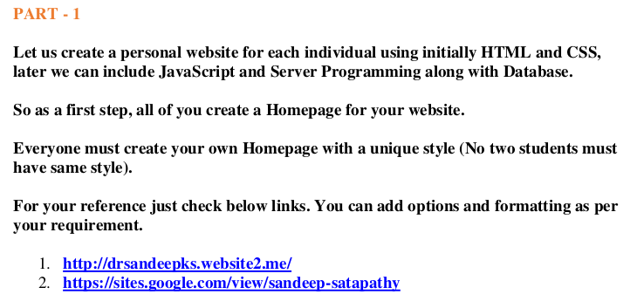

link for portfolio

https://7abhisheknn.github.io/

portfolio source code
https://github.com/7abhisheknn/7abhisheknn.github.io

image:

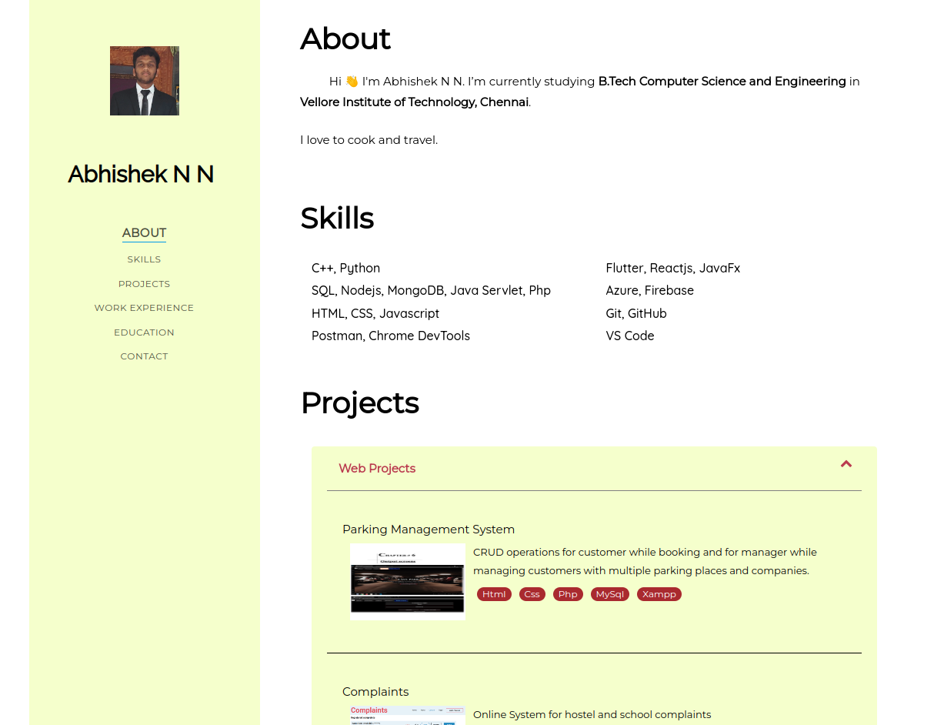

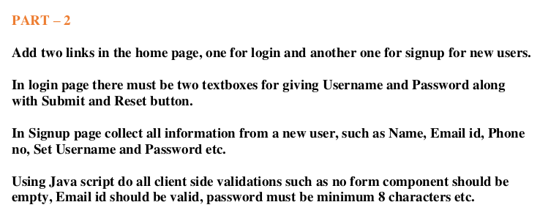
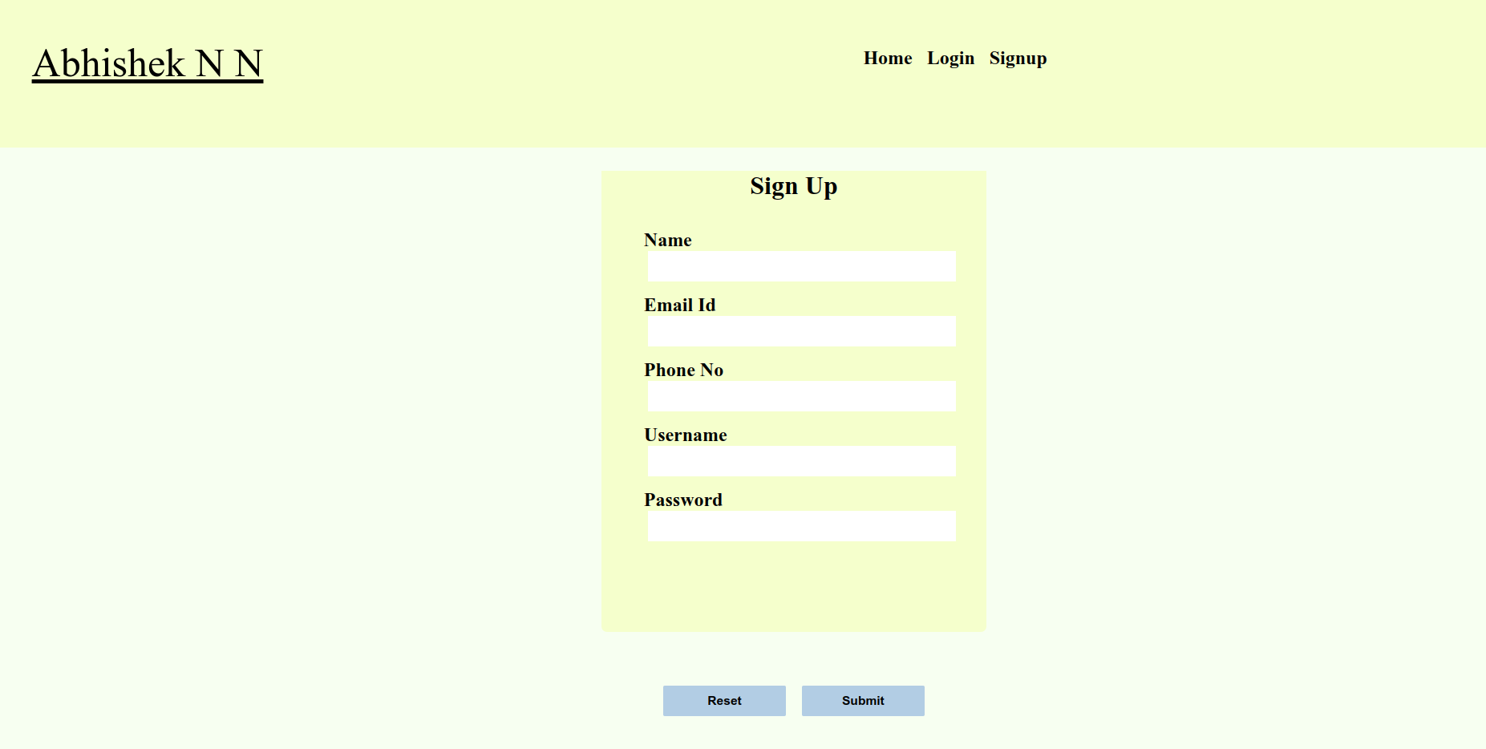
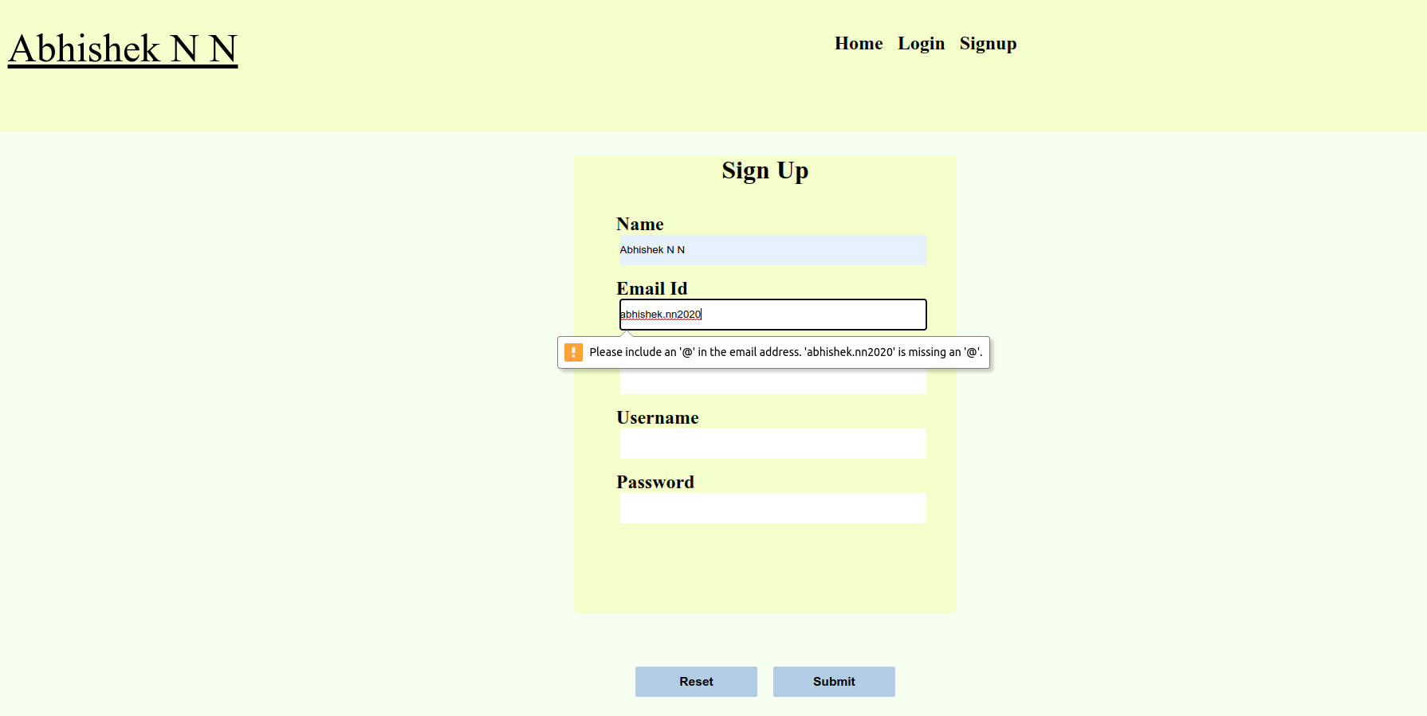

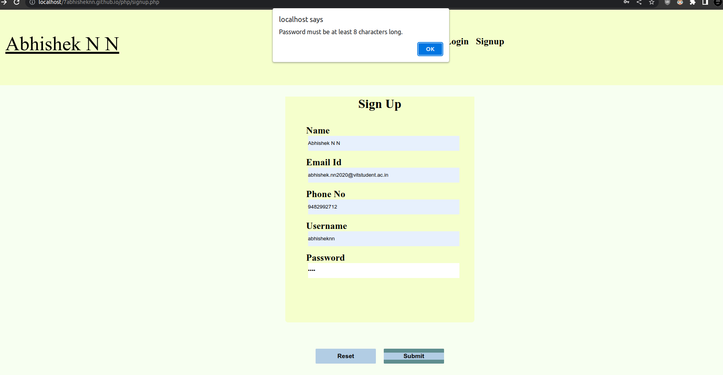
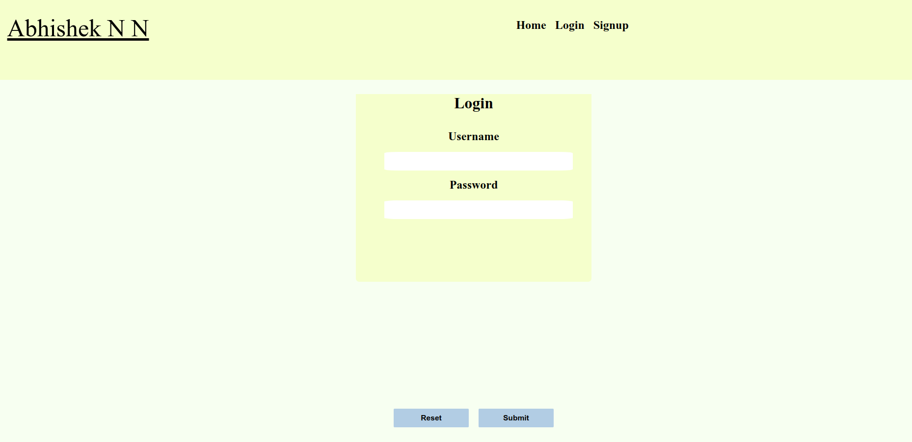

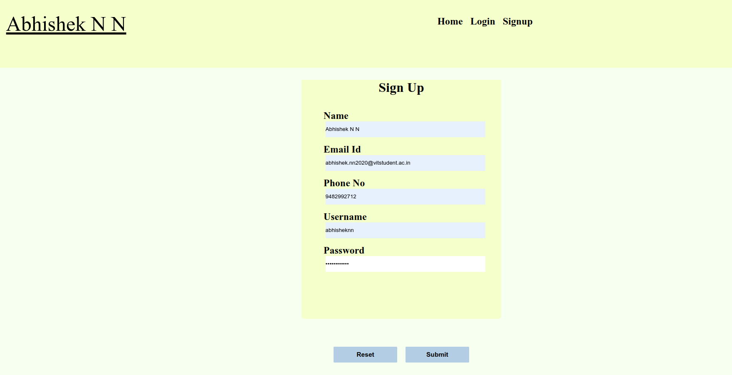
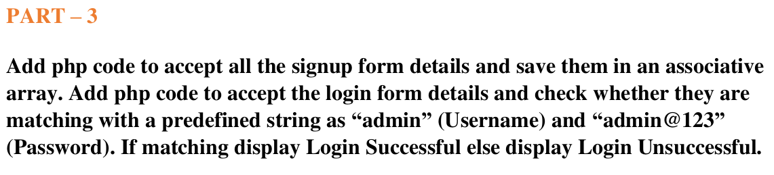
SignUP

after signup
the associative array

Login
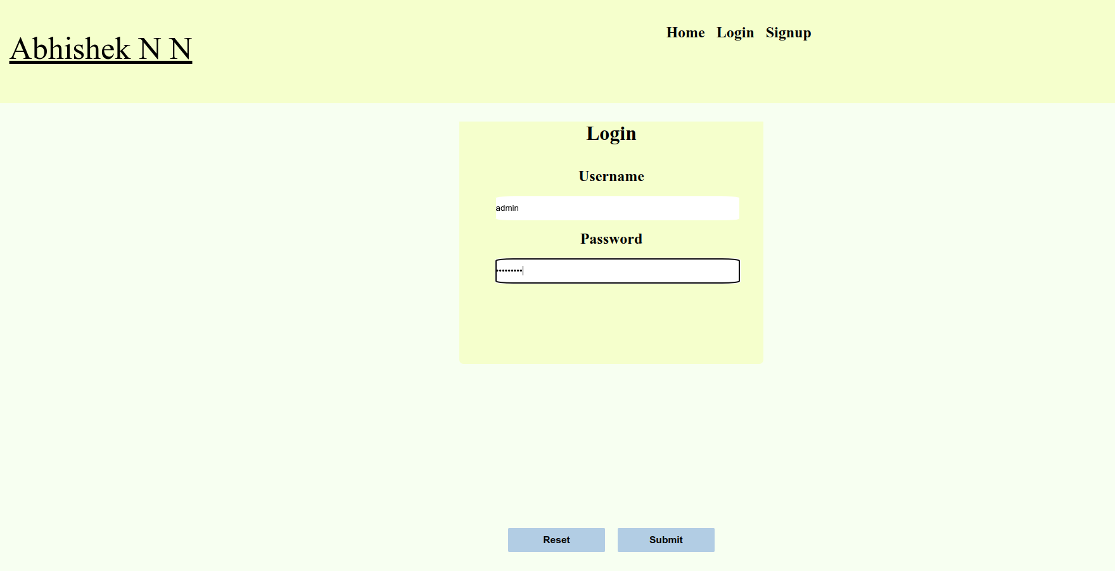
for admin and admin@123
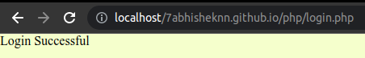

for other inputs

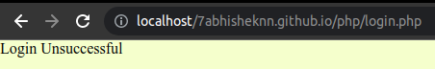

portfolio with login and signup source code

https://github.com/7abhisheknn/7abhisheknn.github.io/tree/IWP_DA_1

