20BCE1025
Abhishek N N

PDC Lab 1
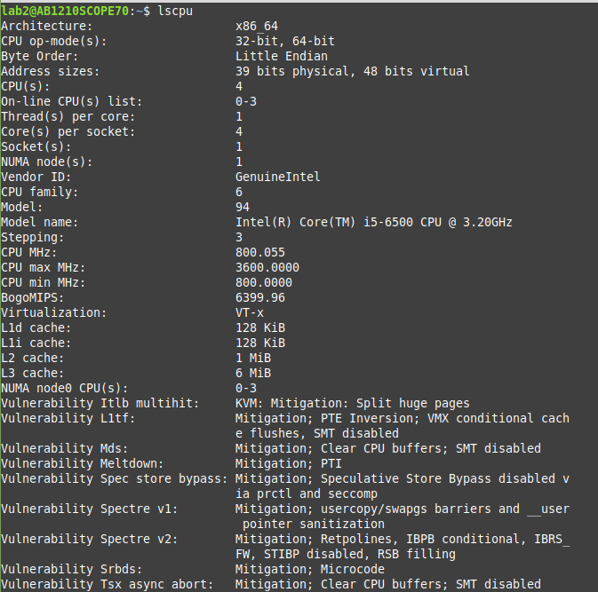

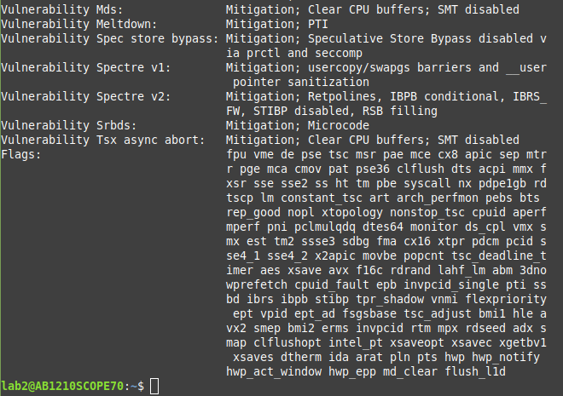

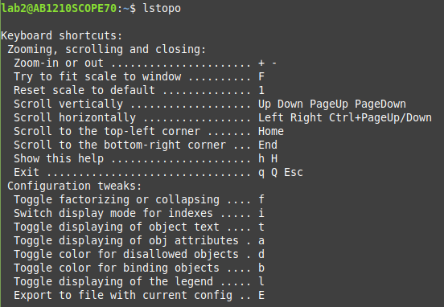

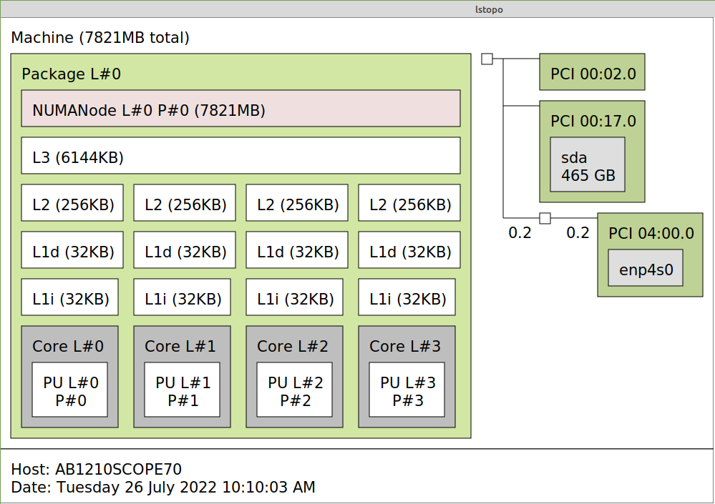

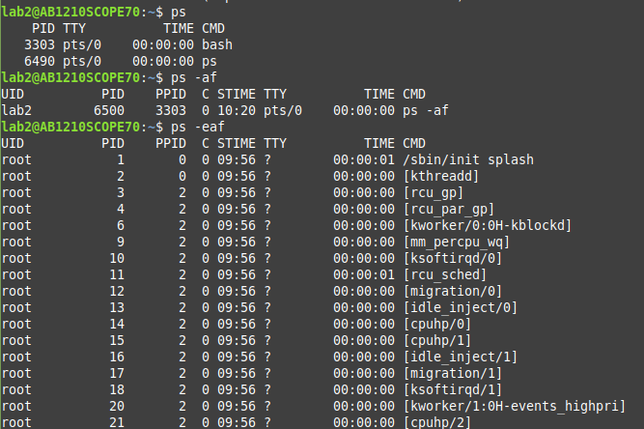

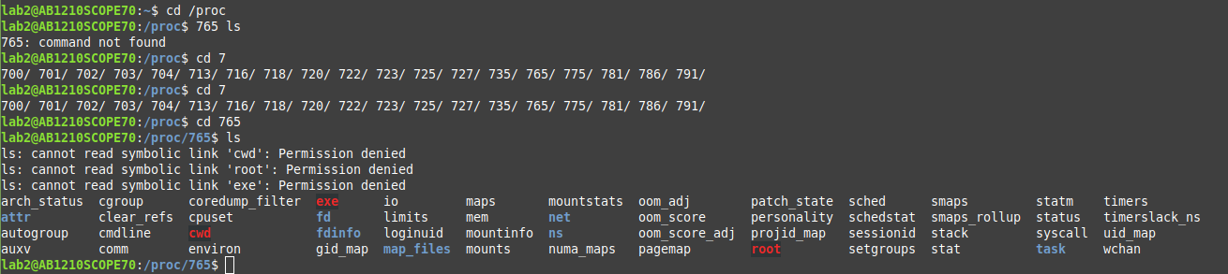
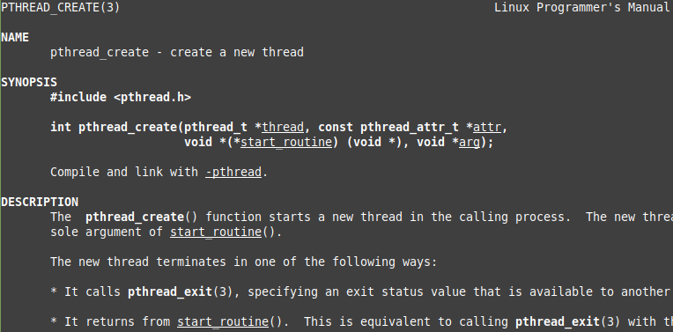
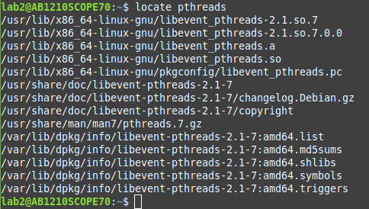

#include <pthread.h>
#include <string.h>
#include <stdio.h>
#include <stdlib.h>
#include <unistd.h>
#include <errno.h>
#include <ctype.h>

#define handle_error_en(en, msg) \
do { errno = en; perror(msg); exit(EXIT_FAILURE); } while (0)

#define handle_error(msg) \
do { perror(msg); exit(EXIT_FAILURE); } while (0)

struct thread_info { /* Used as argument to thread_start() */
pthread_t thread_id; /* ID returned by pthread_create() */
int thread_num; /* Application-defined thread # */
char *argv_string; /* From command-line argument */
};

/* Thread start function: display address near top of our stack,
and return upper-cased copy of argv_string */

static void *
thread_start(void *arg)
{
struct thread_info *tinfo = arg;
char *uargv, *p;

printf("Thread %d: top of stack near %p; argv_string=%s\n",
tinfo->thread_num, &p, tinfo->argv_string);

uargv = strdup(tinfo->argv_string);
if (uargv == NULL)
handle_error("strdup");

for (p = uargv; *p != '\0'; p++)
*p = toupper(*p);

return uargv;
}
int
main(int argc, char *argv[])
{
int s, tnum, opt, num_threads;
struct thread_info *tinfo;
pthread_attr_t attr;
int stack_size;
void *res;

/* The "-s" option specifies a stack size for our threads */

stack_size = -1;
while ((opt = getopt(argc, argv, "s:")) != -1) {
switch (opt) {
case 's':
stack_size = strtoul(optarg, NULL, 0);
break;

default:
fprintf(stderr, "Usage: %s [-s stack-size] arg...\n",
argv[0]);
exit(EXIT_FAILURE);
}
}

num_threads = argc - optind;

/* Initialize thread creation attributes */

s = pthread_attr_init(&attr);
if (s != 0)
handle_error_en(s, "pthread_attr_init");
if (stack_size > 0) {
s = pthread_attr_setstacksize(&attr, stack_size);
if (s != 0)
handle_error_en(s, "pthread_attr_setstacksize");
}

/* Allocate memory for pthread_create() arguments */

tinfo = calloc(num_threads, sizeof(struct thread_info));
if (tinfo == NULL)
handle_error("calloc");

/* Create one thread for each command-line argument */

for (tnum = 0; tnum < num_threads; tnum++) {
tinfo[tnum].thread_num = tnum + 1;
tinfo[tnum].argv_string = argv[optind + tnum];

/* The pthread_create() call stores the thread ID into
corresponding element of tinfo[] */

s = pthread_create(&tinfo[tnum].thread_id, &attr,
&thread_start, &tinfo[tnum]);
if (s != 0)
handle_error_en(s, "pthread_create");
}

/* Destroy the thread attributes object, since it is no
longer needed */

s = pthread_attr_destroy(&attr);
if (s != 0)
handle_error_en(s, "pthread_attr_destroy");

/* Now join with each thread, and display its returned value */
for (tnum = 0; tnum < num_threads; tnum++) {
s = pthread_join(tinfo[tnum].thread_id, &res);
if (s != 0)
handle_error_en(s, "pthread_join");

printf("Joined with thread %d; returned value was %s\n",
tinfo[tnum].thread_num, (char *) res);
free(res); /* Free memory allocated by thread */
}

free(tinfo);
exit(EXIT_SUCCESS);
}
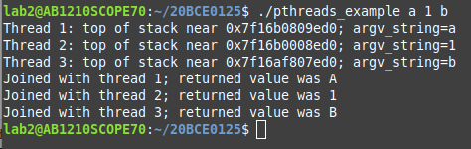

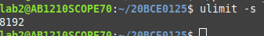

.file "pthreads_example.c"
.text
.section .rodata
.align 8
.LC0:
.string "Thread %d: top of stack near %p; argv_string=%s\n"
.LC1:
.string "strdup"
.text
.type thread_start, @function
thread_start:
.LFB6:
.cfi_startproc
endbr64
pushq %rbp
.cfi_def_cfa_offset 16
.cfi_offset 6, -16
movq %rsp, %rbp
.cfi_def_cfa_register 6
subq $48, %rsp
movq %rdi, -40(%rbp)
movq %fs:40, %rax
movq %rax, -8(%rbp)
xorl %eax, %eax

#include<stdio.h>

int main(){
return 0;
}

.file "hello.c"
.text
.globl main
.type main, @function
main:
.LFB0:
.cfi_startproc
endbr64
pushq %rbp
.cfi_def_cfa_offset 16
.cfi_offset 6, -16
movq %rsp, %rbp
.cfi_def_cfa_register 6
movl $0, %eax
popq %rbp
.cfi_def_cfa 7, 8
ret
.cfi_endproc
.LFE0:
.size main, .-main
.ident "GCC: (Ubuntu 9.4.0-1ubuntu1~20.04.1) 9.4.0"
.section .note.GNU-stack,"",@progbits
.section .note.gnu.property,"a"
.align 8
.long 1f - 0f
.long 4f - 1f
.long 5
0:
.string "GNU"
1:
.align 8
.long 0xc0000002
.long 3f - 2f
2:
.long 0x3
3:
.align 8
4:

