Name : Abhishek N N
Reg.no : 20BCE1025
Email : abhishek.nn2020@vitstudent.ac.in
Mob : 9482992712

CSE4001 Parallel and Distributed Computing

- Display the processors layout of your system

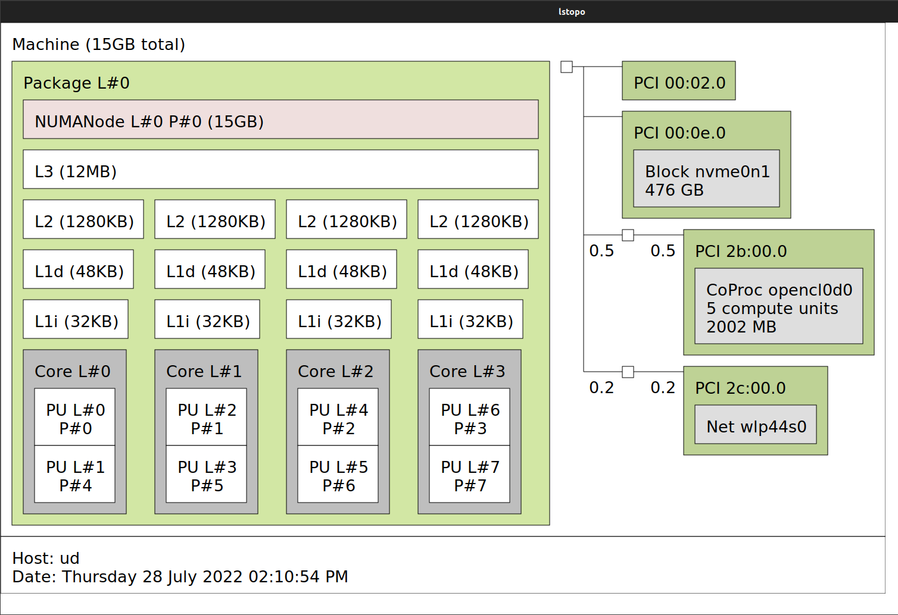

- Write a multithreaded-thread program in c to create 10k, 20k, and 50k threads and measure the time taken for each thread group.

#include <pthread.h>
#include <stdio.h>
#include <stdlib.h>
#include <time.h>

void *thread_function(void *arg) {}

int main() {
int no[3] = {10000, 20000, 50000};

for (int n = 0; n < 3; n++) {
clock_t begin = clock();
pthread_t threads[no[n]];
int rc, i;

for (i = 0; i < no[n]; i++) {
rc = pthread_create(&threads[i], NULL, thread_function, NULL);

if (rc) {
printf("Error:unable to create thread, %d\n", rc);
exit(-1);
}
pthread_join(threads[i], NULL);
}
clock_t end = clock();
double time_spent = (double)(end - begin) / CLOCKS_PER_SEC;
printf("%d threads: %f miliseconds\n", no[n], time_spent);
}
}

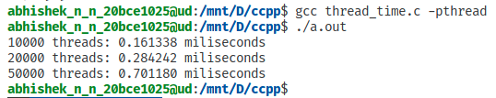

- Write a program to create two threads. Thread1 has to print the print String1 “PDC” and
Thread2 has to print the String2 “Lab”.
Hint: Implement the message_function () is used as the start routine for the threads used
it accepts a void pointer.
Sample output:
Thread1 prints: PDC
Thread2 prints: Lab

#include <pthread.h>
#include <stdio.h>

void *message_function(void *arg) {
char *msg = (char *)arg;
printf("%s", msg);
}

int main() {
pthread_t thread1, thread2;
char *msg1 = "PDC", *msg2 = " Lab\n";
pthread_create(&thread1, NULL, message_function, (void *)msg1);
pthread_join(thread1, NULL);
pthread_create(&thread2, NULL, message_function, (void *)msg2);
pthread_join(thread2, NULL);
return 0;
}

