20BCE1025
Abhishek N N
abhishek.nn2020@vitstudent.ac.in

Lab2 - OpenMP Basics & Vector addition

i) OpenMP Case1 1000 threads by using runtime lib routine

Code:

#include <omp.h>
#include <stdio.h>

int main(int argc, char *argcv[]) {
int pid = 0, numthreads = 1000;
omp_set_num_threads(numthreads);

#pragma omp parallel private(pid)
{
printf("%d ", omp_get_thread_num());
if (omp_get_thread_num() == pid) {
printf("master");
}
}
return 0;
}
Output:
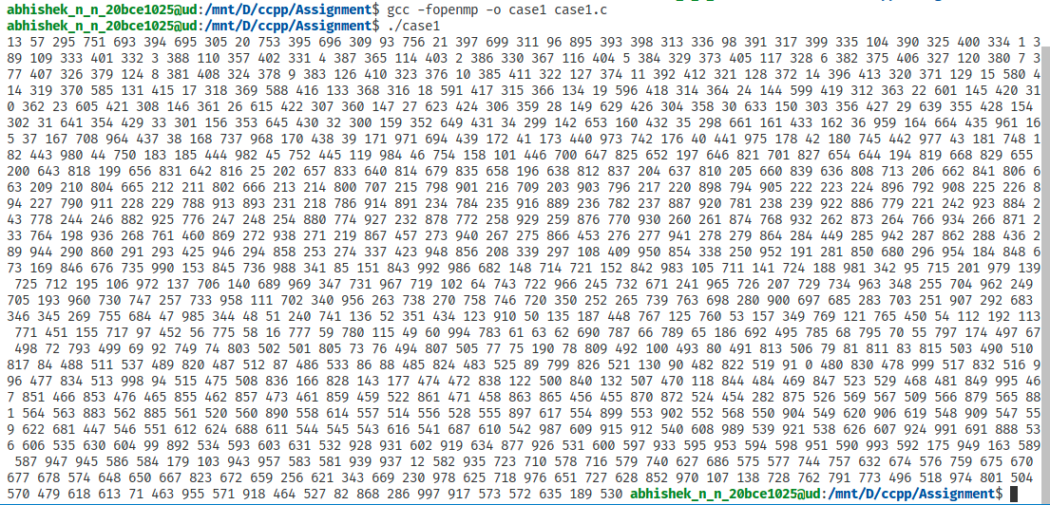

ii) OpenMP Case2 1000 threads by using Compiler directive

Code:

#include <omp.h>
#include <stdio.h>

int main(int argc, char *argcv[]) {
int pid = 0, numthreads = 1000;

#pragma omp parallel num_threads(numthreads) private(pid)
{
printf("%d ", omp_get_thread_num());
if (omp_get_thread_num() == pid) {
printf("master");
}
}
return 0;
}

Output:
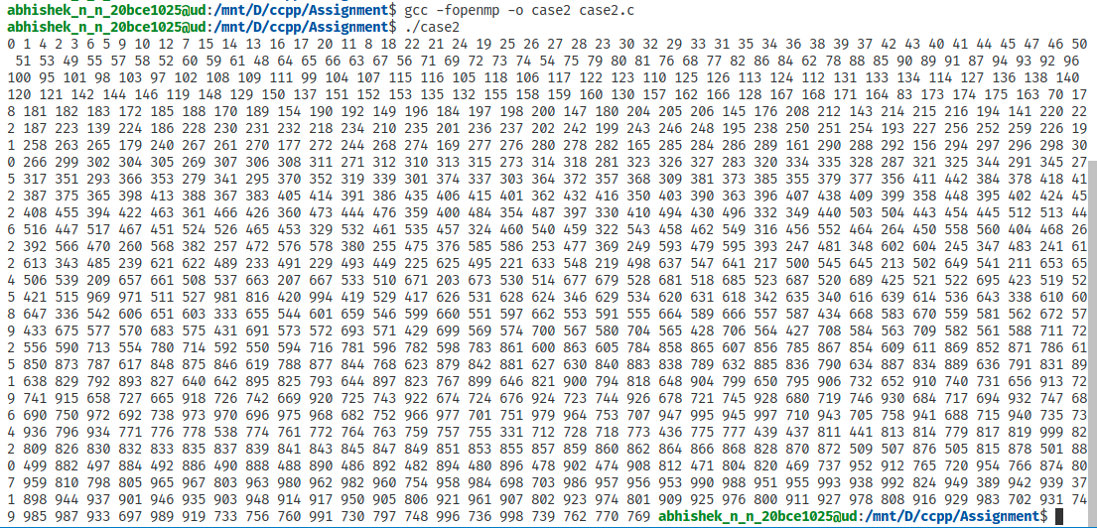

ii) OpenMP Case3 1000 threads by using Environment Variables

Code:

#include <omp.h>
#include <stdio.h>

int main(int argc, char *argcv[]) {
int pid = 0;

#pragma omp parallel private(pid)
{
printf("%d ", omp_get_thread_num());
if (omp_get_thread_num() == pid) {
printf("master");
}
}
return 0;
}

Output:

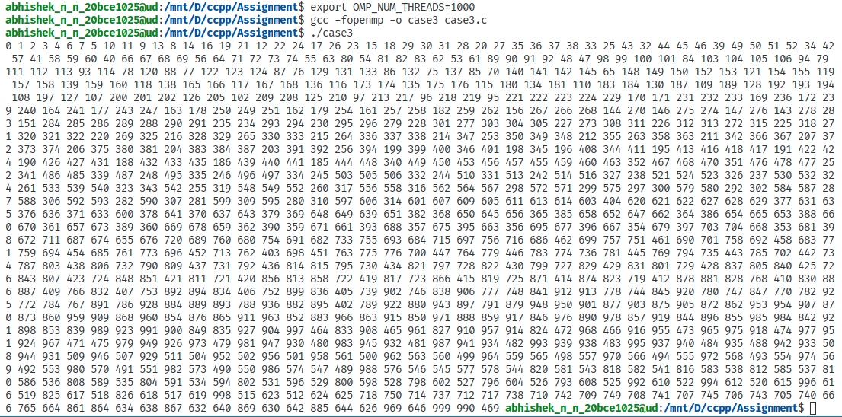

2) OpenMP vector addition of 1 lack elements with serial and parallel with 2, 4, 8, 16, 32, 100, 1000 threads to select the fastest

Serial Code:

#include <stdio.h>
#include <stdlib.h>
#include <time.h>

#define N 100000

void assignRandomValues(int a[], int b[]) {
for (int i = 0; i < N; i++) {
a[i] = rand() % 1000;
b[i] = rand() % 1000;
}
}

int main(int argc, char *argcv[]) {
int a[N], b[N], c[N];
assignRandomValues(a, b);

clock_t begin = clock();

for (int i = 0; i < N; i++) {
c[i] = a[i] + b[i];
}

clock_t end = clock();
double time_spent = (double)(end - begin) / CLOCKS_PER_SEC;
printf("Serial: %f miliseconds\n", time_spent);

return 0;
}

Serial Output Code:
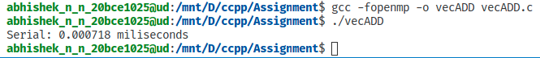

Parallel Code:

#include <stdio.h>
#include <stdlib.h>
#include <time.h>
#define N 100000

void assignRandomValues(int a[], int b[]) {
for (int i = 0; i < N; i++) {
a[i] = rand() % 1000;
b[i] = rand() % 1000;
}
}
int main(int argc, char *argcv[]) {
int a[N], b[N], c[N];
assignRandomValues(a, b);

int p[] = {2, 4, 8, 16, 32, 100, 1000};

for (int i = 0; i < 7; i++) {
clock_t begin = clock();

#pragma omp parallel private(i) shared(a, b, c)
{
#pragma omp for
for (int j = 0; j < N; j++) {
c[j] = a[j] + b[j];
}
}
clock_t end = clock();
double time_spent = (double)(end - begin) / CLOCKS_PER_SEC;
printf("%d threads: %f miliseconds\n", p[i], time_spent);
}

return 0;
}

Parallel Output:

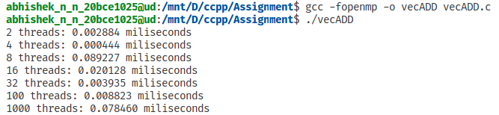
.’. 4 threads are best for my machine.
Extra: vector with 10 elements addtion to check OpenMP

Code:
#include <omp.h>
#include <stdio.h>
#include <stdlib.h>

#define n 10

int main() {
double a[n], b[n], c[n];
float startTime, endTime, execTime;
int i;
int omp_rank;

startTime = omp_get_wtime();
#pragma omp parallel private(i) shared(a, b, c)
{
#pragma omp for
for (i = 0; i < n; i++) {
omp_rank = omp_get_thread_num();
a[i] = i * (rand() % 1000);
b[i] = i * (rand() % 1000);
c[i] = a[i] + b[i];
printf("The value of a[%d] = %lf and b[%d] = %lf and result c[%d] = %lf done by worker Thread ID = %d\n", i, a[i], i, b[i], i, c[i], omp_rank);
}
}
endTime = omp_get_wtime();

execTime = endTime - startTime;
printf("%f \n", execTime);
return (0);
}
Output:
