20BCE1025
Abhishek N N
abhishek.nn2020@vitstudent.ac.in

Lab 3 - Loop sharing
- Write a parallel program in openMP to create 8, 16 and 32 threads using runtime library routines. Construct an array of 10000 elements. Distribute the loop iterations to 32, 64, 128 concurrent threads with a chunk-size of 10, 20 and 50 using static, dynamic, guided and auto scheduling schemes. Find out the odd and even numbers global sum of 10K items. Record your execution times for the abovementioned schemes.
Code:
#include <omp.h>
#include <stdio.h>
#include <stdlib.h>
#include <time.h>

int main() {
int N;
printf("Enter N: ");
scanf("%d", &N);
int tid, i;
long int odd_sum = 0, even_sum = 0;
int A[N];
for (i = 0; i < N; i++) A[i] = i;

clock_t t;
t = clock();

#pragma omp parallel for shared(A, even_sum, odd_sum) num_threads(8) schedule(static, 10)
for (i = 0; i < N; i++) {
if (A[i] % 2 == 0)
even_sum += A[i];
else
odd_sum += A[i];
}
#pragma omp barrier

t = clock() - t;
double time_taken = ((double)t) / CLOCKS_PER_SEC;
printf("8 threads in static: Even sum:%li Odd sum:%li\n", odd_sum, even_sum);
printf("Time for static method: %fs\n\n", time_taken);
odd_sum = 0;
even_sum = 0;

t = clock();

#pragma omp parallel for shared(A, even_sum, odd_sum) num_threads(16) schedule(dynamic, 20)
for (i = 0; i < N; i++) {
if (A[i] % 2 == 0)
even_sum += A[i];
else
odd_sum += A[i];
}
#pragma omp barrier

t = clock() - t;
time_taken = ((double)t) / CLOCKS_PER_SEC;
printf("16 threads in dynamic: Even sum:%li Odd sum:%li\n", odd_sum, even_sum);
printf("Time for dynamic method: %fs\n\n", time_taken);
odd_sum = 0;
even_sum = 0;

t = clock();
#pragma omp parallel for shared(A, even_sum, odd_sum) num_threads(32) schedule(guided, 50)
for (i = 0; i < N; i++) {
if (A[i] % 2 == 0)
even_sum += A[i];
else
odd_sum += A[i];
}
#pragma omp barrier
t = clock() - t;
time_taken = ((double)t) / CLOCKS_PER_SEC;
printf("32 threads in guided: Even sum:%li Odd sum:%li\n", odd_sum, even_sum);
printf("Time for guided method: %fs\n\n", time_taken);

return 0;
}

Output:
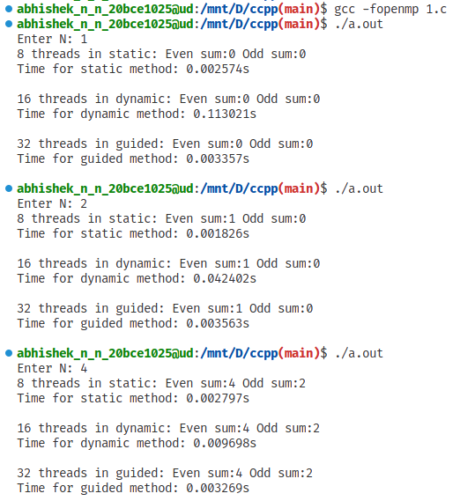
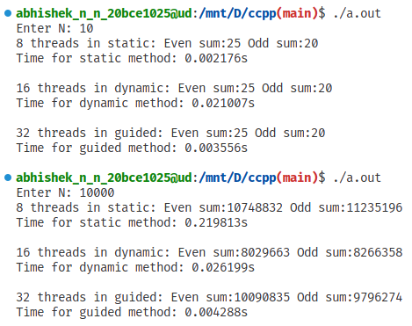

- Write a parallel program to sort N elements in an array using OpenMP
- Bubble Sort
Code:
#include <omp.h>
#include <stdio.h>
#include <stdlib.h>

void swap();

int main(int argc, char *argv[]) {
int SIZE = 10;
int A[SIZE];
for (int i = 0; i < SIZE; i++) {
A[i] = rand() % 100;
printf(" %d", A[i]);
}
printf("\n");

int N = SIZE;
int i = 0, j = 0;
int first;
double start, end;
start = omp_get_wtime();
for (i = 0; i < N - 1; i++) {
first = i % 2;
#pragma omp parallel for default(none), shared(A, first, N)
for (j = first; j < N - 1; j += 1) {
if (A[j] > A[j + 1]) {
swap(&A[j], &A[j + 1]);
}
}
}
end = omp_get_wtime();
for (i = 0; i < N; i++) {
printf(" %d", A[i]);
}

printf("\n-------------------------\n Time Parallel= %f\n", (end - start));
}

void swap(int *num1, int *num2) {
int temp = *num1;
*num1 = *num2;
*num2 = temp;
}
Output:
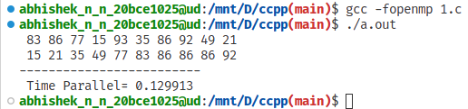

- Quick Sort
Code:
#include <stdio.h>
#include <omp.h>
#include <stdlib.h>

void swap(int* a, int* b) {
int t = *a;
*a = *b;
*b = t;
}

int partition(int arr[], int start, int end) {
int pivot = arr[end];
int i = (start - 1);

for (int j = start; j <= end - 1; j++) {
if (arr[j] < pivot) {
i++;
swap(&arr[i], &arr[j]);
}
}
swap(&arr[i + 1], &arr[end]);

return (i + 1);
}

void quicksort(int arr[], int start, int end) {
int index;

if (start < end) {
index = partition(arr, start, end);

#pragma omp parallel sections
{
#pragma omp section
{
quicksort(arr, start, index - 1);
}
#pragma omp section
{
quicksort(arr, index + 1, end);
}
}
}
}

int main() {
int N = 10;
int arr[N];
for (int i = 0; i < N; i++) {
arr[i] = rand() % 100;
printf(" %d", arr[i]);
}
printf("\n");

quicksort(arr, 0, N - 1);

printf("Array after Sorting is: \n");

for (int i = 0; i < N; i++) {
printf(" %d", arr[i]);
}
printf("\n");
return 0;
}
Output:
