

Digital Assignment 2

Programme | : | BTech. CSE Core | Semester | : | Fall 22-23
Course | : | Parallel and Distributed Computing | Code | : | CSE4001
Faculty | : | Dr. Kumar R | Slot | : | D2
Name | : | Abhishek N N | Register No. | : | 20BCE1025

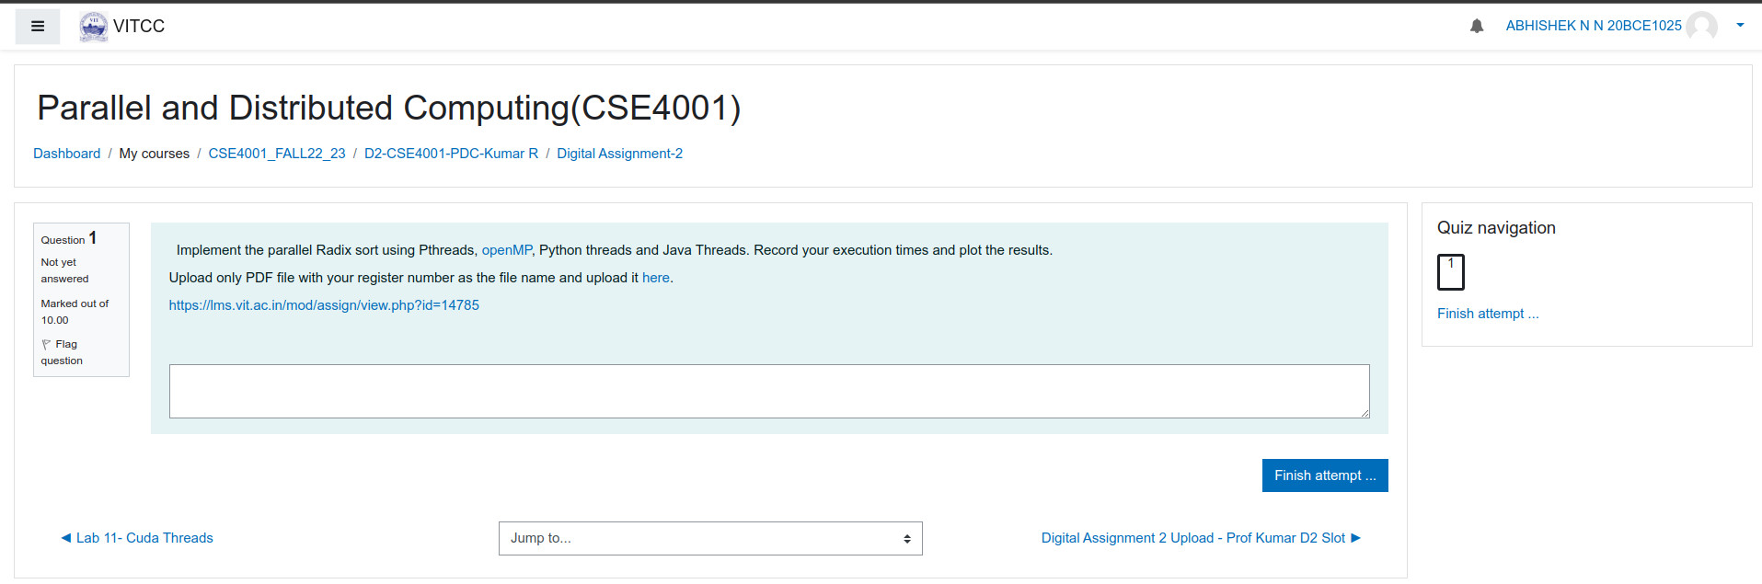

C Serial

// C implementation of Radix Sort

#include <stdio.h>

// A utility function to get maximum value in arr[]
int getMax(int arr[], int n) {
int mx = arr[0];
for (int i = 1; i < n; i++)
if (arr[i] > mx)
mx = arr[i];
return mx;
}
// A utility function to print an array
void print(int arr[], int n){
for (int i = 0; i < n; i++)
printf("%d ",arr[i]);
}

// A function to do counting sort of arr[] according to
// the digit represented by exp.
void countSort(int arr[], int n, int exp){
int output[n]; // output array
int i, count[10] = { 0 };

// Store count of occurrences in count[]
for (i = 0; i < n; i++)
count[(arr[i] / exp) % 10]++;

// Change count[i] so that count[i] now contains actual
// position of this digit in output[]
for (i = 1; i < 10; i++)
count[i] += count[i - 1];

// Build the output array
for (i = n - 1; i >= 0; i--) {
output[count[(arr[i] / exp) % 10] - 1] = arr[i];
count[(arr[i] / exp) % 10]--;
}

// Copy the output array to arr[], so that arr[] now
// contains sorted numbers according to current digit
for (i = 0; i < n; i++)
arr[i] = output[i];
}

// The main function to that sorts arr[] of size n using
// Radix Sort
void radixsort(int arr[], int n){
// Find the maximum number to know number of digits
int m = getMax(arr, n);

// Do counting sort for every digit. Note that instead
// of passing digit number, exp is passed. exp is 10^i
// where i is current digit number
for (int exp = 1; m / exp > 0; exp *= 10)
countSort(arr, n, exp);
}
// Driver Code
int main(){
int arr[] = { 170, 45, 75, 90, 802, 24, 2, 66 };
int n = sizeof(arr) / sizeof(arr[0]);
// Function Call
radixsort(arr, n);
print(arr, n);
return 0;
}
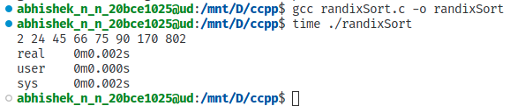

C OpenMp
#include <stdio.h>
#include <omp.h>
#include <stdlib.h>
#define BASE_BITS 8
#define BASE (1 << BASE_BITS)
#define MASK (BASE-1)
#define DIGITS(v, shift) (((v) >> shift) & MASK)
// A utility function to print an array
void print(int arr[], int n) {
for (int i = 0; i < n; i++)
printf("%d ", arr[i]);
}
void omp_lsd_radix_sort(size_t n, unsigned data[n]) {
unsigned * buffer = malloc(n*sizeof(unsigned));
int total_digits = sizeof(unsigned)*8;
//Each thread use local_bucket to move data
size_t i;
for(int shift = 0; shift < total_digits; shift+=BASE_BITS) {
size_t bucket[BASE] = {0};
size_t local_bucket[BASE] = {0}; // size needed in each bucket/thread
//1st pass, scan whole and check the count
#pragma omp parallel firstprivate(local_bucket)
{
#pragma omp for schedule(static) nowait
for(i = 0; i < n; i++){
local_bucket[DIGITS(data[i], shift)]++;
}
#pragma omp critical
for(i = 0; i < BASE; i++) {
bucket[i] += local_bucket[i];
}
#pragma omp barrier
#pragma omp single
for (i = 1; i < BASE; i++) {
bucket[i] += bucket[i - 1];
}
int nthreads = omp_get_num_threads();
int tid = omp_get_thread_num();
for(int cur_t = nthreads - 1; cur_t >= 0; cur_t--) {
if(cur_t == tid) {
for(i = 0; i < BASE; i++) {
bucket[i] -= local_bucket[i];
local_bucket[i] = bucket[i];
}
} else { //just do barrier
#pragma omp barrier
}
}
#pragma omp for schedule(static)
for(i = 0; i < n; i++) { //note here the end condition
buffer[local_bucket[DIGITS(data[i], shift)]++] = data[i];
}
}
//now move data
unsigned* tmp = data;
data = buffer;
buffer = tmp;
}
free(buffer);
}

int main() {
int arr[] = {170, 45, 75, 90, 802, 24, 2, 66};
int n = sizeof(arr) / sizeof(arr[0]);
// Function Call
omp_lsd_radix_sort(n, arr);
print(arr, n);
return 0;
}
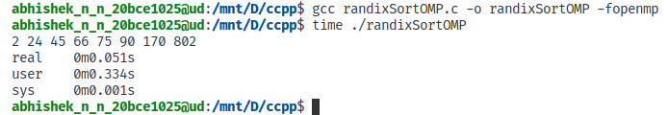

C Pthreads

#include <assert.h>
#include <math.h>
#include <pthread.h>
#include <stdio.h>
#include <stdlib.h>
#include <string.h>
#include <time.h>

#include "barrier.h"

#define BITS 29

#define BARRIER_COUNT 1000
pthread_barrier_t barrier;

struct rs_args {
int id;
unsigned *val;
unsigned *tmp;
int n;
int *nzeros;
int *nones;
int t;
};

struct rs_args *args;
void copy_array(unsigned *dest, unsigned *src, int n) {
for (; n > 0; n--)
*dest++ = *src++;
}

void print_array(unsigned *val, int n) {
int i;
for (i = 0; i < n; i++)
printf("%d ", val[i]);
printf("\n");
}

void initialize_array(unsigned *val, int n) {
int arr[] = {170, 45, 75, 90, 802, 24, 2, 66};
for (int i = 0; i < n; i++) {
val[i] = arr[i];
}
}

int array_is_sorted(unsigned *val, int n) {
int i;
for (i = 1; i < n; i++)
if (val[i - 1] > val[i])
return 0;
return 1;
}

void radix_sort_thread(unsigned *val,unsigned *tmp,int start, int n,int *nzeros, int *nones,int thread_index,int t) {
unsigned *src, *dest;
int bit_pos;
int index0, index1;
int i;

src = val;
dest = tmp;

for (bit_pos = 0; bit_pos < BITS; bit_pos++) {
nzeros[thread_index] = 0;
for (i = start; i < start + n; i++) {
if (((src[i] >> bit_pos) & 1) == 0) {
nzeros[thread_index]++;
}
}
nones[thread_index] = n - nzeros[thread_index];

pthread_barrier_wait(&barrier);

index0 = 0;
index1 = 0;
for (i = 0; i < thread_index; i++) {
index0 += nzeros[i];
index1 += nones[i];
}
index1 += index0;
for (; i < t; i++) {
index1 += nzeros[i];
}

pthread_barrier_wait(&barrier);

for (i = start; i < start + n; i++) {
if (((src[i] >> bit_pos) & 1) == 0) {
dest[index0++] = src[i];
} else {
dest[index1++] = src[i];
}
}

pthread_barrier_wait(&barrier);

/* Swap arrays. */
tmp = src;
src = dest;
dest = tmp;
}
}

void thread_work(int rank) {
int start, count, n;
int index = rank;
n = args[index].n / args[index].t;
start = args[index].id * n;

radix_sort_thread(args[index].val, args[index].tmp, start, n,
args[index].nzeros, args[index].nones, args[index].id, args[index].t);
}

void radix_sort(unsigned *val, int n, int t) {
unsigned *tmp;
int *nzeros, *nones;
int r, i;

long thread;
pthread_t *thread_handles;

tmp = (unsigned *)malloc(n * sizeof(unsigned));
if (!tmp) {
fprintf(stderr, "Malloc failed.\n");
exit(1);
}

nzeros = (int *)malloc(t * sizeof(int));
if (!nzeros) {
fprintf(stderr, "Malloc failed.\n");
exit(1);
}
nones = (int *)malloc(t * sizeof(int));
if (!nones) {
fprintf(stderr, "Malloc failed.\n");
exit(1);
}

thread_handles = malloc(t * sizeof(pthread_t));
pthread_barrier_init(&barrier, NULL, t);

for (i = 0; i < t; i++) {
args[i].id = i;
args[i].val = val;
args[i].tmp = tmp;
args[i].n = n;
args[i].nzeros = nzeros;
args[i].nones = nones;
args[i].t = t;

pthread_create(&thread_handles[i], NULL, thread_work, i);
}
for (i = 0; i < t; i++) {
pthread_join(thread_handles[i], NULL);
}
pthread_barrier_destroy(&barrier);
free(thread_handles);
free(args);
if (BITS % 2 == 1) {
copy_array(val, tmp, n);
}
free(nzeros);
free(nones);
free(tmp);
}
void main(int argc, char *argv[]) {
int n, t;
unsigned *val;
time_t start, end;
int ok;
n = 8;
if (argc > 1)
n = atoi(argv[1]);
if (n < 1) {
fprintf(stderr, "Invalid number of elements.\n");
exit(1);
}
t = 1;
if (argc > 2)
t = atoi(argv[2]);
if (t < 1) {
fprintf(stderr, "Invalid number of threads.\n");
exit(1);
}
if ((n / t) * t != n) {
fprintf(stderr, "Number of threads must divide number of elements.\n");
exit(1);
}
val = (unsigned *)malloc(n * sizeof(unsigned));
if (!val) {
fprintf(stderr, "Malloc failed.\n");
exit(1);
}
fflush(stdout);
initialize_array(val, n);
args = (struct rs_args *)malloc(t * sizeof(struct rs_args));
if (!args) {
fprintf(stderr, "Malloc failed.\n");
exit(1);
}
fflush(stdout);
start = time(0);
radix_sort(val, n, t);
end = time(0);
fflush(stdout);
ok = array_is_sorted(val, n);

if (ok && n <= 30) {
print_array(val, n);
}

free(val);
}

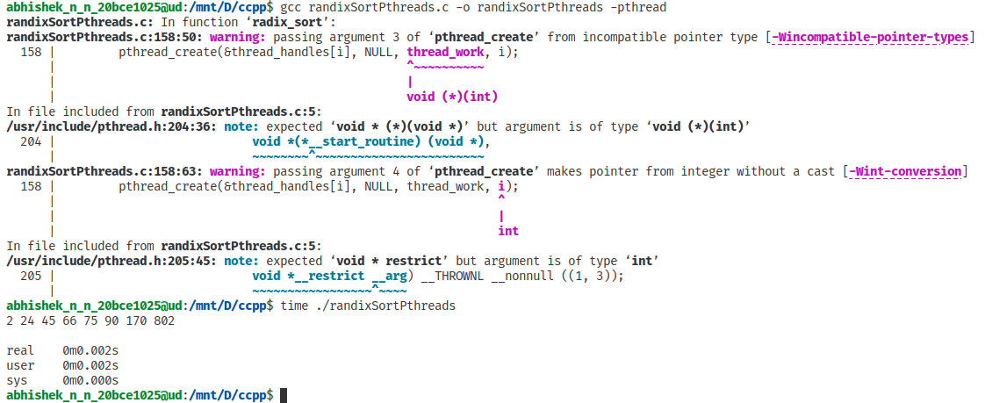

Python Threads
import threading
def countingSort(arr, exp1):
n = len(arr)
output = [0] * (n)
count = [0] * (10)

for i in range(0, n):
index = arr[i] // exp1
count[index % 10] += 1

for i in range(1, 10):
count[i] += count[i - 1]

i = n - 1
while i >= 0:
index = arr[i] // exp1
output[count[index % 10] - 1] = arr[i]
count[index % 10] -= 1
i -= 1

i = 0
for i in range(0, len(arr)):
arr[i] = output[i]

def radixSort(arr):
max1 = max(arr)
exp = 1

while max1 / exp >= 1:
t=threading.Thread(target=countingSort, args=(arr,exp), daemon=True)
t.start()
exp *= 10

arr = [170, 45, 75, 90, 802, 24, 2, 66]
radixSort(arr)

for i in range(len(arr)):
print(arr[i], end=" ")
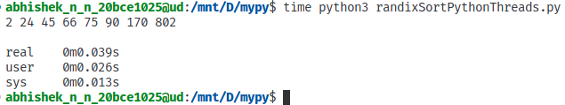
print("");
Java Threads
import java.io.*;
import java.util.*;

class CountSort extends Thread {
public static int arr[];
public static int n;
public static int exp;
CountSort(int arr[], int n, int exp){
this.arr=arr;
this.n=n;
this.exp=exp;
}

public void run() {
int output[] = new int[n];
int i;
int count[] = new int[10];
Arrays.fill(count, 0);

for (i = 0; i < n; i++)
count[(arr[i] / exp) % 10]++;

for (i = 1; i < 10; i++)
count[i] += count[i - 1];

for (i = n - 1; i >= 0; i--) {
output[count[(arr[i] / exp) % 10] - 1] = arr[i];
count[(arr[i] / exp) % 10]--;
}

for (i = 0; i < n; i++)
arr[i] = output[i];
}
}

class Radix {
static int getMax(int arr[], int n) {
int mx = arr[0];
for (int i = 1; i < n; i++)
if (arr[i] > mx)
mx = arr[i];
return mx;
}

static void radixsort(int arr[], int n) {
int m = getMax(arr, n);

for (int exp = 1; m / exp > 0; exp *= 10){
CountSort thread = new CountSort(arr, n, exp);
thread.start();
}
}

static void print(int arr[], int n) {
for (int i = 0; i < n; i++)
System.out.print(arr[i] + " ");
}

public static void main(String[] args) {
int arr[] = { 170, 45, 75, 90, 802, 24, 2, 66 };
int n = arr.length;

radixsort(arr, n);
print(arr, n);
System.out.println("");
}
}
