20BCE1025

Abhishek N N

# Parallel and Distributed Computing(CSE4001)

## Lab 7 -Profiling

**profiling of 2,4,8 threads in matrix multiplication**

**CODE:**

#include <omp.h>

#include <pthread.h>

#include <stdio.h>

#include <stdlib.h>

#include <string.h>

#define N 10

int A[N][N];

int B[N][N];

int C[N][N];

int main() {

int i, j, k;

for (i = 0; i < N; i++) {

for (j = 0; j < N; j++) {

A[i][j] = 2;

B[i][j] = 2;

}

}

int arr[] = {2, 4, 8};

for (int t = 0; t < 3; t++) {

double start = omp_get_wtime();

#pragma omp parallel for private(i, j, k) shared(A, B, C) num_threads(arr[t])

for (i = 0; i < N; i++) {

for (j = 0; j < N; j++) {

for (k = 0; k < N; k++) {

C[i][j] += A[i][k] * B[k][j];

}

}

}

double end = omp_get_wtime();

printf("%d threads, : %f seconds\n", arr[t], end - start);

}

return 0;

}

**Commands:**

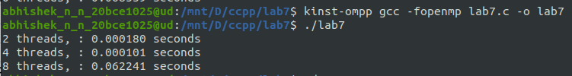

**output:**

