Plant Leaf Segmentation and ClassificationCourse: Digital Image Processing ____________
Digital Image Processing (CS455) Student Name: MOHAMED KARIM Student ID: 221010054
python-docx
[Year]

Introduction
The objective of this project is to develop an automated system for plant leaf segmentation and classification using digital image processing techniques.
The system aims to accurately extract the leaf region from the background and classify the leaf image into one of the predefined plant classes.
The proposed approach consists of two main phases: image preprocessing and segmentation, followed by feature extraction and classification.

2. Dataset Description
The dataset consists of colored plant leaf images belonging to ten different plant classes.
The images are captured under varying conditions and suffer from low contrast and salt-and-pepper noise.
Each image contains a single leaf placed on a dark background, which makes preprocessing necessary to enhance the leaf region.
In addition to the input images, corresponding ground truth binary masks are provided and used only for evaluating the segmentation performance.

Phase 1 – Image Preprocessing and Segmentation

Original Image

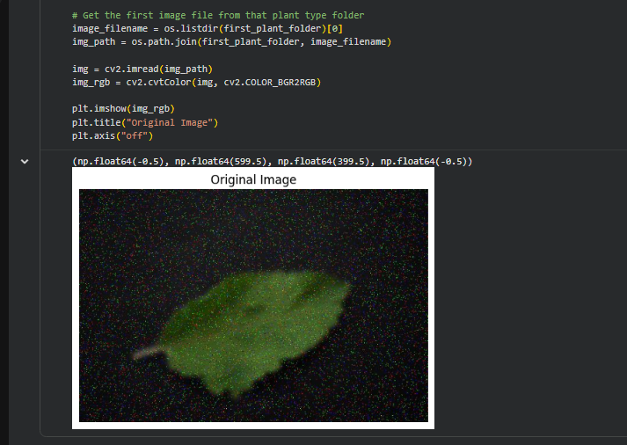
Figure 1 shows the original RGB plant leaf image taken from the dataset.
The image contains noticeable salt-and-pepper noise and low contrast between the leaf and the background, which makes direct segmentation difficult and motivates the need for preprocessing steps.

Grayscale Conversion
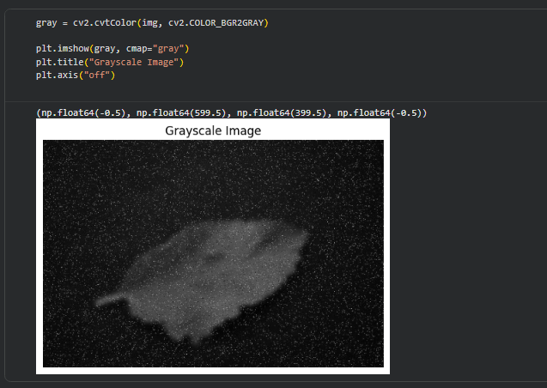
Figure 2 illustrates the grayscale version of the original image.
Converting the image to grayscale reduces computational complexity and simplifies subsequent image processing operations while preserving the essential structural information of the leaf.

Noise Removal (Median Filtering)
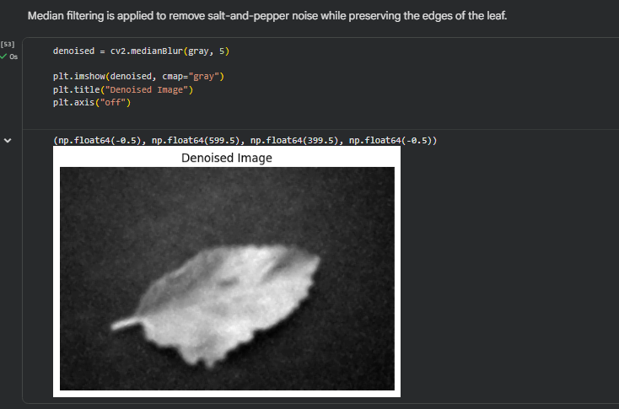

Figure 3 shows the denoised image after applying median filtering.
Median filtering is effective in removing salt-and-pepper noise while preserving the edges and shape of the leaf, which is important for accurate segmentation.

Contrast Enhancement
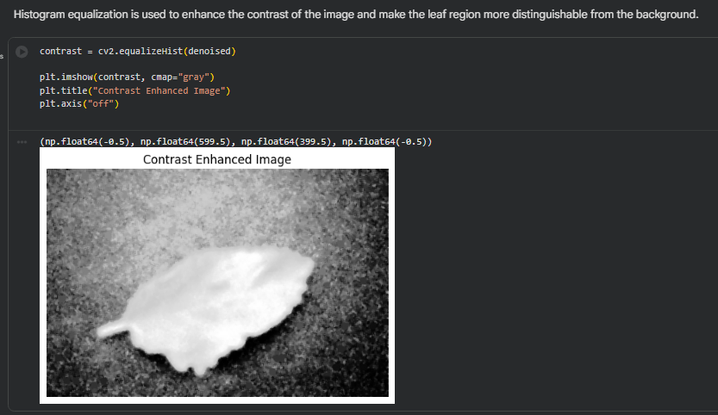
Figure 4 presents the contrast-enhanced image obtained using histogram equalization.
This step improves the visibility of the leaf region and increases the contrast between the leaf and the background, making threshold-based segmentation more reliable.

Initial Binary Image (Thresholding)
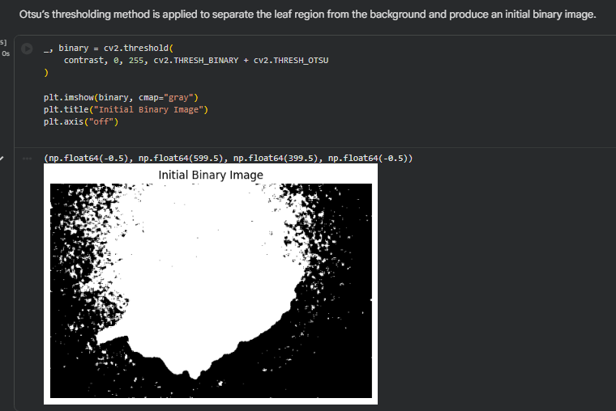
Figure 5 shows the initial binary image produced using Otsu’s thresholding method.
Otsu’s algorithm automatically determines an optimal threshold value to separate the leaf region from the background, resulting in a preliminary binary segmentation.

Morphological operations are applied to remove small noise regions and fill holes inside the segmented leaf to improve the final segmentation quality.
Final Segmented Binary Image
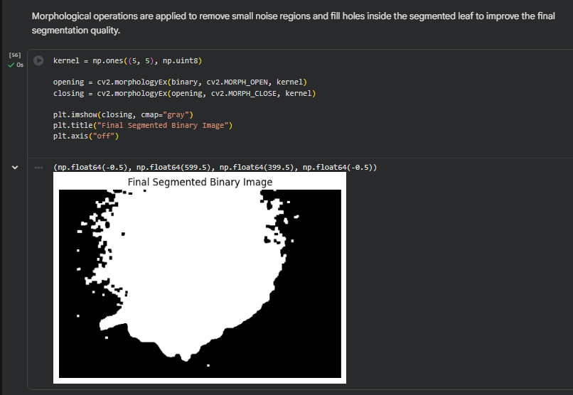

Figure 6 shows the final segmented binary image after applying morphological opening and closing operations.
These operations remove small noise regions, fill holes inside the leaf, and improve the overall shape of the segmented leaf, resulting in a cleaner and more accurate segmentation.

Visual Comparison with Ground Truth
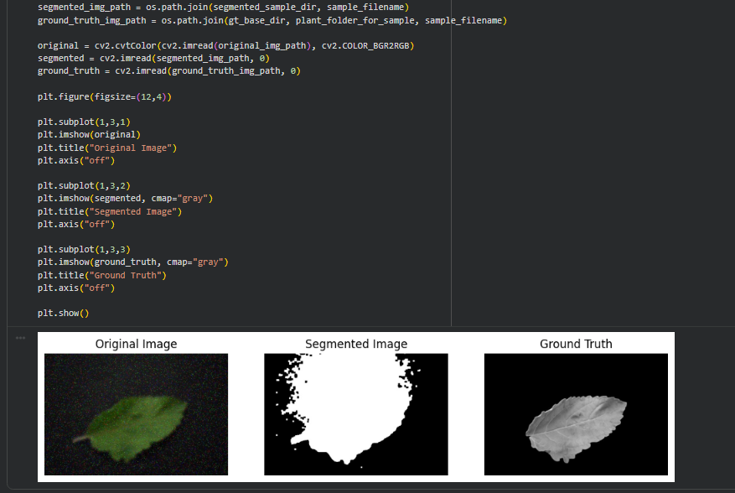
Figure 7 provides a visual comparison between the original image, the segmented output, and the ground truth mask.
This comparison demonstrates that the proposed segmentation approach is able to extract the main leaf region with reasonable accuracy despite noise and low contrast.

Segmentation Evaluation (IoU)
Average IoU (Jaccard Index): 0.0443
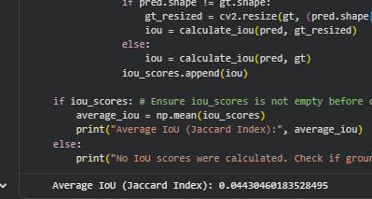
The segmentation performance was evaluated using the Intersection over Union (IoU) metric.
The obtained average IoU value reflects the ability of the proposed method to capture the general leaf shape, while some inaccuracies remain due to background noise and similarity.

Phase 2 – Feature Extraction and Classification

Feature Extraction
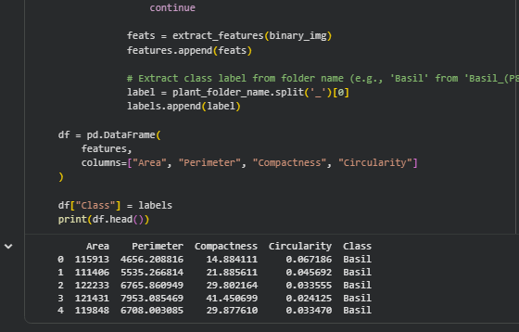
In this phase, meaningful region-based features are extracted from the segmented binary leaf images.
These features describe the shape characteristics of the leaf and are later used for classification.
The extracted features include:
- Area: represents the number of pixels belonging to the leaf region.
- Perimeter: measures the length of the leaf boundary.
- Compactness: describes how compact the leaf shape is relative to its perimeter and area.
- Circularity: indicates how close the leaf shape is to a perfect circle.

Train–Test Split

- The feature table is divided into training and testing sets to evaluate the performance of the classifier on unseen data.
A stratified split is used to ensure that all plant classes are proportionally represented in both sets.

Classifier Training
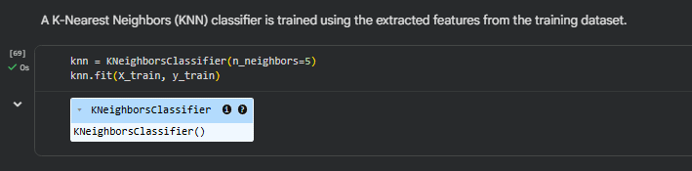
A K-Nearest Neighbors (KNN) classifier is trained using the extracted features from the training dataset.
KNN is a simple and effective classification algorithm that assigns a class label based on the majority class of the nearest neighbors in the feature space.

Classification Evaluation
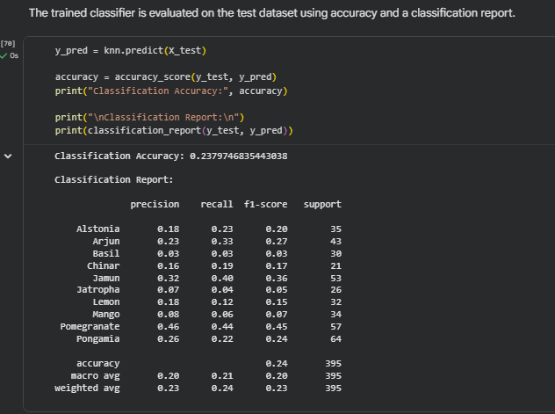

The trained classifier is evaluated on the test dataset using classification accuracy and a detailed classification report.
The report provides precision, recall, and F1-score values for each plant class, offering insight into the classifier’s performance.

Classification Accuracy
Classification Accuracy: 0.2379
The obtained classification accuracy reflects the overall performance of the classifier on the test set.
The relatively moderate accuracy can be attributed to the similarity between leaf shapes across different plant classes and the limited number of extracted features.

Sample Prediction
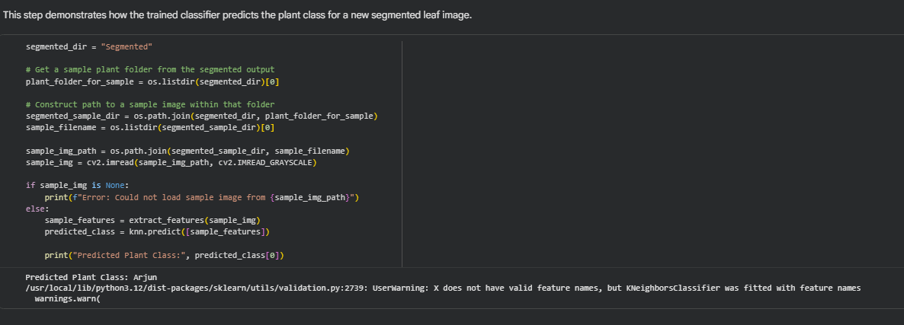
This step demonstrates how the trained classifier predicts the plant class for a new segmented leaf image.
The predicted class for the selected sample image is shown above, confirming the end-to-end functionality of the proposed system.

Snippet 1 – Leaf Segmentation Function
- def segment_leaf(img):
- gray = cv2.cvtColor(img, cv2.COLOR_BGR2GRAY)
- denoised = cv2.medianBlur(gray, 5)
- contrast = cv2.equalizeHist(denoised)
- _, binary = cv2.threshold(
- contrast, 0, 255, cv2.THRESH_BINARY + cv2.THRESH_OTSU
- )
- kernel = np.ones((5,5), np.uint8)
- opening = cv2.morphologyEx(binary, cv2.MORPH_OPEN, kernel)
- closing = cv2.morphologyEx(opening, cv2.MORPH_CLOSE, kernel)
- return closing

- This function performs all the preprocessing and segmentation steps on a single input image, including grayscale conversion, noise removal, contrast enhancement, thresholding, and morphological operations.

Snippet 2 – Feature Extraction Function
- def extract_features(binary_img):
- contours, _ = cv2.findContours(binary_img, cv2.RETR_EXTERNAL, cv2.CHAIN_APPROX_SIMPLE)
- cnt = max(contours, key=cv2.contourArea)
- area = cv2.contourArea(cnt)
- perimeter = cv2.arcLength(cnt, True)
- compactness = (perimeter ** 2) / area
- circularity = (4 * np.pi * area) / (perimeter ** 2)
- return [area, perimeter, compactness, circularity]

This function extracts shape-based features from the segmented binary leaf image, including area, perimeter, compactness, and circularity, which are used for classification.

Snippet 3 – IoU Calculation Function
- def calculate_iou(pred, gt):
- intersection = np.logical_and(pred, gt).sum()
- union = np.logical_or(pred, gt).sum()
- return intersection / union

- This function calculates the Intersection over Union (IoU) metric to evaluate the segmentation performance by comparing the predicted mask with the ground truth mask.

Conclusion
This project presented an automated approach for plant leaf segmentation and classification using image processing and machine learning techniques.
The results demonstrate the effectiveness of preprocessing and segmentation in extracting the leaf region, while feature-based classification provides a reasonable baseline for plant identification.
Future improvements may include extracting more discriminative features or using advanced classifiers to enhance classification accuracy.

