
Faculty of Engineering and Technology
Computer Engineering
Digital Systems
ENCS2340

Verilog Project

Instructor:
Dr.Ismail Khater

Done by:
Hamzah Alqam - 1211173

Date of Submission: 7-2- 2023

Q1:

We should consider the highest possible number of bits operation which is (“2*(X+Y)”) and the highest size of
N-bits signed number is (n-1).
So we substitute the value of X and Y in the above equation :-
2*((2^(n-1) -1) + (2^(n-1) -1)) = 2^(n+1) -4

So the power is (n+1).

We add a one to the power because it’s signed number to get the number of bits, so the size of O that guarantees that no overflow will occurs is →→(n+2)←←

Q2:
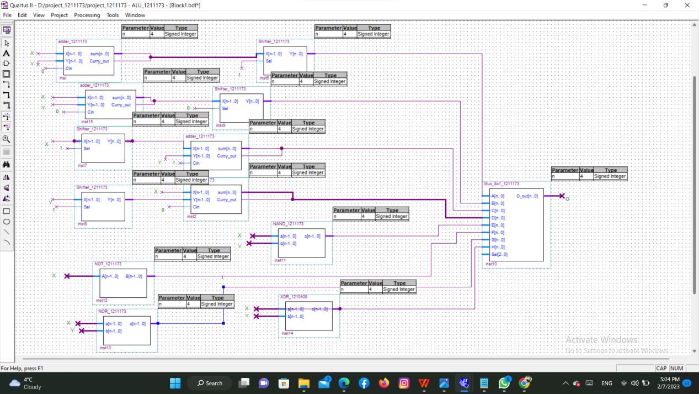

Q3:
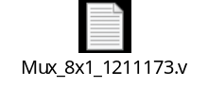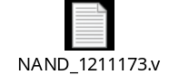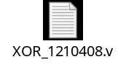


Q4:


Q5:
My number is 1211173
So C1=1,C2=2,X1=3,X2=1,Y1=7,Y2=1

*The first operation was 2*(X+Y) :

C1=1,X1=3,Y1=7
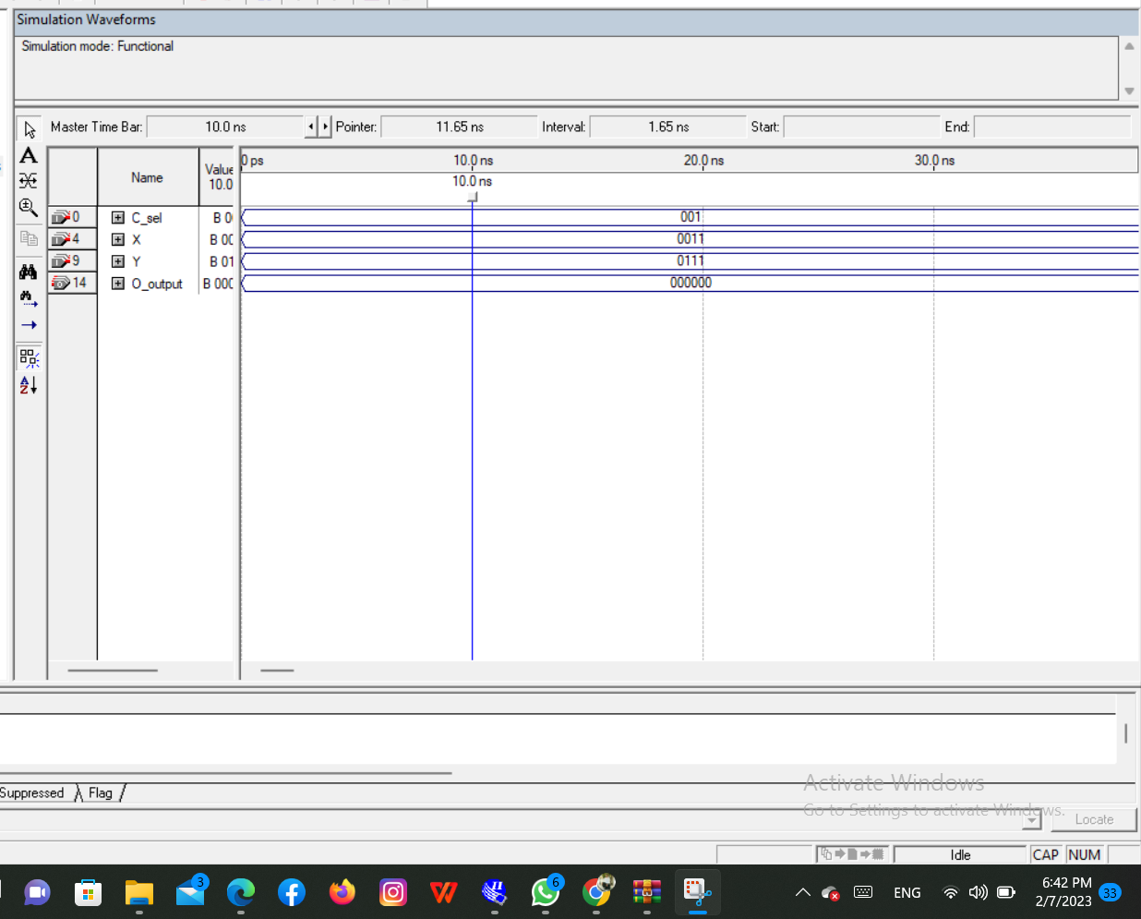

*The second operation was (X/2)+Y :
C2=2,X2=1,Y1=1
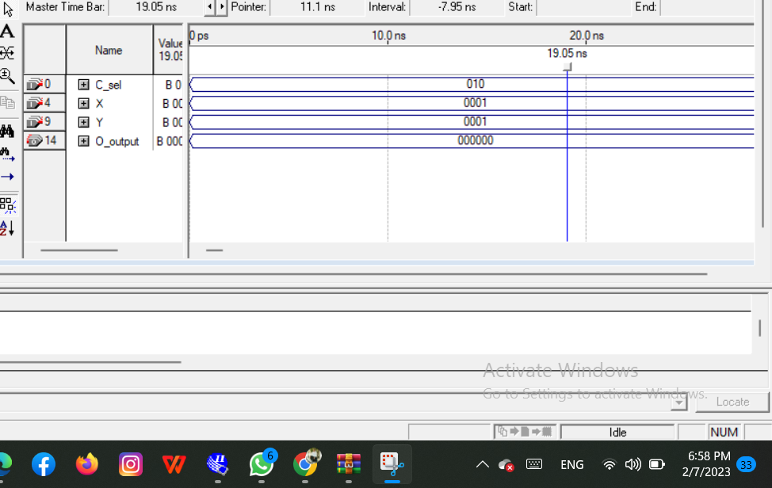

*The third operation was (X/2)+Y :
C3=2,X3=-1,Y3=-1

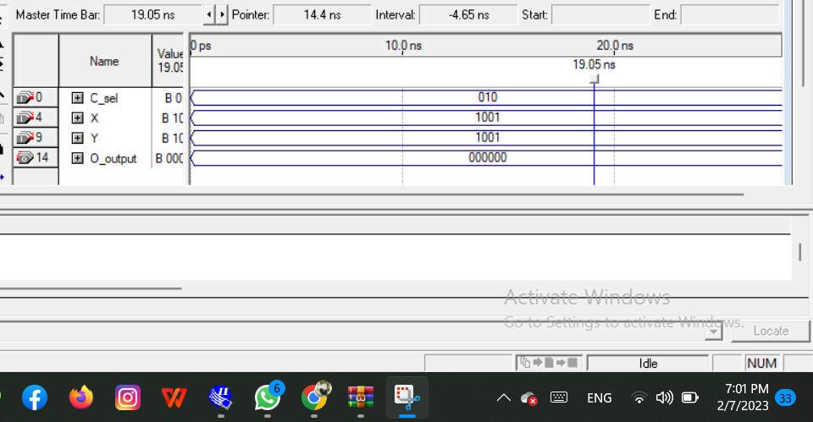

My results are false and I think the error in the full adder and due to carry and sum.

Q6:
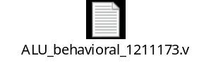

Q7:
My number is 1211173
So C1=1,C2=2,X1=3,X2=1,Y1=7,Y2=1

*The first operation was 2*(X+Y) :

C1=1,X1=3,Y1=7
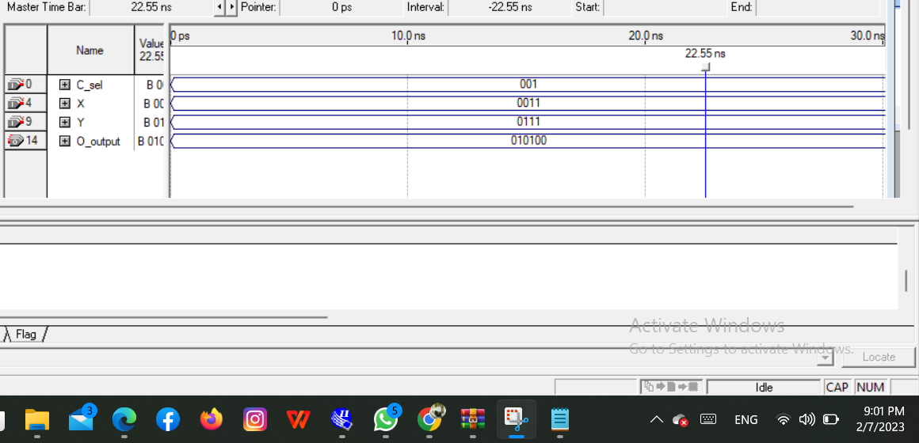

*The second operation was (X/2)+Y :
C2=2,X2=1,Y1=1
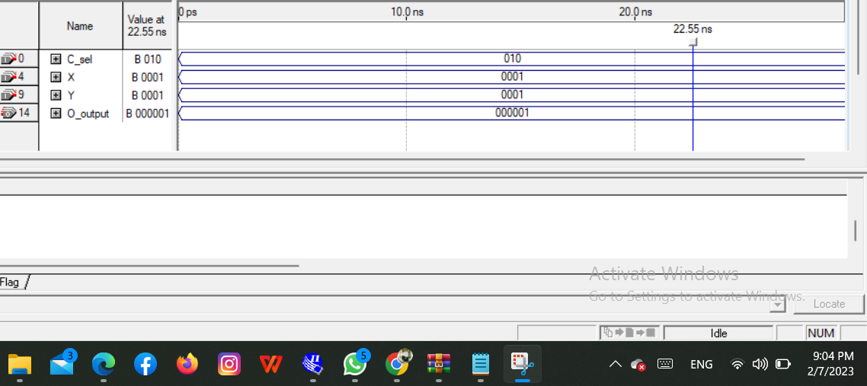

*The third operation was (X/2)+Y :
C3=2,X3=-1,Y3=-1
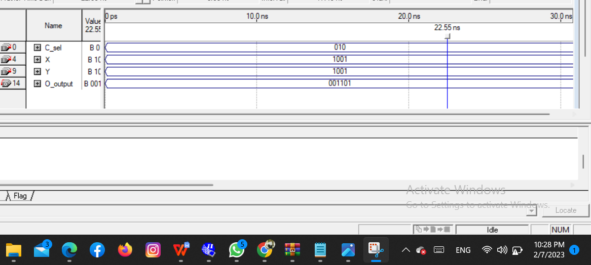

In the last one I have an error .

