A PROJECT REPORT ON

FlickFeel: Automatic Sentiment Analysis of Online Movie Reviews using NLP Techniques

M.Sc. (II Sem) Data Science
SUBMITTED BY
SR. NO. | PRN | NAME OF THE STUDENT
1 | 2501208047 | ANANYA TERWADKAR
2 | 2501208053 | SAPTSHRUNGI KADOLE
3 | 2501208055 | AKANKSHA KALE
4 | 2501208052 | PRIYANKA CHANDESHWARE

UNDER THE GUIDANCE OF
DR. ANITA KHANDIZOD

SCHOOL OF DATA SCIENCE
SYMBIOSIS SKILLS AND PROFESSIONAL UNIVERSITY, PUNE

ACADEMIC YEAR 2025-26
CERTIFICATE
This is to certify that
ANANYA TERWADKAR
SAPTSHRUNGI KADOLE
AKANKSHA KALE
PRIYANKA CHANDESHWARE
has successfully completed the
Project-Based Learning Report in Data Science
titled
“FlickFeel: Automatic Sentiment Analysis of Online Movie Reviews using NLP Techniques”
during the academic year 2025-26.
The project work was carried out under the guidance of
Dr. Anita Khandizhod
and is approved as per the academic requirements.

Project Mentor  (Dr. Anita Khandizod) | Director  (Dr. Darshana Desai) | External Examiner  (Signature)
DECLARATION
I hereby declare that the project report titled “ FlickFeel: Automatic Sentiment Analysis of Online Movie Reviews using NLP Techniques ” submitted in partial fulfilment of the requirements for the award of the degree in MSc Data Science is a record of original work carried out by me/us during the academic year 2025-2026.
I/We further declare that this project has not been submitted to any other university or institution for the award of any degree, diploma, or certificate.
The work presented in this report is genuine and has been carried out under the guidance of Dr. Anita Khandizhod. All sources of information used in this project have been properly acknowledged and cited.
I/We understand that any act of plagiarism or academic dishonesty, if found, will result in appropriate disciplinary action as per institutional norms.
Place: PUNE
Date: 15/04/2026

SR. NO. | PRN | NAME OF THE STUDENT | SIGNATURE
1 | 2501208047 | ANANYA TERWADKAR
2 | 2501208053 | SAPTSHRUNGI KADOLE
3 | 2501208055 | AKANKSHA KALE
4 | 2501208052 | PRIYANKA CHANDESHWARE

INDEX
CHAPTER NO | NAME | PAGE NO.
1 | INTRODUCTION | 5 - 6
2 | OBJECTIVES | 7
3 | PROBLEM DEFINITION | 8 - 9
4 | METHODOLOGY | 10 - 12
5 | DATA COLLECTION & PREPROCESSING | 13 - 15
6 | MODEL DEVELOPMENT / IMPLEMENTATION | 16 - 17
7 | RESULT AND ANALYSIS | 18 - 21
8 | INTEGRATION OF SUBJECTS | 22
9 | CONCLUSION AND FUTURE WORK | 23
10 | REFERNCES | 24
11 | APPENDICES | 25 - 26

CHAPTER 1: INTRODUCTION
The FlickFeel project aims to leverage DistilBERT to build an efficient sentiment analysis system for movie reviews. The system is designed to process user input, analyse sentiment, and display results in real time through a web interface. This project not only demonstrates the application of advanced NLP techniques but also bridges the gap between theoretical models and practical deployment.
1.2 Sentiment Analysis And Deep Learning and Transformers
Sentiment Analysis, also known as opinion mining, is a technique in Natural Language Processing (NLP) that focuses on identifying the emotional tone behind textual data. It enables automated systems to classify text into sentiment categories such as positive, negative, or neutral. Traditional approaches relied on machine learning algorithms like Naive Bayes and Support Vector Machines, which depend heavily on feature engineering and fail to capture deep contextual relationships in language.
With the advancement of deep learning, transformer-based models such as BERT have revolutionized NLP. These models use attention mechanisms to understand the context of words in a sentence, allowing for more accurate sentiment classification. However, BERT is computationally expensive and resource-intensive. DistilBERT, a compressed version of BERT, addresses these limitations by reducing model size while retaining most of its performance. It achieves approximately ninety-five percent of BERT’s performance while being significantly faster and lighter, making it suitable for real-time applications.
1.3 General Objective
The main objective of this project is to design and implement a robust sentiment analysis system capable of accurately classifying movie reviews using modern NLP techniques. The project focuses on achieving both high accuracy and real-world usability.
The specific objectives of the FlickFeel project are as follows:
- To build an automated sentiment classification system that can process and analyse large volumes of textual data efficiently.
- To utilize the IMDb movie review dataset as a benchmark dataset for training and evaluating the model.
- To implement the DistilBERT transformer model, which captures contextual relationships in text and improves prediction accuracy.
- To perform effective data preprocessing, including cleaning, tokenization, and sequence formatting.
- To fine-tune the pre-trained DistilBERT model for the specific task of sentiment classification.
- To evaluate the model using performance metrics such as accuracy and analyse its strengths and limitations.
- To integrate the trained model into a web-based application that allows users to input reviews and obtain sentiment predictions in real time.
- To demonstrate the practical application of NLP and machine learning concepts in solving real-world problems.
1.4 Scope

The scope of this project is to develop an automated sentiment analysis system using the DistilBERT model to classify movie reviews as positive or negative. It involves data preprocessing, model training, and evaluation using the IMDb dataset, along with deployment through a Streamlit-based web application for real-time prediction. The system focuses on improving accuracy through contextual understanding of text and demonstrates the practical application of Natural Language Processing in analyzing user-generated content.

Chapter 2: Literature Review/ Background Study
Sr. No. | Authors & Year |  | Title | Method Used | Key Findings
1 | Pang & Lee (2008) |  | Opinion Mining | Naive Bayes, SVM | Limited context handling
2 | Maas et al. (2011) |  | IMDb Dataset Study | Word embeddings | Improved sentiment accuracy
3 | Liu (2012) |  | Sentiment Analysis | Lexicon-based | Simple but less accurate
4 | Vaswani et al. (2017) |  | Attention Model | Transformer | Better context understanding
5 | Devlin et al. (2019) |  | BERT Model | Transformer (BERT) | High accuracy in NLP tasks
6 | Sanh et al. (2019) |  | DistilBERT | Lightweight BERT | Faster with similar accuracy
7 | Zhang et al. (2018) |  | Deep Learning Survey | Neural networks | Better than traditional ML
8 | Hugging Face (2023) |  | Transformers Docs | Pretrained models | Easy implementation
Table 1.1: Literature Review of Sentiment Analysis Techniques
The above literature review highlights the evolution of sentiment analysis techniques from traditional machine learning approaches to advanced transformer-based models. Earlier methods such as Naive Bayes and lexicon-based techniques showed limitations in capturing context, whereas modern models like BERT and DistilBERT provide significantly improved accuracy by understanding contextual relationships in text. This progression supports the selection of DistilBERT for the present project.

CHAPTER 3 : PROBLEM DEFINITION
3.1 Problem statement
With the rapid growth of online platforms, a large volume of user-generated movie reviews is produced daily. Manually analysing these reviews to understand audience sentiment is time-consuming and inefficient. Traditional machine learning approaches often fail to capture the contextual meaning of text, leading to inaccurate sentiment classification. Therefore, there is a need to develop an efficient and automated system that can accurately analyse and classify movie reviews into positive and negative sentiments using advanced Natural Language Processing techniques.

3.2 Overview of Dataset
The dataset used in this project is the IMDb Movie Reviews Dataset, which has become a widely recognized benchmark in sentiment analysis research. It contains fifty thousand labelled movie reviews, evenly divided into twenty-five thousand positive and twenty-five thousand negative samples. This balanced distribution ensures that the model is trained without bias toward one sentiment category, thereby improving its generalization ability.
Review | Sentiment
The movie had a strong storyline with engaging characters. The performances were convincing and the direction kept the audience interested throughout. Overall, it was an enjoyable and well-executed film. | Positive
A decent watch with some good moments, but the pacing felt slow in parts. While the acting was fine, the story lacked depth and could have been more engaging. | Negative
An entertaining film with a mix of humour and emotion. The visuals were appealing and the soundtrack added to the experience, making it worth watching. | Positive
Table 1.2: Sample IMBD Movie Reviews with Sentiment Labels
3.3 Characteristics of Dataset
The dataset reflects the diversity and complexity of real-world language. Reviews vary in length, style, and tone, ranging from short, direct comments to lengthy, descriptive analyses. They include informal language, slang, punctuation variations, and even sarcasm, making the dataset a realistic representation of the challenges faced in sentiment analysis. This variability forces models to adapt to different linguistic structures, enhancing their robustness and applicability.
3.3 Importance of Dataset
The IMDb dataset has been extensively used in NLP research, and its reliability and scale make it ideal for training deep learning models such as DistilBERT. By providing a balanced, diverse, and realistic set of reviews, the dataset enables the FlickFeel project to develop a sentiment analysis system that is both accurate and adaptable.

CHAPTER 4: SYSTEM DESIGN & METHODOLOGY
4.1 Overview
The methodology adopted in this project follows a structured pipeline consisting of data collection, preprocessing, exploratory analysis, model training using DistilBERT, evaluation, and deployment. The entire process was implemented using Python and executed in a Google Colab environment, ensuring accessibility and reproducibility.
4.2 Data Collection and Loading
The IMDb Movie Reviews Dataset, containing fifty thousand labelled reviews, was selected as the benchmark dataset. The dataset was loaded and inspected to understand its structure, size, and distribution. Initial exploration involved viewing sample records, checking dataset dimensions, and verifying data consistency. The dataset consists of two primary columns: the review text and its corresponding sentiment label.
4.3 Data Cleaning and Label Encoding
Preprocessing was performed to ensure clean and structured input. HTML tags and unwanted symbols were removed, and all text was converted to lowercase for uniformity. Columns were renamed for consistency, and sentiment labels were encoded into numerical format, with positive reviews represented as one and negative reviews as zero. These steps ensured compatibility with machine learning models and improved performance.
4.4 Exploratory Data Analysis
Exploratory analysis was conducted to understand dataset characteristics. Sentiment distribution confirmed a balanced dataset, reducing bias during training. Review length analysis revealed variation in text sizes, ranging from short comments to long descriptive opinions. Word cloud visualizations highlighted commonly used words, with positive reviews frequently containing terms such as good, great, and love, while negative reviews included bad, boring, and worst.
4.5 Train–Test Split
The dataset was divided into training and testing sets to evaluate model performance effectively. Eighty percent of the data was used for training, while twenty percent was reserved for testing. This ensured that the model was trained on one portion of the data and validated on unseen samples, providing a fair assessment of generalization ability.
4.6 Tokenization using DistilBERT
Textual data was converted into a format suitable for DistilBERT through tokenization. Reviews were broken into tokens, converted into numerical representations, and padded or truncated to a fixed maximum length of 256 tokens. Attention masks were generated to help the model focus on relevant parts of the text.
4.7 Model Training
The DistilBERT model was fine-tuned for sentiment classification. Training employed the AdamW optimizer and Cross Entropy loss function, with three epochs and a batch size of sixteen. The model was optimized to minimize classification error and adapt its weights specifically for sentiment analysis.
4.8 Model Evaluation
Evaluation was conducted using accuracy, precision, recall, and F1-score. The model achieved approximately ninety-one percent accuracy, indicating strong performance. Additional evaluation techniques, including confusion matrices and ROC curves, were used to visualize classification outcomes and assess reliability.
4.9 Deployment
The trained model was deployed using Streamlit to create an interactive web application. Users can enter movie reviews, analyse sentiment in real time, and view prediction confidence. The system processes input text, applies tokenization, feeds it to the model, and displays the output instantly.

4.10 Workflow Summary
The overall workflow of the system can be summarized as:
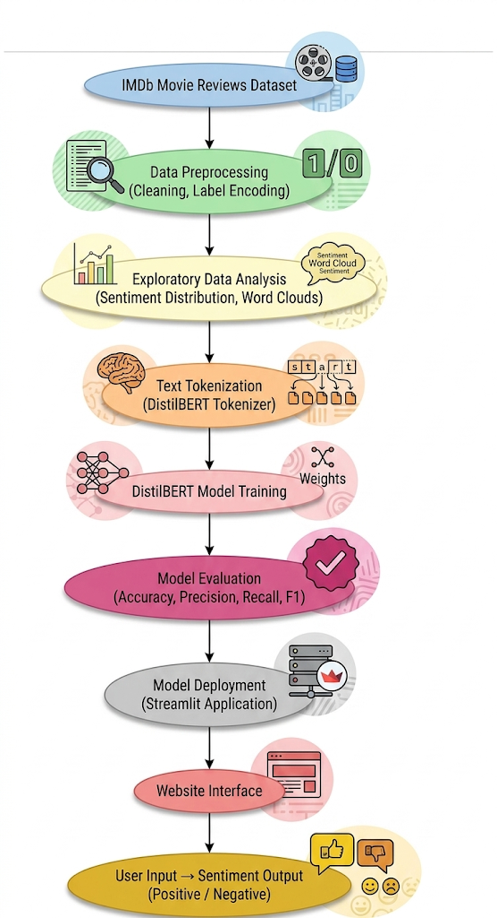
Figure 1.1: Sentiment Analysis System Workflow using DistilBERT

CHAPTER 5: DATA COLLECTION & PREPROCESSING
5.1 Data Collection
The dataset employed in this project is the IMDb Movie Reviews Dataset, which is widely recognized as a benchmark for sentiment analysis research. It contains fifty thousand labelled reviews, evenly distributed into twenty-five thousand positive and twenty-five thousand negative samples. This balanced distribution ensures that the model is trained without bias toward one sentiment category. Each record consists of two attributes: the textual content of the review and its sentiment label. The dataset was obtained from publicly available sources such as the Stanford AI Lab and Kaggle, making it reliable and suitable for deep learning applications.
5.2 Data Loading
The dataset was loaded into the system using Python libraries. Initial inspection confirmed the total number of records, the column structure, and the absence of missing or inconsistent data. The dataset was found to be clean and well-structured, with sentiment labels intact and no null values.
5.3 Data Cleaning
Raw textual data often contains noise that can negatively affect model performance. Several cleaning steps were applied to ensure quality input. HTML tags such as <br /> were removed, special characters and irrelevant symbols were eliminated, and all text was converted to lowercase to maintain uniformity. Whitespace normalization was also performed to remove irregular spacing. These steps ensured that the dataset was clean and consistent.
5.4 Label Encoding
The sentiment labels, originally expressed as “positive” and “negative,” were converted into numerical values to enable binary classification. Positive reviews were encoded as one, while negative reviews were encoded as zero. This transformation ensured compatibility with machine learning models.

5.5 Feature Engineering
Additional features were created to gain deeper insights into the dataset. A new feature representing the length of each review was generated, allowing analysis of text size distribution. Statistical measures such as average, minimum, and maximum review lengths were calculated, which informed decisions about sequence length during tokenization.
5.6 Exploratory Data Analysis
Exploratory Data Analysis was conducted to identify patterns and distributions. Sentiment distribution confirmed that the dataset was perfectly balanced. A histogram of review lengths revealed that most reviews fell within a moderate range, though some outliers existed. Word cloud visualizations highlighted common words: positive reviews frequently included terms such as good, great, and love, while negative reviews contained bad, boring, and worst.
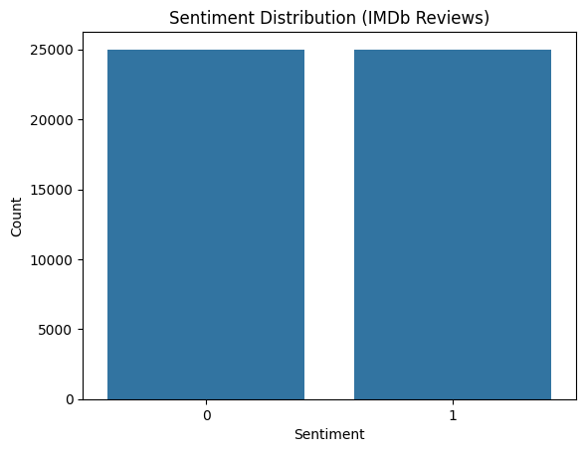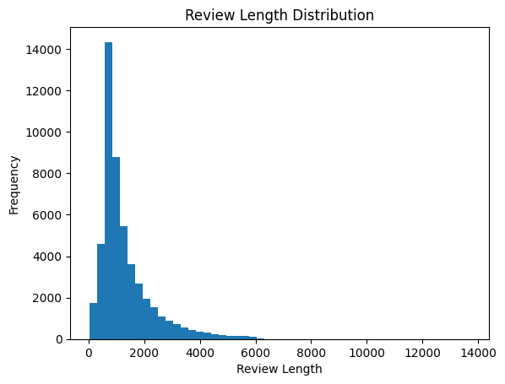
Figure 1.3 : Sentiment Distribution of IMDb Dataset and Distribution of Review Lengths
5.7 Data Splitting
To evaluate model performance effectively, the dataset was divided into training and testing sets. Eighty percent of the data, approximately forty thousand reviews, was used for training, while twenty percent, approximately ten thousand reviews, was reserved for testing. This split ensured that the model was validated on unseen data, reducing the risk of overfitting.

5.8 Text Tokenization
Before training, the text was converted into numerical format using the DistilBERT tokenizer. Reviews were broken into sub word tokens, converted into numerical IDs, and padded or truncated to a fixed maximum length of 256 tokens. Attention masks were generated to help the model focus on relevant parts of the text.
5.9 Data Preparation for Model
The processed inputs were structured into datasets suitable for batch processing. Encoded reviews were aligned with their corresponding sentiment labels, ensuring efficient training and evaluation. This preparation step was critical for optimizing the performance of the DistilBERT model.
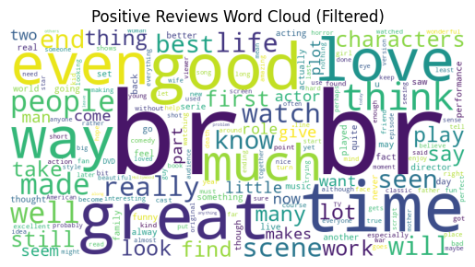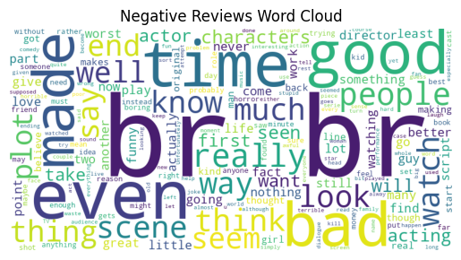
Figure 1.4: Word Cloud of Positive Reviews Figure 1.5: Word Cloud of Negative Reviews

CHAPTER 6: MODEL DEVELOPMENT / IMPLEMENTATION
6.1 Overview
This chapter presents the development and implementation of the sentiment analysis model using the DistilBERT transformer architecture. The model was fine-tuned on the IMDb dataset to classify movie reviews into positive and negative sentiments. Unlike traditional machine learning models, transformer-based architectures capture contextual relationships in text, leading to significantly improved performance in Natural Language Processing tasks.
6.2 Model Selection
The model selected for this project is DistilBERT (Distilled Bidirectional Encoder Representations from Transformers). DistilBERT is a compressed version of BERT that retains most of its performance while being faster and more efficient. It is approximately forty percent smaller than BERT, yet achieves around ninety-five percent of its accuracy. This makes it suitable for real-time applications where speed and scalability are critical.
6.3 Model Architecture
DistilBERT is based on the transformer architecture, which uses self-attention mechanisms to process input text. The architecture includes input embeddings that convert tokens into vector representations, transformer layers that capture contextual relationships, attention mechanisms that assign importance to different words, and a classification head that outputs probabilities for sentiment classes. The model processes text bidirectionally, considering both left and right context simultaneously.
6.4 Model Configuration
The model was fine-tuned using the following configuration: DistilBERT base uncased model, DistilBERT tokenizer, AdamW optimizer, Cross Entropy loss function, three epochs, batch size of sixteen, and maximum sequence length of 256 tokens. These parameters were chosen to balance computational efficiency with performance.

6.5 Training Process
The training process involved tokenizing input text, passing it into the DistilBERT model, generating predictions, calculating loss using Cross Entropy, and updating model weights with the AdamW optimizer. This process was repeated over multiple epochs, allowing the model to learn contextual patterns in movie reviews.
6.6 Fine-Tuning of Pre-trained Model
Instead of training from scratch, a pre-trained DistilBERT model was fine-tuned on the IMDb dataset. Fine-tuning allowed the model to adapt to domain-specific data, improve classification accuracy, and reduce training time by leveraging knowledge already learned from large-scale text corpora.
6.7 Model Evaluation Metrics
Performance was evaluated using accuracy, precision, recall, and F1-score. The model achieved approximately ninety to ninety-one percent accuracy, demonstrating strong capability in sentiment classification. Confusion matrices and ROC curves were also used to visualize classification outcomes and assess reliability.
6.8 Performance Analysis
The model performed well on reviews with clear sentiment, effectively capturing contextual meaning and outperforming traditional machine learning models. Limitations included difficulty in detecting sarcasm, challenges with ambiguous or mixed reviews, and slight performance drops on very short inputs.
6.9 Prediction Mechanism
During prediction, user input is tokenized, processed by the DistilBERT model, and converted into probabilities. The highest probability determines the sentiment class, which is displayed with a confidence score. This mechanism enables real-time sentiment analysis through the deployed application.

CHAPTER 7 : RESULTS AND ANALYSIS
7.1 Overview
This chapter presents the evaluation of the DistilBERT-based sentiment analysis model. The results are analysed using multiple performance metrics and visualizations to assess the effectiveness of the model in classifying movie reviews. The analysis focuses on accuracy, precision, recall, F1-score, and graphical representations such as the confusion matrix and ROC curve.
7.2 Evaluation Metrics
Performance was measured using standard classification metrics. Accuracy represents the proportion of correctly classified reviews. Precision measures how many reviews predicted as positive are actually positive. Recall indicates how well the model identifies all actual positive reviews. The F1-score provides a balance between precision and recall, making it particularly useful for binary classification tasks.
Accuracy: 0.9199
Precision: 0.9164701257861635
Recall: 0.9253820202421116
F1 Score: 0.9209045126888515
7.3 Model Performance
The fine-tuned DistilBERT model achieved an approximate accuracy of ninety-one percent. This indicates that the model correctly classifies the majority of movie reviews. High accuracy was observed for reviews with clear sentiment, and the model demonstrated strong contextual understanding of language. Compared to traditional machine learning models such as Naive Bayes and Support Vector Machines, DistilBERT showed superior performance.
7.4 Confusion Matrix Analysis
The confusion matrix provided a detailed breakdown of classification results. True positives represented correctly predicted positive reviews, while true negatives represented correctly predicted negative reviews. False positives occurred when negative reviews were incorrectly classified as positive, and false negatives occurred when positive reviews were misclassified as negative. The matrix revealed a high number of correct predictions, validating the robustness of the model.
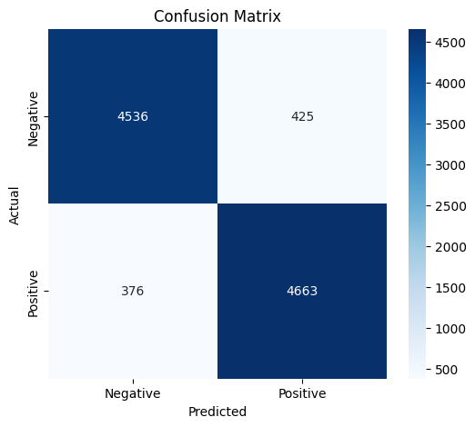
Figure 1.6: Confusion Matrix for Sentiment Classification
7.5 ROC Curve Analysis
The ROC curve was used to evaluate the model’s ability to distinguish between classes. The curve was observed to be close to the top-left corner, indicating strong performance. The Area Under Curve (AUC) value was high, suggesting that the model has excellent classification capability.
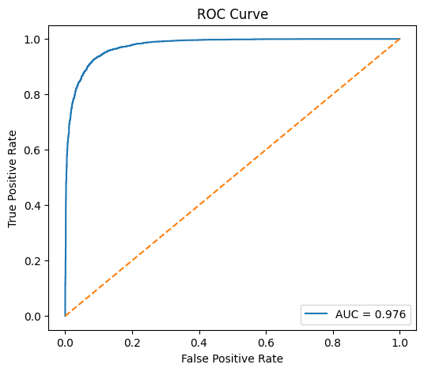
Figure 1.7: Training Loss over Epochs

7.6 Training Performance
Training performance was monitored using loss values across epochs. The training loss consistently decreased, indicating that the model was learning effectively. No significant overfitting was observed, as validation performance remained stable.
7.7 Sample Predictions
Sample predictions were tested to demonstrate real-world performance. For example, the review “The movie was fantastic with great acting” was correctly classified as positive, while “The plot was boring and poorly executed” was correctly classified as negative. These examples highlight the model’s ability to handle both simple and moderately complex sentences.

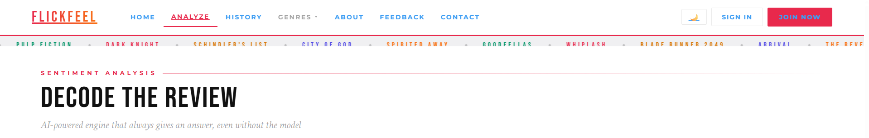
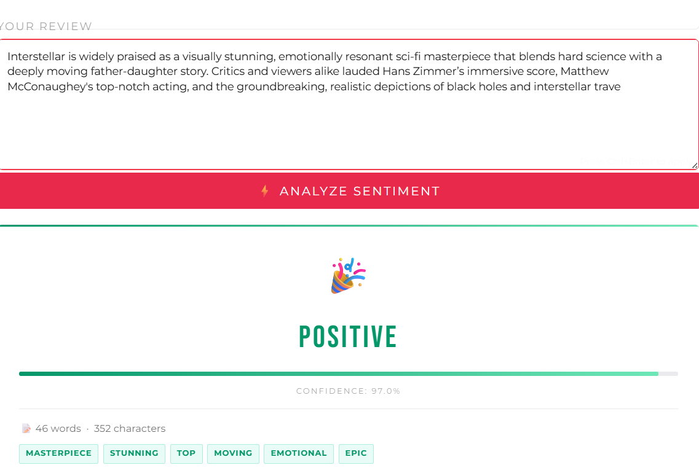
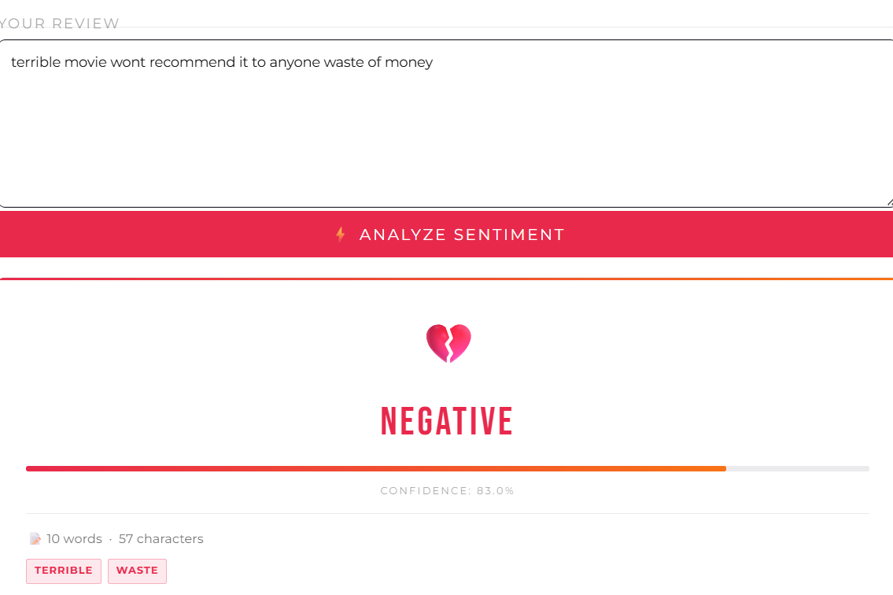
Figure 1.8 Review Analysis on FlickFeel
7.8 Comparison with Traditional Models
When compared to traditional machine learning models, DistilBERT demonstrated clear superiority. Naive Bayes achieved approximately eighty percent accuracy, Support Vector Machines achieved around eighty-five percent, while DistilBERT achieved ninety-one percent. This comparison highlights the advantage of transformer-based architectures in capturing contextual meaning.
Model | Accuracy
Naive Bayes | ~80%
SVM | ~85%
DistilBERT | ~91%
Table 1.3 Comparison to traditional machine learning models
7.9 Summary
The results demonstrate that the DistilBERT model is highly effective for sentiment analysis tasks. With an accuracy of approximately ninety-one percent, the model shows strong capability in understanding textual data and classifying sentiments accurately. The use of advanced evaluation techniques such as confusion matrix and ROC curve further validates the robustness of the model. While challenges remain in handling sarcasm and ambiguous inputs, the overall performance confirms the suitability of DistilBERT for real-world sentiment analysis applications.

CHAPTER 8: INTEGRATION OF SUBJECTS
Course Code | Course Name | Concept Used
MSDS201 | Multivariate Analysis | Statistical analysis, correlation, understanding data distribution
MSDS202 | Data Visualization | Graph plotting, word clouds, data interpretation
MSDS203 | Big Data and Data Clouds | Handling large datasets, data processing concepts
MSDS204 | Artificial Intelligence and Data Science | Model building, intelligent decision systems
MSDS205 | Data Mining and Machine Learning | Classification, training, evaluation metrics
MSDS206 | Linear Models in Data Science | Regression concepts, model understanding

CHAPTER 9 : CONCLUSION AND FUTURE WORK
9.1 Conclusion
The project successfully developed a sentiment analysis system using the DistilBERT model. The system demonstrated high accuracy in classifying movie reviews and effectively handled real-world textual data. Integration into a Streamlit-based web application enabled real-time prediction, making the system practical and user-friendly.
9.2 Future Work
Future enhancements include extending the system to multi-class sentiment classification (positive, negative, neutral), adding multilingual support, improving sarcasm detection, optimizing model performance, and deploying the solution as a scalable API.

REFERENCES
- Sanh, V., Debut, L., Chaumond, J., & Wolf, T. (2019). DistilBERT: A distilled version of BERT. arXiv preprint arXiv:1910.01108.
- Maas, A. L., Daly, R. E., Pham, P. T., Huang, D., Ng, A. Y., & Potts, C. (2011). Learning word vectors for sentiment analysis. Proceedings of the ACL.
- Pang, B., & Lee, L. (2008). Opinion mining and sentiment analysis. Foundations and Trends in Information Retrieval.
- Devlin, J., Chang, M. W., Lee, K., & Toutanova, K. (2019). BERT: Pre-training of deep bidirectional transformers for language understanding. NAACL.
- Vaswani, A., et al. (2017). Attention is all you need. Advances in Neural Information Processing Systems (NeurIPS).
- Liu, B. (2012). Sentiment analysis and opinion mining. Morgan & Claypool Publishers.
- Zhang, L., Wang, S., & Liu, B. (2018). Deep learning for sentiment analysis: A survey. Wiley Interdisciplinary Reviews: Data Mining and Knowledge Discovery.
- Brownlee, J. (2020). How to develop a sentiment analysis model in Python. Machine Learning Mastery.
https://machinelearningmastery.com
- Hugging Face. (2023). Transformers documentation.
https://huggingface.co/docs/transformers
- Stanford AI Lab. (2011). IMDb dataset.
https://ai.stanford.edu/~amaas/data/sentiment/
- TensorFlow. (2023). Text classification with transformers.
https://www.tensorflow.org
- PyTorch. (2023). Deep learning framework documentation.
https://pytorch.org

APPENDICES
Appendix A: Sample Code Snippets
The dataset was loaded and prepared for analysis using Python.
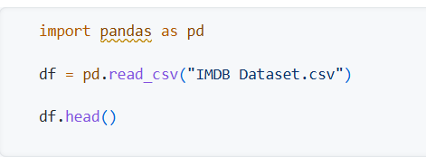
A.2 Tokenization using DistilBERT
Text data was converted into tokens using the DistilBERT tokenizer.
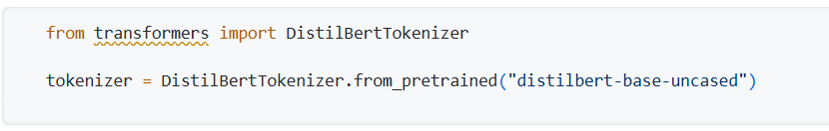
A.3 Model Training Setup
The DistilBERT model was configured for sentiment classification.
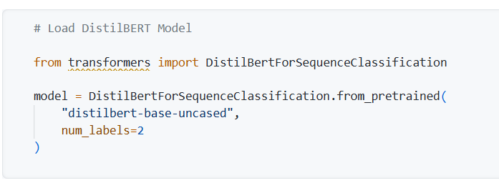

A.4 Model Training
The model was trained using the Trainer API.
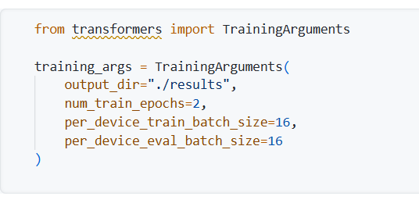
Appendix A: Model Evaluation Output
