International Information Technology University
Faculty of Business Media and Management
Department of Information Systems

Laboratory Work 6
  - Forms and Validation
Thymeleaf Bean Validation Localization Exception Handling

Course RWPSF 3305 Web Application Development with Spring Framework
Educational Programme 6B06105 Information Systems
Team members Aruzhan Zhaksybekova and Mukhamedjan Arman
Group IT1-2404IS
Individual Variant 11
Lecturer Yemberdiyeva Aknur

Almaty 2026

Aim and implemented result
We implemented a book creation form with Spring MVC and Thymeleaf. The form binds request parameters to BookForm, validates the fields with Jakarta Bean Validation, displays messages in English and Russian, and saves valid input through Post/Redirect/Get. A missing book produces an HTML error page or a JSON ProblemDetail response, both with status 404.
The aim is to combine form binding, declarative validation and centralized exception handling while preserving the submitted values when an invalid form is displayed again.
The supplied project contained Laboratory Work 4. We restored the missing book catalogue needed for Laboratory Work 6 in the kz.iitu.springlab.lab6 namespace. BookService stores books in process memory; restarting the application restores the three initial records.
Repository branch lab06: https://github.com/7arman1015-art/spring-lab-01/tree/lab06
Repository status: The lab06 branch is published on GitHub. The code, evidence and report are stored in the repository.
Initial implementation commit: d8df0f1e15fe8949c859466a6c472ac3d4fd5d67

Implementation steps
1. Added spring-boot-starter-thymeleaf and spring-boot-starter-validation. Created BookForm, the Genre enumeration, the separate Book record and the book storage service.
2. Added GET /books/new with an empty form object and the genre list. Bound the template with th:object and th:field, and displayed errors using th:errors, th:errorclass and #fields.
3. Implemented POST /books with BindingResult immediately after the @Valid BookForm parameter. Invalid input returns the same form with the genre options restored. Valid input creates a book, adds a flash message and redirects to /books.
4. Moved labels, error messages, genre names and the success message into messages.properties and messages_ru.properties. Configured SessionLocaleResolver and LocaleChangeInterceptor with the lang parameter and English as the default locale.
5. Created @NoDigits and NoDigitsValidator for the author field. The validator accepts null; @NotBlank separately enforces required input. Added separate advice for HTML pages and the API.
6. Implemented Variant 11 with @ModelAttribute libraryName in PageExceptionHandler. The localized library name is supplied automatically to the catalogue page models.
7. Verified invalid and valid submissions in the browser, both locales, both 404 responses and a reload after a successful save. The following sections contain the measured results and screenshots.

Build and behavior verification
Verification command: Maven 3.9.16: mvn -B package, run directly from the Maven Wrapper cache.
Result: BUILD SUCCESS. Tests run: 18, Failures: 0, Errors: 0, Skipped: 0.
Tests executed: 18
Check | Observed result
Rejected submissions | Six invalid submissions did not create any books.
Variant 11 | libraryName appears in the shared header of the form, catalogue, detail page and error page.
404 responses | HTML: 404 text/html. API: 404 application/problem+json. The response bodies and headers were also saved.
Browser | The forms were submitted in a real headless Google Chrome session. No pageerror events were detected.

Post/Redirect/Get verification: Verified in real Chrome: POST /books returned HTTP 302 with Location: http://localhost:8080/books, followed by GET /books. One book was created. After reloading the page, the flash message disappeared and the total remained four books.

Responses for a missing book
Both requests use the missing identifier 999. BookService throws BookNotFoundException; the controller type and the scope of its advice determine the response format.
Request | Status and Content Type | Handler and response
GET /books/999 | 404  text/html;charset=UTF-8 | PageExceptionHandler.bookNotFound  HTML view error/not-found with a localized Book not found message for identifier 999.
GET /api/books/999 | 404  application/problem+json | ApiExceptionHandler.bookNotFound  JSON ProblemDetail with status=404 and instance=/api/books/999.

Application screenshots and observed results
These screenshots were captured from the running application. The four required cases show an empty title, the year 1200, a missing genre and a successful submission. The English and Russian forms each include a validation message. Further captures show @NoDigits, simultaneous field errors, 404 responses and Variant 11.
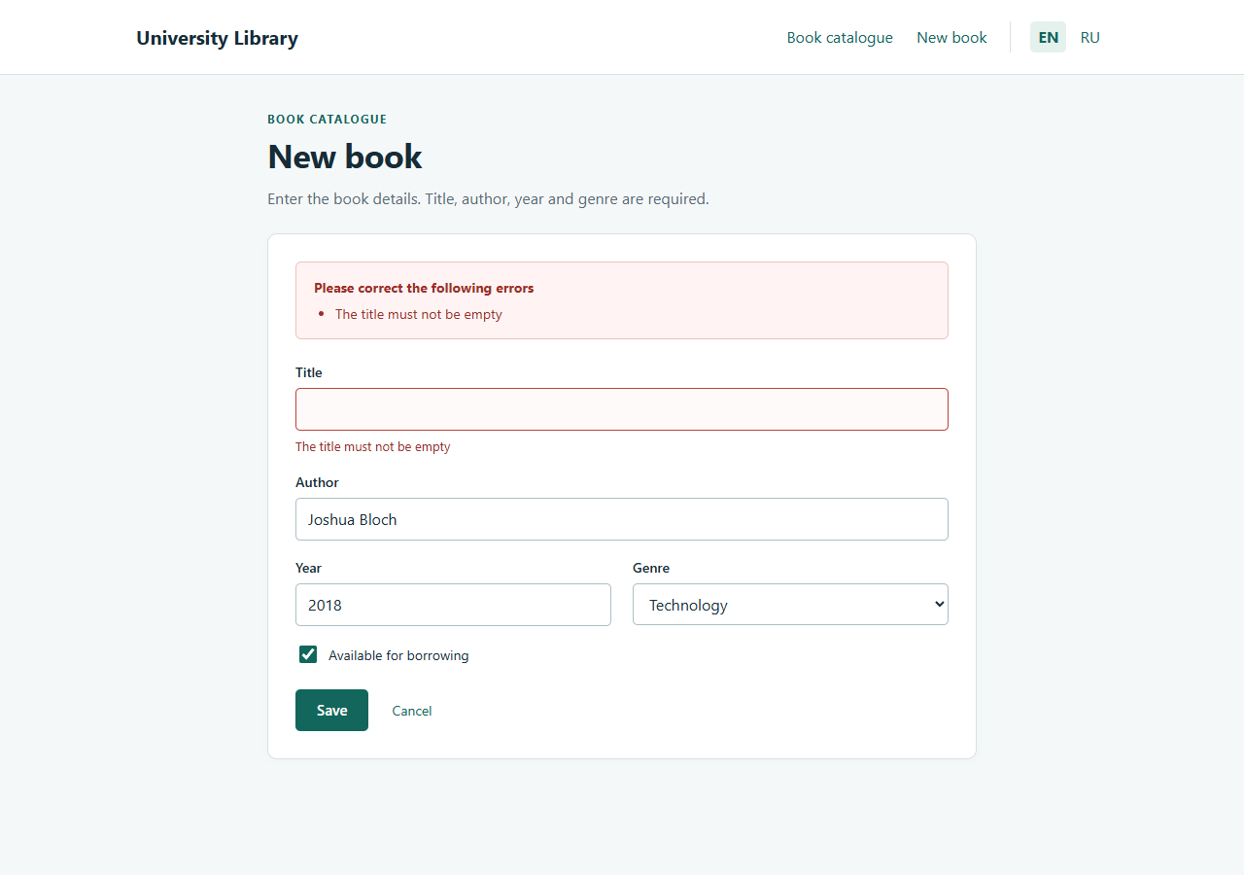
Figure 1. An empty title produces an English validation message
POST /books returned HTTP 200 with the same form. The title error appears next to the field and in the summary. The author, year, genre and availability checkbox retain their values. URL: http://localhost:8080/books
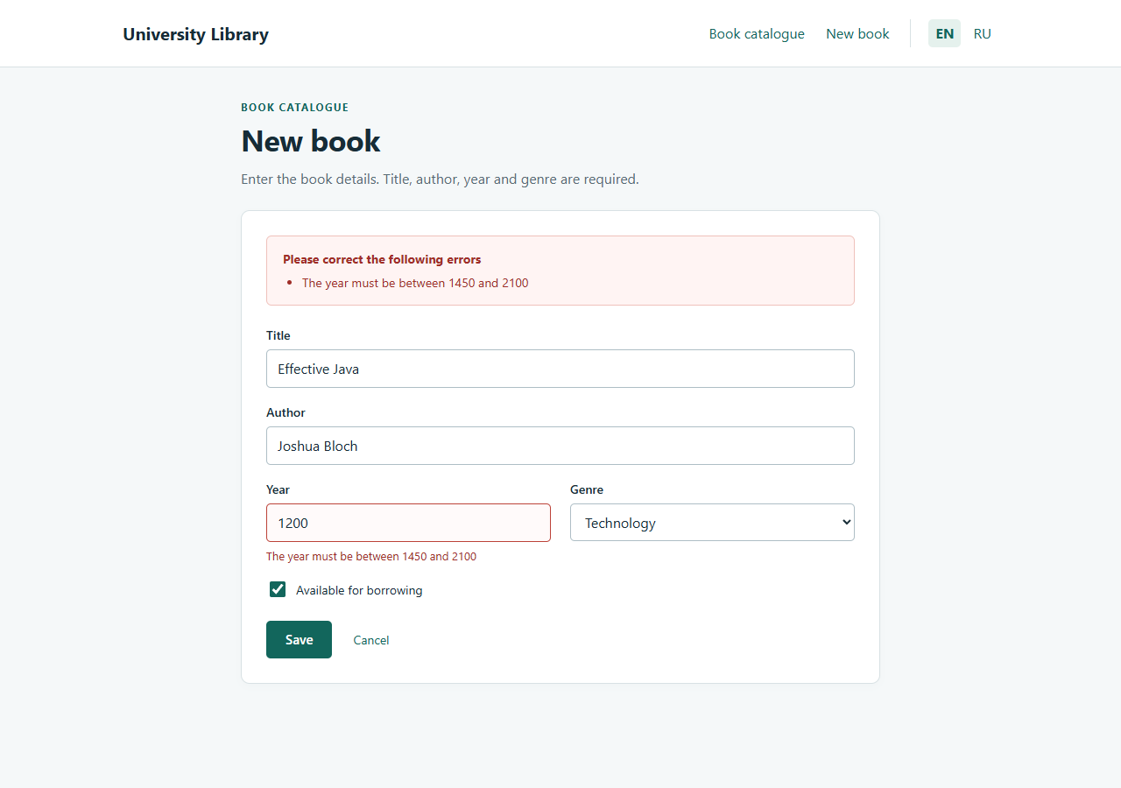
Figure 2. The year 1200 is rejected
@Min rejects the year 1200. The submitted values remain in the form, and the year input has a red border. URL: http://localhost:8080/books
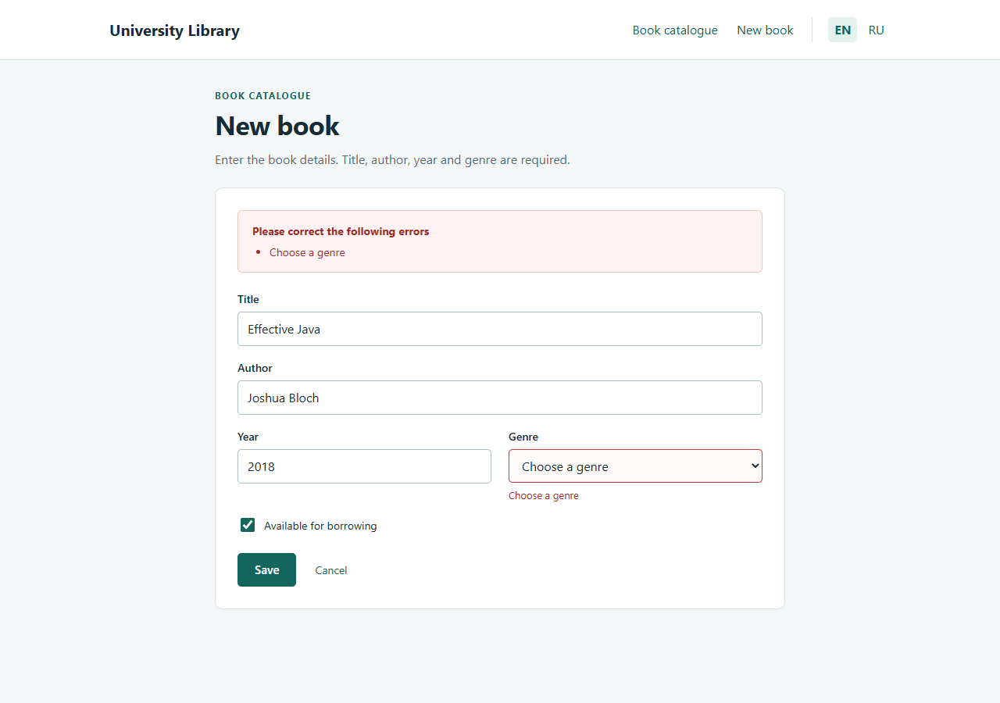
Figure 3. The genre is not selected
@NotNull requires a genre. The title, author, year and availability flag are retained; the controller restores the genre options in the model. URL: http://localhost:8080/books
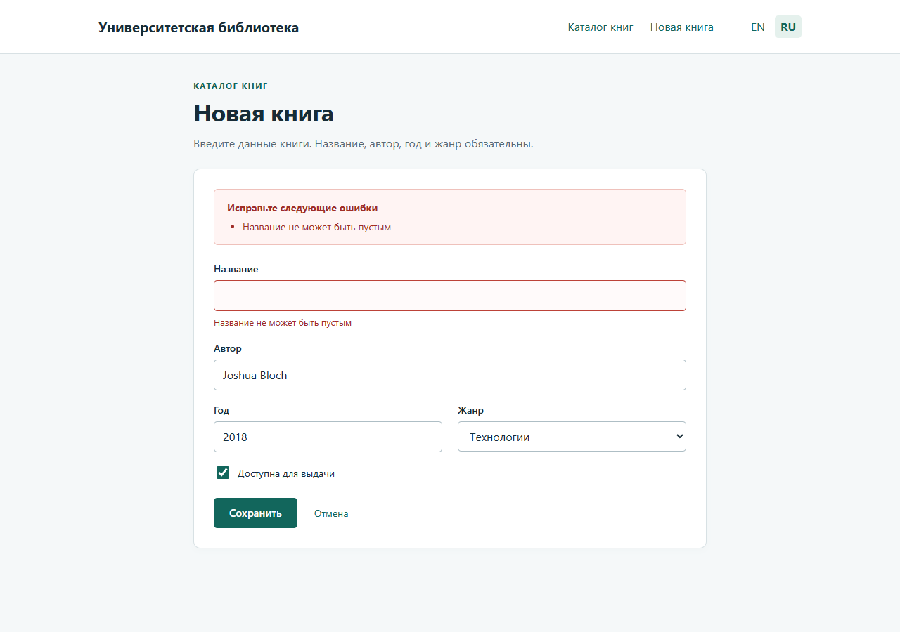
Figure 4. The same form and validation message in Russian
After ?lang=ru, the labels, genres, buttons, shared heading and validation message appear in Russian. The selected locale remains in the HTTP session for the POST request. URL: http://localhost:8080/books
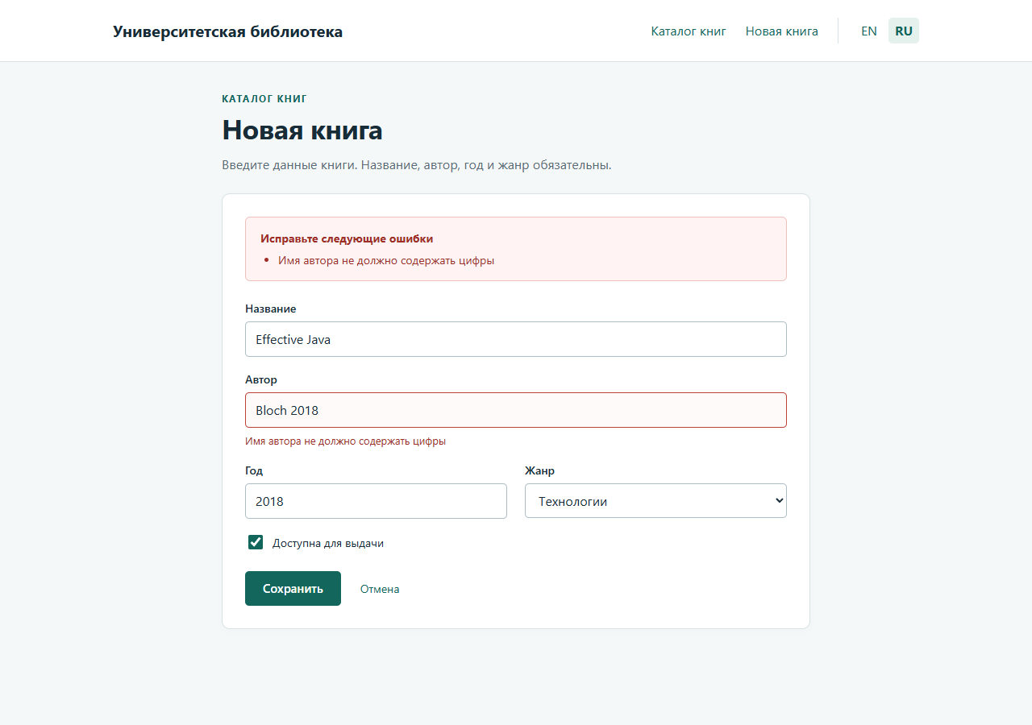
Figure 5. The custom NoDigits constraint rejects an author containing digits
NoDigitsValidator rejects Bloch 2018. The Russian error message is resolved from book.author.nodigits in the Russian resource bundle. URL: http://localhost:8080/books
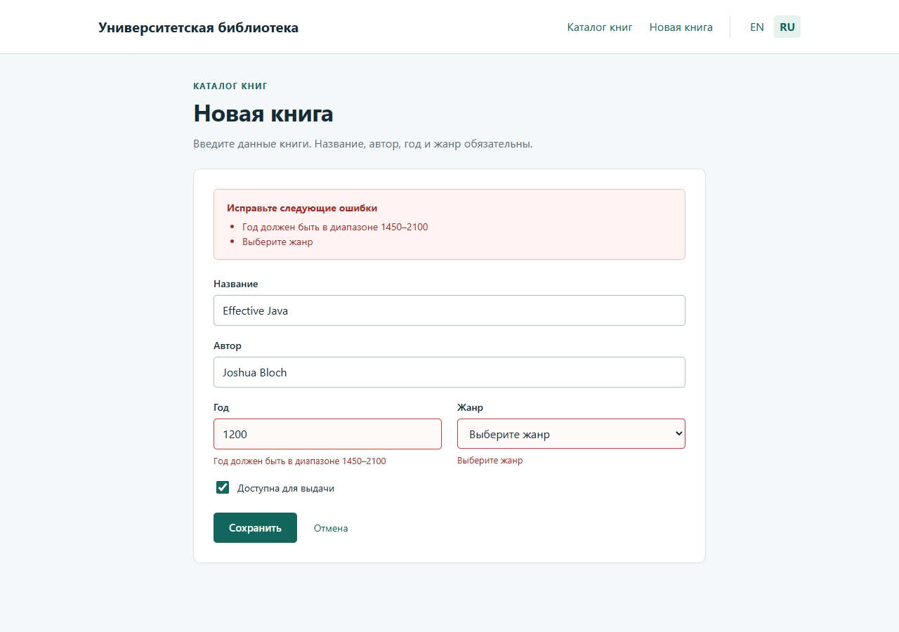
Figure 6. Two field errors are shown together
The year 1200 and the missing genre are checked in the same submission. #fields.allErrors() lists both violations; each message also appears beside its field. URL: http://localhost:8080/books
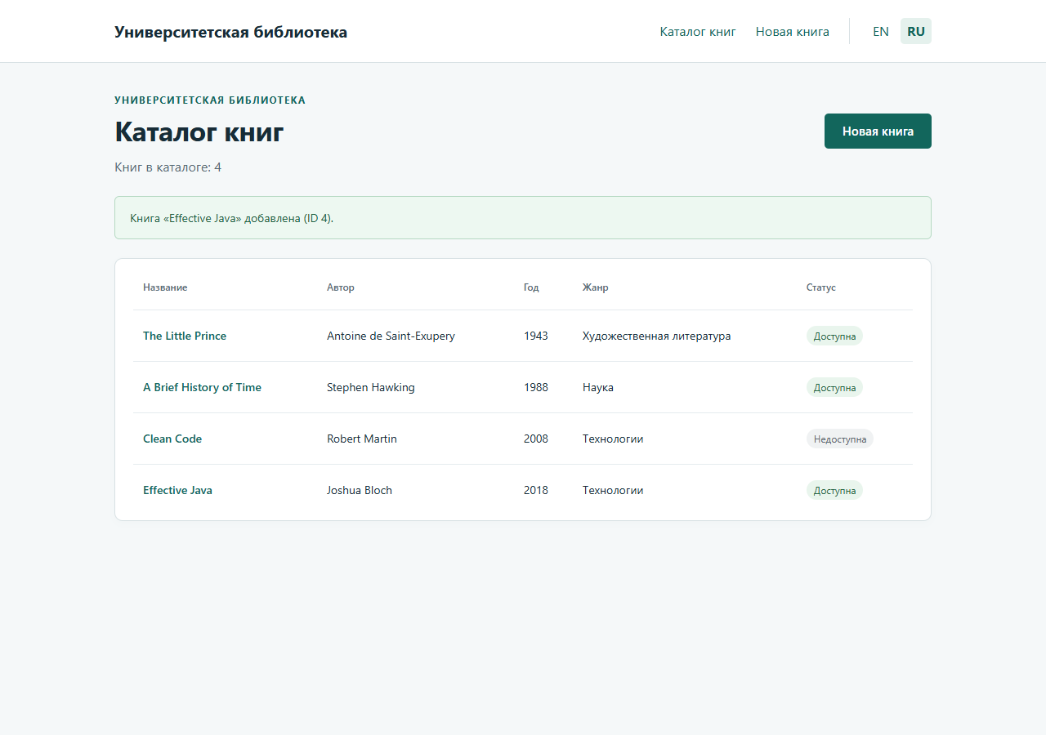
Figure 7. A valid submission creates a book
The valid POST returned HTTP 302 and redirected to /books. The following GET shows a one-time flash message and the new Effective Java book with its selected genre and availability. URL: http://localhost:8080/books
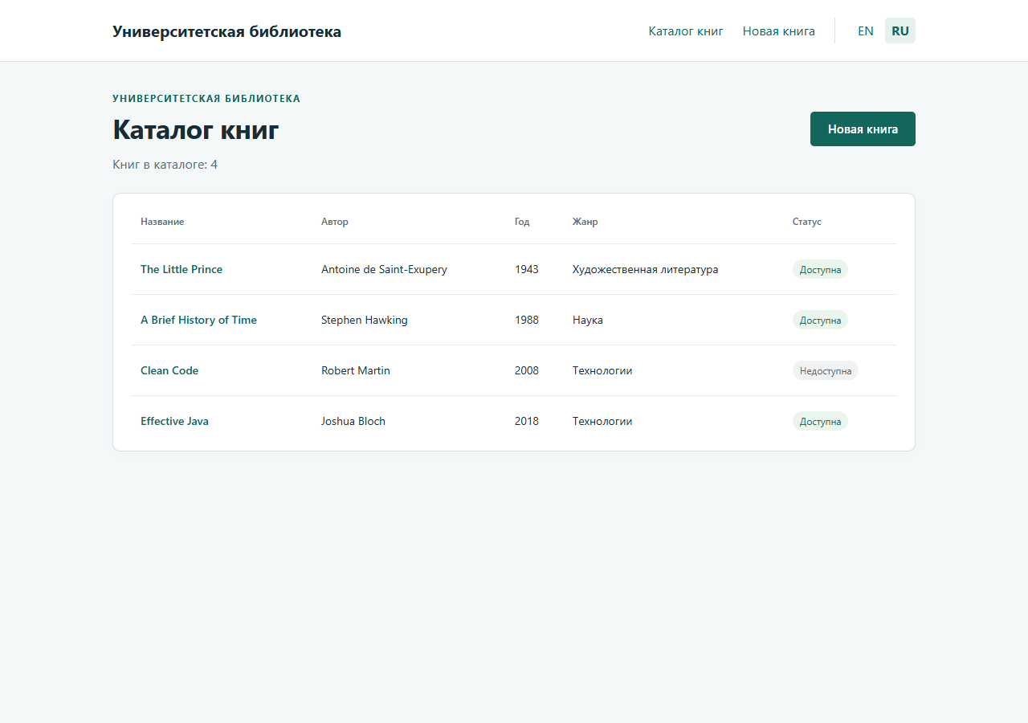
Figure 8. Reloading the result does not create a duplicate
After reloading GET /books, the flash message is gone. The book count remains unchanged, and Effective Java appears exactly once. URL: http://localhost:8080/books
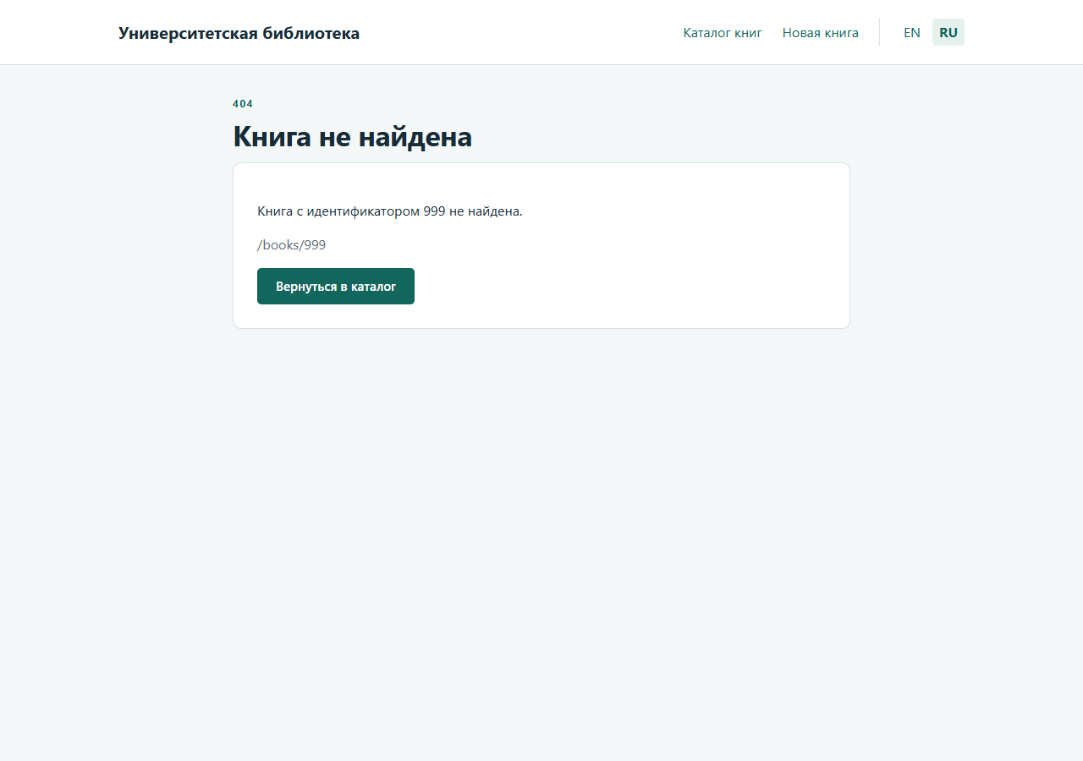
Figure 9. An HTML error page for a missing book
GET /books/999 returned HTTP 404 with the error/not-found HTML view. PageExceptionHandler also supplies the shared libraryName attribute. URL: http://localhost:8080/books/999?lang=ru
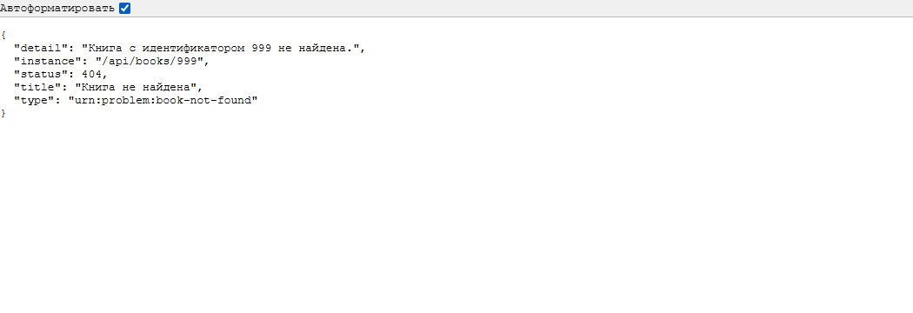
Figure 10. A ProblemDetail response for the API
GET /api/books/999 returned HTTP 404 with Content-Type application/problem+json and the type, title, status, detail and instance fields. ApiExceptionHandler handled the request. URL: http://localhost:8080/api/books/999
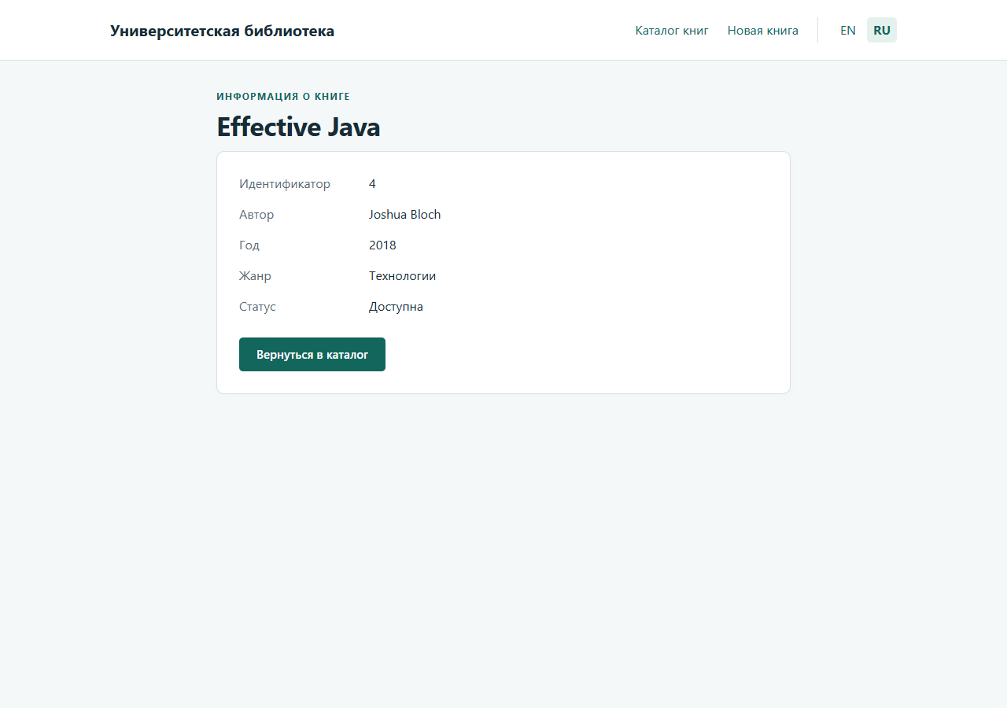
Figure 11. Variant 11 supplies the shared attribute on the book detail page
The detail page displays libraryName supplied by @ModelAttribute in PageExceptionHandler. The same attribute is used by the form, catalogue and HTML error page. URL: http://localhost:8080/books/4?lang=ru

Source code screenshots
The following listings are screenshots of the implemented source code. Each listing identifies its repository path and original line ranges. Long files are split into consecutive captures, including both complete resource bundles.

Form object and data binding
BookForm separates incoming fields from the stored Book record. Integer distinguishes an empty year from a numeric value. @NotNull checks that the year is present, while @Min and @Max enforce the allowed range from 1450 to 2100.

The BookForm class
Listing 1. src/main/java/kz/iitu/springlab/lab6/web/BookForm.java
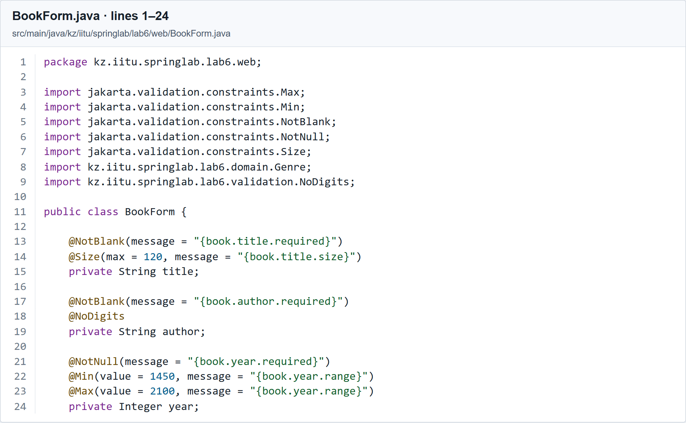
Listing 1 part 1 of 3. Book form and validation constraints. Source lines 1 to 24.
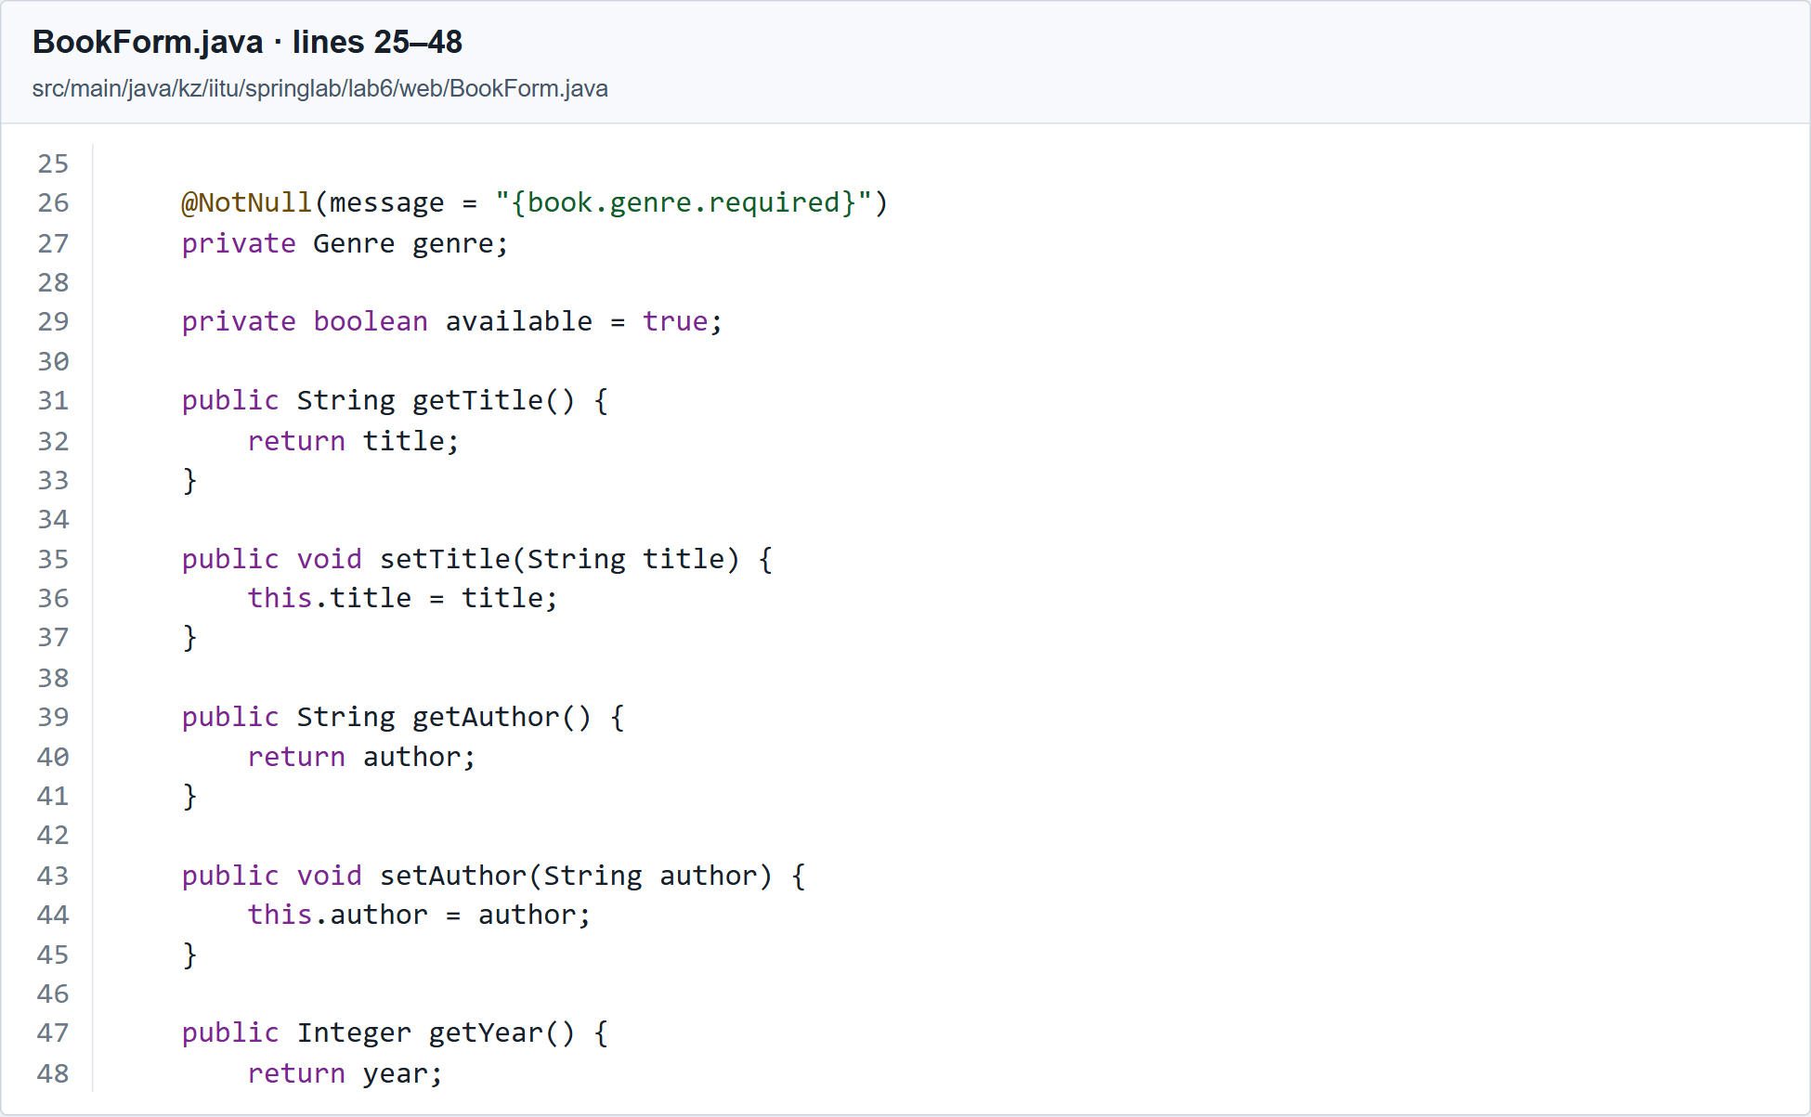
Listing 1 part 2 of 3. Book form and validation constraints. Source lines 25 to 48.
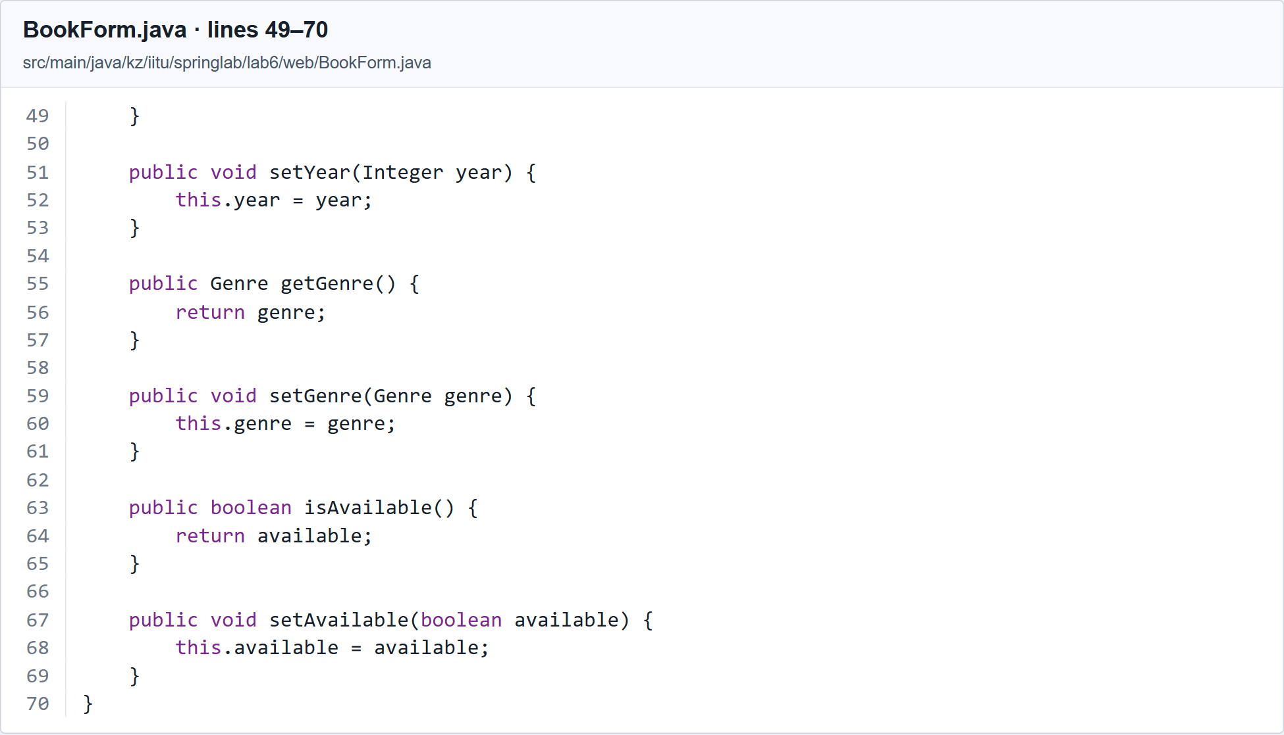
Listing 1 part 3 of 3. Book form and validation constraints. Source lines 49 to 70.

The Genre enumeration
Listing 2. src/main/java/kz/iitu/springlab/lab6/domain/Genre.java
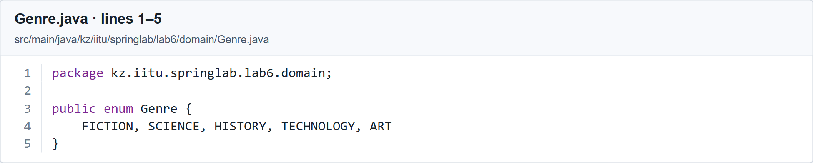
Listing 2. Available book genres. Source lines 1 to 5.

The form template
th:object selects form as the object for *{...} expressions. th:field generates the name, id and current field value, including when invalid input is redisplayed. Messages appear beside the fields and in a summary; CSS highlights invalid fields.

The complete book creation template
Listing 3. src/main/resources/templates/books/form.html
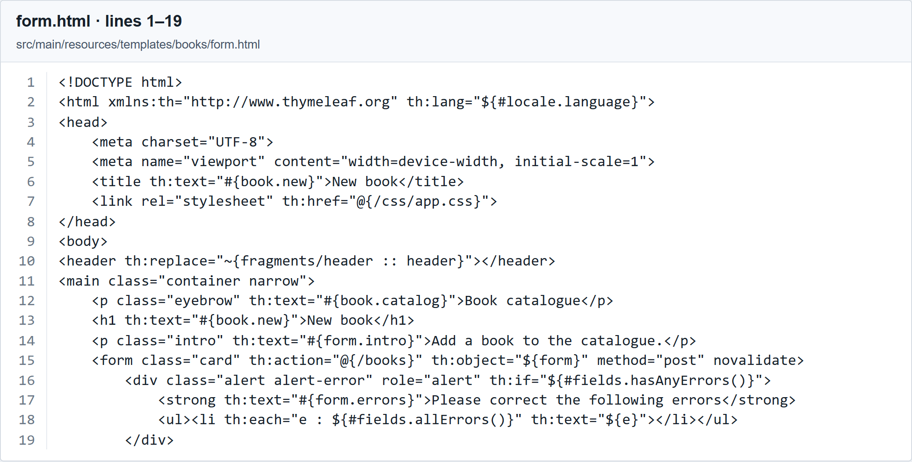
Listing 3 part 1 of 3. Thymeleaf form with binding and validation messages. Source lines 1 to 19.
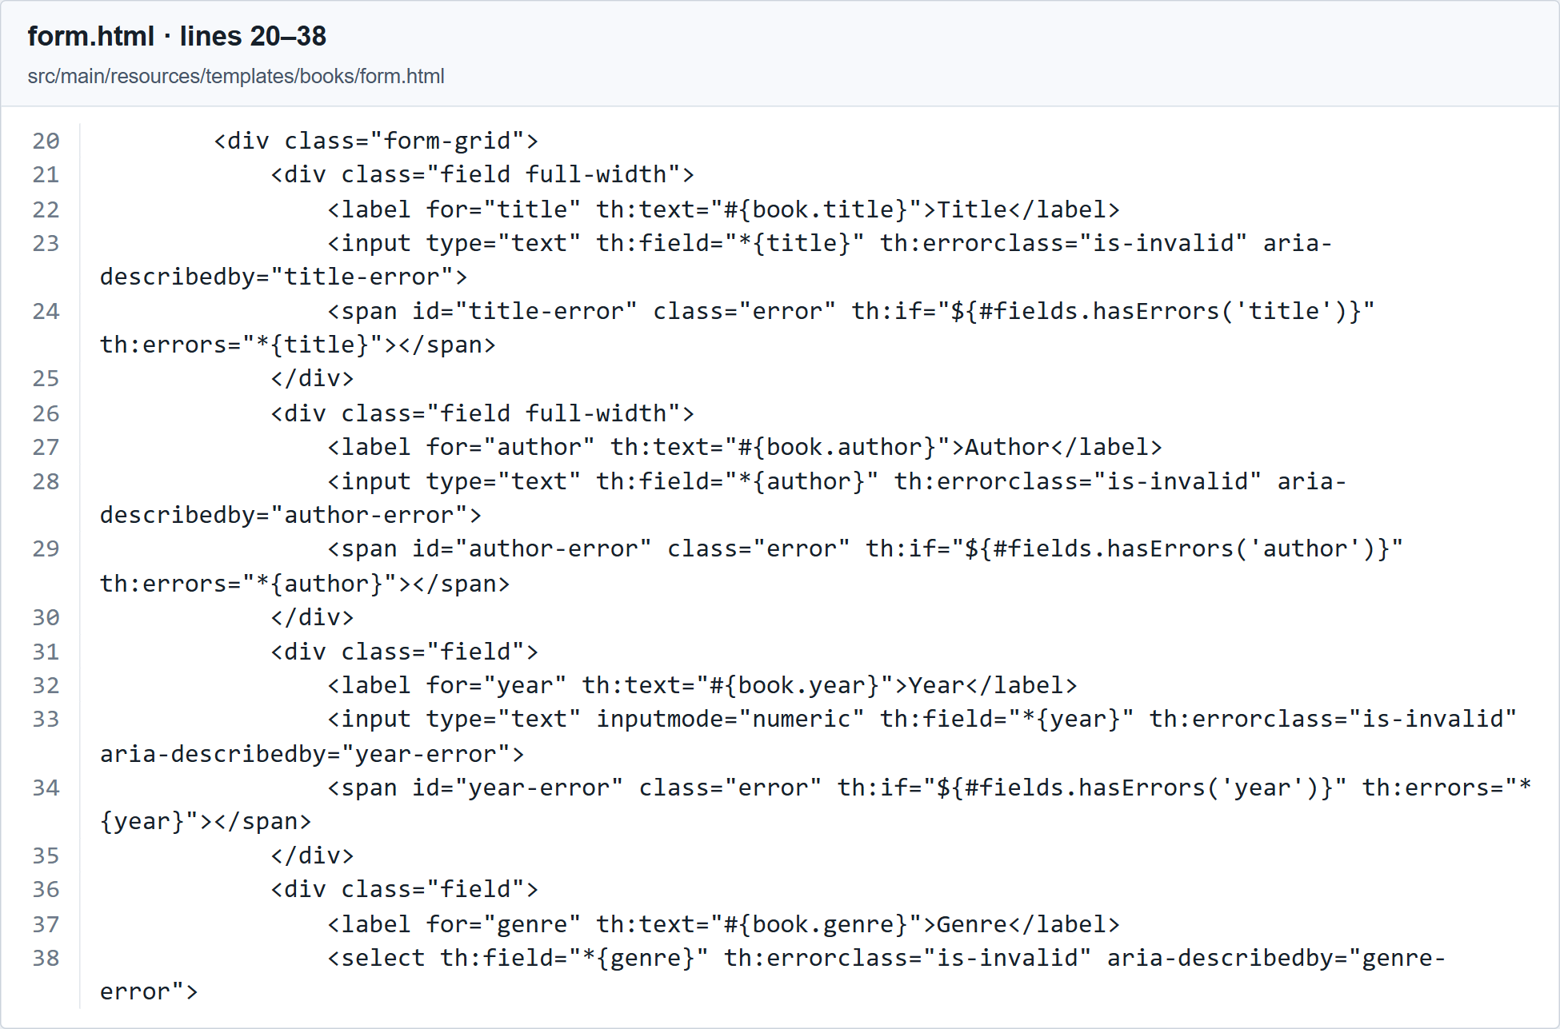
Listing 3 part 2 of 3. Thymeleaf form with binding and validation messages. Source lines 20 to 38.
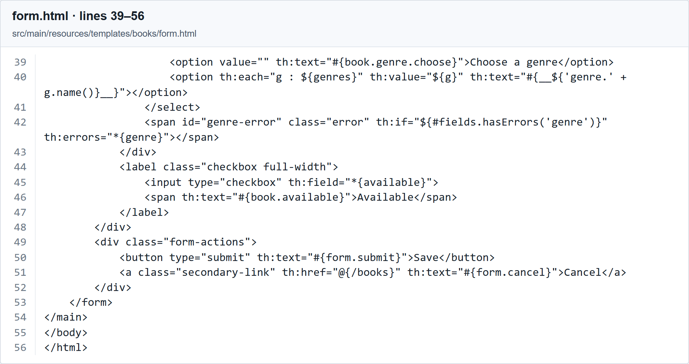
Listing 3 part 3 of 3. Thymeleaf form with binding and validation messages. Source lines 39 to 56.

Handling invalid and valid submissions
@Valid triggers validation and Spring records violations in BindingResult. When errors exist, the controller returns books/form and restores genres. A valid POST finishes with redirect:/books. The localized flash message is available only to the following request.

The POST handler
Listing 4. src/main/java/kz/iitu/springlab/lab6/web/BookPageController.java
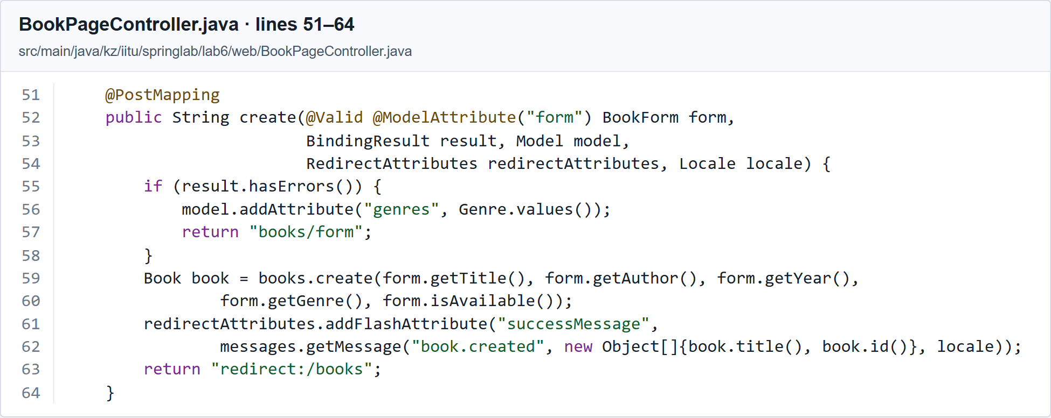
Listing 4. POST handler with BindingResult and Post Redirect Get. Source lines 51 to 64.

The custom author constraint
@NoDigits checks that an author name contains no digits. The annotation declares the required message, groups and payload members and selects NoDigitsValidator. Bloch 2018 is rejected with the message resolved from book.author.nodigits.

The NoDigits annotation
Listing 5. src/main/java/kz/iitu/springlab/lab6/validation/NoDigits.java
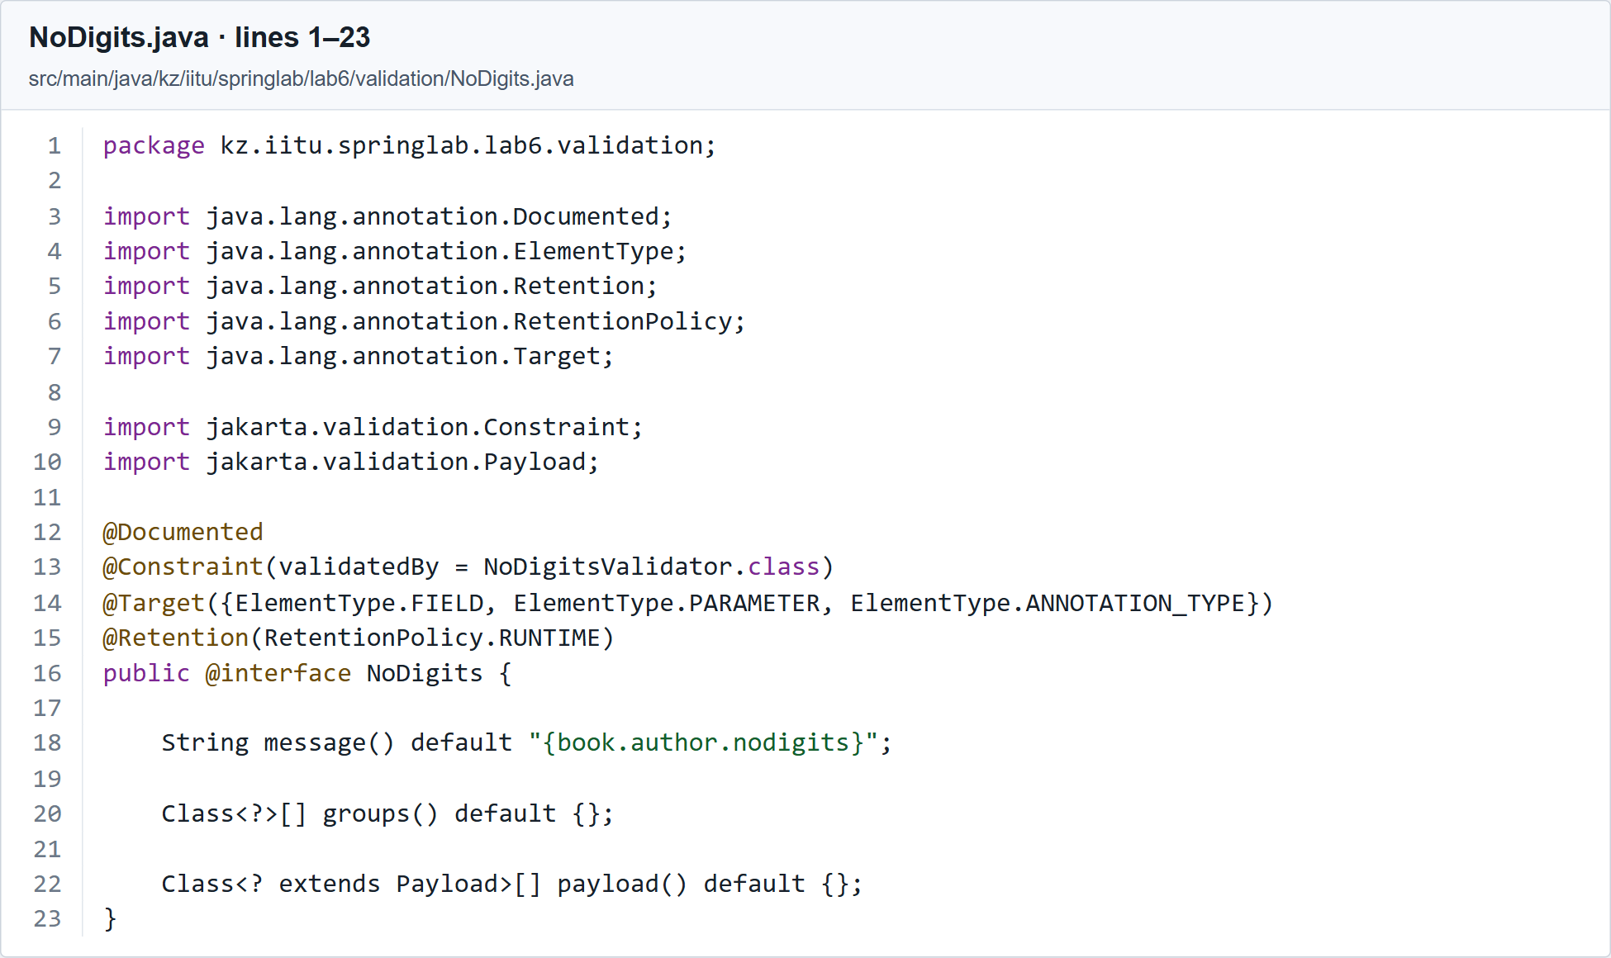
Listing 5. Custom NoDigits constraint annotation. Source lines 1 to 23.

The NoDigitsValidator implementation
Listing 6. src/main/java/kz/iitu/springlab/lab6/validation/NoDigitsValidator.java
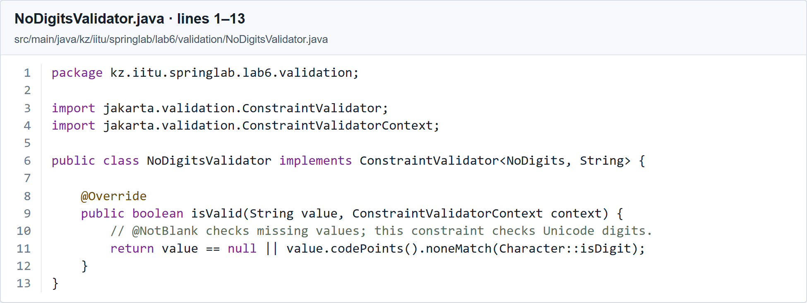
Listing 6. NoDigits validator implementation. Source lines 1 to 13.

Locale selection and centralized exception handling
SessionLocaleResolver stores the selected language in the HTTP session. LocaleChangeInterceptor processes ?lang=en and ?lang=ru. PageExceptionHandler is scoped to the book page controller, while ApiExceptionHandler handles @RestController classes. The same service exception therefore produces the response expected by each client.

Locale configuration
Listing 7. src/main/java/kz/iitu/springlab/lab6/config/LocaleConfiguration.java
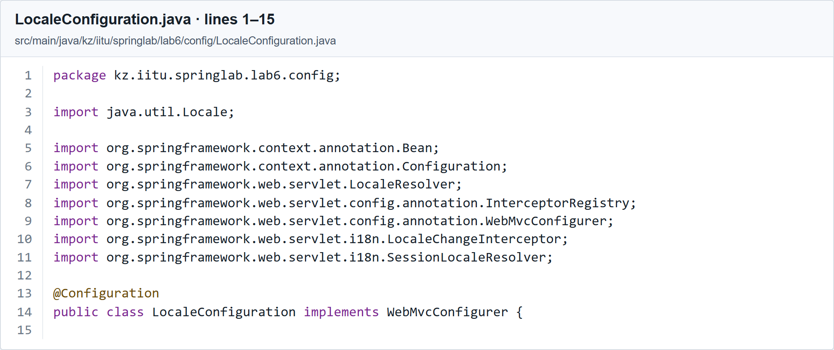
Listing 7 part 1 of 2. Session locale and language interceptor. Source lines 1 to 15.
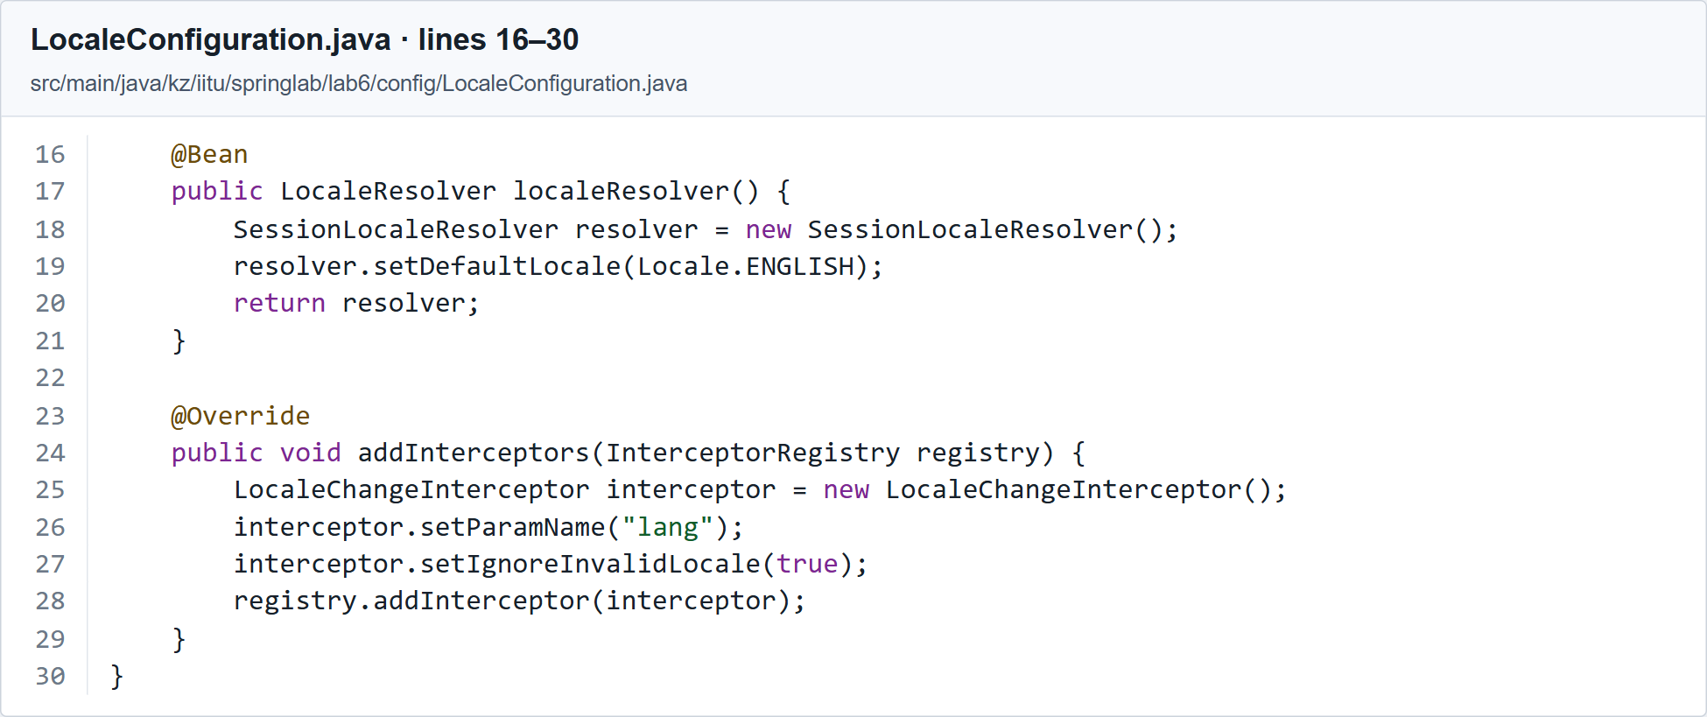
Listing 7 part 2 of 2. Session locale and language interceptor. Source lines 16 to 30.

HTML page advice and Variant 11
Listing 8. src/main/java/kz/iitu/springlab/lab6/web/PageExceptionHandler.java
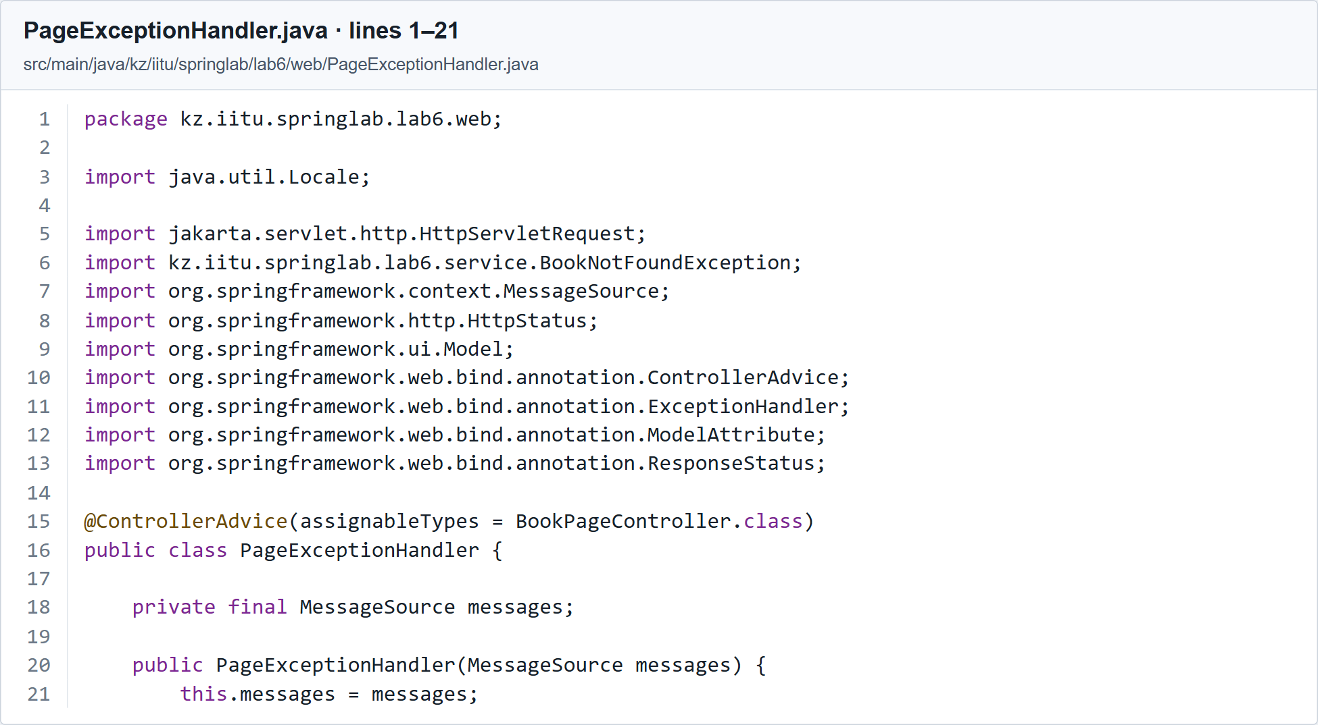
Listing 8 part 1 of 2. HTML advice and shared libraryName model attribute. Source lines 1 to 21.
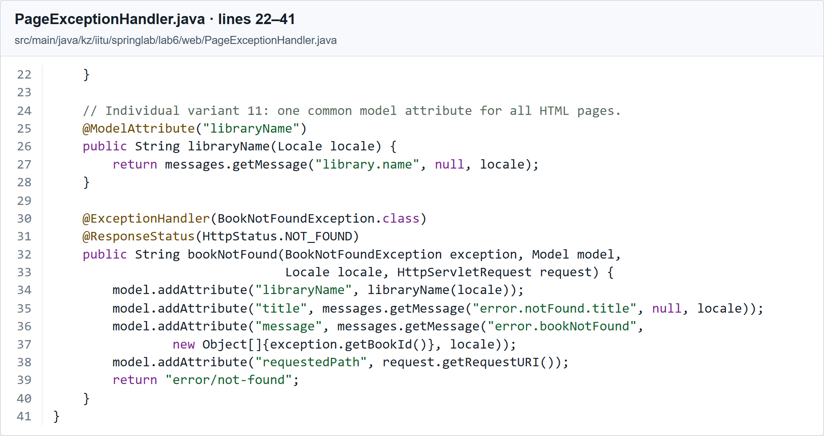
Listing 8 part 2 of 2. HTML advice and shared libraryName model attribute. Source lines 22 to 41.

API advice
Listing 9. src/main/java/kz/iitu/springlab/lab6/web/ApiExceptionHandler.java
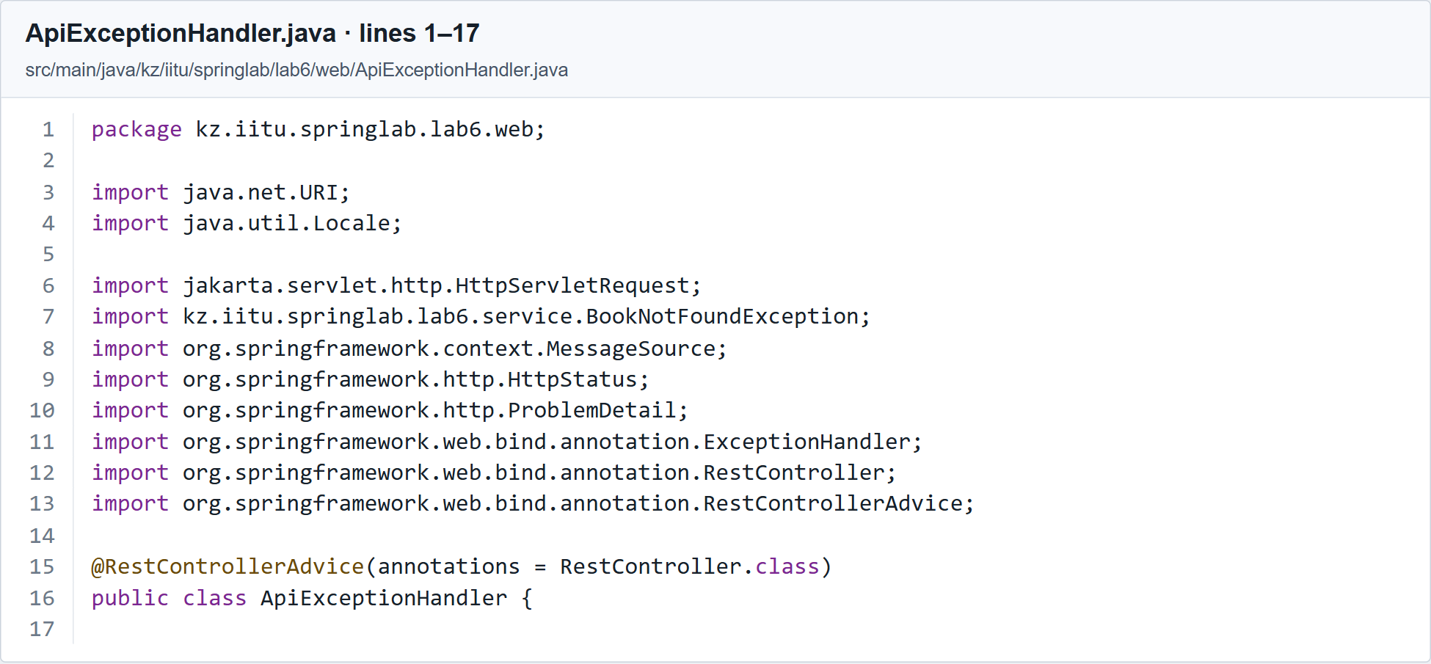
Listing 9 part 1 of 2. REST advice with a ProblemDetail response. Source lines 1 to 17.
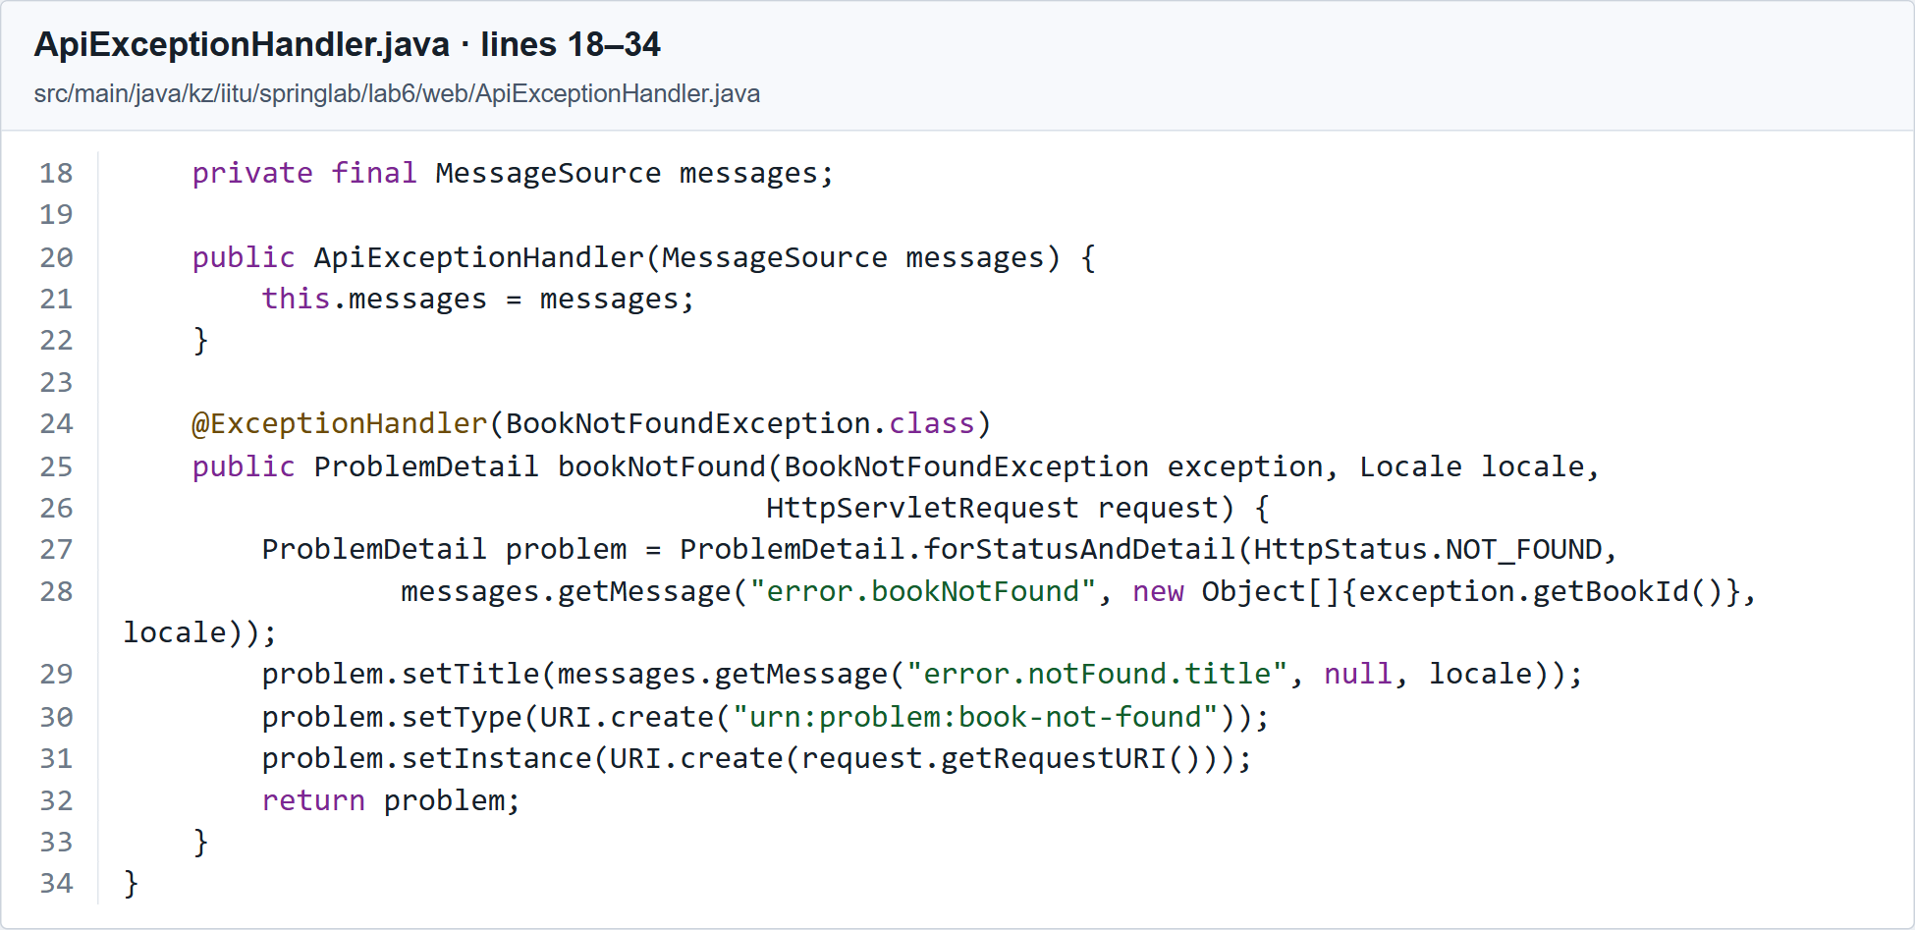
Listing 9 part 2 of 2. REST advice with a ProblemDetail response. Source lines 18 to 34.

Individual Variant 11
Variant 11 requires @ControllerAdvice with @ModelAttribute, a shared model attribute and an exception handler. In Listing 8, libraryName returns the localized library name. The bookNotFound handler in the same class returns error/not-found with status 404.
The shared heading is visible on the form, catalogue, detail page and HTML error page. The normal GET handlers do not each add this attribute manually. Selecting Russian also changes libraryName, as shown in Figures 4, 9 and 11.

Resource bundles
A constraint message in braces is interpreted as a resource key. MessageSource resolves the text for the selected locale, BindingResult retains the error, and th:errors displays it. messages.properties supplies the default bundle and fallback values. Both files use UTF-8; the Russian values are retained to demonstrate the required second language.

English labels and messages
Listing 10. src/main/resources/messages.properties
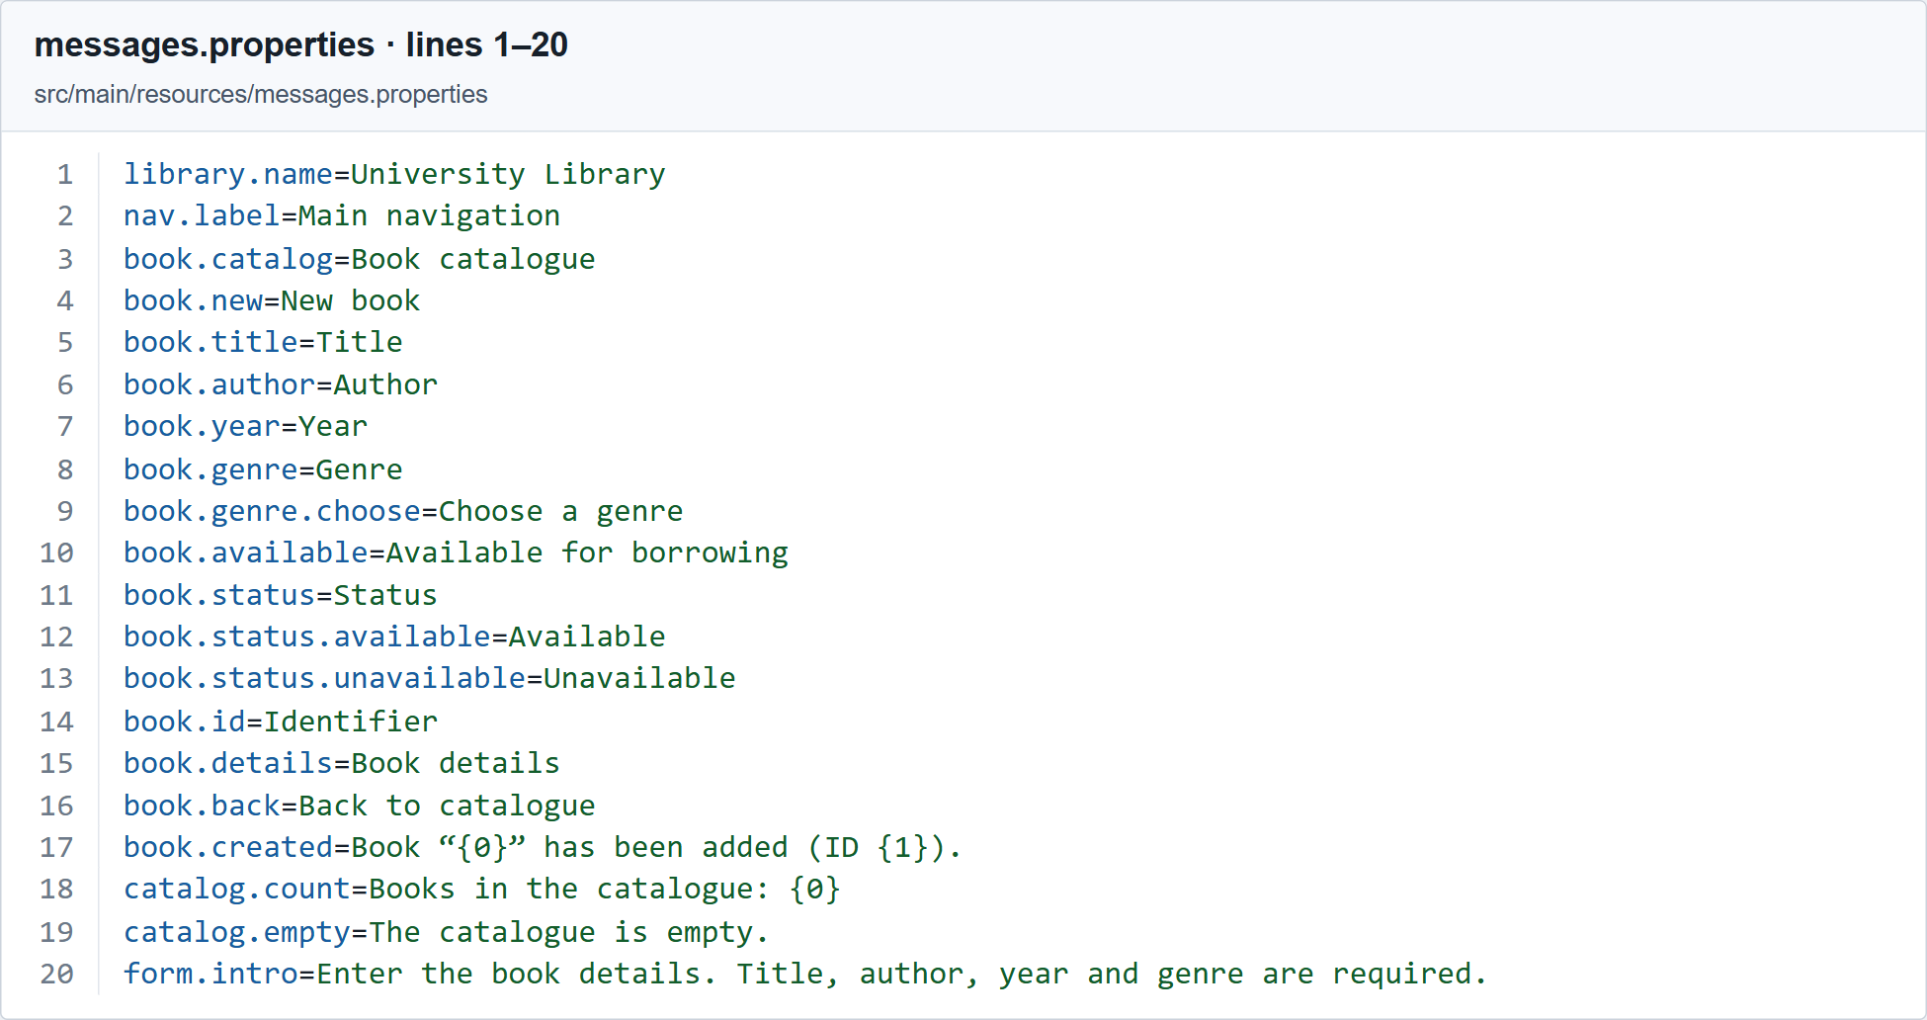
Listing 10 part 1 of 2. English labels and validation messages. Source lines 1 to 20.
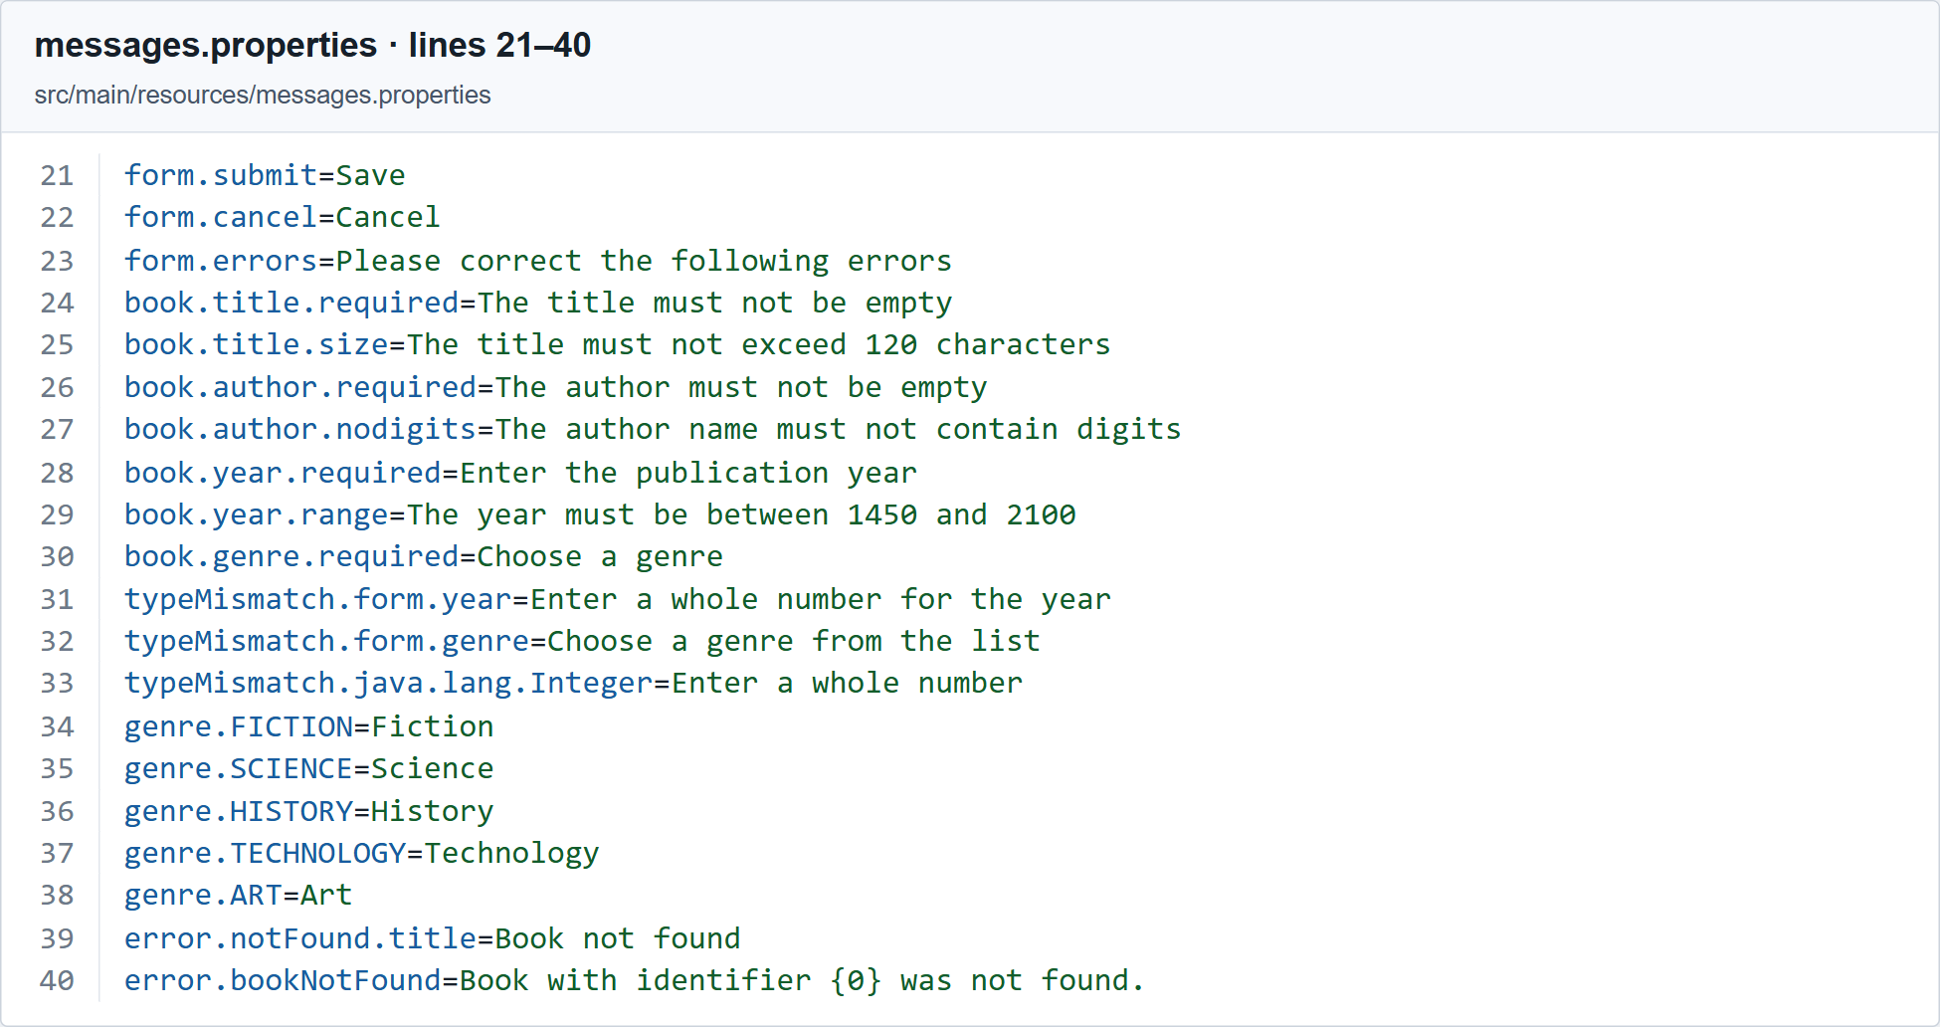
Listing 10 part 2 of 2. English labels and validation messages. Source lines 21 to 40.

Russian labels and messages
Listing 11. src/main/resources/messages_ru.properties
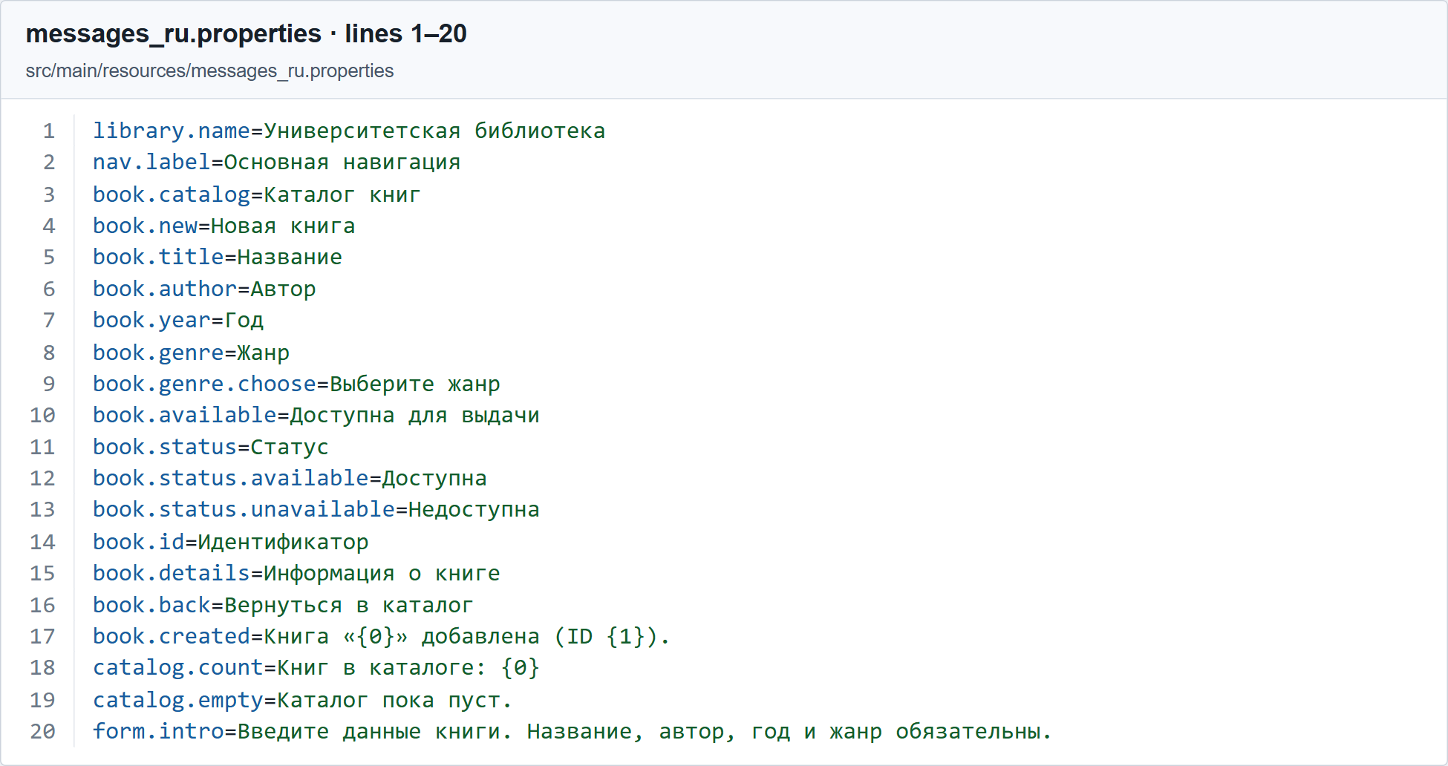
Listing 11 part 1 of 2. Russian labels and validation messages. Source lines 1 to 20.
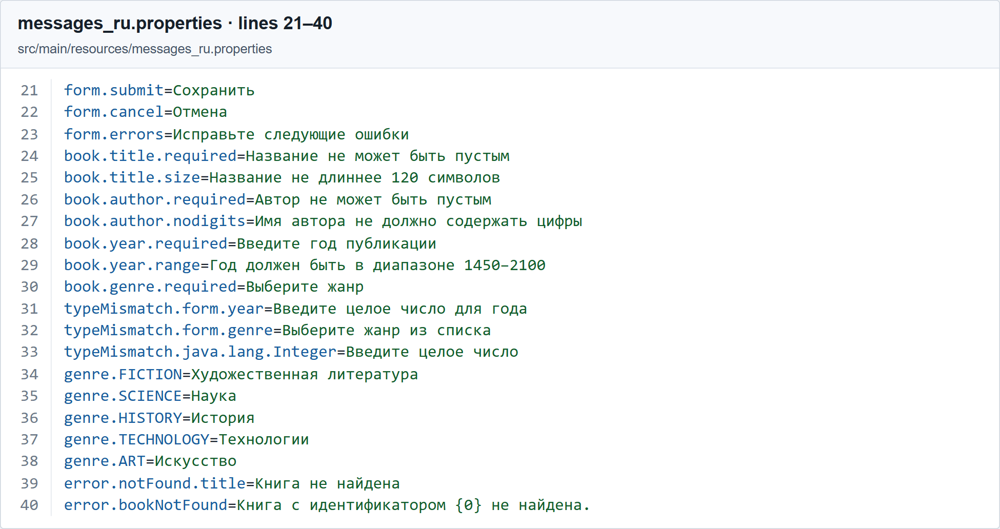
Listing 11 part 2 of 2. Russian labels and validation messages. Source lines 21 to 40.

Comparing the form with the stored model
BookForm has setters for partial binding and constraints for incoming values. Book represents a saved book and contains an identifier assigned by the service. The Book record has no setters; its constructor receives values after successful form validation.

The Book record
Listing 12. src/main/java/kz/iitu/springlab/lab6/domain/Book.java
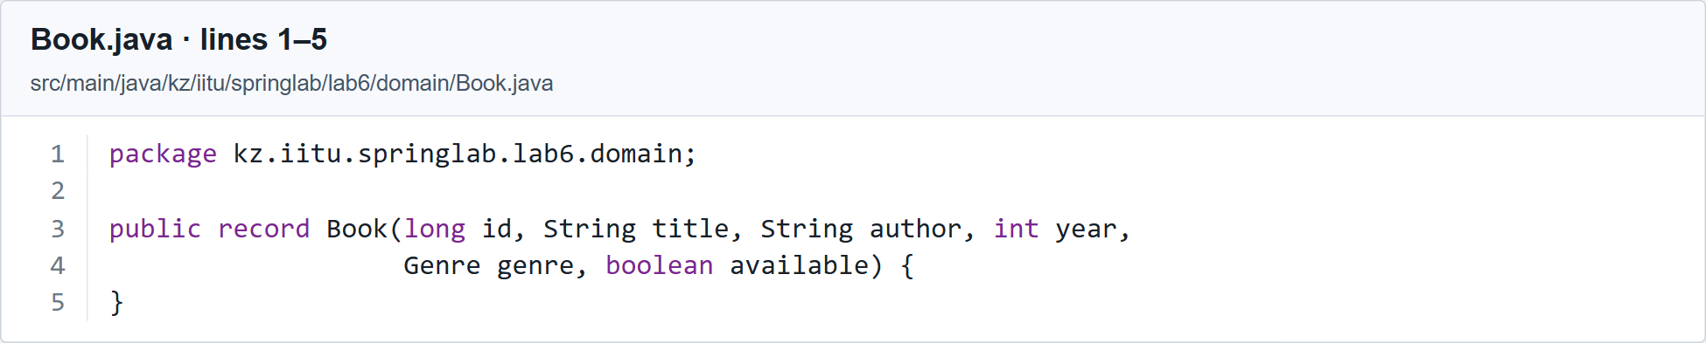
Listing 12. Saved book record. Source lines 1 to 5.
GET /books/new puts an empty BookForm into the model as form and adds Genre.values(). This allows th:object to resolve during the first request and supplies the genre options.

The GET handler for a new book
Listing 13. src/main/java/kz/iitu/springlab/lab6/web/BookPageController.java
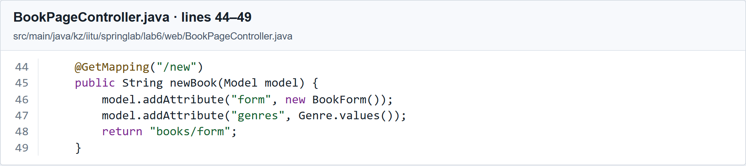
Listing 13. GET handler that initializes the new book form. Source lines 44 to 49.

Conclusions
Declarative validation places field rules in BookForm instead of repeating manual checks in the controller. BindingResult allows all violations to be shown while retaining the submitted values. Resource bundles separate text from code and keep labels and validation messages in the same language. Centralized advice makes HTML and API errors consistent, while Post/Redirect/Get prevents a result-page refresh from repeating the POST.

Short answers for the demonstration
Why use a separate form object. It defines the allowed input fields and validation rules. The stored model can have different fields and constraints.
Why place BindingResult immediately after the form. Spring associates that result with the preceding bound object. Moving it can prevent normal handling of invalid input in this method.
What changes without @Valid. The handler no longer invokes Bean Validation constraints on the object, although binding can still report type conversion errors.
How the required-value constraints differ. @NotNull rejects null. @NotEmpty also rejects empty strings or collections. @NotBlank rejects empty or whitespace-only strings.
Which types of errors are used. The form constraints produce field errors. A year conversion error also belongs to a field. A class-level constraint could create a global error.
Why NoDigitsValidator accepts null. @NotBlank checks required input; the custom validator has the separate responsibility of rejecting digits.
How an exception handler is selected. Spring considers the advice scope and exception type. Local controller handlers are considered before advice; advice order and match specificity affect other choices.
Why display user input with th:text. th:text escapes HTML. th:utext outputs unescaped HTML, so using it for untrusted user input can introduce XSS.

